Table 1: Count and percentage values per group
Representative sample African American
Support | Count Percentage |  | Count Percentage
Strongly Oppose | 51 | 6.53% | 6 | 3.06%
Somewhat Oppose | 36 | 4.61% | 7 | 3.57%
Neutral | 174 | 22.28% | 32 | 16.33%
Somewhat Support | 113 | 14.47% | 41 | 20.92%
Strongly support | 407 | 52.11% | 110 | 56.12%
Total | 781 | 100% | 196 | 100%
Table 2: ABC Model without Family/Community Tradition
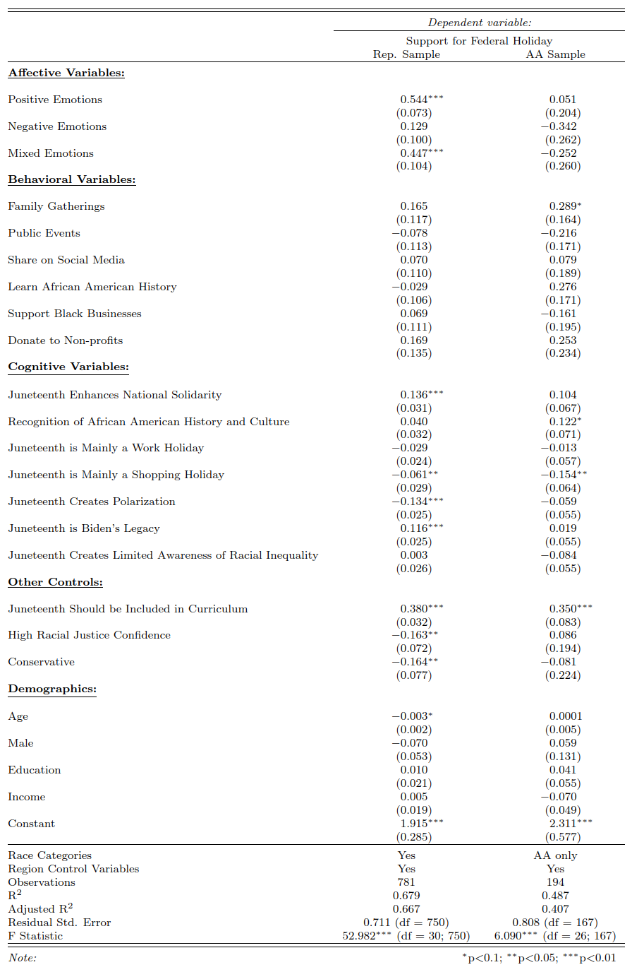
Table 3: ABC Model with Family Traditions
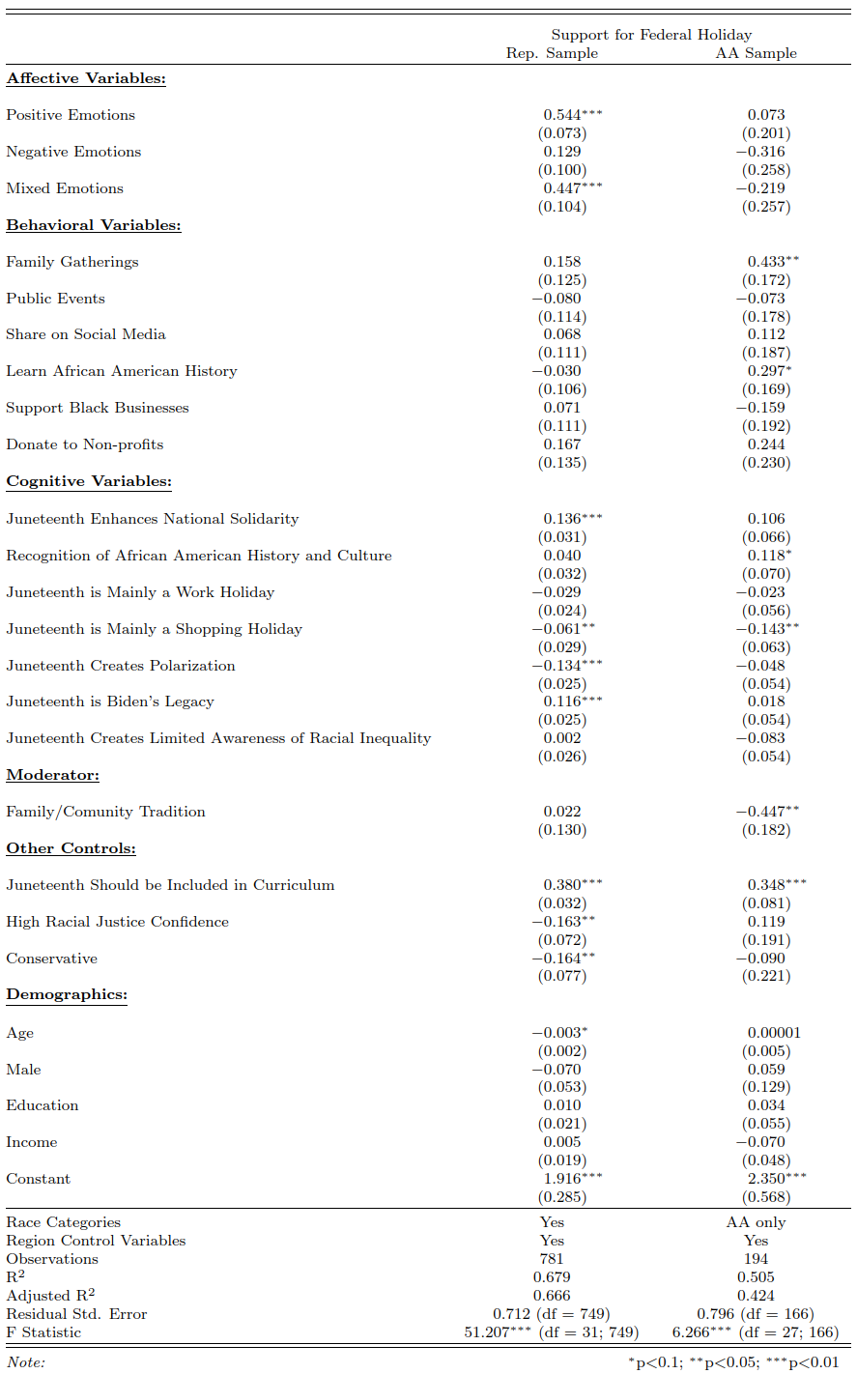
Table 4: Adjusted R-squared Values for Rep Sample and AA Sample
Adjusted R² | Rep Sample | AA Sample
Model without Family/Community Tradition | 0.668 | 0.404
Model with Family/Community Tradition | 0.668 | 0.420
Model with Family/Community Tradition & Interactions | 0.665 | 0.452

Table 5: Model with Family Tradition and Interactions
