Supplementary material for:
Rearing environment influences the interaction between fish gut microbiota and behaviour
Ishrat Z. Anka, Tamsyn M. Uren Webster, Sam McLaughlin, Matthew Hitchings, Carlos Garcia de Leaniz, Sofia Consuegra

Methodology: Probiotic supplement, preparation of diets and feeding protocol
Diet was enriched with either a commercial probiotic, Sanolife® PRO-F (from product range of Health from INVE AQUACULTURE, Belgium) or commercial enrichment Easy Dry Selco® (EDS). The probiotic product was a combination of three Bacillus bacteria (Bacillus subtilis, B. licheniformis and B. pumilus) especially formulated (1x10¹⁰ cfu/g) for aquaculture to prevent and control disease, gut microflora colonization, and to improve feed utilization through inhibiting pathogenic bacteria. EDS is a dry enrichment formulation that boosts Artemia with balanced levels of fats, proteins, vitamins, key minerals, immunostimulants, essential amino acids, and flavonoids. Newly hatched Artemia sp. were used as bio-encapsulates to incorporate the diets. The inclusion of EDS and Probiotic was performed according to the manufacturers’ instructions. Freshly hatched Artemia nauplii were harvested and rinsed carefully prior to enrichment with EDS (~0.6-0.8g/L) and probiotic supplement (~0.5 ml probiotic suspension/L, suspension was made of ~0.05 g dry probiotic powder and 0.5 ml distilled water). Continuous aeration was provided in the Artemia enrichment jar to ensure continuous agitation of the nauplii. For both diets, Artemia was enriched for at least 18 hours to ensure the encapsulation of supplied supplements. Enriched Artemia was filtered out and washed thoroughly before feeding the fish. All fish under experimental conditions were fed daily once at a rate of 0.5 ml/fish for the newly hatched alevins until the age of 1 month, 1 ml/fish for 2-3 months old fish, and 1.5 ml/fish for the fish from 3 months old and onwards.

Table S1. List of experimental mangrove killifish, K. marmoratus, indicating the genetic background (Strain), type of diet (standard EDS or enriched with probiotic), rearing environment (enriched or barren), behaviour (exploration time in seconds, number of inspections and contacts and number of section crosses in the novel object experiment), weight (miligrams), hatching mode (natural or artificially dechorionated) and microbiome alpha diversity (Chao1 and Faith phylogenetic diversity).
Fish_ID | Strain | Diet | Environment | Exploration | Inspections | Contacts | Activity | Weight | Hatching mode | Chao1 | Faith_pd
DF1-03 | DAN | EDS | Enriched | 1200 | 83 | 0 | 365 | 92 | Natural | 17.000 | 1.713
DF1-04 | DAN | EDS | Poor | 1200 | 2 | 0 | 14 | 126 | Natural | 22.000 | 2.874
DF1-05 | DAN | Probiotic | Enriched | 1200 | 0 | 0 | 4 | 75 | Natural | 28.000 | 3.277
DF1-06 | DAN | Probiotic | Poor | 1200 | 37 | 0 | 205 | 152 | Natural | 47.600 | 6.446
DF1-07 | DAN | EDS | Enriched | 1200 | 27 | 0 | 162 | 123 | Natural | 7.000 | 1.268
DF1-08 | DAN | EDS | Poor | 1200 | 0 | 0 | 2 | 139 | Natural | 5.000 | 1.390
DF1-13 | DAN | EDS | Enriched | 1200 | 8 | 0 | 52 | 118 | Artificial | 325.250 | 25.146
DF1-14 | DAN | Probiotic | Poor | 1200 | 16 | 0 | 212 | 102 | Artificial | 305.000 | 22.838
DF1-16 | DAN | Probiotic | Poor | 1200 | 0 | 0 | 6 | 91 | Artificial | 39.500 | 5.593
DF1-21 | DAN | Probiotic | Poor | 1200 | 29 | 0 | 179 | 82 | Artificial | 210.769 | 19.710
DF1-22 | DAN | EDS | Enriched | 1200 | 0 | 0 | 0 | 108 | Artificial | 340.333 | 24.865
DF1-23 | DAN | EDS | Poor | 1200 | 13 | 3 | 52 | 122 | Artificial | 309.000 | 25.076
DF1-24 | DAN | Probiotic | Enriched | 1200 | 4 | 0 | 21 | 100 | Artificial | 193.154 | 18.345
DF1-25 | DAN | Probiotic | Poor | 1200 | 16 | 0 | 90 | 99 | Natural | 297.429 | 23.804
DF1-28 | DAN | Probiotic | Enriched | 1200 | 14 | 0 | 65 | 81 | Artificial | 87.600 | 10.768
DF1-30 | DAN | Probiotic | Enriched | 1200 | 0 | 0 | 2 | 85 | Artificial | 274.243 | 22.599
DF1-31 | DAN | EDS | Poor | 1200 | 21 | 2 | 96 | 119 | Artificial | 126.909 | 12.611
DF1-36 | DAN | EDS | Enriched | 1200 | 7 | 0 | 30 | 92 | Artificial | 278.000 | 22.129
DF1-37 | DAN | Probiotic | Enriched | 1200 | 3 | 0 | 19 | 96 | Artificial | 230.250 | 20.889
DF1-38 | DAN | Probiotic | Poor | 1200 | 61 | 1 | 319 | 80 | Artificial | 211.750 | 19.919
DF1-39 | DAN | Probiotic | Enriched | 1200 | 12 | 0 | 59 | 87 | Artificial | 272.667 | 22.779
DF1-40 | DAN | EDS | Poor | 1200 | 2 | 0 | 12 | 100 | Artificial | 274.833 | 22.833
DF1-41 | DAN | EDS | Enriched | 1200 | 13 | 0 | 69 | 99 | Artificial | 253.167 | 20.924
DF1-45 | DAN | EDS | Poor | 1200 | 10 | 1 | 57 | 83 | Artificial | 383.875 | 27.597
DF1-48 | DAN | EDS | Poor | 1200 | 1 | 0 | 12 | 101 | Artificial | 115.895 | 12.341
DF1-63 | DAN | EDS | Poor | 1200 | 1 | 0 | 20 | 90 | Artificial | 534.055 | 33.056
HF1-02 | HON9 | EDS | Enriched | 1200 | 49 | 1 | 260 | 102 | Natural | 31.000 | 4.282
HF1-04 | HON9 | EDS | Poor | 1200 | 10 | 0 | 56 | 88 | Natural | 38.000 | 4.684
HF1-06 | HON9 | Probiotic | Enriched | 1200 | 0 | 0 | 8 | 97 | Natural | 23.500 | 3.117
HF1-07 | HON9 | EDS | Poor | 1200 | 3 | 0 | 32 | 125 | Natural | 37.000 | 3.843
HF1-11 | HON9 | Probiotic | Poor | 1200 | 22 | 0 | 253 | 158 | Natural | 20.500 | 4.680
HF1-13 | HON9 | Probiotic | Poor | 1200 | 4 | 1 | 28 | 71 | Natural | 35.000 | 5.316
HF1-15 | HON9 | EDS | Poor | 1200 | 11 | 0 | 51 | 135 | Natural | 54.000 | 6.140
HF1-24 | HON9 | EDS | Enriched | 1200 | 0 | 0 | 4 | 109 | Natural | 51.000 | 6.394
HF1-28 | HON9 | EDS | Enriched | 1200 | 6 | 0 | 34 | 100 | Natural | 55.000 | 6.749
HF1-31 | HON9 | Probiotic | Poor | 1200 | 8 | 0 | 40 | 85 | Artificial | 327.400 | 27.110
HF1-35 | HON9 | Probiotic | Poor | 1200 | 0 | 0 | 0 | 104 | Natural | 94.000 | 12.153
HF1-37 | HON9 | EDS | Poor | 1200 | 0 | 0 | 0 | 108 | Natural | 262.000 | 22.167
HF1-38 | HON9 | EDS | Enriched | 1200 | 14 | 1 | 63 | 130 | Natural | 377.000 | 26.958
HF1-41 | HON9 | Probiotic | Poor | 1200 | 0 | 0 | 8 | 94 | Natural | 226.000 | 19.131
HF1-50 | HON9 | Probiotic | Enriched | 1200 | 9 | 0 | 63 | 89 | Natural | 325.500 | 24.592
HF1-52 | HON9 | Probiotic | Enriched | 1200 | 7 | 1 | 30 | 95 | Natural | 268.600 | 22.968
HF1-56 | HON9 | EDS | Enriched | 1200 | 7 | 1 | 30 | 93 | Artificial | 399.565 | 27.797
HF1-57 | HON9 | Probiotic | Poor | 1200 | 0 | 0 | 6 | 79 | Natural | 303.857 | 25.077
HF1-60 | HON9 | Probiotic | Enriched | 1200 | 0 | 0 | 17 | 77 | Natural | 715.356 | 33.320
HF1-66 | HON9 | Probiotic | Enriched | 1200 | 1 | 0 | 12 | 80 | Natural | 706.603 | 32.568

Figure S1. Experimental design including two mangrove killifish (K. marmoratus) strains (DAN and HON9), two environmental enrichment conditions (emriched and poor) and environmental factors (rearing environments and diets) for the experiments.

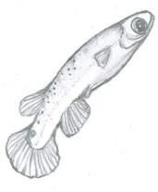
2 Killifish strains

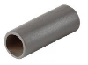
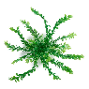
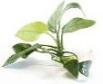
DAN
HON9

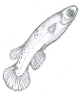
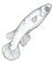
2 rearing environments

Enriched tank (E)
Poor tank (P)
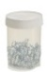
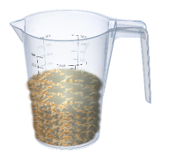
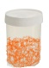
Experimental design
DAN
EDS [P (n=10), E (n=10)] and Probiotic [P (n=10), E (n=10)]
HON9
EDS [P (n=10), E (n=10)] and Probiotic [P (n=10), E (n=10)]

2 diet enrichments

Probiotic enriched artemia (Probiotic)
EDS enriched artemia (EDS)

Figure S2. Behavioural test tank with acclimation zone (0) and five exploratory zones (1-5). A plastic Lego brick (orange colour) was used as a novel object placed at the middle of zone 3.
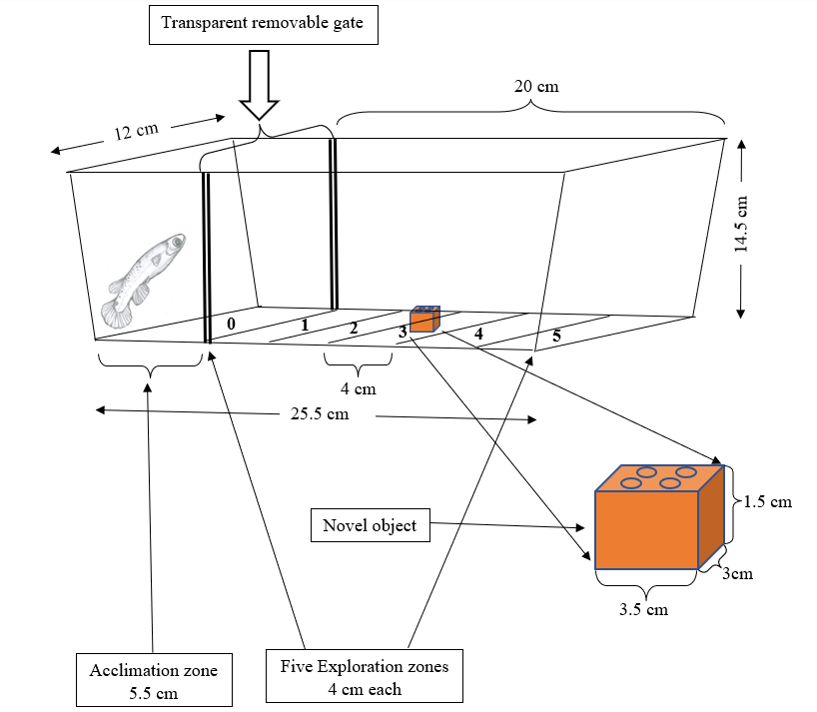

Table S2. Differentially represented ASVs between diets (EDS vs Probiotic enriched) in the microbiome of 46 mangrove killifish identified using DEseq2. BaseMean mean represent the normalised counts, averaged over all samples from both conditions; Log2FoldChange is the logarithm (to basis 2) of the fold change, and the Standard error (LfcSE); pval is the p value for the statistical significance of this change and padj is the p value adjusted for multiple testing with the Benjamini-Hochberg procedure, which controls false discovery rate (FDR).
Feature (ASV) | BaseMean | Log2FoldChange | LfcSE | Stat | pvalue | padj
16_ f__Desulfovibrionaceae | 4.023 | -2.638 | 0.553 | -4.767 | 0.000 | 0.001
24_ f__Prevotellaceae | 2.116 | -1.487 | 0.498 | -2.984 | 0.003 | 0.050
33_ f__Tannerellaceae | 2.133 | -1.423 | 0.462 | -3.083 | 0.002 | 0.044
53_ f__Prevotellaceae | 2.014 | -1.393 | 0.453 | -3.078 | 0.002 | 0.044
88_ f__Cryomorphaceae | 3.191 | -1.526 | 0.490 | -3.118 | 0.002 | 0.044
96_ f__Bacteroidaceae | 2.278 | 1.483 | 0.484 | 3.066 | 0.002 | 0.044
157_ f__Halieaceae | 4.043 | -1.663 | 0.528 | -3.151 | 0.002 | 0.043
169_ f__Muribaculaceae | 2.390 | 1.578 | 0.503 | 3.136 | 0.002 | 0.044
174_ f__Lachnospiraceae | 6.078 | -1.824 | 0.554 | -3.291 | 0.001 | 0.041
176_ f__Oscillospiraceae | 3.933 | -2.266 | 0.544 | -4.169 | 0.000 | 0.007
222_ f__Terrimicrobiaceae | 6.334 | 1.653 | 0.534 | 3.097 | 0.002 | 0.044
245_ f__Legionellaceae | 2.681 | -1.492 | 0.464 | -3.212 | 0.001 | 0.043
257_ f__Muribaculaceae | 2.709 | -1.661 | 0.507 | -3.275 | 0.001 | 0.041
406_ f__Oscillospiraceae | 3.900 | 1.667 | 0.524 | 3.181 | 0.001 | 0.043
428_ o__Bacteroidales | 3.016 | 1.800 | 0.514 | 3.503 | 0.000 | 0.031
430_ f__Rhodobacteraceae | 3.308 | -1.959 | 0.503 | -3.892 | 0.000 | 0.013
432_ f__Rikenellaceae | 2.299 | -1.649 | 0.470 | -3.509 | 0.000 | 0.031
443_ f__Bacteroidaceae | 2.037 | 1.426 | 0.473 | 3.014 | 0.003 | 0.048
510_ f__Prevotellaceae | 3.257 | -1.745 | 0.525 | -3.322 | 0.001 | 0.041
557_ f__Clostridia_UCG-014 | 2.491 | -1.497 | 0.492 | -3.046 | 0.002 | 0.044
591_ f__Bacillaceae | 2.125 | -1.492 | 0.466 | -3.201 | 0.001 | 0.043
681_ f__Bacteroidaceae | 2.115 | -1.486 | 0.496 | -2.998 | 0.003 | 0.049
788_ f__Lachnospiraceae | 4.159 | 1.788 | 0.542 | 3.300 | 0.001 | 0.041
816_f__Coriobacteriales_Incertae_Sedis | 2.184 | -1.550 | 0.470 | -3.295 | 0.001 | 0.041
817_ f__Vibrionaceae | 1244.432 | 1.502 | 0.472 | 3.183 | 0.001 | 0.043
948_ f__Oscillospiraceae | 3.918 | 2.214 | 0.528 | 4.195 | 0.000 | 0.007
1081_ f__Lachnospiraceae | 2.632 | 1.477 | 0.481 | 3.071 | 0.002 | 0.044
1094_ f__Clostridia_UCG-014 | 2.657 | -1.419 | 0.464 | -3.058 | 0.002 | 0.044
1106_ f__Mycobacteriaceae | 2.772 | -1.842 | 0.513 | -3.591 | 0.000 | 0.031
1137_ f__Bacteriovoracaceae | 5.646 | -1.657 | 0.518 | -3.203 | 0.001 | 0.043
1176_ f__Staphylococcaceae | 2.414 | -1.741 | 0.505 | -3.449 | 0.001 | 0.033
1178_ f__Alcanivoracaceae1 | 2.025 | 1.410 | 0.461 | 3.060 | 0.002 | 0.044
1200_ f__Lachnospiraceae | 2.565 | -1.852 | 0.509 | -3.640 | 0.000 | 0.030
1293_ f__Vibrionaceae | 3.698 | 2.429 | 0.594 | 4.093 | 0.000 | 0.007
1409_ f__Muribaculaceae | 2.397 | -1.727 | 0.486 | -3.558 | 0.000 | 0.031
1424_ f__Dadabacteriales | 11.057 | -1.780 | 0.562 | -3.167 | 0.002 | 0.043
1465_ f__Bacteroidaceae | 2.707 | 1.596 | 0.500 | 3.189 | 0.001 | 0.043
1471_ f__Halieaceae | 5.339 | -1.890 | 0.550 | -3.435 | 0.001 | 0.033

Table S3. Differentially represented ASVs between diets (EDS vs Probiotic enriched) in the microbiome of 46 mangrove killifish, identified using the voom-limma Bayesian method. LogFC is the log2 of the fold change, AveExpr id the average expression across all samples, in log2, t is the logFC divided by its standard error, P.Value is the raw p-value (based on t) from testing that logFC differs from 0, adj.P.Val is the Benjamini-Hochberg false discovery rate adjusted p-value.
Feature (ASV) | LogFC | AveExpr | t | P.Value | adj.P.val
332_f__Tannerellaceae | -1.949 | 6.200 | -4.338 | 0.00004 | 0.041
432_f__Rikenellaceae | -1.954 | 6.362 | -4.227 | 0.00006 | 0.041
1176_f__Staphylococcaceae | -1.980 | 6.228 | -4.155 | 0.00008 | 0.041
739_o__Chlamydiales | -1.895 | 6.237 | -4.084 | 0.00011 | 0.041
16_f__Desulfovibrionaceae | -1.847 | 6.506 | -3.956 | 0.00017 | 0.049
591_f__Bacillaceae | -1.700 | 6.301 | -3.895 | 0.00021 | 0.049
53_f__Prevotellaceae | -1.630 | 6.295 | -3.872 | 0.00023 | 0.049
1409_f__Muribaculaceae | -1.517 | 6.335 | -3.638 | 0.00050 | 0.095
1106_f__Mycobacteriaceae | -1.742 | 6.328 | -3.504 | 0.00077 | 0.104
816_f__Coriobacteriales_Incertae_Sedis | -1.411 | 6.317 | -3.501 | 0.00078 | 0.104
78_f__Lachnospiraceae | -1.549 | 6.163 | -3.496 | 0.00079 | 0.104
199_f__Muribaculaceae | -1.489 | 6.178 | -3.487 | 0.00081 | 0.104
33_f__Tannerellaceae | -1.528 | 6.340 | -3.441 | 0.00094 | 0.109
1153_f__Oscillospiraceae | -1.492 | 6.133 | -3.423 | 0.00100 | 0.109
776_f__Lachnospiraceae | -1.394 | 6.180 | -3.377 | 0.00115 | 0.117
383_f__Muribaculaceae | -1.731 | 6.488 | -3.351 | 0.00125 | 0.119
1264_f__Lachnospiraceae | -1.290 | 6.132 | -3.308 | 0.00144 | 0.129
642_f__Chlamydiaceae | -1.616 | 6.616 | -3.284 | 0.00155 | 0.130
1089_f__Lachnospiraceae | -1.358 | 6.106 | -3.269 | 0.00162 | 0.130
896_f__Muribaculaceae | -1.350 | 6.096 | -3.251 | 0.00172 | 0.131

Table S4. Comparison of the best models for microbiome alpha diversity within 2AIC units identified using glmulti. a) Chao1 model: glmulti(chao1 ~ Strain + Diet + Environment + Hatching_type + Weight, data=F0_behavmicrob, crit = GammaAIC, level = 2, method = "h", family=Gamma(link="log"), fitfunction = glm, confsetsize = 100); b) Faith_pd model: glmulti(faith ~ Strain + Diet + Hatching_type + Environment + Weight, data=F0_behavmicrob, crit = aicc, level = 2, method = "h", fitfunction = glm, confsetsize = 100).
(a)
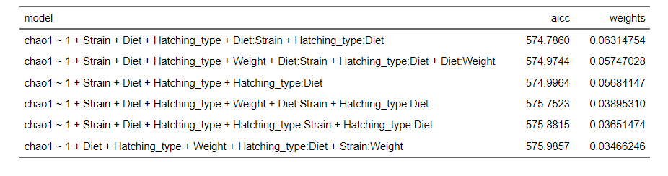
(b)
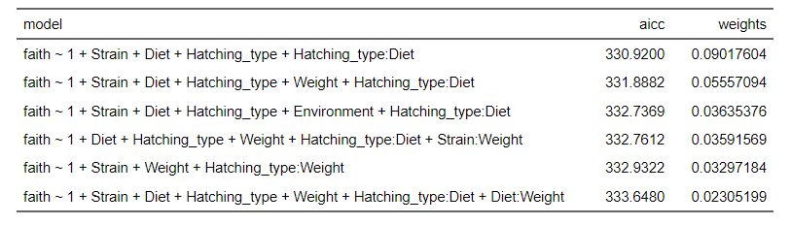
Table S5. Comparison of the 5 best models for behaviour within 2AIC units identified using glmulti. Tables a and b correspond to Activity models: glmulti(Activity ~ Strain + Diet + Hatching_type + alpha diversity + Weight, data=F0_behavmicrob3, crit = aic, family=negative.binomial(theta = 0.714, link = log), level = 1, method = "h", fitfunction = glm, confsetsize = 100) Tables c and d correspond to Inspection models: glmulti(Inspections ~ Strain + Diet + Hatching_type + alpha diversity + Weight, data=F0_behavmicrob3, crit = aic, family=negative.binomial(theta = 0.571, link = log), level = 1, method = "h", fitfunction = glm, confsetsize = 100). Tables e and f correspond to Exploration models: glmulti(Explor_prop ~ Strain + Diet + Hatching_type + alpha diversity + Weight, data=F0_behavmicrob3, crit = aic, family=binomial, level = 1, method = "h", fitfunction = glm, confsetsize = 100). Alpha diversity = chao1 or faith_pd.
(a)
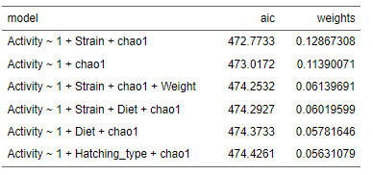
(b)
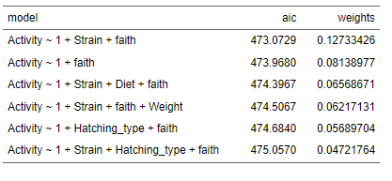
(c)
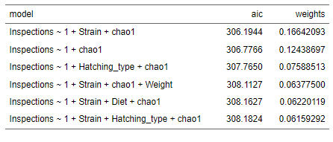

(d)
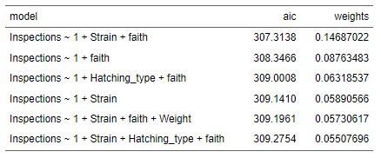
(e)
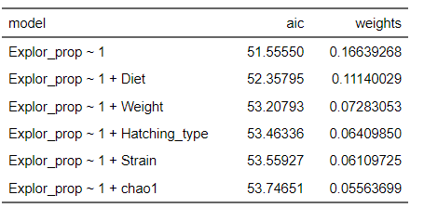
(f)
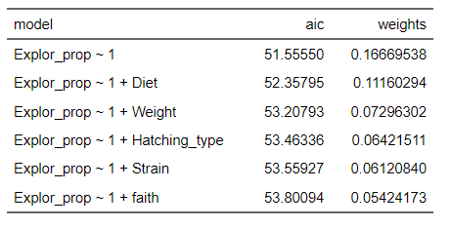

Table S6. Analysis of deviance table (Type II tests) of the first 5 best models for behaviour within 2AIC units identified using glmulti (Table S5). A and B: microbiome diversity Chao1 and Faith_pd; C and D: Activity with Chao1 and Faith_pd as behaviour predictors respectively; E and F: Inspections with Chao1 and Faith_pd as behaviour predictors respectively.
A.
Chao1
Model 1 | LR Chisq | Df | Pr(>Chisq)
Strain | 10.133 | 1 | 0.001
Diet | 3.392 | 1 | 0.066
Hatching_type | 13.322 | 1 | 0.000
Strain:Diet | 2.691 | 1 | 0.101
Diet:Hatching_type | 11.227 | 1 | 0.001
Model 2 | LR Chisq | Df | Pr(>Chisq)
Strain | 6.789 | 1 | 0.009
Diet | 0.348 | 1 | 0.555
Hatching_type | 8.942 | 1 | 0.003
Weight | 1.921 | 1 | 0.166
Strain:Diet | 5.644 | 1 | 0.018
Diet:Hatching_type | 15.544 | 1 | 0.000
Diet:Weight | 3.579 | 1 | 0.059
Model 3 | LR Chisq | Df | Pr(>Chisq)
Strain | 8.545 | 1 | 0.003
Diet | 2.860 | 1 | 0.091
Hatching_type | 12.161 | 1 | 0.000
Diet:Hatching_type | 8.444 | 1 | 0.004
Model 4 | LR Chisq | Df | Pr(>Chisq)
Strain | 7.594 | 1 | 0.006
Diet | 0.296 | 1 | 0.587
Hatching_type | 7.638 | 1 | 0.006
Weight | 1.630 | 1 | 0.202
Strain:Diet | 3.460 | 1 | 0.063
Diet:Hatching_type | 10.369 | 1 | 0.001
Model 5 | LR Chisq | Df | Pr(>Chisq)
Strain | 8.536 | 1 | 0.003
Diet | 3.110 | 1 | 0.078
Hatching_type | 12.148 | 1 | 0.000
Strain:Hatching_type | 1.454 | 1 | 0.228
Diet:Hatching_type | 8.651 | 1 | 0.003

B.
Faith PD
Model 1 | LR Chisq | Df | Pr(>Chisq)
Strain | 6.056 | 1 | 0.014
Diet | 1.297 | 1 | 0.255
Hatching_type | 21.535 | 1 | 0.000
Diet:Hatching_type | 7.051 | 1 | 0.008
Model 2 | LR Chisq | Df | Pr(>Chisq)
Strain | 4.623 | 1 | 0.032
Diet | 0.270 | 1 | 0.604
Hatching_type | 15.134 | 1 | 0.000
Weight | 1.619 | 1 | 0.203
Diet:Hatching_type | 6.880 | 1 | 0.009
Model 3 | LR Chisq | Df | Pr(>Chisq)
Strain | 5.801 | 1 | 0.016
Diet | 1.299 | 1 | 0.254
Hatching_type | 21.252 | 1 | 0.000
Environment | 0.858 | 1 | 0.354
Diet:Hatching_type | 7.234 | 1 | 0.007
Model 4 | LR Chisq | Df | Pr(>Chisq)
Diet | 0.240 | 1 | 0.624
Hatching_type | 13.335 | 1 | 0.000
Weight | 3.085 | 1 | 0.079
Diet:Hatching_type | 7.470 | 1 | 0.006
Weight:Strain | 3.784 | 1 | 0.052

C.
Activity (with Chao1 as predictor)
Model 1 | LR Chisq | Df | Pr(>Chisq)
Strain | 2.511 | 1 | 0.113
chao1 | 5.277 | 1 | 0.022
Model 2 | LR Chisq | Df | Pr(>Chisq)
chao1 | 4.445 | 1 | 0.035
Model 3 | LR Chisq | Df | Pr(>Chisq)
Strain | 2.776 | 1 | 0.096
chao1 | 3.152 | 1 | 0.076
Weight | 0.545 | 1 | 0.460
Model 4 | LR Chisq | Df | Pr(>Chisq)
Strain | 2.400 | 1 | 0.121
Diet | 0.554 | 1 | 0.457
chao1 | 5.947 | 1 | 0.015
Model 5 | LR Chisq | Df | Pr(>Chisq)
Diet | 0.702 | 1 | 0.402
chao1 | 5.367 | 1 | 0.021
Activity (with Faith_pd as predictor)
Model 1 | LR Chisq | Df | Pr(>Chisq)
Strain | 3.105 | 1 | 0.078
faith | 4.736 | 1 | 0.030
Model 2 | LR Chisq | Df | Pr(>Chisq)
faith | 4.031 | 1 | 0.044
Model 3 | LR Chisq | Df | Pr(>Chisq)
Strain | 3.068 | 1 | 0.080
Diet | 0.768 | 1 | 0.381
faith | 5.739 | 1 | 0.017
Model 4 | LR Chisq | Df | Pr(>Chisq)
Strain | 3.337 | 1 | 0.068
faith | 2.775 | 1 | 0.096
Weight | 0.571 | 1 | 0.450
Model 5 | LR Chisq | Df | Pr(>Chisq)
Hatching_type | 1.336 | 1 | 0.248
faith | 4.827 | 1 | 0.028

D.
Inspections (with Chao1 as predictor)
Model 1 | LR Chisq | Df | Pr(>Chisq)
Strain | 3.377 | 1 | 0.066
chao1 | 6.760 | 1 | 0.009
Model 2 | LR Chisq | Df | Pr(>Chisq)
chao1 | 6.161 | 1 | 0.013
Model 3 | LR Chisq | Df | Pr(>Chisq)
Hatching_type | 1.218 | 1 | 0.270
chao1 | 7.414 | 1 | 0.006
Model 4 | LR Chisq | Df | Pr(>Chisq)
Strain | 3.283 | 1 | 0.070
chao1 | 5.480 | 1 | 0.019
Weight | 0.101 | 1 | 0.751
Model 5 | LR Chisq | Df | Pr(>Chisq)
Strain | 3.329 | 1 | 0.068
Diet | 0.040 | 1 | 0.841
chao1 | 6.058 | 1 | 0.014
Inspections (with Faith_pd as predictor)
Model 1 | LR Chisq | Df | Pr(>Chisq)
Strain | 3.828 | 1 | 0.050
faith | 4.831 | 1 | 0.028
Model 2 | LR Chisq | Df | Pr(>Chisq)
faith | 3.673 | 1 | 0.055
Model 3 | LR Chisq | Df | Pr(>Chisq)
Hatching_type | 1.565 | 1 | 0.211
faith | 5.396 | 1 | 0.020
Model 4 | LR Chisq | Df | Pr(>Chisq)
Strain | 2.323 | 1 | 0.128
Model 5 | LR Chisq | Df | Pr(>Chisq)
Strain | 3.707 | 1 | 0.054
faith | 3.710 | 1 | 0.054
Weight | 0.139 | 1 | 0.710

Table S7. Results from microbiome multivariable association analyses carried oput using MAasLin2, showing the correlation coefficient (coef) of the individual bacterial features and fish behaviour (activity), standard error (stderr) and statistical significance (q-value with Benjamini–Hochberg correction for multiple testing).
Feature (ASV) | Predictor | Value | Coef | Stderr | N | N.not.0 | pval | qval
X103_.o__Rickettsiales | Diet | Probiotic | -1.602 | 0.494 | 46 | 8 | 0.001 | 0.036
X1078_.f__Prevotellaceae | Diet | Probiotic | -1.103 | 0.331 | 46 | 14 | 0.001 | 0.032
X1149_.f__Alcanivoracaceae1 | Activity | Activity | -2.222 | 0.710 | 46 | 13 | 0.002 | 0.046
X1188_.o__Thalassobaculales | Activity | Activity | 0.732 | 0.119 | 46 | 9 | 0.000 | 0.000
X1188_.o__Thalassobaculales | Diet | Probiotic | 1.394 | 0.302 | 46 | 9 | 0.000 | 0.001
X1193_.f__Gimesiaceae | Strain | HON9 | 4.278 | 1.326 | 46 | 16 | 0.001 | 0.036
X1226_.f__Prevotellaceae | Activity | Activity | -2.523 | 0.408 | 46 | 8 | 0.000 | 0.000
X1226_.f__Prevotellaceae | Diet | Probiotic | 1.880 | 0.415 | 46 | 8 | 0.000 | 0.001
X1232_.f__Gemmataceae | Diet | Probiotic | -1.355 | 0.366 | 46 | 8 | 0.000 | 0.012
X1232_.f__Gemmataceae | Hatching_mode | Natural | 1.903 | 0.587 | 46 | 8 | 0.001 | 0.036
X1279_.f__Acidaminococcaceae | Activity | Activity | 2.492 | 0.377 | 46 | 15 | 0.000 | 0.000
X1279_.f__Acidaminococcaceae | Diet | Probiotic | -0.505 | 0.157 | 46 | 15 | 0.001 | 0.036
X1289_.f__Deferribacteraceae | Activity | Activity | -3.166 | 0.658 | 46 | 9 | 0.000 | 0.000
X1289_.f__Deferribacteraceae | Diet | Probiotic | -2.085 | 0.521 | 46 | 9 | 0.000 | 0.005
X1289_.f__Deferribacteraceae | Hatching_mode | Natural | 3.088 | 0.791 | 46 | 9 | 0.000 | 0.007
X1326_.f__Marinifilaceae | Strain | HON9 | 1.994 | 0.543 | 46 | 10 | 0.000 | 0.012
X1326_.f__Marinifilaceae | Activity | Activity | 0.887 | 0.284 | 46 | 10 | 0.002 | 0.046
X1356_.f__Pirellulaceae | Diet | Probiotic | -2.581 | 0.583 | 46 | 7 | 0.000 | 0.001
X1356_.f__Pirellulaceae | Activity | Activity | 0.800 | 0.217 | 46 | 7 | 0.000 | 0.012
X1520_.f__Bacteroidaceae | Strain | HON9 | -2.584 | 0.786 | 46 | 9 | 0.001 | 0.034
X257_.f__Muribaculaceae | Activity | Activity | 2.712 | 0.619 | 46 | 7 | 0.000 | 0.001
X326_.f__Succinivibrionaceae | Diet | Probiotic | -0.478 | 0.132 | 46 | 27 | 0.000 | 0.013
X358_.f__Microbacteriaceae | Diet | Probiotic | -1.312 | 0.259 | 46 | 9 | 0.000 | 0.000
X373_.f__Moraxellaceae | Activity | Activity | 0.439 | 0.119 | 46 | 8 | 0.000 | 0.012
X424_.f__Pirellulaceae | Activity | Activity | 1.088 | 0.113 | 46 | 13 | 0.000 | 0.000
X441_.f__Pirellulaceae | Activity | Activity | 0.584 | 0.109 | 46 | 24 | 0.000 | 0.000
X461_.f__Rhodobacteraceae | Activity | Activity | -0.888 | 0.272 | 46 | 9 | 0.001 | 0.036
X477_.f__Prevotellaceae | Hatching_mode | Natural | -1.543 | 0.416 | 46 | 13 | 0.000 | 0.012
X477_.f__Prevotellaceae | Diet | Probiotic | -0.880 | 0.266 | 46 | 13 | 0.001 | 0.032
X49_.f__Pirellulaceae | Diet | Probiotic | -1.710 | 0.517 | 46 | 9 | 0.001 | 0.032
X49_.f__Pirellulaceae | Hatching_mode | Natural | 1.630 | 0.524 | 46 | 9 | 0.002 | 0.047
X517_.f__Muribaculaceae | Diet | Probiotic | -0.968 | 0.306 | 46 | 18 | 0.002 | 0.043
X538_.f__Lachnospiraceae | Strain | HON9 | 0.797 | 0.255 | 46 | 21 | 0.002 | 0.046
X573_.f__Prevotellaceae | Diet | Probiotic | -1.686 | 0.449 | 46 | 12 | 0.000 | 0.011
X582_.f__Muribaculaceae | Diet | Probiotic | -2.049 | 0.595 | 46 | 7 | 0.001 | 0.023
X584_.f__Aerococcaceae | Hatching_mode | Natural | -6.296 | 2.011 | 46 | 8 | 0.002 | 0.046
X599_.f__Desulfovibrionaceae | Hatching_mode | Natural | 1.184 | 0.366 | 46 | 16 | 0.001 | 0.036
X605_.f__Campylobacteraceae | Strain | HON9 | 2.165 | 0.602 | 46 | 9 | 0.000 | 0.014
X605_.f__Campylobacteraceae | Activity | Activity | 0.599 | 0.181 | 46 | 9 | 0.001 | 0.032
X624_.f__Mycobacteriaceae | Hatching_mode | Natural | 3.447 | 0.951 | 46 | 24 | 0.000 | 0.013
X643_.f__Prevotellaceae | Diet | Probiotic | -1.405 | 0.432 | 46 | 11 | 0.001 | 0.036
X675_.f__Vibrionaceae | Hatching_mode | Natural | 1.663 | 0.413 | 46 | 37 | 0.000 | 0.005
X727_.f__Prevotellaceae | Hatching_mode | Natural | -2.019 | 0.403 | 46 | 8 | 0.000 | 0.000
X727_.f__Prevotellaceae | Strain | HON9 | 1.536 | 0.338 | 46 | 8 | 0.000 | 0.001
X748_.f__Lachnospiraceae | Diet | Probiotic | -1.924 | 0.476 | 46 | 10 | 0.000 | 0.005
X761_.f__Prevotellaceae | Activity | Activity | 1.386 | 0.351 | 46 | 16 | 0.000 | 0.006
X825_.f__Vermiphilaceae | Diet | Probiotic | -0.931 | 0.266 | 46 | 12 | 0.000 | 0.019
X88_.f__Cryomorphaceae | Diet | Probiotic | 4.258 | 1.269 | 46 | 11 | 0.001 | 0.030
X90_.f__Dadabacteriales | Activity | Activity | 0.606 | 0.163 | 46 | 16 | 0.000 | 0.012
X907_.f__Streptococcaceae | Diet | Probiotic | -0.918 | 0.249 | 46 | 15 | 0.000 | 0.012
X915_.f__Muribaculaceae | Hatching_mode | Natural | 1.234 | 0.349 | 46 | 11 | 0.000 | 0.017
X915_.f__Muribaculaceae | Diet | Probiotic | -1.211 | 0.353 | 46 | 11 | 0.001 | 0.024
X936_.f__Rubinisphaeraceae | Activity | Activity | 0.753 | 0.194 | 46 | 9 | 0.000 | 0.007
X946_.f__Intrasporangiaceae | Hatching_mode | Natural | 1.956 | 0.406 | 46 | 10 | 0.000 | 0.000
X946_.f__Intrasporangiaceae | Strain | HON9 | -3.280 | 0.729 | 46 | 10 | 0.000 | 0.001
X950_.f__Prevotellaceae | Activity | Activity | 0.745 | 0.194 | 46 | 11 | 0.000 | 0.008
X950_.f__Prevotellaceae | Hatching_mode | Natural | -0.930 | 0.297 | 46 | 11 | 0.002 | 0.046

Table S8. Results from microbiome multivariable association analyses carried oput using MAasLin2, showing the correlation coefficient (coef) of the individual bacterial features and fish behaviour (inspections), standard error (stderr) and statistical significance (q-value with Benjamini–Hochberg correction for multiple testing).
Feature (ASV) | Predictor | Value | Coef | Stderr | N | N.  not.0 | pval | qval
X103_.o__Rickettsiales | Diet | Probiotic | -1.632 | 0.476 | 46 | 8 | 0.001 | 0.022
X103_.o__Rickettsiales | Inspections | Inspections | 1.443 | 0.463 | 46 | 8 | 0.002 | 0.046
X1078_.f__Prevotellaceae | Diet | Probiotic | -1.112 | 0.333 | 46 | 14 | 0.001 | 0.026
X1081_.f__Lachnospiraceae | Strain | HON9 | 1.548 | 0.454 | 46 | 8 | 0.001 | 0.023
X1094_.f__Clostridia_UCG.014 | Diet | Probiotic | 4.502 | 1.158 | 46 | 9 | 0.000 | 0.007
X1094_.f__Clostridia_UCG.014 | Inspections | Inspections | -4.653 | 1.498 | 46 | 9 | 0.002 | 0.047
X1188_.o__Thalassobaculales | Inspections | Inspections | 0.708 | 0.115 | 46 | 9 | 0.000 | 0.000
X1188_.o__Thalassobaculales | Diet | Probiotic | 1.393 | 0.304 | 46 | 9 | 0.000 | 0.000
X121_.f__Bacteroidaceae | Inspections | Inspections | -0.376 | 0.118 | 46 | 7 | 0.001 | 0.039
X1210_.f__Ruminococcaceae | Diet | Probiotic | -1.127 | 0.361 | 46 | 8 | 0.002 | 0.046
X1226_.f__Prevotellaceae | Inspections | Inspections | -2.353 | 0.376 | 46 | 8 | 0.000 | 0.000
X1226_.f__Prevotellaceae | Diet | Probiotic | 1.889 | 0.391 | 46 | 8 | 0.000 | 0.000
X1232_.f__Gemmataceae | Diet | Probiotic | -1.259 | 0.360 | 46 | 8 | 0.000 | 0.019
X1279_.f__Acidaminococcaceae | Inspections | Inspections | 2.079 | 0.424 | 46 | 15 | 0.000 | 0.000
X1289_.f__Deferribacteraceae | Hatching_mode | Natural | 2.206 | 0.598 | 46 | 9 | 0.000 | 0.013
X1289_.f__Deferribacteraceae | Diet | Probiotic | -1.594 | 0.447 | 46 | 9 | 0.000 | 0.018
X1289_.f__Deferribacteraceae | Inspections | Inspections | -1.848 | 0.548 | 46 | 9 | 0.001 | 0.025
X1326_.f__Marinifilaceae | Inspections | Inspections | 2.832 | 0.561 | 46 | 10 | 0.000 | 0.000
X1326_.f__Marinifilaceae | Diet | Probiotic | -2.106 | 0.434 | 46 | 10 | 0.000 | 0.000
X1356_.f__Pirellulaceae | Diet | Probiotic | -1.936 | 0.414 | 46 | 7 | 0.000 | 0.000
X1356_.f__Pirellulaceae | Inspections | Inspections | 0.564 | 0.168 | 46 | 7 | 0.001 | 0.025
X1434_.f__Lactobacillaceae | Inspections | Inspections | 0.580 | 0.161 | 46 | 13 | 0.000 | 0.016
X15_.f__Victivallaceae | Strain | HON9 | -2.219 | 0.422 | 46 | 7 | 0.000 | 0.000
X15_.f__Victivallaceae | Inspections | Inspections | -2.884 | 0.556 | 46 | 7 | 0.000 | 0.000
X1520_.f__Bacteroidaceae | Strain | HON9 | -2.376 | 0.721 | 46 | 9 | 0.001 | 0.029
X257_.f__Muribaculaceae | Inspections | Inspections | 1.655 | 0.447 | 46 | 7 | 0.000 | 0.012
X265_.f__Peptostreptococcaceae | Strain | HON9 | 3.846 | 1.205 | 46 | 13 | 0.001 | 0.039
X326_.f__Succinivibrionaceae | Diet | Probiotic | -0.461 | 0.129 | 46 | 27 | 0.000 | 0.018
X358_.f__Microbacteriaceae | Diet | Probiotic | -1.320 | 0.261 | 46 | 9 | 0.000 | 0.000
X373_.f__Moraxellaceae | Inspections | Inspections | 0.432 | 0.106 | 46 | 8 | 0.000 | 0.003
X428_.o__Bacteroidales | Inspections | Inspections | 1.986 | 0.410 | 46 | 7 | 0.000 | 0.000
X477_.f__Prevotellaceae | Diet | Probiotic | -0.890 | 0.256 | 46 | 13 | 0.001 | 0.020
X477_.f__Prevotellaceae | Hatching_mode | Natural | -1.473 | 0.431 | 46 | 13 | 0.001 | 0.023
X49_.f__Pirellulaceae | Hatching_mode | Natural | 1.746 | 0.525 | 46 | 9 | 0.001 | 0.027
X49_.f__Pirellulaceae | Diet | Probiotic | -1.651 | 0.525 | 46 | 9 | 0.002 | 0.044
X573_.f__Prevotellaceae | Diet | Probiotic | -1.668 | 0.439 | 46 | 12 | 0.000 | 0.009
X582_.f__Muribaculaceae | Diet | Probiotic | -1.928 | 0.595 | 46 | 7 | 0.001 | 0.035
X599_.f__Desulfovibrionaceae | Hatching_mode | Natural | 1.260 | 0.366 | 46 | 16 | 0.001 | 0.022
X599_.f__Desulfovibrionaceae | Strain | HON9 | -1.081 | 0.341 | 46 | 16 | 0.001 | 0.040
X605_.f__Campylobacteraceae | Strain | HON9 | 2.065 | 0.582 | 46 | 9 | 0.000 | 0.018
X605_.f__Campylobacteraceae | Inspections | Inspections | 0.547 | 0.171 | 46 | 9 | 0.001 | 0.039
X624_.f__Mycobacteriaceae | Hatching_mode | Natural | 3.404 | 0.967 | 46 | 24 | 0.000 | 0.019
X643_.f__Prevotellaceae | Diet | Probiotic | -1.286 | 0.408 | 46 | 11 | 0.002 | 0.044
X67_.f__Rikenellaceae | Inspections | Inspections | -0.698 | 0.152 | 46 | 10 | 0.000 | 0.000
X675_.f__Vibrionaceae | Hatching_mode | Natural | 1.654 | 0.407 | 46 | 37 | 0.000 | 0.003
X727_.f__Prevotellaceae | Strain | HON9 | 1.502 | 0.313 | 46 | 8 | 0.000 | 0.000
X727_.f__Prevotellaceae | Hatching_mode | Natural | -1.962 | 0.433 | 46 | 8 | 0.000 | 0.001
X748_.f__Lachnospiraceae | Diet | Probiotic | -1.809 | 0.501 | 46 | 10 | 0.000 | 0.016
X761_.f__Prevotellaceae | Inspections | Inspections | 1.348 | 0.398 | 46 | 16 | 0.001 | 0.024
X780_.f__Lachnospiraceae | Inspections | Inspections | -1.867 | 0.417 | 46 | 7 | 0.000 | 0.001
X780_.f__Lachnospiraceae | Strain | HON9 | -1.688 | 0.415 | 46 | 7 | 0.000 | 0.003
X825_.f__Vermiphilaceae | Diet | Probiotic | -1.033 | 0.293 | 46 | 12 | 0.000 | 0.019
X88_.f__Cryomorphaceae | Diet | Probiotic | 3.650 | 0.986 | 46 | 11 | 0.000 | 0.012
X907_.f__Streptococcaceae | Diet | Probiotic | -0.870 | 0.248 | 46 | 15 | 0.000 | 0.019
X915_.f__Muribaculaceae | Diet | Probiotic | -1.171 | 0.329 | 46 | 11 | 0.000 | 0.018
X915_.f__Muribaculaceae | Hatching_mode | Natural | 1.159 | 0.338 | 46 | 11 | 0.001 | 0.022
X946_.f__Intrasporangiaceae | Hatching_mode | Natural | 1.932 | 0.417 | 46 | 10 | 0.000 | 0.000
X946_.f__Intrasporangiaceae | Strain | HON9 | -3.06 | 0.682 | 46 | 10 | 0 | 0
X950_.f__Prevotellaceae | Inspections | Inspections | 0.762 | 0.231 | 46 | 11 | 0 | 0.03

