Supplementary Information
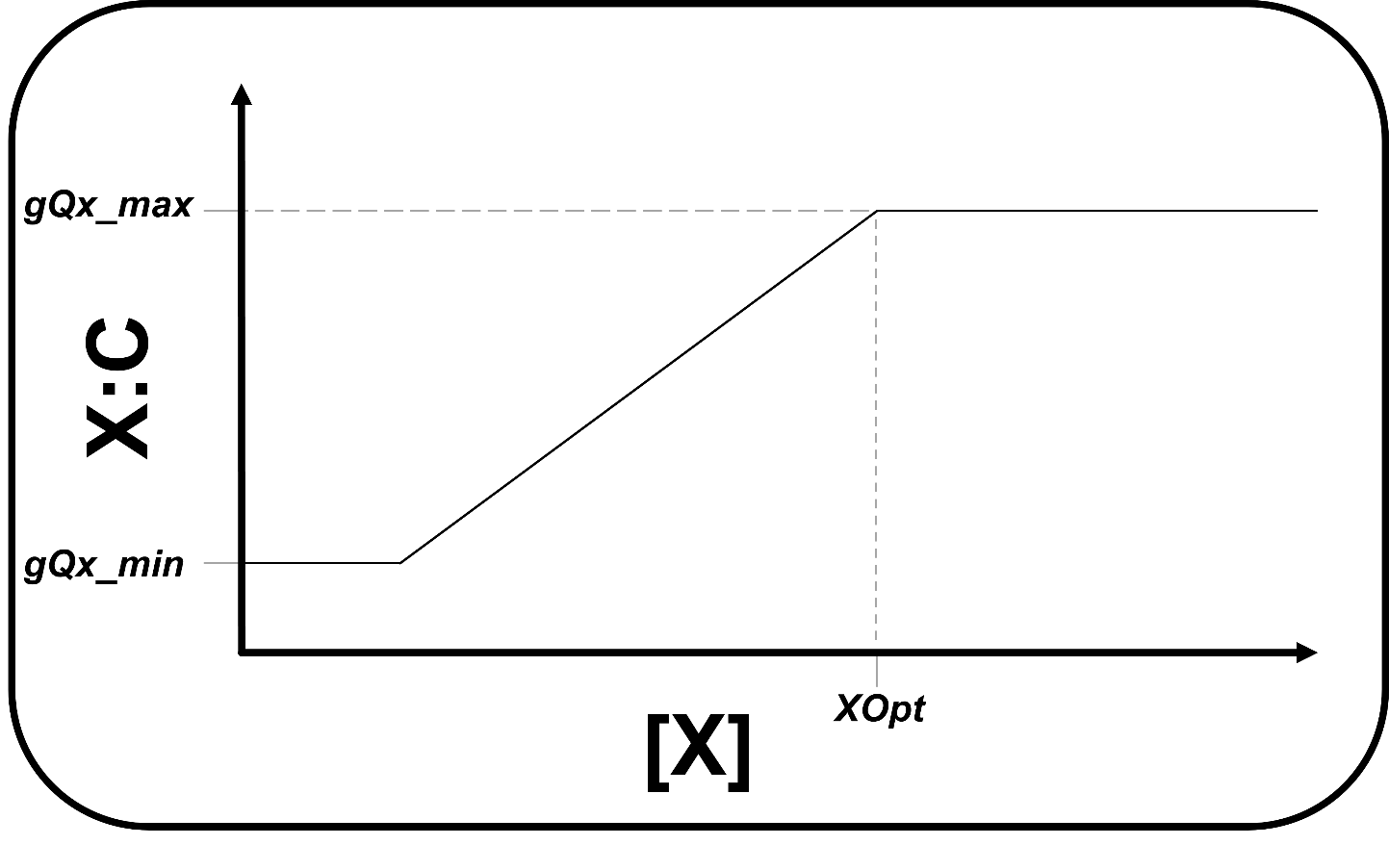SFig. 1. Phytoplankton nutrient to carbon (X:C) ratio for new growth as a function of dissolved ambient nutrient concentration [X]. XOpt determines the dissolved ambient nutrient concentration at which phytoplankton X:C reaches it maximum value (gQx_max). X:C decreases linearly with decreasing dissolved nutrient concentration between the prescribed, group-specific maximum (gQx_max) and minimum (gQx_min) quotas. X here applies for nitrogen, phosphorus, iron, and silica.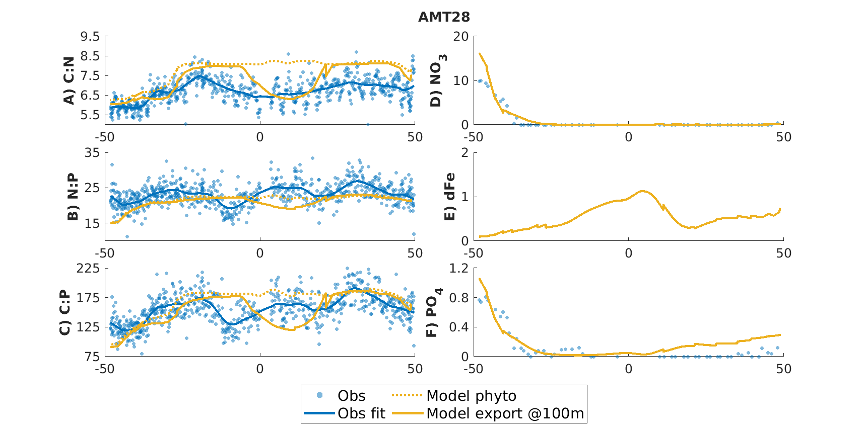SFig 2. Observed and simulated phytoplankton and organic matter stoichiometry (A-C) and surface nutrients (D-F) for GO-SHIP cruise transect AMT28 in the Atlantic. Observed particulate organic matter stoichiometry from GO-POPCORNv2 is shown as individual blue dots and smoothed as the blue line²³. Simulated phytoplankton surface community and export at 100m stoichiometries are shown as the dotted and solid yellow lines respectively (A-C). Observed surface nutrients from GO-POPCORNv2 are also shown for dissolved nitrate and phosphate as blue dots, while model surface nitrate, iron, and phosphate are shown as yellow lines (D-F).
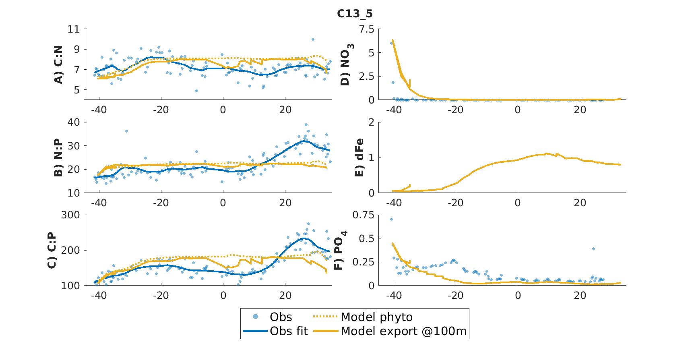SFig 3. Observed and simulated phytoplankton and organic matter stoichiometry (A-C) and surface nutrients (D-F) for GO-SHIP cruise transect C13_5 in the Atlantic. Observed particulate organic matter stoichiometry from GO-POPCORNv2 is shown as individual blue dots and smoothed as the blue line²³. Simulated phytoplankton surface community and export at 100m stoichiometries are shown as the dotted and solid yellow lines respectively (A-C). Observed surface nutrients from GO-POPCORNv2 are also shown for dissolved nitrate and phosphate as blue dots, while model surface nitrate, iron, and phosphate are shown as yellow lines (D-F).
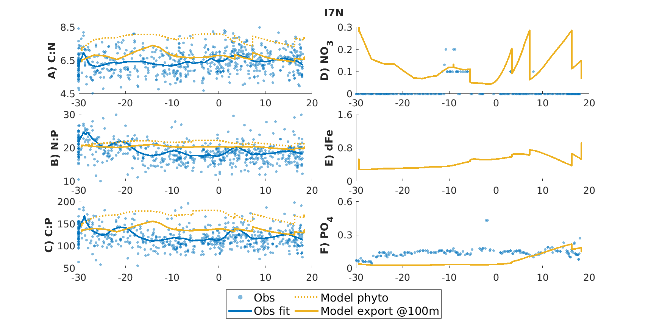SFig. 4. Observed and simulated phytoplankton and organic matter stoichiometry (A-C) and surface nutrients (D-F) for GO-SHIP cruise transect I7N in the eastern Indian Ocean. Observed particulate organic matter stoichiometry from GO-POPCORNv2 is shown as individual blue dots and smoothed as the blue line²³. Simulated phytoplankton surface community and export at 100m stoichiometries are shown as the dotted and solid yellow lines respectively (A-C). Observed surface nutrients from GO-POPCORNv2 are also shown for dissolved nitrate and phosphate as blue dots, while model surface nitrate, iron, and phosphate are shown as yellow lines (D-F).
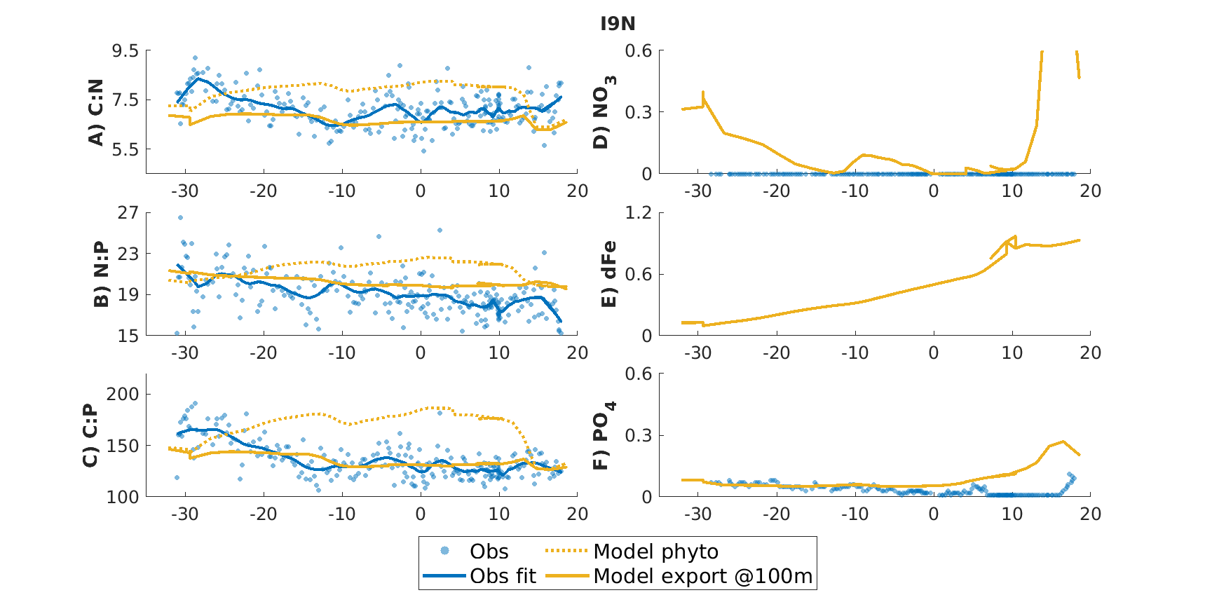SFig. 5. Observed and simulated phytoplankton and organic matter stoichiometry (A-C) and surface nutrients (D-F) for GO-SHIP cruise transect I9N in the western Indian Ocean. Observed particulate organic matter stoichiometry from GO-POPCORNv2 is shown as individual blue dots and smoothed as the blue line²³. Simulated phytoplankton surface community and export at 100m stoichiometries are shown as the dotted and solid yellow lines respectively (A-C). Observed surface nutrients from GO-POPCORNv2 are also shown for dissolved nitrate and phosphate as blue dots, while model surface nitrate, iron, and phosphate are shown as yellow lines (D-F).

A)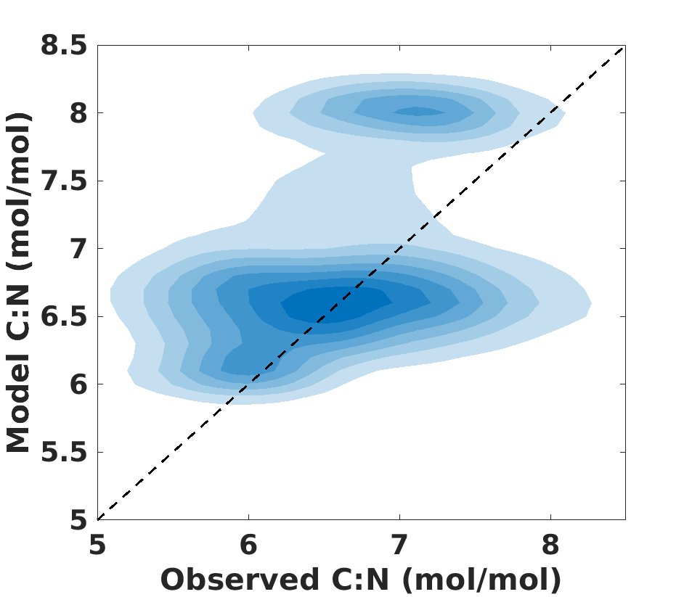B)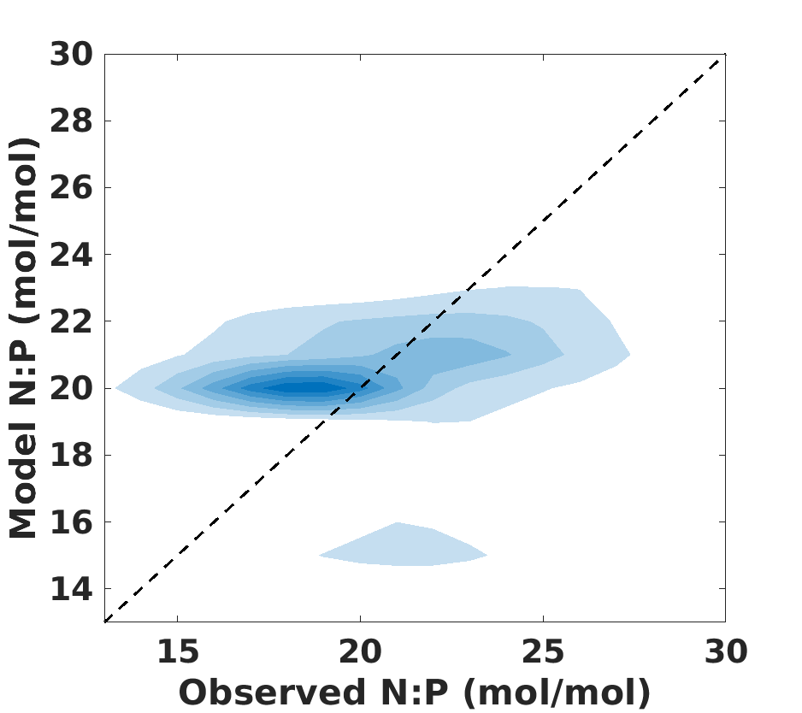
C)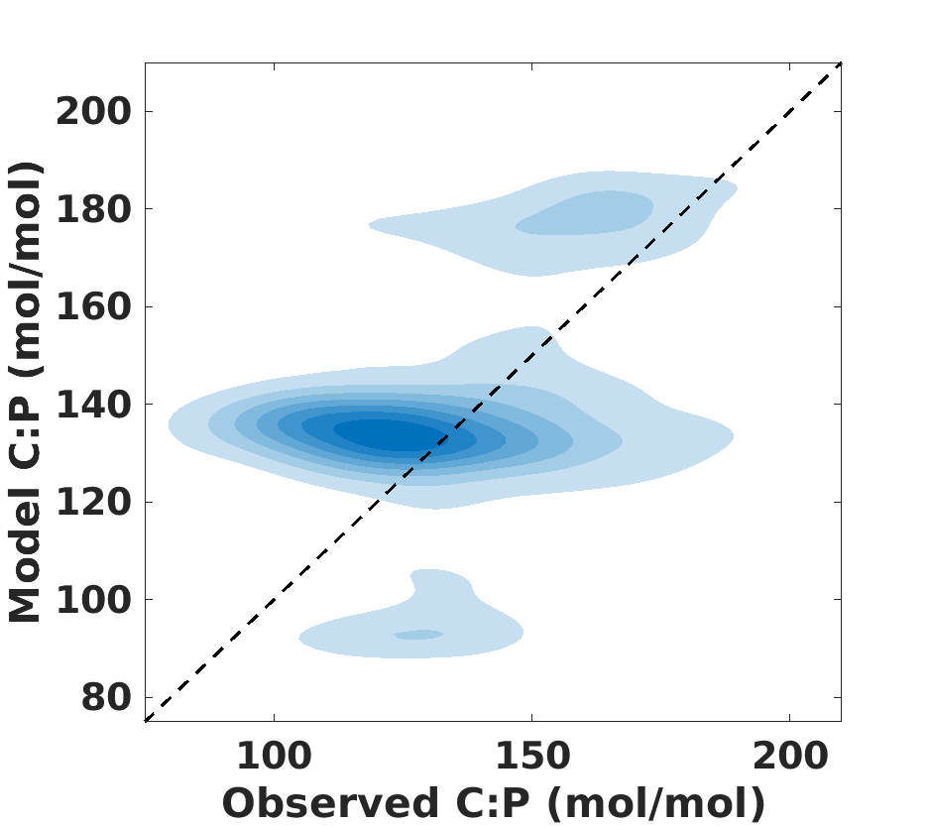D)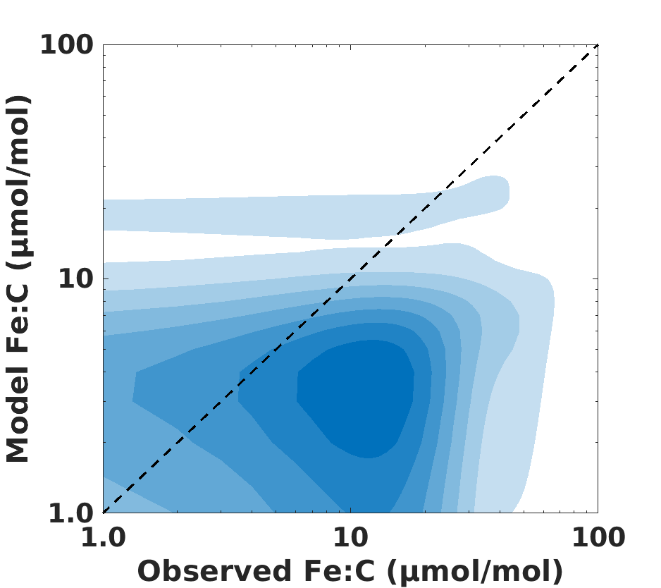
SFig. 6. Bivariate kernel density of simulated particulate organic matter export at 100m stoichiometry (A-C) and phytoplankton stoichiometry (D) plotted against observations from GO-POPCORNv2 and Wiseman et al., 2023^{23,24}. Model output was extracted from the same locations as the plotted observations.
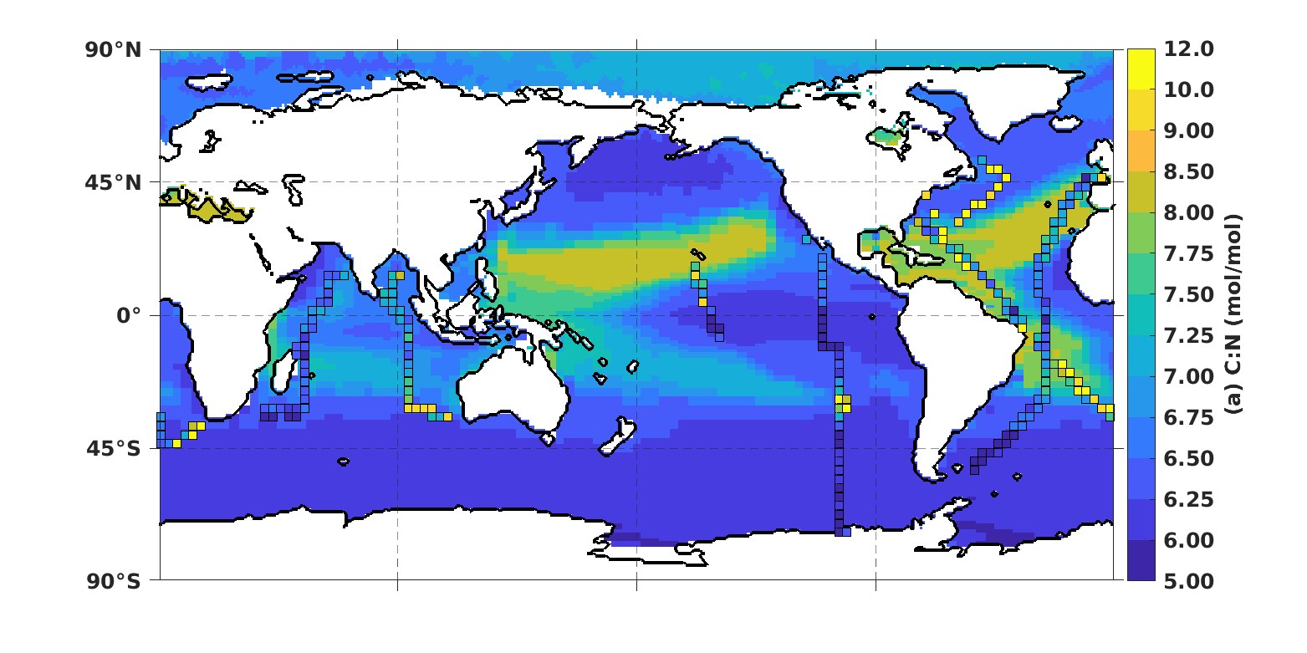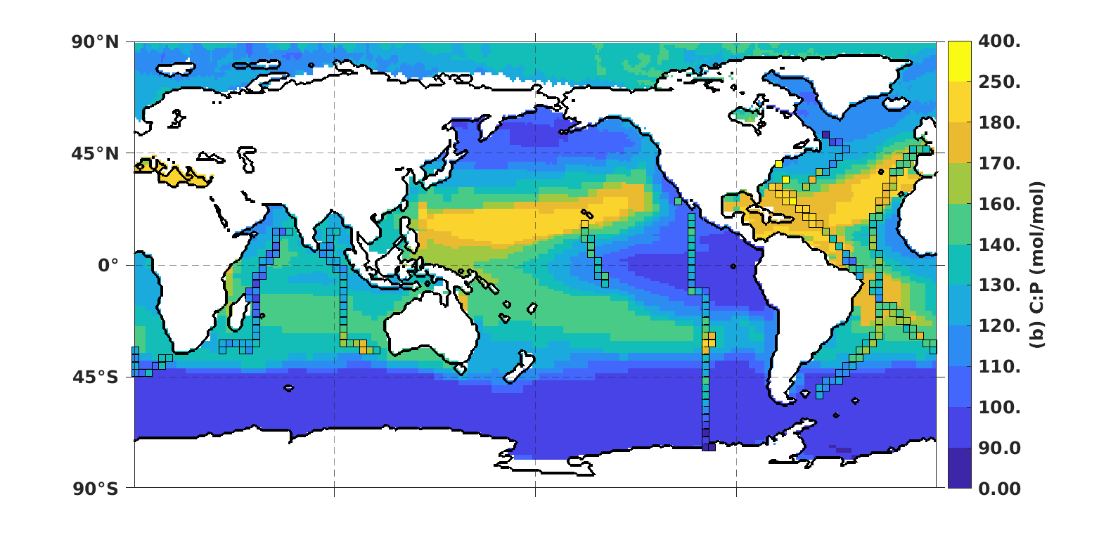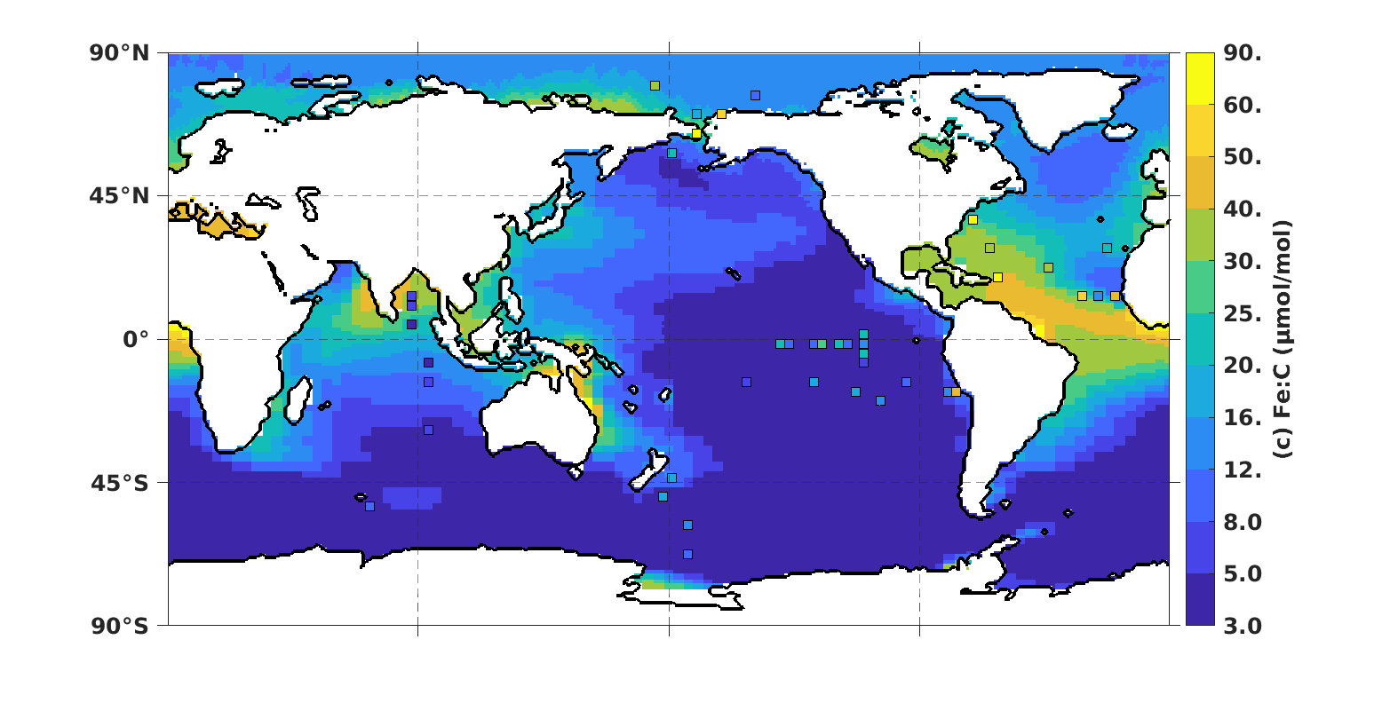
SFig. 7. Export particulate organic carbon to phosphorus and nitrogen (C:P, C:N) ratio for VarAll case overlaid with surface (5m) particulate C:P and C:N from the GO-POPCORNv2 database²⁴. GO-POPCORNv2 data is averaged into 3-degree x 3-degree bins for visualization purposes. Model small phytoplankton iron to carbon (Fe:C) ratio for VarAll case overlaid with observations of autotrophic flagellate cellular Fe:C compiled from Wiseman et al., 2023²³.

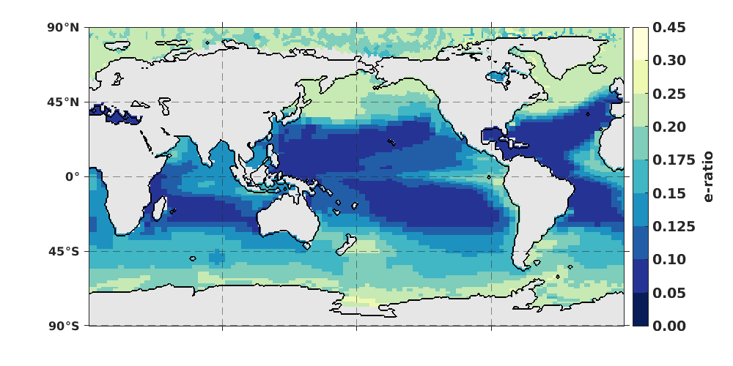SFig. 8. Global patterns of e-ratio in the VarAll simulation. Lighter colors indicate a higher e-ratio, which is defined as NPP/POC Export at 100m.
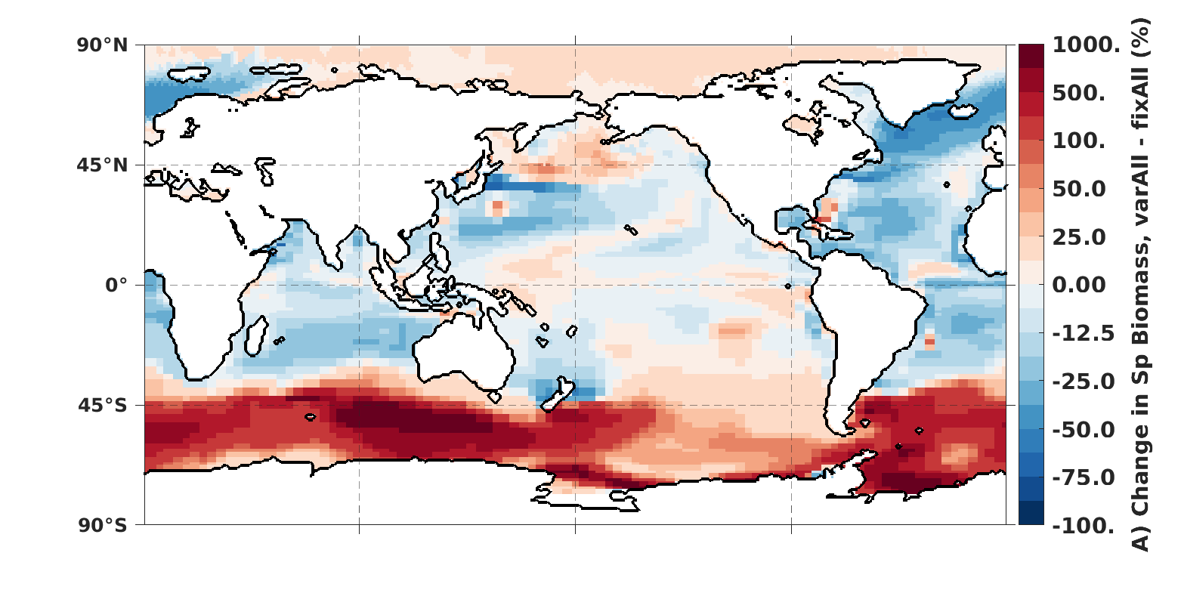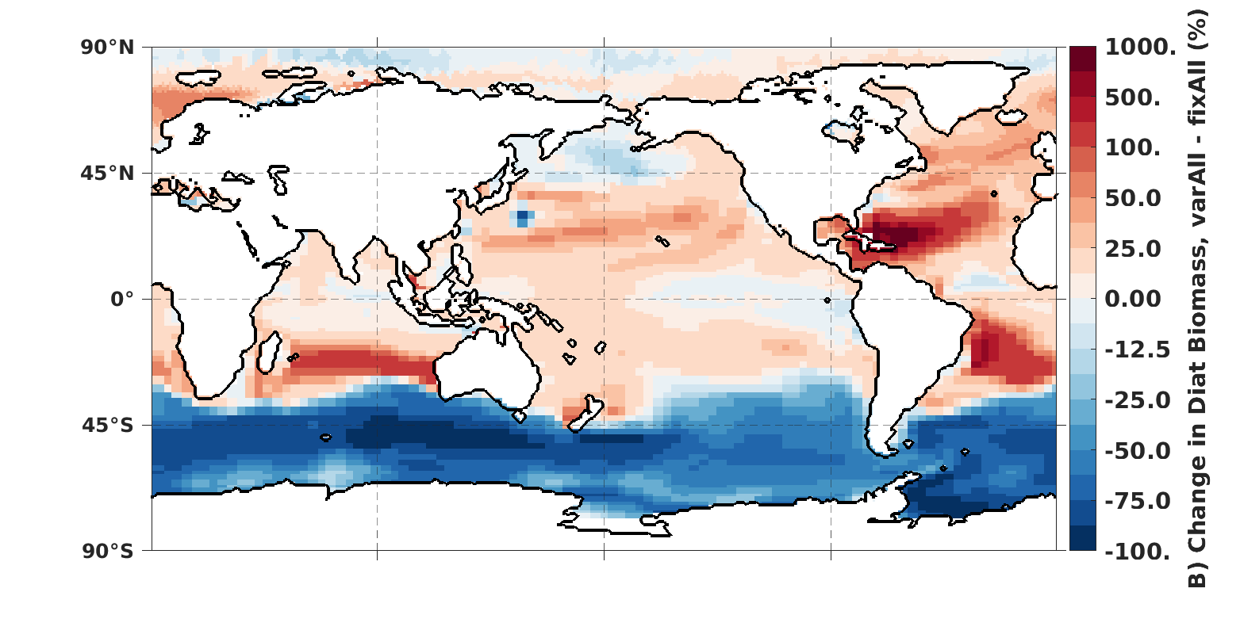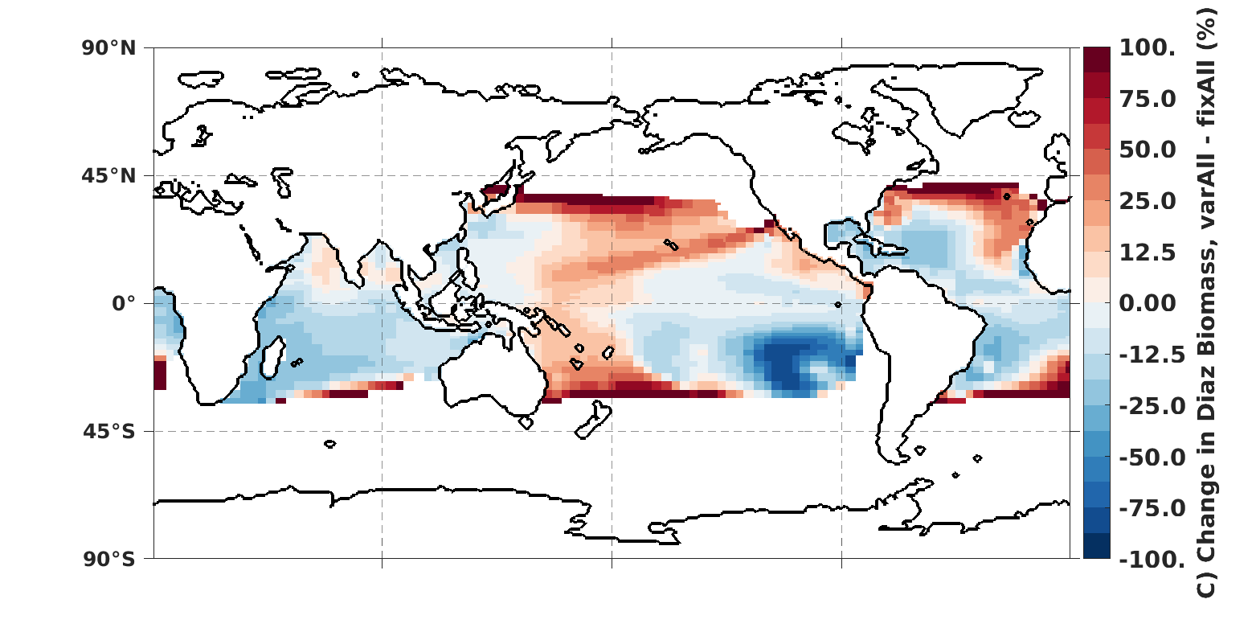SFig. 9. Changes in phytoplankton biomass by type for A) small phytoplankton, B) diatoms, and C) diazotrophs. Red indicates increased biomass when phytoplankton can vary their resource acquisition.

Table S1. Model parameters for phytoplankton nutrient quotas
 | Small Phytoplankton | Diatoms | Diazotrophs
NOpt, gQn_min, gQn_max | 0.5, 0.111, 0.167 | 0.5, 0.111, 0.167 | 0.5, 0.111, 0.167
POpt, gQp_min¹, gQp_max | 0.75, 0.006944, 0.011 | 0.75, 0.00833, 0.011 | 0.75, 0.0033, 0.0083
FeOpt, gQfe_min, gQfe_max | 2.2e-3, 2.5, 90.0 | 2.2e-3, 2.5, 90.0 | 2.2e-3, 3.75, 135.0
SiOpt, gQsi_min, gQsi_max | N/A | 9.0, 0.41668, 0.83335 | N/A
¹P:C minimum quotas can be reduced to a smaller value due to the N:P scaling

