Supplementary material: Watt-class CMOS-compatible optical high power amplifier
Neetesh Singh^{1*}, Jan Lorenzen¹, Kai Wang², Mahmoud A. Gaafar¹, Milan Sinobad¹, Henry Francis³, Marvin Edelmann¹, Michael Geiselmann³, Tobias Herr¹, Sonia M Garcia-Blanco², and Franz X. Kärtner¹
¹Center for Free-Electron Laser Science CFEL, Deutsches Elektronen-Synchrotron DESY, Germany
²Integrated Optical Systems, MESA+ Institute for Nanotechnology, University of Twente, 7500AE, Enschede, The Netherlands
³LIGENTEC SA, EPFL Innovation Par L, Chemin de la Dent-d’Oche 1B, Switzerland CH-1024 Ecublens, Switzerland
*neetesh.singh@desy.de
Table of content
- Gain film deposition and measurements
- Refractive index measurement of Al₂O₃ film
- Photoluminescence measurements
- Amplifier simulations
- Component and reliability testing:
  - Passive component testing
  - Stability of the amplifier
  - Conversion efficiency
  - Noise figure measurement
  - Co and counter propagation pumping
  - Pump and signal coupling variations
  - Implications of high-power pumping
- Comparison table and future integration
- Future integration and scope
- Gain film deposition and measurements:
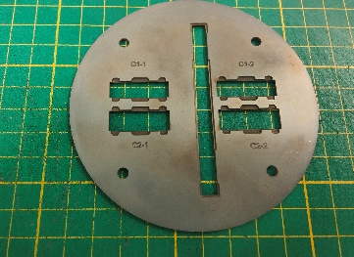
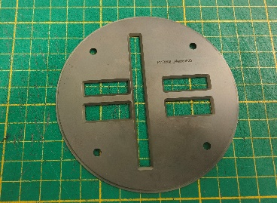
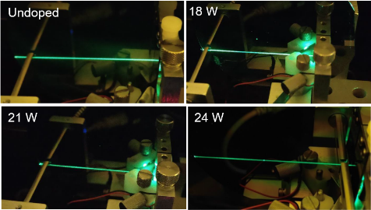
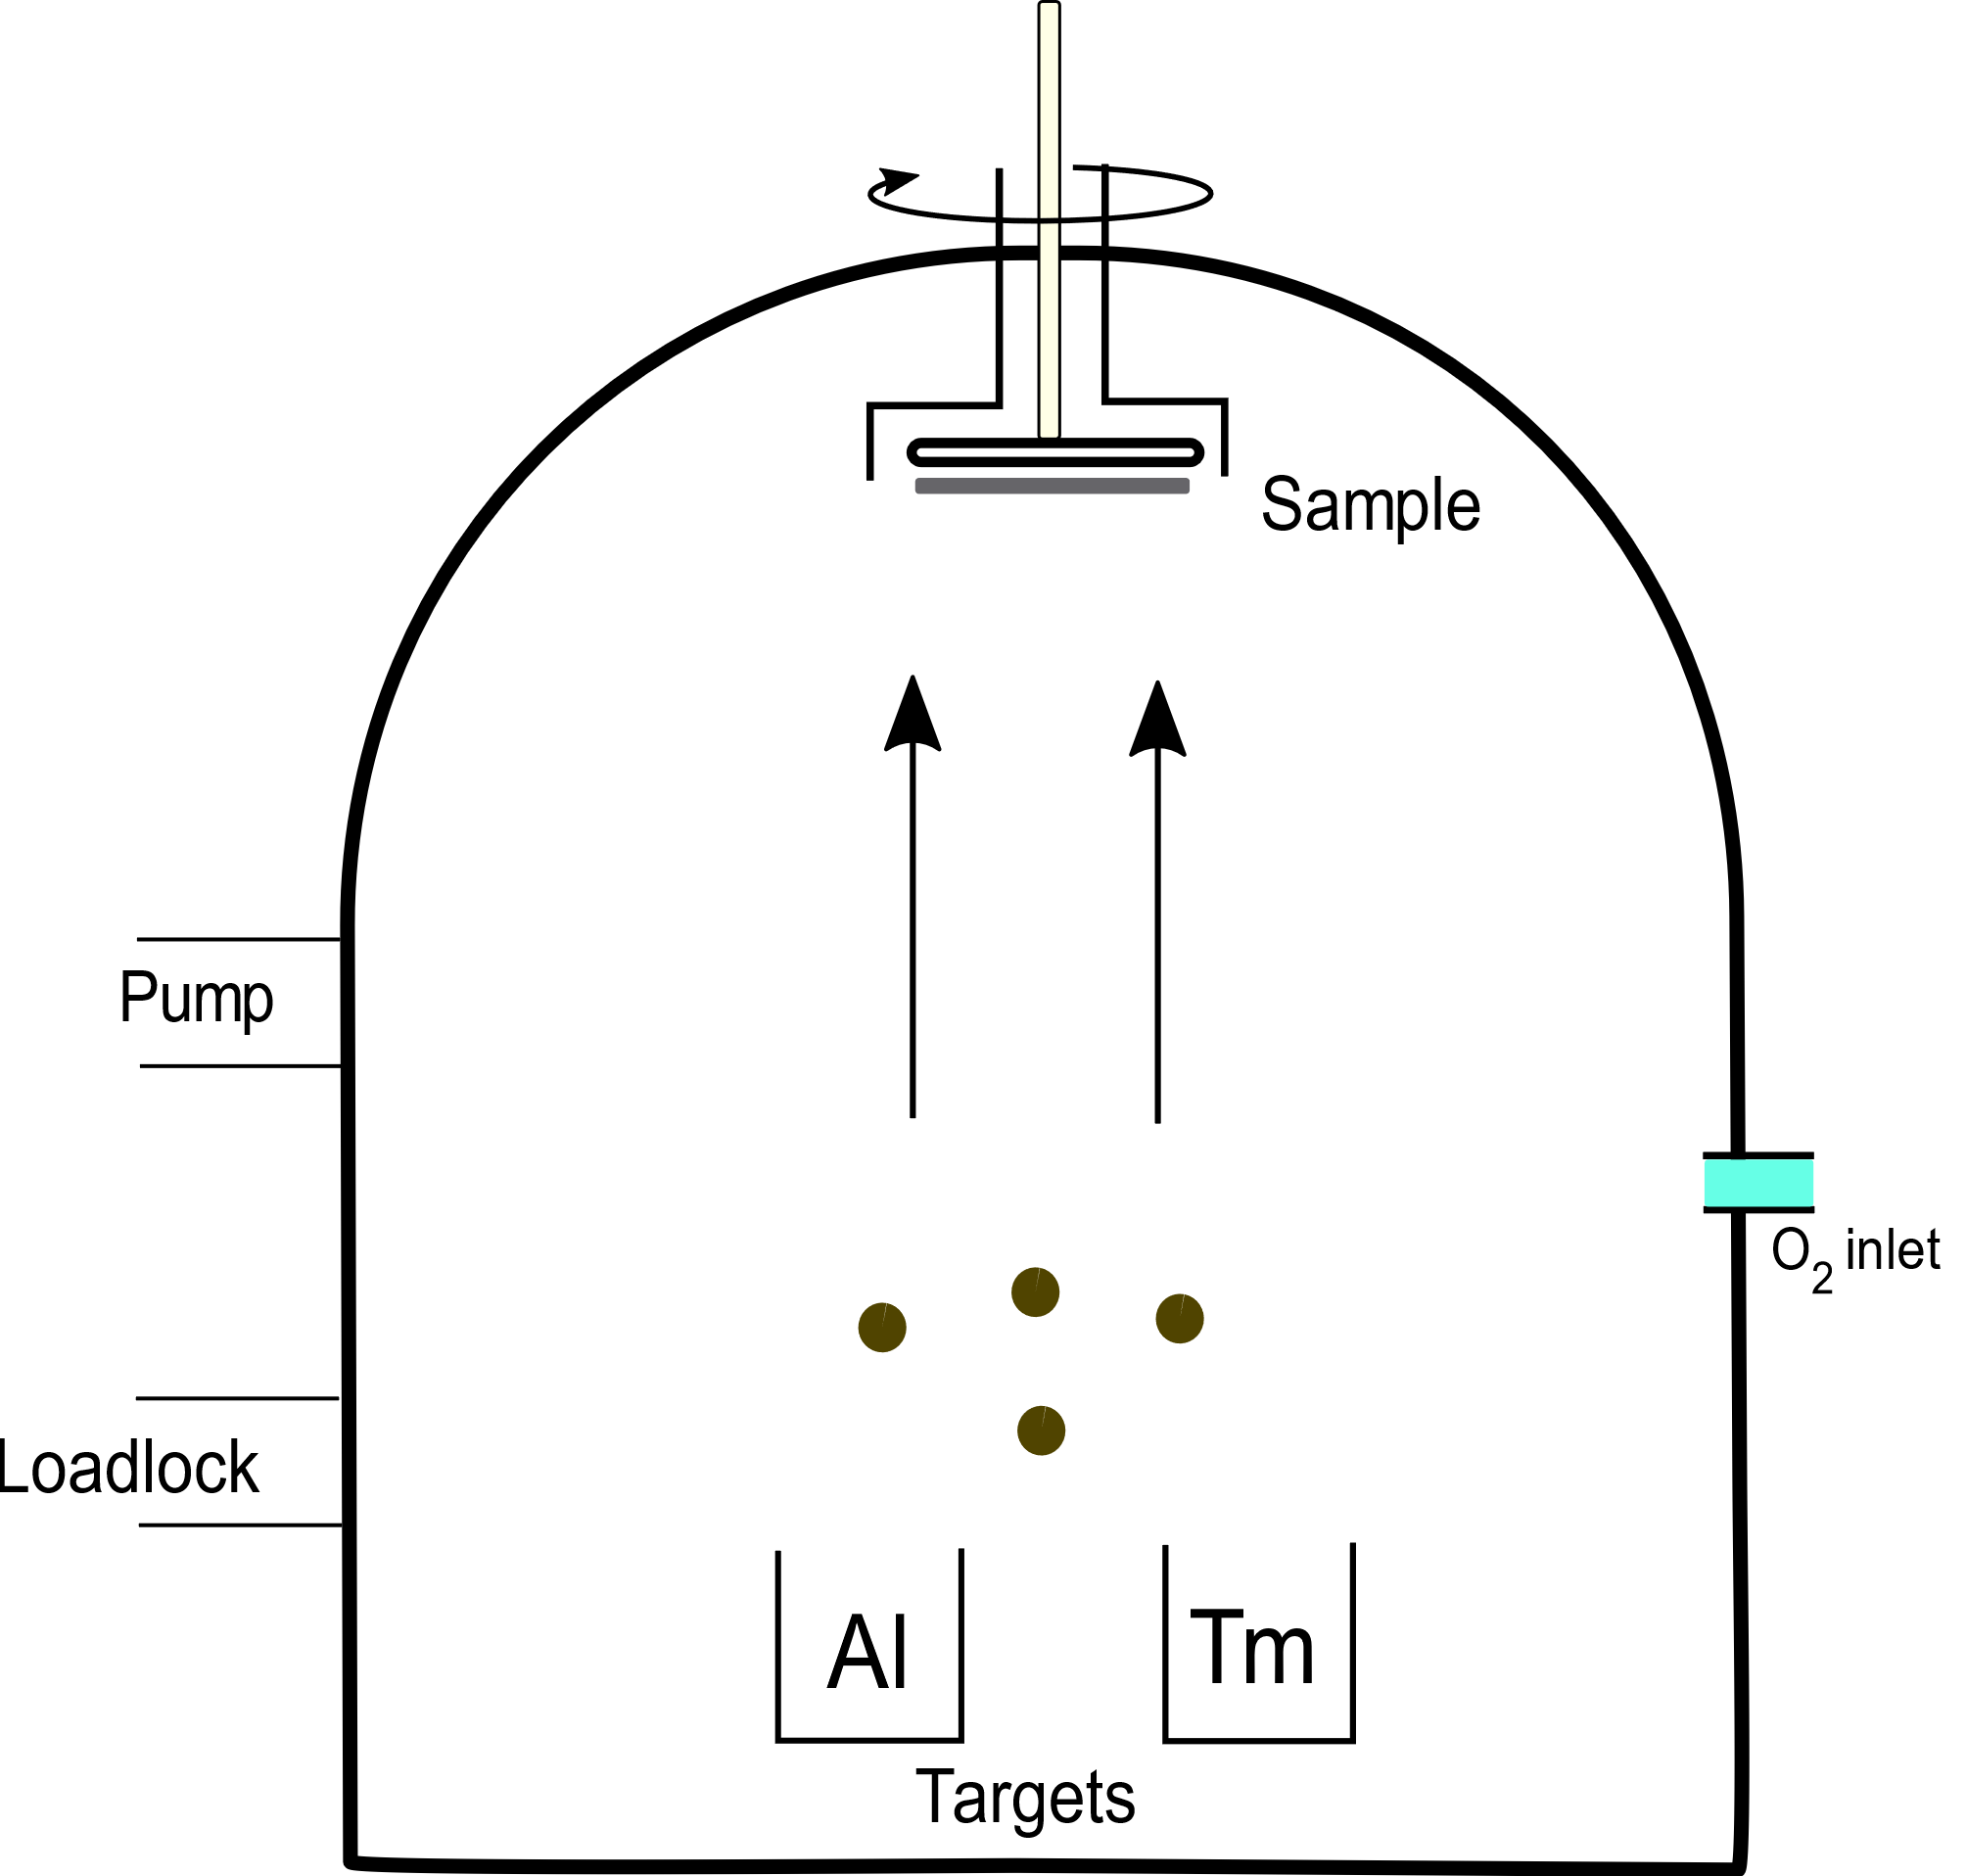
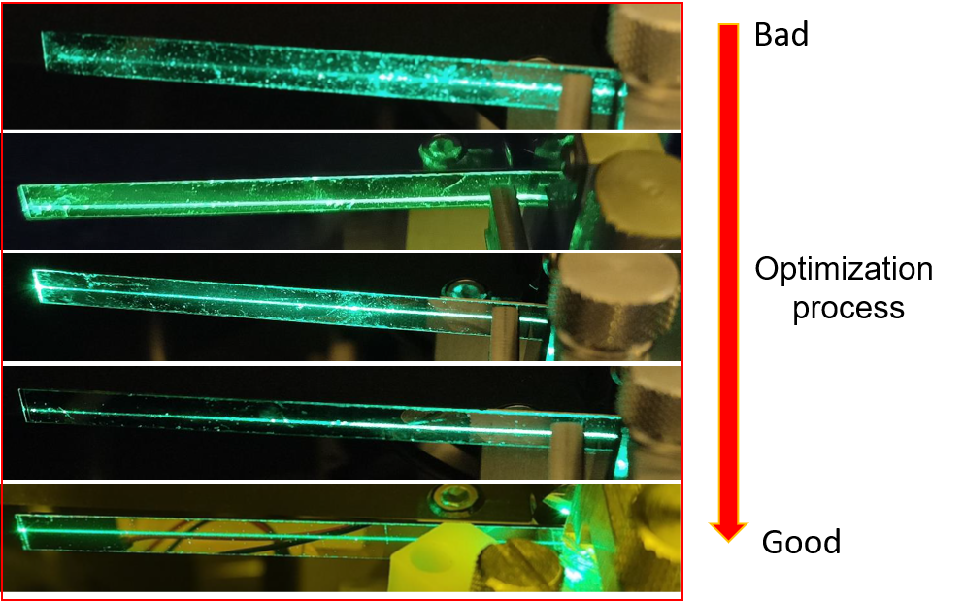
Front
Back
a)
b)
c)
d)
Low quality

High quality

Fig. S1. a) A schematic of the AJA system with the loaded Aluminum (Al) and Thulium (Tm) target. b) The scattering streak of doped films along with an undoped alumina film (excited with a 520 nm laser). c) The scattering streak of witness test samples measured during the optimization process. d) Chip and witness sample holder. The front part is the side from where the film gets deposited, and the back part is for mounting the chips in the holder. This holder can take 4 chips and one witness sample in the middle.

We deposit the gain film on top of the passive silicon nitride chips using back end of the line (BEOL) process. The gain films are deposited at MESA+ Institute for Nanotechnology, University of Twente using a radio frequency (RF) co-sputtering system as shown in Fig.1(a). Prior to the gain deposition on the amplifier chips we perform film quality tests by depositing several gain films on witness samples (rectangular pieces ~10x0.7 cm of thermally oxidized silicon) until a good quality film is obtained. The process starts with the loading of aluminum and thulium targets into the chamber (through the loadlock) which are then mounted on a target mount that rotates and is heated. The chamber is subsequently pre-evacuated to a base pressure of 0.1 µTorr using a turbomolecular pump to remove OH ions, which are avoided to reduce the film loss due to OH absorption which is especially detrimental at 1.9 µm. The Al-target (aluminum) is powered with 200W and argon gas is flown in at rate of 25.0 sccm. Oxygen is also flown in at a rate of 3 sccm to grow aluminum oxide on the samples. The deposition temperature is close to 400°C at the substrate (at 4 mTorr chamber pressure) measured with a thermostat, and the samples are placed 6 inches away from the target.
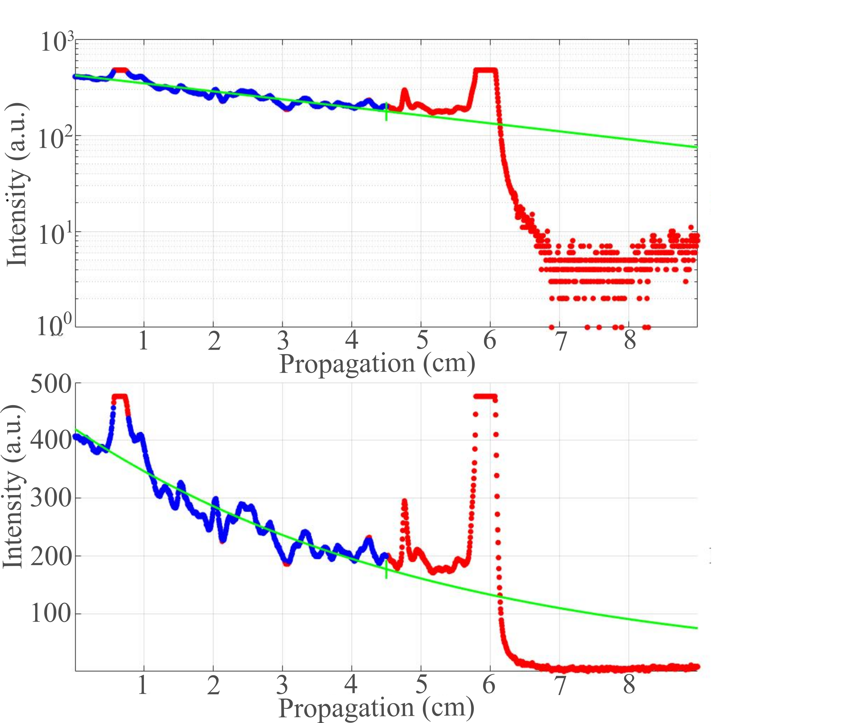
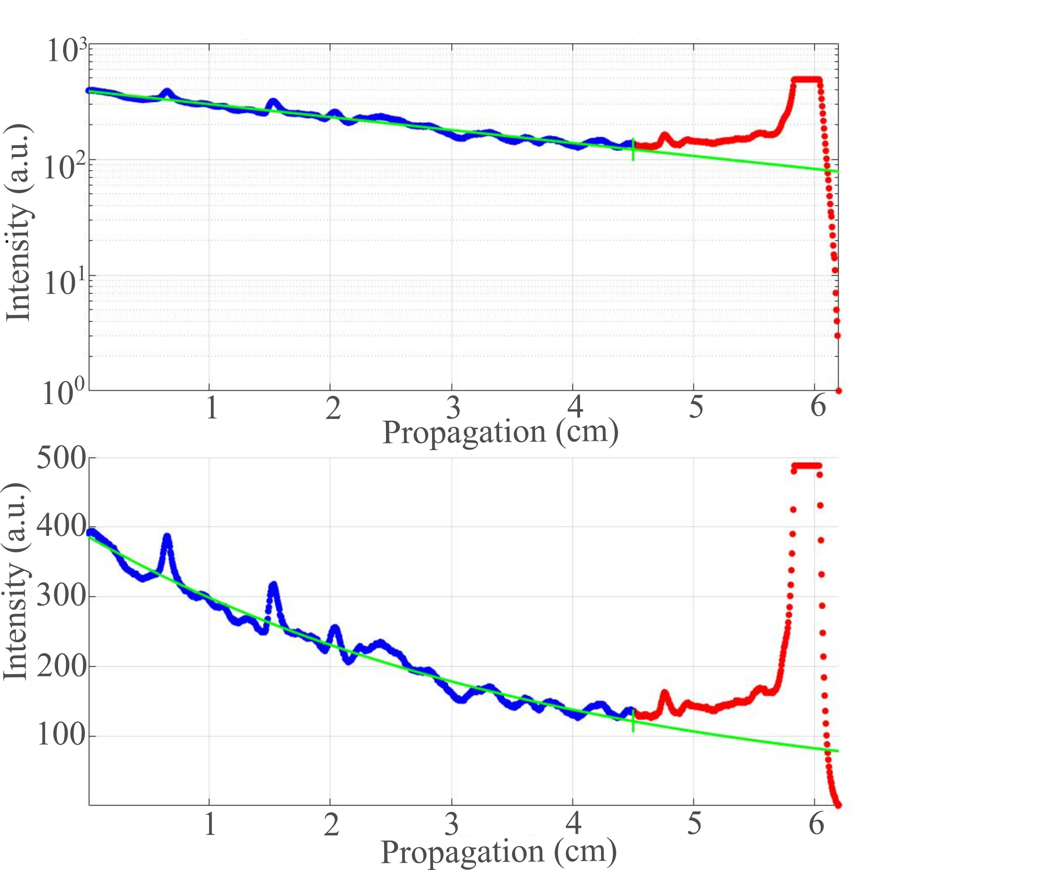
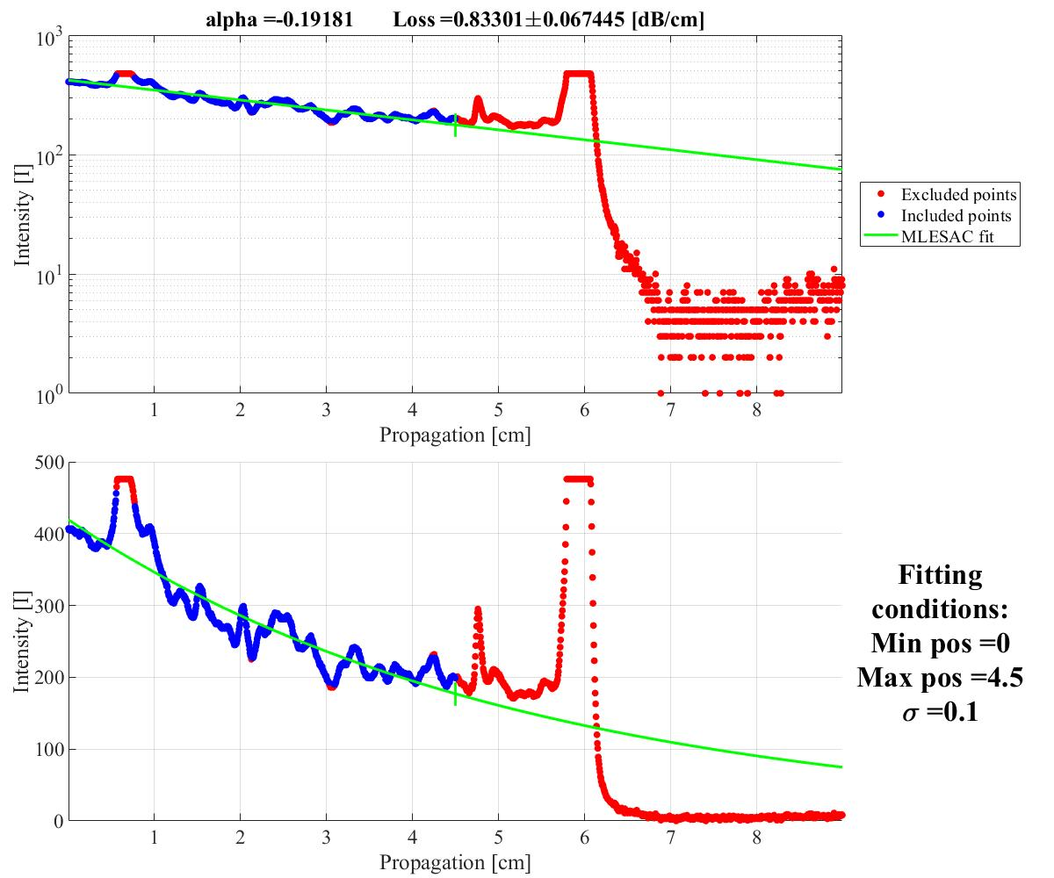
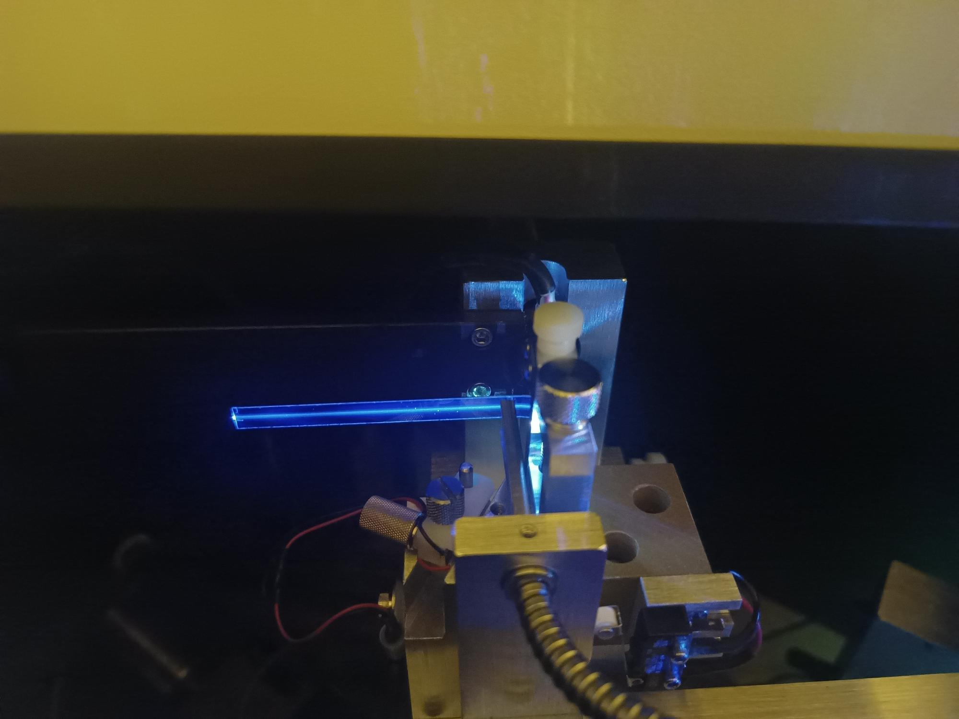
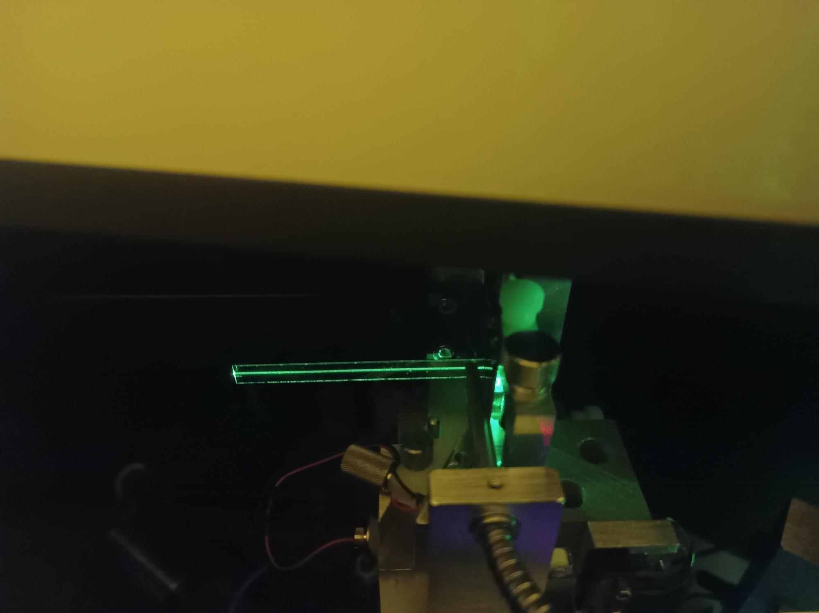
The oxygen flow rate is an important parameter in reactive sputtering, influencing the stoichiometry, deposition rate and structure of the deposited Al₂O₃ layers. It is crucial that the oxygen flow and the film quality is well studied before the desired gain deposition cycle is performed. In order to do that, the chamber bias voltage between the target (cathode) and the chamber wall (anode) as a function of the flow rate of oxygen is monitored which defines the state of the target, which can transition from metallic to oxidized state depending on the oxygen flow rate [1]. One has to vary the O₂ flow such that the target is not strongly oxidized (target poisoning), we maintain the O₂ flow close to 2-3.5 sccm in the presence of constant argon flow of 25 sccm [1]. The substrate containing the test sample (in a sample holder (Fig. S1(d)) is introduced into the chamber while making sure the bias voltage is stable which is followed by the film deposition. Throughout the deposition the bias voltage is monitored and controlled (with the O₂ flow rate) to ascertain the bias voltage variation is within 1-2% of the desired value. After one hour of deposition the witness sample is characterized with a prism coupling method (Metricon 2010/M). Here a laser excites guided slab modes with the help of a prism into the Tm³⁺:Al₂O₃ deposited witness sample (8 µm thick silica on silicon), see Fig. S1(b) and (c). Film thickness and refractive index information can be obtained with this technique because the launching angle of the laser determines the set of excited modes which can indicate the index and the thickness of the film [2].
a)
b)
c)
d)
e)
f)

Fig. S2. Scattering streak measurement of a doped witness sample. The concentration of the film is around 6x10²⁰/cm³. a), b) and c), are taken with a laser at 451 nm and d), e), and f) are taken at 521 nm. b) and e) are logarithmic plots. The film loss measured at 451 nm and 521 nm are 1.2 dB/cm and 0.83 dB/cm, respectively.
The propagation loss in the film can be qualitatively obtained by measuring, with an inbuilt detector, the gradual drop in the strength of the signal along the length of the witness sample. A weak decay indicates a high quality film whereas a strong decay is usually associated with a lossy film. Prior to depositing the gain films on the amplifier chip, we tested the film quality on witness samples with optimized film quality and also measured the films with different concentrations at wafer scale (as shown in Fig.S1(b) and (c)). Once a high quality film is obtained the amplifier chips are deposited with gain film. The deposition rate of the gain film is around ~5 nm/min and takes more than 4 hrs to grow the desired thickness. Another factor to pay attention to is that the film thickness varies across the area of the sample holder, and usually follows a parabolic profile from the center (not shown) [3]. That means the film gets thinner by 60-70 nm or 20 nm when measured 3 cm or 1 cm away from the center of the holder, respectively, which one has to consider for thickness control. Subsequently, the witness sample was characterized with a Metricon with a 451 nm and 521 nm diode laser, the scattering streaks are shown in Fig. S2. The fitting gives a loss of 1.2 dB/cm (@ 451 nm) and 0.83 dB/cm (@ 521 nm) which is high due to the presence of the thulium dopants.

- Refractive index measurement of the Al₂O₃ film:
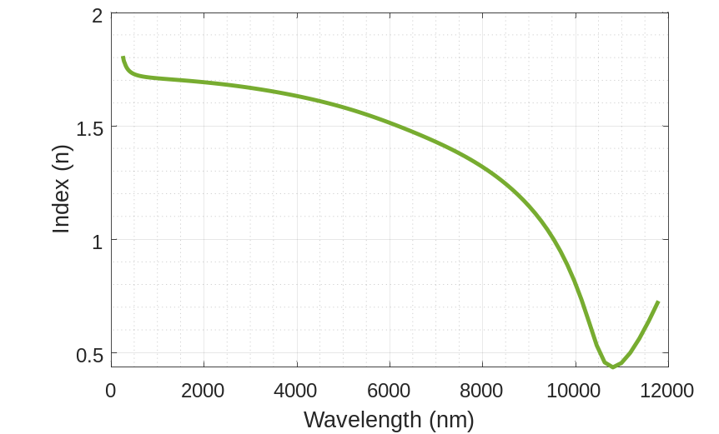
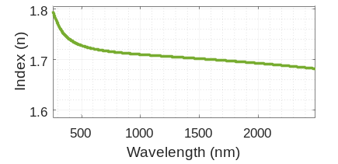
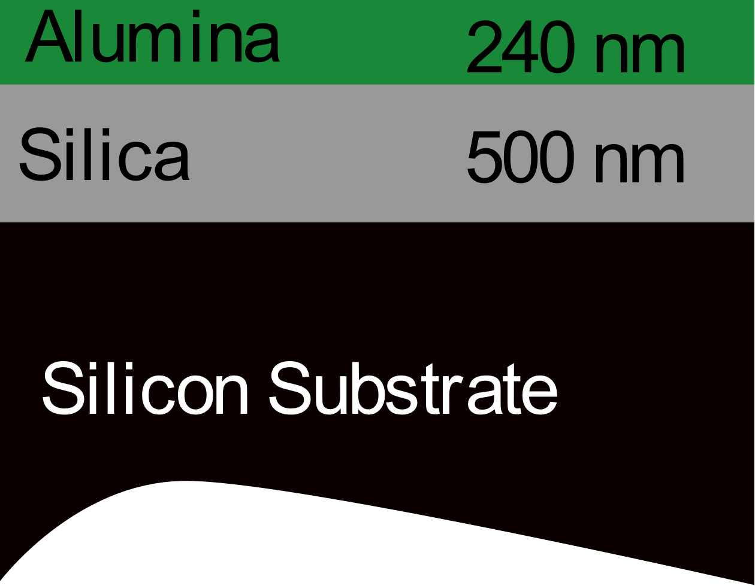
To design the amplifier, one has to know the refractive index of the alumina film, which also helps to determine the waveguide dispersion.

Fig. S3. Index of refraction and the absorption coefficient of Al₂O₃ film measured from 250 nm to 11800 nm.
A 240 nm Al₂O₃ film was deposited on an oxidized silicon sample to determine the refractive index of the alumina film with an ellipsometer. The thickness of silica layer was 500 nm as shown in Fig. S3. We measured the optical properties of the Al₂O₃ film with the VASE ellipsometer (J.A. Woollam Co.). To take into account the influence of the silicon and silica substrates on the measured data, samples with only oxidized silicon and bare silicon were also measured. The data taken from 250 nm to 11800 nm is shown in Fig. S3. The refractive index of the alumina can vary from 1.57 to 1.7 (@1.55 µm) depending on the deposition parameter. The advantage of high index alumina is that one has to deposit only a thin film to get a larger mode compared to low index alumina which reduces the deposition time.
3. Photoluminescence measurement:
The upperstate lifetime is an important parameter for amplifiers and lasers that determines efficiency of the gain - a long lifetime allows high gain with low pump power. One can measure the upperstate lifetime by exciting the medium with the pump for a short period of time and observe the decay of the spontaneously emitted signal right after the switching off of the pump. A schematic of the measurement setup is shown in Fig. S4.
The device was optically pumped by an amplified low noise CW laser (Alnair labs, TLG 220) at 1.61 µm. A small free-space setup consisting of two collimators and two lenses is used to focus the pump beam to a small spot (to allow for a fast on and off of the pump beam), at which a chopping blade with 10% duty cycle is placed (Thorlabs MC1F2P10). The blade is driven by a chopper (Thorlabs MC2000B-EC) with 80 Hz chopping rate. The modulated pump light is edge coupled to the waveguide through a lensed fiber and the photoluminescence (PL) is collected with an out-of-plane setup using a 400 µm core size multimode (MM) fiber (Thorlabs M124L02). With this setup one can measure the PL from a gain film with and without a silicon nitride layer underneath. When there is no silicon nitride layer underneath, the launched pump light is not guided along the length of the chip, but the PL can be collected with the multimode fiber aligned normal to the surface of the chip. PL light can also be collected along the length of the gain waveguide (with SiN layer within the gain film), in which case the pump propagates down the length of the gain waveguide (which is ensured with a monitor output port) and the PL can be collected at any point along this length with the MM fiber. With this method one can compare the variation in PL properties over the surface of the chip.
Once the PL light is collected it is collimated and launched into a free-space setup with a bandpass filter (Thorlabs FB2000-500), which removes the scattered pump light and allows the contribution only from the energy level ³F₄ (signal level) to pass through to a lens which is used to focus the beam onto an extended InGaAs detector (Thorlabs PDA10D2). High frequency noise in the detector signal is filtered out by a 20 kHz low noise lowpass filter (Thorlabs EF122), and the signal is recorded on a digital oscilloscope (RS pro RSDS 1304CFL). The reference signal of the chopper is used to trigger the oscilloscope. An average over 128 traces is performed by the oscilloscope and each trace is recorded 10 times to estimate statistical errors. A cartoon of the measured and extracted signal is shown in Fig. S4(b) and (c); images of the input and output (out-of-plane MM fiber) and the monitor port are shown in Fig. S4(d)and (e).
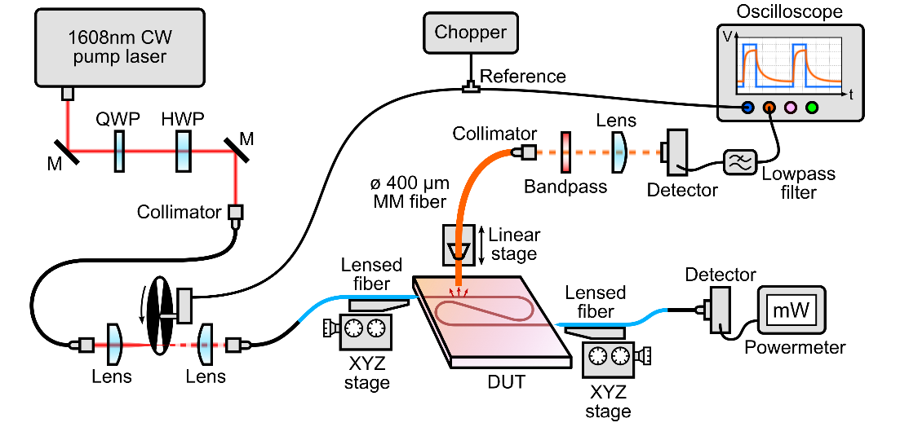
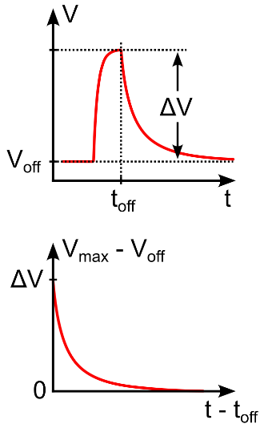
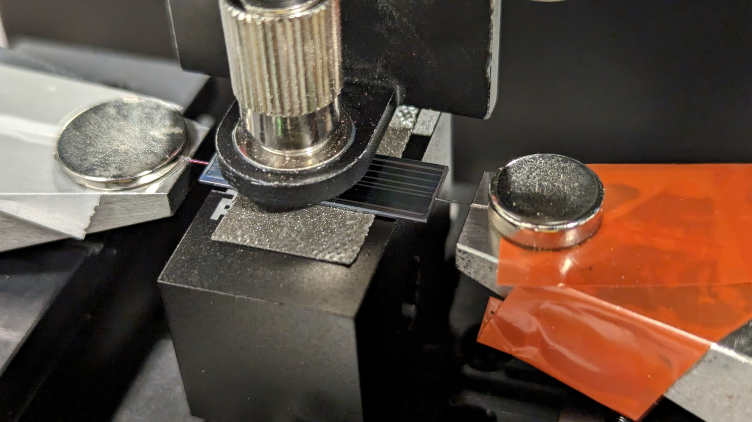
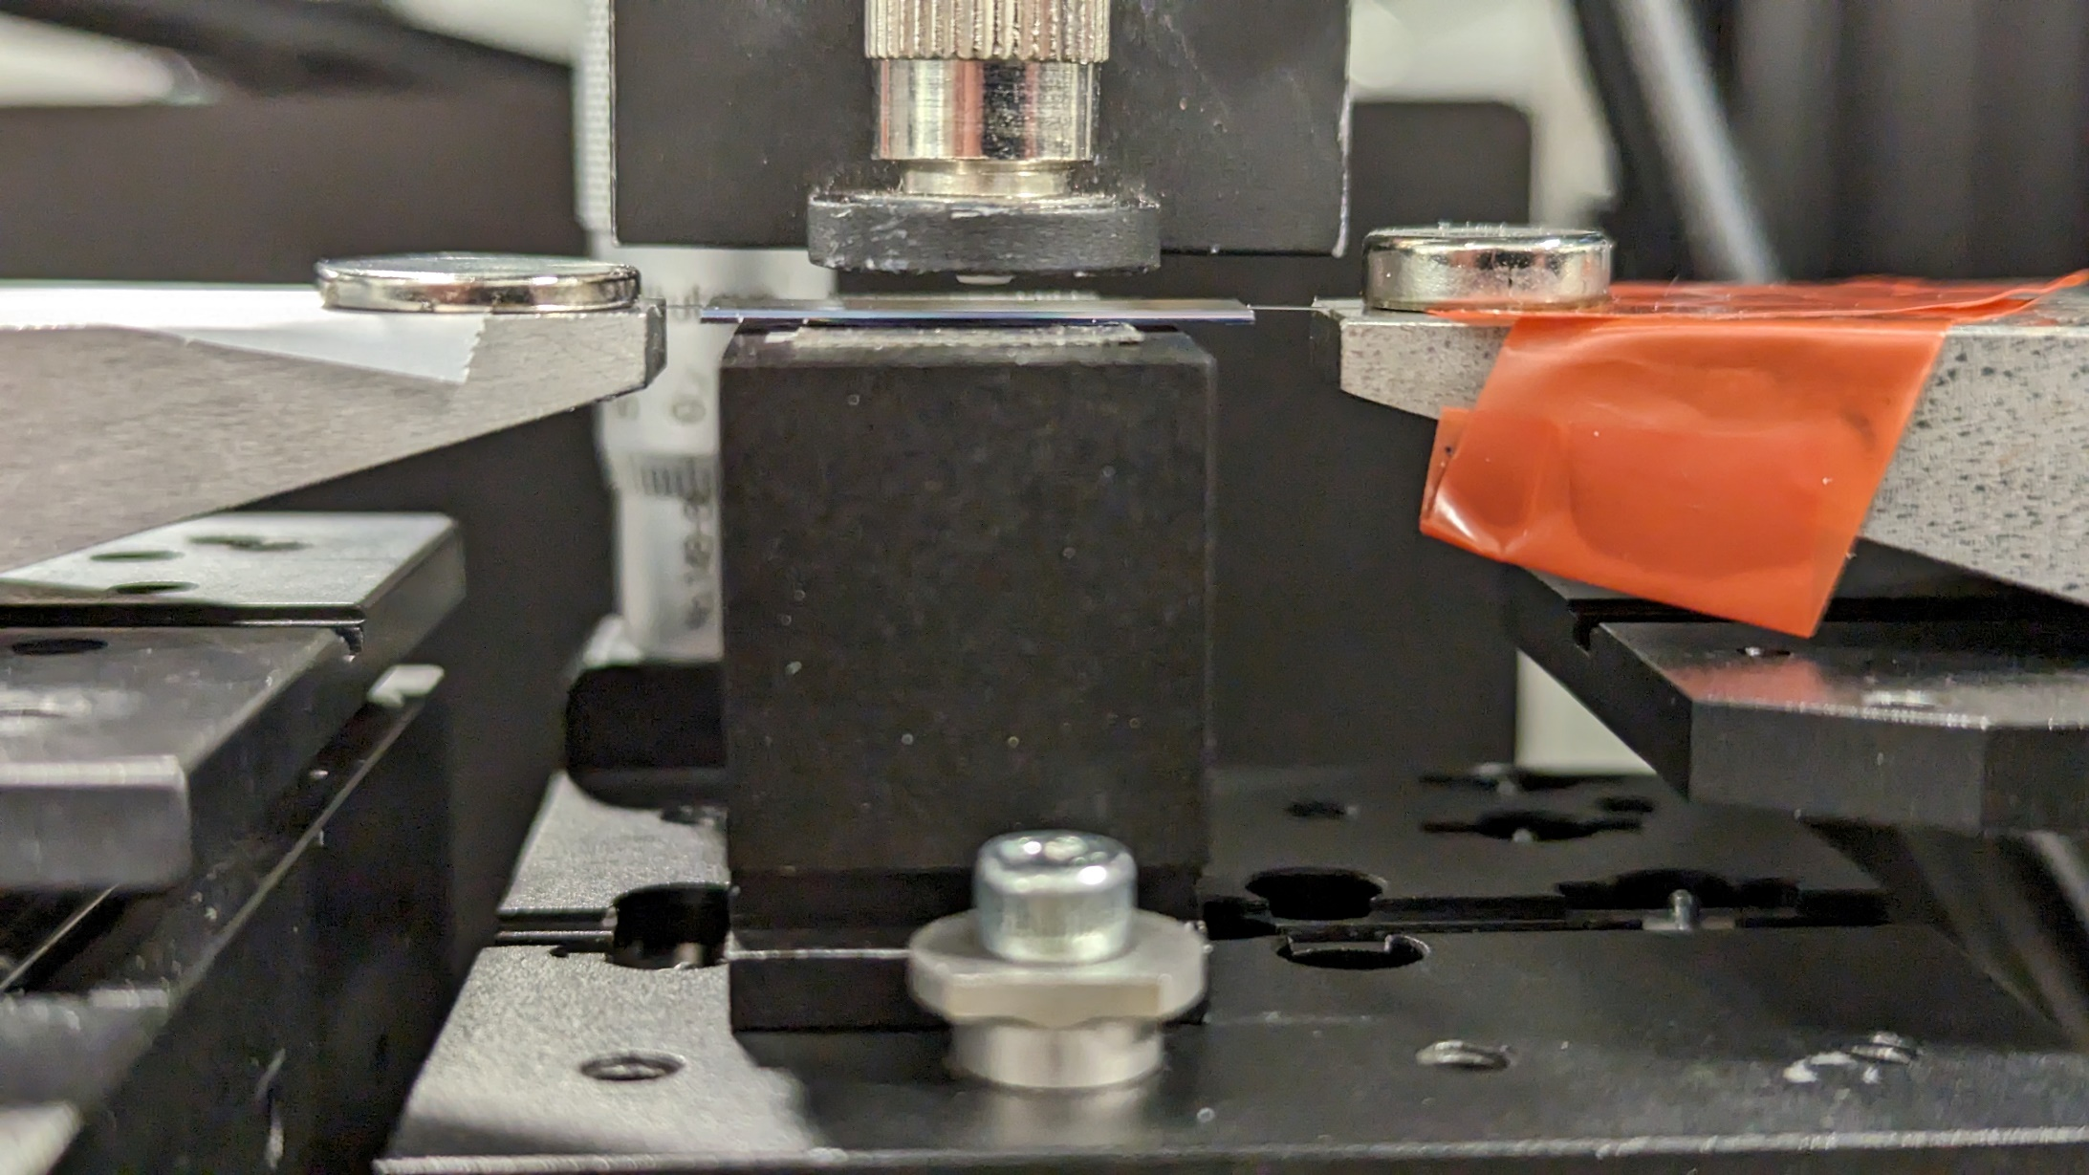
The measured data is shown in Fig. S5 for different pump powers levels ranging from 10 mW to 1 W. PL data for 17 different pump power levels for TE polarization and 14 pump power levels for TM polarization were recorded and a selection of the data is presented in Fig. S5 (a) and (b). To obtain the lifetime traces the data is normalized to account for the voltage due to the dark current (V_{off}), see Fig. S4(b) and (c). The voltage offset is subtracted from the raw data, such that the corrected data starts at 0V before the pump pulse comes in. The falling edge of the recorded chopper reference signal indicates the time at which the pump light is shut off and the PL decay begins (t_{off}). This time offset is then subtracted from the raw data, such that the PL decay starts at t=0. In this way one can extract the PL curve to perform function fitting and extract the upper-state lifetime. We note that the discretization in the measured PL data (see Fig. S5 a, and b) is due to the finite resolution of the 8-bit oscilloscope used in the experiment, which becomes apparent for low pump powers where the PL emission is very weak.
a)
Fig. S4. a) Upper state lifetime measurement setup. QWP - quarter-wave plate; HWP - half-wave plate; M - mirror; DUT - device under test. b) A cartoon showing raw data from an oscilloscope and c) extracted data ready for fitting. d) and e) Pictures of the out-of-plane PL collection setup.
b)
c)
Pump
input
Monitor
port
d)
PL fiber
e)
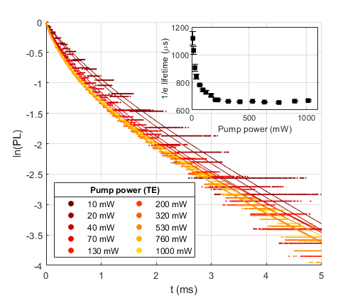
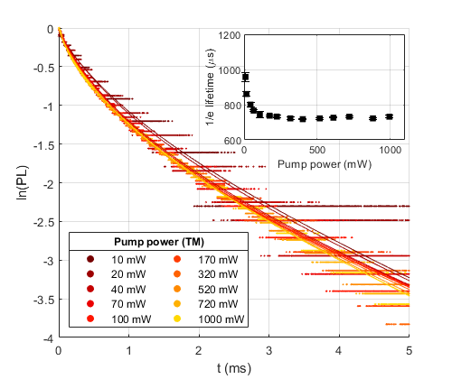
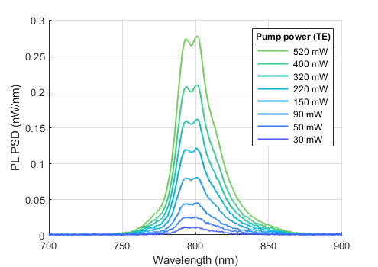
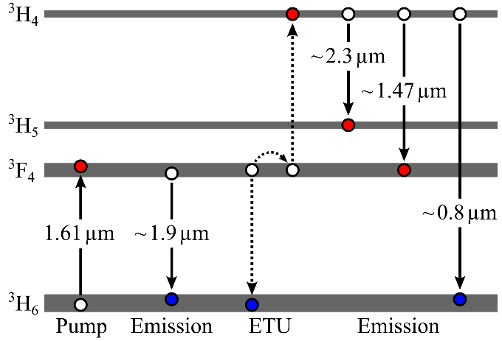
To extract the upperstate lifetime, which includes the radiative and non-radiative decays, from the measured PL curve, one has to apply with care the correct fitting functions out of the many in existence [4]. The decay of the upper state is generally not well described by a single or double exponential decay function due to ion-ion interaction, namely energy-transfer upconversion (ETU), which is apparent also from the measured upconverted PL around 800nm (see Fig. S5 (c)). In the ETU process as shown in Fig. S5 (d), an excited ion in the ³F₄ state transfers its energy non-radiatively to a neighboring excited ion, promoting it to the higher energy ³H₄ state while itself dropping to the ³H₆ ground state. This effectively removes two ions from the excited state population. The upconverted ion in the ³H₄ state can then either drop directly to the ground state by emitting a photon or it can drop to the intermediate states and potentially repopulate the ³F₄ state. Photoluminescence spectra of the ³H₄ state emitting around 800 nm were recorded for different power levels of TE polarized 1610 nm pump light (Fig. S5 (c)). The integrated PL power of upconverted ions was more than 20 times weaker than the PL of the main signal transition around 1850 nm. Photons emitted by the ³H₄ → ³F₄ (~1470 nm) and ³H₄ → ³H₅ (~2300 nm) transitions could not be detected with 1610 nm excitation, but a weak PL signal around 1470 nm was detected with direct pumping of the ³H₄ state via a 790 nm pump diode, which is not shown here. To fit the lifetime traces we use the rate equation model proposed by Zubenko et al. [5], which includes ETU, in a form that was adapted for in-band pumped erbium-doped Al₂O₃ [4]. The energy level structure of erbium-doped Al₂O₃ is very similar to the one of the thulium-doped Al₂O₃ presented here. As a result of this model, the decay of the excited state population density $N_{1}$ is given by the following relation:
a)
b)
Fig. S5. Normalized lifetime data for varying pump powers with a) TE and b) TM polarization and fits taken with Zubenko’s model (Eq. 1). Dots represent the measured data; fits are shown as lines. The y-axis is the natural log of the normalized PL signal. c) PL spectra of upconverted thulium ions for different power levels of 1610nm pumping. d) A simplified energy diagram of thulium showing ETU.
c)
d)
$$N_{1}\left(t\right)=\frac{N_{1}\left(0\right) \exp\left(-\frac{t}{τ_{1}}\right)}{1 +{ N}_{1}\left(0\right)\frac{{ π}^{2}}{3}\sqrt{\frac{C_{DA}}{τ_{0}}} τ_{1}\left[\sqrt{1+\frac{τ_{0}}{τ_{1}}}\operatorname{erf}\left(\sqrt{t\left(\frac{1}{τ_{0}}+\frac{1}{τ_{1}}\right)}\right)- \exp\left(-\frac{t}{τ_{1}}\right)\operatorname{erf}\left(\sqrt{\frac{t}{τ_{0}}}\right)\right]} . (1)$$
In Eq. (1), the coefficient $C_{DA}$ is the ETU microparameter in the donor-acceptor model [4, 5], $τ_{1}$ is the intrinsic upper state lifetime, which includes radiative and non-radiative transitions to the ground state, $τ_{0}$ is the energy migration time and $N_{1}\left(0\right)$ is the initial upper state population density at $t=0$, dependent on the pump power. Eq. 1 was used to fit the lifetime data with $N_{1}\left(0\right)$, $τ_{0}$, $τ_{1}$ and $C_{DA}$ as free parameters. High quality fits with $R^{2}>0.99$ are obtained for every pump power level and are shown in Fig. S5 (a) and (b). As the pump power is increased, the measured 1/e (≈0.37) lifetime drops from ~1100 µs at low power and saturates around ~660 µs at high power with TE polarized pump light, which can be attributed to the accelerated depopulation of the upper state due to ETU [4-8]. With TM polarized pump light, the lifetime at low power is shorter at around ~950 µs, which can be explained by the smaller effective mode area and thus higher pump intensity, which means that the upconversion process becomes more significant even at low pump power. The lifetime saturates around ~720 µs with high pump power in the TM case, slightly longer than in the TE case. An explanation might be given by the larger mode area of the TE polarized pump light, which has a larger probability of interacting with defects in the gain film, and thus shortening the lifetime slightly. The intrinsic upper state lifetime $τ_{1}$ extracted from the fits is around ~2.3 ms. This is shorter than the expected radiative lifetime of thulium-doped glasses of several milliseconds [9] and can be attributed to phonon-assisted non-radiative decay mechanisms [10].
4. Amplifier simulations:
We modelled the gain medium at different input pump and signal power by using modified steady state rate equations (2-7) [4, 11] for in-band pumping of an LMA waveguide.
$$\frac{{dN}_{2}}{dt}=W_{ETU}N_{1,(a,q)}^{2}-\frac{1}{τ_{2}}N_{2,\left(a,q\right)}=0 (2)$$
$$\frac{{dN}_{1,\left(a,q\right)}}{dt}=R_{P, \left(a,q\right)}- R_{S, \left(a,q\right)}-2W_{ETU}N_{1,\left(a,q\right)}^{2}+\frac{1}{τ_{2}}N_{2,\left(a,q\right)}-\frac{1}{τ_{1}}N_{1,\left(a,q\right)}=0 (3)$$
$$f_{(a,q)}N_{d}= N_{0,(a,q)}+N_{1,(a,q)}+ N_{2,(a,q)} (4)$$
$$R_{P,\left(a,q\right)}= \frac{λ_{P}}{hc}I_{P}\left[σ_{a,P}N_{0,\left(a,q\right)}-σ_{e,P}N_{1,\left(a,q\right)}\right] (5)$$
$$R_{S,(a,q)}= \frac{λ_{S}}{hc}I_{S}\left[σ_{e,S}N_{1,\left(a,q\right)}-σ_{a,S}N_{0,\left(a,q\right)}\right] (6)$$
The $N_{i}$ denotes the population density of level $i$ = 0, 1 or 2 which are the thulium levels ³H₆, ³F₄ and ³H₄, respectively. Level 2 is mainly dominated by energy transfer up-conversion by the signal photon from level 1. We also take into account the quenched ions due to high concentration (which can cause clustering) which is considered to be weak in a thulium doped aluminum oxide host [9, 12], less than 5% in our case, here ‘a’, ‘q’ represents active and quenched ions, respectively. The lifetime (τ₂) of the ³H₄ level is considered to be very short which can range from 1-30 µs [10]. The intrinsic transition lifetime (τ₁) of the signal amplification level (³F₄) is measured to be around 2.5 ms. The$R_{P}$ and $R_{s}$are the pump and signal rate and the $I_{P}$ and $I_{s}$ are the pump and signal intensity, respectively. The fraction of quenched and active ions is given as $f_{(a,q)}$, and $N_{d}$ is the doping concentration (~6 x10²⁰/cm³). The absorption and emission cross-sections parameters are given as $σ_{a}$ and $σ_{e}$, respectively [13]. The energy transfer up-conversion parameter is given as, W_{ETU} = ${π^{2}}/3\sqrt{C_{DD}}C_{DA}N_{D}$ where C_{DD} and C_{DA} are the donor-donor and donor-acceptor micro parameters as mentioned above, which are not easily available for a thulium doped amorphous medium so we chose it to be between a thulium doped crystal and an erbium doped amorphous film [14]. The excited state absorption is not taken into account as we employ in-band pumping [13].
$$\frac{{dP}_{p}(z)}{dz}=P_{P}\left(z\right)\left\{\iint{ψ_{P }[σ_{e,P}N_{1,\left(a,q\right)}-σ_{a,P}N_{0,\left(a,q\right)})]dxdy- α_{loss,P}}\right\} (7)$$
$$\frac{{dP}_{s}(z)}{dz}=P_{s}\left(z\right)\left\{\iint{ψ_{s}[σ_{e,S}N_{1,\left(a,q\right)}-σ_{a,S}N_{0,\left(a,q\right)}]dxdy- α_{loss,S}}\right\} (8)$$
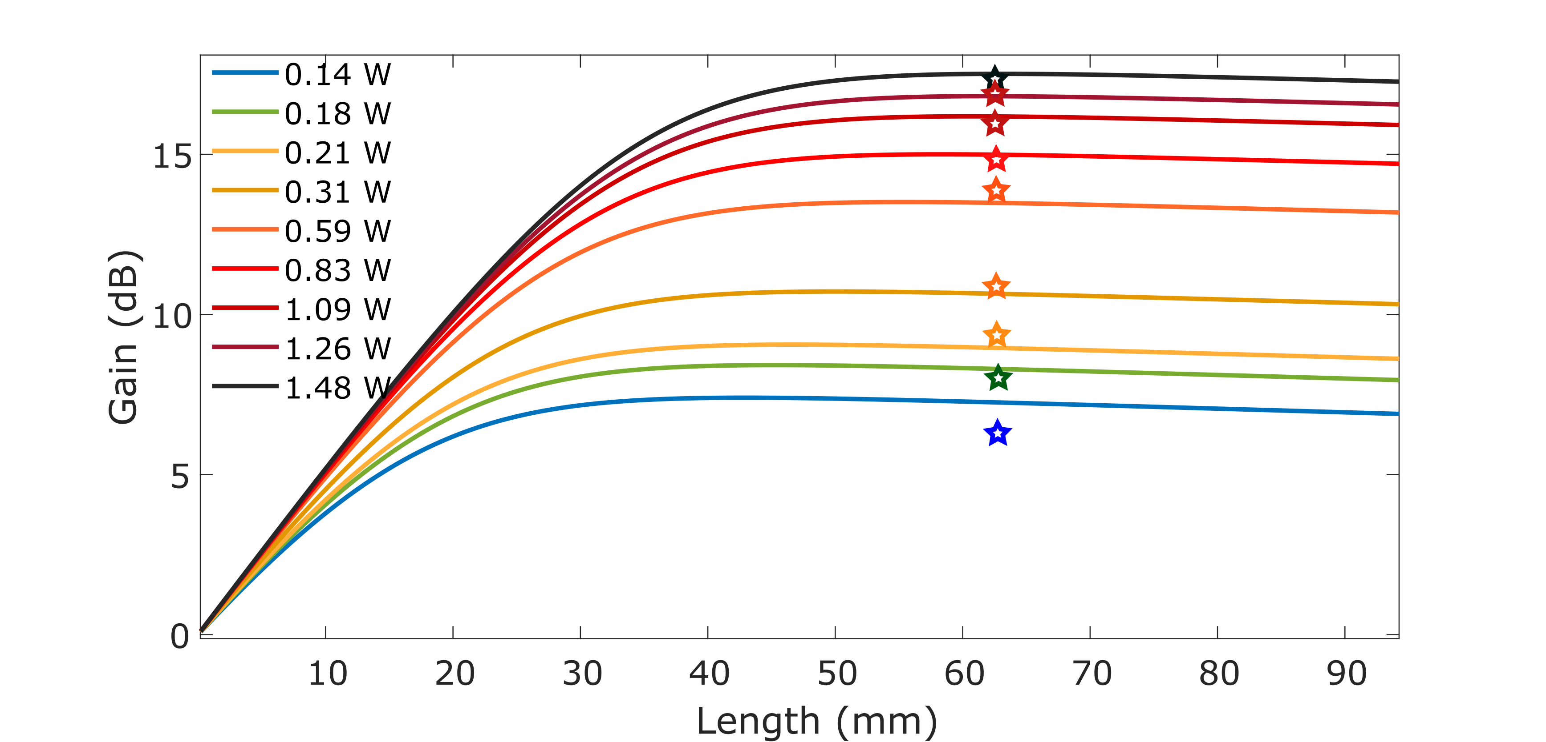
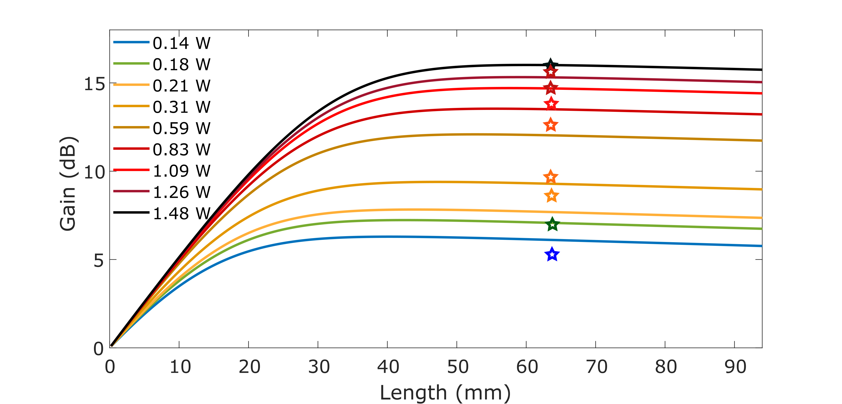
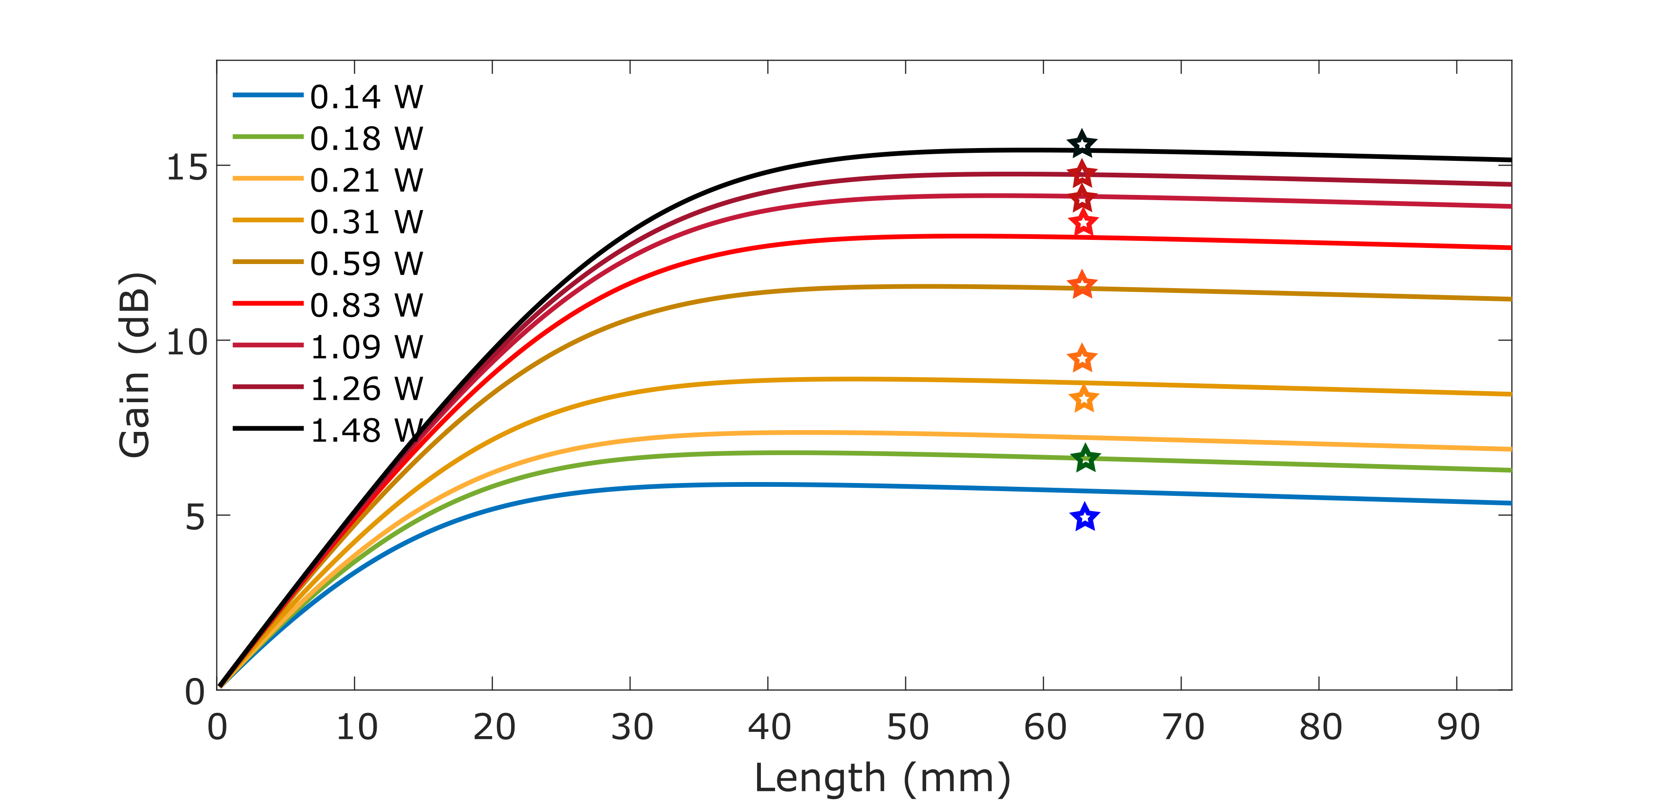
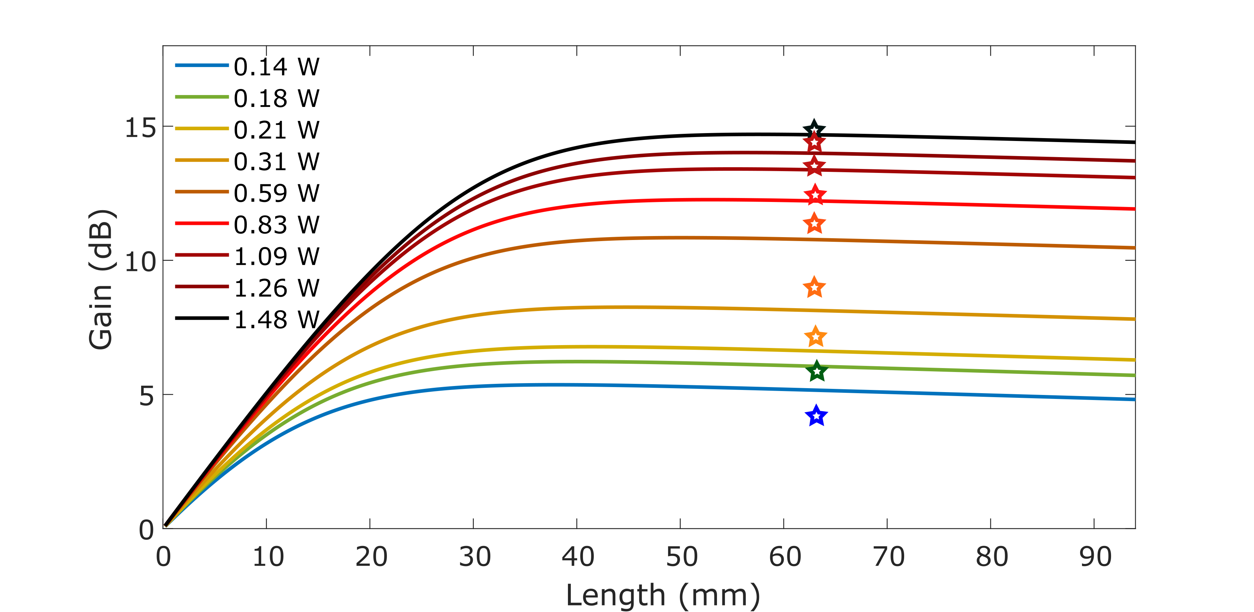
The pump and signal propagation along the length of the waveguide (~6.2 cm long) is given by Eq. (7) and (8), respectively. The overlap of pump and signal light with the gain is described by ψ_{P} and ψ_{s} and the signal and pump mode area are >30 µm². The propagation loss is given as $α_{loss,P}$ and $α_{loss,S}$for the pump and signal light, respectively. The results are shown in Fig. S6
a)
b)
b)
c)
Signal 18 mW
Signal 26 mW
Signal 30 mW
Signal 36 mW

Fig. S6. Gain as a function of waveguide length for different pump power. a), b) c) and d) Input signal power of 18 mW, 26 mW, 30 mW and 36 mW in the waveguide as in the experiment. The star symbols indicate the experimentally measured values (as shown in Fig. 2d of the manuscript).
The simulated curves show gain as a function of waveguide length for different pump power. We see that the simulation matches quite well with the experiment. The gain curves also suggest that even shorter gain waveguide can be utilized and longer length may only be useful for lower concentration or higher pump power. The peak of the gain shifts with pump power to longer length simply because the pump can bleach further in the waveguide. At low pump power we also measured longer devices (not shown) having lengths of 10.5 cm and 14.75 cm. The gain was measured experimentally (and in simulation) to be roughly 1 dB (0.8 dB) and 2 dB (1.5 dB) lower in the 10.5 cm and 14.75 cm long devices, respectively, compared to the 6.2 cm long device presented here.
- Component and reliability testing:

a) Passive component testing:
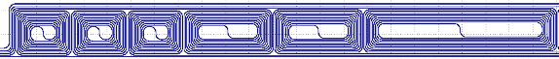
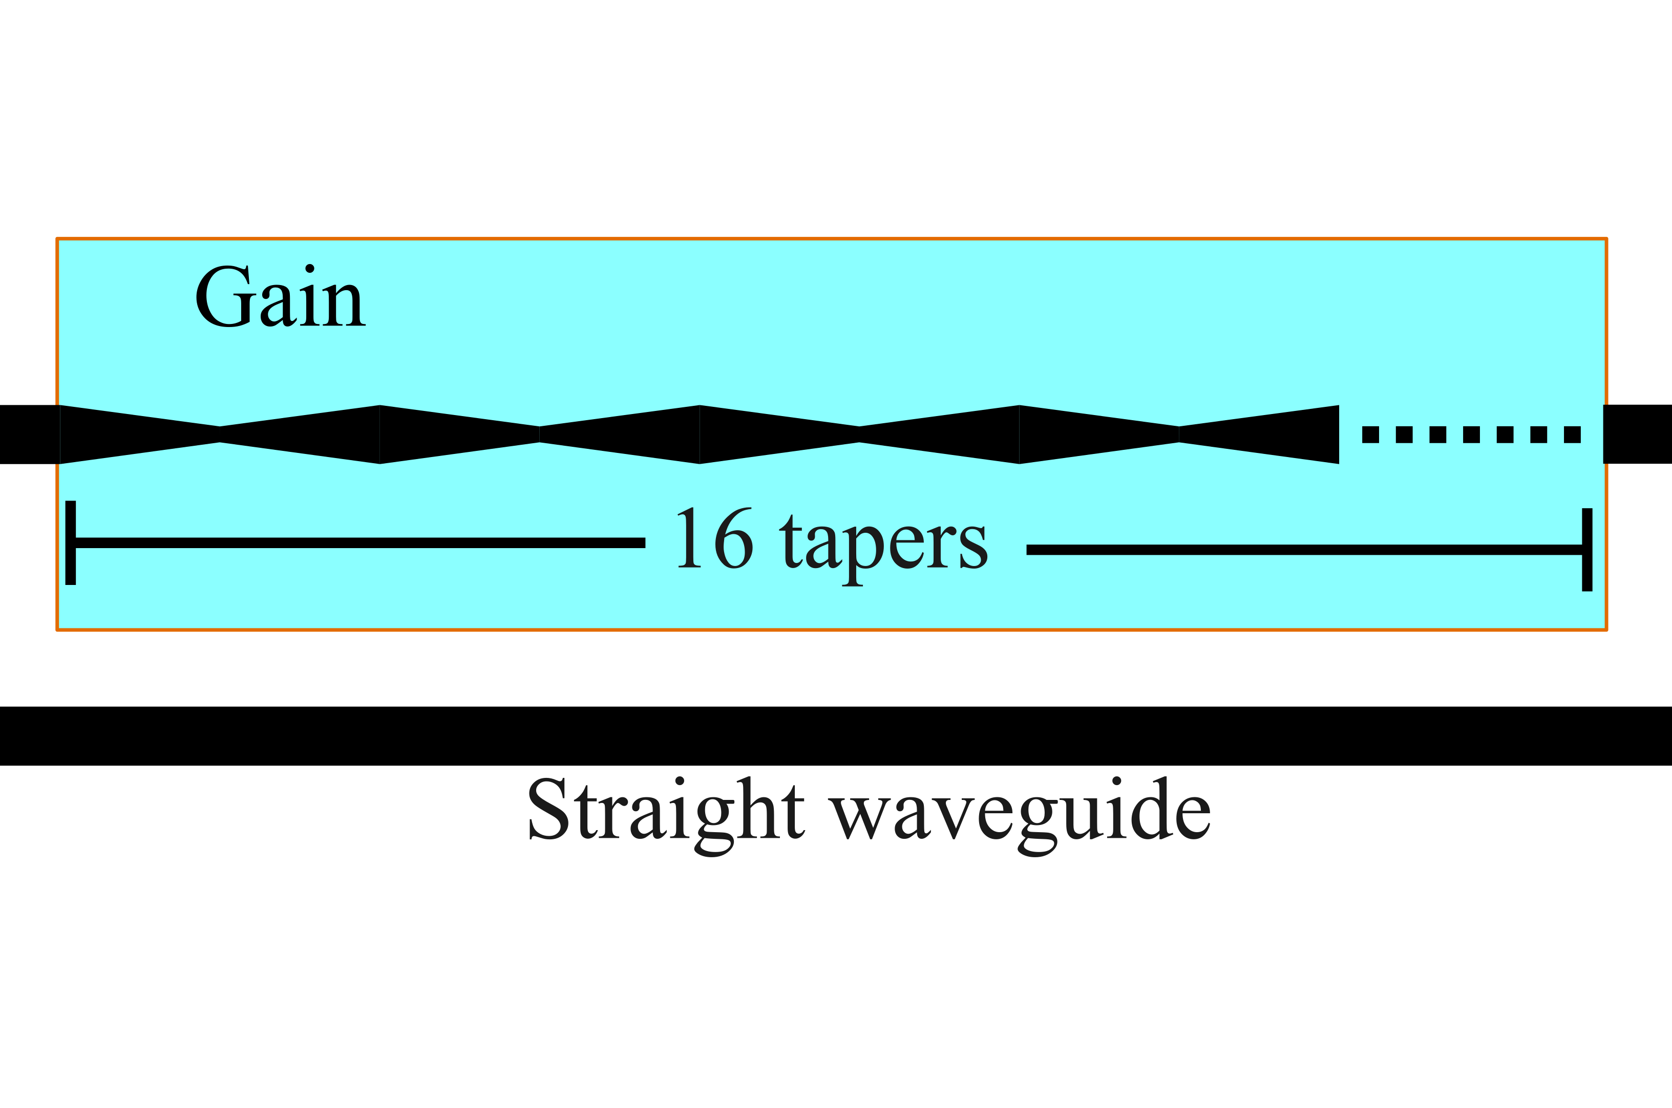
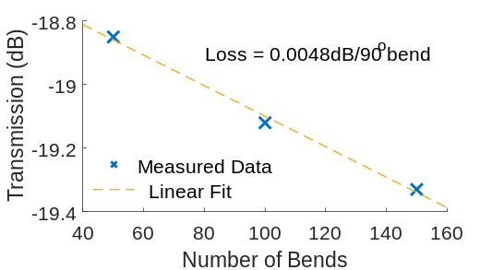
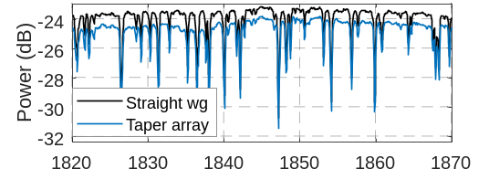
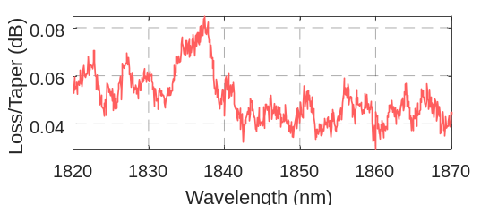
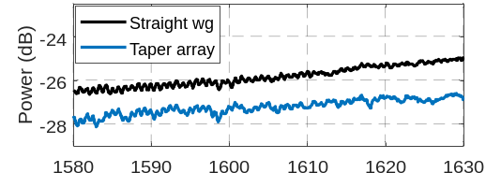
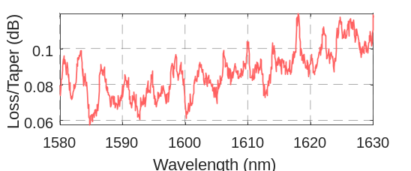
We measured the propagation loss introduced by the components in the gain section: tapers, bends and gain waveguide. The taper loss was determined by comparing the loss of a taper test structure against a low loss reference waveguide. The taper test structure is a set of 16 tapers (each taper 1.25 mm long), connected in series as shown in Fig. S7a. The measurements were performed by coupling a broad band signal (from a supercontinuum source, NKT) into the device. The transmission power difference between the low loss reference waveguide and the taper test structure around the pump and signal wavelength was measured and the loss per taper was estimated as, (Power_{ref. wg} – Power_{taper array})/16, as shown in Fig. S7c,e. The measured loss is an upper estimate as the device was covered with a thulium doped alumina layer where the presence of gain ions causes additional absorption loss. The bend loss was measured with the cutback method for which we tested bend structures with 90º bends (bending radii 80 µm). The test structure contains 50, 100, and 150 bends. The measured loss around 1850 nm is 0.005dB per bend as shown in Fig. S7d. We tested 90° bends instead of 180° bends as the 90° bends are compact and therefore a large number of bends can be accommodated. Moreover, they provide an upper limit on the bend loss caused by the interface mismatch of the bend and the straight waveguide, which is the dominant loss mechanism for bends with large bending radii [15, 16]. Our test suggest that the loss caused by a 180º bend is similar to that of a 90° and the radiation loss is relatively low. Similarly, we measured with the cutback method at the signal wavelength gain waveguide loss with different lengths of gain waveguide, 6 cm, 11 cm, and 16 cm. The total loss was measured to be 0.24 dB/cm, from which when the taper and bend losses are removed, the LMA waveguide loss with doped ions can be extracted to be between 0.15 to 0.2 dB/cm (as an upper limit).
a)
b)
d)
f)
Bend test structure
Taper test structure
3x50
2x50
1x50
c)
e)

Fig. S7. a) Taper test structures and bend loss test structures containing 50, 100 and 150 bends (from left to right). b) Transmission spectrum through the reference straight waveguide and the taper array, and c) the loss per taper around the pump wavelength. The fluctuations are due to water vapor absorption and laser signal fluctuations. d) Transmission spectrum through the reference straight waveguide and the taper array, and e) the loss per taper around the signal wavelength. The fluctuations are due to laser signal fluctuations. f) Cut back measurement of bend loss at 1850 nm.

b) Stability of the amplifier:
We also measured the stability of the high-power amplifier as shown in Fig. S8. The stability is measured with a power meter (Thorlab S148C, PM100D) at the highest amplified signal output power. At the start of the experiment when the device is cold we observed the power was dropping within every approximately 4 minutes. In Fig. S8, the blue region indicates the realignment of the chip and lensed fiber and the black curves show measured power which drops over time. The drop is due to the thermal drift of the relative position of the lensed fibers and the chip. We needed 6 realignments of the lensed fibers within the first 20 minutes. As the time progressed the number of required realignments reduced. After roughly 1 hour of operation, every 20 minutes the chip realignment was performed which seemed to improve even further with time. We performed the stability measurement for up to 2 hours; however, we have observed such stability behavior over 2 months of testing, indicating that the amplifier performance does not degrade over long period of time.
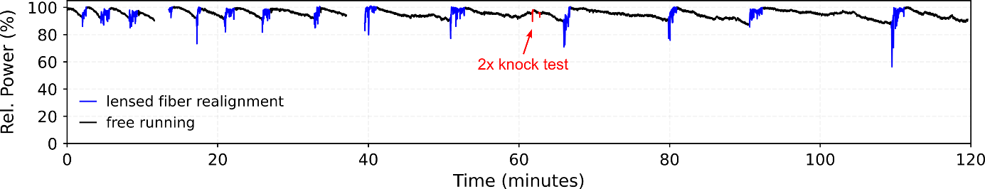

Fig. S8. Normalized amplified output power from the amplifier over 2 hour period. The setup needed realignment of the chip and the lensed fibers frequently at the beginning and once/20 minutes after 1 hour of operation. Knock tests were performed by knocking the optical table with optical metal posts.

The stability can be well controlled once the device is fully packaged. Due to the measurement error with the power meter we lost the data at the 12th and the 38th minute of the recording, leaving blank spaces in those instances, as seen in Fig.S8. We also tested the mechanical stability of the laser against any sudden mechanical vibration. In this test, we knocked the optical table (which is not mechanically isolated from the setup) with optical posts at a force of roughly 1N (essentially dropping a 13 cm long post, Thorlabs MS05R/M, from a height of roughly 15 cm), and observed any change in power. The power suddenly drops as seen around the 62nd minute, but then it immediately recovers to the original value with 1-2% variation in power. These tests suggest that the current device is quite stable and has long operation time, and once fully packaged it can be used for field applications over a very long time.

c) Conversion efficiency:
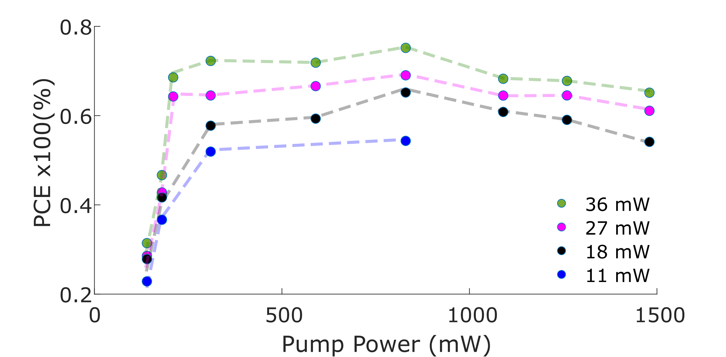
The power conversion efficiency as a function of pump power and the input seed power is shown in Fig.S9. The power conversion efficiency is defined as (P_{o(s)}-P_{in(s)})/P_{in(p)} [17]. P_{o(s)} is the amplified output signal power, P_{in(s)} is the input signal power and the P_{in(p)} is the pump power.

Fig. S9. The power conversion efficiency (PCE), as a function of pump power for various seed power.

The conversion is weaker at low pump power simply because all the ions in the gain medium are not well excited which absorb the signal causing loss. As the pump power increases the signal power increases and so does the conversion efficiency. Higher power seed signals have higher conversion simply because they are dominant over the amplified spontaneous emission which otherwise can take away the gain from the low power seed signal. However, by increasing the seed signal power further the conversion efficiency will not increase, for a given ion concentration and mode area, which is due to the limited number of gain ions interacting with the signal mode. We also overserve that as the pump power is increased further the conversion efficiency starts dropping. That is also because of the limited number of ions in the gain medium, that is, the signal is getting stronger with the pump power and beyond certain point signal gain starts approaching saturation due to limited number of gain ions. With even longer devices, larger mode area and/or higher concentration (below the concentration level at which the gain quenching is dominant) the conversion efficiency can be kept higher. A device can be designed for the best conversion efficiency for a given pump and signal power and amplifier length. Such designs have been explored in fiber amplifiers [18]. In the future studies we will explore such a design for the best PCE (>85%) to generate several watts of amplified signal power.

d) Noise figure measurement:
We have tested the noise figure with a high-power home-built CW laser. Details of a similar laser can be found in ref. [19]. The noise figure (NF) is defined as, NF = P_{ASE}/(hυΔυG) + 1/G, where P_{ASE} is the amplified spontaneous emission power measured over 0.5 nm bandwidth (Δυ) with the OSA, Yokogawa AQ6376 (measured 4 nm away from the amplified signal), hυ is the signal photon energy and G is the linear gain (ratio of amplified signal output to input seed power). We measured the NF for two different signal seed powers, 36 mW and 82 mW. We observe that as the net gain increases (with increasing pump power) the noise figure reduces, as is expected, since the noise figure is inversely proportional to the gain. Additionally, at lower gain (due to lower pump power), the ASE noise is higher which is directly proportional to the spontaneous emission factor. The spontaneous emission factor reduces as the gain increases, because n_{sp} = N₂/(N₂ – σ_{a}N₁/σ_{e}), here N₂ is the concentration of excited ions and N₁ is the concentration of ground state ions; and σ_{a} and σ_{e} are the absorption and emission cross-sections [17]. As the pump power increases the N₂ increases (and hence the gain increases), which reduces the n_{sp} and therefore the noise figure.

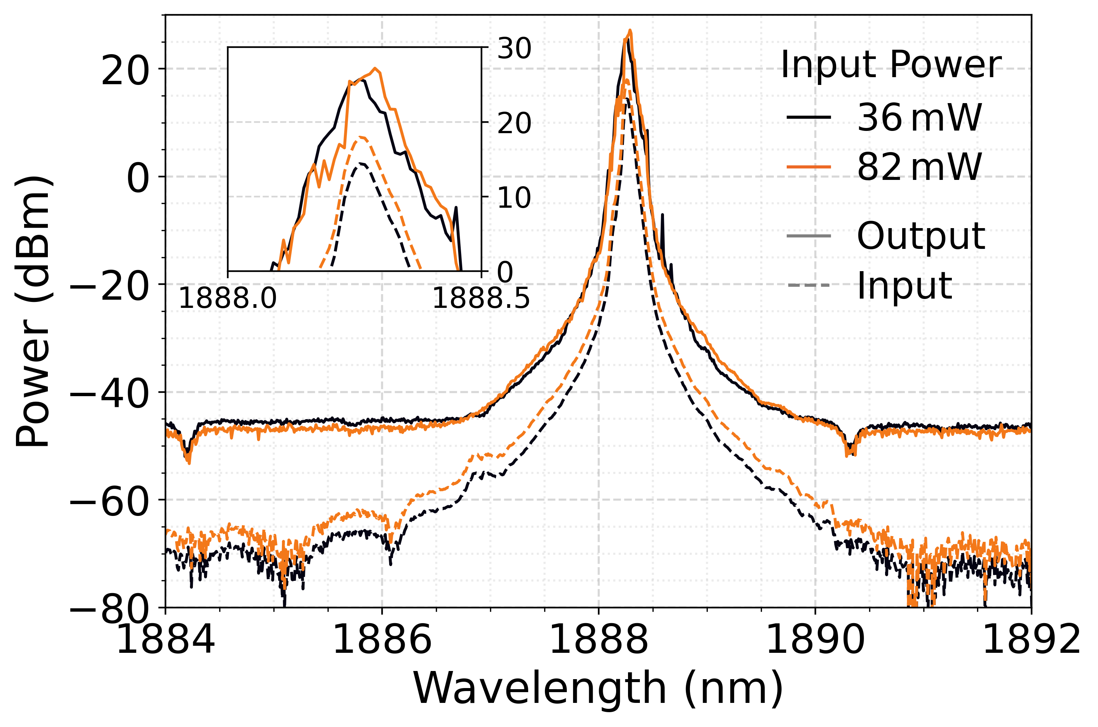
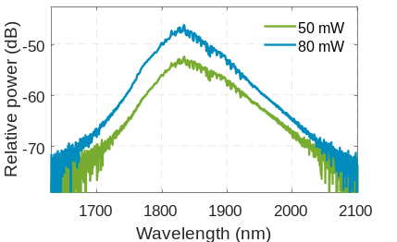
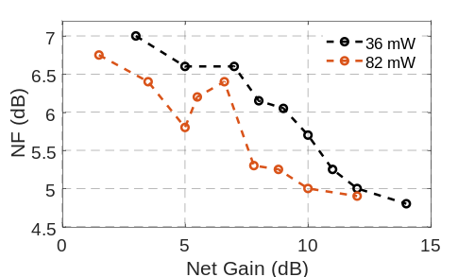
a)
c)
b)
Fig. S10 Noise figure (NF) measurement at different seed power. b) Typical spectrum of the input and amplified output signal (taken at 13 dB and 10 dB net gain for 36 mW and 82 mW on-chip seed signal power). c) The ASE spectra with different on-chip pump power. Small fluctuations seen around 1850 nm are due to water absorption.

At low seed power the noise figure is higher compared to high seed power (for a fixed gain), mainly due to the high P_{ASE}; however, as the gain for low seed power increases the overall noise figure drops due to the inverse relationship between the gain and noise figure, which is much more dominant than the increase in P_{ASE} associated with higher gain (due to higher pumping). A small bump in NF of ~0.7 dB seen around 6 dB net gain could be due pump/signal fluctuation. The typical spectra of the input signal and the amplified output signal is shown in Fig. S10b, for approximately 13 dB and 10 dB gain for 36 mW and 82 mW seed power, respectively. The CW laser spectra show fluctuations due to the use of a broadband birefringent filter in the seed laser cavity which will be replaced with narrow linewidth interferometric filter in the future studies. Testing on the high power amplification with CW seed laser is currently on-going which will be reported elsewhere [20, 21]. Additionally, we plot ASE spectra as a function of pump power for the 6 cm device (we limit the pump power here, as too high of a pump power leads to lasing without any seed signal). Here, we see that the ASE peak shifts towards 1830 nm with the pump power due to increase in excitation of ions with the pump, which is expected as the photoluminescence measurement show peak signal around 1830 nm (Fig. 4a in the manuscript)

e) Co and counter propagation pumping:

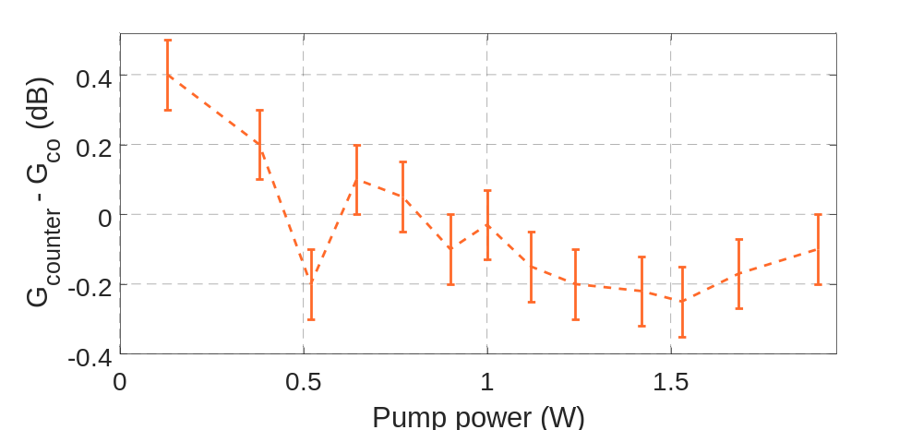
We measured the impact of the co- and counter-directional pumping of the amplifier. In co-directional pumping the pump and signals are launched from the same side, whereas in the counter-directional pumping the pump and signal are launched from opposite ends.

Fig.S11. The difference in net gain between counter and co-directional pumping as a function on pump power.
The net gain was measured with a fixed signal input power of 36-40 mW having a fixed polarization. The pump and signal polarizations were the same. As shown in Fig. S11, there is a very small difference between the net gain for the two-pumping scheme. The gain is slightly higher for the counter propagation scheme at low pump power, and as the pump power increase the difference becomes negligible, and in fact the gain is a little bit higher than the counter-propagating case at higher pump power which could be due to the fact that the signal in co-propagating case is able to bleach through the amplifier and is affected less by the ion absorption as compared to the counter-propagation scheme. However, the overall difference between the measured net gain from the two schemes is negligible. This is expected as we are launching a high power seed signal. Some differences in gain can be seen in the small signal testing in which a weak signal (in the microwatt level) is launched into an amplifier, which is mainly due to the presence of ASE [17]. For example, with co-directional pumping the ASE is very strong near the input side of the device, this is because the signal is weak (in small signal testing) and the inversion is high compared to the output side of the amplifier. This causes the strong ASE at the input of the amplifier to steal the gain away from the signal which results in a slightly lower gain. But the gain can be slightly higher if the signal is launched from the other side, as the signal is stronger by the time it reaches the pump side where the inversion is the strongest, which suppresses the ASE build up.

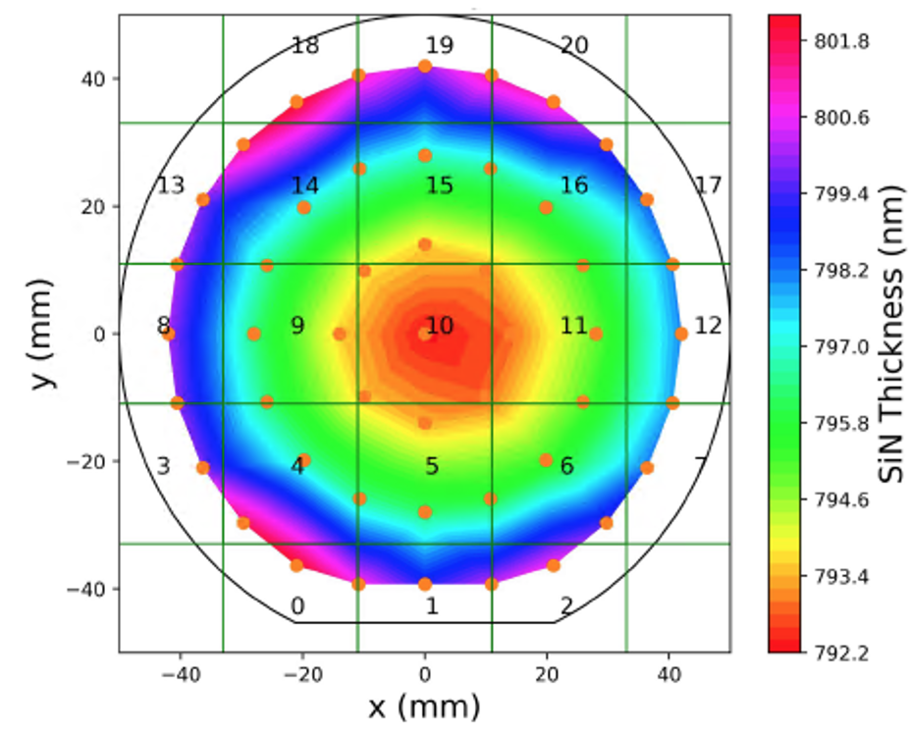
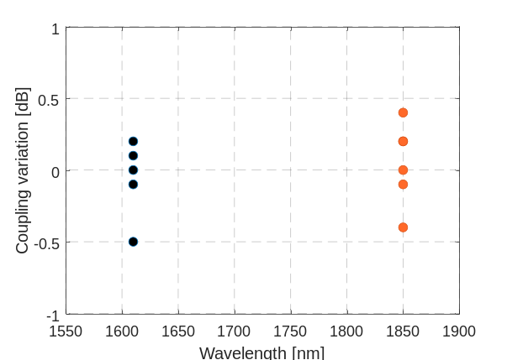
f) Pump and signal coupling variations
a)
b)

Fig. S12. a) Coupling loss at the pump (1610 nm) and signal (1850 nm) measured for devices in different chips having identical inverse taper couplers. b) The measured thickness variation over a wafer.

We have measured the pump and signal coupling loss from fiber to a low loss reference waveguide with exactly the same inverse tapers in different chips, and in chips from different wafers. The measured coupling loss variation is shown in Fig S12a. Within the same wafer the coupling loss variation is less than the variation measured between wafer to wafer. For the signal the largest variation is around ±0.4 dB and for the pump the it is ±0.3 dB. An outlier is seen which is close to -0.5 dB from the mean at pump wavelength which is most likely due to the chip being at the edge of the wafer where film thickness variation can be large and the waveguide tip width at the facet can vary by ~5% (see Fig.S12b). The mean coupling loss at the signal and the pump is 2.5 and 3.5 dB/facet respectively.

g) Implications of high-power pumping:
Currently, the device is pumped with a high-power pump source off the chip. This separates the cooling requirements of the pump laser from the amplifier chip. At high pump power there are a few challenges that one may encounter. One of them is the chip movement against the lensed fiber, which needs full packaging to avoid thermal drift. Fortunately, high thermal conductivity of alumina can alleviate this problem, especially, together with high-power packaging as discussed below which is commonly used by the industry. The optical damage of the SiN layer at high pump power is another challenge. Due to tight confinement of the mode in the SiN bend the SiN layer is prone to such a damage compared to the alumina layer. The SiN waveguide CW damage happens between 6 to 10 W coupled power [22]. This entails that 4 to 7 W of amplified signal power can be achieved per amplifier before the damage occurs.
For on-chip pumping high power pump diodes will have to be integrated. However, the heat dissipation is an important concern that needs to be addressed for high power pump diodes for pumping the gain medium. An effective heat dissipation is important not only to increase the durability of the pump diodes but also to reduce degradation in performance due to high non-radiative recombination process due to Auger recombination [23]. This leads to reduction in carrier lifetime which in turn increases the requirement on the pump current to achieve the same gain as that during the low temperature operation. Without active cooling of the diodes this can lead to further reduction in performance and eventual failure of operation [23]. The diodes can be integrated in a hybrid approach where either the diode is coupled to the amplifier using micro optical bench (where the pump is coupled to a micro ball lens and a prism that couples light into the device) or simply with edge coupling. Micro optical bench has been successfully demonstrated with high thermal conductivity substrate based on aluminum nitride (by Tyndal) and silicon (by Luxtera) [24, 25]. The entire device can be further mounted on copper heat sinks for effective conductive cooling which is known to be sufficient for diode bars operating at 30 W [26, 27]. Edge coupling is promising as it avoids complex integration, which is required for micro optical benches. In this method, an etched recess down to the silicon substrate is created on the photonics chip where pump diodes can be flip-chip bonded [28]. This allows wafer level integration as well as effective heat dissipation through silicon substrate to copper heat sink. Back reflection can play a role. But for diode pumped rare-earth device, attention is required to avoid catastrophic-optical-mirror-damage at the diode facet at very high power, in the 10s of watts operation [26]. In both approaches active cooling with thermoelectric cooler can significantly reduce the thermal load on the pump diodes [24]. Such an active cooling with copper mounted chip will benefit the off-chip pumped devices as well.

- Comparison table and future integration
In table S1 we compare different amplifier technologies. We mainly compare the device footprint, CMOS compatibility and the power obtained at the output (which is directly related to the size of the optical mode). As is shown in the table, our LMA device occupies a small footprint in a CMOS compatible platform and generated power levels above 1000 mW, which is higher than most of the table top SOAs, and compares and even outperforms (at 1.9 µm) some of the best research grad table-top SOAs [29-31]. The output power even surpasses many benchtop standard-fiber based amplifier. The device footprint is defined as the size of a device to accommodate at least two 180° bends to allow for an amplifier with long enough length (for high power applications). This is important because a photonic chip is limited in size (reticle size ~ 22x22 mm) and requires bending of the waveguide to obtain long optical path length for high power signal generation. The recently demonstrated ion implanted SiN waveguide amplifier has reached a power level of 140 mW with the help of a 0.5 m long ultra-low loss waveguide, requiring high temperature annealing >1000 C which is not suitable for CMOS integration; additionally, the small mode area limits the gain saturation power hence the total output power. Integrated SOAs exhibit very high gain in a short length, therefore the footprint is quite small, however due to the small mode area the power generation remains small. Commercial grade benchtop semiconductor optical amplifiers are currently limited in power, but the research grade devices, with large mode area, have been successful at generating power levels over a watt. The best output power performance can be obtained with fiber-based systems; however, they have a large footprint, and not unlike the benchtop SOAs, cannot be integrated.
Device | Mode Area, µm² | Device Footprint (Bend radius per 0.01 dB loss), mm | CMOS | Power, W
 |  |  |  | Max. @ any wavelength | @ 1.9µm
Ion implanted SiN [32] | 1 | 0.5 | No (Annealing >1000C), Integrated | 0.14 | -
Integrated SOA [33-39] | 1-2 | 0.05 – 0.08 | No (Hybrid integration), Integrated | 0.05-0.09 | 0.001-0.02
Commercial SOA [40] | - | 50-100 | No | 0.06-0.35 | -
Research grade SOA [29-31] | 25-35 | 200 | No | 1-2 | 0.06
Standard fiber [40] | 30-74 | 25-40 | No | 0.05-20 | 0.05-10
LMA fiber [42] | 300-700 | 100-400 | No | 10-1000
This work | 30 | 0.08-0.11 | Yes | > 1

Table S1. Here we compare our results with the best results obtained with the state-of-the-art devices from the other technologies. We compare our results with best integrated devices based on ion implanted silicon nitride (SiN) gain waveguide and hybrid integrated SOA devices. Both suffer from small mode area and hence low output power. The shaded rows include benchtop devices, which have very large mode area (and therefore high power), but have a large footprint and are not integrable. The power levels are shown for the best performing devices (at any wavelength), and at the relevant molecular vibration window (1.9 µm) demonstrated here.

- Future integration and scope

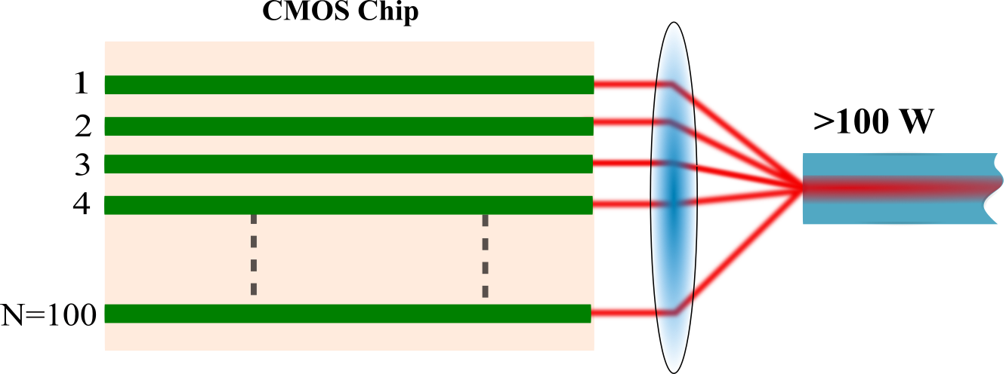
As discussed and demonstrated in the manuscript several watts of power can be extracted from a single device. A single device can produce even up to 3-5 Watts of signal power with high power pump before the damage threshold of SiN waveguide becomes a limiting factor. These high-power signals from a single device can be coherently combined with other devices on the same chip to obtain even higher output power

Fig.S13 Coherently combining the amplified signals from many LMA high power amplifiers from a single standard CMOS chip of 22x22 mm size. Light is coupled through an output lens into a single mode high power handling fiber. Just like a lens, integrated grating couplers could be used to combine beams off-chip.

For example, a CMOS die is 22x22 mm in size which can hold more than hundred amplifiers, which if combined coherently can produce >100 watts of output power. The coherent combining can be achieved with integrated grating couplers or integrated lenses at the chip facet. For this, one can pump the device with off-chip pump lasers or integrated pump diodes, see Fig.S13 showing an example of such a high-power system. Moreover, different amplifiers operating at slightly different wavelengths can be combined with a wavelength division multiplexer, and if the phases of the high-power signals are controlled appropriately (for example with a low noise thermal phase shifter) then the combined signal could produce pulses with high power and high repetition rate. The integrated pump diodes can be multimode with high output power or coherently combined single mode pump diodes can equally be used with high total output power for pumping (or multiple single mode diodes operating at different wavelengths can be combined with a WDM). Moreover, continuous wave lasers with high power and narrow linewidth operation can be achieved with integrated distributed Bragg reflector grating (DBR) and distributed feedback (DFB) lasers, and ring lasers. Such lasers and amplifiers can be demonstrated for different wavelengths windows, for example, for datacom applications neodymium doped aluminum oxide can be used for signal generation and amplification around 1300 nm. For telecom application erbium doped aluminum oxide LMA amplifiers and lasers can be used with the potential to generate beyond 100 watts of power from a single CMOS die. Additionally, modelocked lasers will benefit from such a high-power operation. A single 1 GHz repetition rate modelocked laser can produce pulses with peak power of more than 10 kW at the output of the laser (for a 100 fs pulse width), with several 10s of kilowatts of intracavity power, which will correspond to a timing jitter of the pulse train to be <<1fs.

References:
- C. I. van. Emmerik, et. al. “Relative oxidation state of the target as guideline for depositing optical quality RF reactive magnetron sputtered Al₂O₃ layers,” Opt. Mat. Express, 10, (2020).
- P. K. Tien, “Light waves in thin films and integrated optics,” Appl. Optics, 10, (1971).
- Purnawirman, et. al. “Reliable Integrated Photonic Light Sources Using Curved Al2O3:Er3+ Distributed Feedback Lasers” IEEE photonics journal, 8, (2017).
- L. Agazzi, "Spectroscopic excitation and quenching processes in rare-earth-ion-doped Al2O3 and their impact on amplifier and laser performance", Thesis (2012).
- D. A. Zubenko, M. A. Noginov, V. A. Smirnov, and I. A. Shcherbakov, “Different mechanisms of nonlinear quenching of luminescence”, Phys. Rev. B 55, 8881-8886 (1997).
- D. A. Simpson, et. al. “Energy transfer up-conversion in Tm3+ - doped silica fiber,” J. Non-Crystalline Solids, 352, 2006
- G. Nykolak et. al. “Concentration-dependent 4I13/2 lifetimes in Er3+ doped fibers and Er3+ doped planar waveguides,” IEEE Photon. Technology Lett. 5 (1993).
- K. Kuroda et. al. “Pump-probe measurment of metastable state lifetime reduced by cooperative upconversion in a high-concentration erbium doped fiber,” Appl. Optics. 57 (2018).
- A. Sincore, et. al. “High average power thulium-doped silica fiber lasers: review of systems and concepts”, IEEE J Sel Top Quantum Electron IEEE J SEL TOP QUANT, 24 (2018).
- B. M. Walsh and N. P. Barnes, “Comparison of Tm:ZBLAN and Tm: silica fiber lasers; Spectroscopy and tunable pulsed laser operation around 1.9 µm”, Appl. Phys. B, (2004).
- S. A. V. Cordova et. al. “Erbium-doped spiral amplifiers with 20 dB of net gain on silicon,” Opt. Express, 22 (2014).
- K. Arai, et. al. “Aluminum or phosphorus co‐doping effects on the fluorescence and structural properties of neodymium‐doped silica glass,” Journal of Applied Phys. 59 (1986).
- B. Dussardier, et. al. “Tailoring of the Local Environment of Active Ions in Rare-Earth- and Transition-Metal-Doped Optical Fibers, and Potential Applications,” Sel. Top. On Optical Fiber Techn. (2012).
- L. Guillemott, et. al. “Excited-state absorption in thulium-doped materials in the near-infrared,” Opt. Express, 30 (2022).
- F. Vogelbacher, et. al. “Analysis of silicon nitride partial Euler waveguide bends,” Opt. Express, 27, (2019).
- M. Bahadori, et. al. “Universal Design of Waveguide Bends in Silicon-on-Insulator Photonics Platform,” J. Light. Techn. 37 (2019).
- P. C. Becker, N. A. Olsson and J. R. Simpson, “Erbium-doped fiber amplifiers,” Academic Press 1999.
- J. F. Massicott, et. al. “Efficient, high power, high gain, Er₃₊ doped silica fibre amplifier,” Electronics Letter, 26 (1990).
- U. Demirbas, et. al. “Continuous-wave Tm:YLF laser with ultrabroad tuning (1772-2145 nm),” Opt. Express 30 (2022).
- J. Lorenzen et. al. “Spectroscopic properties of thulium-doped high power integrated LMA amplifiers,” CLEO, 2024.
- N. Singh et. al. “High power >1.5W tunable laser based on integrated LMA power amplifier, IEEE Silicon Photonics 2024.
- H. E. Dirani, et. al. “Ultralow-loss tightly confining Si₃N₄ waveguides and high Q microresonators,” Opt. Express, 27 (2019).
- G. P. Agrawal and N. K. Dutta, Semiconductor Lasers, 2nd ed., Van Nostrand Reinhold,New York, 1993.
- B. Snyder, et. al. “Hybrid integration of the wavelength-tunable laser with a silicon photonic integrated circuit,” J. Light Wave Technology, 31 (2013).
- L. Carroll, et. al. “Photonic packaging: transforming silicon photonic integrated circuits into photonic devices,” Appl. Sci, 6 (2016).
- P. O Leisher et. al. “Feedback-induced failure of high-power diode lasers,” IEEE J. of Quant. Electron. 54 (2018).
- M. Leers et. al. “Next generation heat sinks for high-power diode laser bars,” IEEE Semiconductor Thermal Measurement and Management Symposium, 2007.
- M. Theurer et. al., “Flip-chip integration of InP to Sin photonic integrated circuits,” J. Light. Technol. 38 (2020).
- J. Campbell et. al. “30 dBm single mode fiber-coupled semiconductor optical amplifier at 1550 nm”, ISLC, (2022)
- J. P. Donnelly, et. al. “High power slab coupled optical waveguide lasers and amplifiers,” Elsevier Inc. Chapter 1 (2012).
- P. W. Juodawlkis et. al. “High-Power, Low-Noise 1.5-μm Slab-Coupled Optical Waveguide (SCOW) Emitters: Physics, Devices, and Applications,” IEEE J. Sel. Top. Quantum, 17, 2011.
- Y. Liu et. al., “A photonic integrated circuit based erbium doped amplifier,” Science, 376 (2022).
- R. Wang et. al. “Widely tunable 2.3 um III-V on silicon Vernier lasers for broadband spectroscopic sensing,” Photon. Research, 6 (2018).
- N. Volet, et. al. “Semiconductor optical amplifier at 2 µm wavelength on silicon,” Laser Photonics Rev. 11, 2017.
- M. L. Davenport et. al., “Heterogeneous Silicon/III–V Semiconductor Optical Amplifiers,” IEEE J. Sel. Top (2016).
- T. Matsumoto et. al. “Hybrid integration of SOA on silicon photonics platform based on flip chip bonding,” IEEE J. of Lightwave (2019).
- C. O. Beeck, et. al. “Hetrogenous III-V on silicon nitride amplifiers and laser via microtransfer printing,” Optica (2020).
- Y. Wang, et. al. “Efficiency-boosted semiconductor optical amplifiers via mode division multiplexing,” Optica (2023).
- K. V Gasse et. al., “27 dB gain III-V on silicon semiconductor optical amplifier with >17 dBm output power,” Opt. Express (2019).
- www.thorlabs.com; www. seminex.com
- www.amonics.com; www.bktel-photonics.com
- C. Gaida et. al. “Ultrafast thulium fiber laser system emitting more than 1 kW of average power,” Opt. Lett. 43 (2018).

