Table S1 Average rainfall and temperature, dry monitoring period

Grande River Station |  | Date | Minimum temperature | Maximum Temperature | Total Rainfall (mm) | Ondas River Station | Date | Minimum temperature | Maximum Temperature | Total Rainfall (mm)
Dry Period | 83263 | May/22 | 11.30 | 35.10 | 0.00 | A402 | May/22 | 11.30 | 34.50 | 0.20
Dry Period | 83263 | Jun/22 | 10.20 | 34.60 | 0.00 | A402 | Jun/22 | 10.70 | 34.20 | 0.00
Dry Period | 83263 | Jul/22 | 10.70 | 35.60 | 0.00 | A402 | Jul/22 | 11.60 | 34.90 | 0.00
Dry Period | 83263 | Aug/22 | 11.00 | 36.30 | 0.00 | A402 | Aug/22 | 12.50 | 36.30 | 0.00
Dry Period | 83263 | Sep/22 | 12.60 | 39.20 | 38.70 | A402 | Sep/22 | 14.10 | 38.70 | 3.20
Dry Period | 83263 | Oct/22 | 15.00 | 38.40 | 32.80 | A402 | Oct/22 | 16.50 | 38.60 | 25.40
 |  | Mean | 11.80 | 36.53 | 11.92 |  | Mean | 12.78 | 36.20 | 4.80
Source: Adapted from INMET (2023).

Table S2 Average rainfall and temperature, rainy monitoring period
Grande River Station |  | Date | Minimum temperature | Maximum Temperature | Total Rainfall (mm) | Ondas River Station |  | Date | Minimum temperature | Maximum Temperature | Total Rainfall (mm)
Rainy Period | 83263 | Nov/22 | 19.30 | 34.20 | 471.4 | A402 | Nov/22 |  | 19.60 | 34.40 | 402.20
Rainy Period | 83263 | Dec/22 | 20.20 | 32.70 | *0.00 | A402 | Dec/22 |  | 19.20 | 33.30 | 231.60
Rainy Period | 83263 | Jan/23 | 18.10 | 33.40 | 226.0 | A402 | Jan/23 |  | 18.70 | 33.30 | 186.80
Rainy Period | 83263 | Feb/23 | 18.50 | 35.10 | 8.00 | A402 | Feb/23 |  | 18.80 | 35.50 | 32.80
Rainy Period | 83263 | Mar/23 | 18.00 | 35.40 | 126.00 | A402 | Mar/23 |  | 18.20 | 34.00 | 125.40
Rainy Period | 83263 | Apr/23 | 17.30 | 34.80 | 53.10 | A402 | Apr/23 |  | 17.60 | 34.60 | 45.20
 |  | Mean | 18.57 | 34.27 | 147.65 |  | Mean |  | 18.68 | 34.32 | 170.67
*No records.
Source: Adapted from INMET (2023).

Fig.S1 Average flow of rivers year of monitoring
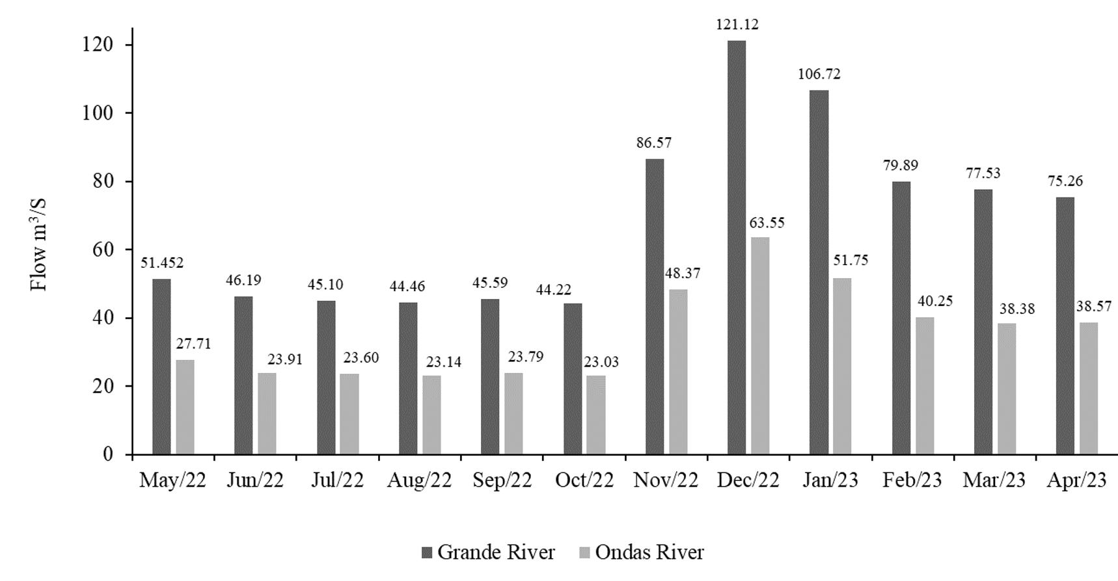
Source: Adapted from ANA (2023).

Table S3 Descriptive statistics for seasonal variation in the monitoring period

Parameter | Measurement unit | Dry period |  |  |  | Rainy period
Parameter | Measurement unit | Mean | Median | Minimum | Maximum | Mean | Median | Minimum | Maximum
DO | mg/L | 6.83 | 6.82 | 5.95 | 7.70 | 7.34 | 7.19 | 6.55 | 8.17
pH | - | 6.49 | 6.50 | 5.64 | 7.20 | 6.16 | 6.20 | 5.28 | 6.72
EC | μS/cm | 11.61 | 12.00 | 0.00 | 49.00 | 26.72 | 32.00 | 0.00 | 50.00
Alkalinity | mgCaCO₃/L | 7.45 | 8.00 | 0.00 | 19.33 | 11.18 | 8.67 | 4.00 | 28.00
Turbidity | Ut | 1.46 | 1.30 | 0.06 | 3.59 | 29.67 | 4.79 | 0.04 | 347.67
Apparent Color | Uh | 29.39 | 28.13 | 2.03 | 64.30 | 252.90 | 89.67 | 20.50 | 2453.33
True Color | Uh | 15.98 | 12.70 | 1.90 | 38.80 | 60.08 | 40.80 | 1.60 | 164.00
BOD_{5,20} | mgO₂ /L | 9.22 | 11.42 | 0.59 | 18.70 | 7.33 | 6.96 | 3.46 | 11.20
Total Coliforms | MPN/100 mL | 25001.82 | 9300.00 | 300.00 | 110000.00 | 40918.18 | 24000.00 | 2300.00 | 110000.00
Thermotolerant coliforms | MPN/100 mL | 13135.15 | 2100.00 | 300.00 | 110000.00 | 32330.91 | 24000.00 | 920.00 | 110000.00
Heterotrophic bacteria | CFU/mL | 12063.50 | 3850.00 | 64.00 | 111800.00 | 326942.40 | 26800.00 | 750.00 | 3360000.00

EC: Electrical Conductivity; DO: Dissolved Oxygen; BOD_{5.20}: Biochemical Oxygen Demand 5 days, 20 °C

Table S4 Evaluation of the significance of seasonal variation in the monitoring period

Parameter | Shapiro-wilk p>0.05 | Levene p>0.05 | df | H | p<0.05
DO | 0.7654 | 0.6509 | 2.0000 | 12.5800^{f} | 0.0003
pH | 0.7043 | 0.0628 | 4.0000 | 3.8300^{f} | 0.0057
EC | 0.0001 | 0.0601 | 1.0000 | 10.1597 | 0.0014
Alkalinity | 0.0015 | 0.0906 | 1.0000 | 4.9300 | 0.0263
Turbidity | 0.0000 | 0.0000 | 1.0000 | 20.5000 | 0.0000
Apparent Color | 0.0000 | 0.0000 | 1.0000 | 36.9500 | 0.0000
True Color | 0.0000 | 0.0000 | 1.0000 | 28.5995 | 0.0000
BOD_{5,20} | 0.0962 | 0.0000 | 1.0000 | 1.8700 | 0.1720
Total Coliforms | 0.0000 | 0.0000 | 1.0000 | 8.8541 | 0.0029
Thermotolerant coliforms | 0.0000 | 0.0000 | 1.0000 | 15.9223 | 0.0001
Heterotrophic bacteria | 0.0000 | 0.0000 | 1.0000 | 22.0916 | 0.0000

f: anova test; df: degrees of freedom; H: Kruskal-wallis test

Table S5 Descriptive statistics of the seasonal variation in the monitoring period between the groups performed by CA
Group 1 | Measurement unit | Dry period |  |  | Rainy period
Group 1 | Measurement unit | mean ± Std. Dev | minimum | maximum | mean ± Std. Dev | minimum | maximum
DO | mg/L | 6.74 ± 0.50 | 6.20 | 7.49 | 7.10 ± 0.45 | 6.55 | 7.78
pH | - | 6.63 ± 0.33 | 6.18 | 7.20 | 6.34 ± 0.19 | 5.95 | 6.50
EC | μS/cm | 21.11 ± 11.04 | 12.00 | 49.00 | 38.11 ± 5.56 | 30.00 | 45.00
Alkalinity | mgCaCO₃/L | 10.37 ± 4.18 | 5.33 | 19.33 | 13.80 ± 5.10 | 8.00 | 24.00
Turbidity | Ut | 2.20 ± 0.88 | 0.72 | 3.04 | 70.99 ± 120.34 | 1.24 | 347.67
Apparent Color | Uh | 34.32 ± 14.82 | 16.00 | 61.03 | 536.99 ± 847.95 | 54.37 | 2453.33
True Color | Uh | 17.44 ± 13.78 | 3.10 | 38.80 | 82.32 ± 55.25 | 28.20 | 164.00
BOD_{5,20} | mgO₂ /L | 9.51 ± 5.64 | 1.32 | 15.86 | 7.39 ± 2.24 | 3.47 | 10.42
Total Coliforms | MPN/100 mL | 56766.67 ± 52547.81 | 300.00 | 110000.00 | 69555.56 ± 39303.66 | 24000.00 | 110000.00
Thermotolerant coliforms | MPN/100 mL | 39022.22 ± 44236,80 | 300.00 | 110000.00 | 62444.44 ± 36780.13 | 24000.00 | 110000.00
Heterotrophic bacteria | CFU/mL | 13493.61 ± 15821.77 | 141.50 | 47800.00 | 737383.30 ± 1176360.00 | 11750.00 | 3230000.00
Group 2 | Measurement unit | Dry period |  |  | Rainy period
Group 2 | Measurement unit | mean ± Std. Dev | minimum | maximum | mean ± Std. Dev | minimum | maximum
DO | mg/L | 6.75 ± 0.58 | 5.95 | 7.58 | 7.34 ± 0.40 | 6.83 | 7.99
pH | - | 6.55 ±0.48 | 5.84 | 7.20 | 6.32 ± 0.32 | 5.81 | 6.72
EC | μS/cm | 15.08 ± 3.50 | 10.00 | 22.00 | 39.08 ± 8.26 | 26.00 | 50.00
Alkalinity | mgCaCO₃/L | 8.72 ± 3.64 | 1.33 | 16.00 | 14.47 ± 5.85 | 6.67 | 28.00
Turbidity | Ut | 1.81 ± 1.05 | 0.50 | 3.59 | 22.88 ± 31.61 | 1.13 | 107.33
Apparent Color | Uh | 29.30 ± 13.42 | 10.27 | 64.30 | 207.48 ± 225.47 | 61.03 | 844.00
True Color | Uh | 15.50 ± 10.21 | 2.75 | 30.25 | 47.99 ± 34.72 | 1.60 | 125.50
BOD_{5,20} | mgO₂ /L | 9.42 ± 6.32 | 1.15 | 17.08 | 7.36 ± 1.91 | 4.16 | 10.14
Total Coliforms | MPN/100 mL | 17588.33 ±31879.23 | 300.00 | 110000.00 | 47275.00 ± 40008.39 | 9300.00 | 110000.00
Thermotolerant coliforms | MPN/100 mL | 3505.00 ± 4363.21 | 300.00 | 15000.00 | 31875.00 ± 30168.77 | 2800.00 | 110000.00
Heterotrophic bacteria | CFU/mL | 3520.33 ± 4348.50 | 64.00 | 11100.00 | 23087.50 ± 12510,00 | 8050.00 | 53300.00
Continued on next page…

Group 3 | Measurement unit | Dry period |  |  | Rainy period
Group 3 | Measurement unit | mean ± Std. Dev | minimum | maximum | mean ± Std. Dev | minimum | maximum
DO | mg/L | 6.97 ± 0.48 | 6.26 | 7.70 | 7.52 ± 0.40 | 7.15 | 8.17
pH | - | 6.33 ± 0.44 | 5.64 | 7.02 | 5.86 ± 0.37 | 5.28 | 6.64
EC | μS/cm | 1.00 ± 1.28 | 0.00 | 3.00 | 5.80 ± 10.72 | 0.00 | 38.62
Alkalinity | mgCaCO₃/L | 4.00 ± 2.79 | 0.00 | 9.33 | 5.92 ± 1.45 | 4.00 | 8.40
Turbidity | Ut | 0.57 ± 0.53 | 0.06 | 1.45 | 5.45 ± 6.82 | 0.04 | 18.97
Apparent Color | Uh | 25.78 ± 17.17 | 2.03 | 60.60 | 85.26 ± 60.26 | 20.50 | 188.00
True Color | Uh | 15.38 ± 13.03 | 1.90 | 37.40 | 55.50 ± 41.88 | 19.20 | 151.00
BOD_{5,20} | mgO₂ /L | 8.79 ± 6.38 | 0.59 | 18.70 | 7.26 ± 2.42 | 3.77 | 11.20
Total Coliforms | MPN/100 mL | 8591.67 ± 7975.70 | 300.00 | 24000.00 | 13083.33 ± 12334.05 | 23000.00 | 46000.00
Thermotolerant coliforms | MPN/100 mL | 3350.00 ± 4262.63 | 300.00 | 15000.00 | 10201.67 ± 12479.18 | 920.00 | 46000.00
Heterotrophic bacteria | CFU/mL | 19534.08 ± 32755.09 | 100.00 | 111800.00 | 322966.70 ± 958640.00 | 750.00 | 3360000.00

