Figure 2. ROC curve of female age for sensitivity and specificity
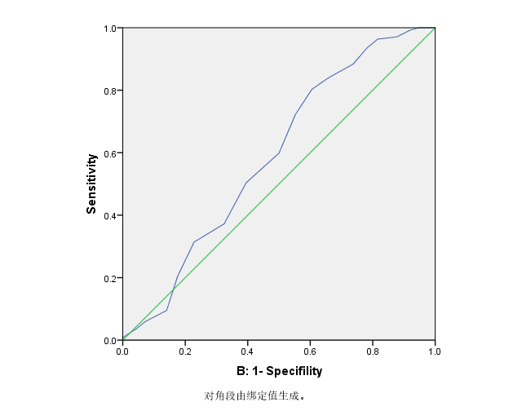
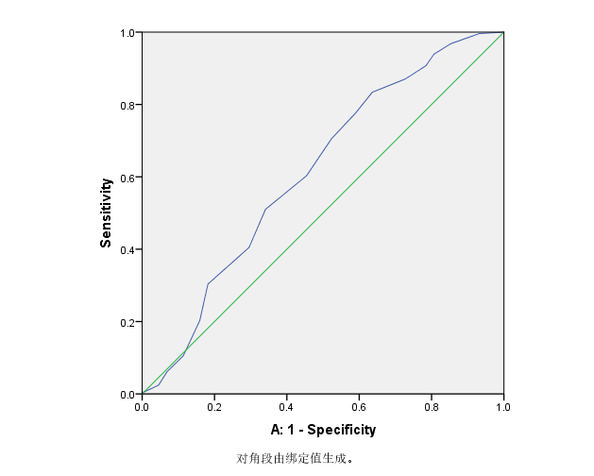
Note: A: ROC curve for cumulative clinical pregnancy;
B: ROC curve for cumulative birth rate

