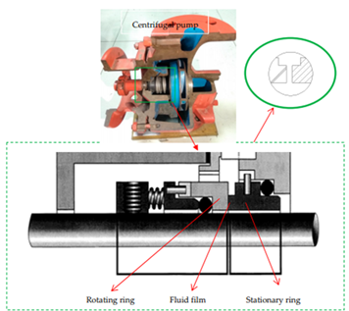
Supplementary Figure S1. Rotary shaft seal structure diagram.

(a) (b)
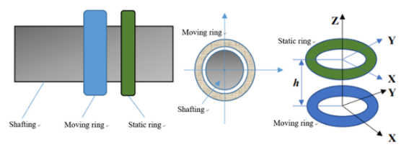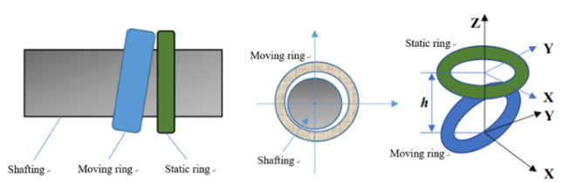
Supplementary Figure S2. The state of rotary shaft seal: (a)Standard; (b) under faulty condition.

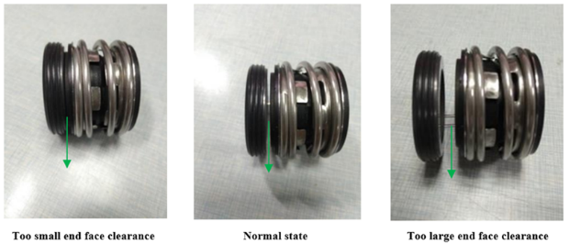
Supplementary Figure S3. Different degrees of extrusion failure and schematic diagram.

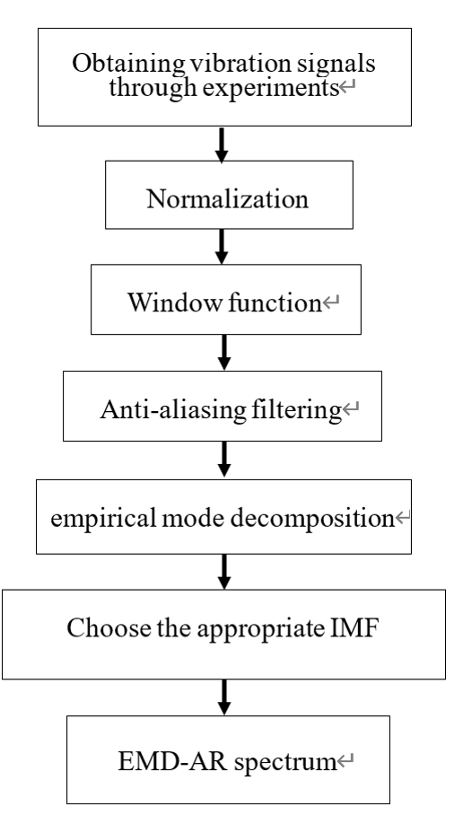
Supplementary Figure S4. Signal processing flowchart.

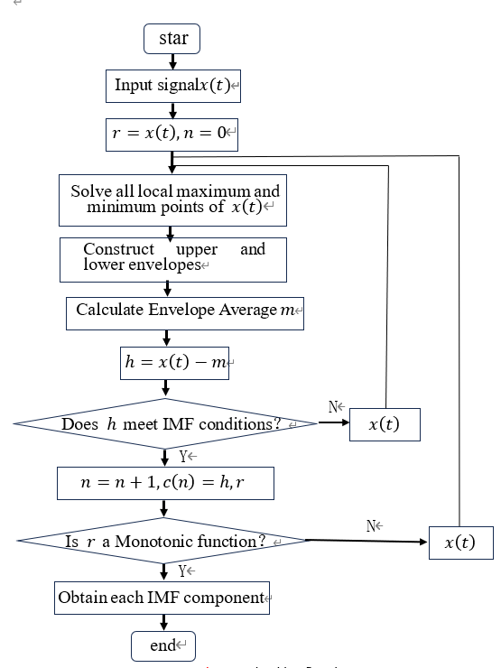
Supplementary Figure S5. Algorithm flowchart.

(a)

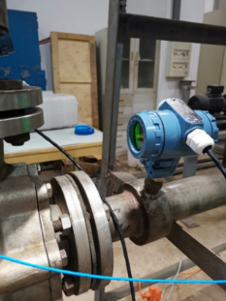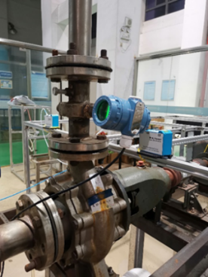

(b)
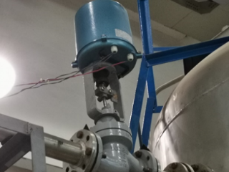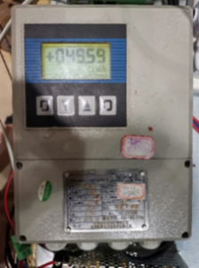

(c)
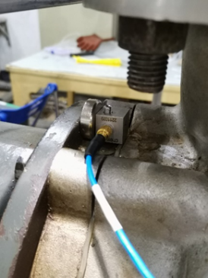

(d)
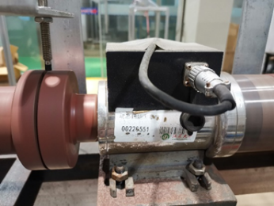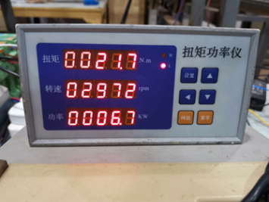

(e)
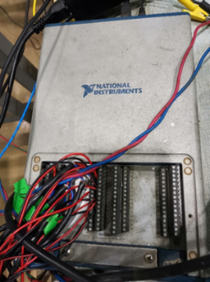
Supplementary Figure S6. All sensors and the acquisition card: (a) Static pressure sensor at the inlet and outlet; (b) Solenoid valve and digital display; (c) Installation diagram of vibration sensor; (d) Torque meter; (e) NI USB-6343 acquisition card.

(a) (b)
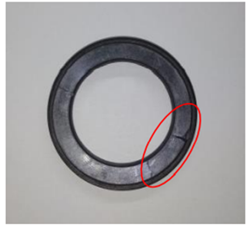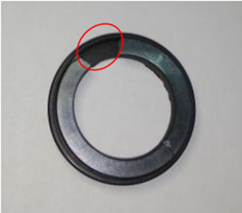
Supplementary Figure S7. Destroyed static ring and face: (a) Static ring end face under slight extrusion failure; (b) Static ring end face under severe extrusion failure.

