Population density is based on the WorldPop global population data set. It provides the latest and most accurate population data worldwide. It is widely used in research and data analysis around the world. The population density distribution data of the study area in 2000,2010 and 2020 are obtained. The population density of the study area is 0-36 people/km². The natural disaster risk level in the study area has obvious spatial heterogeneity (Fig. 7). On the whole, the high-risk areas of earthquakes, landslides and debris flows, and glacial lake outburst disasters are located in large areas on the southern and eastern edges of the region. Many road networks and pipe networks are in the frequent areas, and their potential hazards are huge. Mountain disaster data consider landslides, debris flows, flash floods and other disasters, using the risk assessment formula proposed by the United Nations Department of Humanitarian Affairs, combined with the risk of mountain disasters and the vulnerability of hazard-affected bodies to assess the possibility of risk. The risk value of mountain disasters in the study area is 0.3-123. The study area belongs to the plateau temperate semi-arid and semi-humid climate. In winter, it is windy, less precipitation and dry, while in summer, there is relatively more precipitation and higher temperature. The annual average temperature data and annual precipitation data are the CRU TS climate data set provided by the National Center for Atmospheric Sciences (NCAS) in the United Kingdom, with a range of −4-14°C and 183-2,393mm, respectively. The east-west and north-south rivers constitute the water system pattern of the Himalayan transboundary region. The MNDWI data and the NDVI data are available through the GEE platform processing. By loading MODIS image data through code input operation, preprocessing and band calculation of remote sensing data, MNDWI and NDVI in a wide range of areas are efficiently obtained, ranging from −0.8 to 0.9 and −0.4 to 1, respectively. Download digital elevation data for 2020 from the USGS website. ArcGIS is used to cut and splice DEM data, and slope tool is used to extract slope information. The spatial distribution map of slope factor is calculated, and the range is 0-60°. The NPP data is MOD17A3 remote sensing data from 2001 to 2020 provided by NASA, which has been widely used in global and regional NPP and carbon cycle research. The NPP data required for this study in 2000 will be replaced by the data in 2001, with a range of 0-1,903gC/m²·a. Nighttime light remote sensing data has been widely used in research work such as urbanization process monitoring, which can reflect the degree of social and economic development of the region to a certain extent, ranging from 0 to 16.
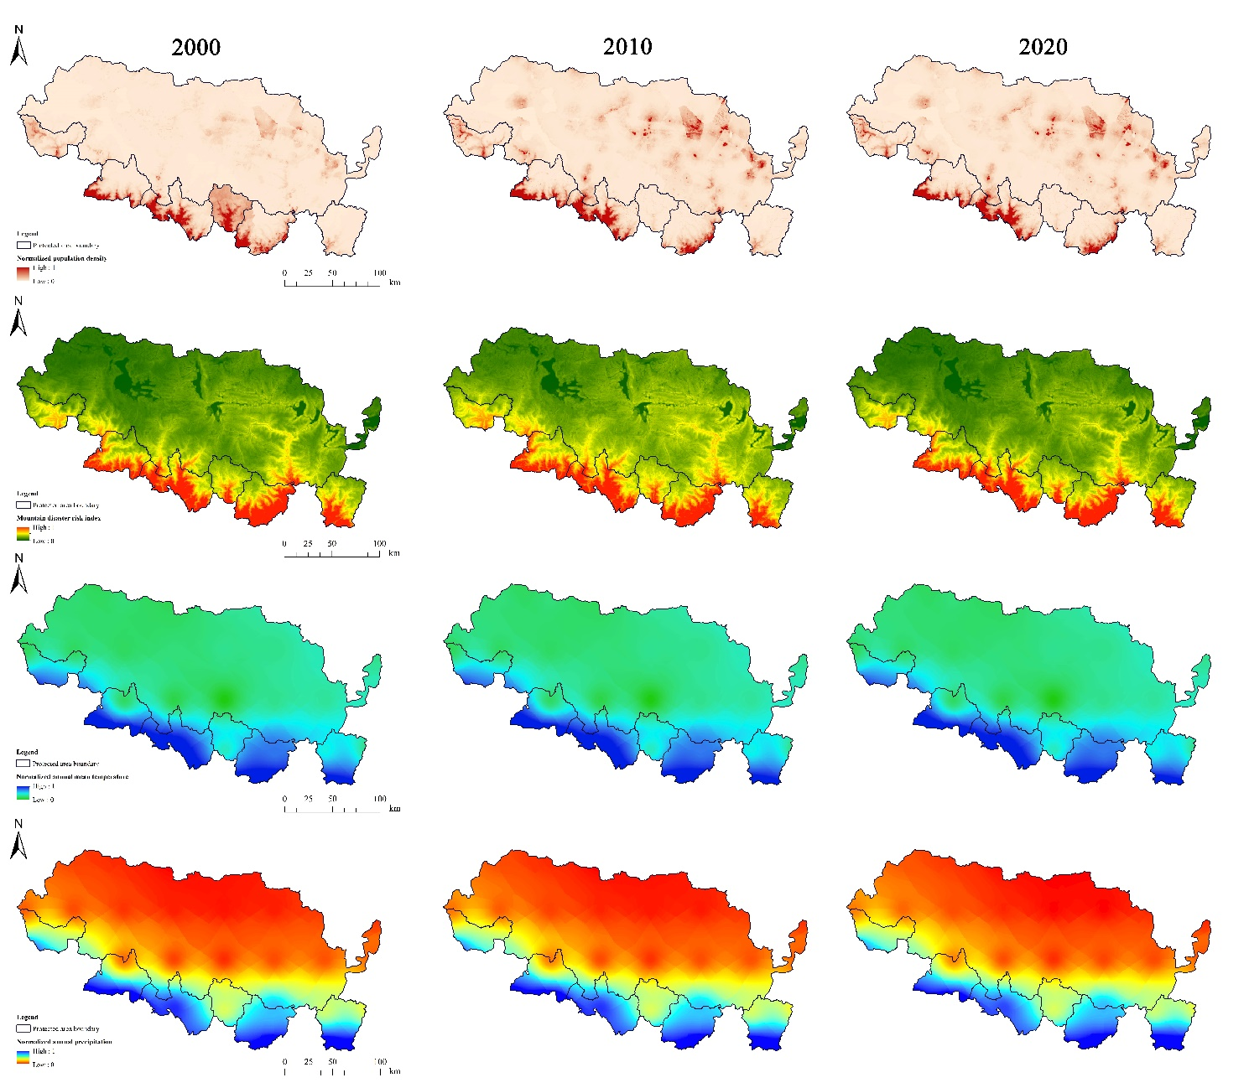
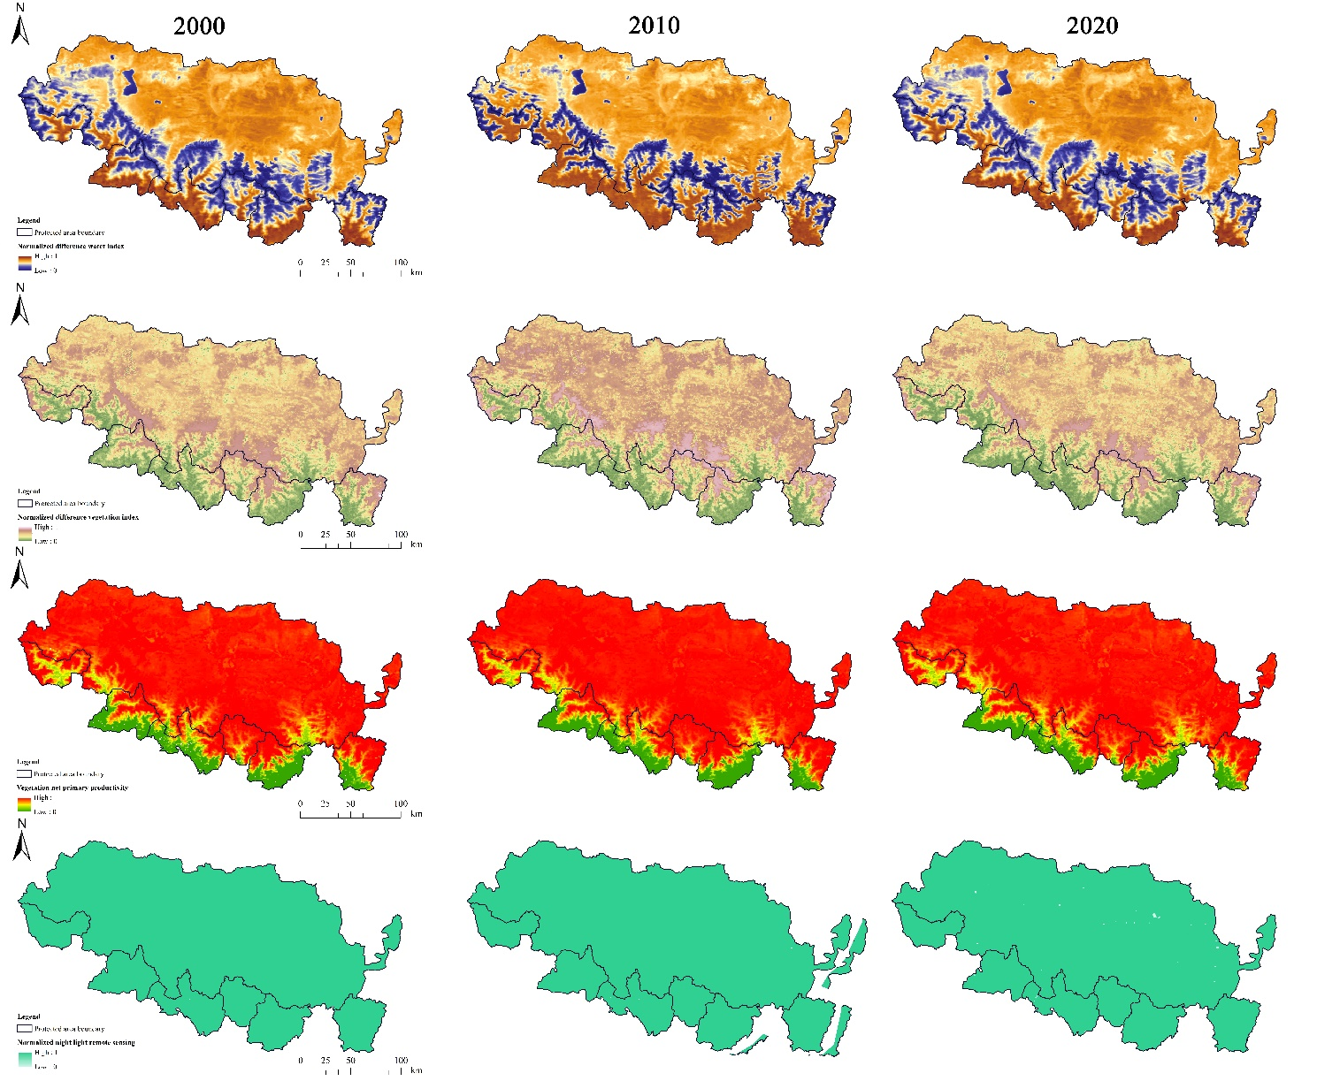
Figure 7. Environmental impact factors in the Himalayan cross-border region.
The R² value of the fitting model was between 0.002 and 0.557, and all the fitting models passed the F test (P < 0.05), which was statistically significant. The tolerance of all variables is high enough to ensure that multicollinearity problems are excluded. For the same landscape index, the regression coefficients and significance of different influencing factors are different (Table 3). The specific results are as follows: worldpop was positively correlated with PD, and had a weak negative correlation with CONTAG. Disaster has a significant impact on CONTAG in the landscape pattern. Tmp mainly had a significant impact on PD and SHEI in the landscape pattern. Pre mainly affects the LPI, LSI, CONTAG and SHEI in the landscape pattern. MNDWI and NDVI mainly affected PD, LPI, LSI, CONTAG and SHEI in landscape pattern. PD, LSI and SHEI were negatively correlated, and LPI was positively correlated with CONTAG. Slope mainly affects LPI, LSI, CONTAG and SHEI in landscape pattern, and LPI is negatively correlated with CONTAG. Npp mainly affects LPI and LSI in landscape pattern, among which LPI shows negative correlation and other indicators are positively correlated. Ntl mainly affects PD and LPI in landscape pattern. There was no significant effect between other landscape indices and influencing factors.
Particular year | Influencing factor | PD |  | LPI |  | LSI |  | CONTAG |  | SHEI
Particular year | Influencing factor | Beta | Sig | Beta | Sig | Beta | Sig | Beta | Sig | Beta | Sig
2000 | Disaster | -0.113 | 0.29 | -0.045 | 0.567 | 0.103 | 0.185 | 0.231 | 0.012 | -0.045 | 0.578
2000 | MNDWI | -0.184 | 0 | 0.412 | 0 | -0.345 | 0 | 0.316 | 0 | -0.391 | 0
2000 | NDVI | -0.184 | 0.006 | 0.435 | 0 | -0.462 | 0 | 0.304 | 0 | -0.381 | 0
2000 | Npp | 0.059 | 0.594 | -0.321 | 0.014 | 0.352 | 0.004 | -0.054 | 0.589 | 0.147 | 0.151
2000 | Ntl | 0.038 | 0.006 | 0.026 | 0.047 | -0.002 | 0.899 | 0.014 | 0.063 | -0.018 | 0.241
2000 | Pre | 0.165 | 0.188 | -0.379 | 0 | 0.398 | 0 | -0.464 | 0 | 0.557 | 0
2000 | Slope | 0.085 | 0.309 | -0.177 | 0.005 | 0.236 | 0 | -0.195 | 0.001 | 0.145 | 0.019
2000 | Tmp | 0.269 | 0.013 | -0.006 | 0.956 | -0.04 | 0.682 | 0.066 | 0.486 | -0.153 | 0.094
2000 | Worldpop | 0.253 | 0 | -0.037 | 0.418 | -0.061 | 0.212 | -0.067 | 0.034 | 0.047 | 0.251
2000 | Disaster | -0.072 | 0.803 | -0.29 | 0.078 | 0.237 | 0.029 | 0.096 | 0.761 | 0.317 | 0.01
2000 | MNDWI | -0.251 | 0 | 0.333 | 0 | -0.294 | 0 | 0.302 | 0 | -0.333 | 0
2000 | NDVI | -0.122 | 0.145 | 0.391 | 0 | -0.431 | 0 | 0.296 | 0.001 | -0.353 | 0
2000 | Npp | -0.165 | 0.138 | -0.293 | 0.004 | 0.276 | 0.002 | 0.19 | 0.348 | 0.202 | 0.351
2000 | Ntl | 0.027 | 0.183 | 0.016 | 0.6 | 0.009 | 0.664 | -0.024 | 0.491 | 0.021 | 0.448
2000 | Pre | 0.284 | 0.001 | -0.462 | 0 | 0.527 | 0 | -0.393 | 0 | 0.512 | 0
2000 | Slope | 0.062 | 0.607 | -0.055 | 0.562 | 0.096 | 0.267 | -0.004 | 0.956 | 0.029 | 0.762
2000 | Tmp | 0.2 | 0.137 | 0.253 | 0.294 | -0.254 | 0.237 | 0.134 | 0.523 | -0.265 | 0.003
2000 | Worldpop | 0.059 | 0.458 | 0.11 | 0.285 | -0.104 | 0.176 | 0.145 | 0.185 | -0.097 | 0.212
2000 | Disaster | -0.072 | 0.803 | -0.29 | 0.078 | 0.237 | 0.029 | 0.096 | 0.761 | 0.317 | 0.01
2000 | MNDWI | -0.251 | 0 | 0.333 | 0 | -0.294 | 0 | 0.302 | 0 | -0.333 | 0
2000 | NDVI | -0.122 | 0.145 | 0.391 | 0 | -0.431 | 0 | 0.296 | 0.001 | -0.353 | 0
2000 | Npp | -0.165 | 0.138 | -0.293 | 0.004 | 0.276 | 0.002 | 0.19 | 0.348 | 0.202 | 0.351
2000 | Ntl | 0.027 | 0.183 | 0.016 | 0.6 | 0.009 | 0.664 | -0.024 | 0.491 | 0.021 | 0.448
2000 | Pre | 0.284 | 0.001 | -0.462 | 0 | 0.527 | 0 | -0.393 | 0 | 0.512 | 0
2000 | Slope | 0.062 | 0.607 | -0.055 | 0.562 | 0.096 | 0.267 | -0.004 | 0.956 | 0.029 | 0.762
2000 | Tmp | 0.168 | 0.322 | -0.203 | 0.266 | 0.136 | 0.582 | -0.126 | 0.383 | -0.184 | 0.462
2000 | Worldpop | 0.097 | 0.26 | 0.113 | 0.009 | -0.1 | 0.083 | 0.141 | 0.008 | -0.085 | 0.182
Table 1. The driving force source coefficient and significance test of landscape pattern in the Himalayan transboundary area.

