Supplementary Figure
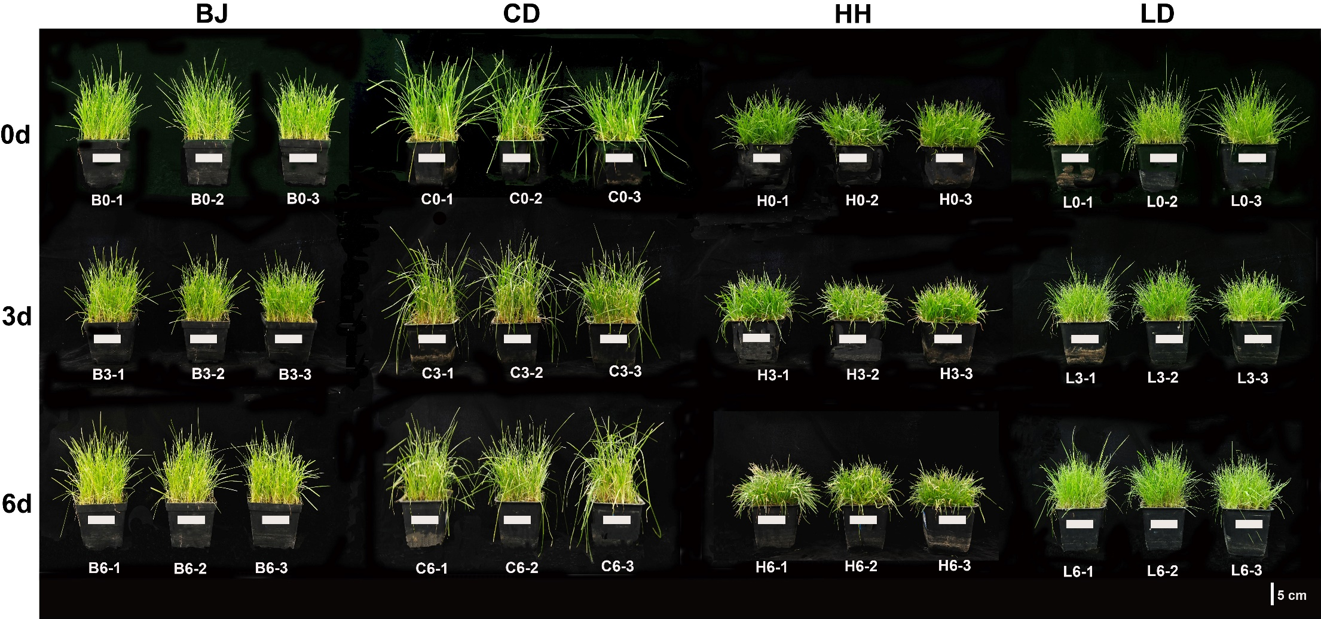
Fig. S1 Growth phenotypes of four Poa species under cold treatment at 4°C. BJ, P. pratensis var. anceps. CD, P. pratensis. HH, P. sinoglauca. LD, P. crymophila.
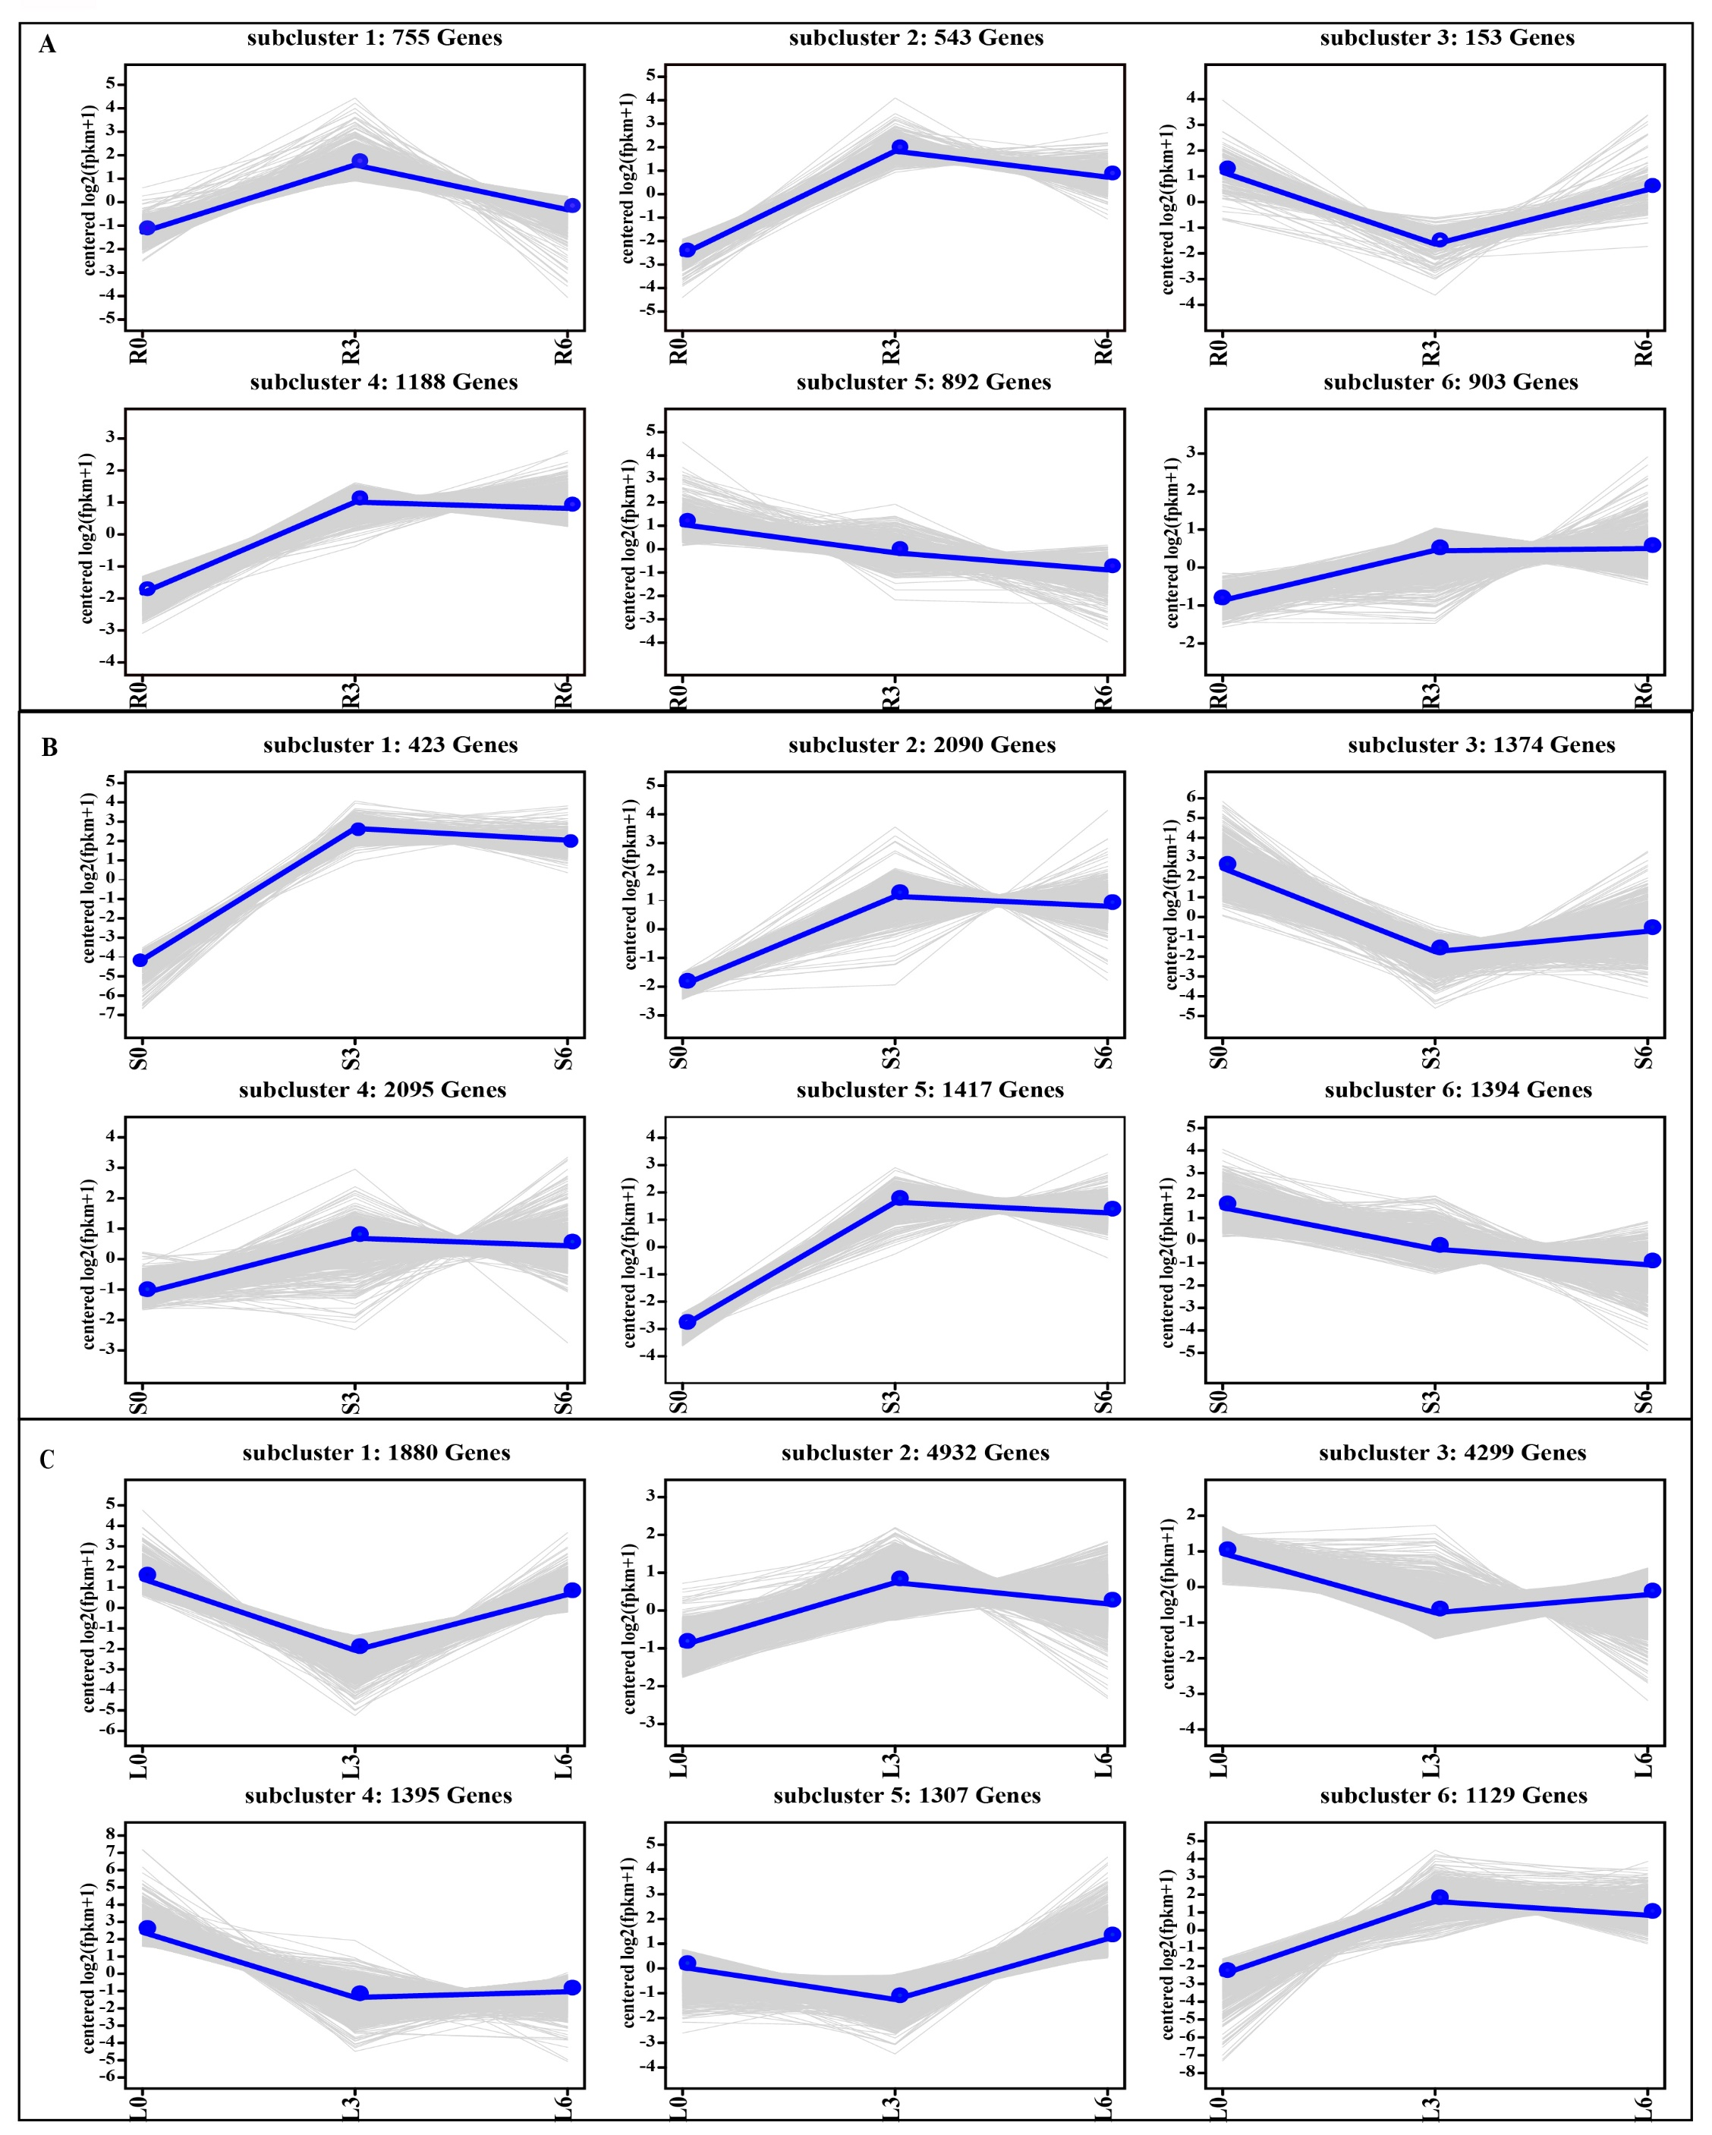
Fig. S2 Differentially expressed gene expression patterns in roots, stems and leaves across three time. A, roots. B, stems. C, leaves. The light grey lines represent the expression pattern of each gene, while the thick, blue lines represent the expression tendency of all the genes. In the roots, subclusters 2, 4, and 6 were three up-regulated patterns containing 543, 1118, and 903 DEGs, respectively (A); subcluster 5 was the down-regulated pattern, containing 892 DEGs (A). In the stems, subclusters 1, 2, 4 and 5 were three up-regulated patterns containing 423, 2090, 2095 and 1417 DEGs, respectively (B); Subclusters 3 and 5 were down-regulated patterns containing 1374 and 1394 DEGs, respectively (B). In the leaves, subclusters 2 and 6 were up-regulated patterns, containing 4932 and 1129 DEGs, respectively (C).
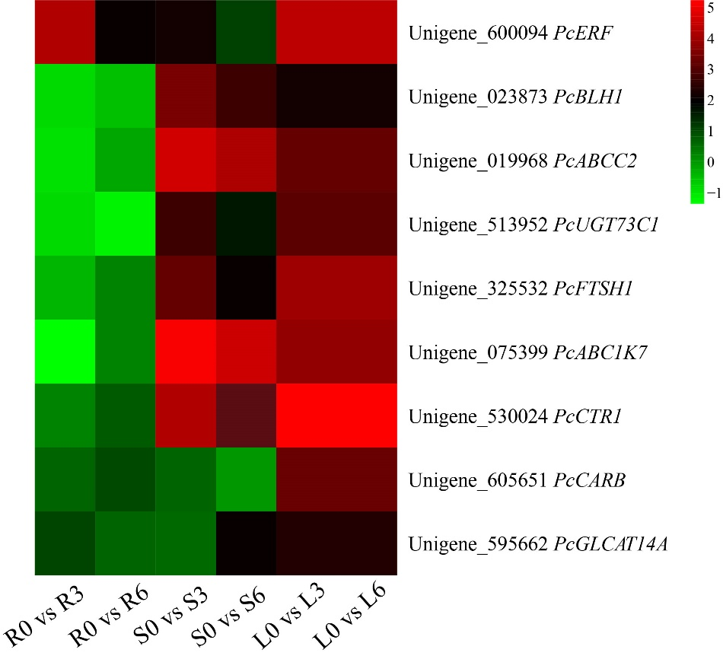
Fig. S3 Heat map of the expression of the nine selected Hub genes.

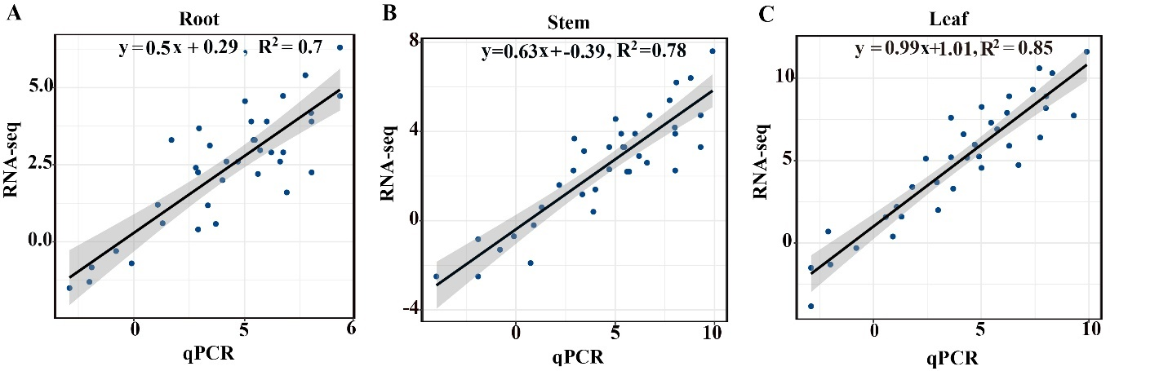
Fig. S4 Correlation analysis.

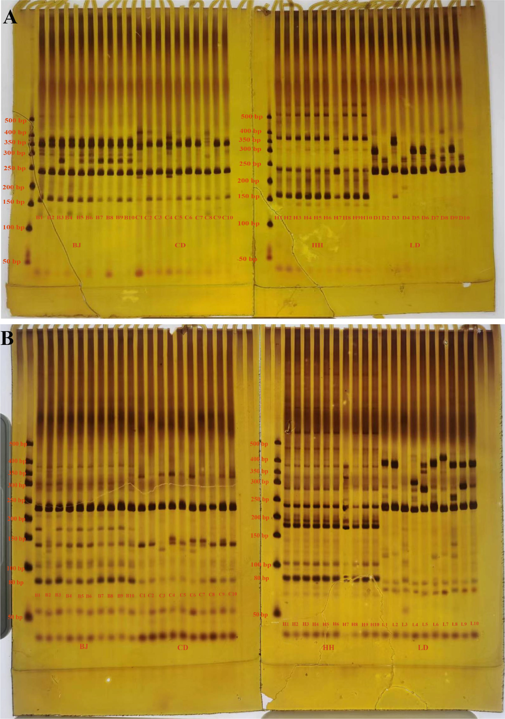
Fig. S5 Results of PCR amplification of primers P37(A) and P148(B) in 40 individual plants of four Poa species. The different codes represent the genotypes of the individuals, B1 to B10 for the 10 genotypes of BJ (P. pratensis var. anceps), C1 to C10 for the 10 genotypes of CD (P. pratensis), H1 to H10 for the 10 genotypes of HH (P. botryoides), L1 to L10 represent the 10 genotypes of LD (P. crymophila).

