Supporting Information

Extensive, reversible, and Controllable Reduction in Friction of Atomically Thin Two-Dimensional Materials through High-Stress Pre-Rubbing

Haoyang Su#, Honglin Zhang#, Haojie Lang, Kun Zou, Junhui Sun, Yitian Peng*

H. Y. Su, K. Zou, H. J. Lang, Y. T. Peng
College of Mechanical Engineering, Donghua University, Shanghai 201620, China.
E-mail: yitianpeng@dhu.edu.cn

H. L. Zhang, J. H. Sun
Tribology Research Institute, State Key Laboratory of Traction Power, School of Mechanical Engineering, Southwest Jiaotong University, Chengdu 610031, China.
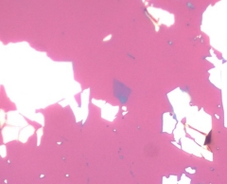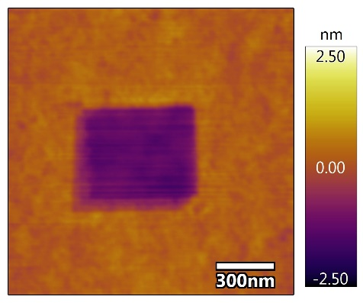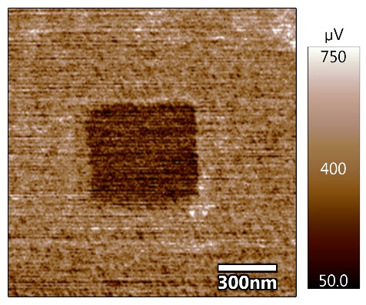
MoS₂
(b)

(c)

(a)

Fig S1. Pre-rubbing and friction measurements of MoS₂ on SiO₂/Si substrate. (a) Optical image of a 1.1nm thick MoS₂ flake deposited on SiO₂/Si substrate. (b) Topography image after pre-rubbing under 10.0 GPa, note that a drift occurs during the scanning-down stage. (c) Friction mapping after pre-rubbing (with a normal load of 50nN) acquired simultaneously with topography.

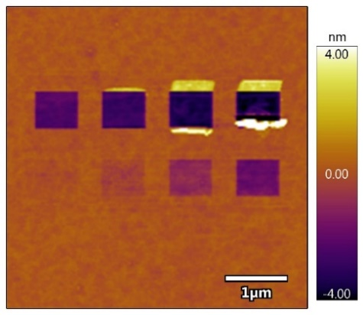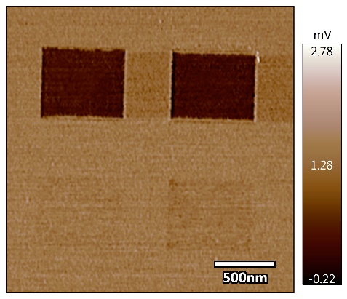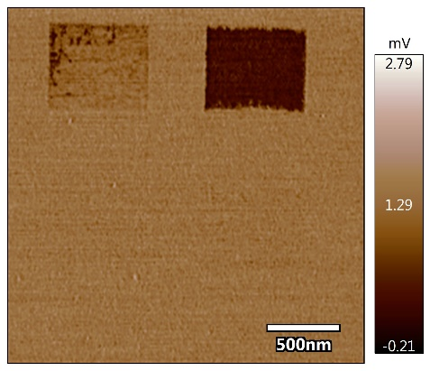
Region 2
Region 1
13.2GPa
12.5GPa
11.6GPa
10.5GPa
9.2GPa
7.8GPa
(e)
(c)
(a)
Region 2
Region 1
12.5GPa
13.2GPa
13.9GPa
14.6GPa
7.8GPa
9.2GPa
10.5GPa
11.6GPa
6.6GPa
5.8GPa
4.6GPa
3.9GPa
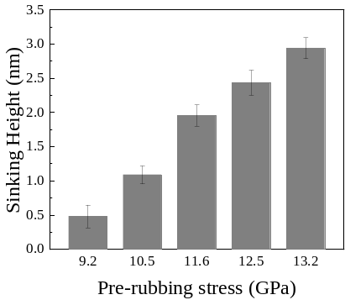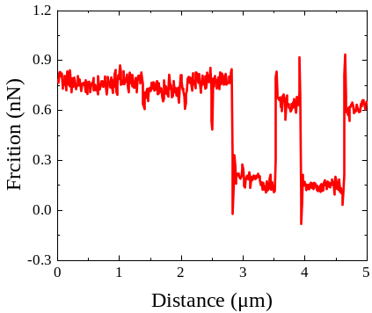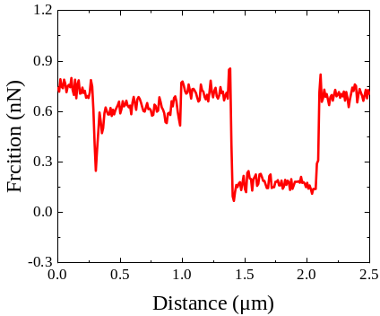
(b)

12.5GPa
11.6GPa
10.5GPa
9.2GPa
13.2GPa
(f)

(d)

Fig S2. Friction mapping of the graphene pre-rubbed under different stress levels after 10 days involves localized scanning to avoid damaged areas, acquired using a Si tip (Multi75Al-G, 3.0 N/m, Budget Sensors). (a) Topography image acquired in noncontact mode. (b) Average sinking height as a function of the pre-rubbing stress. (c) and (e) presented the friction mappings of Region 1 and Region 2 as illustrated in (a) at a normal load of 20nN, respectively. (d) and (f) depicted the profiles corresponding to the red lines in (b) and (c) respectively. Note that the two traces in (b) have been linked in (d).

The Young's modulus measurement was conducted with an AC160TS tip (26 N/m, OLYMPUS) in the AM-FM AFM model, as shown in Figure S3. The results in Figure S3(c) show that Young's modulus has no significant difference between the high-stress pre-rubbed region and the pristine graphene region, indicating that the reduction of the friction in the pre-friction region is not caused by the change of the basement Young's modulus
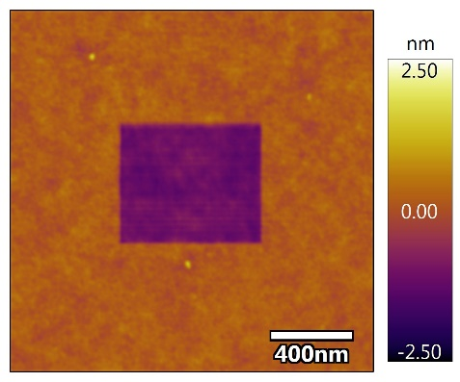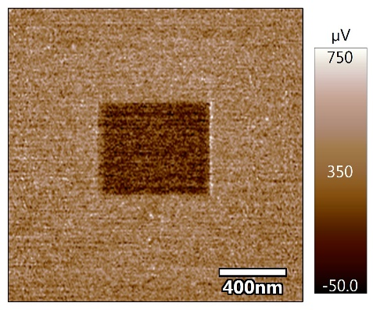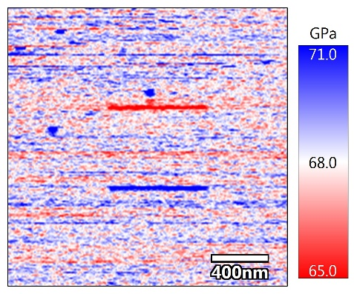
(b)
(c)
(a)
Fig S3. Young's modulus of graphene on SiO₂/Si substrate contains a pre-rubbed region. (a) Morphology. (b) Friction mapping acquired simultaneously with topography. (c) Young’s modulus.

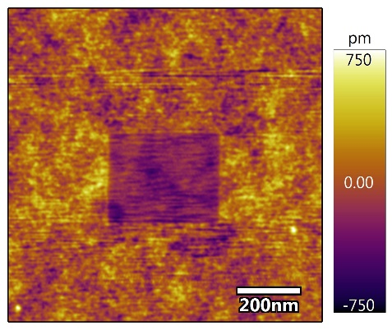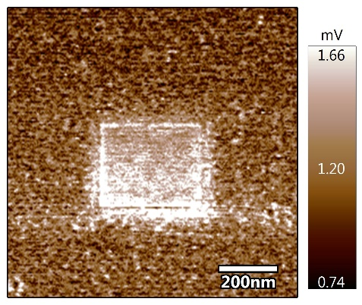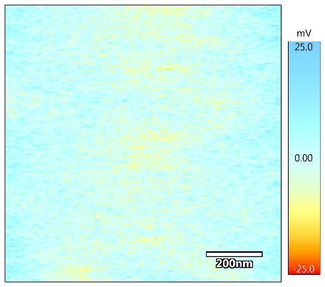
(c)
(b)
(a)
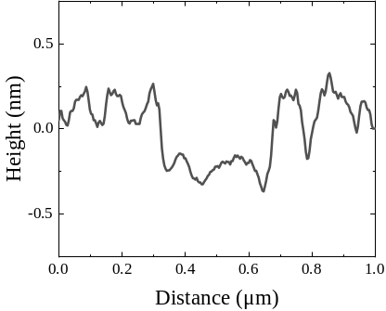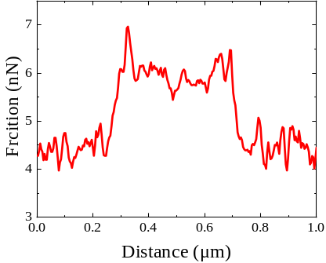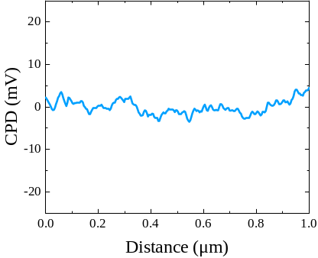
(f)

(e)

(d)

Fig S4. Experiments on the bare substrate with a stress level of 9.2GPa. (a) Topography image. (b) Friction mapping acquired simultaneously with topography under a normal force of 20nN. (c) SKPM image. (d), (e), and (f) depict the cross-sectional data profiles of the lines in (a), (b), and (c).
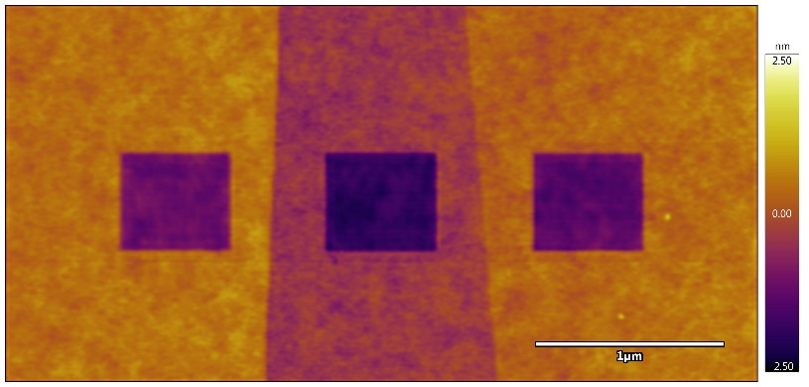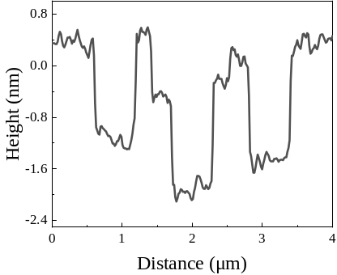
3L 1L 2L
(b)
(a)
Fig S5. Pre-rubbing experiments on the distinct thickness of graphene. (a) and (b) demonstrate the morphology and cross-sectional data profiles along the black dashed lines.

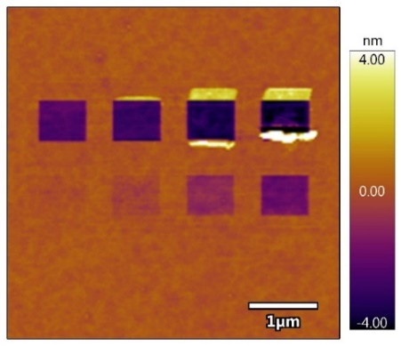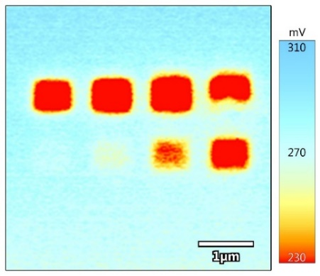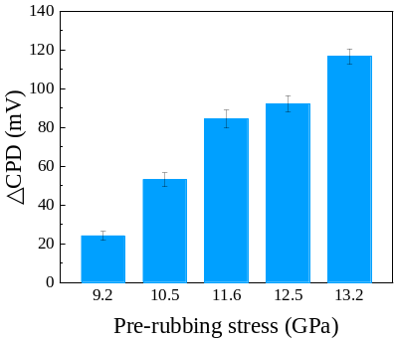
(c)
(b)
(a)
12.5GPa
13.2GPa
13.9GPa
14.6GPa
7.8GPa
9.2GPa
10.5GPa
11.6GPa
6.6GPa
5.8GPa
4.6GPa
3.9GPa
Fig S6. Characterization of surface potential. (a) Topography image of graphene following varied stress pre-rubbing. (b) SKPM image acquired simultaneously with topography. (c) △CPD as a function of the pre-rubbing stress.

High-stress pre-rubbing results in the sinking of the surface, forming a "crater". Because of the indentation, the graphene at the edge of the area is stretched, resulting in in-plane stress, as indicated by the red portion in Figure S7a. During the reciprocating sliding of the tip, disturbance is introduced to the graphene at the area's edge. The region with stress at the edge gradually lifts the graphene that is strongly adhered to the substrate, akin to the process of 'tearing tape'.
(b)
(a)
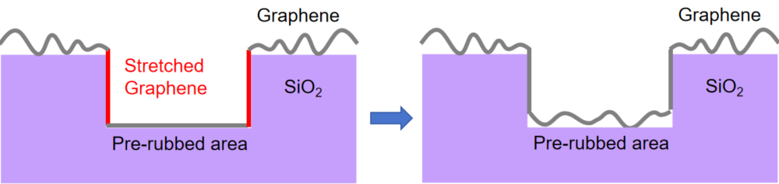
Fig S7. Schematic of the graphene before and after friction revivification.

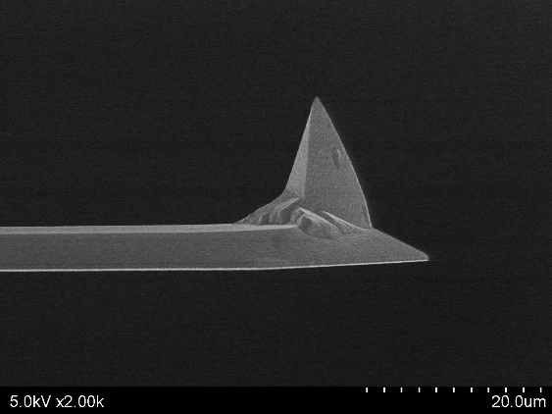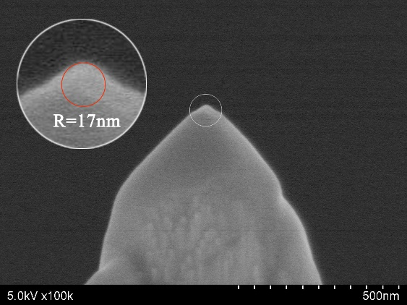
Fig S8. SEM images of the probe and an estimation of the tip radius after pre-rubbing.

