Appendix

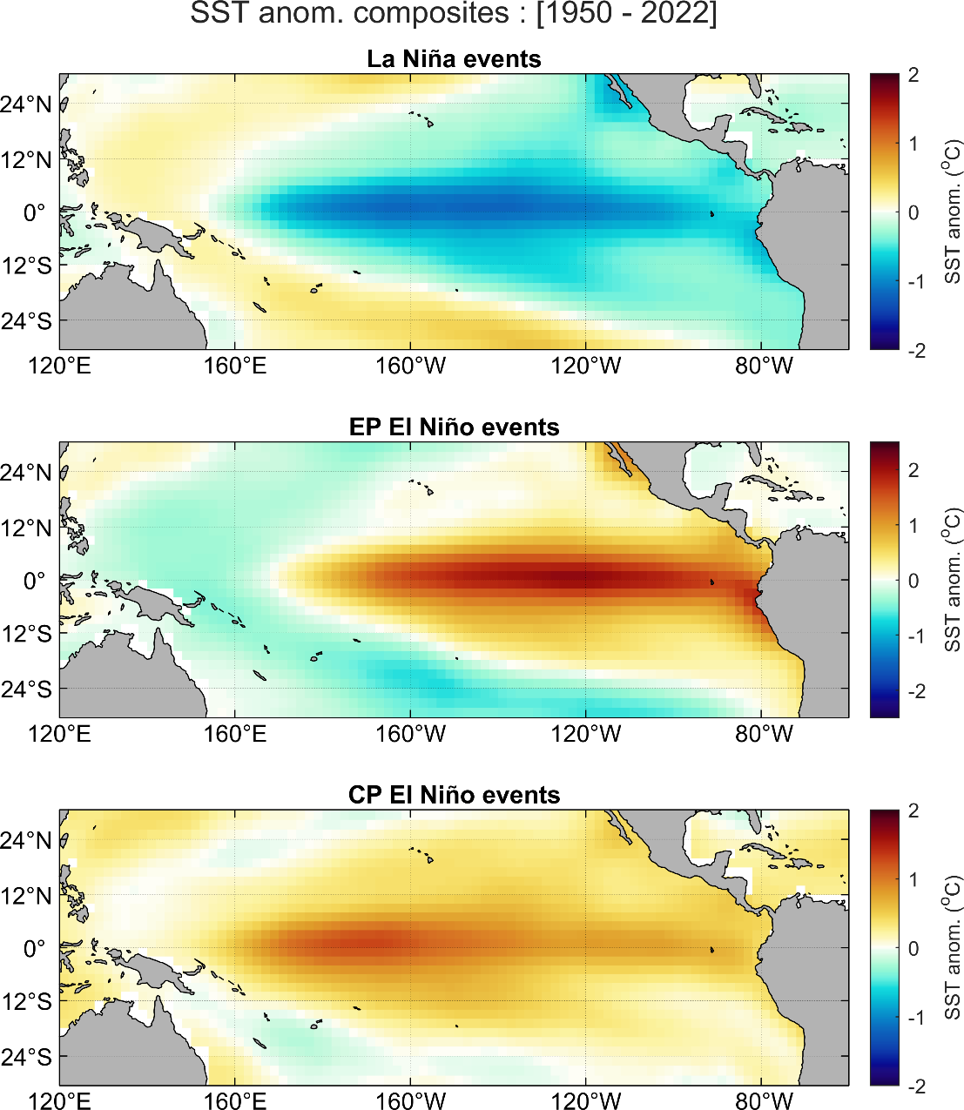
Fig. 15 Composite of SST anomalies during a) La Niña events, b) EP El Niño events and c) CP El Niño events identified between 1950 and 2022 as illustrated in Fig. 1

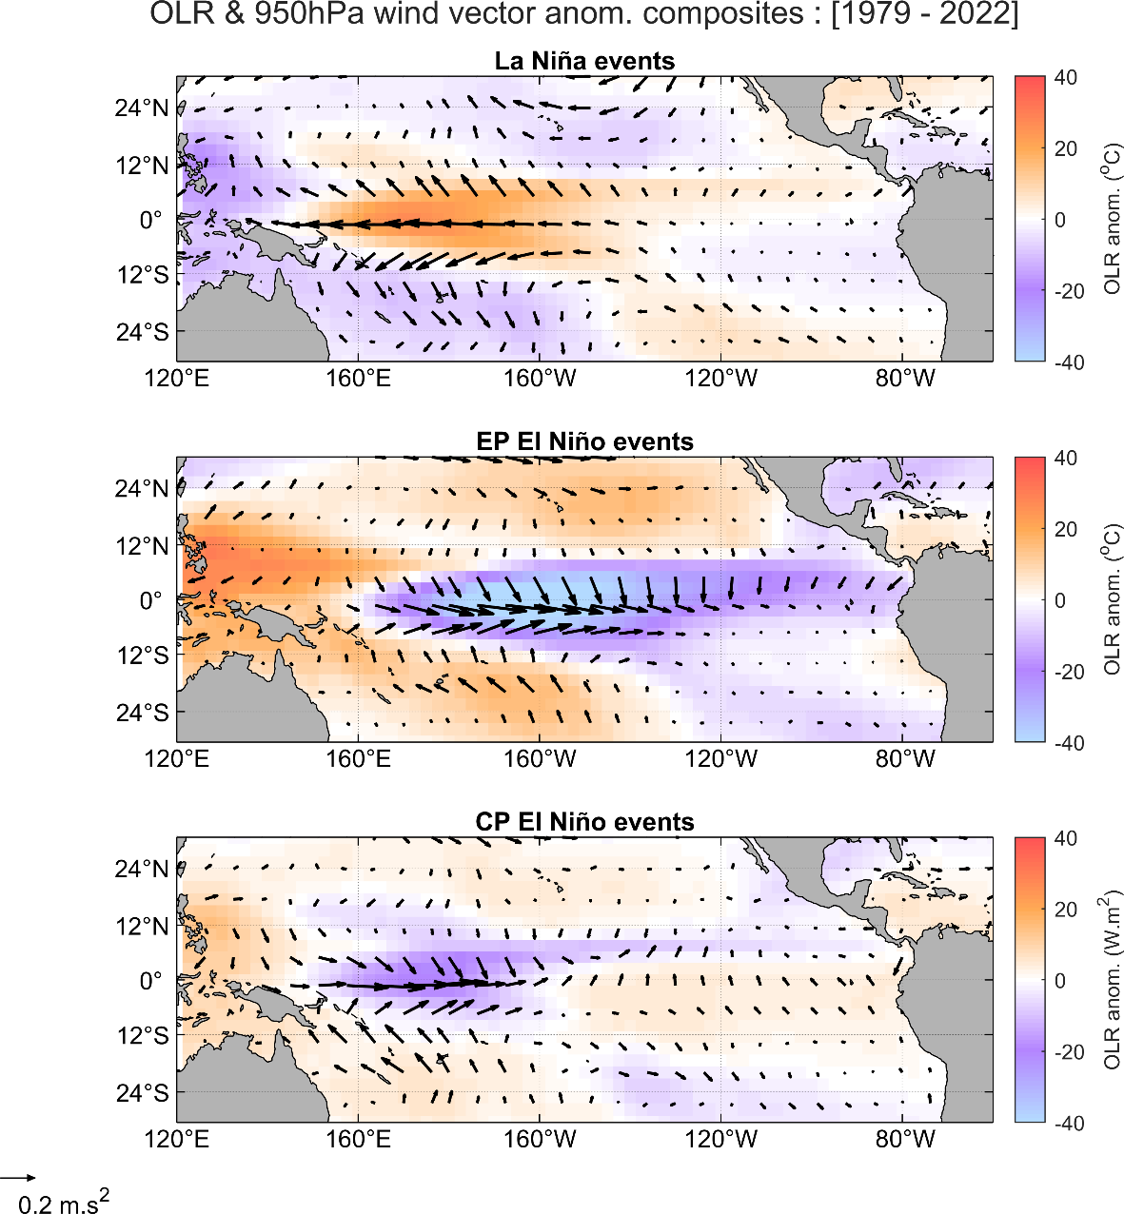
Fig. 16 Composite mean of Outgoing Longwave Radiation (OLR, shaded) and vector winds near-surface (950 hPa) during a) La Niña events, b) EP El Niño events and c) CP El Niño events observed between 1979 and 2022 as illustrated in Fig.1

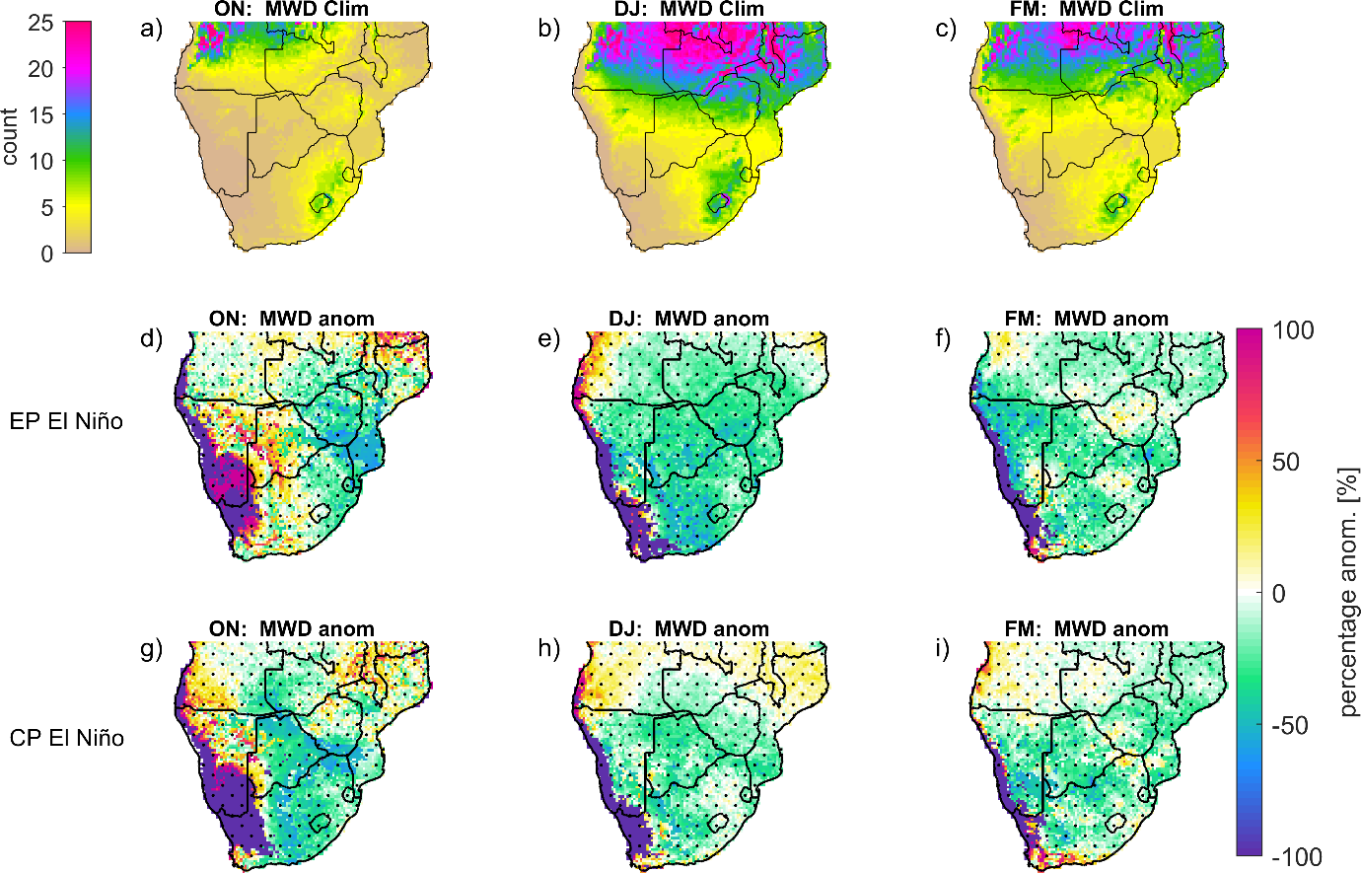
Fig. 17 same as Fig. 9, except that the 1997/98 EP El Niño and 1987/88 CP El Niño events are excluded from the composite analysis of EP El Niño (d-f) and CP El Niño (g-i), respectively

