In situ deposition of bismuth on pre-anodized screen-printed electrode for sensitive determination of Cd²⁺ in water and rice with a portable device
Yongfang Li¹, Zijun Wang¹, Xuan Chen¹, Zhijian Yi¹, Rui Wang^{2,3,4*}
¹ School of Food Science and Engineering, Foshan University, Foshan, 528231, China
² Human Phenome Institute, State Key Laboratory of Genetic Engineering, Fudan University, Shanghai, 200438, China
³ Center for Medical Research and Innovation, Shanghai Pudong Hospital, Fudan University Pudong Medical Center, Shanghai, 200438, China
⁴ International Human Phenome Institutes, Shanghai, 200438, China
*Correspondence: wangr@fudan.edu.cn (R.W.)

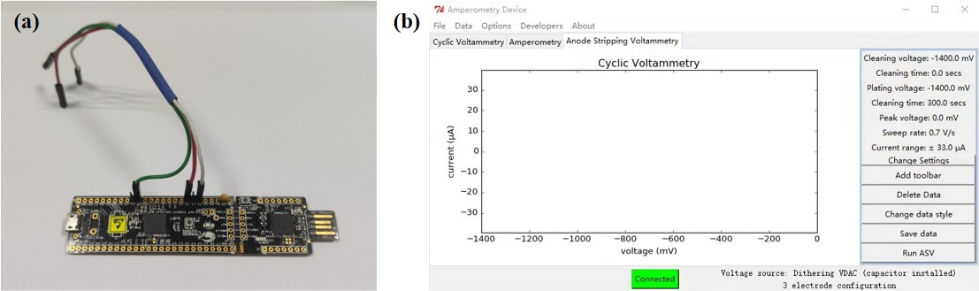

Figure S1. Demonstration of the self-made PSoC Stat potentiostat. (a) The main part of the potentiostat. (b) Software interface of PSoC Stat potentiostat.

Figure S2. Demonstration of the self-made stirring device. The time-delay relay, DC motor speed controller and motor were fabricated on a small plastic box.

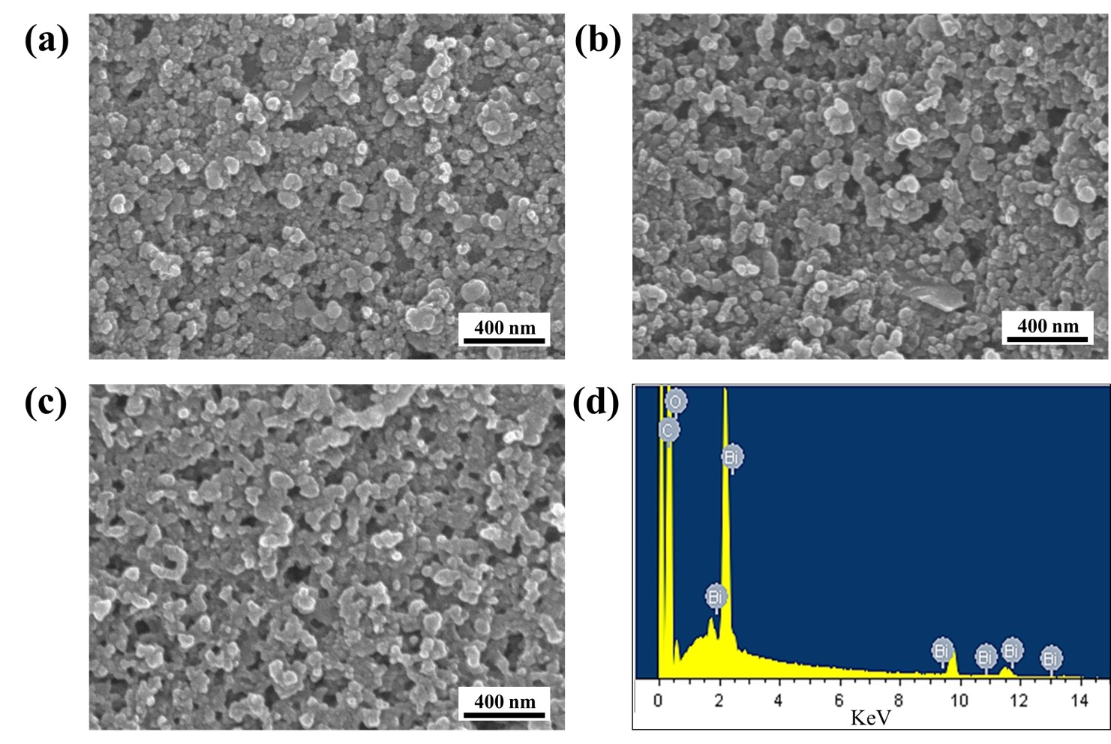
Figure S3. SEM images of bare electrode (a), pre-anodized electrode (b), and in-situ bismuth modified pre-anodized electrode (c). (d) EDX spectrum of in-situ bismuth modified pre-anodized electrode.

Figure S4. Influence of stirring rate on stripping peak signal of Cd²⁺.

Figure S5. The standard curves for Cd²⁺ determination using commercial potentiostat. (a) Stripping curves of Cd²⁺ with different concentrations. (b) The relationship between peak current value and Cd²⁺ concentration.

Figure S6. Simultaneous determination of Cd²⁺ and Pb²⁺ with in-situ bismuth modified pre-anodized electrode.

