Supplementary

Electret Integrated Magnetic Field Sensor Based on Magnetostrictive Polymer Composite with nT Resolution

Authors:
Lukas Zimoch^{*,1}, Stefan Schröder², Eric Elzenheimer^{3, 4}, Sören Kaps¹, Thomas Strunskus², Franz Faupel², Michael Höft³, Rainer Adelung^{*, 1}
* Corresponding authors, E-Mail: luzi@tf.uni-kiel.de, ra@tf.uni-kiel.de

Figure S1 shows frequency sweeps from four sensor elements, with a different filling factor of iron particles. The sensor element containing 10 wt.% iron particles is not able to detect the applied magnetic fields. A closer examination, as depicted in the inset, reveals the signal of the sensor element containing 30 wt.% of iron particles. The resonance frequency at 97 Hz has a signal strength of about 4 µV. The largest signal is generated by the 50 wt.% sensor element, while the signal decreases by increasing the particle concentration further, up to 70 wt.%.

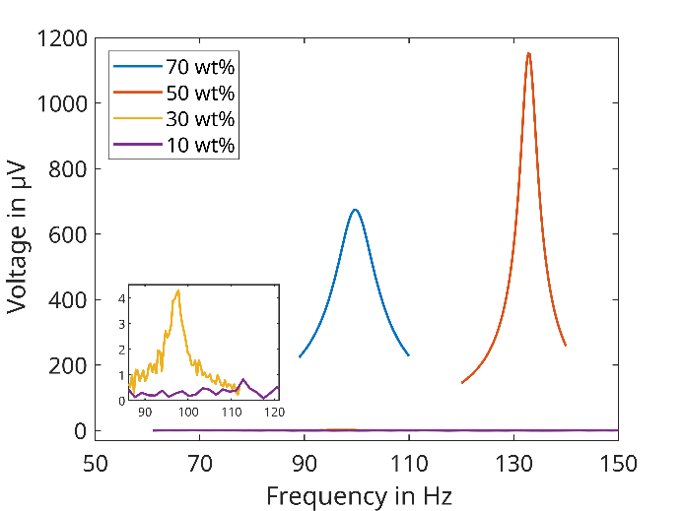
Figure S1: Frequency response of the sensor elements with different particle concentrations. The sensor element with a 50 wt.% concentration generates the largest signal. The inset reveals the resonance frequency of the 30 wt.% sample. It also verifies that the 10 wt.% sensor element does not measure any magnetic field.

The measurement involved applying a direct current (DC) bias field within the range of -1 mT to 1 mT. Starting at 1 mT, it increased in 0.1 mT increments until reaching 0 mT, then reversed to return from 0 mT to 1 mT (depicted as blue open circles) and all the way back to -1 mT (red crosses), cf. figure S1. The bias field does not change the magnetization of the sensor, thus the data points of the sweeps in both directions show the same value with a slight deviation originating from the accuracy of the measurement.
Between -200 µT and -300 µT there is a noticeable gap created by the measurement equipment, caused by a change of the measurement range. For absolute values larger than ± 600 µT, the voltage signal reaches a constant value. The largest signal is reached at a bias field of -533 µT.
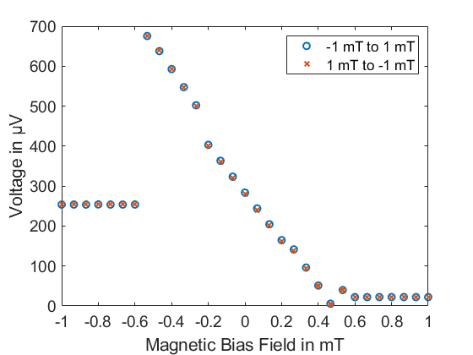
Figure S2: A bias measurement identified the optimal magnetic working point of the sensor. To make sure that the magnetization of the sensor is not changed during the measurement the bias field was first altered from -1 mT to 1 mT (black data points) and then the other way around (red data points). The magnetization of the sensor element is not changed and the optimal working point is at -533 mT. The measurement was performed, while the sensor was excited with an AC field of 100 µT at resonance frequency of 160.5 Hz.

