Table 1: Summary of yields for synthesis of 2-phenyl-4-oxo-4H-chromen-7-yl methanesulfonate derivatives
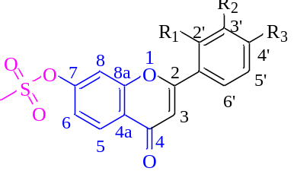
Entry | R1 | R2 | R3 | Yield of Step (ii) | Melting point (℃) | Yield of Step (iii) | Melting point (℃)
3a | H | H | H | 23% | >250 | 67% | 120-121
3b | H | H | CH₃ | 21% | >250 | 69% | 184-185
3c | H | H | OCH₃ | 32% | >250 | 78% | 208-212
3d | H | H | Cl | 12% | >250 | 71% | 201-203
3e | H | H | Br | 16% | >250 | 65% | 229-230
3f | OCH₃ | OCH₃ | H | 13% | >250 | 43% | 218-220
3g | OCH₃ | H | OCH₃ | 15% | >250 | 52% | 215-216
3h | H | OCH₃ | OCH₃ | 17% | >250 | 48% | 219-221
3i | OCH₃ | OCH₃ | OCH₃ | 26% | >250 | 54% | 224-226

Table 2. The cytotoxic activity of synthetic non-steroidal flavone-methanesulfonate derivatives against a breast cancer cell line (MCF-7) after 48 h treatment
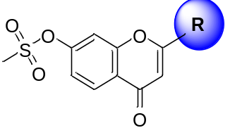
Compound | R | IC₅₀ (µM)ª | Compound | R | IC₅₀ (µM)ª
3a | 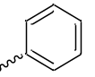 | 1.591± 0.433 | 3f | 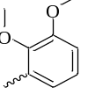 | 2.598± 0.32
3b | 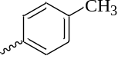 | 2.359± 0.177 | 3g | 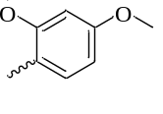 | 3.215± 0.070
3c | 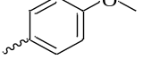 | 0.615± 0.077 | 3h | 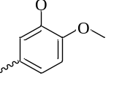 | 5.669± 0.050
3d | 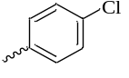 | 1.057± 0.408 | 3i | 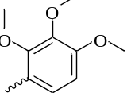 | 1.024± 0.300
3e | 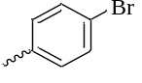 | 1.303± 0.410 | Positive control | Docetaxel | 0.500± 0.108
ª Each value represents the mean ± SD (n = 3-5)

