Supplementary Materials for

Synthesis of selective BCL-X_{L} PROTAC and potent antitumor activity in glioblastoma

Sun Biao¹⁺, Meichen Liu^{1,2,3+}, Yue Zhang¹, Rui Niu¹, XinYu Li¹, Jiefei Wang¹, Bingyang Shi^{1,5} and Jinlong Yin*^{1,4}

¹ Henan Key Laboratory of Brain Targeted Bio-nanomedicine, School of Life Sciences, Henan University, Kaifeng 475000, Henan, China, E-mail: jlyin@henu.edu.cn
² Department of Cancer Biomedical Science, Graduate School of Cancer Science and Policy, National Cancer Center, Goyang 10408, Republic of Korea
³ School of Basic Medical Science, Henan University, Kaifeng 475000, Henan, China
⁴ Huaihe Hospital of Henan University, Kaifeng 475000, Henan, China
⁵ Department of Biomedical Science, Faculty of Medicine, Health and Human Science Macquarie University, Sydney 201101, Australia
+ These authors contributed equally to this work.

This word file includes:

Figure S1. Bioinformatics analysis shows that BCL-X_{L} is associated with low survival rate and MDM2 is highly expressed in GBM.
Figure S2. Immunoblot analysis showed that BCL-X_{L} and MDM2 were highly expressed in GSCs, and ABT-263 could reduce the expression of BCL-X_{L} in GSCs.
Figure S3. The effects of AN-1 and AN-2 on GSC (448 cells).
Figure S4. Comparison of the effects of AN-1 and AN-2 with ABT-263 on GSCs at 0.1µm.

Synthetic Procedures and Characterization
Scheme S1. Synthesis of intermediate B11.
Scheme S2. Synthesis of intermediate C6.
Scheme S3. Synthesis of ligand D10 targeting BCL-X_{L}.

1. Supplementary Figures

Figure S1. (A) BCL-X_{L} expression in each type of brain tumor from the REMBRANDT database. (B) Kaplan-Meier survival plots for all glioma patients with high and low BCL-X_{L} expression. Data were obtained from the public database. (C) BCL-X_{L} expression in each type of brain tumor from the CGGA database. (D) Kaplan-Meier survival plots for all glioma patients with high and low BCL-X_{L} expression. Data were obtained from the public database. (E) BCL-2 expression in each type of brain tumor from the REMBRANDT database. (F) Kaplan-Meier survival plots for all glioma patients with high and low BCL-2 expression. Data were obtained from the public database. (G) BCL-2 expression in each type of brain tumor from the CGGA database. (H) Kaplan-Meier survival plots for all glioma patients with high and low BCL-2 expression. Data were obtained from the public database. (I) MDM2, VHL, CRBN expression in GBM from the REMBRANDT database.

Figure S2. (A) Expression of MDM2 and BCL-X_{L} in GSCs. (B) Expression of MDM2 and BCL-X_{L} in X01, 83, and 448 cells after ABT-263 treatment.

Figure S3. (A) Cell proliferation assays were performed in 488 cells treated with different concentrations of AN-1 and AN-2. Relative proliferation folds data are presented as mean ± SEM (n = 3, independent experiments), two-tailed Student’s t-test. (B) Representative images (left) and statistical analysis of data (right) for sphere-formation assays were performed using 488 cells treated with different concentrations of compound AN-1 and AN-2. Images are representative of three independent experiments. Scale bar, 50 µm. (C) Immunoblotting for PARP1, Cleaved-PARP1, Caspase3, Cleaved-Caspase3, MCL-1, BCL-2, BCL-X_{L} expression in 448 cells. (D) Flow cytometry for PI/Annexin-V apoptosis assay in X01, 83, and 448 GSCs treated with different concentrations of AN-1, AN-2 and ABT-263. Data were presented as mean ± S.E.M. of three independent experiments. Student’s t-test was conducted to detect significant differences. *P<0.05, **P<0.01, ***P<0.001.

Figure S4. (A) Immunoblotting for BCL-X_{L} expression in X01, 83 and 448 GSCs treatment with AN-1, AN-2 and ABT-263. (B) Cell proliferation assays were performed in X01, 83 and 448 GSCs treated with AN-1, AN-2 and ABT-263. Relative proliferation folds data are presented as mean ± SEM (n = 3, independent experiments), two-tailed Student’s t-test. (C) Representative images for sphere-formation assays were performed using X01, 83 and 448 GSCs treated with AN-1, AN-2 and ABT-263 (left image) and statistical analysis of data (right panel). Images are representative of three independent experiments. Scale bar, 50 µm. Bar charts show the mean ± S.E.M. of three independent experiments. Student’s t-test was conducted to detect significant differences. *P<0.05, **P<0.01, ***P<0.001.

Compound B1 is esterified with ethanol to obtain B2. Then, it was coupled with Boc piperazine to obtain B3. Then deprotection forms B4. B5 yields B6 in the presence of PBr₃ and DMF. B6 coupling yields B7. Then reduce with NaBH₄ to obtain B8. B8 is replaced by PBr₃ to obtain B9. The reaction between B9 and B4 yields B10. After hydrolysis of B10, B11 is obtained.

Scheme S1. Synthesis of intermediate B11.
Reagents and conditions: (a) DMF, SOCl₂, DCM, 0°C then 60°C, 4 h; (b) Boc-piperazidine, Pd(OAc)₂, Xantphos, Cs₂CO₃, 1,4-dioxane, 100°C, 12 h; (c) TFA, DCM, 0°C then rt, 2 h; (d) PBr₃, DMF, DCM, 0°C then rt, 12 h; (e) 4-Chlorophenylboronic acid, Pb(dppf)Cl₂, CH₃COOK, 1,4-dioxane, H₂O, 90°C, 0.5 h; (f) NaBH₄, H₂O, rt, 1 h; (g) PBr₃, DCM, 0°C, 0.5 h; (h) K₂CO₃, 100°C, 12 h; (i) THF, NaOH, H₂O, 90°C,10 h.

2-nitroaniline forms C2 in HCl, NaNO₂ and NaBF₄ at 0℃. And then react with CF₃NaO₂S to get C3. C3 reacts with KF to give C4, then ClHSO₃ to give C5, and finally NH₄OH to give C6.

Scheme S2. Synthesis of intermediate C6.
Reagents and conditions: (a) HCl, NaNO₂, H₂O, NaBF₄, 0°C, 0.5 h; (b) CF₃NaO₂S, Cu₂O, DMSO, 0°C then rt°C, 12 h; (c) Tetraphenylphosphonium bromide, KF, DMSO, 130°C, 3 h; (d) ClHSO₃, 0°C then 90°C, 3 h; (e) NH₄OH, isopropanol, 0°C, 1 h.

Compound D1 is reduced by NaBH₄ to D2, reacts with diphenyl disulfide to D3, and is reduced by DIBAL-H to D4. D4 was oxidized to D5, then reacted with Troc-piperazine to D6, and then removed Boc protective group to D7. D7 reacts with C6 to get D8, then condensates with B11 to get D9, and then removes Troc protection group to get D10.

Scheme S3. Synthesis of ligand D10 targeting BCL-X_{L}.
Reagents and conditions: (a) (1) N-methylmorpholine, isobutyl chloroformate, THF, -25°C then -15°C, 0.5 h; (2) NaBH₄, H₂O, -15°C, 0.5 h; (b) Bu₃P, diphenyl disulfide, toluene, 80°C, 12 h; (c) DIBAL-H, toluene, -78°C, 3 h; (d) Oxalyl chloride, DMSO, TEA, DCM, -78°C, 0.5 h; (e) NaBH(OAc)₃, TEA, DCM, rt, 12 h; (f) TFA, DCM, 0°C then rt, 4 h; (g) TEA, acetonitrile, reflux; (h) EDCI, DMAP, DCM, rt; (i) Zn, HOAc, THF, rt.

ethyl 4-bromobenzoate (B2).
Compound B1 (2.01 g, 10.0 mmol), N, N-dimethylformamide (DMF) (50 µL) and thionyl chloride (0.87 mL, 12.0 mmol) in dichloromethane (DCM) (10 mL) at 0°C and stirred for 0.5 h, and heated to 60°C stirred for 4 h. Anhydrous ethanol (1.17 mL, 20.0 mmol) and triethylamine (TEA) (4.17 mL, 30.0 mmol) were added dropwise at 0°C. The mixture was stirred at room temperature for 4 h and quenched with saturated sodium bicarbonate. The combined organic phases were washed with brine, dried over Na₂SO₄, filtered and evaporated to dryness under reduced pressure. The crude product was purified by silica gel flash column chromatography using ethyl acetate and hexanes as eluents to afford the title compound B2 (1.72 g, yield 75%).
tert-butyl 4-(4-(ethoxycarbonyl)phenyl)piperazine-1-carboxylate (B3).
Compound B2 (0.46 g, 2 mmol), Boc-piperazine (0.56 g, 3.0 mmol), palladium acetate (9.0 mg, 0.04 mmol), xantphos (35 mg, 0.06 mmol), cerium carbonate (1.3 g, 4.0 mmol) in 1-4 dioxane (10 mL) at 100°C under N₂ overnight. The reaction was quenched with saturated sodium bicarbonate. The combined organic phases were washed with brine, dried over Na₂SO₄, filtered and evaporated to dryness under reduced pressure. The crude product was purified by silica gel flash column chromatography using ethyl acetate and hexanes as eluents to afford the title compound B3 (0.46 g, yield 69%). ¹H NMR (300 MHz, CDCl₃) δ 7.97 (d, J = 8.9 Hz, 2H), 6.90 (d, J = 8.9 Hz, 2H), 4.37 (dd, J = 14.2, 7.1 Hz, 2H), 3.62 (s, 4H), 3.33 (s, 4H), 1.52 (s, 9H), 1.41 (t, J = 7.1 Hz, 3H).
ethyl 4-(piperazin-1-yl)benzoate (B4).
To a mixture of compound B3 (3.34 g, 10.0 mmol) in DCM (2 mL) was added to trifluoroacetic acid (TFA) (2.0 mL, 26.1 mmol). The mixture was stirred at room temperature for 4 h, and solvents were removed under reduced pressure. Add toluene for vacuum concentration, repeat 3 times to obtain compound B4 (2.23g, yield 95%).
2-Bromo-5,5-dimethylcyclohex-1 -ene-1 -carbaldehyde (B6).
Phosphine tribromide (7 mL,74.5 mmol) was added to an ice bath-cooled mixture of dichloromethane (50 mL) and DMF (6.5 mL). The reaction mixture was stirred at room temperature for 30 minites. The mixture was cooled to 0°C, 4,4-dimethylcyclohexanone (3.25 g, 25.8 mmol) was dissolved in DCM (25 mL) and added to the reaction mixture. The mixture was gradually returned to room temperature and stirred for 16 h. The reaction was quenched with saturated sodium bicarbonate of ice. The combined organic phases were washed with brine, dried over Na₂SO₄, filtered and evaporated to dryness under reduced pressure. The crude product was purified by silica gel flash column chromatography using ethyl acetate and hexanes as eluents to afford the title compound B6 (4.12 g, yield 74%). ¹H NMR (300 MHz, CDCl₃) δ 10.06 (s, 1H), 2.84-2.74 (m, 2H), 2.12 (s, 2H), 1.56 (s, 2H), 0.99 (s, 6H).
4'-Chloro-4,4-dimethyl-3,4,5,6-tetrahydro-[1,1'-biphenyl]-2-carbaldehyde (B7).
Compound B6 (2.16 g, 10.0 mmol) and 4-chlorophenyl boronic acid (1.88 g, 15.0 mmol) in 1,4-dioxane (50 mL) and H₂O (0.5 mL) were added KOAc (2.94 g, 30.0 mmol) and Pd(dppf)Cl₂ (73.2 mg, 0.1 mmol) under N₂. The reaction mixture was stirred at 90°C for 1 h, and then quenched with H₂O. The combined organic phases were washed with brine, dried over Na₂SO₄, filtered and evaporated to dryness under reduced pressure. The crude product was purified by silica gel flash column chromatography using ethyl acetate and hexanes as eluents to afford the title compound B7 (1.49 g, yield 60%). ¹H NMR (300 MHz, CDCl₃) δ 9.53 (s, 1H), 7.39 (d, J = 8.4 Hz, 2H), 7.20 (d, J = 8.4 Hz, 2H), 2.57 (t, J = 2.1 Hz, 2H), 2.18 (s, 2H), 1.57 (t, J = 6.4 Hz, 2H), 1.02 (s, 6H).
(4'-Chloro-4,4-dimethyl-3,4,5,6-tetrahydro-[1,1 '-biphenyl]-2-yl) methanol (B8).
Compound B7 (1.66 g, 6.7 mmol) in THF (5 mL) and H₂O (5 mL) was added NaBH₄ (0.37 g, 7.9 mmol). The mixture was stirred at room temperature for 1 h and quenched with saturated sodium bicarbonate. The combined organic phases were washed with brine, dried over Na₂SO₄, filtered and evaporated to dryness under reduced pressure. The crude product was purified by silica gel flash column chromatography using ethyl acetate and hexanes as eluents to afford the title compound B8 (1.22 g, yield 78%). ¹H NMR (300 MHz, CDCl₃) δ 7.32 (t, J = 5.7 Hz, 2H), 7.12 (d, J = 8.3 Hz, 2H), 3.95 (s, 2H), 2.32 (s, 2H), 2.09 (s, 2H), 1.52 (t, J = 6.5 Hz, 2H), 1.34 (t, J = 12.0 Hz, 3H), 1.04 (s, 6H).
6-(Bromomethyl) -4'-chloro-4,4-dimethyl-2,3,4,5-tetrahydro-1,1'-biphenyl (B9).
Compound B8 (1.67 g, 6.7 mmol) in DCM (15 mL) was added PBr₃ (1.34 g, 5.0 mmol) at 0°C. The reaction mixture was stirred at 0°C for 0.5 h and then quenched with saturated sodium bicarbonate. The combined organic phases were washed with brine, dried over Na₂SO₄, filtered and evaporated to dryness under reduced pressure. The crude product was purified by silica gel flash column chromatography using ethyl acetate and hexanes as eluents to afford the title compound B9 (1.50 g, yield 72%).
ethyl 4-(4-((4'-chloro-4,4-dimethyl-3,4,5,6-tetrahydro-[1,1'-biphenyl]-2-yl)methyl)piperazin-1-yl)benzoate (B10).
Compound B9 (1.66, 5.3 mmol), Methyl 4-piperazin-1-ylbenzoate (1.36 g, 5.8 mmol) and K₂CO₃ (1.6 g, 11.6 mmol) in DMSO (5 mL) was heated at 100°C under N₂ overnight, and then quenched with H₂O. The combined organic phases were washed with brine, dried over Na₂SO₄, filtered and evaporated to dryness under reduced pressure. The crude product was purified by silica gel flash column chromatography using ethyl acetate and hexanes as eluents to afford the title compound B10 (1.54 g, yield 62%). ¹H NMR (400 MHz, CDCl₃) δ 7.82 (d, J = 8.9 Hz, 2H), 7.20 (d, J = 8.3 Hz, 2H), 6.92 (d, J = 8.3 Hz, 2H), 6.73 (d, J = 8.9 Hz, 2H), 4.24 (q, J = 7.1 Hz, 2H), 3.19 (s, 4H), 2.73 (s, 2H), 2.28 (s, 4H), 2.17 (d, J = 6.0 Hz, 2H), 1.96 (d, J = 5.5 Hz, 2H), 1.39 (t, J = 6.4 Hz, 2H), 1.27 (d, J = 7.4 Hz, 3H), 0.92 (s, 6H).
4-(4-((4'-chloro-4,4-dimethyl-3,4,5,6-tetrahydro-[1,1'-biphenyl]-2-yl)methyl)piperazin-1-yl)benzoic acid (B11).
NaOH (1.6 g, 12 mmol) in H₂O (7.3 mL) and MeOH (100 mL) was added compound B10 (1.39 g, 3.0 mmol) in THF (15 mL) at room temperature. The reaction mixture was stirred at 80°C for 10 h. An excess of solvent was concentrated and the residue was poured into ice-water (25 mL). The resulting mixture was adjusted to pH=5-6, and white solid precipitated. The solid was collected by filtration and dried to afford the compound B11 (1.18 g, yield 90%).¹H NMR (300 MHz, CDCl₃) δ 10.33 (s, 1H), 7.99 (d, J = 8.7 Hz, 2H), 7.33 (d, J = 8.2 Hz, 2H), 7.05 (d, J = 8.2 Hz, 2H), 6.87 (d, J = 8.8 Hz, 2H), 3.36 (s, 4H), 2.93 (s, 2H), 2.47 (s, 4H), 2.30 (s, 2H), 2.09 (s, 2H), 1.51 (t, J = 6.2 Hz, 2H), 1.03 (s, 6H). ¹³C NMR (75 MHz, MeOD-d₄) δ 174.14, 152.96, 142.02, 134.86, 131.80, 130.31, 129.72, 129.15, 127.90, 127.59, 113.84, 60.47, 52.63, 41.30, 35.35, 30.56, 28.48, 27.17.
2-nitrobenzenediazonium tetrafluoroborate (C2).
Compound C1 (2.99 g, 21.6 mmol) in HCl (6 mL) and H₂O (6 mL) at 0°C for 1h. Then the mixture of NaNO₂ (1.79 g, 26.0 mmol) and H₂O (4mL) and the mixture of sodium tetrafluoroborate (3.9 g, 35.5 mmol) and H₂O (8 mL) were slowly added in turn, and the reaction mixture was stirred at 0°C for 0.5 h.After filtration, the mixture was recrystallized using 5% sodium tetrafluoroborate and methanol, and obtain the brown yellow crystal C2 (2.76 g, yield 54%).
1-nitro-2-((trifluoromethyl)sulfonyl)benzene (C3).
Compound C2 (0.47 g, 2 mmol), NaSO₂CF₃ (0.94 g, 6 mmol) and Cu₂O (0.03 g, 0.2 mmol) in DMSO (5 mL) was stirred at room temperature overnight and quenched with saturated sodium bicarbonate. The combined organic phases were washed with brine, dried over Na₂SO₄, filtered and evaporated to dryness under reduced pressure. The crude product was purified by silica gel flash column chromatography using ethyl acetate and hexanes as eluents to afford the title compound C3 (0.33 g, yield 65%). ¹H NMR (300 MHz, CDCl₃) δ 8.29 (dd, J = 6.2, 2.6 Hz, 1H), 8.11-8.02 (m, 1H), 8.01-7.89 (m, 2H).
1-fluoro-2-((trifluoromethyl)sulfonyl)benzene (C4).
Compound C3 (5.1 g, 20 mmol), Anhydrous KF (2.3 g, 40 mmol) and tetraphenylphosphonium bromide (4.2 g, 10 mmol) in DMSO (100 mL) was heated at 130°C for 3 h and quenched with saturated sodium bicarbonate. The combined organic phases were washed with brine, dried over Na₂SO₄, filtered and evaporated to dryness under reduced pressure. The crude product was purified by silica gel flash column chromatography using ethyl acetate and hexanes as eluents to afford the title compound C4 (3.06 g, yield 67%).
4-fluoro-3-((trifluoromethyl)sulfonyl)benzenesulfonyl chloride (C5).
Compound C4 (0.64 g, 3.0 mmol) in HClSO₃ (1.5 mL) was heated at 90°C for 3 h. The mixture was then poured into ice water. The combined organic phases were washed with brine, dried over Na₂SO₄, filtered and evaporated to dryness under reduced pressure. The crude product was purified by silica gel flash column chromatography using ethyl acetate and hexanes as eluents to afford the title compound C5 (0.50 g, yield 51%).
4-fluoro-3-((trifluoromethyl)sulfonyl)benzenesulfonamide (C6).
Compound C5 (0.65 g, 2.0 mmol) in isopropanol (10 mL) precooled to -78°C was added NH₃-H₂O (0.18 g, 5.0 mmol) dropwise. The reaction mixture was stirred at the same temperature for 1 h. The combined organic phases were washed with brine, dried over Na₂SO₄, filtered and evaporated to dryness under reduced pressure. The crude product was purified by silica gel flash column chromatography using ethyl acetate and hexanes as eluents to afford the title compound C6 (0.37 g, yield 61%). ¹H NMR (300 MHz, DMSO-d₆) δ 8.60-8.50 (m, 1H), 8.27-8.16 (m, 1H), 7.82 (dd, J = 11.0, 8.9 Hz, 1H), 7.74 (s, 2H). ¹³C NMR (75 MHz, DMSO-d₆) δ 163.95, 160.41, 142.61, 142.56, 138.90, 138.76, 131.26, 120.90, 120.60.
(R)-3-((tert-butoxycarbonyl)amino)-4-hydroxybutyric acid benzyl ester (D2).
N-Methylmorpholine (2.21 mL, 20.1 mmol) and isobutyl chloroformate (2.22 mL, 17.1 mmol) were added into a stirred solution of N-Boc-D-aspartic acid 4-benzyl ester (compound D1) (5.0 g, 15.5 mmol) in THF (100 mL) at −25°C. The resulting mixture was stirred at −25°C for 30 min and allowed to warm to −15°C. A solution of NaBH₄ (1.47 g, 38.9 mmol) in water (50 mL) was then added to the mixture in one portion resulting in evolution of gas. The mixture was stirred for 30 min at −15°C and quenched with 1N HCl . The solution was extracted with ethyl acetate three times, and the combined organic layers were washed with brine, dried over Na₂SO₄, filtered and evaporated to dryness under reduced pressure. The crude product was used directly in the next step.
benzyl (R)-3-((tert-butoxycarbonyl) amino)-4-(phenylthio) butanoate (D3).
Compound D2 (4.78g, 15.5 mmol), diphenyl disulfide (4.4 g, 20.1 mmol) and Bu₃P (4.95 mL, 20.1 mmol) in toluene (150 mL) was heated at 80°C under N₂ overnight. The mixture was cooled to room temperature and then vacuum-concentrated. The combined organic phases were washed with brine, dried over Na₂SO₄, filtered and evaporated to dryness under reduced pressure. The crude product was purified by silica gel flash column chromatography using ethyl acetate and hexanes as eluents to afford the title compound D3 (3.24 g, yield 52%).
tert-butyl (R)-(4-hydroxy-1-(phenylthio) butan-2-yl) carbamate (D4).
The diisobutylaluminum hydride (DIBAL-H; 0.6 M in toluene, 17.0 mL, 20.4 mmol) was added dropwise to a solution of compound D3 (3.55 g, 8.9 mmol) in toluene (40 mL). The mixture was stirred at -78°C for 3 h and subsequently quenched with saturated sodium bicarbonate solution before being slowly heated to room temperature and diluted with ethyl acetate. The resulting mixture was filtered, and the filtrate was then poured into water followed by extraction using ethyl acetate.The combined organic phases were washed with brine, dried over Na₂SO₄, filtered and evaporated to dryness under reduced pressure. The crude product was purified by silica gel flash column chromatography using ethyl acetate and hexanes as eluents to afford the title compound D4 (2.0 g, yield 76%). ¹H NMR (300 MHz, CDCl₃) δ 7.48-7.18 (m, 5H), 4.93 (d, J = 7.6 Hz, 1H), 4.06 (s, 1H), 3.67 (d, J = 5.5 Hz, 2H), 3.19 (t, J = 21.0 Hz, 3H), 1.91 (ddd, J = 18.5, 12.1, 6.3 Hz, 1H), 1.47 (s, 9H).
tert-butyl N-[(2R)-4-oxo-1-(phenylsulfanyl)butan-2-yl]carbamate (D5).
A mixture of compound D4 (0.6 g, 2.0 mmol), oxalic acid chloride (0.17mL, 2.4 mmol) , dimethyl sulfoxide (0.4 mL, 5.4 mmol) and triethylamine (2 mL, 11.0 mmol) were slowly added in DCM (50 mL) at −78°C and stirred for 0.5 h. The reaction mixture was quenched with saturated sodium bicarbonate, slowly heated to room temperature, and diluted with ethyl acetate. The resulting mixture was filtered, and the filtrate was poured into water and extracted with ethyl acetate. The combined organic phases were washed with brine, dried over Na₂SO₄, filtered and evaporated to dryness under reduced pressure. The crude product was purified by silica gel flash column chromatography using ethyl acetate and hexanes as eluents to afford the title compound D5 (0.43 g, yield 72%). ¹H NMR (300 MHz, CDCl₃) δ 9.65 (d, J = 21.2 Hz, 1H), 7.47-7.20 (m, 5H), 5.11 (d, J = 7.5 Hz, 1H), 4.19 (dd, J = 18.5, 6.4 Hz, 1H), 3.18 (ddd, J = 20.5, 13.7, 6.3 Hz, 2H), 2.80 (d, J = 5.5 Hz, 2H), 1.44 (s, 9H).
2,2,2-trichloroethyl(R)-4-(3-((tert-butoxycarbonyl)amino)-4-(phenylthio)butyl)piperazine-1-carboxylate (D6).
Compound D5 (0.6 g, 2.0 mmol), 2,2,2-trichloroethylpiperazine-1-carboxylate (0.753 mg, 2.9 mmol), triethylamine (1.12 mL, 8.1 mmol) and NaBH(OAc)₃ (638 mg, 3.0 mmol) in DCM (10 mL). The resulting solution was stirred at room temperature overnight before being poured into water and extracted with DCM. The combined organic phases were washed with brine, dried over Na₂SO₄, filtered and evaporated to dryness under reduced pressure. The crude product was purified by silica gel flash column chromatography using ethyl acetate and hexanes as eluents to afford the title compound D6 (0.68 g, yield 63%). ¹H NMR (300 MHz, CDCl₃) δ 7.42 (d, J = 7.6 Hz, 2H), 7.32 (d, J = 8.2 Hz, 2H), 7.22 (d, J = 7.3 Hz, 1H), 5.54 (d, J = 6.6 Hz, 1H), 4.78 (s, 2H), 3.91 (s, 1H), 3.57 (d, J = 13.5 Hz, 4H), 3.25 (dd, J = 13.3, 4.6 Hz, 1H), 3.05 (dd, J = 12.9, 6.3 Hz, 1H), 2.53-2.37 (m, 6H), 1.94-1.81 (m, 1H), 1.70 (dd, J = 15.5, 8.9 Hz, 1H), 1.45 (s, 9H).

2,2,2-trichloroethyl (R)-4-(3-amino-4-(phenylthio)butyl)piperazine-1-carboxylate trifluoroacetic acid salt (D7).
To a mixture of compound D6 (1.08 g, 2.0 mmol) in DCM (2 mL) was added to TFA (2.0 mL, 26.1 mmol). The mixture was stirred at room temperature for 4 h, and solvents were removed under reduced pressure. Add toluene for vacuum concentration, repeat 3 times to obtain compound D7 (0.83 g, yield 95%).
2,2,2-trichloroethyl(R)-4-(4-(phenylthio)-3-((4-sulfamoyl-2-((trifluoromethyl) sulfonyl) phenyl)amino)butyl)piperazine-1-carboxylate (D8).
A mixture of compounds D7 (0.44 g, 1.0 mmol) and C6 (0.31 mg, 1.0 mmol) and TEA (0.51 µL, 5.0 mmol) in acetonitrile (20 mL) was stirred under reflux for 4 h and quenched with saturated sodium bicarbonate. The combined organic phases were washed with brine, dried over Na₂SO₄, filtered and evaporated to dryness under reduced pressure. The crude product was purified by silica gel flash column chromatography using DCM and MeOH as eluents to afford the title compound D8 (0.57 g, yield 78%). ¹H NMR (300 MHz, CDCl₃) δ 8.27 (d, J = 2.0 Hz, 1H), 7.88 (dd, J = 9.1, 2.0 Hz, 1H), 7.38 (ddd, J = 18.3, 9.3, 4.9 Hz, 5H), 7.09 (d, J = 8.4 Hz, 1H), 6.66 (d, J = 9.3 Hz, 1H), 4.78 (s, 2H), 3.95 (s, 1H), 3.57 (s, 4H), 3.31-2.98 (m, 2H), 2.59-2.29 (m, 6H), 2.09 (d, J = 7.1 Hz, 1H), 1.83-1.62 (m, 1H).
2,2,2-trichloroethyl(R)-4-(3-((4-(N-(4-(4-((4′-chloro-4,4-dimethyl-3,4,5,6-tetrahydro-[1,1′-biphenyl]-2-yl)methyl)piperazin-1-yl)benzoyl)sulfamoyl)-2-((trifluoromethyl)sulfonyl) phenyl) amino)-4-(phenylthio) butyl) piperazine-1-carboxylate (D9).
A mixture of compounds D8 (726 mg, 1.0 mmol) and B11 (438 mg, 1.0 mmol), 1-ethyl-3-(3-dimethylaminopropyl) carbodiimide (EDCI) (384 mg, 2.14 mmol) and 4-dimethylaminopyridine (DMAP) (245 mg, 2.0 mmol) in DCM (20 mL) was stirred at room temperature overnight. The reaction was quenched with saturated sodium bicarbonate. The combined organic phases were washed with brine, dried over Na₂SO₄, filtered and evaporated to dryness under reduced pressure. The crude product was purified by silica gel flash column chromatography using DCM and MeOH as eluents to afford the title compound D9 0.86 g, yield 75%). ¹H NMR (300 MHz, CDCl₃) δ 8.40 (d, J = 1.9 Hz, 1H), 8.15 (dd, J = 9.2, 2.0 Hz, 1H), 7.72 (d, J = 8.8 Hz, 2H), 7.38 (dd, J = 23.6, 6.6 Hz, 7H), 7.12 (d, J = 8.5 Hz, 1H), 7.03 (d, J = 8.3 Hz, 2H), 6.79 (d, J = 8.9 Hz, 2H), 6.62 (d, J = 9.4 Hz, 1H), 4.79 (s, 2H), 3.92 (s, 1H), 3.59 (s, 4H), 3.34 (s, 4H), 3.21 – 2.98 (m, 2H), 2.96 (s, 2H), 2.48 (s, 8H), 2.40 – 2.26 (m, 5H), 2.18 (dd, J = 5.4, 3.3 Hz, 1H), 2.07 (s, 2H), 1.73 (dd, J = 13.5, 8.0 Hz, 1H), 1.50 (t, J = 6.2 Hz, 2H), 1.01 (s, 6H).
(R)-4-(4-((4′-chloro-4,4-dimethyl-3,4,5,6-tetrahydro-[1,1′-biphenyl]-2-yl) methyl) piperazin-1-yl)-N-((4-((1-(phenylthio)-4-(piperazin-1-yl)butan-2-yl)amino)-3-((trifluoromethyl)sulfonyl)phenyl) sulfonyl) benzamide (D10).
Zinc powder (1.6 g, 26.4 mmol) was added to a mixture of compound D9 (573 mg, 0.5 mmol) and acetic acid (1 mL, 17.4 mmol) in THF (20 mL). The reaction mixture was stirred at room temperature for 5 h. The solid was removed by filtration, and the filtrate was poured into water and extracted with ethyl acetate. The combined organic phases were washed with brine, dried over Na₂SO₄, filtered and evaporated to dryness under reduced pressure. The crude product was purified by silica gel flash column chromatography using DCM, MeOH and TEA as eluents to afford the title compound D10 (365 mg, yield 75%). ¹H NMR (300 MHz, DMSO-d₆) δ 8.10 (s, 1H), 7.98 (d, J = 8.6 Hz, 1H), 7.74 (d, J = 8.2 Hz, 2H), 7.50 – 7.32 (m, 5H), 7.30 (d, J = 7.2 Hz, 2H), 7.16 (dd, J = 25.0, 7.1 Hz, 3H), 6.90 (d, J = 9.1 Hz, 1H), 6.78 (t, J = 9.5 Hz, 3H), 4.04 (d, J = 6.6 Hz, 1H), 3.16 (d, J = 10.0 Hz, 4H), 3.08 (d, J = 7.3 Hz, 2H), 3.03 (s, 4H), 2.89 (s, 2H), 2.77 (s, 1H), 2.74 (s, 2H), 2.33 (dd, J = 40.8, 22.7 Hz, 11H), 1.99 (s, 2H), 1.79 – 1.69 (m, 1H), 1.43 (s, 2H), 0.96 (s, 6H)。¹³C NMR (75 MHz, DMSO-d₆) δ 171.84, 170.38, 169.14, 162.81, 160.39, 157.28, 155.39, 153.35, 151.50, 142.05, 137.81, 137.61, 136.94, 135.77, 132.35, 131.65, 131.48, 130.48, 130.35, 130.35, 130.19, 129.58, 129.58, 129.51, 129.21, 128.59, 127.89, 126.68, 114.11, 113.95, 113.59, 106.31, 105.33, 99.93, 71.15, 70.47, 70.05, 70.02, 69.59, 68.47, 67.18, 60.24, 55.97, 53.79, 53.23, 52.56, 52.48, 50.92, 47.15, 46.01, 45.96, 41.49, 39.05, 37.74, 35.57, 33.18, 30.77, 30.69, 30.30, 29.05, 28.39, 28.14, 22.21.
2-hydroxy-4-methoxybenzaldehyde (N2).
2,4-dihydroxybenzaldehyde (13 g, 100 mmol), iodomethane (14.2 g, 100 mmol) and K₂CO₃ (16.6 g, 120 mmol) in DMF under N₂ overnight. The reaction was quenched with saturated sodium bicarbonate. The combined organic phases were washed with brine, dried over Na₂SO₄, filtered and evaporated to dryness under reduced pressure. The crude product was purified by silica gel flash column chromatography using ethyl acetate and hexanes as eluents to afford the title compound N2 (12.16 g, yield 80%).
3-isopropoxy-4-methoxybenzaldehyde (N3).
Compound N2 (15.3 g, 100 mmol), iodinated isopropyl ether (20.4 g, 120 mmol) and potassium carbonate (27.6g, 200 mmol) in DMF was heated at 80°C for 3 h.The reaction was quenched with saturated sodium bicarbonate. The combined organic phases were washed with brine, dried over Na₂SO₄, filtered and evaporated to dryness under reduced pressure. The crude product was purified by silica gel flash column chromatography using ethyl acetate and hexanes as eluents to afford the title compound N3 (15.3 g, yield 79%).
(4S,5R)-4,5-bis(4-chlorophenyl)-2-(2-isopropoxy-4-methoxyphenyl)-4,5-dihydro-1H-imidazole (N4).
Compound N3 (5.6 g, 28.8 mmol), (1R,2S)-1,2-bis(4-chlorophenyl) ethane-1,2-diamine (9.0 g, 3.2 mmol) in DCM (50 mL) at 0°C for 30 min, NBS (7.9 g, 44.5 mmol) was added to the reaction system.The reaction mixture at room temperature for 12 h and quenched with saturated sodium bicarbonate. The combined organic phases were washed with brine, dried over Na₂SO₄, filtered and evaporated to dryness under reduced pressure. The crude product was purified by silica gel flash column chromatography using DCM and MeOH as eluents to afford the title compound N4 (8.52 g, yield 65%).¹H NMR (300 MHz, CDCl₃) δ 8.93 (d, J = 8.9 Hz, 1H), 7.09 (d, J = 8.5 Hz, 4H), 7.00 (d, J = 8.5 Hz, 4H), 6.80 (dd, J = 9.0, 2.2 Hz, 1H), 6.58 (d, J = 2.1 Hz, 1H), 5.94 (s, 2H), 4.82 (dt, J = 12.2, 6.1 Hz, 1H), 3.94 (s, 3H), 1.45 (d, J = 6.1 Hz, 6H).
tert-butyl 4-((4S,5R)-4,5-bis(4-chlorophenyl)-2-(2-isopropoxy-4-methoxyphenyl)-4,5-dihydro-1H-imidazole-1-carbonyl) piperazine-1-carboxylate (N5).
Compound N4 (2.28 g, 5.0 mmol), and triethylamine (5.06 g, 50.0 mmol) in DCM (8 mL) Under N₂, the mixture of triphosgene (4.45 g, 15.0 mmol) and DCM (10 mL) was slowly added at 0°C for 30 min, and the solvent was removed by vacuum evaporation. The intermediate was dissolved in DCM (10 mL), and the mixture of triethylamine (5.06 g, 50 mmol), Boc-piperazine (1.86 g, 10 mmol) and DCM (5 mL) was slowly added at 0°C, and the mixture was slowly raised to room temperature for 1 h. The reaction was quenched with saturated sodium bicarbonate. The combined organic phases were washed with brine, dried over Na₂SO₄, filtered and evaporated to dryness under reduced pressure. The crude product was purified by silica gel flash column chromatography using DCM and MeOH as eluents to afford the title compound N5 (2.01 g, yield 62%). ¹H NMR (300 MHz, CDCl₃) δ 7.55 (d, J = 8.4 Hz, 1H), 7.11 (d, J = 8.4 Hz, 2H), 7.05 (d, J = 8.4 Hz, 2H), 6.97 (d, J = 8.3 Hz, 2H), 6.88 (d, J = 8.3 Hz, 2H), 6.65-6.51 (m, 2H), 5.63 (d, J = 9.8 Hz, 1H), 5.49 (d, J = 9.8 Hz, 1H), 4.64 (dt, J = 12.0, 5.9 Hz, 1H), 3.87 (s, 3H), 3.11 (s, 4H), 3.00 (s, 4H), 1.50 – 1.41 (m, 12H), 1.38 (d, J = 6.0 Hz, 3H).
((4S,5R)-4,5-bis(4-chlorophenyl)-2-(2-isopropoxy-4-methoxyphenyl)-4,5-dihydro-1H-imidazol-1-yl) (piperazin-1-yl) methanone (N6).
Compound N5 (0.67 g, 1.0 mmol) in DCM (2 mL) was added to TFA (2.0 mL, 26.1 mmol) and thioanisole (12.4 mg, 0.1 mmol). The mixture was stirred at room temperature for 2 h, and solvents were removed under reduced pressure. Add toluene for vacuum concentration, repeat 3 times. The crude product was purified by silica gel flash column chromatography using DCM and MeOH as eluents to afford the title compound N6 (0.54 g, yield 95%). ¹H NMR (300 MHz, CDCl₃) δ 7.52 (d, J = 8.1 Hz, 1H), 7.12 (d, J = 8.1 Hz, 2H), 7.07 (d, J = 8.0 Hz, 2H), 7.00 (d, J = 8.0 Hz, 2H), 6.90 (d, J = 8.0 Hz, 2H), 6.57 (d, J = 9.6 Hz, 2H), 5.65 (d, J = 9.8 Hz, 1H), 5.48 (d, J = 9.8 Hz, 1H), 4.71 – 4.57 (m, 1H), 3.88 (s, 3H), 3.15 (s, 4H), 2.48 (d, J = 20.0 Hz, 4H), 2.18 (s, 1H), 1.42 (dd, J = 15.3, 5.8 Hz, 6H). ¹³C NMR (75 MHz, CDCl₃) δ 163.23, 160.32, 157.30, 155.33, 136.03, 135.07, 133.16, 132.93, 131.97, 129.25, 128.84, 128.46, 128.13, 128.01, 126.57, 125.02, 113.16, 104.75, 100.17, 71.46, 71.02, 69.25, 55.56, 44.59, 43.61, 22.11, 15.84.
4-(4-((4S,5R)-4,5-bis(4-chlorophenyl)-2-(2-isopropoxy-4-methoxyphenyl)-4,5-dihydro-1H-imidazole-1-carbonyl)piperazin-1-yl)-4-oxobutanoic acid (N7).
Compound N6 (56.6 mg, 0.1 mmol), succinic anhydride (10 mg, 0.1 mmol) in DCM (5 mL) at room temperature for 3 h, and the solvent was removed by vacuum evaporation.Obtain crude product N7 and directly use it for the next step.
N-((4-(((R)-4-(4-(4-(4-((4R,5S)-4,5-bis(4-chlorophenyl)-2-(2-isopropoxy-4-methoxyphenyl)-4,5-dihydro-1H-imidazole-1-carbonyl)piperazin-1-yl)-4-oxobutanoyl)piperazin-1-yl)-1-(phenylthio)butan-2-yl)amino)-3-((trifluoromethyl)sulfonyl)phenyl)sulfonyl)-4-(4-((4'-chloro-4,4-dimethyl-3,4,5,6-tetrahydro-[1,1'-biphenyl]-2-yl)methyl)piperazin-1-yl)benzamide (AN-1).
Compound N7 (66.7 mg, 0.1 mmol), DIPEA (39 mg, 0.3 mmol), TBTU (32.7 mg, 0.1 mmol) and D10 (97.2 mg, 0.1 mmol), reacted at room temperature for 2 h. The reaction was quenched with saturated sodium bicarbonate. The combined organic phases were washed with brine, dried over Na₂SO₄, filtered and evaporated to dryness under reduced pressure. The crude product was purified by silica gel flash column chromatography using DCM and MeOH as eluents to afford the title compound AN-1 (94 mg, yield 58%). ¹H NMR (300 MHz, CDCl₃) δ 8.32 (s, 1H), 8.08 (d, J = 9.1 Hz, 1H), 7.73 (d, J = 8.3 Hz, 2H), 7.58 (d, J = 8.4 Hz, 1H), 7.38 (d, J = 6.9 Hz, 2H), 7.29 (d, J = 8.1 Hz, 5H), 7.14-6.99 (m, 7H), 6.96 (d, J = 8.2 Hz, 2H), 6.89 (d, J = 8.2 Hz, 2H), 6.71 (d, J = 8.6 Hz, 2H), 6.56 (dd, J = 15.6, 7.2 Hz, 3H), 5.63 (d, J = 9.7 Hz, 1H), 5.51 (d, J = 9.6 Hz, 1H), 4.72-4.55 (m, 1H), 3.86 (s, 3H), 3.60 (s, 1H), 3.48 (s, 4H), 3.31 (s, 4H), 3.25-3.00 (m, 10H), 2.96 (s, 2H), 2.61 (s, 4H), 2.37 (d, J = 54.4 Hz, 13H), 2.06 (s, 3H), 1.71 (s, 1H), 1.48 (s, 2H), 1.39 (dd, J = 13.9, 5.9 Hz, 6H), 0.99 (s, 6H). ¹³C NMR (75 MHz, CDCl₃) δ 170.54, 170.25, 165.97, 163.06, 162.75, 160.57, 157.28, 155.49, 153.92, 151.55, 141.61, 137.98, 136.22, 135.99, 135.27, 134.78, 134.57, 133.03, 132.81, 132.21, 132.10, 131.10, 130.12, 129.67, 129.36, 129.31, 128.53, 128.41, 128.05, 127.92, 127.44, 121.35, 113.47, 113.39, 112.77, 108.61, 104.61, 100.20, 71.51, 70.93, 69.26, 60.44, 55.57, 53.95, 52.20, 52.64, 52.29, 50.76, 46.88, 45.95, 45.73, 45.02, 44.66, 41.49, 41.40, 41.07, 38.93, 35.56, 30.93, 29.69, 29.31, 28.95, 28.07, 27.92, 27.88, 22.20, 22.10, 14.92.
tert-butyl 3-(2-(2-(4-(4-((4S,5R)-4,5-bis(4-chlorophenyl)-2-(2-isopropoxy-4-methoxyphenyl)-4,5-dihydro-1H-imidazole-1-carbonyl)piperazin-1-yl)-4-oxobutanamido)ethoxy)ethoxy)propanoate (N8).
Compound N7 (82.5 mg, 0.1 mmol), DIPEA (39 mg, 0.3 mmol), TBTU (32.7 mg, 0.1 mg) and tert-butyl 3-(2-(2-aminoethoxy)ethoxy)propanoate (23.3 mg, 0.1 mmol), reacted at room temperature for 2 h. The reaction was quenched with saturated sodium bicarbonate. The combined organic phases were washed with brine, dried over Na₂SO₄, filtered and evaporated to dryness under reduced pressure. The crude product was purified by silica gel flash column chromatography using DCM and MeOH as eluents to afford the title compound N8 (64 mg, yield 73%). ¹H NMR (300 MHz, CDCl₃) δ 7.55 (d, J = 8.4 Hz, 1H), 7.11 (d, J = 8.2 Hz, 2H), 7.05 (d, J = 8.2 Hz, 2H), 6.96 (d, J = 8.2 Hz, 2H), 6.88 (d, J = 8.2 Hz, 2H), 6.60 – 6.48 (m, 2H), 6.41 (s, 1H), 5.61 (d, J = 9.8 Hz, 1H), 5.48 (d, J = 9.8 Hz, 1H), 4.68 – 4.56 (m, 1H), 3.87 (s, 3H), 3.74 (t, J = 6.4 Hz, 2H), 3.61 (s, 4H), 3.53 (d, J = 4.9 Hz, 2H), 3.42 (d, J = 4.9 Hz, 2H), 3.12 (d, J = 16.7 Hz, 8H), 2.53 (dd, J = 13.4, 6.5 Hz, 6H), 1.46 (s, 9H), 1.42 (d, J = 6.0 Hz, 3H), 1.37 (d, J = 6.0 Hz, 3H).
3-(2-(2-(4-(4-((4S,5R)-4,5-bis(4-chlorophenyl)-2-(2-isopropoxy-4-methoxyphenyl)-4,5-dihydro-1H-imidazole-1-carbonyl)piperazin-1-yl)-4-oxobutanamido)ethoxy)ethoxy)propanoic acid (N9).
To a mixture of compound N8 (88.2 mg, 0.1 mmol) in DCM (2 mL) was added to TFA (2.0 mL, 26.1 mmol). The mixture was stirred at room temperature for 4 h, and solvents were removed under reduced pressure. Add toluene for vacuum concentration, repeat 3 times to obtain compound N9 (74.4 mg, yield 90%).
N-((4-(((R)-4-(4-(3-(2-(2-(4-(4-((4R,5S)-4,5-bis(4-chlorophenyl)-2-(2-isopropoxy-4-methoxyphenyl)-4,5-dihydro-1H-imidazole-1-carbonyl)piperazin-1-yl)-4-oxobutanamido)ethoxy)ethoxy)propanoyl)piperazin-1-yl)-1-(phenylthio)butan-2-yl)amino)-3-((trifluoromethyl)sulfonyl)phenyl)sulfonyl)-4-(4-((4'-chloro-4,4-dimethyl-3,4,5,6-tetrahydro-[1,1'-biphenyl]-2-yl)methyl)piperazin-1-yl)benzamide (AN-2).
Compound N9 (82.6 mg, 0.1 mmol), DIPEA (39 mg, 0.3 mmol), HBTU (38.7 mg, 0.1 mmol) and D10 (97.2 mg, 0.1 mmol), reacted at room temperature for 2 h. The reaction was quenched with saturated sodium bicarbonate. The combined organic phases were washed with brine, dried over Na₂SO₄, filtered and evaporated to dryness under reduced pressure. The crude product was purified by silica gel flash column chromatography using DCM and MeOH as eluents to afford the title compound AN-2 (96.2 mg, yield 54%). ¹H NMR (300 MHz, DMSO-d₆) δ 8.15 (s, 1H), 7.97 (d, J = 9.0 Hz, 1H), 7.81 (s, 1H), 7.75 (d, J = 7.9 Hz, 2H), 7.52 (d, J = 8.4 Hz, 1H), 7.32 (dt, J = 14.7, 7.6 Hz, 7H), 7.12 (dt, J = 16.3, 8.4 Hz, 9H), 6.98 (d, J = 8.1 Hz, 2H), 6.85 (d, J = 8.7 Hz, 3H), 6.63 (d, J = 7.1 Hz, 2H), 5.67 (d, J = 10.1 Hz, 1H), 5.55 (d, J = 9.6 Hz, 1H), 4.79 – 4.60 (m, 1H), 4.08 (s, 1H), 3.82 (s, 3H), 3.60 (d, J = 5.6 Hz, 2H), 3.38 (s, 10H), 3.21 (d, J = 11.7 Hz, 8H), 3.03 (d, J = 13.2 Hz, 8H), 2.84 (s, 2H), 2.47 – 2.14 (m, 18H), 2.00 (s, 4H), 1.77 (dd, J = 11.8, 5.0 Hz, 1H), 1.44 (s, 2H), 1.29 (d, J = 5.3 Hz, 3H), 1.25 (d, J = 5.4 Hz, 3H), 0.97 (s, 6H). ¹³C NMR (75 MHz, DMSO-d₆) δ 171.84, 170.38, 169.14, 162.81, 160.39, 157.28, 155.39, 153.35, 151.50, 142.05, 137.81, 137.61, 136.94, 135.77, 132.35, 131.65, 131.48, 130.48, 130.35, 130.35, 130.19, 129.58, 129.58, 129.51, 129.21, 128.59, 127.89, 126.68, 114.11, 113.95, 113.59, 106.31, 105.33, 99.93, 71.15, 70.47, 70.05, 70.02, 69.59, 68.47, 67.18, 60.24, 55.97, 53.79, 53.23, 52.56, 52.48, 50.92, 47.15, 46.01, 45.96, 41.49, 39.05, 37.74, 35.57, 33.18, 30.77, 30.69, 30.30, 29.05, 28.39, 28.14, 22.21.

The spectra of the synthesized compounds
¹H×NMR of compound B3

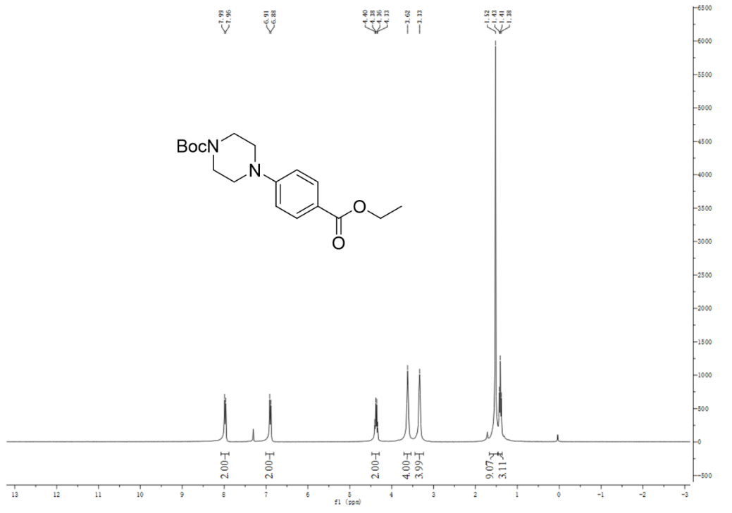

¹H×NMR of compound B6

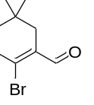

¹H×NMR of compound B7

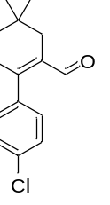

¹H×NMR of compound B8

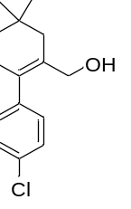

¹H×NMR of compound B10

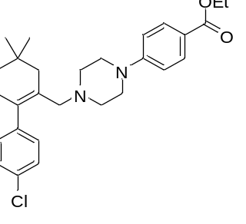

¹H×NMR of compound B11

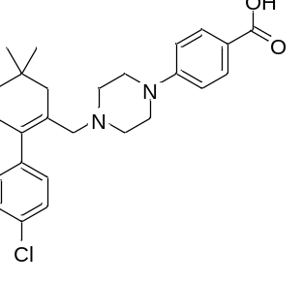

¹³C×NMR of compound B11

¹H×NMR of compound C3

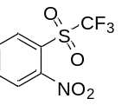

¹H×NMR of compound C6

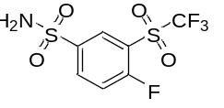

¹³C×NMR of compound C6

¹H×NMR of compound D4

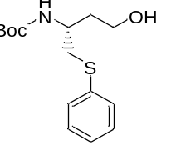

¹H×NMR of compound D5

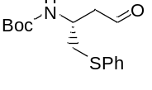

¹H×NMR of compound D6

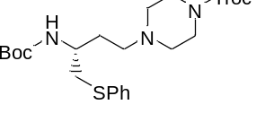

¹H×NMR of compound D8

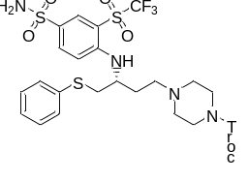

¹H×NMR of compound D9

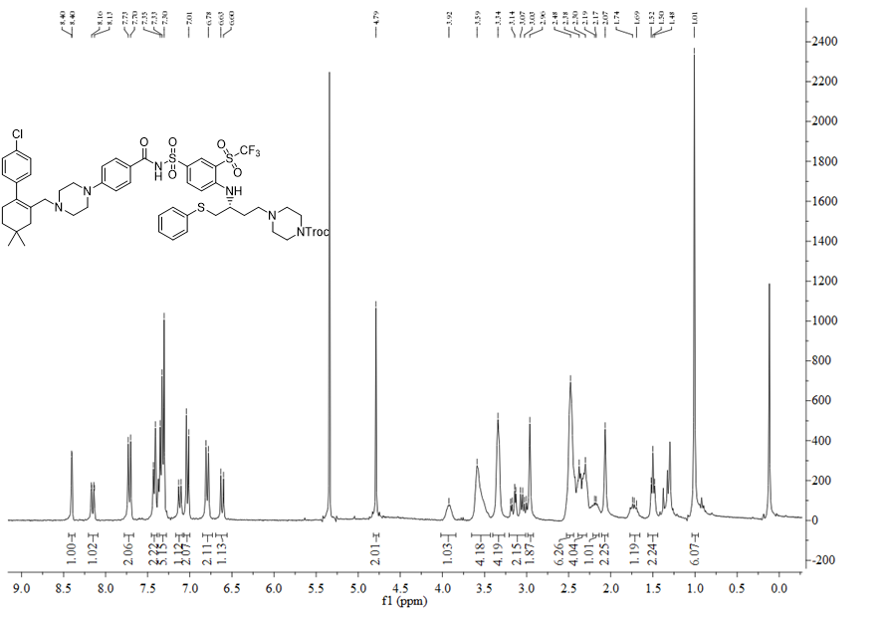
¹H×NMR of compound D10

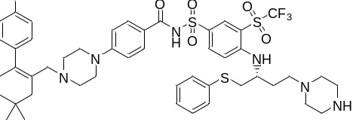

¹³C×NMR of compound D10

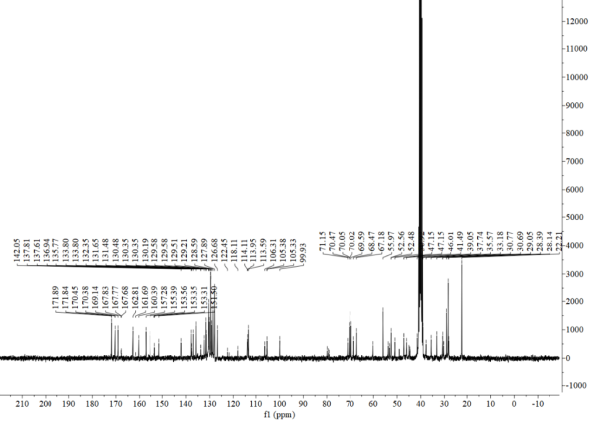

¹H×NMR of compound N5

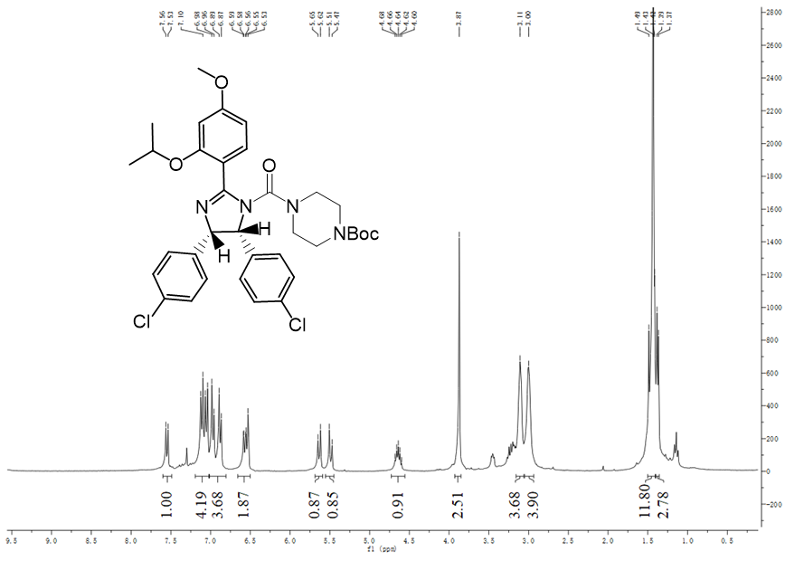

¹H×NMR of compound N6

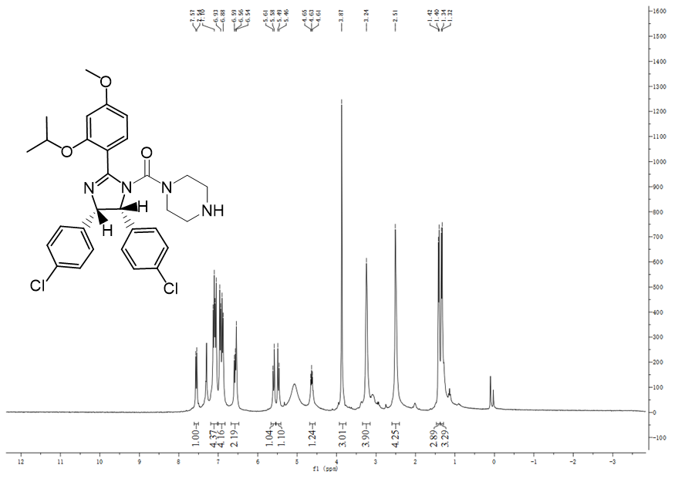

¹³C×NMR of compound N6
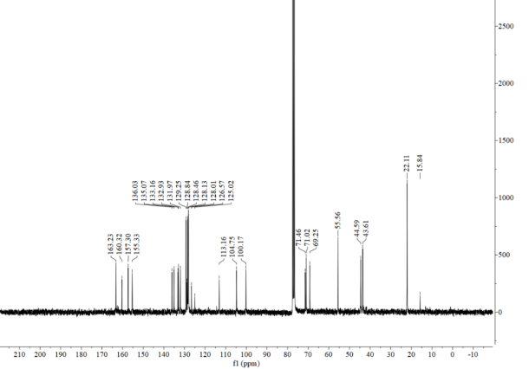

¹H×NMR of compound AN-1

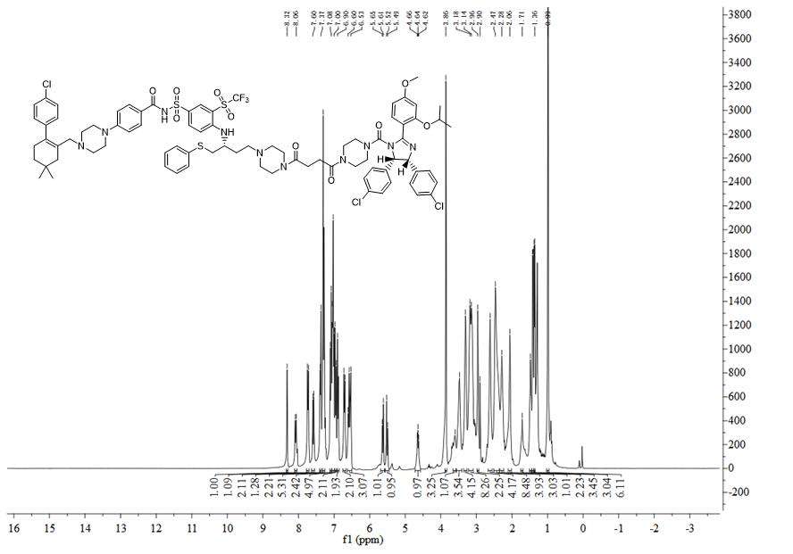

¹³C×NMR of compound AN-1

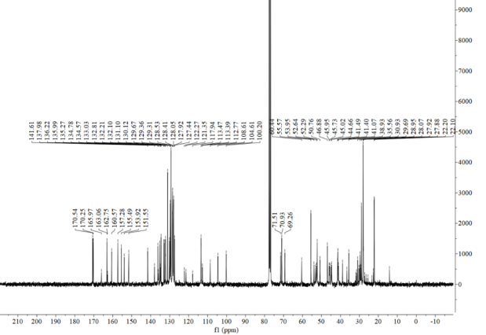

¹H×NMR of compound N8

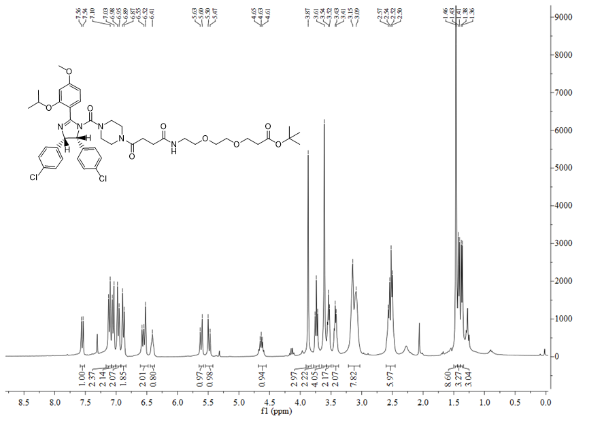

¹H×NMR of compound AN-2

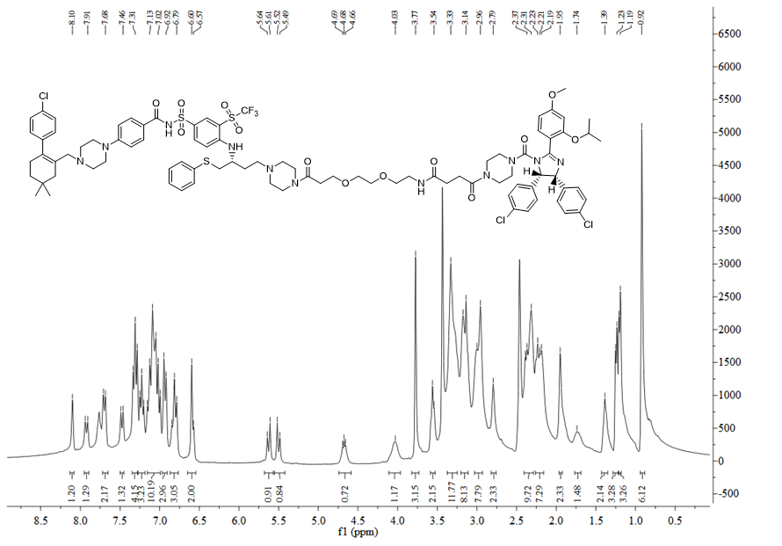

¹³C×NMR of compound AN-2

