Supplementary material:
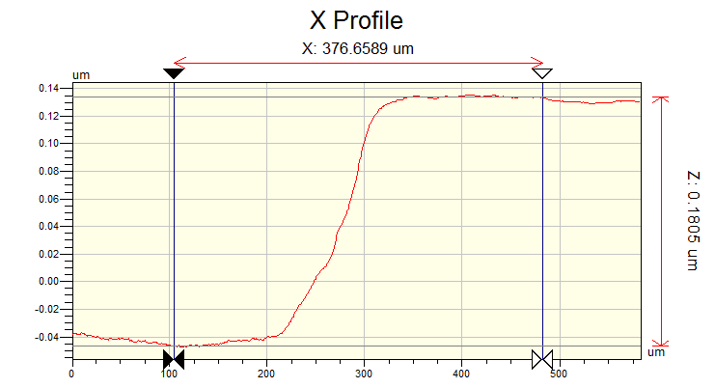
Fig.S1. Thin film thickness measurement using Profilometer
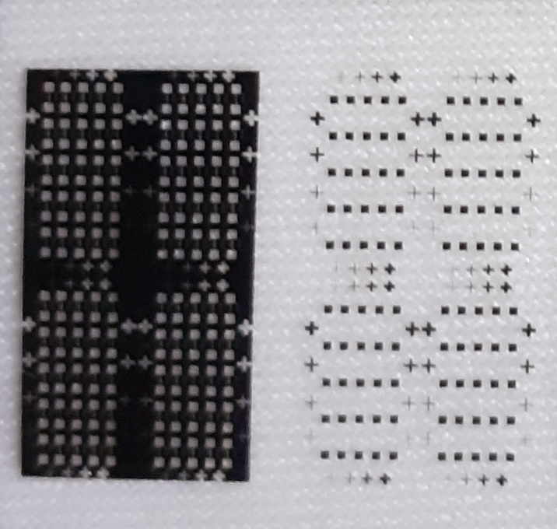
Fig.S2. Image of the dark field photomask used for channel creation and light field photomask used for contact metallization.
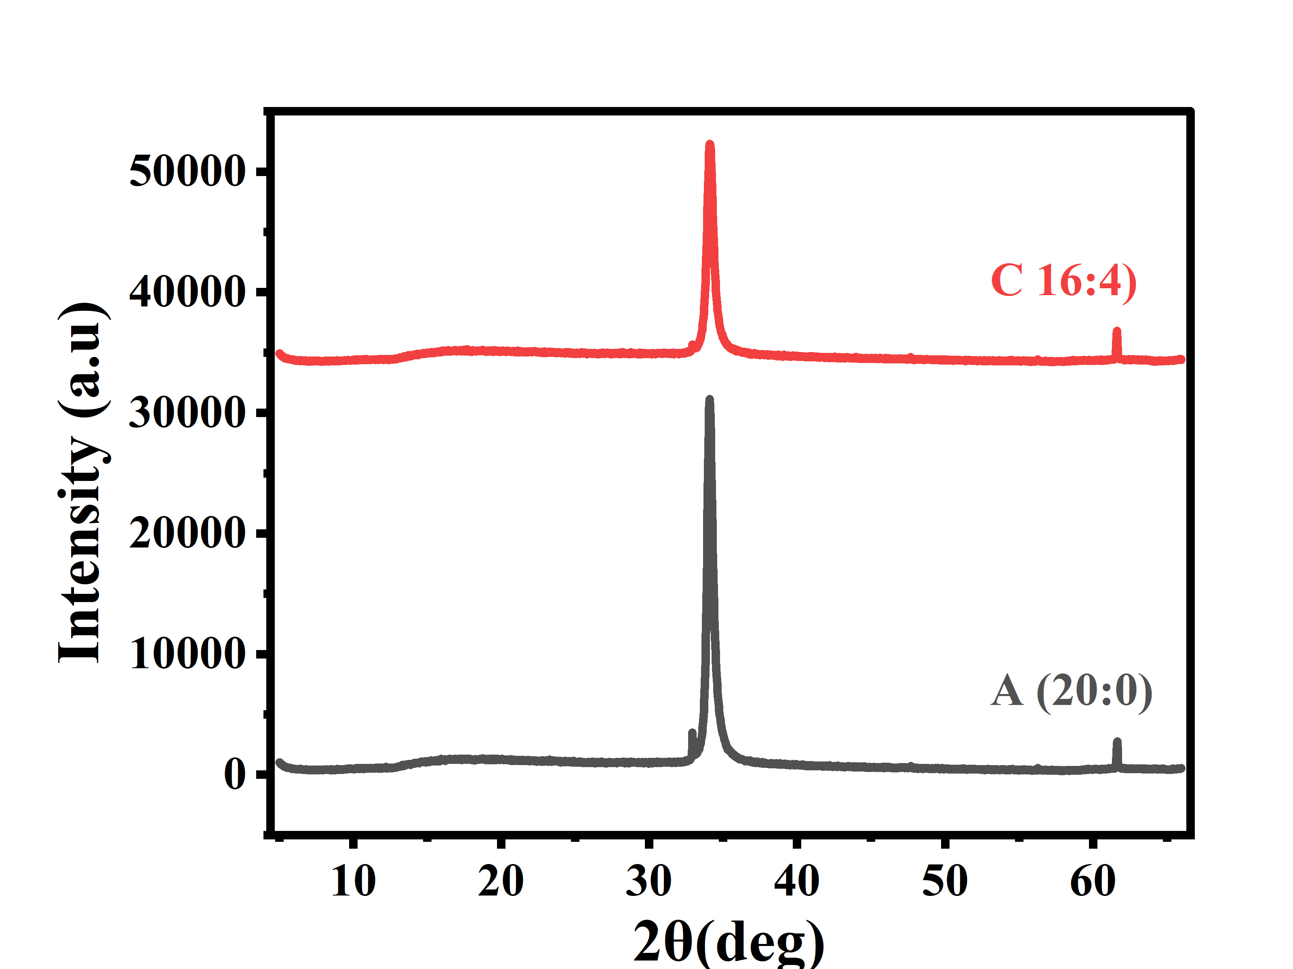
Fig.S3. Conventional XRD of ZnO thin film deposited at room temperature with different Ar:O₂ flow rate

