Supplementary data

Picomolar inhibition of SARS-CoV-2 variants of concern by an engineered ACE2-IgG4-Fc fusion protein

Hristo L. Svilenov^{†,1}, Julia Sacherl^{†,2}, Alwin Reiter^{†,5}, Lisa Wolff², Cho-Chin Chen^{2,4}, Marcel Stern^{3,4}, Vincent Grass², Frank-Peter Wachs⁵, Nicole Simonavicius⁵, Susanne Pippig⁵, Florian Wolschin⁵, Oliver T. Keppler^{3,4}, Johannes Buchner¹, Carsten Brockmeyer*⁵, Ulrike Protzer*^{2,4}

†These authors contributed equally to this work.
*Corresponding authors’ emails: carsten.brockmeyer@formycon.com and protzer@tum.de.
¹ Department of Chemistry, Technical University of Munich, Garching, Germany.
² Institute of Virology, Technical University of Munich / Helmholtz Zentrum Munich, Munich, Germany.
³ Max von Pettenkofer Institute & Gene Center, Virology, LMU München, Munich, Germany.
⁴ German Center for Infection Research, Munich partner site, Munich, Germany.
⁵ Formycon AG, Martinsried/Planegg, Germany.

Supplementary Material and Methods
Analytical Size Exclusion Chromatography (SEC)
Purified proteins were analyzed by analytical size exclusion chromatography (SEC) on a Waters H-Class bio UPLC system using an Acquity UPLC Protein BEH SEC column, 4.6 mm x 150 mm, 200 Å, 1.7 μm. Detection was based on UV absorbance at 280 nm. 20 μg of samples were loaded, the mobile phase consisted of 20 mM sodium phosphate pH 7.0, 150 mM NaCl and proteins were eluted isocratically at a flow rate of 0.3 mL/min.
Capillary Electrophoresis - Sodium Dodecyl Sulfate (CE-SDS)
Purified proteins were analyzed by capillary electrophoresis sodium dodecyl sulfate (CE-SDS) under non-reducing as well as reducing conditions on a CESI8000 instrument (AB Sciex) following the manufacturer’s protocol from the IgG purity/heterogeneity kit. Before the measurement via pressure injection, the buffer was adjusted to 50 mM Tris pH 7.5, 50 mM NaCl.

Supplementary Figures
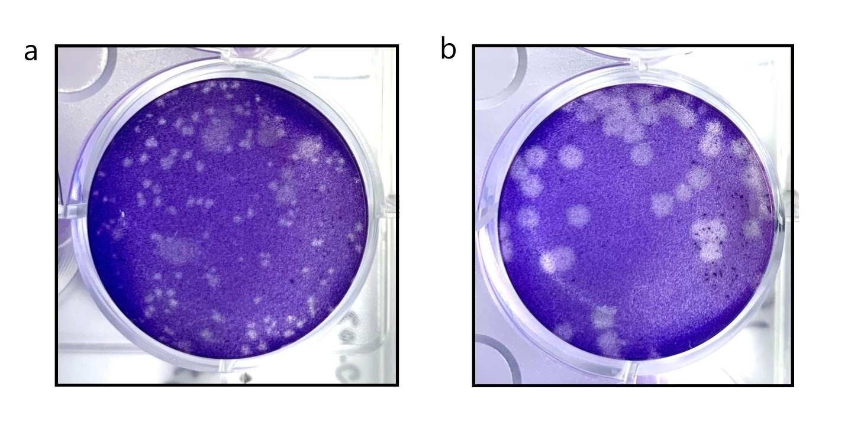
Supplementary Figure 1 Appearance of plaques stemming from different primary SARS-CoV-2 isolates. Viral plaques observed after infection of HepG2 cells with a SARS-CoV-2-Jan or b SARS-CoV-2-April.
Supplementary Figure 2 Neutralization potency of a neutralizing antibody targeting the SARS-CoV-2 RBD against pandemic SARS-CoV-2 variants. Serial dilutions of neutralizing anti-RBD antibody were used to pre-incubate with the indicated SARS-CoV-2 primary isolates SARS-CoV-2-Jan and SARS-CoV-2-April or SARS-CoV-2 VoCs B.1.1.7 and B.1.351. Data given are means ± SEM of three independent experiments each. 50% inhibitory concentrations (IC50 values) determined as well as the 95% confidence interval (CI 95%) are shown for each construct. The dashed lines indicate the IC50 values on the corresponding curves

Supplementary Table 1
Supplementary Table 1 Yield and purity of the ACE2-Fc constructs
Construct | Normalized  Relative Yield* | HMWS (%)  Analytical SEC | Purity  CE-SDS non-reduced | Purity  CE-SDS reduced
1 | 0.8 | 2.1 | 97.3 | 96.7
2 | 0.6 | 4.7 | 97.4 | 97.4
3 | 1.0 | 3.1 | 95.1 | 94.8
4 | 0.6 | 3.7 | 97.0 | 98.2
5 | 1.0 | 2.6 | 97.0 | 95.2
6 | 0.6 | 3.4 | 97.2 | 96.8
7 | 0.9 | 1.9 | 95.3 | 96.7
8 | 0.8 | 3.7 | 96.9 | 97.8
* Normalized against construct 5

