Phosphopeptide-bridged NH₂-TiO₂-mediated carbon dots self-enhancing and electrochemiluminescence microsensors for label-free protein kinase A detection

Jianping Guoª, Lele Yue^{c}, Lingya Ning^{b}, Ailing Han^{a*}, Junping Wang^{b*}

ªSchool of Food Science, Shanxi Normal University, Taiyuan, 030031, Shanxi, China
^{b}State Key Laboratory of Food Nutrition and Safety, Tianjin University of Science & Technology, 29 The Thirteenth Road, Tianjin Economy and Technology Development Area, Tianjin, 300457, P.R. China
^{c}Shanxi Key Laboratory of Micro Nano Sensors & Artificial Intelligence Perception, College of Information and Computer, Taiyuan University of Technology, Taiyuan 030024, China
*Corresponding Authors: E-mail addresses: 20220072@sxnu.edu.cn; wangjp@tust.edu.cn

Reagents
Cys-labeled kemptide (CLRRASLG) used in this study were synthesized by Sangon Biochem (Shanghai, China). Protein kinase A (PKA) and Adenosine Triphosphate (ATP) were purchased from Sigma-Aldrich Co., Ltd (St. Louis, MO, USA). Amino functionalized nano TiO₂ (5 nm) (NH₂-TiO₂) supplied by Liuzhou Nano Materials Co., tyrphostin AG 1478, epigallocatechin gallate (EGCG) and N-[2-(p-bromocinnamylamino) ethyl]-5-isoquinolinesulfonamide dihydrochloride (H-89) were obtained from Sigma-Aldrich. For the biosensor buffers used were as follows: (A) protein sites blocking buffer: 1 mM 6-mercaptohexanol (MCH) sodium phosphate buffered saline (PBS), pH 7.4; (B) ECL-assay buffer: 0.01 M K₂S₂O₈-PBS in 0.01 M PBS at pH 7.4.
Apparatus
The morphologic and structural characteristics of different materials were investigated by scanning electron microscopy (SEM, JSM-IT300, JEOL, Tokyo, Japan) and High-resolution transmission electron microscopy (HR-TEM, JEOLJEM 2100, 100 kV). The UV-visible (UV-vis) spectra were collected by a UV-2550 (Daojin) spectrophotometer. Fourier Transform Infrared spectroscopy (FT-IR) were obtained on a Perkin-Elemer PE-983 spectrometer. The structure of hybrid nano-polymer Ti@NMg-CDs was characterized by X-ray diffraction (XRD, X'Pert PRO MPD). The zeta potentials of Ti@NMg-CDs, Mg@N-CDs and NH₂-TiO₂ under pH values 7.4 were tested, respectively, by Malvern Zen 3600 Zetasizer. The photoelectrochemical and electrochemical tests were performed by a ECL analysis system electrochemical workstation (Model MPI-EⅡ; Xi’an Remax Electronic Science & Technology Co., Ltd.; Xi’an, China). Meanwhile, a three-electrode system was adopted, including an Au electrode (3 mm diameter) as the working electrode, a counter electrode (platinum wire), and an auxiliary electrode (saturated calomel electrode, SCE). Electrochemical impedance spectroscopy (EIS) experimental data were fitted with Randles circuit [RS(Q[RctW])]. RS represents the electrolyte resistance, and Q is the equivalent element of constant phaseangle element (CPE) reflecting the capacitance between electrode and electrolyte. Rct corresponds to the charge transfer resistance, and W is Warburg resistance, describing the resistance of reactants from the solution to the electrode interface (concentration polarization resistance).

Synthesis of the luminophore-NTi@MgCDs
The Mg@N-CDs was synthesized according to previous reports with a slightly adjustment.³³ All synthetic details are provided in the electronic Supplementary material. (Synthesis of Mg@N-CDs by one-step hydrothermal method: 4.2 g of magnesium hydroxide and 5 mL of ethylenediamine were slowly dissolved into 10 g-40 mL citric-acid/de) ionized water under continuous stirring. Subsequently, the resultant solution was transferred into a 100 mL Teflon-lined stainless autoclave and then heated to 200°C for 3 h. After being cooled down to room temperature naturally, the brownish-yellow precipitates were collected by centrifugation and rinsed several times with deionized water and ethanol. Finally, the obtained powder (Mg@N-CDs) was freeze-dried overnight and protected from light at 4°C.) A novel nano-composite luminophores NTi@MgCDs was synthetized with a volume ratio of Mg@N-CDs to NH₂-TiO₂ of 1:1.5 using chemical ultrasonic-method by hydrogen bonding O-H···N.
ECL tests
AuE/Cys-kemptides/MCH electrodes catalyzed with different concentrations of PKA (0.001-30 U/mL) were incubated in Ti@NMg-CDs-solution. And then, the working-electrodes were detected in 500 μL of PBS-K₂S₂O₈ buffer (0.1 mol/L K₂S₂O₈, phosphate-buffered saline (PBS): 0.1 mol/L, pH 7.4). All ECL data were acquired via cyclic voltammetry and electrochemiluminescence simultaneously. The detection conditions were that the cathode potential range was 0 to -1.8 V, the scanning speed was 200 mV/s, and the photomultiplier tube voltage was 650 V.
Characterization results of Ti@NMg-CDs including fluorescence data and UV absorption
FL spectra further reveal the improved FL intensity of Ti@NMg-CDs compared Mg@N-CDs (Fig. S2C). The ECL spectra of Ti@NMg-CDs/AuE was showed in Fig. S2D. The ECL spectrum of Ti@NMg-CDs/AuE achieving maximum at 520 nm, which presented an obvious red shift comparing PL intensity at 445 nm. It may be caused by two different light-emitting mechanisms. To our best knowledge, a blue emission at 445 nm attributinmission spectrum of Mg@N-CDs is mainly caused by the transition of electrons. For ECL process, the possible mechanism may be interpreted by electron transfer, what is illustrated later in the article [1]. Ti@NMg-CDs present the excitation-independent FL emission (445 nm) (Fig. S2A, B). As illustrated in Figure, with increasing the excitation of Ti@NMg-CDs in the range of 300-360 nm (Fig. S2A), the fluorescence intensity at 445 nm increased gradually and then weaked until disappeared when the excitation wavelength at 370-420 nm (Fig. S2B). The superior excitation-independent FL feature of Ti@NMg-CDs is mainly related to the oxidation-degree of the surface. The lower-oxidation degree and fewer surface-defects of Ti@NMg-CDs based on TiO₂ coordinated with Mg@N-CDs via O-H···N bonding may cause the excitation-independent FL emission.
UV–vis absorption spectrum is carried out to confirm the formation of Ti@NMg-CDs. In the UV–vis spectrum of Mg@N-CDs solution (Fig. S3(b)), a strong band at 241 nm and 352 nm were observed, which can be contributed to the π-π* transition of C=C bonds and n-π* transition of C=O bonds, respectively. NH₂-TiO₂ had a characteristic absorption peak at 234 nm (Fig. S3(c)). Curve c show that the UV-vis absorption obviously insufficient after 350 nm, which is derived from wide band gap of TiO₂ [2]. Another absorbance bands at 242 nm appeared in the spectrum of Ti@NMg-CDs (curve a) as accompanied by the disappearances of the ultraviolet peak of NH₂-TiO₂ and Mg@N-CDs. Meanwhile, it obviously shows the enhanced absorption from 200 nm to 400 nm, which may ascribe to the formation of transfer-state of charge between defected-state of NH₂-TiO₂ and Mg@N-CDs.
ECL intensity of Ti@NMg-CDs and the excellent photocatalytic performance of nano-TiO₂
FL spectra further reveal the improved FL intensity of Ti@NMg-CDs compared Mg@N-CDs. The ECL spectra of Ti@NMg-CDs/AuE was showed in Fig. R1D. The ECL spectrum of Ti@NMg-CDs achieving maximum at 520 nm, which presented an obvious red shift comparing PL intensity at 445 nm. It may be caused by two different light-emitting mechanisms. To our best knowledge, a blue emission at 445 nm attributinmission spectrum of Mg@N-CDs is mainly caused by the transition of electrons. To explain the enhancement of the nano NH₂-TiO₂ to ECL signals, cyclic voltammograms (CVs) was measured during a potential scan cycle -1.2 ~ 0 V. It is well known that S₂O₈²⁻ can be electrochemically reduced to a strong oxidation intermediate (SO₄^{·-}). On the surface of bare-AuE, reduction peak was detected (curve a) obviously at - 0.97 V in Fig. 3A, which results from the formation of strong oxidation intermediate (SO₄^{·-}) at a certain voltage. In addition, a weak negative cathodic peak (-0.89 V) was observed on the NH₂-TiO₂-modified AuE (curve b) in K₂S₂O₈-PBS, which was attributed to the conductivity and narrow energy gap of semiconductor nano-titania. Compared with the Mg@N-CDs/AuE (curve c), a more positive potential (-0.83 V) of Ti@NMg-CDs/AuE was observed than peak potential -1.02 V. This potential-shift in CVs may be related to the photocatalytic sites of the titanium dioxide. The peak at -0.89 V indicate the negatedively charged Mg@N-CDs (Mg@N-CDs^{·-}) were produced by injecting electrons into the unoccupied molecular orbitals (LUMOs) [3]. In comparison to the electroreduction peak at -0.89 V of Mg@N-CDs, Ti@NMg -CDs exhibited more positive reduction potentials (-0.83V) due to the small energy gap of NH₂-TiO₂. More, NH₂-TiO₂ with more positive reduction potentials (-1.02V) could speed up the reduction of S₂O₈²⁻ to form the excited state of Mg@N-CDs* for releasing stronger ECL signals. These results indicated that the better ECL-signal of the Ti@NMg-CDs/AuE was the result of the interaction between the Mg@N-CDs and the NH₂-TiO₂. The ECL reaction mechanism of Ti@NMg-CDs can be summarized in the following eq (1)-(7) [4, 5].
S₂O₈²⁻ + e⁻ → SO₄^{·-} (1)
Mg@N-CDs + e⁻ → Mg@N-CDs^{·-} (2)
SO₄^{·-} + TiO₂ → TiO₂^{·+} + SO₄²⁻ (3)
Mg@N-CDs^{·-} + TiO₂^{·+} → TiO₂* + Mg@N-CDs (4)
TiO₂* → TiO₂ + hv (5)
and/or
Mg@N-CDs^{·-} + TiO₂^{·+} → TiO₂ + Mg@N-CDs* (6)
Mg@N-CDs* → Mg@N-CDs + hv (7)
Ti@NMg-CDs present the excitation-independent FL emission (445 nm) (Fig. S2A, B). As illustrated in Figure, with increasing the excitation of Ti@NMg-CDs in the range of 300-360 nm (Fig. S2A), the fluorescence intensity at 445 nm increased gradually and then weaked until disappeared when the excitation wavelength at 370-420 nm (Fig. S2B). The superior excitation-independent FL feature of Ti@NMg-CDs is mainly related to the oxidation-degree of the surface. The lower-oxidation degree and fewer surface-defects of Ti@NMg-CDs based on TiO₂ coordinated with Mg@N-CDs via O-H···N bonding may cause the excitation-independent FL emission.

Reproducibility and stability of the biosensor
The reproducibility of the biosensor is confirmed by preparing seven electrodes to detect 30 U/mL of PKA. The relative standard deviation (RSD) of triplicate measurements is 0.98% (Fig.S5). This experimental result demonstrates acceptable reproducibility of the biosensor. The long-term storage stability of the biosensor is also evaluated. When the working electrode is stored at 4℃ for 10 days (Fig.S4), the ECL response remains 90.3% of its original value, implying good stability.

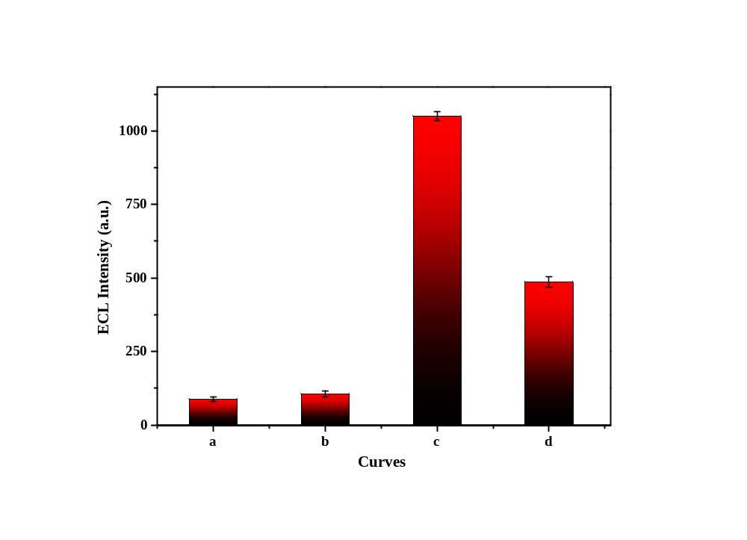
Fig. S1. ECL intensity-potential behavior obtained at the bare-AuE in PBS containing 0.1 mol/L K₂S₂O₈ (curve a); AuE/Mg@N-CDs in PBS (curve b); AuE/Mg@N-CDs (curve c) and AuE/NH₂-TiO₂ (curve d) in PBS-K₂S₂O₈ system
Fig. S2. (A)/(B) FL emission spectra of Ti-doped Mg@N-CDs under excitation at different wavelengths. (C) Fluorescence spectra (FL, Ex:360 nm) and (D) ECL spectra.
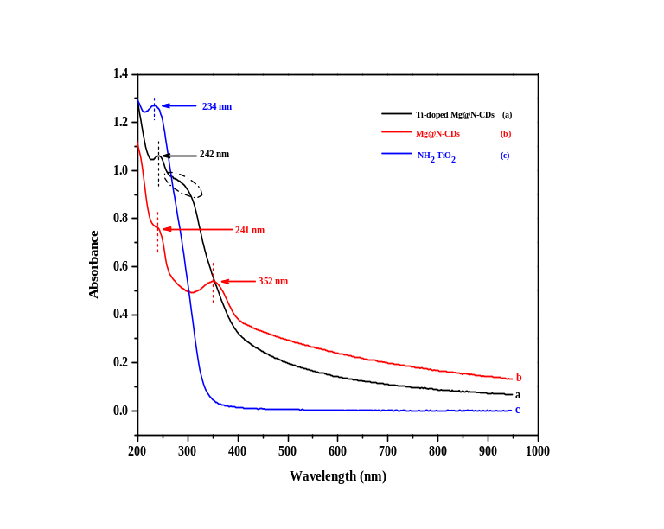
Fig. S3. UV–vis absorption spectra of prepared Ti-doped Mg@N-CDs.
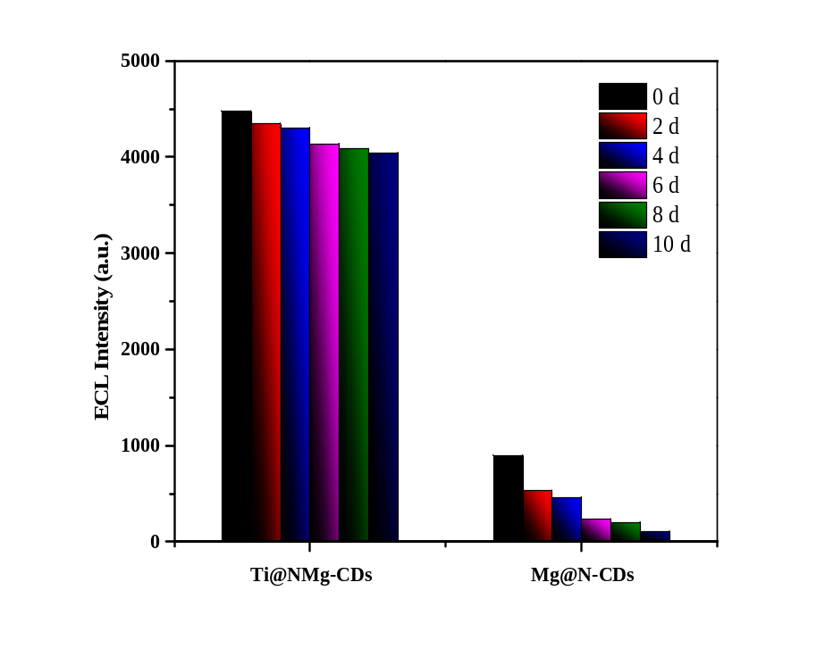

Fig. S4. ECL intensity of Mg@N-CDs/AuE and Ti-doped Mg@N-CDs/AuE stored in the refrigerator for 10 days (detected every two day)

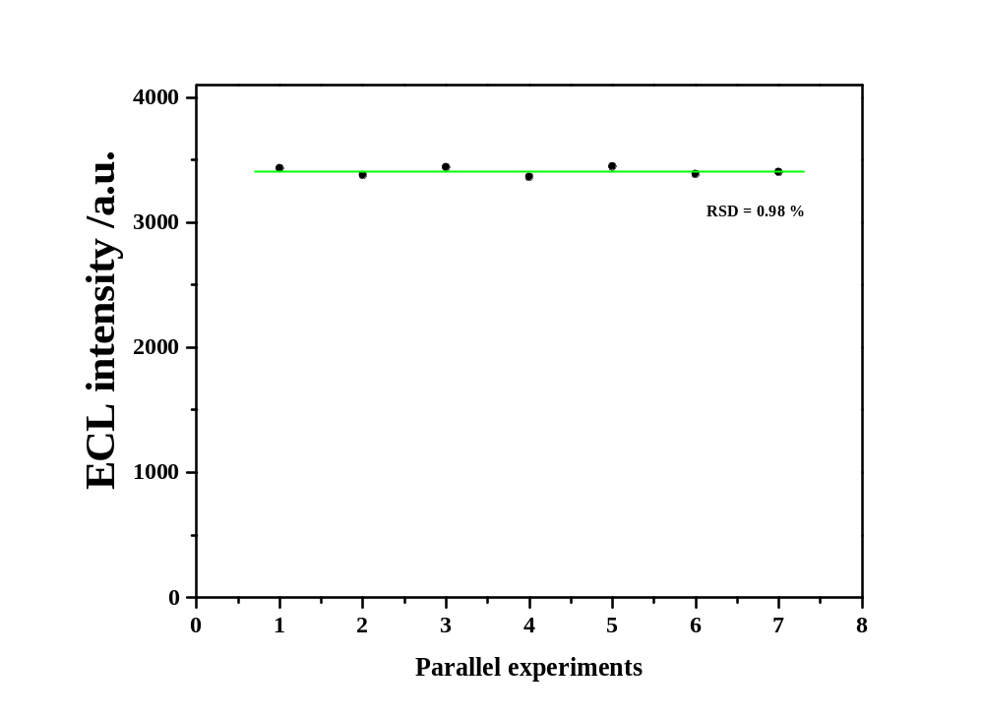
Fig. S5. ECL response of the biosensor for seven parallel detections. The concentration of PKA is about 30 U/mL.
Fig. S6. TEM images of carbon dot

Reference
[1] Li, P.; Yu, J.; Zhao, K.; Deng, A.; Li, J. Efficient enhancement of electrochemiluminescence from tin disulfide quantum dots by hollow titanium dioxide spherical shell for highly sensitive detection of chloramphenicol. Biosensors & bioelectronics, 2020, 147, 111790, DOI: 10.1016/j.bios.2019.111790.
[2] Zhang, D.; Dong, S. Challenges in band alignment between semiconducting materials: A case of rutile and anatase TiO₂. Progress in Natural Science: Materials International, 2019, 29 (3), 277-284, DOI: 10.1016/j.pnsc.2019.03.012.
[3] Lei, Y. M.; Zhou, J.; Chai, Y. Q.; Zhuo, Y.; Yuan, R. SnS₂ Quantum Dots as New Emitters with Strong Electrochemiluminescence for Ultrasensitive Antibody Detection. Analytical chemistry, 2018, 90 (20), 12270-12277, DOI: 10.1021/acs.analchem.8b03623.
[4] Liao, H.; Zhou, Y.; Chai, Y.; Yuan, R. An ultrasensitive electrochemiluminescence biosensor for detection of MicroRNA by in-situ electrochemically generated copper nanoclusters as luminophore and TiO₂ as coreaction accelerator. Biosensors & bioelectronics, 2018, 114, 10-14, DOI: 10.1016/j.bios.2018.05.011.
[5] Tian, C. Y.; Zhao, W. W.; Wang, J.; Xu, J. J.; Chen, H. Y. Amplified quenching of electrochemiluminescence from CdS sensitized TiO₂ nanotubes by CdTe-carbon nanotube composite for detection of prostate protein antigen in serum. The Analyst, 2012, 137 (13), 3070-3075, DOI: 10.1039/c2an35493d.

