Supporting information for

Radiolabeling and PET-MRI microdosing of the experimental cancer therapeutic, MN-anti-miR10b, demonstrates delivery to metastatic lesions in a murine model of metastatic breast cancer

Mariane Le Fur^{1,2}, Alana Ross¹, Pamela Pantazopoulos¹, Nicholas Rotile^{1,2}, Iris Zhou^{1,2}, Peter Caravan^{1,2*}, Zdravka Medarova^{1*}, Byunghee Yoo^{1*}

¹MGH/MIT/HMS Athinoula A. Martinos Center for Biomedical Imaging, Massachusetts General Hospital and Harvard Medical School, Boston, MA 02129, USA.

²Institute for Innovation in Imaging, Massachusetts General Hospital, Boston, MA 02129, USA.

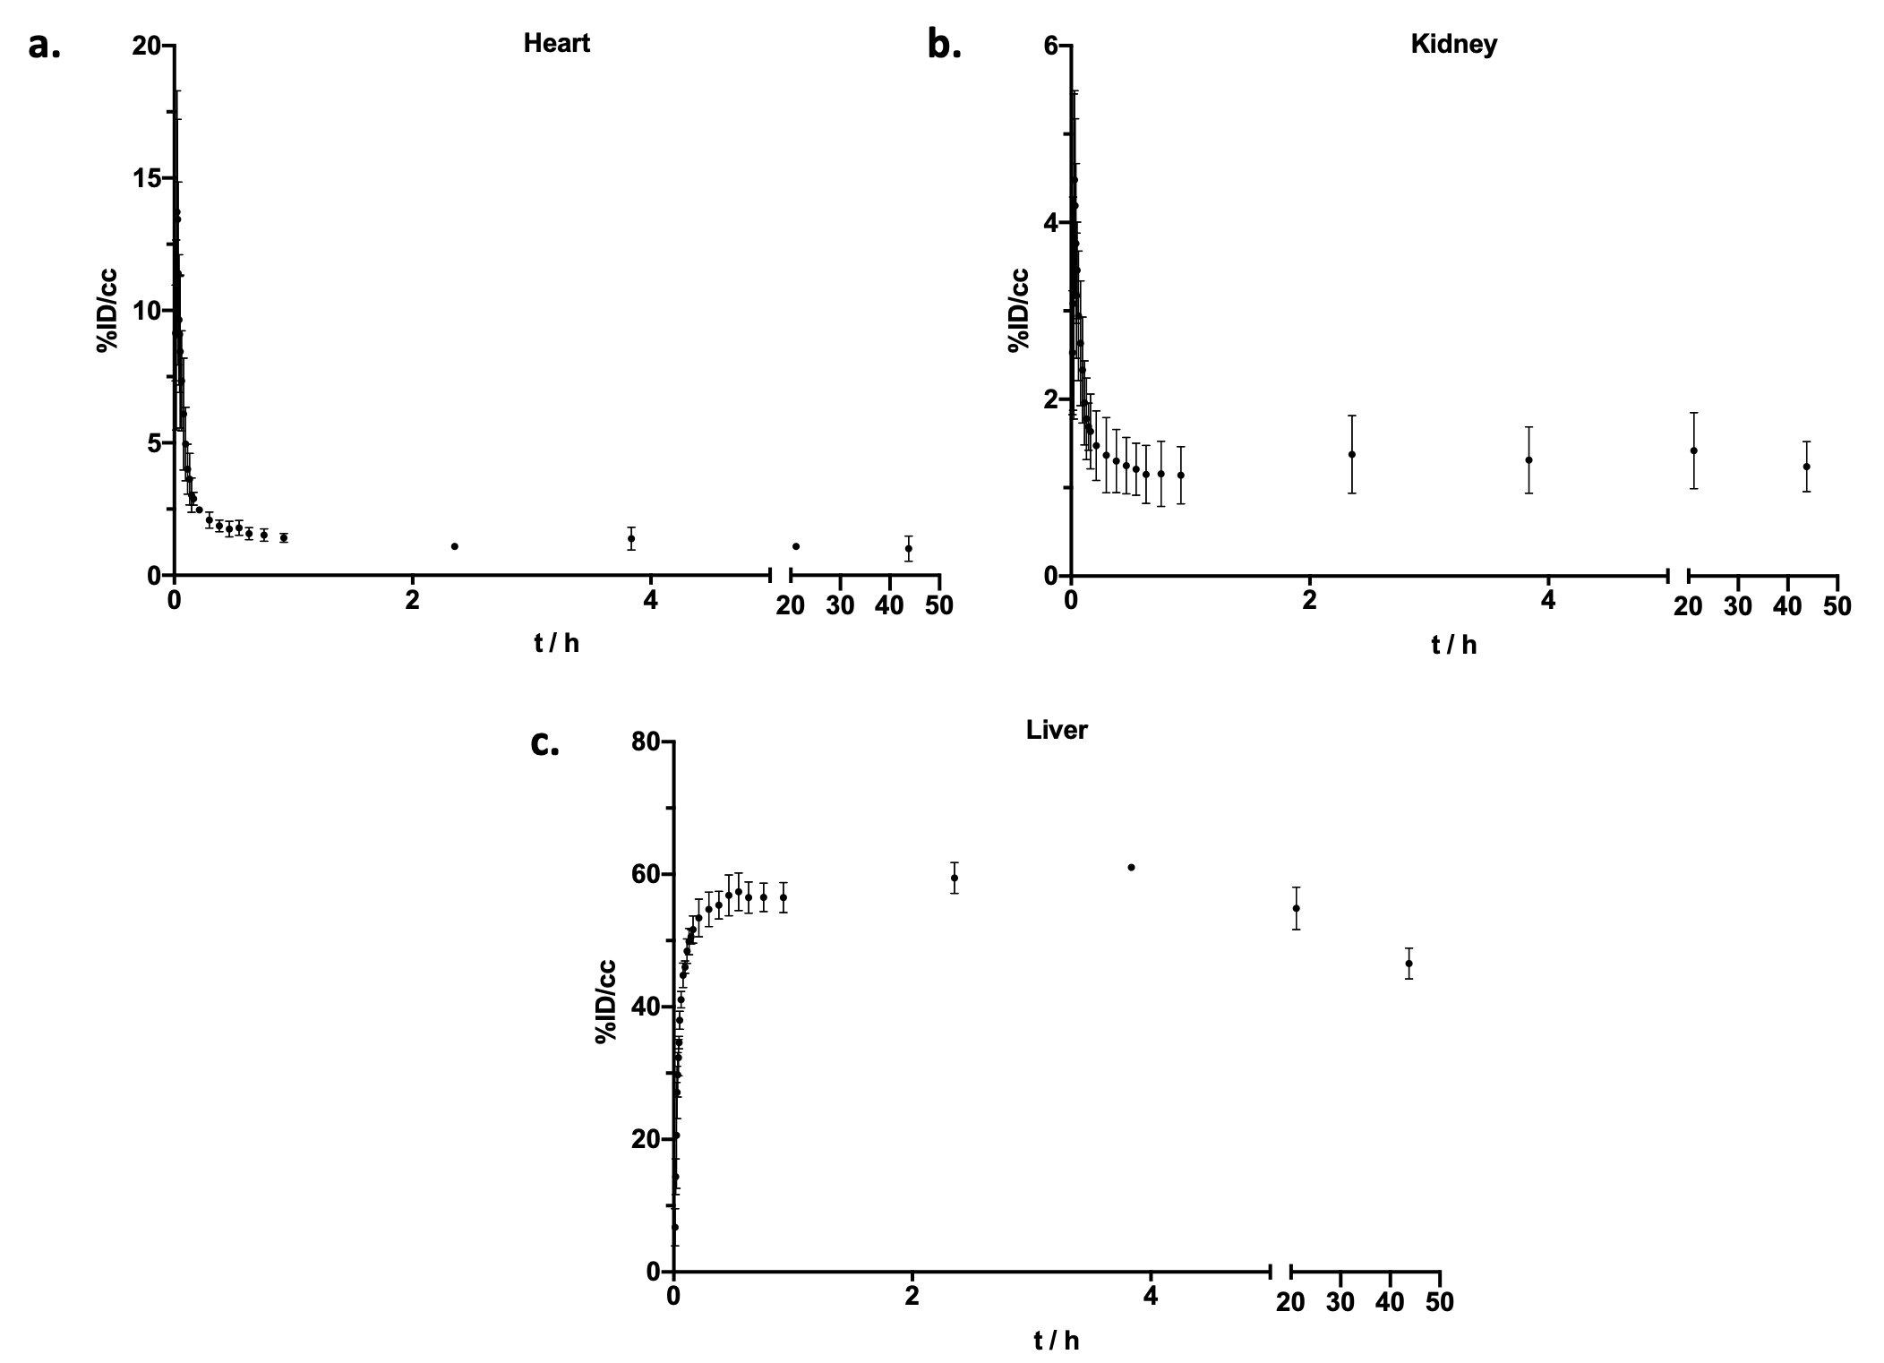

Figure S1. Time-activity curves obtained from PET images from 5 min to 48 hrs post injection in a. Heart, b. Kidney and c. Liver from mice (n = 3) that were administered a microdose of ⁶⁴Cu-MN-anti-miR10b. Error bars represent the standard deviation.

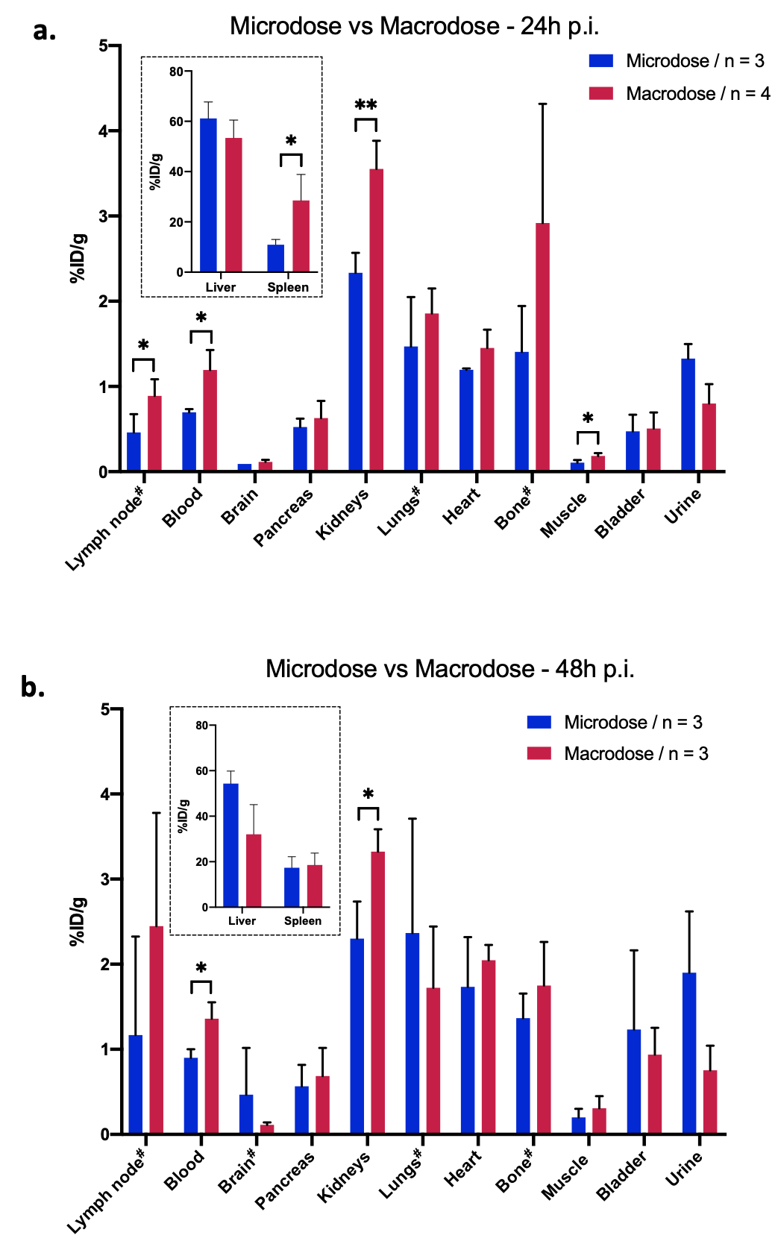

Figure S2. Biodistribution of ⁶⁴Cu-MN-anti-miR10b injected at a microdose and a standard therapeutic dose (macrodose) measured at a. 24 and b. 48 hours after injection. # Denotes organs with metastasis as detected by BLI. Results are expressed as %ID/g. Error bars represent the standard deviation. (t-test, *P < 0.05, **P < 0.01).

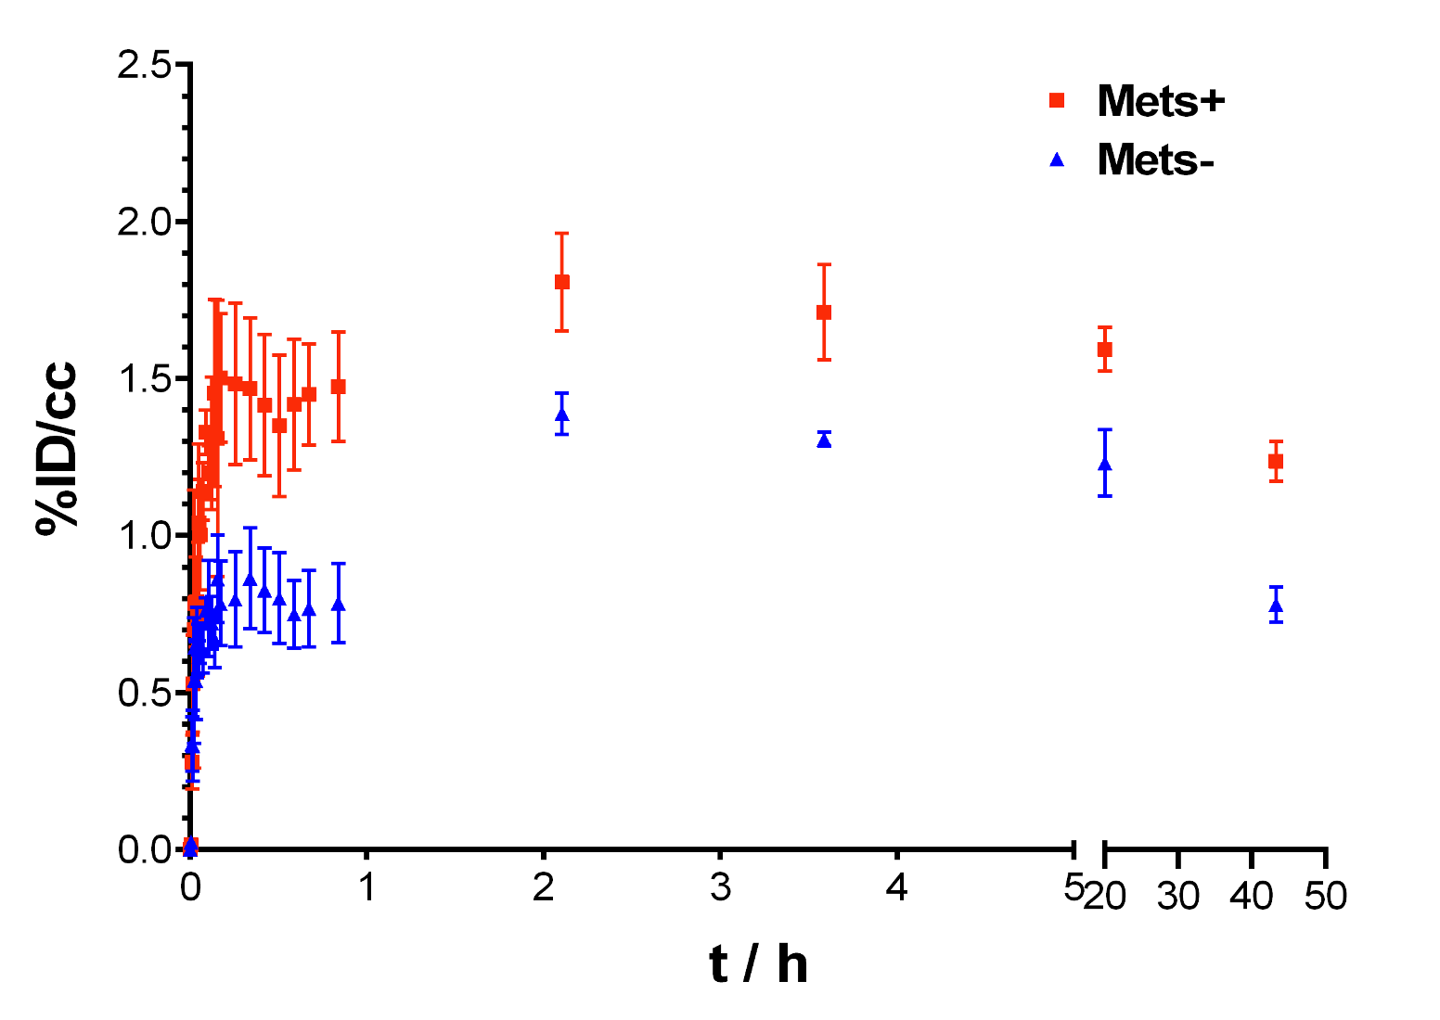

Figure S3. Time-activity curves obtained from PET imaging from 5 min to 48 hrs post injection of a microdose of ⁶⁴Cu-MN-anti-miR10b in metastatic and non-metastatic bones (n = 3).

