Supplementary Materia
A novel NIR fluorescent probe for rapid response to hydrogen sulfide
1. Synthesis of intermediate compounds
Compound 1: Take 27 g of polyphosphate (PPA) in 100 mL three-neck flask and heat it at 80 ℃ to melt. 2.86 g (23 mmol) of p-toluenthiophenol was dissolved in 3.25 g (25 mmol) of ethyl acetoacetate, slowly injected into a three-neck flask with a syringe, and stirred in an oil bath at 90 ℃ for 3 h. After natural cooling to room temperature, add an appropriate amount of ice water to the flask, stir with a glass to dissolve all the oil, and then adjust the pH of the solution to 7-8 to precipitate the solid. The yellow solid was obtained by vacuum filtration and washing with deionized water three times. The light yellow solid of 1.93 g compound 1 was obtained by recrystallization of petroleum ether after vacuum drying overnight, and the yield was 44.26%. ESI-MS: calculated for C₁₁H₁₀OS: [M]190.06; measured: 190.10.
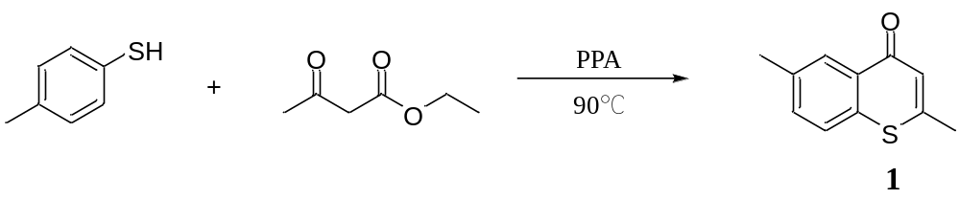
a）

b）
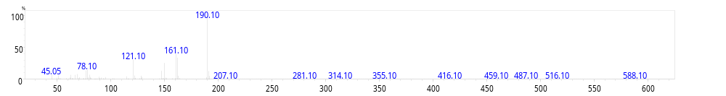

Fig. S 1. a Synthetic path diagram of compound 1. b GC-MS diagram of compound 1
Compound 2: Add 0.38 g (2 mmol) compound 1 to a 25 mL round-bottomed flask and dissolve it with 8 mL acetic anhydride (Ac₂O). Then 0.68 g (10 mmol) of malonitrile was added to the flask, and the reaction was stirred in an oil bath at 140 ℃ for 16 h. After natural cooling to room temperature, add 15 mL methanol and stir in 55 ℃ oil bath for 3 h. After the reaction, appropriate amount of silica gel was added to spin dry, and column layer separation (petroleum ether: ethyl acetate = 20:1), and finally 90.4 mg of compound 2 golden solid was obtained, the yield was 19%.ESI-MS: calculated for C₁₄H₁₀O₂S: [M]238.06; measured: 238.05.
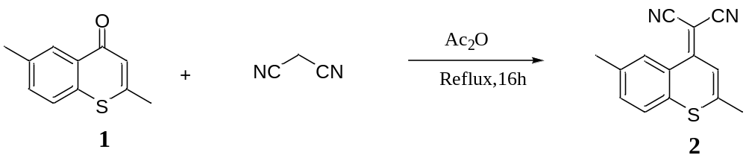
a）

b）
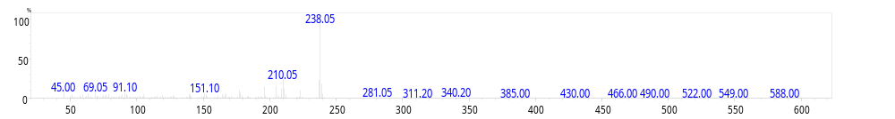

Fig. S 2. a Synthetic path diagram of compound 2. b GC-MS diagram of compound 2
Synthesis of compound 3: Compound 2 (71.4 mg, 0.3 mmol) and 3-quinoline formaldehyde (51.8 mg, 0.33 mmol) were dissolved in 10 mL ultra-dry acetonitrile solution in a 25 mL round-bottled flask, and 2 drops of piperidine were added as a catalyst. The reaction was carried out at 80 °C for 8 h by reflux and monitored by TLC until the reaction was complete (development agent: Petroleum ether/ethyl acetate =2:1). The obtained mixed solution was filtered by vacuum to obtain a deep red solid 101 mg with a yield of 89.7%. ESI-MS: calculated for C₂₄H₁₅N₃S: [M+H]+378.1; measured: 377.9.
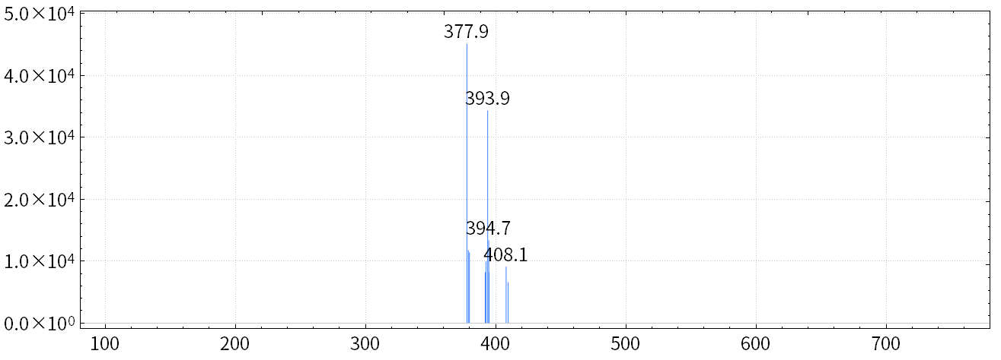

Fig. S 3. OMS spectrum of compound 3

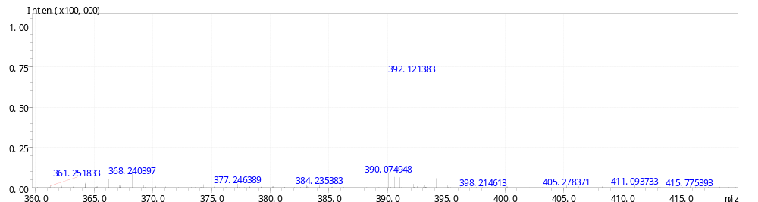
- Characterization of probe DMT

Fig. S 4. HRMS spectrum of probe DMT

Fig. S 5. ¹H NMR spectrum of probe DMT in DMSO-d6

Fig. S 6. ¹C NMR spectrum of probe DMT in DMSO-d6

- Table S1. A few H₂S response probe
Probes | Target analyte | λ_{ex}/λ_{em}  (nm) | Stokes shift （nm） | NIR emission | LOD  (nM) | Response  time | DOI
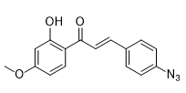 | H₂S | 430/570 | 140 | No | 122 | 30 min | 10.1007/s10895-023-03327-8
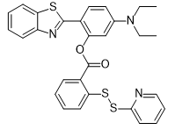 | H₂S | 385/430 | 45 | No | 417 | 10 min | 10.1016/j.dyepig.2023.111418
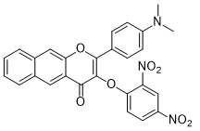 | H₂S | 442/566 | 124 | No | 824 | 6 min | 10.1007/s10895-023-03377-y
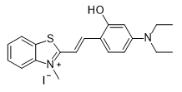 | H₂S | 520/622 | 102 | Yes | 99 | 30 s | 10.1016/j.jphotochem.2023.114993
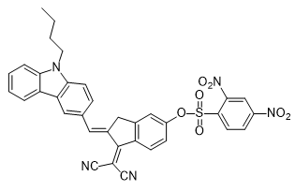 | H₂S | 463/554 | 91 | No | 123 | 40 min | 10.1007/s10895-024-03660-6
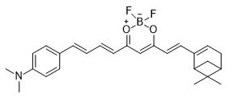 | H₂S | 575/620 | 45 | Yes | 440 | 6 min | 10.1016/j.saa.2022.121609
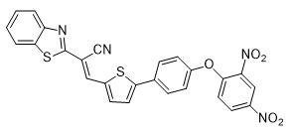 | H₂S | 455/600 | 145 | Yes | 76 | 90 s | 10.1016/j.molstruc.2024.137978
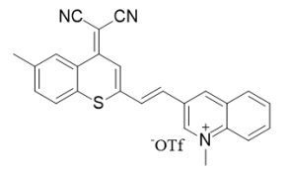 | H₂S | 590/684 | 94 | Yes | 162 | 10 s | This work

