Supporting Information
Excellent Electromagnetic Interference Shielding of Multi-layered Thermoplastic Polyurethane Nanocomposites with CoFe₂O₄ Nanoparticles and Graphite
Nithiya Hanna Wilson, Anju, Milan Masař, Michal Machovský, David Škoda, Pavel Urbánek, Michal Urbánek, Marek Pöschl, Jarmila Vilčáková, Ivo Kuřitka, Raghvendra Singh Yadav*
Centre of Polymer Systems, University Institute, Tomas Bata University in Zlin, Trida Tomase Bati 5678, 760 01 Zlin, Czech Republic
*Corresponding author: yadav@utb.cz , Tel.: +420576031725

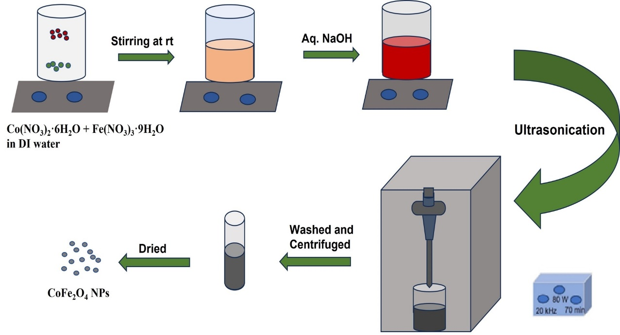
Fig. S1 Schematic representation of the synthesis of CoFe₂O₄ NPs by sonochemical approach.

(a) | (b) | 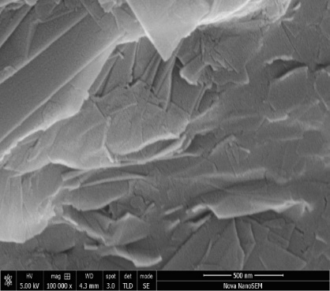  (c)

Fig. S2 FE-SEM surface images of (a) TPU, (b) F/F/F, and (c) G/G/G.

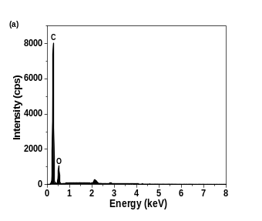 | 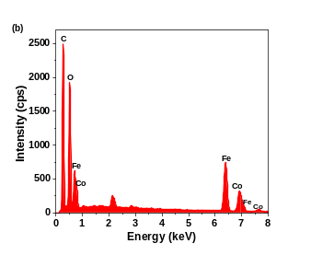 | 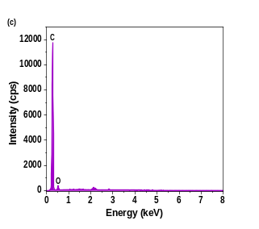
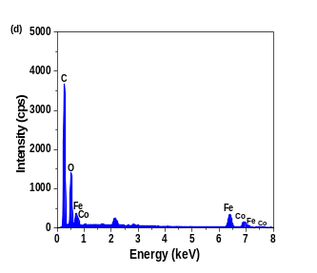 | 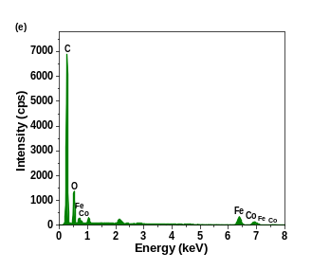

Fig. S3 EDX spectra of (a) TPU, (b) F/F/F, (c) G/G/G, (d) F/G/F, and (e) G/F/G.

Table S1 The percentage compositions of carbon, oxygen, iron, and cobalt in TPU and TPU-based multi-layered nanocomposites.
Sample/Material | C % | O % | Fe % | Co %
TPU | 86.2 | 10.7 | - | -
FFF-TPU | 37.0 | 19.0 | 27.0 | 13.0
GGG-TPU | 90.3 | 9.3 | - | -
FGF-TPU | 50.0 | 20.0 | 18.0 | 9.0
GFG-TPU | 66.0 | 12.0 | 12.0 | 6.0

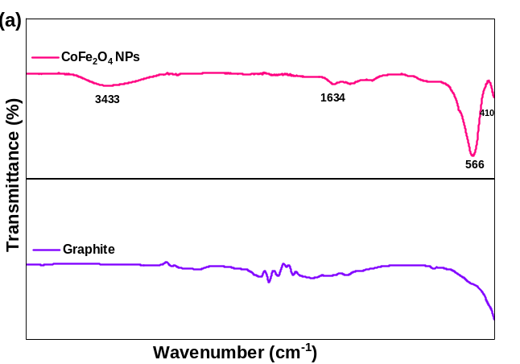 | 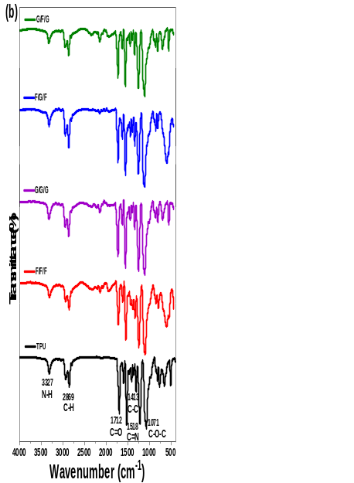

Fig. S4 FT-IR spectra of (a) CoFe₂O₄ NPs and graphite, (b) TPU and its multi-layered nanocomposites F/F/F, G/G/G, F/G/F, and G/F/G.
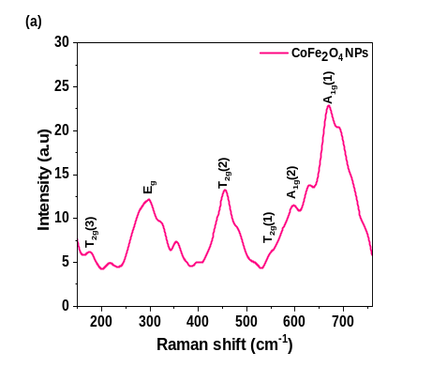 | 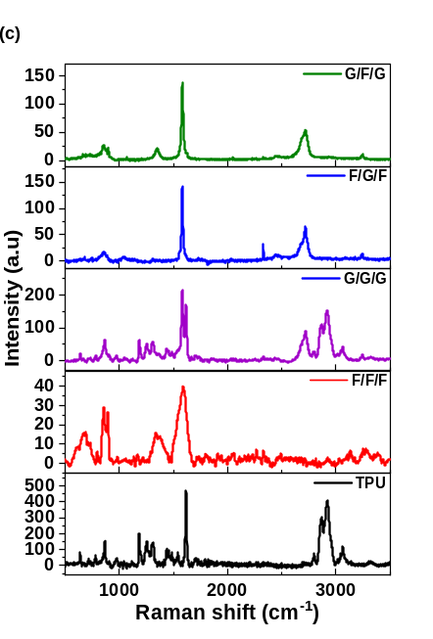
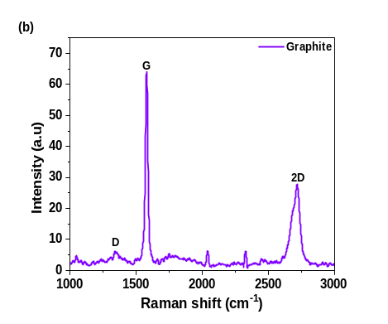

Fig. S5 Raman spectra of (a) CoFe₂O₄ NPs, (b) graphite, (c) TPU and its multi-layered nanocomposites F/F/F, G/G/G, F/G/F, and G/F/G.

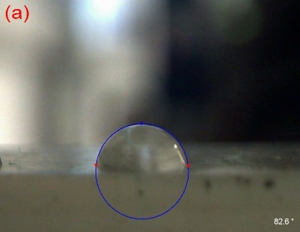 | 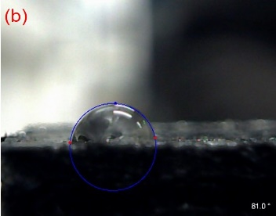

Fig. S6 Contact angle images of (a) TPU and (b) G/F/G.

