Supplementary material for:

Dynamic conditions for large, shallow intraslab earthquakes

Masaki Yoshida^{1*}
¹Department of Physical Sciences, College of Science and Engineering, Ritsumeikan University, 1-1-1 Nojihigashi, Kusatsu, Shiga 525-8577, Japan

*Correspondence: Masaki Yoshida
masakiy@fc.ritsumei.ac.jp

Supplementary figures

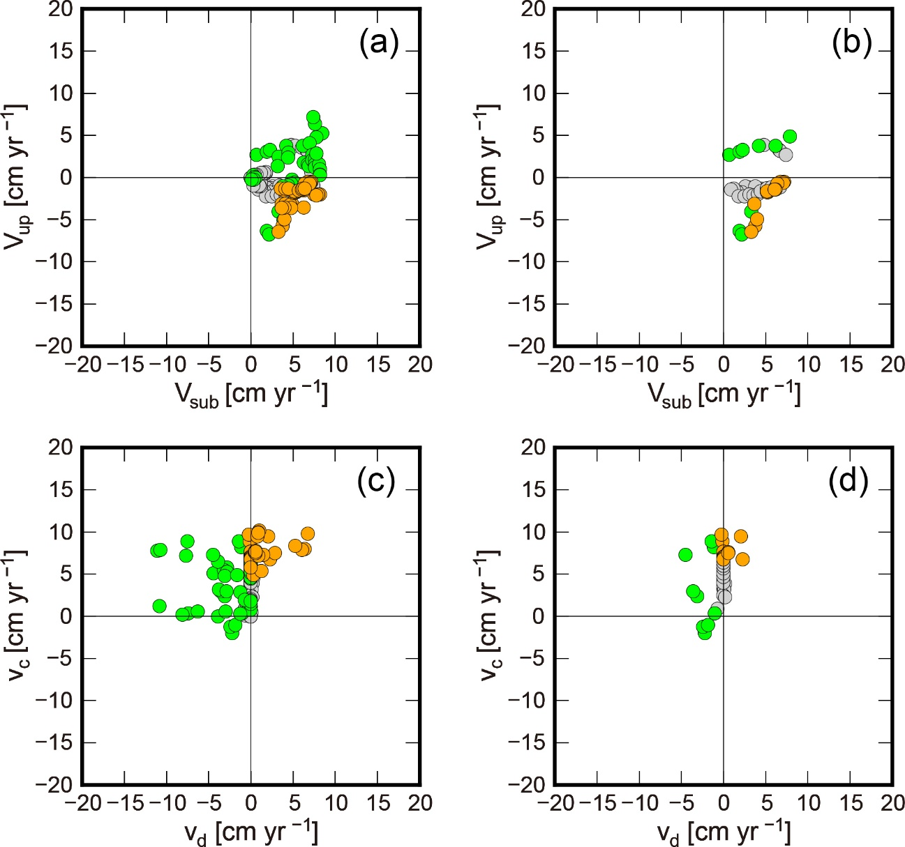

Figure S1. Diagrams relating to trenches in SB4 reference frame (Becker, 2006; Steinberger et al., 2004). Velocities of the subducting plate (V_{sub}) versus the that of overriding plate (V_{up}) for (a) 166 trenches and (b) trenches where the large shallow intraslab earthquakes (LSIEs) occur. Back-arc deformation (v_{d}) versus fore-arc deformation (v_{c}) for (c) 166 trenches and (d) trenches where LSIEs occur. Green, gray, and orange circles show the extension, neutral, and compressional stress regimes as deduced from focal mechanisms of earthquakes following the work of Lallemand et al. (2008).

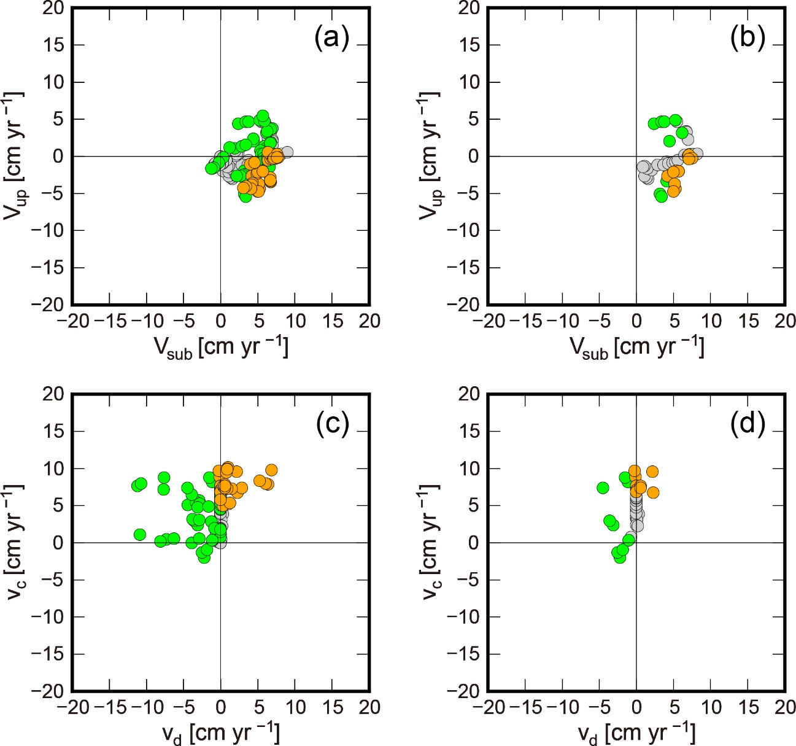

Figure S2. Diagrams relating to trenches in NNR reference frame (DeMets et al., 1994; Gripp and Gordon, 2002). Velocities of the subducting plate (V_{sub}) versus the that of overriding plate (V_{up}) for (a) 166 trenches and (b) trenches where the large shallow intraslab earthquakes (LSIEs) occur. Back-arc deformation (v_{d}) versus fore-arc deformation (v_{c}) for (c) 166 trenches and (d) trenches where LSIEs occur. Green, gray, and orange circles show the extension, neutral, and compressional stress regimes as deduced from focal mechanisms of earthquakes following the work of Lallemand et al. (2008).

References
Becker TW (2006) On the effect of temperature and strain-rate dependent viscosity on global mantle flow, net rotation, and plate-driving forces. Geophys. J. Int. 167(2):943-957. https://doi.org/10.1111/j.1365-246X.2006.03172.x.
DeMets C, Gordon RG, Argus DF, Stein S (1994) Effect of recent revisions to the geomagnetic reversal time scale on estimates of current plate motions. Geophys. Res. Lett. 21(20):2191-2194. https://doi.org/10.1029/94GL02118.
Gripp AE, Gordon RG (2002) Young tracks of hotspots and current plate velocities. Geophys. J. Int. 150(2):321-361. https://doi.org/10.1046/j.1365-246X.2002.01627.x.
Lallemand S, Heuret A, Faccenna C, Funiciello F (2008) Subduction dynamics as revealed by trench migration. Tectonics 27(3):TC3014. https://doi.org/10.1029/2007TC002212.
Steinberger B, Sutherland R, O'Connell RJ (2004) Prediction of Emperor-Hawaii seamount locations from a revised model of global plate motion and mantle flow. Nature 430:167-173. https://doi.org/10.1038/nature02660.

