TableS1 Strength parameters of quadriceps femoris muscle of the quadriceps femoris muscle during isometric knee extension tests at different angles and positions of the knee join [Median(IQR)]
Knee Position | Knee Flexion Angle(°) | Average Torque | Peak torque
Neutral  (NR) | 30 | 97.5(39) | 117.4(43)
Neutral  (NR) | 60 | 141.6(79.8) | 175.3(91.8)
Neutral  (NR) | 90 | 104.3(52.3) | 131.3(63.1)
Internal(10 ° IR) | 30 | 97.7(46.3) | 118.7(54.4)
Internal(10 ° IR) | 60 | 144.4(64.6) | 187.3(100.7)
Internal(10 ° IR) | 90 | 102.1(59.5) | 120.8(66.9)
External(10 °ER) | 30 | 104(44.6) | 121.7(42.8)
External(10 °ER) | 60 | 134.4(62.2) | 163(75)
External(10 °ER) | 90 | 103.1(49.6) | 123.4(56.8)
Abbreviations: NR indicates maximal Isometric knee extensions of the advantageous side leg at the neutral position of the knee joint without rotation; Internal(10 ° IR) indicates maximal Isometric knee extensions of the advantageous side leg at position of 10° internal rotation of the knee joint; External(10 °ER) indicates maximal Isometric knee extensions of the advantageous side leg at position of 10° external rotation of the knee joint; 0 in Knee Flexion Angle indicates the test results in a resting position.
P-valueª Indicates differences between different angles at the same knee joint position and level, P-value^{b} Indicates differences between different positions at the same knee flexion angle and level.

TableS2 Muscle Stiffness of the quadriceps femoris muscle during isometric knee extension tests at different angles and positions of the knee join [Median(IQR)]
Knee Position | Knee Flexion Angle(°) | Muscle Stiffness(RF) | Muscle Stiffness(VL) | Muscle Stiffness(VM)
Neutral  (NR) | 0 | 244.8 (72.9) | 334.2 (44.8) | 281(69.4)
Neutral  (NR) | 30 | 417.3(345.1) | 608.7(244.5) | 613.7(379.3)
Neutral  (NR) | 60 | 402(352.5) | 639.7(227.7) | 507.5(336.3)
Neutral  (NR) | 90 | 434.2 (347.1) | 650.3(257.7) | 612.7(322.3 )
Internal  (10 ° IR) | 0 | 250 (78.2) | 339.8(66.2) | 280(68.3)
Internal  (10 ° IR) | 30 | 409.3(328.3) | 622(268.8) | 552.1(415.6)
Internal  (10 ° IR) | 60 | 419(270.4) | 634.3(264.4) | 574.2(364.4)
Internal  (10 ° IR) | 90 | 363.5(342.2) | 659.8(257.6) | 613.8(291.9)
External  (10 °ER) | 0 | 246(71.3) | 340.7(73.5 ) | 292(71.7)
External  (10 °ER) | 30 | 394(338.1) | 614.7(261.8) | 542.8(393.2)
External  (10 °ER) | 60 | 378.3(341) | 656.8(290.2) | 559.2(350.8)
External  (10 °ER) | 90 | 421.4(363.8) | 681(248.1) | 616.7(89.9 )
Abbreviations: RF, rectus femoris; VL, vastus lateralis; VM, vastus medialis; NR indicates maximal Isometric knee extensions of the advantageous side leg at the neutral position of the knee joint without rotation; Internal(10 ° IR) indicates maximal Isometric knee extensions of the advantageous side leg at position of 10° internal rotation of the knee joint; External(10 °ER) indicates maximal Isometric knee extensions of the advantageous side leg at position of 10° external rotation of the knee joint; 0 in Knee Flexion Angle indicates the test results in a resting position.
P-value^{c} Indicates differences between different angles at the same knee joint position and level, P-value^{d} Indicates differences between different positions at the same knee flexion angle and level.

S1: Ethical approval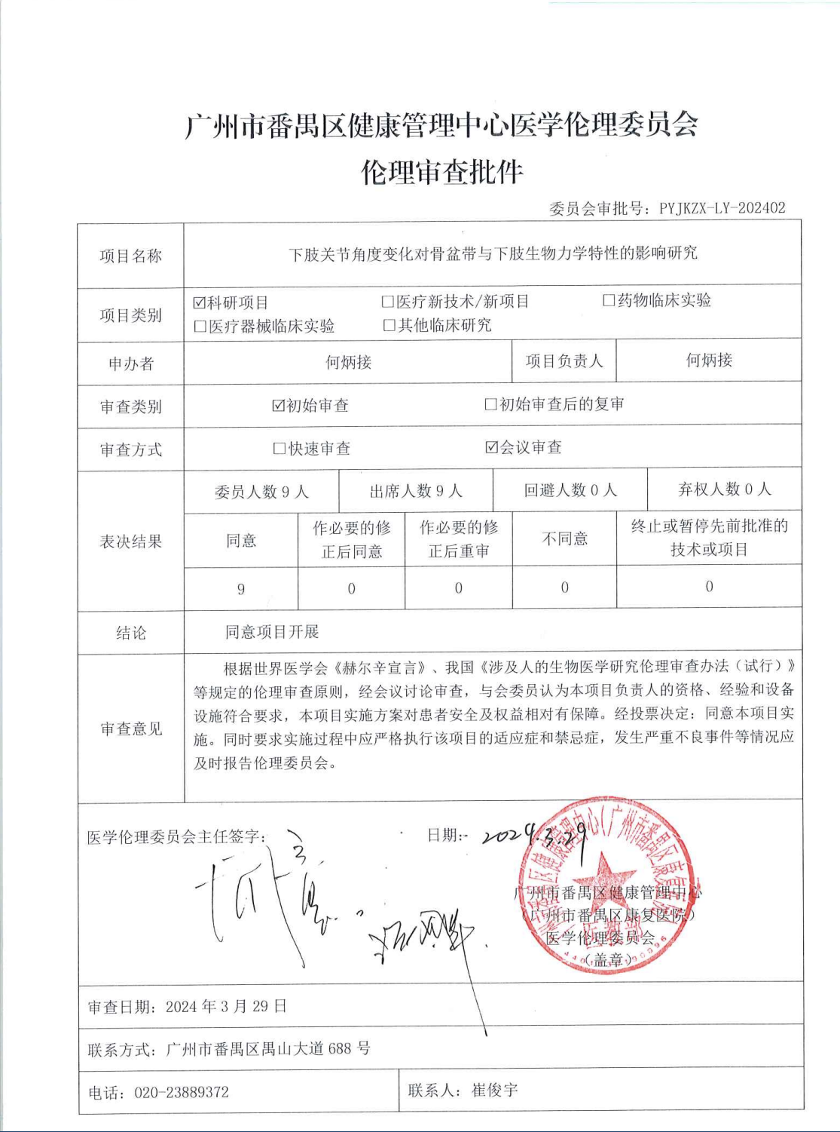
Google Translate Version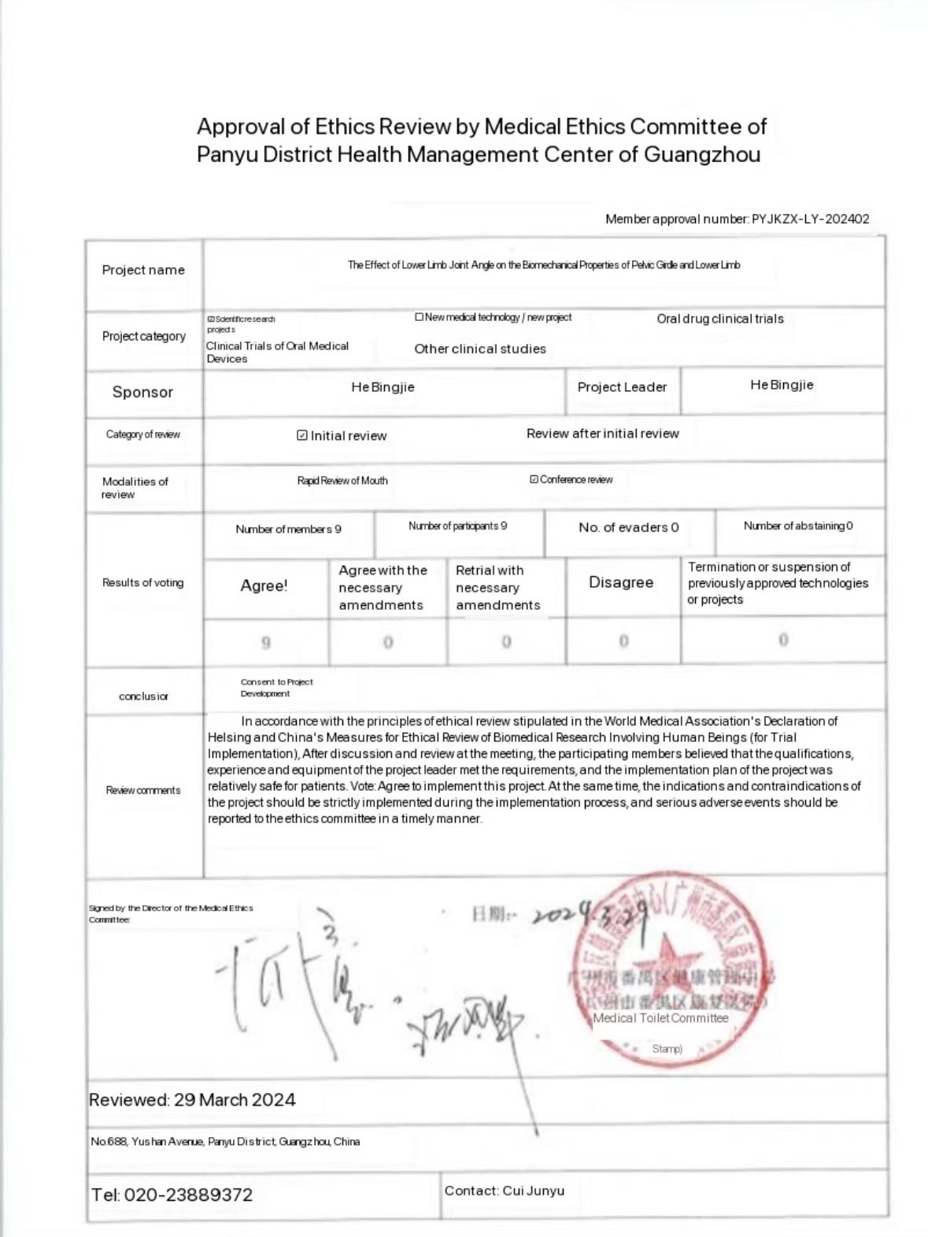

S3: Conducting an experiment on a certain subject
