Supporting Information

Supplementary Figures
Figure S1. Correlation between the expression level of transferrin receptor and liver cancer progression
A: the expression level of transferrin receptor in liver cancer tissues, B: the survival rate of patients with high and low TfR expression level
Figure S2. The expression level of ACh and AchE in liver cancer
A: the expression level of ACh in liver cancer tissues, B: the expression level of AChE in liver cancer tissues.
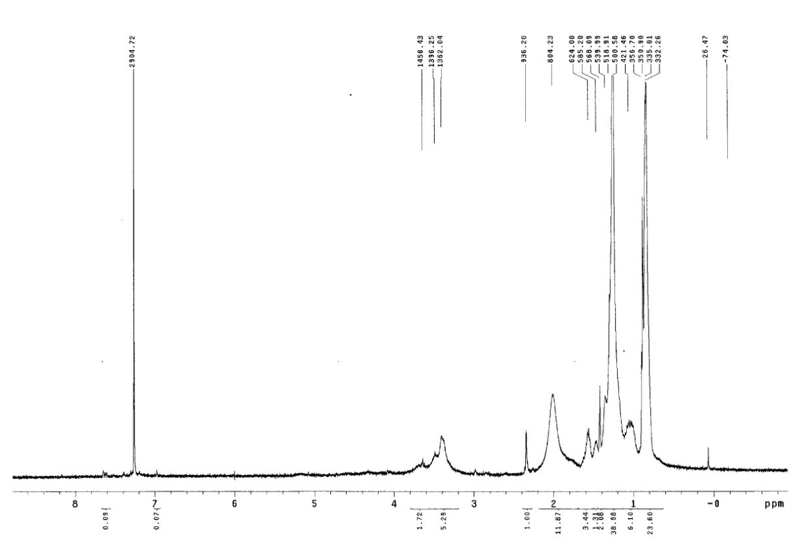
Figure S3. ¹H-NMR spectrum of Tf-GHDC.
Tf-GHDC were dissolved in D₂O for ¹H-NMR spectrum.
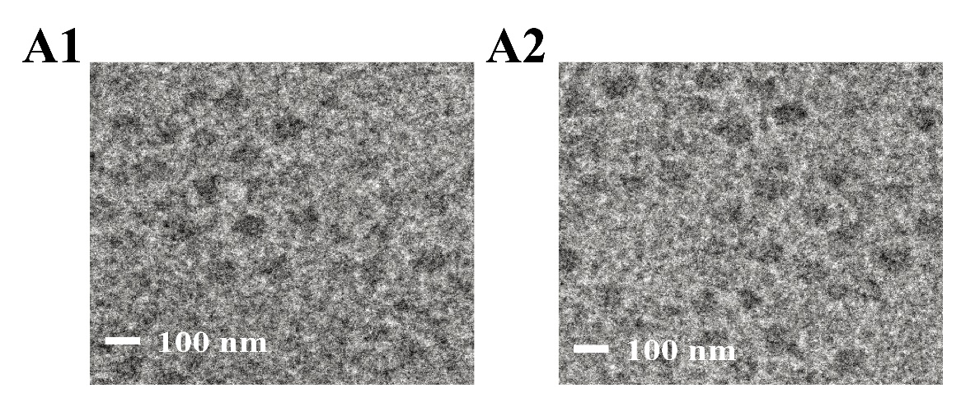 Figure S4. The transmission electron microscopy of PL-AChE and Tf-PL-AChE.
A: PL-AChE, B: Tf-PL-AChE.
Figure S5. Cytotoxicity of the prepared proteoliposomes.
A: PL-AChE, B: Tf-PL-AChE.

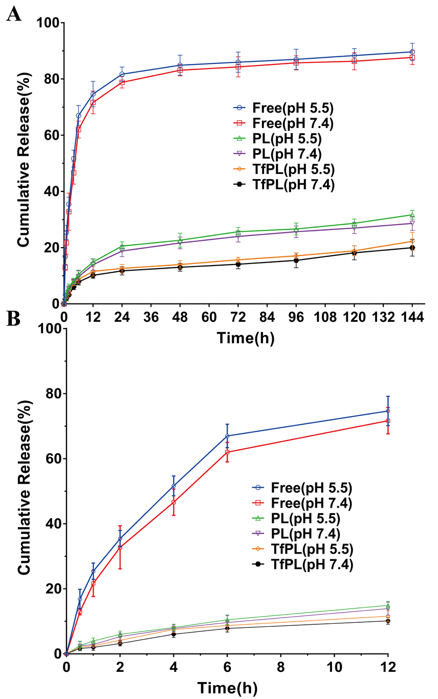
Figure S6. Controlled-release kinetics of the different Ache formulations.
A: Release of the whole observation points；B: Release of the observation points within 12 h of Ache gene.
Figure S7. Fluorescence intensity of in vitro EGFP expression.

Figure S8. Effect on SMMC-7721 cell proliferation of Ach and Ache.
A: SMMC-7721 cell proliferation under different Ach concentration；B: SMMC-7721 cell proliferation under different AchE concentration.
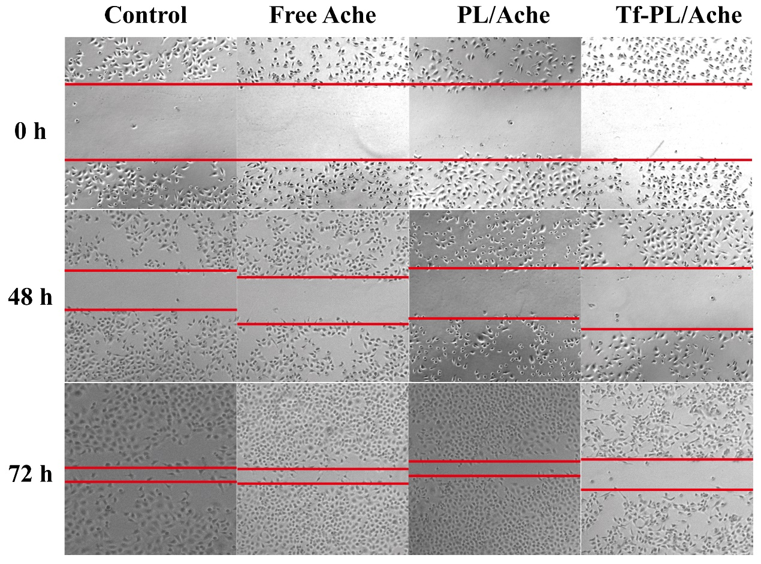
Figure S9. Cell scratch repair experiment.
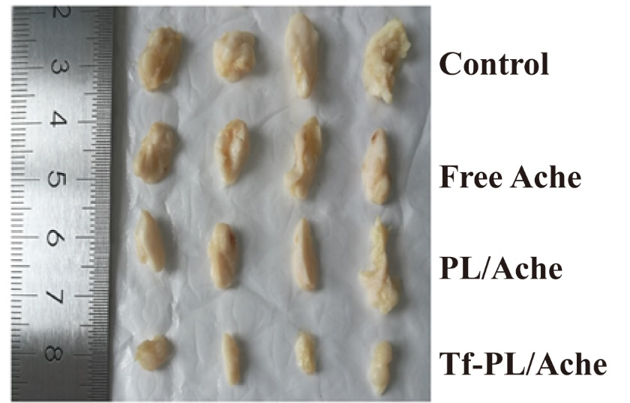
Figure S10. Photographic images of dissected tumor tissues
Supplementary Tables
Analysis of physical and chemical properties of liposomes
Table 1. Influence of different proportion of GHDC: Chol on liposome particle size
GHDC/Chol (W/W) | Mean diameter (nm)
1:0.1 | 69.1
1:0.2 | 80.3
1:0.4 | 113.0
1:0.6 | 154.0
1:0.8 | 208.5
1:1.0 | 344.6

Table 2. Effects of different proportions of Tf-GHDC: Chol on the particle size of liposomes
Tf-GHDC/Chol (W/W) | Mean diameter (nm)
1:0.1 | 71.0
1:0.2 | 83.0
1:0.4 | 121.0
1:0.6 | 174.4
1:0.8 | 231.3
1:1.0 | 374.0

Table 3. Effects of different proportion of GHDC: Chol: Ache on liposomal-loaded genes
GHDC/Chol /Ache(W/W/W) | Mean diameter (nm) | DL% | EL%
1:0.1:0.1 | 92.1 | 5.82 | 90.1
1:0.1:0.2 | 96.0 | 6.07 | 91.2
1:0.1:0.5 | 135.0 | 6.13 | 91.3
1:0.2:0.1 | 154.0 | 5.15 | 90.0
1:0.2:0.2 | 178.1 | 6.1 | 91.0
1:0.2:0.5 | 272.6 | 5.63 | 92.1

Table 4. Effects of different proportions of Tf-GHDC: Chol: Ache on liposomal - loaded genes
Tf-GHDC/Chol /Ache(W/W/W) | Mean diameter (nm) | DL% | EL%
1:0.1:0.1 | 101.0 | 5.3 | 89.7
1:0.1:0.2 | 113.0 | 6.31 | 94.3
1:0.1:0.5 | 121.0 | 6.49 | 94.1
1:0.2:0.1 | 170.4 | 5.45 | 91.3
1:0.2:0.2 | 191.3 | 5.4 | 94.3
1:0.2:0.5 | 304.0 | 5.43 | 93.7

Table 5. Optimization of Tf-GHDC:Chol:Ache ratio on lipoplastological influence
Formulation | Size | PDI | Zeta potential | DL% | EE% | CE%
PL | 96.0±7.0 | 0.187±0.02 | 30.0±0.17 | 6.07±0.43 | 91.2±0.79 | -
Tf-PL | 113.0±5.2 | 0.113±0.03 | 28.5±0.22 | 6.31±0.32 | 94.3±1.01 | 88.7±2.31

