Kataegis associated mutational processes linked to adverse prostate cancer presentation in African men
Jue Jiang, Avraam Tapinos, Ruotian Huang, M.S. Riana Bornman, Phillip D. Stricker, Shingai B. A. Mutambirwa, David C. Wedge, Weerachai Jaratlerdsiri & Vanessa M. Hayes

Extended Data

Extended Data Tables

Extended Data Table S1. Kataegis events (n=249) in our study cohort of 109 African and 79 non-African derived prostate tumours.

Extended Data Table S2. Annotated kataegis SNVs and spanning 611 gene regions in our study cohort of 109 African and 79 non-African derived prostate tumours.

Extended Data Table S3. Cancer Gene Census (CGC) genes (n=11) spanned with kataegis in our study cohort of 109 African and 79 non-African derived prostate tumours.

Extended Data Table S4. Kataegis events assigned to each evolutionary epoch based on SNV composition.
 | SNV composition*
Kataegis | Early clonal SNVs | Late clonal SNVs | Unspecified clonal SNVs | Subclonal SNVs | Unknown SNVs
Early clonal kataegis | Yes | No | Optional | No | Optional
Late clonal kataegis | No | Yes | Optional | No | Optional
Unspecified clonal kataegis | No | No | Yes | No | Optional
Subclonal kataegis | No | No | No | Yes | Optional
Unknown kataegis | No | No | No | No | Yes
*Each row represents a kataegis evolutionary type with required SNVs noted as yes, optional SNVs noted as optional, and SNVs should not be contained that denoted as no.

Extended Data Figures

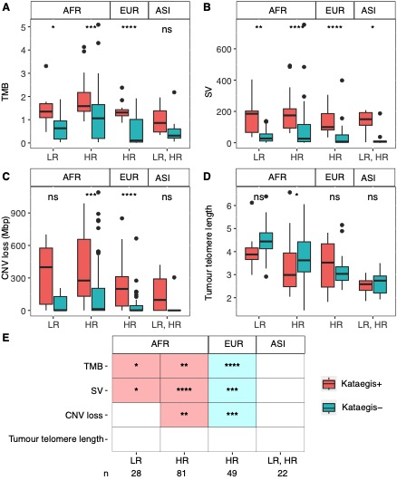
Extended Data Fig. 1 | Associating presence of kataegis with tumour molecular features in our multi-ethnic cohort of 188 PCa patients distinguished by risk level and ancestry. Genomic features include: A. Tumour Mutational Burden (TMB), B. count of Structural Variants (SVs), C. Copy Number Variant (CNV) loss in Mbp, and D. Tumour telomere length. The comparison was made between kataegis positive (+) versus negative (-) by risk level defined as low-risk (LR) for GG1/2, and high-risk (HR) for GG3-5 clinicopathological presentation, and by ancestries including African (AFR), European (EUR) or Asian (ASI). Significance was defined by P-value (ns, not significant). E Significant levels after FDR adjustment for tumour genomic features stratified by kataegis, indicating study size (n) and none significance by blank tiles. Significant level descriptors: *, P-value, FDR $≤$ 0.05; **, P-value, FDR $≤$ 0.01; ***, P-value, FDR <= 0.001; and ****, P-value, FDR <= 0.0001.
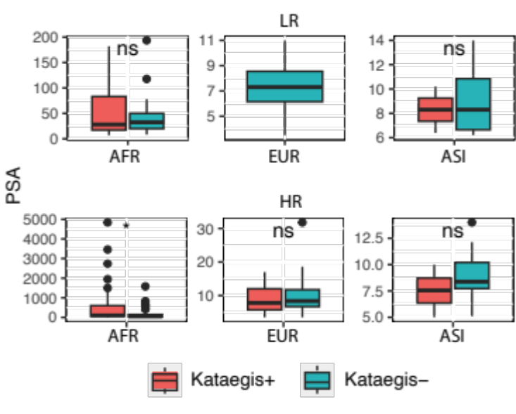
Extended Data Fig. 2 | Prostate-specific antigen (PSA) presented in 188 PCa patients distinguished by clinical risk and ancestry. PSA values were compared between kataegis positive (+) and negative (-) within risk levels, defined as low-risk (LR) for GG1/2, and high-risk (HR) for GG3-5 clinicopathological presentation, and by derived ancestries, including African (AFR), European (EUR) and Asian (ASI). Significance was defined by P-value with ns for not significant and * for P-value < 0.05.

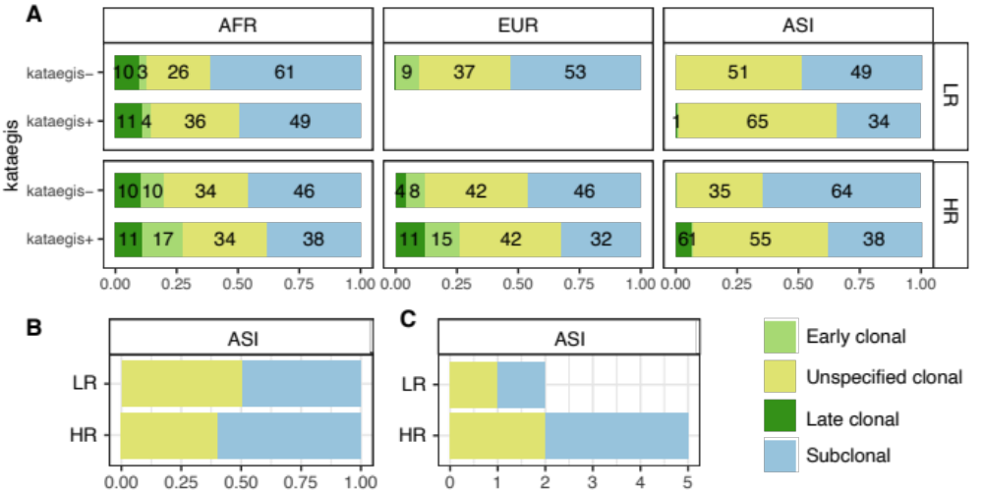

Extended Data Fig. 3 | Evolution of genome-wide SNVs and kataegis events. A Fraction of genome-wide SNVs per evolutionary epoch presented in kataegis positive (+) and negative (-) tumours by risk-level and ancestry occurring in evolutionary epochs. The risk level of tumour was defined as low-risk (LR) for IUP1/2, and high-risk (HR) for GG3-5 clinicopathological presentation. Studied ancestries includes African (AFR n=109), European (EUR, n=57), and Asian (ASI, n = 22). Percentage of larger than 5% are shown. B and C shows evolution of kataegis events of Asian patients by clinical risk are shown as proportion and number of different epochs, respectively.

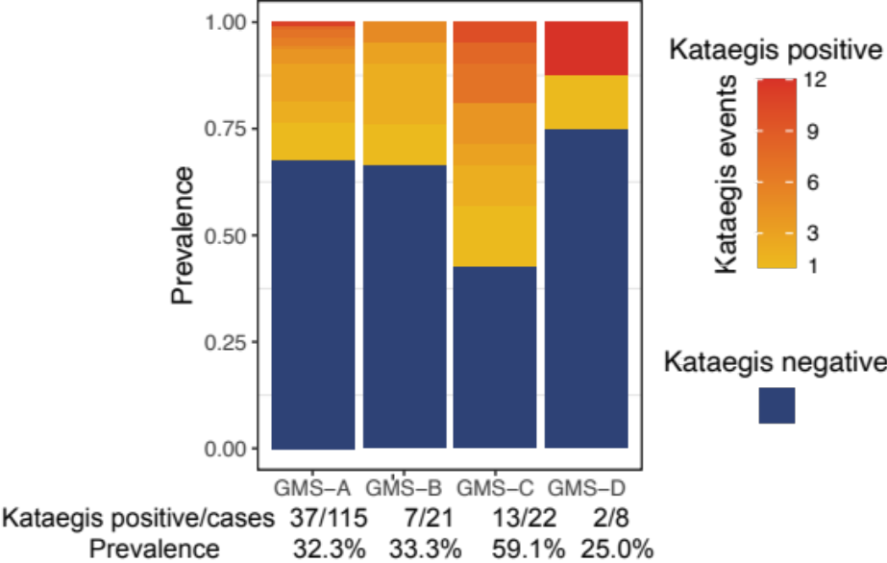

Extended Data Fig. 4 | Prevalence of kataegis by global molecular subtype (GMS). Each row represents a tumour, ordered by kataegis burden. While kataegis negative tumours are in dark blue, the yellow to red gradient for positive tumours represents the number of kataegis events from smallest to largest. Kataegis positives versus total cases and prevalence of each GMS are labelled underneath.
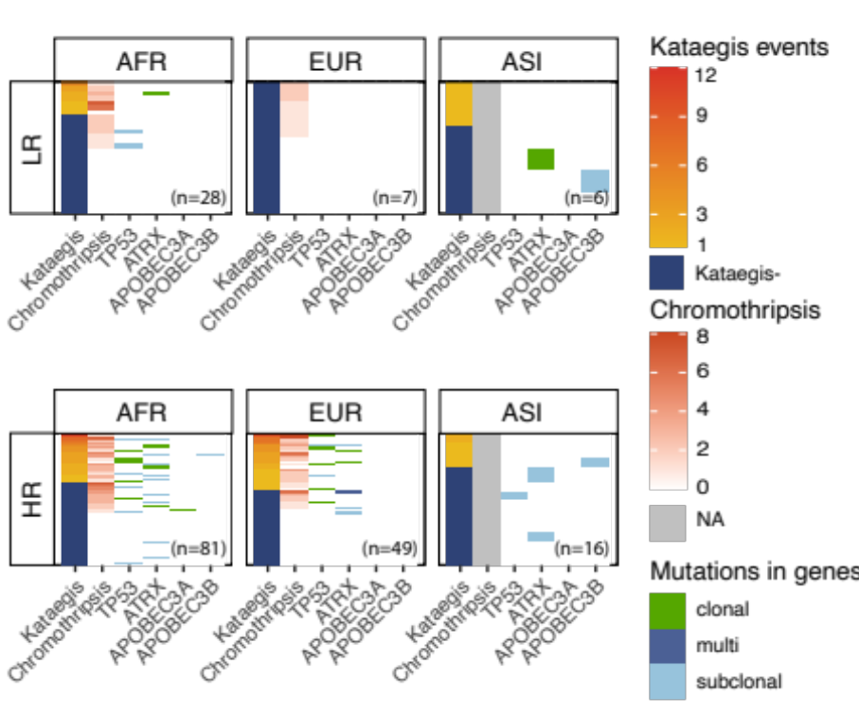
Extended Data Fig. 5 | Concurrence of kataegis and chromothripsis and small mutations in selected genes. Each row represents a tumour, in the order of the number of kataegis and chromothripsis. Tumours were grouped by risk level, defined as low-risk (LR) for GG1/2, and high-risk (HR) for GG3-5 clinicopathological presentation, and by ancestries, including African (AFR), European (EUR), and Asian (ASI). The number of cases of each group are shown on the right bottom. Columns, from left to right, show kataegis negative (-) or kataegis burden if positive (+), chromothripsis burden, evolutionary timing of mutations in selected genes TP53, ATRX, APOBEC3A, and APOBEC3B. A tumour had both clonal and subclonal mutations in ATRX and was denoted as multi-hit.

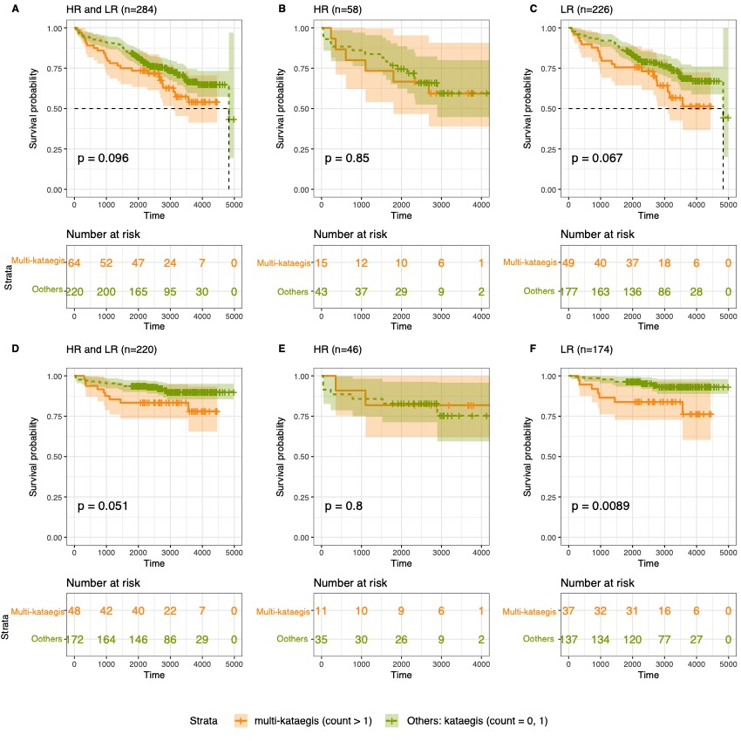
Extended Data Fig. 6 | Kaplan-Meier survival estimates correlating presence of multiple kataegis with log-rank test on European public cohort by clinical follow-up (time in days). The comparison was between patients having multiple kataegis against having one or no kataegis. The risk level was defined as low-risk (LR) for GG1/2, and high-risk (HR) for GG3-5 clinicopathological presentation. Clinical progression was defined as biochemical relapse (BCR) and/or metastasis against no progression for A - C and defined as metastasis against no progression for D – E. A. The progression comparison between multiple kataegis patients (n = 64) and others (n = 220) regardless of the risk level. Comparison within HR tumours and LR tumours are shown respectively in B (multiple kataegis, n = 15 versus others, n = 43) and C (multiple kataegis, n = 49 versus others, n = 177). With progression defined as metastasis, D shows the comparison between multiple kataegis patients (n = 48) and others (n = 172) regardless of the risk level. Comparison within HR tumours and LR tumours are shown respectively in E (multiple kataegis, n = 11 versus others, n = 35) and F (multiple kataegis, n = 37 versus others, n = 137).

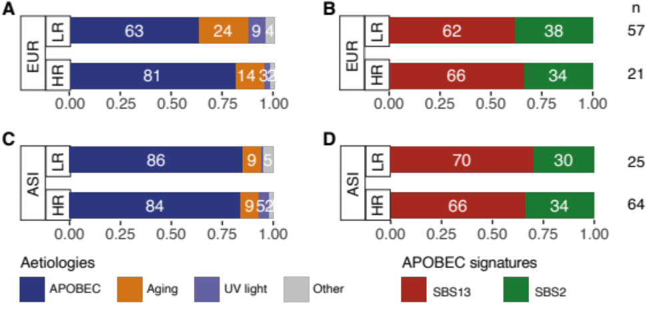
Extended Data Fig. 7 | Associated aetiology of Single-base substitution (SBS) contributing to kataegis identified in PCa of European (EUR) and Asian (ASI) public cohort. Proportion of related aetiology contributing to kataegis by risk groups and ancestry for the EUR (A) and ASI (C) public cohorts. APOBEC aetiology shows proportion of SBS2 and SBS13. Aging aetiology shows proportion of SBS1 and SBS5. Ultraviolet (UV) light exposure shows proportion of SBS7b. Others show proportions of SBS9 and SBS28. The risk level was defined as low-risk (LR) for GG1/2, and high-risk (HR) for GG3-5 clinicopathological presentation. Proportion of APOBEC signatures SBS2 and SBS13 in kataegis identified in the EUR (B) and ASI (D) public cohorts. Numbers on the right show the numbers of kataegis positive genomes per group. The three EUR patients excluded had z-scores greater than three and were regarded as outliers.

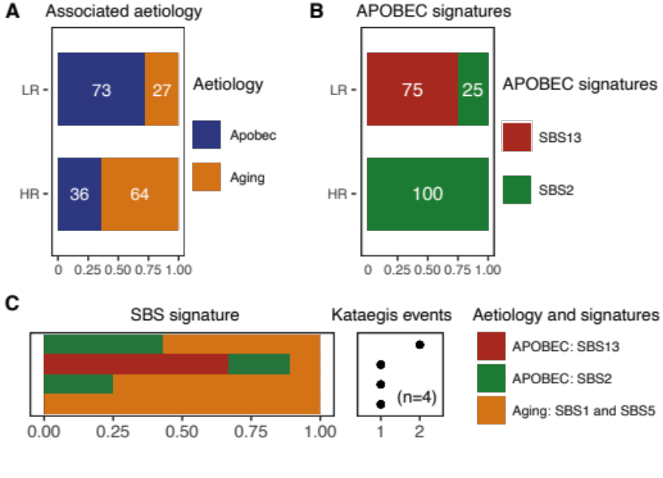
Extended Data Fig. 8 | Single-base substitution (SBS) and associated aetiology contributing to kataegis identified in PCa derived from Asian patients. A. Proportion of related aetiology contributing to kataegis. APOBEC aetiology shows proportion of SBS2 and SBS13. Aging-related aetiology shows proportion of SBS1 and SBS5. The risk level was defined as low-risk (LR) for GG1/2, and high-risk (HR) for GG3-5 clinicopathological presentation. B. Proportion of APOBEC signatures SBS2 and SBS13. C. APOBEC-related signatures SBS2 and SBS13 and aging-related aetiology contributed to each kataegis. Each row represents a tumour, ordered by kataegis burden shown as dots on the right. APOBEC related signatures SBS2 and SBS13 are in different colour. Aging-related signatures SBS1 and SBS5 are in the same colour.

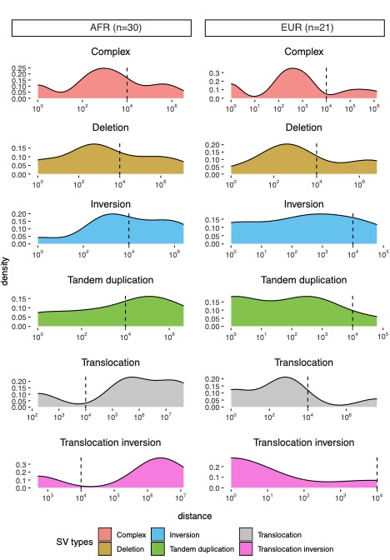
Extended Data Fig. 9 | Detailed distance between kataegis and their proximal SV of each type in African (AFR, n=30) and European (EUR, n=21) derived high-risk PCa. High-risk (HR) tumour was defined as for having GG3-5 clinicopathological presentation. Numbers of subjects for each group is labelled in brackets. A hyper-kataegic tumour was excluded.

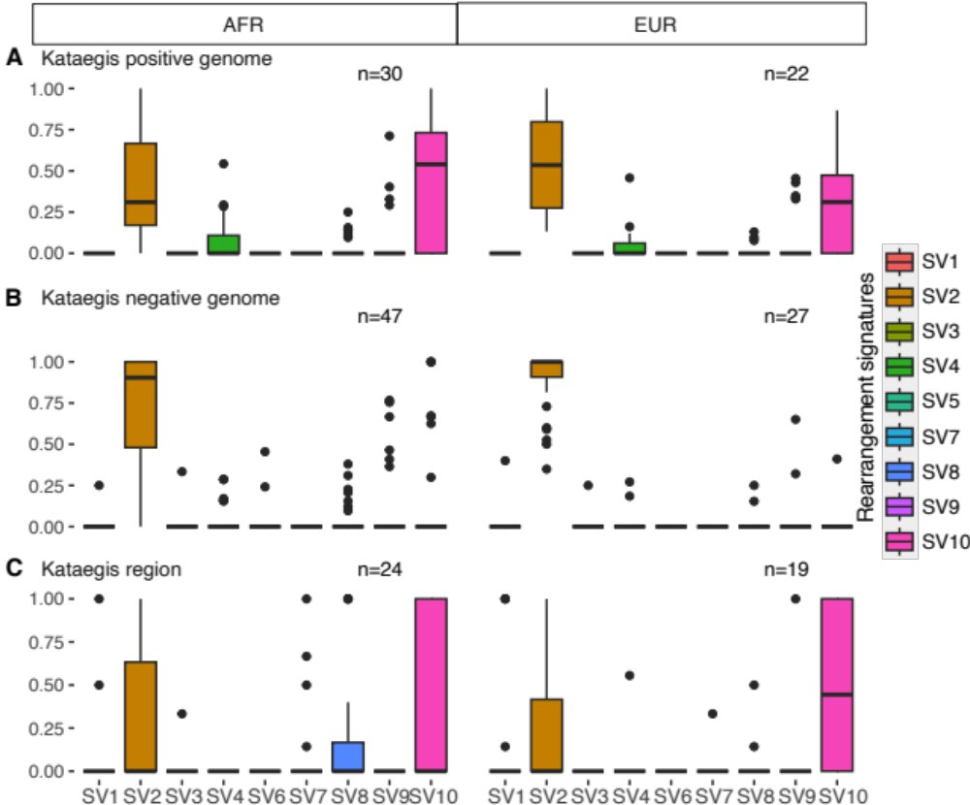
Extended Data Fig. 10 | Proportions of all SV signatures in high-risk African (AFR, n=77) or European (EUR, n=49) derived tumours with respect to their kataegis status or association. High-risk (HR) tumour was defined as for having GG3-5 clinicopathological presentation. Proportion shown by ancestry for genome-wide SV signatures in A. kataegis positive tumours (n=52) and B. kataegis negative tumours (n=74) and C. for kataegis region (10 kbp flanking) SV in kataegis positive tumours (n=43).

