Super-resolution 3D Tomography of Vector Near-fields in Dielectric Optical Nano-resonators
Bingbing Zhu^{1,2,†}, Qingnan Cai^{1,2,†}, Yaxin Liu^{1,2,†}, Sheng Zhang^{1,2,†}, Weifeng Liu^{1,2}, Qiong He^{1,2}, Lei Zhou^{1,2,*}, Zhensheng Tao^{1,2,*}
¹ State Key Laboratory of Surface Physics, Key Laboratory of Micro and Nano Photonic Structures (MOE), and Department of Physics, Fudan University, Shanghai 200433, China.
² Shanghai Key Laboratory of Metasurfaces for Light Manipulation, Fudan University, Shanghai 200433, China.
† These authors contributed equally to this work.
*Corresponding author. Email: phzhou@fudan.edu.cn; zhenshengtao@fudan.edu.cn.

The PDF file includes:

Supplementary Text
Figs. S1 to S12
Tables S1 to S2
References (61-70)

Other Supplementary Materials for this manuscript include the following:
Movie S1

S1. Experimental setup
Figure S1 illustrates the setup of our experiments. We employed an Yb:KGW amplifier operating at a repetition rate of 5 kHz, delivering 1 mJ pulse energy and 170 fs pulse duration. The majority of the laser energy (83%) drove an optical parametric amplifier (OPA), which was pumped by the second harmonic generation (SHG) of the laser. The idler output of the OPA detuned the laser wavelength from 1030 nm to ~1110 nm. Strong and carrier-envelope-phase-stabilized mid-infrared (MIR) pump pulses with a wavelength of 𝜆_{Pu}≈15μm were generated through difference-frequency generation (DFG) between the idler beam and a fundamental laser beam (~13% of the total energy) in a GaSe crystal⁶¹. The signal output of the OPA (𝜆_{Pr}≈967 nm) was used as the near-infrared (NIR) probe pulse. The relative time delay (𝜏) between the MIR pump and NIR probe pulses was adjusted by a mechanical delay stage.
The MIR pump and NIR probe beams were collinearly focused by an objective lens (Obj. lens) with a numerical aperture (NA) of 0.28. This configuration resulted in a FWHM beam size of ~1 μm for the probe laser on the sample. The FWHM beam size of the pump laser was ~60 μm, ensuring the uniform excitation of near-field modes inside the resonator. The highest intensity of the pump pulse could reach 4.7×10¹⁰ W/cm² with a pulse energy of ~0.45 μJ and a pulse duration of ~240 fs. The highest intensity of the probe pulse could reach 1.0×10¹⁰ W/cm². The polarization direction of the probe pulse was adjusted by a NIR half-waveplate (NIR $\frac{λ}{2}$). The intensity of the pump pulse was adjusted by a pair of MIR polarizers (MIR pol.). The generated HSG beam was collected by another objective lens (Obj. lens, NA=0.40). A confocal setup was built by applying a 150 μm-diameter pinhole at the refocused plane of the HSG fields after a 50 cm lens, thereby filtering out the surrounding rings of the Airy pattern. The HSG spectrum was recorded by a spectrometer (Horiba iHR320), after passing through a broadband polarizer (HSG polarizer).
The samples were mounted on a 3D piezo-stage. The real-space imaging of near-field wave patterns was achieved by transversely scanning the sample in the x-y plane with a precision of ~5 nm. The step sizes employed in the experiments ranged from 0.3 to 0.4 μm in most cases. For the measurement of near-field phases, the spectrum of the NIR probe pulse was slightly broadened by focusing the probe beam into a 4 mm-thick YAG crystal, leading to supercontinuum generation (SCG).

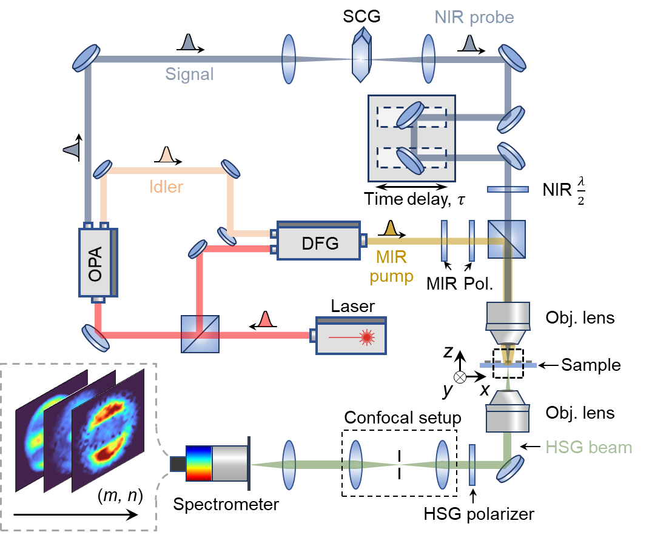
Figure S1. Schematic of the experimental setup. Pol.: Polarizer; Obj.: Objective.

In Fig. S2A and B, we present the knife-edge response of the spectral intensities of the F-HSG (1, 2) and SH-HSG (2, 1), obtained by scanning across a sharp flat edge of a 0.1 μm-thick silicon thin film. The spatial resolutions of 𝛿₁=1.35 μm and 𝛿₂=0.92 μm for the (1, 2) and (2, 1) orders, respectively, were determined by the error-function fitting. The resolution enhancement of ${δ_{2}}/{δ_{1}}=\frac{1}{1.46}≈\frac{1}{\sqrt{2}}$ can be attributed to the involvement of two probe photons (m=2) in the SH-HSG process.

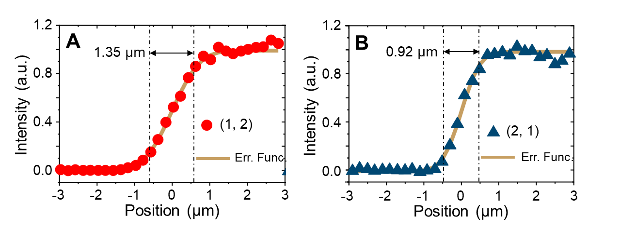
Figure S2. Knife-edge measurement using (A) the (1, 2) order and (B) the (2, 1) order. The symbols are the experimental results. The solid lines represent the error-function (Err. Func.) fitting.

In Fig. S3, we present the dependence of HSG intensity on pump and probe intensities, which can be well characterized by $I_{HSG}^{(m,n)}∝{\left|I_{Pr}\right|}^{m}∙{\left|I_{Pu}\right|}^{\left|n\right|}$, where I_{Pr} and I_{Pu} are the probe and pump intensities, respectively.
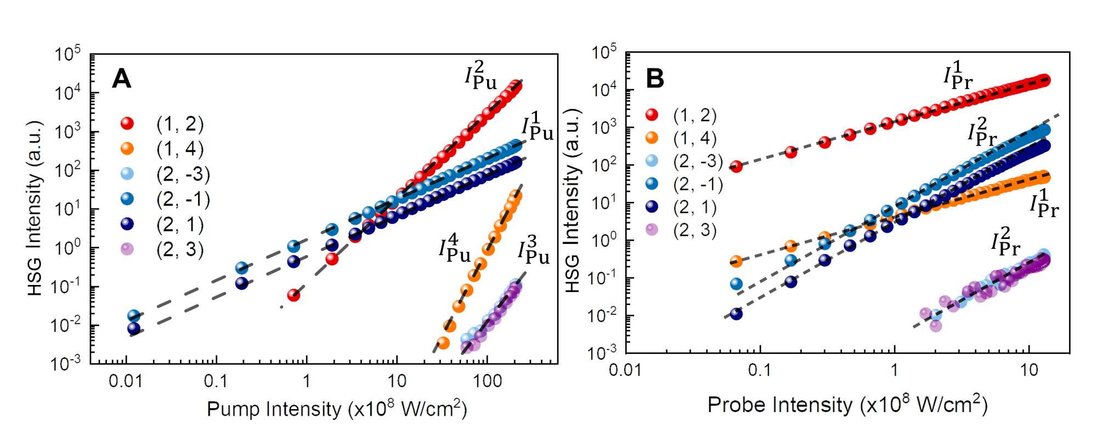
Figure S3. HSG intensity of different orders as a function of (A) the pump intensity and (B) the probe intensity. Dashed lines represent the power function fitting results.

To determine the spectra and phases of probe and pump fields, we employed blind frequency-resolved optical gating (blind-FROG) measurement⁶² using the HSG order (1, 2) on a homogenous 0.5 μm-thick silicon sample. Specifically, we recorded the HSG spectra under different time delay 𝜏, as shown in Fig. S4A. As the coherent length of the nonlinear process (>5 μm) is far larger than the sample thickness, the averaging effect along z can be ignored. The delay-dependent spectrogram is given by
$I\left(ω, τ\right)∝{\left|\int_{-∞}^{+∞}{{\left[E^{Pu}\left(t\right)\right]}^{2}⋅E^{Pr}\left(t-τ\right)e^{iωt}dt}\right|}^{2}$. (S1)
We reconstructed the fields $E^{Pu}\left(t\right)$ and $E^{Pr}\left(t\right)$ by employing the Principal Component Generalized Projections Algorithm (PCGPA) ^{62,63}. The reconstructed trace is shown in Fig. S4B. The spectra and phases for the pump and probe fields are displayed in Fig.S4C and D, respectively.
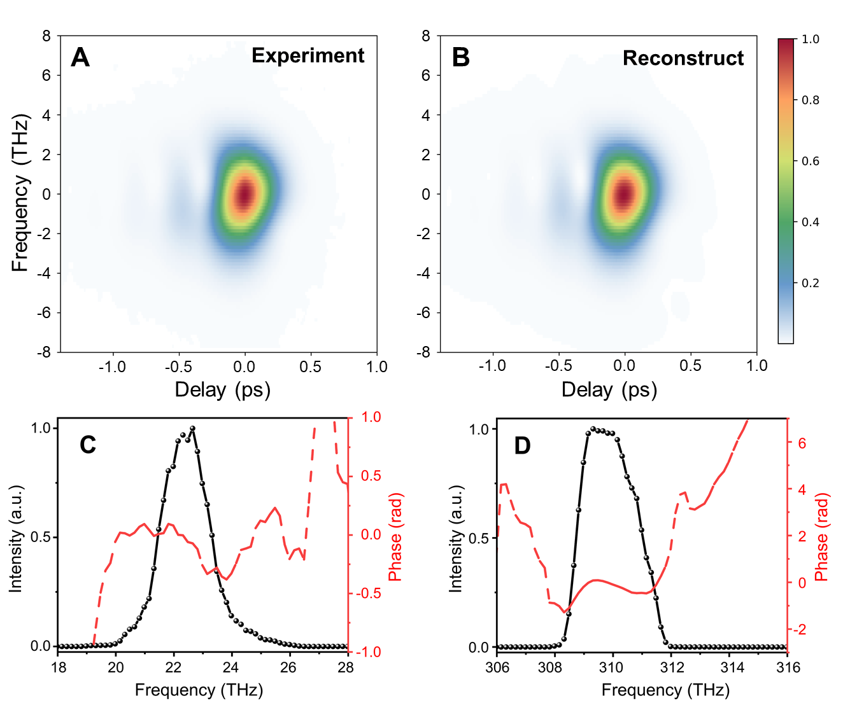
Figure S4. (A) Experimentally measured spectrogram of the (1, 2) HSG order. (B) Spectrogram obtained by reconstruction from the results in (A) using the PCGPA algorithm. (C) and (D) Spectra and phases of the MIR pump and NIR probe pulses obtained from the reconstruction.

S2. Sample preparation
The schematic of the sample fabrication process is illustrated in Fig. S5. A 1.5 µm-thick layer of amorphous silicon was first deposited on a 500 µm-thick quartz substrate using Plasma Enhanced Chemical Vapor Deposition (PECVD). The growth parameters were set as follows: RF power of 40W, pressure of 1500 mTorr, SiH₄ flow rate of 40 sccm, Ar flow rate of 450 sccm, temperature of 350°C, and a growth rate of approximately 80 nm/min. Subsequently, photolithography was employed to define patterns on the amorphous silicon film. Prior to spin-coating the photoresist, the substrate underwent HMDS (hexamethyldisilazane) treatment. The AZ6112 photoresist was deposited with the substrate spinning at a speed of 500 rpm for 5s, followed by 4000 rpm for 30 s, resulting in an expected thickness of ~1.2 µm. After pre-baking at 100°C for 120 s, the exposure time was set at 2.2 s, followed by development using 3038 developer for 31-33 s.
Subsequently, silicon film was etched using Inductively Coupled Plasma (ICP) etching process on an STS AOE etcher. The etching parameters were set as follows: ICP power of 1000W, RF power of 100W, pressure of 10 mTorr, CHF₃ flow rate of 30 sccm, with an expected etching rate of approximately 400 nm/min and an etching selectivity ratio of 1:1. Following etching, the residual photoresist was removed using organic solvents. This process involved immersion in acetone at 70°C for 10 minutes, followed by isopropanol soaking for 10 minutes or more, rinsing with deionized water for 10 times or more, and drying with a nitrogen gun. This comprehensive process can successfully fabricate micrometer-scale cylindrical structures on a 500 µm-thick quartz substrate.
Figure S5. Illustration of the sample preparation procedures.

S3. Finite-element-method simulations
We employed COMSOL program for the finite-element-method (FEM) simulations. Our investigation focused on a scenario where a planar electromagnetic wave with a wavelength corresponding to the pump light was incident normally onto a single silicon cylinder placed on a quartz substrate. The refractive indices of the substrate and silicon were obtained from Ref. ⁶⁴ and Ref. ⁶⁵, respectively.
Our simulations comprised two steps: First, the silicon cylinder was removed, and the response of an incident plane wave on an infinitely large quartz substrate was computed. Subsequently, using the resultant total field as the background field, we calculated the scattering of the silicon cylinder against this background field. The scattering cross-section (𝜎_{scatter}) corresponds to the energy-flow integral of the scattered field in the second step. In the first step, a periodic boundary condition was applied in the x and y directions to simulate an infinitely extended air-substrate interface. In the second step, the boundary condition of perfectly matched layers (PML) was employed in the x and y directions to simulate an isolated scatterer, radiating electromagnetic waves to infinity without reflection.
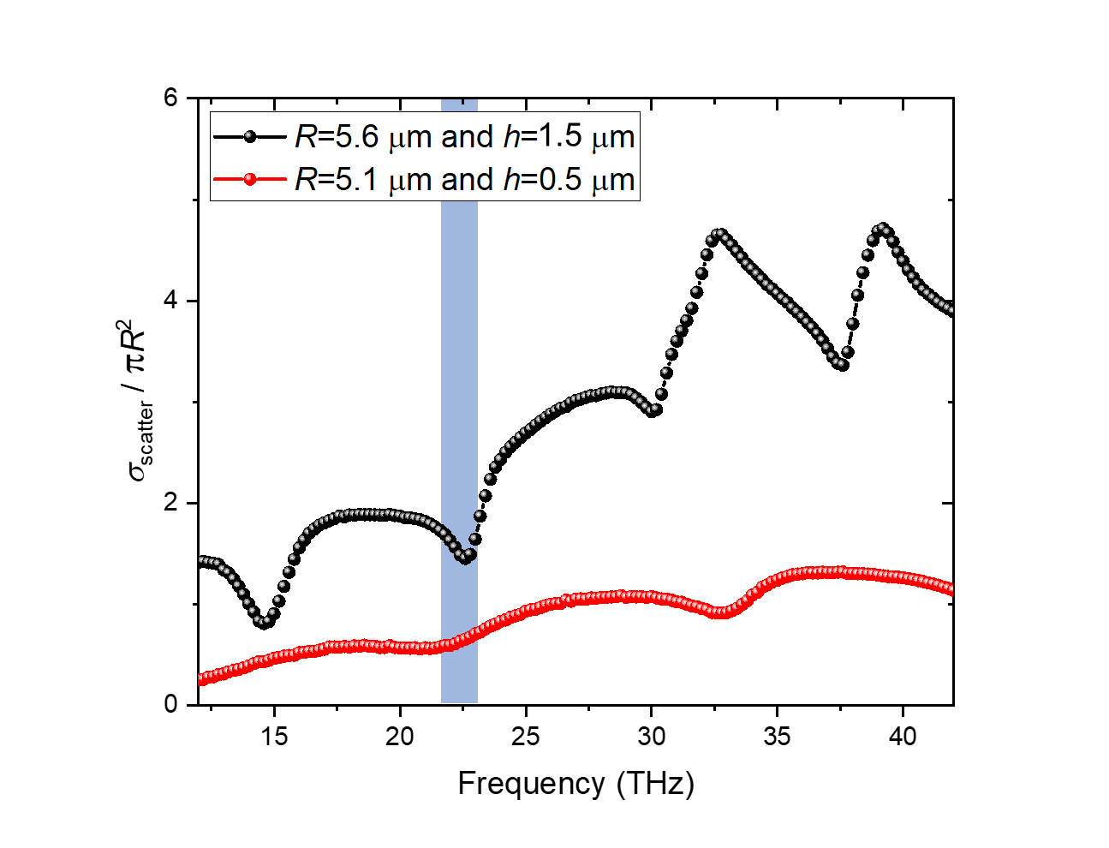
Figure S6. Simulation results of the scattering cross-section as a function of the frequency for two dimensions of the silicon resonators: R=5.6 μm, h=1.5 μm and R=5.1 μm, h=0.5 μm. The spectral range of the pump frequency is highlighted.

The scattering cross-section of the silicon cylinders at different pump frequencies is shown in Fig. S6. For the cylinder with a radius of 5.6 μm and a thickness of 1.5 μm, one scattering dip appears at ~22.5 THz, coinciding with the pump frequency. Such dips in the scattering cross-section represent quasi-anapole modes, that do not radiate to the far field^{50–52}. The 3D distributions of near-field amplitudes and phases can be obtained from the FEM simulations. In Fig. S7, we present the simulated vectorial near-field distributions inside the silicon cylinder at 4 anapole-mode frequencies: f=14.6, 22.4, 30 and 37.6 THz.
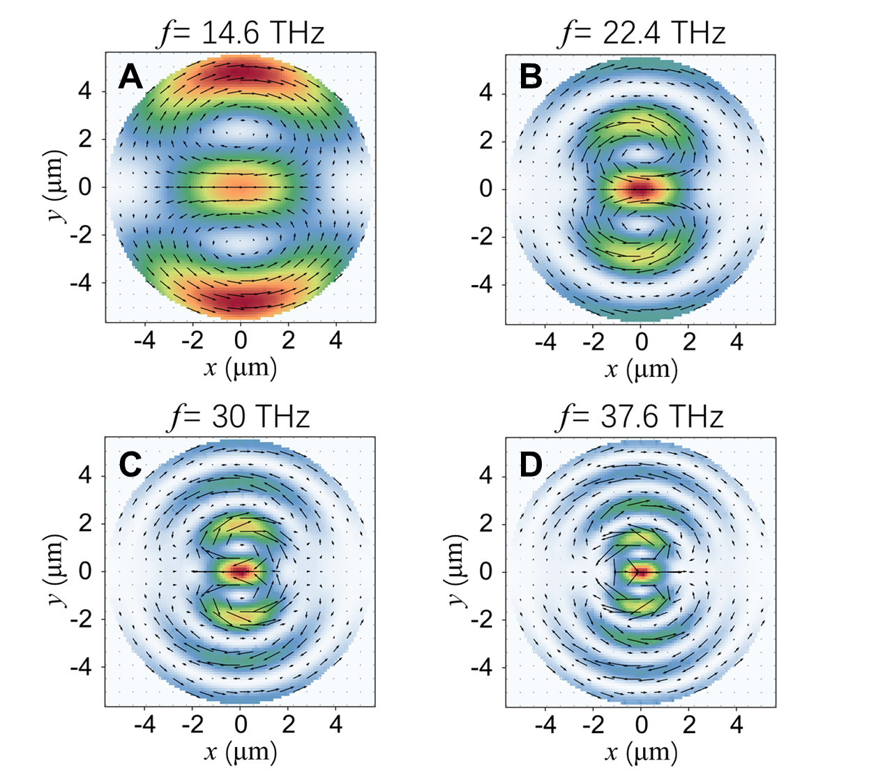
Figure S7. Vectorial near-field distributions inside the silicon cylinder at the frequencies of (A) 14.6 THz, (B) 22. 4 THz, (C) 30 THz, and (D) 37.6 THz.

S4. Model for tomographic imaging using different HSG orders
In our experiment, where the NIR probe beam is incident normally onto the silicon resonator, a comprehensive analysis considers the impact of multiple reflections at the silicon-air and silicon-substrate interfaces in calculating the probe field distribution along the z-axis. The probe field distribution E^{Pr}(z) is given by
$E^{Pr}\left(z\right)=E_{inc}^{Pr}∙\left(a_{Pr}e^{-ik_{Pr}z}+b_{Pr}e^{ik_{Pr}z}\right)$, (S2)
where $E_{inc}^{Pr}$ represents the incident probe field, k_{Pr} is the probe-field wavevector, and z=0 corresponds to the silicon-substrate interface. The coefficients a_{Pr} and b_{Pr} are given by
$\left\{\begin{matrix}a_{Pr}=\frac{t_{1}e^{ik_{Pr}h}}{1-r_{2}r_{1}^{'}e^{2ik_{Pr}h}} \\ b_{Pr}=\frac{t_{1}r_{2}e^{ik_{Pr}h}}{1-r_{2}r_{1}^{'}e^{2ik_{Pr}h}}\end{matrix}\right.$, (S3)
where h is the sample thickness, $t_{1}=\frac{2n_{0}}{n_{0}+n_{1,Pr}}$, $t_{2}=\frac{2n_{1, Pr}}{n_{1, Pr}+n_{2,Pr}}$, $r_{1}=\frac{n_{0}-n_{1,Pr}}{n_{0}+n_{1,Pr}}=-r_{1}^{'}$, $r_{2}=\frac{n_{1,Pr}-n_{2,Pr}}{n_{1,Pr}+n_{2,Pr}}$ are the transmittance and reflectance for the probe beam at the two interfaces, and n₀, n_{1,Pr} and n_{2,Pr} represent the refractive indices of air, silicon and the substrate at the probe-field frequency, respectively.
The probe field, focused by an objective lens with NA=0.28, is modeled as a Gaussian distribution with a beam waist of w₀. Given that the confocal parameter of the probe beam inside the silicon layer is much larger than the sample thickness ($\frac{n_{1,Pr}πw_{0}^{2}}{λ_{Pr}}≈15 μm≫h$), the variance of the beam radius inside the silicon layer can be neglected. Thus, the incident probe field can be modeled by $E_{inc}^{Pr}\left(x, y, z\right)=E_{0}⋅e^{-\frac{x^{2}+y^{2}}{w_{0}^{2}}}$, where E₀ is the field amplitude. Eq. (S2) is further converted to
$E^{Pr}\left(x, y, z\right)=E_{0}⋅e^{-\frac{x^{2}+y^{2}}{w_{0}^{2}}}∙s_{Pr}\left(z\right)$, (S4)
where $s_{Pr}\left(z\right)=a_{Pr}e^{-ik_{Pr}z}+b_{Pr}e^{ik_{Pr}z}$.
The collected HSG fields originate from the nonlinear polarizations inside the silicon layer by the intermixing of the probe fields (E^{Pr}) and the local near-fields (E^{NF}). Since the HSG process is constrained in the perturbative region, when the probe spot is focused at (x₀, y₀), the induced nonlinear polarization at (x, y, z) is given by
$P_{HSG}^{(m,n)}\left(x,y,z\right)=ε_{0}χ_{\left(m,n\right)}{\left[E^{Pr}\left(x-x_{0},y-y_{0},z\right)\right]}^{m}⋅{\left[S^{NF}\left(x,y,z\right)\right]}^{\left|n\right|}$, (S5)
where $S^{NF}=\left\{\begin{matrix}E^{NF}, (n>0) \\ {\left(E^{NF}\right)}^{*}, (n<0)\end{matrix}\right.$. The wave equation governing the HSG electric field is given by
$\left(∇×\left(∇×\right)-\frac{ω^{2}}{c^{2}}ε_{r}\left(x,y,z,ω\right)\right){\tilde{E}}^{(m,n)}\left(x,y,z,ω\right)=iωμ_{0}\left[-iω {\tilde{P}}_{HSG}^{(m,n)}\left(x,y,z, ω\right)\right]$, (S6)
where 𝜀_{r} is the relative permittivity at the HSG frequency 𝜔, and ${\tilde{E}}^{(m,n)}$ and ${\tilde{P}}_{HSG}^{(m,n)}$ respectively denote the Fourier components of the HSG electric field and the nonlinear polarization. The ${\tilde{P}}_{HSG}^{(m,n)}$ term on the right-hand side of the Eq. (S6) serves as a source term.
Under the experimental condition, where the numerical aperture of the focusing objective lens is not large, and the transverse dimension of the silicon cylinder is large, we expect that the HSG polarizations vary slowly along the x and y directions, i.e. $\left|\frac{∂}{∂x}P_{HSG}^{(m,n)}\left(x,y,z\right)\right|\sim \left|\frac{∂}{∂y}P_{HSG}^{(m,n)}\left(x,y,z\right)\right|≪\left|k_{\left(m,n\right)}P_{HSG}^{(m,n)}\left(x,y,z\right)\right|$, where k_{(m,n)} is the wavevector of the (m, n) order HSG field. Under this condition, the HSG electric fields can be calculated by the coherent summation of the polarization sources at each z shell, and the propagation of the HSG field can be simplified to a one-dimensional problem along z at every (x, y) points. The resultant HSG electric field at the surface of the substrate (z=0⁻) is hence given by
$E^{(m,n)}\left(x,y, z=0^{-}\right)=\int_{0}^{h}{\frac{ω_{\left(m,n\right)}^{2}μ_{0}}{2k_{\left(m,n\right)}} P_{HSG}^{(m,n)}\left(x,y,z^{'}\right)u_{(m,n)}\left(z^{'}\right) dz^{'}}$, (S7)
where 𝜔_{(m,n)} is the angular frequency of the (m, n) order HSG field, and u_{(m,n)} accounts for the multiple reflections and interference of the HSG fields inside the silicon layer:
$u_{(m,n)}\left(z\right)=c_{(m,n)}e^{-ik_{\left(m, n\right)}z}+d_{(m,n)}e^{ik_{\left(m, n\right)}z}$, (S8)
with
$\left\{\begin{matrix} c_{(m,n)}=\frac{-r_{1}^{'}t_{2}e^{2ik_{\left(m,n\right)}h}}{1-r_{1}^{'}r_{2}e^{2ik_{\left(m,n\right)}h}} \\ d_{(m,n)}=\frac{t_{2}}{1-r_{1}^{'}r_{2}e^{2ik_{\left(m,n\right)}h}}\end{matrix}\right.$. (S9)
Here, t₁, t₂, r₁ and r₂ are the transmittance and reflectance at the two interfaces, but at the HSG frequency 𝜔_{(m,n)}.
Assuming that the transverse variation of the near-fields inside the probe spot region (defined by the waist w₀) is small, we have $E^{NF}\left(x, y, z\right)≈E^{NF}\left(x_{0}, y_{0}, z\right)$. The HSG intensity is hence given by
$$I_{HSG}^{(m,n)}\left(x_{0},y_{0}, z=0^{-}\right)=∫dx∫dy\frac{1}{2η}{\left|E^{\left(m,n\right)}\left(x,y, z=0^{-}\right)\right|}^{2}$$
$={\left|\int_{0}^{h}{dz} g_{(m,n)}\left(z\right)⋅{\left[S^{NF}\left(x_{0}, y_{0}, z\right)\right]}^{\left|n\right|}\right|}^{2}$ , (S10)
where the gate function $g_{m,n}\left(z\right)$ is given by
$g_{(m,n)}\left(z\right)=\frac{1}{\sqrt{2η}}\frac{ω_{\left(m,n\right)}^{2}μ_{0}}{2k_{\left(m,n\right)}}\sqrt{\frac{πw_{0}^{2}}{2m}}⋅ε_{0}χ_{(m,n)}∙{\left(E_{0}\right)}^{m}⋅u_{m,n}\left(z\right)⋅{\left[s_{Pr}\left(z\right)\right]}^{m}$, (S11)
with $η=\sqrt{μ_{0}/ε_{0}}$ being the vacuum impedance. Eq. (S10) is alias to Eq. (2) in the main text.
The refractive indices play an important role in determining the gate function g_{(m,n)}(z). In our experiments, the complex refractive indices of amorphous silicon are directly measured by fitting the optical reflection from a 1 μm-thick homogeneous film, prepared using the same manufacturing process as the silicon resonators. The experimental and simulation results⁶⁶ are present in Fig. S8A. The extracted refractive indices from these measurements are plotted in Fig. S8B. For the substrate (fused silica), we utilize refractive indices obtained from Ref.⁶⁷, while a refractive index of n=1 is applied for air. In Table S1, we summarize the refractive indices of silicon and the substrate at the wavelengths of different HSG orders used in our model.
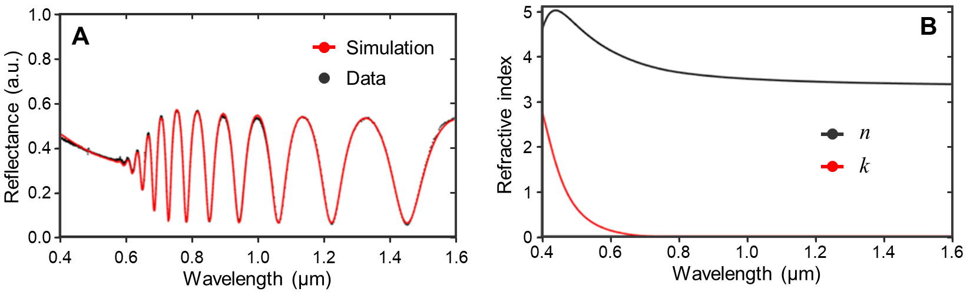
Figure S8. (A) Experimentally measured reflectance of amorphous silicon. The solid line represents the simulation results. (B) Real and imaginary parts of the silicon refractive indices extracted from the simulation results in (A).

n+ik | Probe | Pump | (1, 2) | (1, 4) | (2, -3) | (2, -1) | (2, 1) | (2, 3)
Wavelength (nm) | 967 | 13380 | 845 | 750 | 542 | 502 | 467 | 436
Silicon | 3.515 | 3.470 | 3.598 | 3.713+  0.0005i | 4.426+  0.344i | 4.690+  0.638i | 4.925+  1.098i | 5.012+  1.760i
Substrate | 1.451 | 1.898+ 0.158i | 1.453 | 1.454 | 1.460 | 1.462 | 1.464 | 1.467
Table S1. Refractive indices of silicon and the substrate at different wavelengths used in the reconstruction algorithm.

S5. Reconstruction algorithm for 3D tomographic imaging
For the 3D tomographic reconstruction of the near-fields, we first parameterize the MIR near-field in the longitudinal direction by
$E^{NF}\left(x,y,z\right)=\sum_{j=0}^{M}{α_{j}\left(x,y\right)⋅e_{j}\left(z\right)}$. (S12)
Here, j is an integer, e_{j}(z) is the expansion basis, 𝛼_{j}(x, y) is the complex-valued expansion coefficients, and M is the truncation integer. A set of initial coefficients $\left\{α_{j}^{\left(0\right)}(x,y)\right\}$ defines the initial guess of the near-field distribution, which is used to compute the HSG imaging patterns of different HSG orders using Eq. (S10), yielding the initial modeled imaging pattern, $I_{model}^{\left(m, n\right)}\left(x, y\right)$.
The difference between the modeled and experimental images is then quantified by a loss function:
$J\left(x,y\right)=\sum_{\left(m,n\right)}{\frac{1}{2}{\left\{{\left[I_{expr}^{\left(m, n\right)}\left(x, y\right)\right]}^{\frac{1}{\left|n\right|}}-{\left[β_{(m, n)}∙I_{model}^{\left(m, n\right)}\left(x, y\right)\right]}^{\frac{1}{\left|n\right|}}\right\}}^{2}}+C\left[α_{j}\left(x,y\right)\right]$, (S13)
where 𝛽_{(m,n)} is a normalization factor dependent on the HSG order (m, n), and $C\left[α_{j}\left(x,y\right)\right]$ introduces necessary constraints on the expansion coefficients.
The factor 𝛽_{(m,n)} determines the relative intensity contributions from different HSG orders, which is associated with the unknown nonlinear susceptibility 𝜒_{(m,n)} and the HSG collection optics. The constraint function $C\left[α_{j}\left(x,y\right)\right]$ is given by
$C\left[α_{j}\left(x,y\right)\right]=\sum_{j=0}^{M}{\left[\frac{η_{j}}{2}{|α_{j}\left(x,y\right)-α_{j}\left(x+δx,y+δy\right)|}^{2}+ρ_{j}{|α_{j}\left(x,y\right)-α_{j}^{calc}\left(x,y\right)|}^{2}\right]}$. (S14)
The first term on the right-hand side ensures the transverse continuity of the coefficients $\left\{α_{j}\left(x,y\right)\right\}$ in the x-y plane, where 𝜂_{j} is a small-valued constant, and $(x+δx, y+δy$) represents a nearest sampled point relative to (x, y) in the HSG image. The second term takes advantages of the FEM simulations to aid the convergence of the fitting, where $ρ_{j}$ a small-valued constant, and $\left\{α_{j}^{calc}\left(x,y\right)\right\}$ represents the expansion coefficients obtained from the FEM calculation.
In principle, different types of expansion bases can be employed in the fitting procedure. Our FEM simulations show that the expansion using second-order polynomials: $\left\{1, z, z^{2}\right\}$ can very well describe the longitudinal near-field modes in the silicon resonators. As shown in Fig. S9A and B, the FEM simulated 3D field distribution could be well approximated by the second-order polynomial expansion of z at each (x, y) point. Hence, the determination of the complex-valued coefficients $\left\{α_{0}\left(x,y\right), α_{1}\left(x,y\right), α_{2}\left(x,y\right)\right\}$ can reconstruct the 3D near-field distribution in this case.
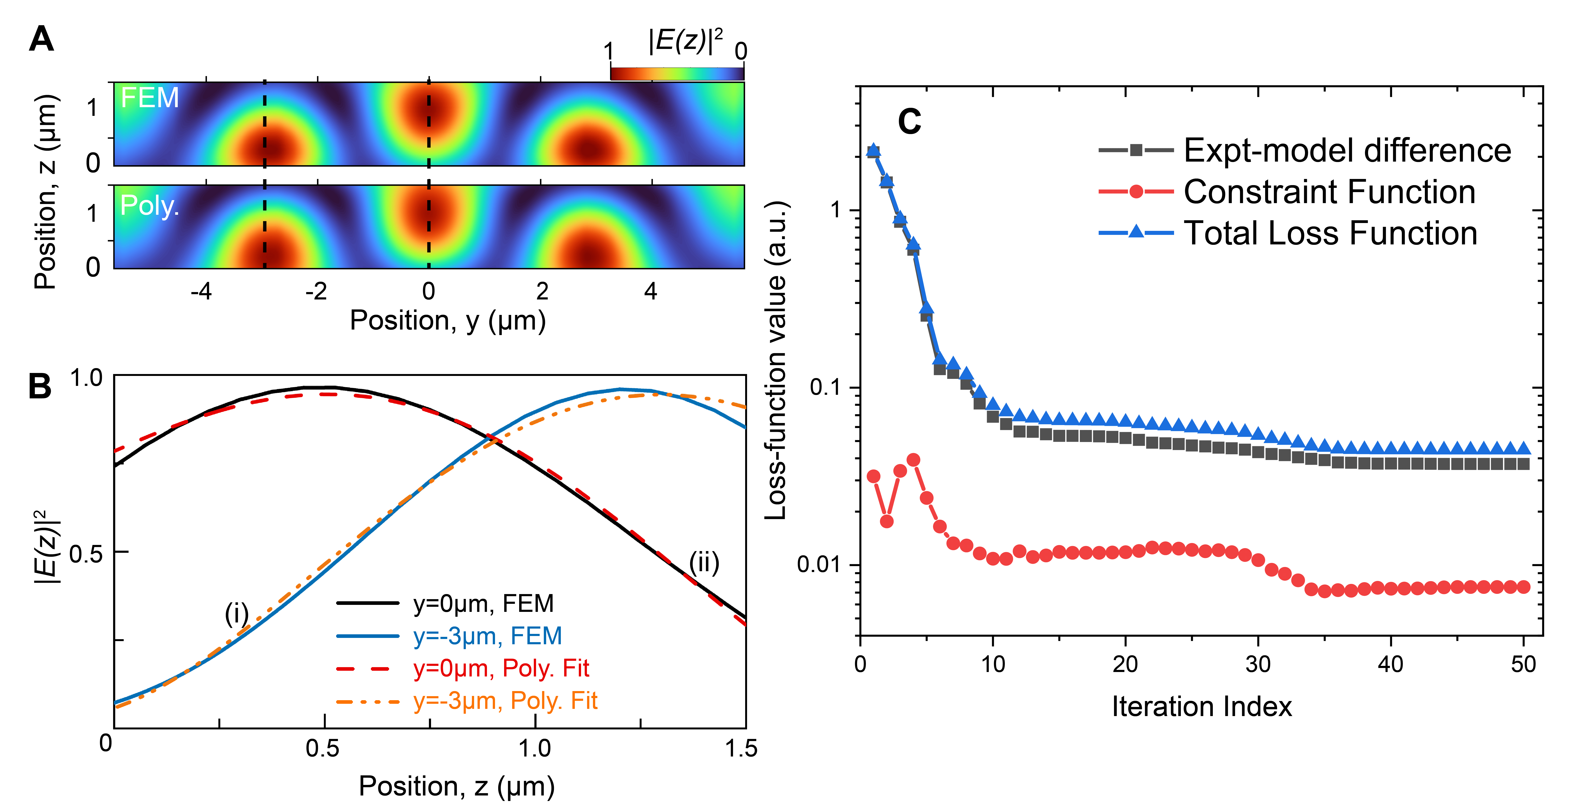
Figure S9. (A) y-z cross-section view of the near-field distribution obtained from the FEM simulation and the fitting using second-order polynomials. (B) Lineouts of the near-field strength as a function of z at different y positions labeled in (A) for more comprehensive comparison. (C) Loss-function value as a function of the iteration index of our algorithm. Different contributions from the experimental-model difference and the constraint function are plotted for comparison.

We then execute the minimization process in two steps:
Step (1): We fit the cross-sectional results of the experimental images, $I_{expr}^{\left(m, n\right)}\left(x=0, y\right)$, using our model to determine the factor 𝛽_{(m,n)} for different HSG orders.
Step (2): We fit the entire experimental images, $I_{expr}^{\left(m, n\right)}\left(x, y\right)$, with random initial values {$α_{0}^{\left(0\right)}\left(x,y\right), α_{1}^{\left(0\right)}\left(x,y\right), α_{2}^{\left(0\right)}\left(x,y\right)$} and fixed 𝛽_{(m,n)} values determined in Step (1).
In Step (2), we follow the following fitting procedure:
(2.1) We minimize J(x₀, y₀) at the point (x₀, y₀) using the Broyden-Fletcher-Goldfarb-Shanno method ⁶⁸, determining $\left\{α_{j}^{fit}\left(x_{0},y_{0}\right)\right\}$.
(2.2) We move to the next point (x₀+𝛿x, y₀) or (x₀, y₀+𝛿y), where 𝛿x and 𝛿y are the transverse intervals of data points, setting the fitting results $\left\{α_{j}^{fit}\left(x_{0},y_{0}\right)\right\}$ at the previous point as the initial value.
(2.3) Loop Steps (2.1) and (2.2) until all the data points are fitted.
In this study, we employed $η_{j}=0$ and $\left(ρ_{0},ρ_{1}, ρ_{2}\right)=(0.1, 0.03, 0.01)$ for the fitting procedure. The reconstructed 3D field distribution is shown in Fig. 2D in the main text. It is important to note that while we utilized the field distribution obtained from FEM simulations to facilitate the convergence of the fitting procedure, the constraint function value $C\left[α_{j}\left(x,y\right)\right]$ typically contributes ~10% of the loss function $J(x, y)$. Consequently, the fitting procedure is dominantly driven by the difference between the experimental data and the model results obtained using Eq. (S10). In Fig. S9C, we present the typical loss-function values obtained at $\left(x=-2 μm,y=0 \right)$ as a function of the iteration index, showing the convergence of our fitting procedure. The contributions between different components: experiment-model difference and constraint-function values are plotted for comparison.
S6. Longitudinal spatial resolution of HSM tomography
To elucidate the longitudinal resolution of HSM tomography, we conduct theoretical and numerical analyses. We begin by considering the expansion of the near-field: $E^{NF}=α_{0}+α_{1}z+α_{2}z^{2}$, where 𝛼₀ is real-valued and 𝛼₁, 𝛼₂ are complex-valued expansion coefficients. This expression can be rewritten as an inner product of coefficients and basis vectors: $E^{NF}=\left(α_{0}, α_{1r}, α_{1i}, α_{2r}, α_{2i}\right)⋅{\left(1, z, iz, z^{2}, iz^{2}\right)}^{T}≡{\vec{α}}^{T}⋅\vec{e}\left(z\right)$. Our model predicts the HSG intensities from such a near-field using Eq. (S10). In this study, we employed 6 HSG orders to determine 5 coefficients in $\vec{α}$ (including both real and imaginary parts of $α_{1}$ and $α_{2}$). When experimental noise is ignored, the fitting problem is overdetermined, and a unique $\vec{α}$ can be retrieved using our algorithm, where the loss function can be reduced to 0.
When experimental noise is considered, the HSG intensity becomes ${I_{HSG}^{\left(m,n\right)}}^{'}=I_{HSG}^{\left(m,n\right)}+ς^{\left(m,n\right)}$, where $ς^{\left(m,n\right)}$ represents the experimental noise. Under these conditions, our model predicts a new set of coefficients ${\vec{α}}^{'}=\vec{α}+δ\vec{α}$, which is close to the noise-free prediction $\vec{α}$, with $δ\vec{α}$ representing the deviation of the model prediction. We analyze the derivative behavior of our model around $\vec{α}$. The HSG intensity $I_{HSG}^{\left(m,n\right)}\left(\vec{α}+δ\vec{α}\right)$ can be approximated by the linear expansion of $δ\vec{α}$:
$I_{HSG}^{\left(m,n\right)}\left(\vec{α}+δ\vec{α}\right)=I_{HSG}^{\left(m,n\right)}\left(\vec{α}\right)⋅\left[1+δ\vec{α}⋅{\vec{d}}_{\left(m,n\right)}\left(\vec{α}\right)\right]$, (S15)
where ${\vec{d}}_{\left(m,n\right)}\left(\vec{α}\right)=2Re\left\{{\left[X\left(\vec{α}\right)\right]}^{-1}⋅\left[∇_{\vec{α}}X\left(\vec{α}\right)\right]\right\}$ is the expansion coefficient, with $∇_{\vec{α}}$ denoting the gradient operator along $\vec{α}$, and $X\left(\vec{α}\right)=\int_{0}^{h}{dz}g_{\left(m,n\right)}\left(z\right)⋅{\left[S^{NF}\left(\vec{α}\right)\right]}^{\left|n\right|}$. Thus, the deviation of the model prediction, $δ\vec{α}$, can be directly related to the experimental noise by
$ξ_{\left(m,n\right)}≡\frac{ς^{\left(m,n\right)}}{I_{HSE}^{\left(m,n\right)}}≃δ\vec{α}⋅{\vec{d}}_{\left(m,n\right)}\left(\vec{α}\right)$. (S16)
Considering all the involved HSG orders, this relationship becomes a linear matrix equation, $\vec{ξ}=D⋅δ\vec{α}$, where $\vec{ξ}$ is the vector of $ξ_{\left(m,n\right)}$ for all the HSG orders, and $D$ is a matrix composed of ${\vec{d}}_{\left(m,n\right)}^{T}\left(\vec{α}\right)$ in each row. By employing pseudo-inverse, we obtain that ^{69,70},
$δ\vec{α}=D^{I}⋅\vec{ξ}$ , (S17)
where $D^{I}={\left(D^{T}D\right)}^{-1}D^{T}$ is the Moore-Penrose pseudo-inverse of the matrix $D$.
We consider independent white noises with a Gauss distribution: $\left\langle ξ_{\left(m,n\right)}\right\rangle =0$, $\left\langle ξ_{\left(m,n\right)}^{2}\right\rangle ≠0$ (here $⟨·⟩$ represents the statistical average). The variances of the retrieved coefficients from the noisy experimental data are thus given by,
$\left\langle δ\vec{α}\right\rangle =0$, $\left\langle {\left(δ\vec{α}\right)}^{2}\right\rangle =\left\langle {\vec{ξ}}^{T}⋅{\left(D^{I}\right)}^{T}D^{I}⋅\vec{ξ}\right\rangle$. (S18)
The longitudinal fitting uncertainty can be analyzed from the statistical property of $δ\vec{α}$ calculated using Eq. (S17) and (S18).
We numerically consider the uncertainty of fitting under our experimental conditions. The experimental signal-to-noise ratios (SNR) for the 6 HSG orders are listed in Table S2. Here, we investigate the longitudinal uncertainty of fitting E^{NF}(z) at (x=0, y=-3 μm) in the silicon cylinder. The results are shown in Fig. S10A. With the experimental noise, the fitting results could vary around the best prediction within an uncertain band. The translational uncertainty along z could be determined by the standard deviation of the results, yielding 𝜎_{z}≈0.13 μm.
The dependence of translation uncertainty on the experimental noise is further plotted in Fig. S10B, with $\overline{σ}$ being the order-averaged noise level, given by $\overline{σ}≡\sqrt{\frac{1}{N}\sum_{\left(m,n\right)}{\left\langle ξ_{\left(m,n\right)}^{2}\right\rangle }}$, where N=6 the total number of HSE orders in this study. In general, a smaller $\overline{σ}$ corresponding to a higher experimental SNR, could result in smaller uncertainty in fitting.
For more complex near-field modes (when the thickness of sample is comparable to the wavelength, for example), a larger sized basis shall be used. In order to maintain the longitudinal high spatial resolution, the overdetermined condition should be ensured by involving more HSG orders.
 | (1, 2) | (1, 4) | (2, -3) | (2, -1) | (2, 1) | (2, 3)
SNR | 6900:1 | 6400:1 | 54:1 | 3800:1 | 790:1 | 38:1
Table S2. SNR levels in this study for different HSG orders.

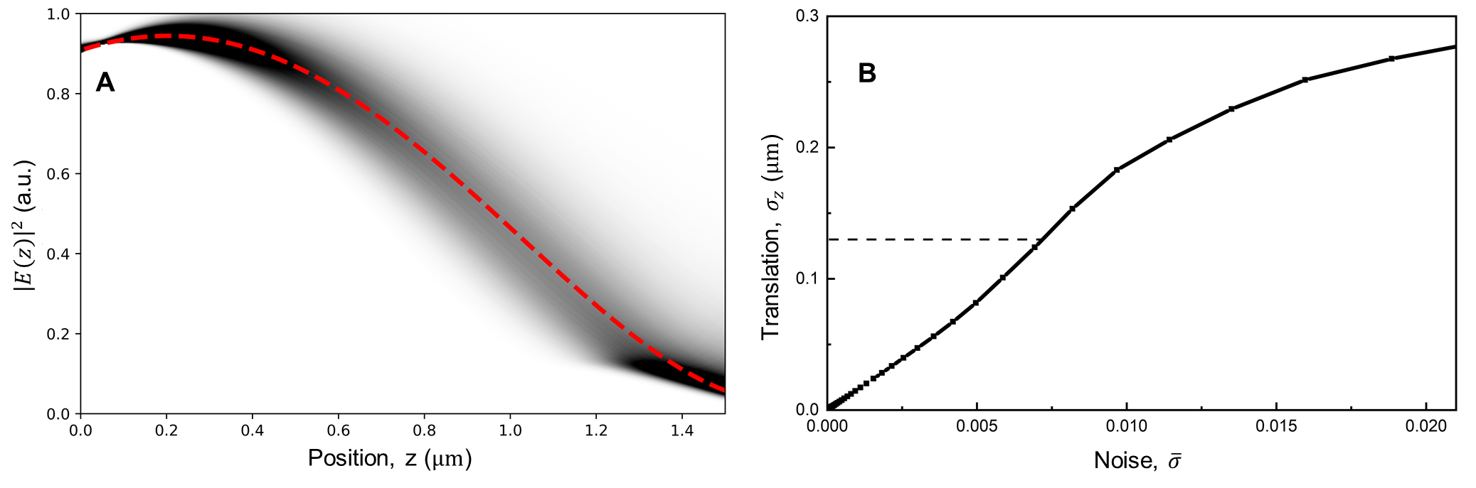
Figure S10. (A) Longitudinal fitting uncertainty induced by the experimental noise. Red-dashed line: the near-field at $\left(x=0, y=-3 μm \right)$ from FEM calculations. Gray region: the probability distribution of fitting results under the experimental noise listed in Table S2. (B) Dependence of the longitudinal fitting uncertainty, 𝜎_{z}, as a function of the order-averaged experimental noise, $\overline{σ}$.

S7. Polarization-resolved near-field imaging
The nonlinear polarization for the SH-HSG order (2, -1) can be generally expressed as⁵⁴
$P_{i}\left(ω_{2, -1}=ω_{a}+ω_{b}-ω_{c}\right)=ε_{0}\sum_{jkl}{\sum_{\left(abc\right)}{χ_{ijkl}^{\left(3\right)}\left(ω_{2, -1}, ω_{a}, ω_{b}, ω_{c}\right)E_{j}\left(ω_{a}\right)E_{k}\left(ω_{b}\right)E_{l}^{*}\left(ω_{c}\right)}}$, (S19)
where $ijkl∈\left\{x, y, z\right\}$, $ω_{a, b}$ represent the angular frequency of the probe field and $ω_{c}$ the near-field, $(abc)$ represents the permutations of a, b and c. For an isotropic medium with full permutation symmetry, we have 21 nonvanishing elements in $χ_{ijkl}^{\left(3\right)}$, and only one independent element $χ^{\left(3\right)}$ ⁵⁴:
$$χ_{xxxx}^{\left(3\right)}=χ_{yyyy}^{\left(3\right)}=χ_{zzzz}^{\left(3\right)}=3χ^{\left(3\right)}$$
$χ_{yyzz}^{\left(3\right)}=χ_{xxzz}^{\left(3\right)}=χ_{xxyy}^{\left(3\right)}=χ_{yzyz}^{\left(3\right)}=χ_{yzzy}^{\left(3\right)}=χ_{zzyy}^{\left(3\right)}=…=χ^{\left(3\right)}$. (S20)
When the probe beam is focused with a small numerical aperture, the depolarization effects can be ignored. Thus, the nonlinear polarization is given by:
${\left(\begin{matrix}P_{x} \\ P_{y} \\ P_{z}\end{matrix}\right)}_{(2, -1)}=ε_{0}χ^{\left(3\right)}\left(\begin{aligned}3{\left(E_{x}^{Pr}\right)}^{2}{\left(E_{x}^{NF}\right)}^{*}+2E_{x}^{Pr}E_{y}^{Pr}{\left(E_{y}^{NF}\right)}^{*}+{\left(E_{y}^{Pr}\right)}^{2}{\left(E_{x}^{NF}\right)}^{*} \\ 3{\left(E_{y}^{Pr}\right)}^{2}{\left(E_{y}^{NF}\right)}^{*}+2E_{y}^{Pr}E_{x}^{Pr}{\left(E_{x}^{NF}\right)}^{*}+{\left(E_{x}^{Pr}\right)}^{2}{\left(E_{y}^{NF}\right)}^{*} \\ {\left(E_{y}^{Pr}\right)}^{2}{\left(E_{z}^{NF}\right)}^{*}+{\left(E_{x}^{Pr}\right)}^{2}{\left(E_{z}^{NF}\right)}^{*}\end{aligned}\right)$. (S21)
Eq. (S21) is alias to Eq. (3) in the main text.
Here, we further assume that the near-field inside the dielectric medium is polarized along x: $E^{NF}=E_{0}^{NF}\hat{i}$, and the relative angle between the probe-field polarization and the x axis is 𝜃: $E^{Pr}=E_{0}^{Pr}\left(\cos{θ}\hat{i}+\sin{θ}\hat{j}\right)$. The nonlinear polarization is simplified to $P_{x}=ε_{0}χ^{\left(3\right)}{\left(E_{0}^{Pr}\right)}^{2}{\left(E_{0}^{NF}\right)}^{*}\left(3\cos^{2}θ+\sin^{2}{θ}\right)$ and $P_{y}=2ε_{0}χ^{\left(3\right)}{\left(E_{0}^{Pr}\right)}^{2}{\left(E_{0}^{NF}\right)}^{*}\sin{θ}\cos{θ}$. Consequently, when the HSG polarizer (Fig. S1) is aligned parallel to the polarization of the probe field, the observed HSG intensity is given by
$I_{HSG}^{(2, -1)}\left(θ\right)∝{\left|P_{x}\cos{θ}+P_{y}\sin{θ}\right|}^{2}∝\cos^{2}θ$. (S22)
This result is consistent with the experimental observation shown in Fig. 3A of the main text. The polarization extinction ratio (PER) is then determined by the experimental results:$PER=10\log_{10}\left(\frac{I_{HSG}^{(2, -1)}\left(0\right)}{I_{HSG}^{(2, -1)}\left({90}^{0}\right)}\right)≈30 dB.$
On the other hand, for the F-HSG order (1, 2), similar symmetry of $χ_{ijkl}^{\left(3\right)}$ can be implemented. The nonlinear polarization for this F-HSG order is given by
${\left(\begin{matrix}P_{x} \\ P_{y} \\ P_{z}\end{matrix}\right)}_{(1,2)}=ε_{0}χ^{\left(3\right)}\left(\begin{aligned}3E_{x}^{Pr}{\left(E_{x}^{NF}\right)}^{2}+2E_{x}^{NF}E_{y}^{NF}E_{y}^{Pr}+E_{x}^{Pr}{\left(E_{y}^{NF}\right)}^{2} \\ 3E_{y}^{Pr}{\left(E_{y}^{NF}\right)}^{2}+2E_{x}^{Pr}E_{y}^{NF}E_{x}^{NF}+E_{y}^{Pr}{\left(E_{x}^{NF}\right)}^{2} \\ E_{z}^{Pr}{\left(E_{y}^{NF}\right)}^{2}+E_{z}^{Pr}{\left(E_{x}^{NF}\right)}^{2}\end{aligned}\right).$ (S23)
By applying the same geometry of the near-field and probe-field polarization: $\left\{\begin{matrix}E^{NF}=E_{0}^{NF}\hat{i} \\ E^{Pr}=E_{0}^{Pr}\left(\cos{θ}\hat{i}+\sin{θ}\hat{j}\right)\end{matrix}\right.$, we obtain $P_{x}=3ε_{0}χ^{\left(3\right)}E_{0}^{Pr}{\left(E_{0}^{NF}\right)}^{2}\cos{θ}$ and $P_{y}=ε_{0}χ^{\left(3\right)}E_{0}^{Pr}{\left(E_{0}^{NF}\right)}^{2}\sin{θ}$. Consequently, when the HSG polarizer is aligned in parallel to the polarization of the probe field, the observed HSG intensity becomes
$I_{HSG}^{(1,2)}\left(θ\right)∝{\left|P_{x}\cos{θ}+P_{y}\sin{θ}\right|}^{2}∝\frac{1}{9}{\left(2\cos^{2}θ+1\right)}^{2}$. (S24)
This explains that the polarization extinction ratio of F-HSG orders is significantly lower than that of the SH-HSG orders. PER for the F-HSG (1, 2) order is ~10 dB.
For higher HSG orders, the polarization resolving power generally persists, and the extinction ratio of SH-HSG orders is, in general, higher than that of F-HSG orders. For example, for the orders (2, 3), (2, -3) and (1, 4), the $χ^{\left(5\right)}$ nonlinearity shall be considered. Assuming the isotropic symmetry and the full permutation symmetry, we have
$$χ_{xxxxxx}^{\left(5\right)}=χ_{yyyyyy}^{\left(5\right)}=χ_{zzzzzz}^{\left(5\right)}=15χ^{\left(5\right)}$$
$$χ_{xxyyyy}^{\left(5\right)}=χ_{xxzzzz}^{\left(5\right)}=χ_{yyxxxx}^{\left(5\right)}=…=3χ^{\left(5\right)}$$
$χ_{xxyyzz}^{\left(5\right)}=χ_{yyxxzz}^{\left(5\right)}=…=χ^{\left(5\right)}$. (S25)
Hence, under the same measurement geometry, the HSG intensities of the above HSG orders are given by
$I_{\left(1,4\right)}^{∥}\left(θ\right)∝\frac{1}{25}{\left(4\cos^{2}{θ}+1\right)}^{2}$ and
$I_{\left(2,±3\right)}^{∥}\left(θ\right)=\frac{1}{25}{\left(2\cos^{3}{θ}+3\cos{θ}\right)}^{2}$. (S26)
In Fig. S11, we present the experimental measurements of the polarization resolving power of these HSG orders. Here, to avoid the complex polarization states of E^{NF}, we conducted this measurement on a homogeneous silicon thin film, where the polarization of E^{NF} is the same as the pump pulse. The experimental results can be well explained by Eq. (S26).
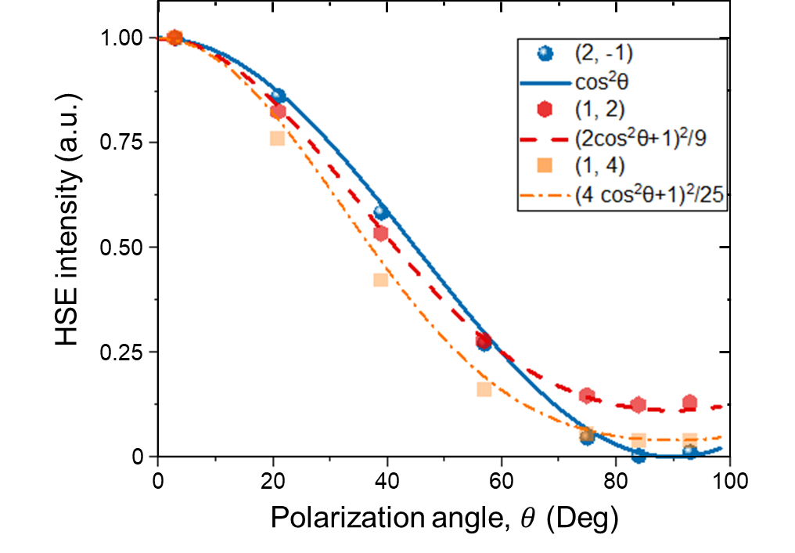
Figure S11. HSG intensity as a function of the polarization angle 𝜃 for different HSG orders. The lines represent the fitting using different functions predicted by the theory.

S8. Phase measurement via quantum-path interference
In order to induce quantum-path overlap between neighboring HSG orders, we broaden the spectral bandwidth of the probe pulse through SCG in a 4 mm-thick YAG crystal (see Fig. S1), resulting in a bandwidth Δ𝜔 of 40 nm at 1/e² intensity. Meanwhile, SCG also introduces normal dispersion of the probe pulse, characterized by a group-delay dispersion (GDD) of D₂. Hence, the probe field can be described as a dispersive Gaussian pulse:
$E^{Pr}\left(t\right)=E_{0}^{Pr}\sqrt{\frac{π}{α}}e^{-\frac{1}{4α}{\left(t-τ\right)}^{2}-iω_{c}\left(t-τ\right)}$, (S27)
where 𝜔_{c} is the center angular frequency, 𝜏 is the time delay between the pump and probe pulses, and $α=\frac{2\ln{2}}{{\left(Δω\right)}^{2}}-i\frac{D_{2}}{2}$ defines the pulse bandwidth and dispersion. The local near-field can be generally modeled as $E^{NF}\left(t\right)=E_{0}^{NF}⋅e^{-i\left(ω_{Pu}t-ϕ_{NF}\right)}$, where 𝜙_{NF} is the near-field phase. The nonlinear polarization of the HSG order (m, n) is thus given by
$P_{HSG}^{\left(m,n\right)}\left(t\right)=ε_{0}χ_{(m,n)}{\left(E_{0}^{Pr}\right)}^{m}{\left(E_{0}^{NF}\right)}^{\left|n\right|}∙ {\left[\sqrt{\frac{π}{α}}e^{-\frac{1}{4α}{\left(t-τ\right)}^{2}-iω_{c}\left(t-τ\right)}\right]}^{m}∙e^{-in\left(ω_{Pu}t-ϕ_{NF}\right)}$. (S28)
The corresponding Fourier components are given by
$${\tilde{P}}_{HSG}^{\left(m,n\right)}\left(ω\right)=∫P_{HSG}^{\left(m,n\right)}\left(t\right)e^{iωt}dt$$
$=ε_{0}χ_{(m,n)}{\left(E_{0}^{Pr}\right)}^{m}{\left(E_{0}^{NF}\right)}^{\left|n\right|}⋅e^{inϕ_{NF}+i\left(ω-nω_{Pu}\right)τ}⋅{\left(\frac{π}{α}\right)}^{m-1}\frac{1}{\sqrt{m}}e^{-\frac{α}{m}{\left(ω-mω_{c}-nω_{Pu}\right)}^{2}}$. (S29)
The neighboring HSG orders (m, n) and (m, n-2) overlap at the final-state frequency being $ω=mω_{1}+nω_{Pu}=mω_{2}+\left(n-2\right)ω_{Pu}$, where 𝜔₁ and 𝜔₂ are two frequencies within the probe-pulse bandwidth. The spectral intensity at 𝜔 is given by
$I\left(ω\right)∝{\left|{\tilde{P}}_{HSG}^{\left(m,n\right)}\left(ω\right)+{\tilde{P}}_{HSG}^{\left(m,n-2\right)}\left(ω\right)\right|}^{2}=I_{static}\left(ω\right)+I_{inter}\left(ω\right)\cos{Δϕ\left(ω\right)}$, (S30)
where I_{static} and I_{inter} represent the static background and interfering intensities, respectively, and Δ𝜙 is the interference phase:
$Δϕ\left(ω\right)=\frac{D_{2}}{2m}\left\{-2ω_{Pu}\left[2ω-2mω_{c}-\left(2n-2\right)ω_{Pu}\right]\right\}+2ϕ_{NF}-2ω_{Pu}τ$. (S31)
By applying the constructive interference condition: $Δϕ\left(ω\right)=2πl$, with l being an integer, we obtain the spectral frequency for constructive interference
$ω=\left[mω_{c}+\left(n-1\right)ω_{Pu}\right]+\frac{m\left(-lπ-ω_{Pu}τ+ϕ_{NF}\right)}{D_{2}ω_{Pu}}$. (S32)
Here, we consider the spectral interference between the HSG orders (2, 1) and (2, -1). The time delay 𝜏 is fixed during the imaging process, leading to a static delay-related phase $ϕ_{τ}=-ω_{Pu}∙τ$. The spatial variation of the near-field phase 𝜙_{NF}(x, y) is observed through the spatially varying frequency for constructive spectral interference, given by
$ω\left(x,y\right)=2ω_{c}+2\frac{ϕ_{NF}\left(x,y\right)-lπ+ϕ_{τ}}{D_{2}ω_{Pu}}$. (S33)
Equation (S33) corresponds to Eq. (4) in the main text. We can extract the spatial variation of the near-field phase 𝜙_{NF}(x, y) from the locations of interference maxima, after the probe-pulse GDD (D₂) is determined.
In our experiment, D₂ was determined by directly measuring the spectral shifts of the patterns as a function of the delay 𝜏 induced by quantum-path interference (QPI)⁵³. The results are shown in Fig. S12A. The QPI induces 2𝜔_{Pu} oscillation of the spectral intensity as a function of the time delay 𝜏. Due to the probe-pulse GDD, we can observe shifts of the oscillation pattern at different spectral frequencies. The slope of the bright stripes vs. 𝜏 yields a direct measurement on D₂, which is approximately 1500 fs² in this case.
The spatial variations of the interferogram are plotted by normalizing the experimental results by the static background intensity [I_{static}(𝜔) in Eq. (S31)], which can be obtained by averaging the HSG spectra across 𝜏 over several cycles of pump-field oscillations. A typical marginal curve is shown in Fig. S12B. In Fig. S12C, we plot the variations of the spectral interference across the silicon resonator for the y-polarized near-fields, which presents a π-phase shift along the trajectory. Similar measurement was also conducted for the x-polarized components (Fig. S12D). where a stationary phase along the same trajectory can be observed. This result is consistent with our FEM simulations.
In the theoretical simulations (Figs. 4E and F in the main text), a Gaussian pulse, centered at 306.5 THz with FWHM spectrum width of 25 THz and D₂=1520 fs² was employed. The transverse waist of the probe field was 1.1 μm. The vectorial near-field wave patterns, E^{NF} (x, y, z), was obtained from FEM. Due to the fact that longitude variance of E^{NF} is small inside the 0.5 μm-thick resonator, we ignore the averaging effects of HSG phase along z. The HSG signals for order (2,1) and (2, -1) are directly calculated from Eq. (1) in the main text, with their relevant strengths match the experimental data. The spatially varied normalized spectrograms along trajectories (i) and (ii) are thus shown in Fig. 4E and F in the main text.
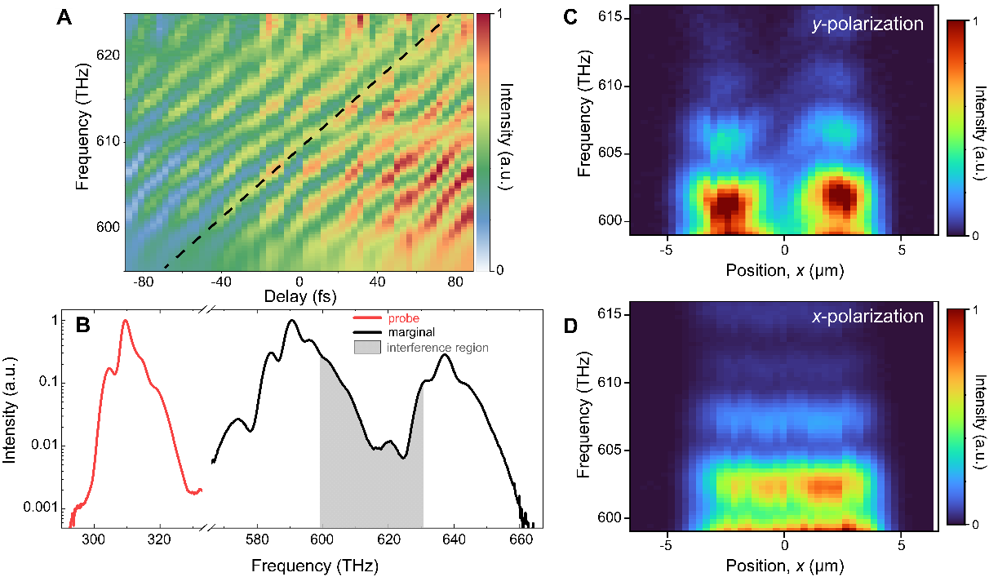
Figure S12. (A) The spectral pattern shifts as a function of the delay 𝜏 in the spectral overlapping region of HSG orders. The dashed line highlights the slope of the frequency shift, which provides the GDD information. (B) The static background intensity spectrum obtained by averaging across a few cycles around the time zero in (A). The spectrum of the probe pulse is also plotted for comparison. (C) Spatial variation of the interferogram for the y-polarized near-field components, which clearly shows a π phase shift of the near-fields. (D) Same as (C) for the x-polarized components, where the phase shift disappears.

