Supplementary materials
Table 1 shows the basic mechanical parameters of the studied experimental subject, which were obtained from the roof sandstone of a mine in Shandong, China.
Table 1 Basic parameters of rock samples
Rock samples number | Diameter | Height | Mass | Density | Wave velocity
Rock samples number | (mm) | (mm) | (g) | (g/cm3) | (m/s)
R1 | 49.80 | 99.50 | 455.0 | 2.348 | 2538
R1 | 49.82 | 99.50 | 455.0 | 2.346 | 2513
R1 | 49.80 | 99.52 | 455.0 | 2.347 | 2488
R2 | 49.78 | 99.52 | 457.5 | 2.362 | 2415
R2 | 49.82 | 99.54 | 457.5 | 2.358 | 2488
R2 | 49.80 | 99.52 | 457.5 | 2.360 | 2415
R3 | 49.82 | 99.52 | 457.1 | 2.356 | 2463
R3 | 49.82 | 99.54 | 457.1 | 2.356 | 2463
R3 | 49.80 | 99.56 | 457.1 | 2.357 | 2513
R4 | 49.80 | 99.40 | 454.8 | 2.349 | 2538
R4 | 49.80 | 99.42 | 454.8 | 2.349 | 2488
R4 | 49.82 | 99.44 | 454.8 | 2.346 | 2513
R5 | 49.82 | 99.42 | 453.9 | 2.342 | 2463
R5 | 49.78 | 99.40 | 453.9 | 2.346 | 2489
R5 | 49.80 | 99.44 | 453.9 | 2.343 | 2439
The correlation coefficients, permutation entropy, and variance contribution rates for the IMF components of SIG2-2, SIG2-3 and SIG2-4 are illustrated in Tables 2-4.
Table 2 Correlation coefficients, permutation entropy, and variance contribution rates for the IMF components of SIG2-2
Components | IMF1 | IMF2 | IMF3 | IMF4 | IMF5 | IMF6 | IMF7 | IMF8 | IMF9
Correlation coefficients | 0.127 | 0.354 | 0.201 | 0.138 | 0.124 | 0.682 | 0.672 | 0.471 | 0.183
Permutation entropy | 0.905 | 0.555 | 0.381 | 0.312 | 0.208 | 0.135 | 0.126 | 0.117 | 0.081
Variance contri-  bution rates | 0.000 | 0.095 | 0.011 | 0.005 | 0.017 | 0.111 | 0.307 | 0.180 | 0.043

Table 3 Correlation coefficients, permutation entropy, and variance contribution rates for the IMF components of SIG2-3
Components | IMF1 | IMF2 | IMF3 | IMF4 | IMF5 | IMF6 | IMF7 | IMF8 | IMF9 | IMF10
Correlation coefficients | 0.332 | 0.602 | 0.436 | 0.364 | 0.330 | 0.545 | 0.340 | 0.048 | 0.055 | 0.034
Permutation entropy | 0.878 | 0.512 | 0.380 | 0.302 | 0.205 | 0.153 | 0.120 | 0.118 | 0.114 | 0.070
Variance contri-  bution rates | 0.006 | 0.232 | 0.079 | 0.095 | 0.052 | 0.253 | 0.071 | 0.025 | 0.001 | 0.000

Table 4 Correlation coefficients, permutation entropy, and variance contribution rates for the IMF components of SIG2-4
Components | IMF1 | IMF2 | IMF3 | IMF4 | IMF5 | IMF6 | IMF7 | IMF8 | IMF9
Correlation coefficients | 0.057 | 0.479 | 0.520 | 0.481 | 0.525 | 0.303 | 0.344 | 0.138 | 0.030
Permutation entropy | 0.905 | 0.553 | 0.375 | 0.273 | 0.193 | 0.150 | 0.132 | 0.118 | 0.110
Variance contri-  bution rates | 0.004 | 0.088 | 0.107 | 0.152 | 0.192 | 0.132 | 0.142 | 0.026 | 0.013

The specific decomposition principle of the ICEEMDAN algorithm is as follows:
(1) Let the original signal be x[n]. Define the operator Ek(*) to represent the k-th intrinsic mode function (IMF) obtained from Empirical Mode Decomposition (EMD), define the operator M(*) to represent the local mean of the signal, and define the operator <*> to represent taking the mean. According to EMD, E1(x) = x[n] − M(x).
(2) Construct x(i) = x[n] + ε₀E1(w^{i}[n]),
where w^{i}[n] represents the i-th added white noise, and ε₀ is the noise standard deviation.
(3) Calculate the local mean M(x(i)) of x(i) and take the mean to obtain the first residual component r₁[n] = < M(x(i))>.
(4) Calculate the first intrinsic mode function IMF1: IMF1 = x[n] - r₁[n].
(5) Calculate the second intrinsic mode function IMF2: IMF2 = r₁[n] - r₂[n],
where r₂[n] = < M(r₁[n] + ε₁E2(w^{i}[n])>.
(6) Using the formula IMF2 = r_{k−1}[n] - r_{k}[n], calculate the value of the kth intrinsic mode function IMFk.
where r_{k}[n] = < M(r_{k−1}[n] + ε_{k-1}Ek(w^{i}[n])>, for k = 2, 3, …, N.
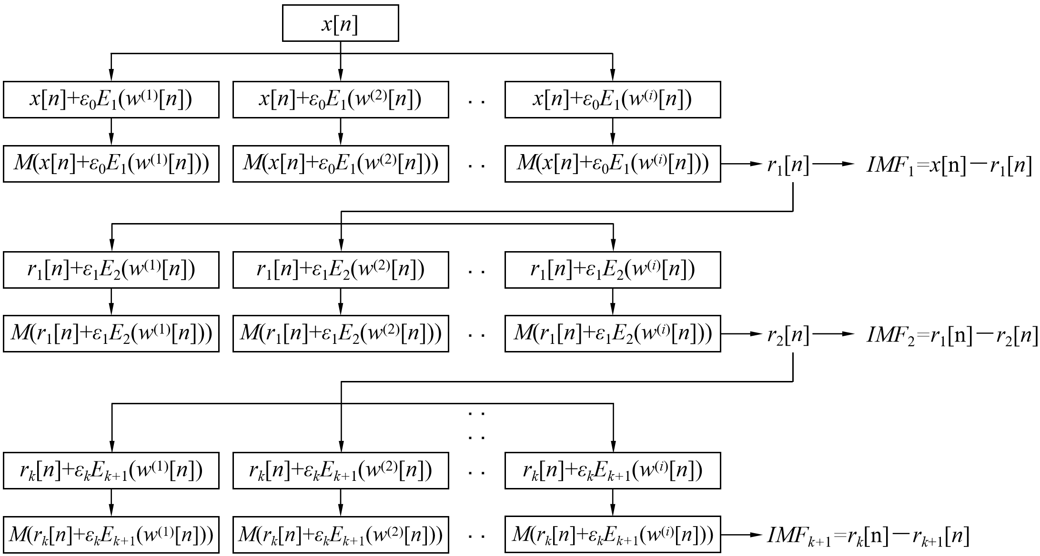
Figure 1 Principle of the ICEEMDAN Algorithm

The relationship between correlation coefficient, permutation entropy, and their respective thresholds for the components of SIG2-2, SIG2-3, and SIG2-4 are illustrated in Figures 2-4.
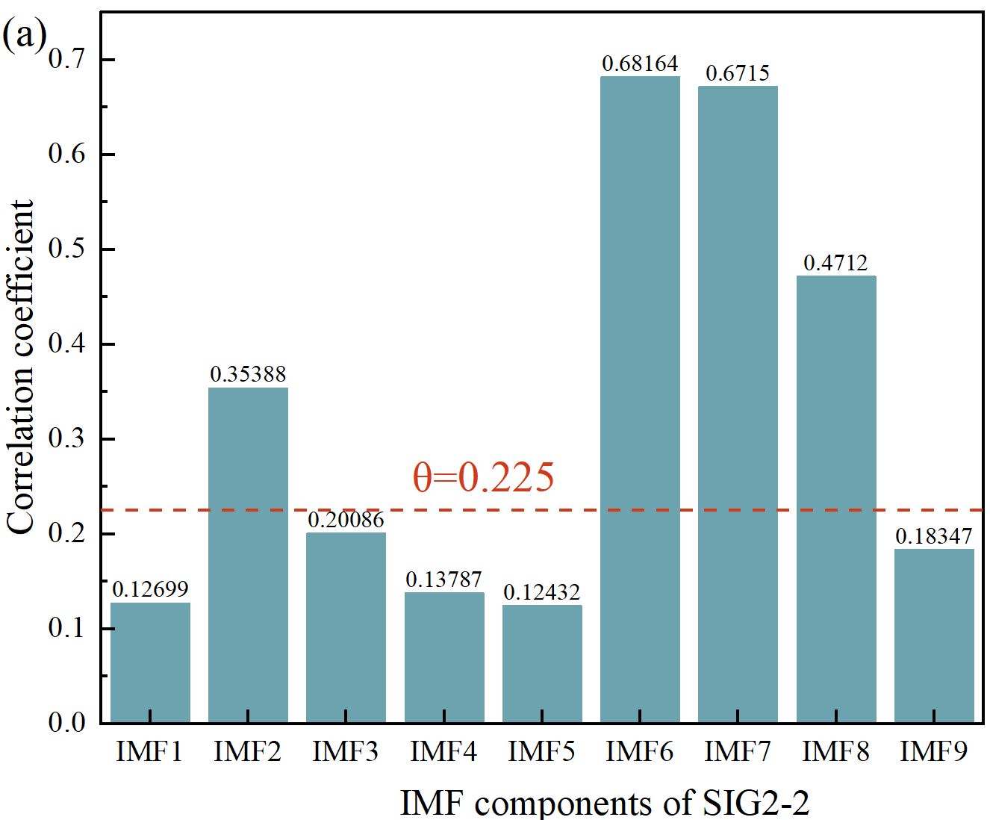 | 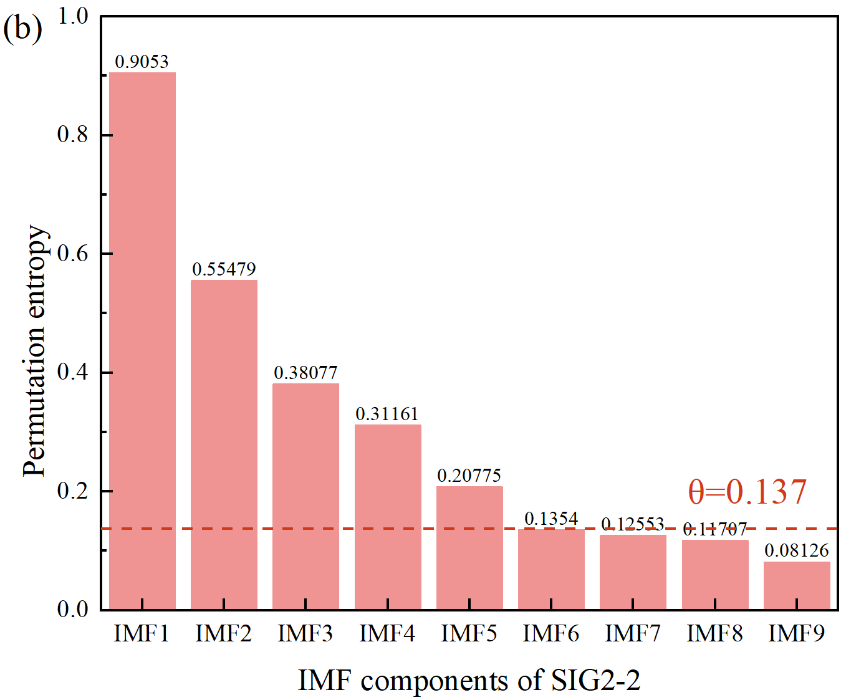
Figure 2 The relationship between (a) correlation coefficient, (b) permutation entropy, and their respective thresholds for the components of SIG2-2
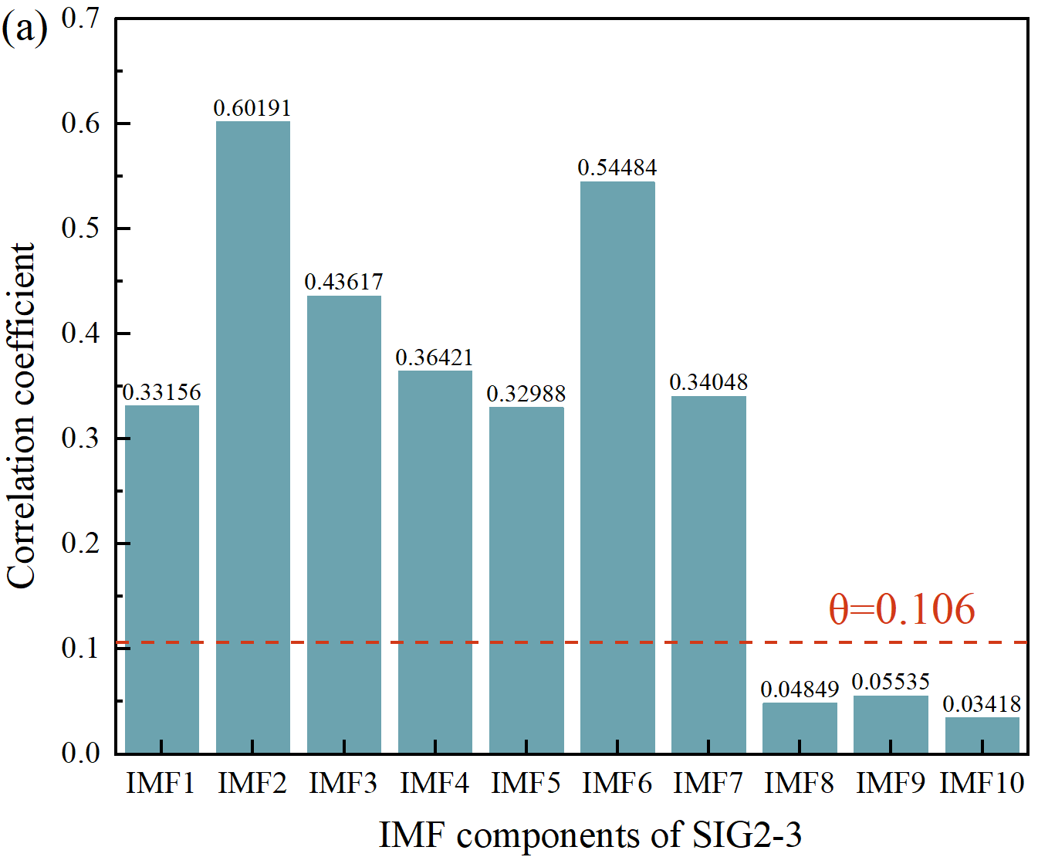 | 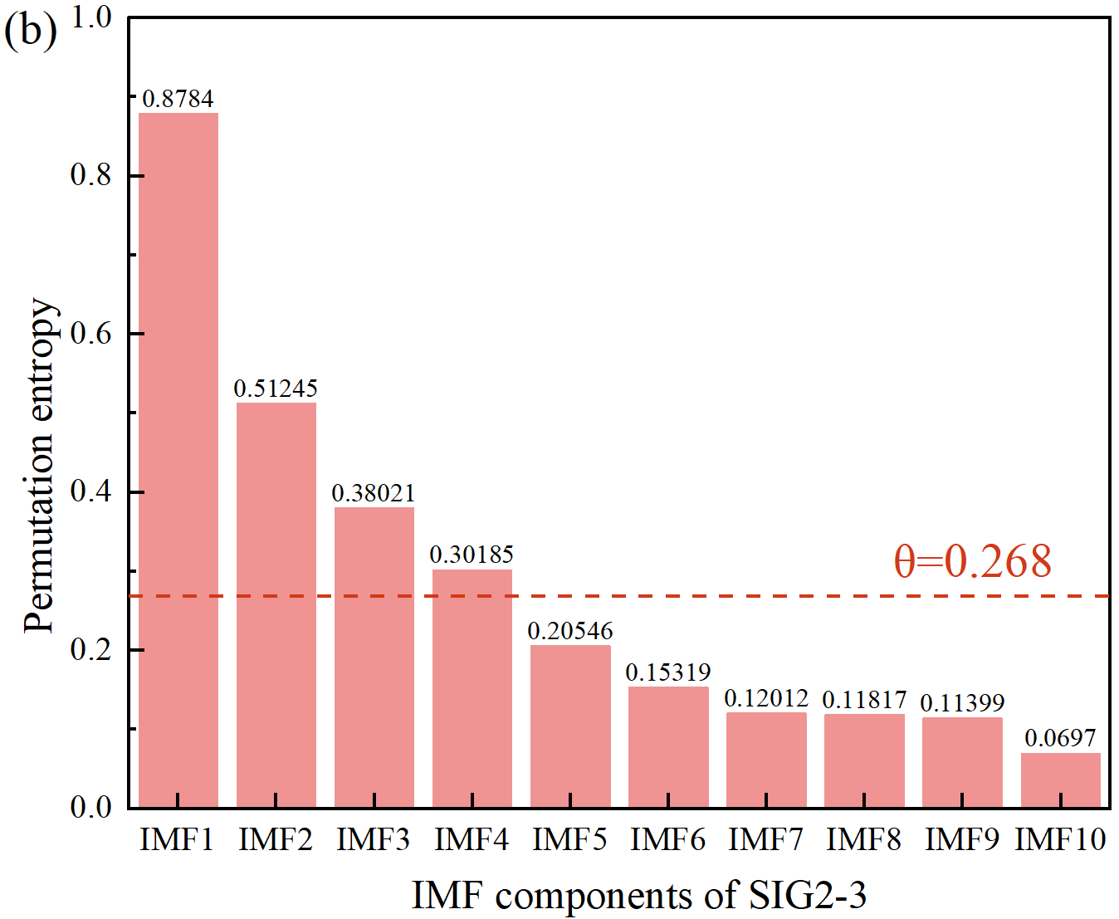
Figure 3 The relationship between (a) correlation coefficient, (b) permutation entropy, and their respective thresholds for the components of SIG2-3
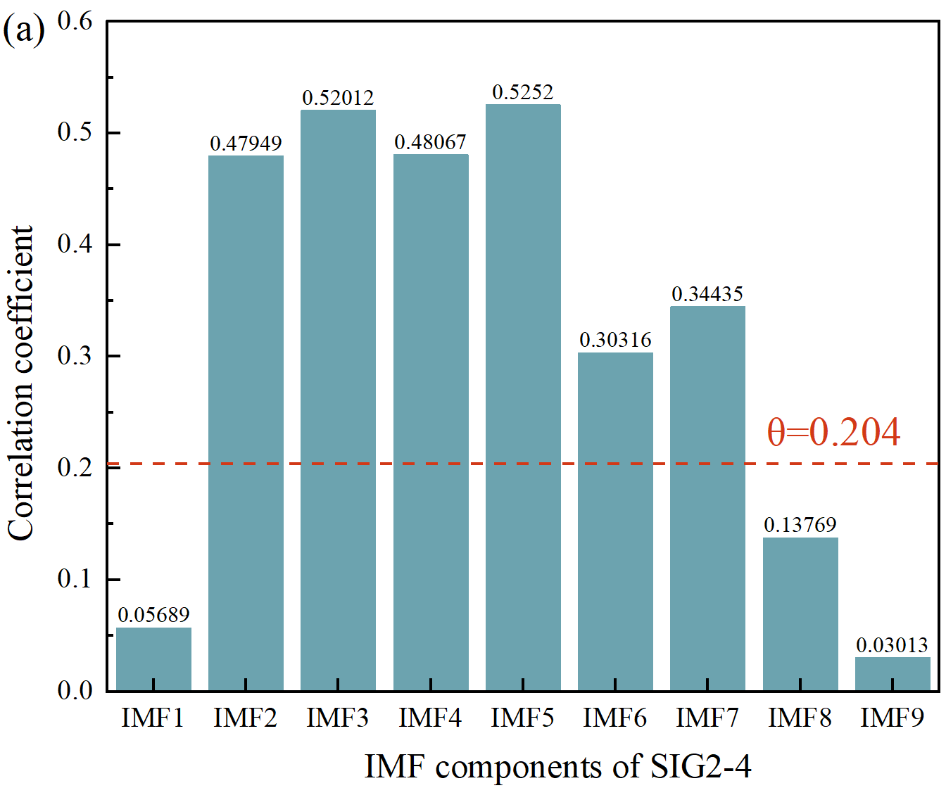 | 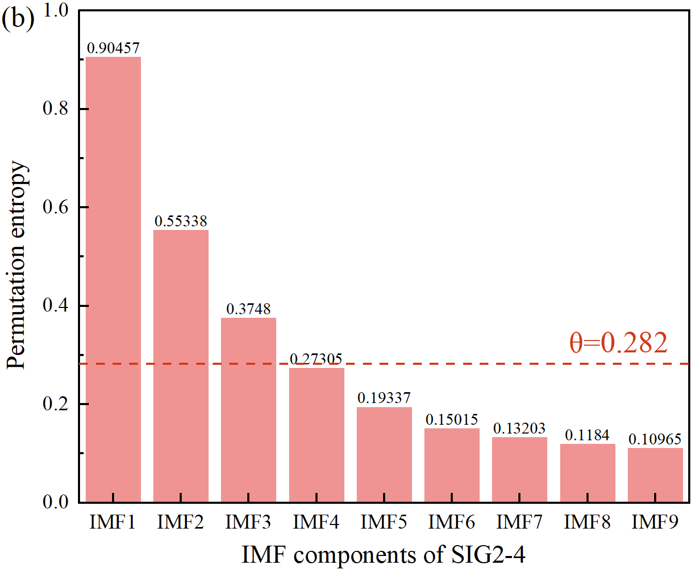
Figure 4 The relationship between (a) correlation coefficient, (b) permutation entropy, and their respective thresholds for the components of SIG2-4

