Yucel, Emre
eyucel@amgen.com
Abstract
As a result of literature reviews and evaluation of identified PRO instruments, TSQM has been determined to be used as a PRO instrument to select ‘off the shelf’ for measuring medication satisfaction. On the other hand, costs and feasibility of developing an in-house PRO instrument could also be evaluated.
SEARCH FOR AND EVALUATION OF PATIENT REPORTED OUTCOME INSTRUMENTS FOR MEDICATION SATISFACTION FOR 20170596
Selection of a PRO instrument off the shelf

SEARCH FOR AND EVALUATION OF PATIENT REPORTED OUTCOME INSTRUMENTS FOR MEDICATION SATISFACTION FOR 20170596

Prepared by
Emre Yucel

Date
Monday, September 18, 2017

Purpose of this brief report
This report aims to help decision-making by evaluating the concept of patient satisfaction. To achieve that, this report will report on the methods and results of the literature review conducted, offer methods to measure patient satisfaction for the study 20170596, and compare patient reported outcome (PRO) instruments for fit for purpose for this study in planning. This study focuses on satisfaction with 70mg/m2 once-weekly for cycles 7-12 (Kd70) vs 56mg/m2 twice-weekly for cycles 1-6 (Kd56). This report focuses on medication satisfaction and excludes other domains because these are out of the spectrum of this study;
- treatment satisfaction domains such as satisfaction due to procedures, activity limitations, and/or dietary restrictions,
- satisfaction due to interaction with healthcare personnel and healthcare facilities,
- satisfaction with health delivery systems such as accessibility, patient-physician interaction, perceived quality of staff and facilities [1].
Specifically, this report aims to evaluate the results of the first literature review [2], expand with a second literature review, and offer recommendations on the combined findings out of these two literature reviews on the appropriateness of PRO instruments.

Search for PRO instruments to measure patient satisfaction
Kyprolis 20170596 study has the primary objective to describe treatment tolerability of a Kd56 twice-weekly for cycles 1-6, followed by Kd70 once-weekly for cycles 7-12 regimen that includes preventative and supportive measures in subjects with multiple myeloma with relapsing or progressing disease at study entry [3].
Tolerability is measured by:
- % of subjects completing 12 cycles of Kd treatment
- dose intensity defined as total actual dose/planned dose up to cycle 12 or disease progression
- all grade treatment-emergent adverse events (TEAEs) and SAEs
  - treatment discontinuations due to all AEs
  - reasons for treatment discontinuation due to all AEs
  - dose reductions due to all AEs
The study has secondary aims to assess treatment adherence and subject satisfaction by switching to once-weekly dosing of Kd70 after 6 cycles of Kd56 with the following endpoints:
- dose intensity in Cycles 1-6 and Cycles 7-12 defined as total actual dose/planned dose up to cycle 6 or 12 or disease progression
- dose reductions in Cycles 1-6 and Cycles 7-12
- treatment discontinuation for all reasons in Cycles 1-6 and Cycles 7-12
- EORTC QLQ-C30 and MY-20
One of the exploratory objectives of the study is assess response to Kd treatment in subjects with multiple myeloma with relapsing or progressing disease at study entry with Cancer Treatment Satisfaction Questionnaire (CTSQ). This PRO instrument is suggested but it is not confirmed.
This brief report is evaluated to assess the appropriateness of CTSQ or other PRO instruments for this study and provide strategic recommendations before the study ensues.

Limitations of the Phase II study that could affect self-reported medication satisfaction
Although the secondary aim is to assess treatment adherence and subject satisfaction by switching to once-weekly dosing of Kd70 from Kd56, there are only two PRO instruments used to assess symptoms and HRQL domains of function: EORTC QLQ-C30 and MY20. Although these PRO instruments can assess satisfaction by demonstrating a symptom relief over time by comparing scores of items and domains between Kd70 and Kd56, other issues pertaining to medication satisfaction will remain missing as outlined in “Medication Satisfaction as a concept”.
Medication Satisfaction versus other PROs could get confused because satisfaction with medication is conceptually distinct from HRQL, symptom assessment, functional status, or any other PRO that may be assessed. HRQL pertains to the impact of health on a person’s physical, psychological, and social/occupational functioning and well-being by the patient’s own assessment of his/her status. HRQL or utility scores don’t directly reveal the patient’s satisfaction with the medication. Therefore, scores reported from EORTC QLQ-C30 and MY20 will reveal scores reported by patients on these standardized symptom questionnaires, not satisfaction of the medication. HRQL and self-reported symptoms represent patient reports of the patient’s status on each of the constructs in question, whereas satisfaction takes into account the extent to which the patient values each of these status points, as well as other factors that enter into determining satisfaction.
The study could also suffer from a survival bias which could manifest itself by remaining patients who make it to Kd70 period versus who didn’t.
An ‘order’ effect could ensue because it is possible that the order in which the Kd56 is administered may affect the outcome due to survival bias as mentioned above, response shift, and a learning effect.
There could be differences between those who dropped out and were lost to follow up versus those who adhered to regimen and stayed on course of treatment.
To rephrase the exploratory objective; to “assess response to Kd treatment in subjects with multiple myeloma with relapsing or progressing disease at study entry with Cancer Treatment Satisfaction Questionnaire (CTSQ).” There is a minor mistake. In essence, there is no “Cancer Treatment Satisfaction Questionnaire” but a “Cancer Therapy Satisfaction Questionnaire” [4].

Medication Satisfaction as a concept
Medication Satisfaction is defined as the patient’s evaluation of the process of taking the medication and the outcomes associated with the medication [1]. There are factors that may influence medication satisfaction that have little or nothing to do with the perceived effect of the drug on symptoms, HRQL, or functional status. These factors include the ease and convenience with which a patient can adhere to their medication. Other factors include medication’s dosing schedule, the patient’s confidence in his or her ability to take (here, more appropriately; tolerate) the medication properly, or the comfort level a patient feels with the amount of information received on the medication from the provider. Furthermore, patient’s expectations will inform satisfaction with respect to the impact of the medication on symptom relief, on side effects, and on HRQL and functionality.
Medication satisfaction is more narrowly focused and should be distinguished from other aspects of satisfaction [1]. According to the Theory of Reasoned Action, there are several domains of the concept of satisfaction closely linking it to adherence. Satisfaction has a minimum of the following concepts inherent: symptom relief/efficacy, side effects, ease and convenience, impact on health related quality of life (HRQL), general satisfaction, and additional domains specific to a study’s research question.
The (20170596) study’s primary and secondary objectives fit well with medication satisfaction because this is a study that aims to evaluate the efficacy and safety profile of the Kd70 versus Kd56. Therefore, measurement of medication satisfaction should be aligned with the primary and secondary endpoints to enable clear interpretation. This study has the following characteristics:
- One medication regimen (Kd70) over another (Kd56), offering offsetting advantages (hypothesis) relative to the other in terms of efficacy and side effects
- Regimens of approximate modes of administration (Kd70 and Kd56) have competing efficacy or other convenience factors (i.e., dosing schedules and dosing intensity)
The outcomes associated with medication satisfaction should be aligned with the outcomes of the study 20170596 by including the following concepts, hence:
- Tolerability (as opposed to non-tolerability. For example, for some drugs and for some patients, the cure might be seen as “worse than the disease.”)
- Adherence (as opposed to treatment discontinuation)
- [Relief from] Symptom burden (as opposed to high symptom burden or no efficacy)
- Convenience of treatment regimen (ease and convenience; dosing schedule)
- Impact on HRQL (assessment with HRQL’s association with satisfaction)
- Overall or general satisfaction, ex;
  - How satisfied are you with your medication?
  - How likely are you to recommend this medication to a friend who had the same disease?
  - Would you ask your doctor to prescribe this medication in the future if you suffer from this disease again?
- Other domains may include;
  - Patient’s confidence in Kd70 vs Kd56 with respect to efficacy
  - Patient’s confidence in Kd70 vs Kd56 with respect to side effect severity
  - Lifestyle limitations and resulting adherence
These are perceived domains and symptoms that patients consider for satisfaction with medication.
Patient satisfaction instruments should be subjected to the same rigorous psychometric principles as any other PRO instruments and should also adhere to regulatory and industry standards [1].
Pitfalls to consider are:
- There could be ‘saliency’ of side effects which can change over the course of medication regimen (e.g., side effects early on during the course of treatment may be less important than side-effects later in the treatment).
- Response shift; as patients adapt to their illness, their responses to items may shift because of the change in internal standard of measurement or a personal redefinition of satisfaction or change in person’s beliefs or values
- Disease and treatment history; e.g. internal acceptance of side effect and symptom severity may induce patients to tolerate more severe symptoms with less than adequate symptom management
- Patient history and other characteristics; patients with long-term chronic illnesses will have very different expectations than patients who are first-time users (this is going to be less of an issue because the patient population is expected to be more homogeneous for this trial, diagnosed with RRMM with at least one prior therapy, however, there could still be difference between patients who had one prior therapy versus three prior therapies), and patients with more severe comorbidities will have very different expectations as patients with less severe comorbidities

Findings from the first literature review
The first literature review identified the following PRO instruments for review [2]:
- Cancer Therapy Satisfaction Questionnaire (CTSQ)
- Chemotherapy Convenience and Satisfaction Questionnaire (CCSQ)
- Treatment Satisfaction Questionnaire for Medication (TSQM)
- FACIT-Treatment Satisfaction-General (FACIT-TS-G)
- Treatment Satisfaction with Medicines Questionnaire (SATMED-Q)
- Global assessment of treatment benefit, satisfaction and willingness to continue (BSW)
- Pain Treatment Satisfaction Scale (PTSS)
- Anti-Clot Treatment Scale (ACTS)
- Diabetes Medication Satisfaction Tool (DMSAT)
- Patient Global Impression of Change (PGIC)
- Brief Pain Inventory
- American Pain Society Patient Outcome Questionnaire
- FACIT Fatigue Scale
- Brief Fatigue Inventory (BFI)
- Cancer-Related Fatigue Distress Scale (CRFDS)
- Daily Fatigue Impact Scale (D-FIS)
An initial evaluation revealed that CCSQ and TSQM could better fit for purpose as a PRO instrument for this trial. Therefore, these two PRO instruments will be included with the other PRO instruments identified as a result of the second literature review.

Second literature review
A literature review is conducted using Ovid Medline, Embase , and PubMed on 18th September 2017 without any period limitations. 1246 citations were found through database search, 332 of which constituted internal and external duplicate citations. Due to time limitation to finish the report, only abstracts & articles between 2015 and today were scanned out of resulting 914 titles & abstracts.
The remaining 385 titles & abstracts screened first according whether they included concepts such as patient expectation, medication satisfaction, convenience, adherence and tolerability due to therapy. The underlying criterion was the use of a validated and reliable PRO instrument in these included articles.
Exclusion criteria
- Those studies whose patient population was not adults were excluded.
- Entirely qualitative studies or studies that didn’t report use of a validated and reliable PRO instrument were also excluded.
- Other reported outcomes such as proxy reported outcomes as in outcomes reported by members of the family instead of the patient were also excluded.
- Studies with only survivors or studies that concentrated on survivors’ satisfaction with healthcare delivery and accessibility were excluded.
- Studies that mentioned patient package and related medication satisfaction were excluded.
- Studies about sexual satisfaction or sexual dysfunction of patients were excluded.
- Studies on the satisfaction of patients after an educational intervention were excluded. Satisfaction difference studies due to gender differences were excluded.
- Satisfaction difference studies due to race/ethnicity were excluded.
- Satisfaction studies that evaluated medical or healthcare professionals’ education and training interventions were excluded.
- Treatment satisfaction PRO instruments that evaluated satisfaction with specific questions on surgery only were excluded.
- Patient quality metrics and related studies about patient satisfaction assessed for quality of health care delivery were excluded.
- Narrative reviews and editor-written introductions or literature reviews without systematic literature review criteria imposed were excluded.
- Physical training interventions (e.g., yoga), non-pharmacological interventions, and assessments of patient satisfaction of these were excluded.
A total of 316 articles were excluded in the first screening [5-254].
Because of time constraints, only those articles and abstracts between 2015 and current date were included for the second screening. As a result, 68 articles were included to the second screening [255-323]. Only those abstracts & articles that studied medication satisfaction with the comprehensive approach of tolerability, treatment continuity, symptom burden and impact on HRQL, convenience, and overall treatment satisfaction were included. As a result, 31 articles were identified.

Findings from the second literature review
The following PRO instruments were found as a result of the second literature review. Characteristics for applicability are evaluated.
PRO instrument | Characteristics and applicability
HIV Treatment Satisfaction Questionnaire (TSQ) [321, 324] | 10- item instrument (Appendix 1)  Scores ranging from 0-6 (0 least favorable – 6 most favorable response score range: 0–60,with higher scores indicating greater treatment satisfaction),with a recall period encompassing ‘the past few weeks’.  Scores 1–5 do not have specific descriptions defined on the questionnaire but represent intermediary responses between least favorable and most favorable.  Two HIV TSQ subscales: The General Satisfaction/Clinical subscale and the Lifestyle/Ease subscale  HIV specific: Not applicable
Treatment Satisfaction Questionnaire for Medication (TSQM) | Already included in the first literature review results  This questionnaire was also used extensively in studies about switching to teriflunomide [281, 282, 287, 325], and another study for rituximab [286].  The TSQM is a PRO instrument of the major dimensions of patients' satisfaction with medication; effectiveness, side effects, convenience and global satisfaction (Appendix 2).  It is not disease specific and contains many items that fit with the objectives of 20170596. Could be helpful.
Facial Line Satisfaction Questionnaire (FLSQ) | Created to assess patient satisfaction with facial line treatment and to assess treatment satisfaction in facial line patients  Therapeutic area specific questionnaire with domains such as achievement of botulinum toxin treatment expectations, satisfaction with duration of treatment, severity of glabellar lines (GL) and crow’s feet lines (CFL)  Facial line specific: Not applicable
Beliefs about Medicines Questionnaire (BMQ) | Assessed domains are beliefs about medication, other non-adherence predictors and domains are side-effects [326].  The Beliefs about Medicines Questionnaire (BMQ) aims to assess patients’ beliefs and worries about taking medication for asthma  Asthma-specific and beliefs oriented: Not applicable
Satisfaction with Information about Medicines Scale (SIMS) | Information about medication and barriers to adherence (cognitive and physical) domains are included [327]  Designed to assess the extent to which patients feel they have received enough information about prescribed medicines. This is a PRO instrument to assess whether patient is knowledgeable about the medicine and doesn’t consider medicine satisfaction as described before.  Not applicable.
Medication Adherence Rating Scale (MARS) | Ten-item self-report measure of medication adherence in psychosis [328].  Psychosis-oriented and adherence-oriented: Not applicable.
Brief Illness Perception Questionnaire (Brief IPQ) | Nine-item scale designed to rapidly assess the cognitive and emotional representations of illness [329].  Illness-oriented: Not applicable.
The Women's Health Questionnaire (WHQ) | A measure of mid-aged women's emotional and physical health [330]. Not applicable
Patient Satisfaction Questionnaire (PSQ) by RAND Health | Version III: A 50-item survey that taps global satisfaction with medical care as well as satisfaction with six aspects of care: technical quality, interpersonal manner, communication, financial aspects of care, time spent with doctor, and accessibility of care  Short form (PSQ-18) [331]  Healthcare system delivery and access-oriented: Not applicable
Medication Compliance Questionnaire | 10 items with five-point Likert-type response format with two domains measuring specific medication-taking and medication-stopping behavior[332, 333]  Used for cancer patients and could be helpful in measuring adherence/compliance of patients
Several diabetes-specific satisfaction and HRQL related PRO instruments | A systematic literature review revealed 19 instruments based on their potential to differentiate between oral hypoglycemic agents [315]  Another SLR review revealed 8 PRO instruments [297]  Diabetes-specific PRO instruments are too specific and therefore, not applicable.
Several psoriasis-specific satisfaction related PRO instruments | This systematic literature review revealed 4 publications on adherence, 5 publications on patient preference, and 7 publications on patient satisfaction [312]. Five articles used study-specific instruments, while the other two studies used TSQM.  Another study used only one study specific categorical questionnaire to measure treatment satisfaction for etanercept [289].  Psoriasis-specific instruments are skincare and psoriasis-focused. Not applicable.
Macular Treatment Satisfaction Questionnaire (MacTSQ) | A tool of 12 questions, with response options ranging on a 6-point Likert scale to rate level of satisfaction from not at all satisfied to completely satisfied, generating a range of possible total scores from 0 to 72 (Appendix 3). The MacTSQ provides two subscale scores: impact of treatment (range 0–36) and information provision and convenience (range 0–36) [307]  Macular degeneration oriented: Not applicable
Patient Satisfaction and Preference Questionnaire (PSPQ)  And  Clinician Satisfaction and Preference Questionnaire (CSPQ) | The PSPQ assessed patients’ receptiveness and satisfaction with the pharmacologic stress agents (PSA) that they received [305]. (Appendix 4)  The CSPQ assessed clinicians’ satisfaction with the time and ease of PSA preparation, administration, and monitoring of the PSA. The optional preference question in both instruments assesses preference among PSAs.  Specifically ‘injection’ focused but not containing items on convenience or general life satisfaction: Not applicable
Several PRO instruments identified that aimed to measure patient experience of using prescription medicines | 15 PRO instruments were identified (Appendix 5) [304]. Domains covered were the following: effectiveness; convenience, practicalities, and/or managing medicines; information, knowledge, and/or understanding; side effects; relationships and/or communication with health professionals; impact on daily living and/or social life; general satisfaction; attitudes; beliefs, concerns, and/or perceptions; medical follow-up and/or adherence-related issues; treatment- and/or medicine-related burden, perceived control, or autonomy; self-confidence about medicine use; availability and accessibility; and medicine-related quality of life. None of the identified questionnaires covered all domains.
Patient-reported Outcomes Measure of Pharmaceutical Therapy for Quality of Life (PROMPT-QoL) | The 43-item (Appendix 6) PROMPT-QoL comprised 10 domains: General Attitude toward Medication Use, Medicine Information, Disease Information, Medicine Effectiveness, Impacts of Medicines and Side-effects, Psychological Impacts of Medication Use, Convenience, Availability and Accessibility, Therapeutic Relationship with Healthcare Providers, and Overall QoL [334].  Although it contains 43 items, it has the following items that could be used for the purpose of this study:  Symptom relief, impacts of medicines and symptom relief, convenience, availability and accessibility, overall satisfaction
Patient Satisfaction and Preference Questionnaire (PASAPQ) | A multi-item measure of device satisfaction and preference, designed to be easily understood and administered to patients with asthma and COPD [301, 335].  Inhalation-specific: Not applicable
Rituximab Administration Satisfaction Questionnaire (RASQ) | The Rituximab Administration Satisfaction Questionnaire (RASQ) was created to assess patients’ perceptions and satisfaction with rituximab SC (RASQ-SC) or rituximab intravenous (RASQ-IV) [291]. There was an unmet need to develop a new, patient self-reported measure to assess the burden, impact, and preference for different routes of administration in the context of IV and SC administration of rituximab. RASQ includes 19 items per each PRO instrument; RASQ-SC and RASQ-IV, compiled from existing PRO instruments; eg, Functional Assessment of Cancer Therapy,18 the Cancer Therapy Satisfaction Questionnaire (CTSQ), and the Patient-Reported Outcomes version of the Common Terminology Criteria for Adverse Events. (Appendix 7)  Proprietary and created out of compilation of different PRO instruments; making it not transparent: Not applicable
Cancer Therapy Satisfaction Questionnaire (CTSQ) | CTSQ was also identified in the first literature review. This study specifically targeted chronic myeloid leukemia (CML) patients to assess the impact of patient-reported treatment restrictions and negative medication experiences (NMEs) on satisfaction and other health outcomes among patients with CML treated with oral TKIs. [336].  Overall satisfaction with current CML treatment was assessed using the Satisfaction with Therapy component of the Cancer Therapy Satisfaction Questionnaire (CTSQ) [4, 337]. Respondents were asked about the difficulty of following specific CML treatment restrictions or requirements: “Would it be easier for you to follow your CML treatment regimen if you did not need to follow the specific dietary restrictions or requirements?” (Yes/No). Individuals who did not report any treatment restrictions did not complete this questionnaire item but were coded as “No” responses, reflecting the lack of possibility of improvement over their current regimen.  Doesn’t include convenience items: Not applicable
the European Organization for Research and Treatment of Cancer In-patient Satisfaction with Care Questionnaire 32 (EORTC IN-PATSAT32) | A questionnaire to assess patient satisfaction, which has been validated in a multicenter study with patients from nine countries [338-342]. The EORTC IN-PATSAT32 is composed of 32 items assessing cancer patients’ perceptions of the quality of hospital doctors and nurses, as well as selected aspects of the care organization and hospital environment that are relevant across national settings. The questionnaire is organized into eleven multi-item scales, including doctors’ and nurses’ technical skills (for example, knowledge, experience, assessment of physical symptoms), interpersonal skills (for example, interest, willingness to listen), information provision (for example, about the disease, medical tests, and treatment), and availability (for example, time devoted to patients); other hospital staff members’ interpersonal skills; wait times; hospital access; and three single items consisting of information exchange, hospital comfort, and overall satisfaction. A “poor”, “fair”, “good”, “very good”, or “excellent” response scale is used to rate each aspect of care.  Healthcare delivery and access-oriented: Not appicable
the European Organisation for Research and Treatment of Cancer (EORTC) QLQ-INFO25 questionnaire | Used to evaluate the perceived level of and satisfaction with information among NHL, HL and MM patients [343-345]. The provisional EORTC INFO module had 26 items organized in four Hypothesized scales—information about the disease (4 items), medical tests (3 items), treatment (7 items) and other services (4 items)—and eight single items. The response  format is a 4-point Likert scale (1 – not at all, 2 – a little, 3 – quite a bit, 4 – very much), except items 51, 52, 54 and 55,which have a dichotomous response (yes/no) (Appendix 8). This is also used in RCT NCT03190525, one of whose secondary outcome measures is to investigate relationship between satisfaction with information provision (outcome measure: EORTC INFO-25) and QoL outcomes (outcome measures: EORTC QLQ-C30 and QLQ-MY20).  Information on disease and treatment specific: Not applicable

Evaluation of PRO instruments
As a result of two literature reviews, the following PRO instruments were decided to be evaluated for the purpose of this study:
- Chemotherapy Convenience and Satisfaction Questionnaire (CCSQ)
- Medication Compliance Questionnaire (MSQ)
- Patient-reported Outcomes Measure of Pharmaceutical Therapy for Quality of Life (PROMPT-QoL)
- Treatment Satisfaction Questionnaire for Medication (TSQM)
Patient reported outcome instrument evaluation points are combined with the essential elements to create a list of characteristics to assess the appropriateness of the PRO instruments found.
Psychometrics | Explanation
Documentation | Is there formal written documentation, peer-review publications, or a user’s manual to support the claims of the developers?
Development | Were rigorous procedures, motivated by a clear conceptual basis and a clear aim of the undertaking, adopted and tracked through all stages from item selection to large-scale field testing?
Validity | Is there sufficient evidence that the scale is measuring what it is intended to measure?
Reliability | Is there sufficient evidence that the scale is precise in accurately measuring its scores?
Responsiveness / Sensitivity to change | Is there sufficient evidence that the scale is sensitive to change in time and responsive to change?
Target population | Is the scale suitable for the target population under study and, if not, is it reasonable to expect the scale to be applicable?
Feasibility | Does the scale have questions that are easy to understand, have a convenient mode of administration, and no undue patient burden?
Language and cultures | Are there validated translations of the questionnaire to meet the needs under study?
Scoring | How is the scoring procedure defined and does it make sense?
Interpretation | Are there guidelines for interpreting scale scores?
Specific for 20170596 | Explanation
Disease specific | Is the PRO instrument MM specific?
If not disease specific, applicable | Is the PRO instrument applicable to be used in RRMM if it was generic?
 | Does the PRO instrument include items that are fit for 20170596?
Does the PRO instrument include items that are valuable according to MM patients[346]?
- Emotional Status (low mood, frustration & anger, bodily violation)
- Activity & Participation (e.g., work life, mobility, activities of daily living, sex and intimacy)
- Support factors (e.g., financial, housing,
- Treatment factors (e.g., vein-fragility, port or port-a-cath, Hickman line,
- Biological status (e.g., bone lesions, fractures)
- Symptom status (e.g., pain, nausea, breathlessness, numbness)
- Expectations (e.g., socialization, gaining ability to be active again)
- Adaptation & Coping (e.g., acceptance, adjusting)
- Spirituality (e.g., faith, belief, God)
Medication satisfaction | Does the PRO instrument entail elements of medication specification?
If yes to above, which ones are included? | Tolerability
 | Adherence
 | Convenience
 | Symptom burden
 | Impact on HRQL
 | General satisfaction
 | Patient’s confidence
 | Lifestyle limitations

Results

Chemotherapy Convenience and Satisfaction Questionnaire (CCSQ)
Chemotherapy Convenience and Satisfaction Questionnaire (CCSQ) was developed to capture the burden of i.v. vs oral administration of chemotherapy in patients receiving treatment in a large phase III trial of oral capecitabine plus i.v. oxaliplatin vs. bolus 5-FU/LV as adjuvant therapy for stage III colon cancer [347]. Because it is not easy to find the elements of documentation, lack of sufficient information on development, lack of evidence of sensitivity to change and responsiveness, lack of scoring procedures or guidelines, it is not recommended to use CCSQ for this study.

Medication Compliance Questionnaire (MCQ)
MCQ assesses medication compliance only and was developed by compiling items from other adherence-focused PRO instruments[348]. Because of lack of sufficient evidence that the scale is sensitive to change, and because it doesn’t have elements of medication compliance, it is not recommended.

Patient-reported Outcomes Measure of Pharmaceutical Therapy for Quality of Life (PROMPT-QoL)
PROMPT-QoL has been recently developed to facilitate medication management, such as evaluation of outcomes of disease management and pharmaceutical care in hospitals and community pharmacies [334]. Furthermore, this PRO instrument was developed in Thai and a translated version to English doesn’t exist yet [349]. Furthermore, PROMPT-QoL has not been evaluated for responsiveness and sensitivity to change. Therefore, it is not recommended to use this instrument.

Treatment Satisfaction Questionnaire for Medication (TSQM)
TSQM was identified in both literature reviews. TSQM has 14 items that can be used for the purposes of 20170596 [350]. TSQM has items on effectiveness (the ability of the medication to prevent or treat the condition; item 1), symptom relief (the way the medication relieves symptoms; item 2), side effects (item 3), interference with physical health and ability to function (e.g., strength, energy levels; item 4), interference with mental function (e.g. ability to think clearly, stay awake; item 5) [which touch on both cognitive function and fatigue to some degree], emotional status (dissatisfaction by side effects that interfere with mood or emotions; item 6), ease of use (item 7), planning [interference with daily activities]; item 8), frequency of use (item 9), patient’s beliefs on benefit/risk ratio of the treatment (item 10), and overall satisfaction (item 11). TSQM was also mentioned in a guideline by the Agency for Healthcare Research and Quality (AHRQ) [351]. The items of TSQM are applicable and fit for measuring medication satisfaction for this study.

Conclusion
As a result of literature reviews and evaluation of identified PRO instruments, TSQM has been determined to be used as a PRO instrument to select ‘off the shelf’ for measuring medication satisfaction. On the other hand, costs and feasibility of developing an in-house PRO instrument could also be evaluated.

Appendices

Appendix 1 – HIV Treatment Satisfaction Questionnaire (TSQ)
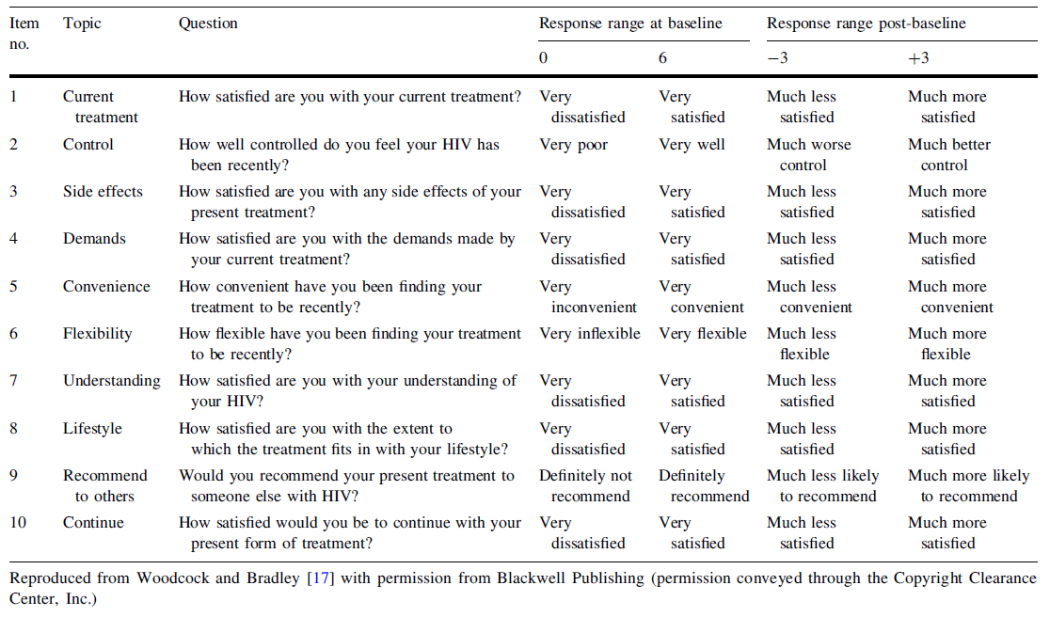
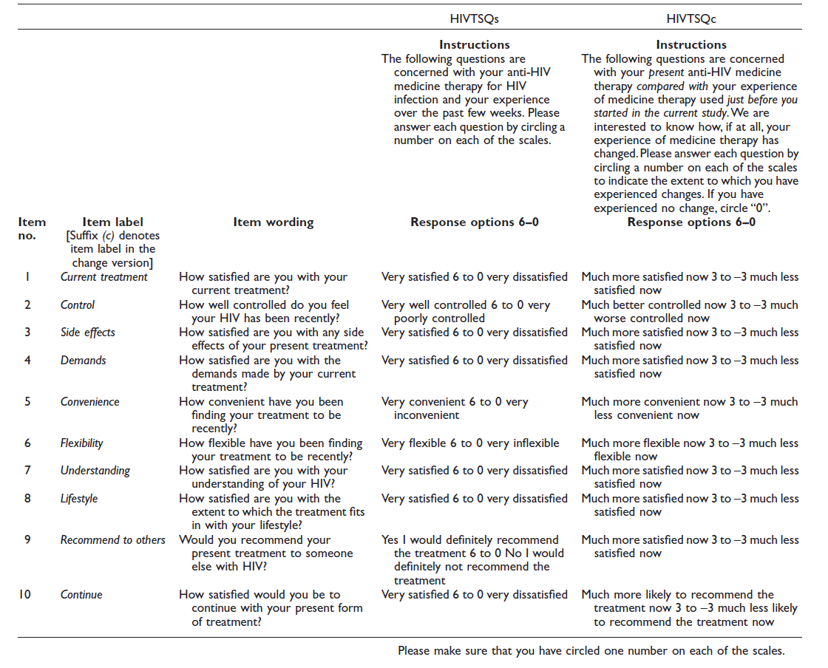

Appendix 2 TSQM Domains
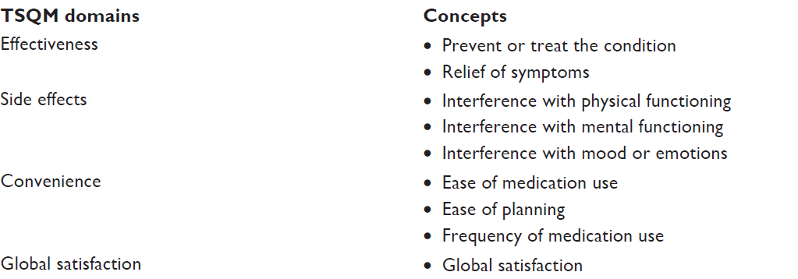
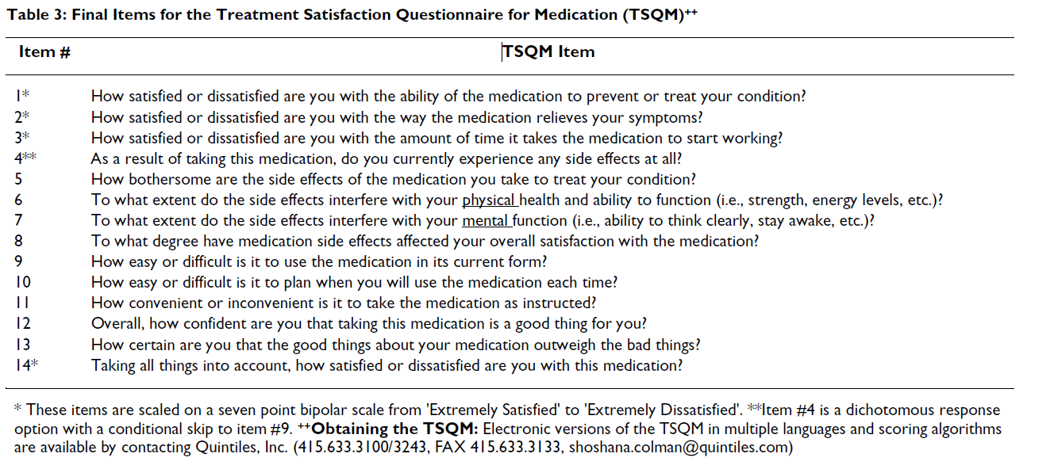
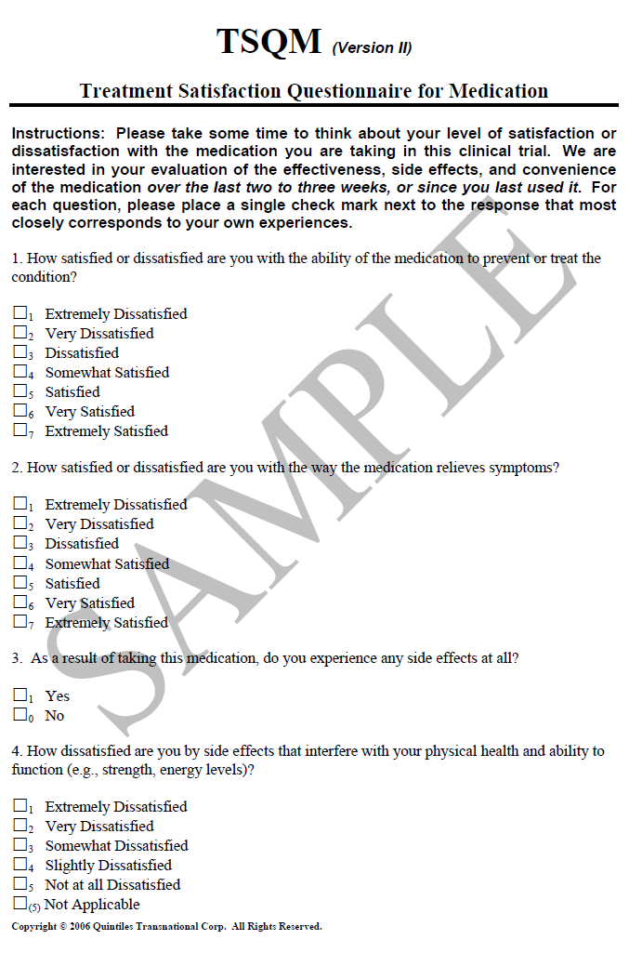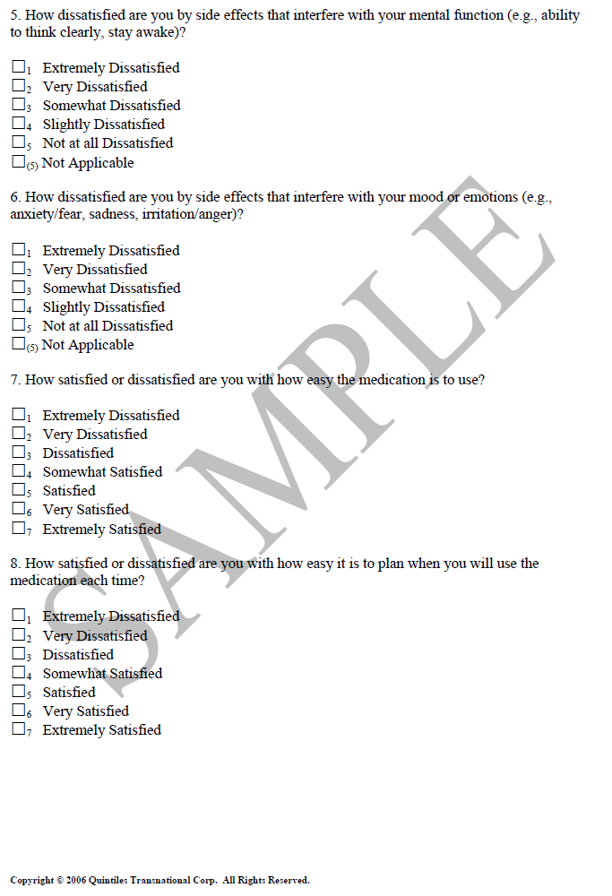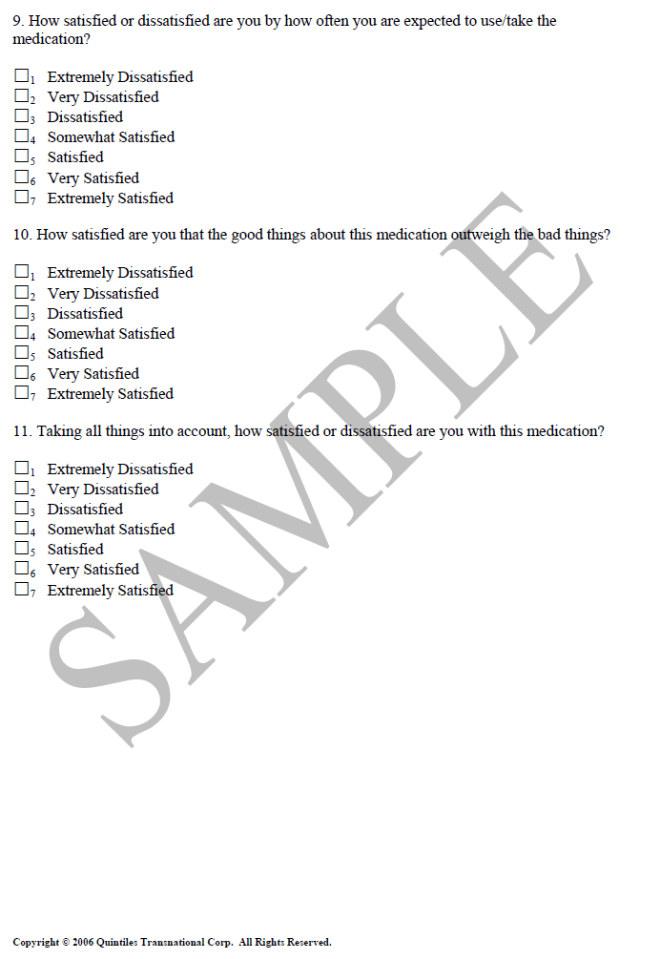

Appendix 3 Macular Treatment Satisfaction Questionnaire (MacTSQ)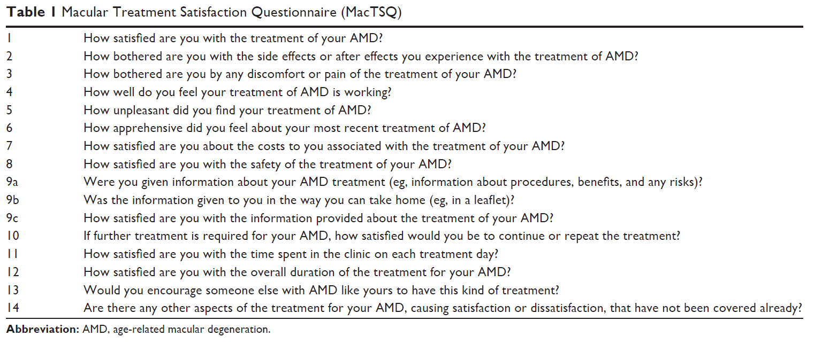

Appendix 4 Patient Satisfaction and Preference Questionnaire (PSPQ) And Clinician Satisfaction and Preference Questionnaire (CSPQ)
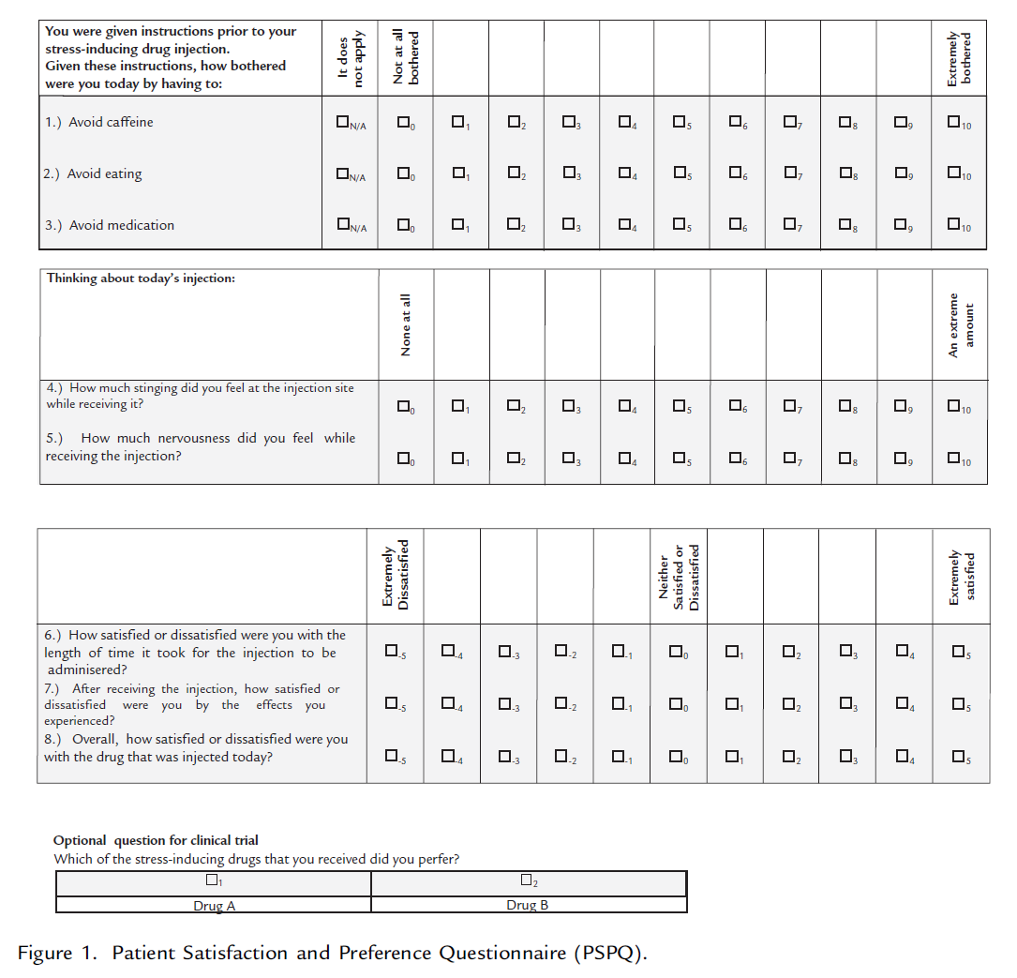
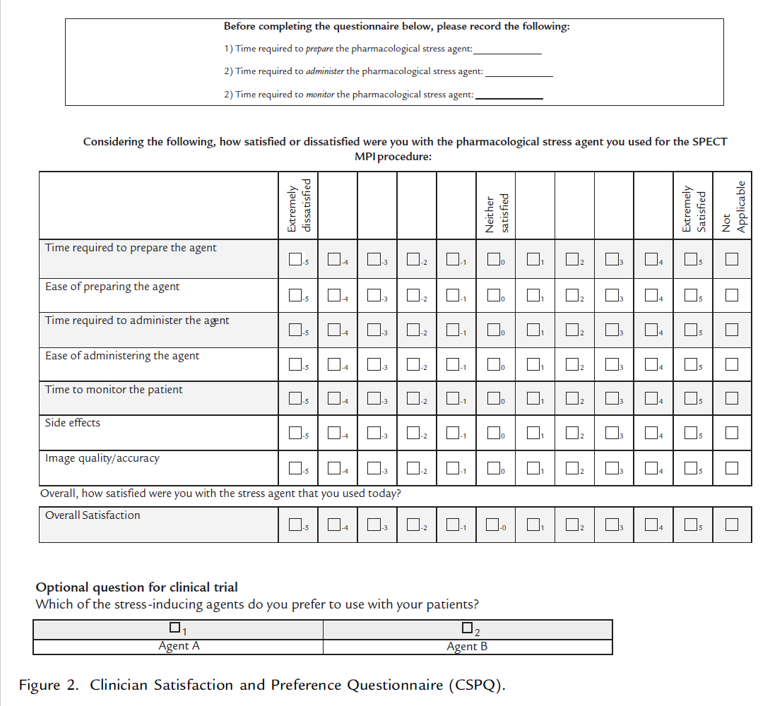

Appendix - 5 PRO instruments of medicine-related patient experiences
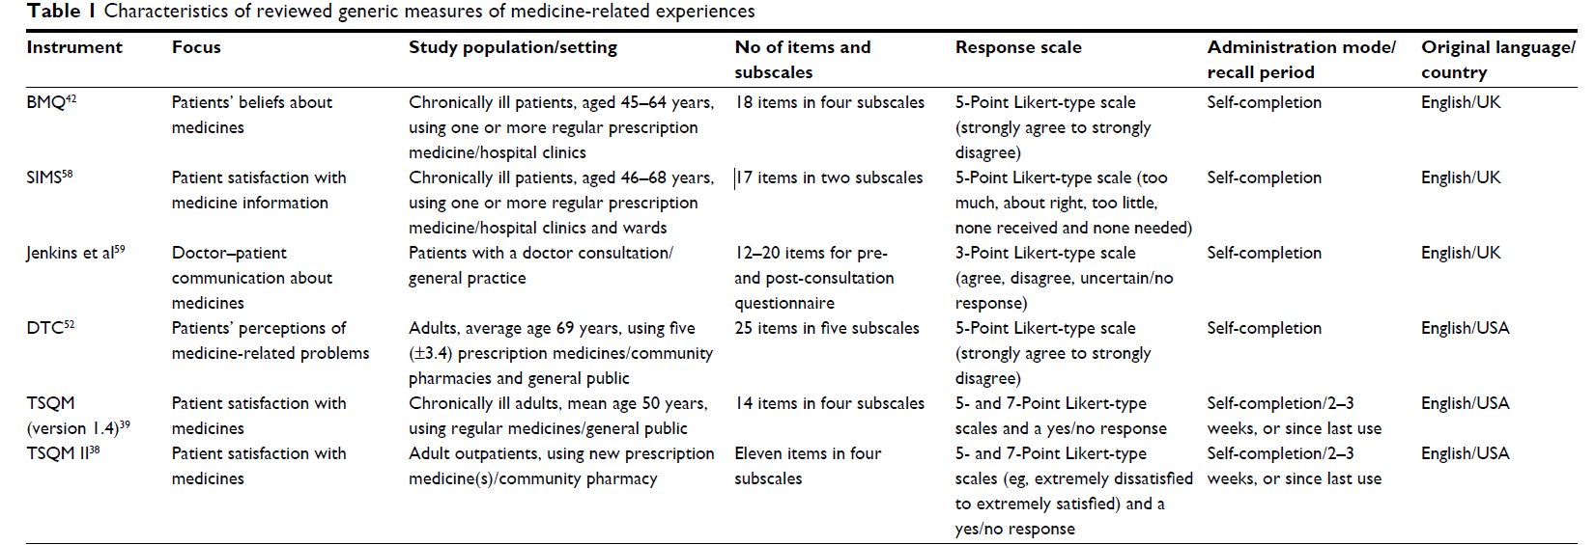
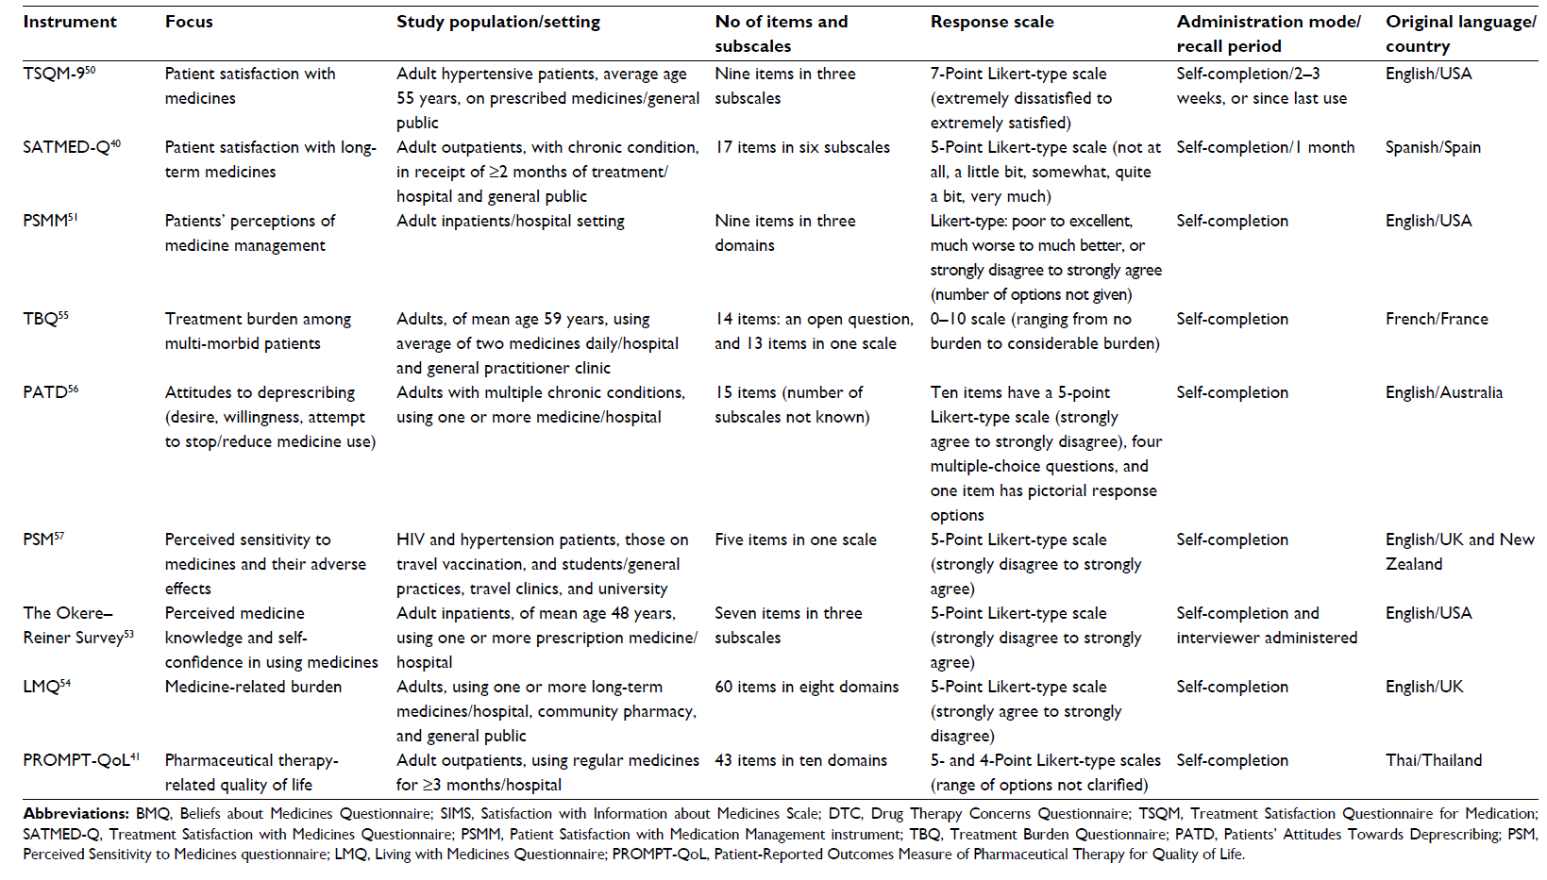
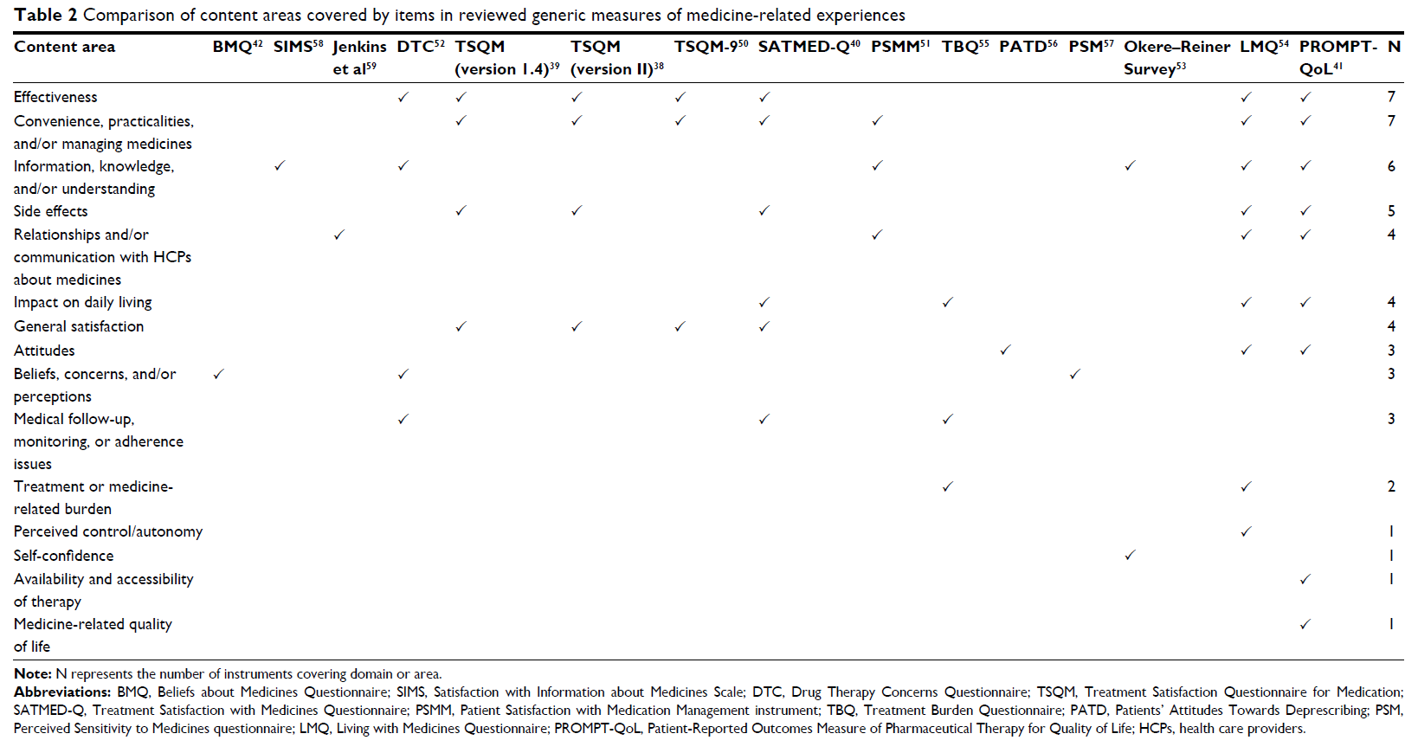

Appendix 6 - 43 items of the PROMPT-QOL
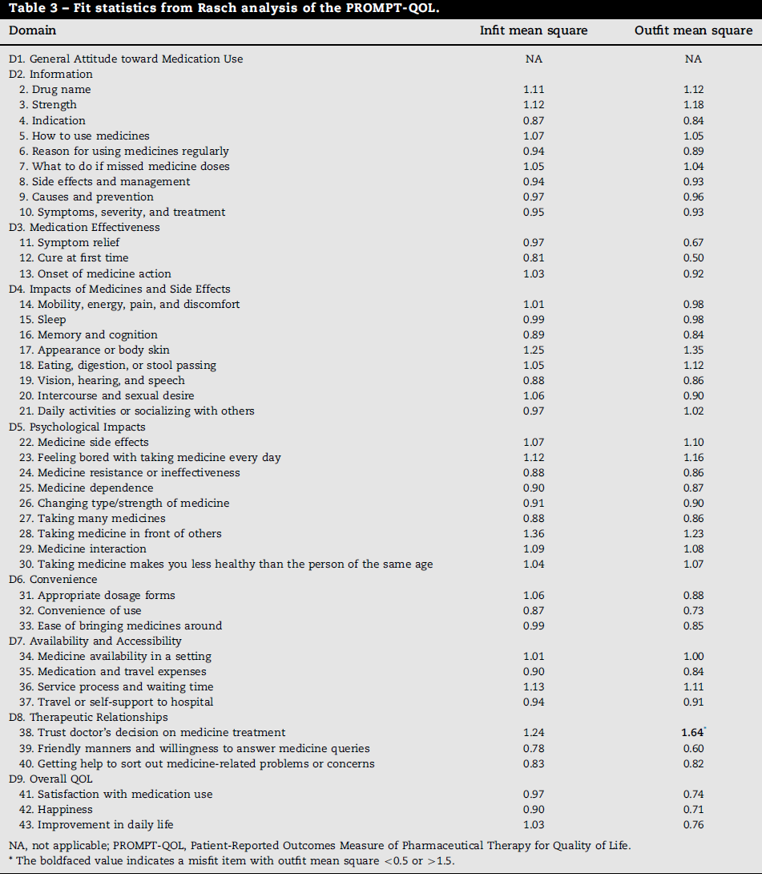
Reference: [349]

Appendix 7 - RASQ Items
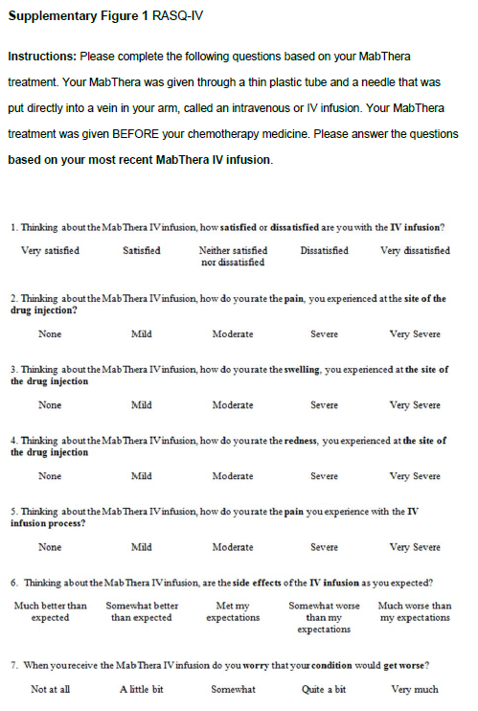
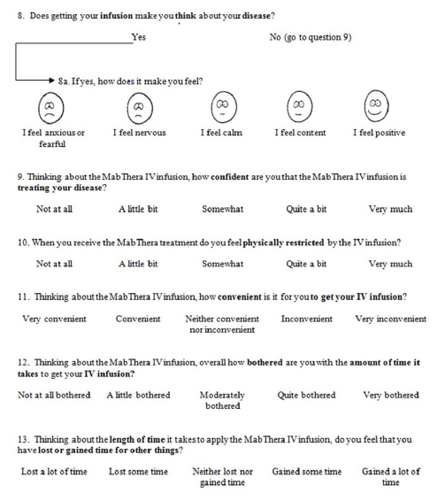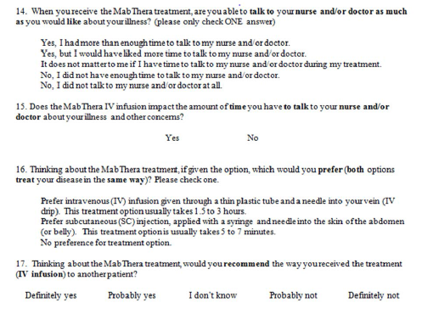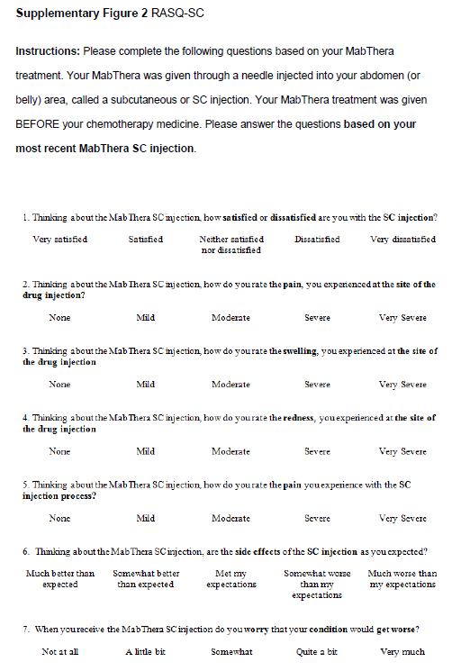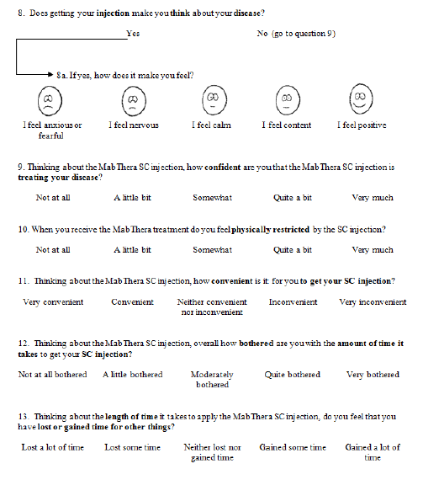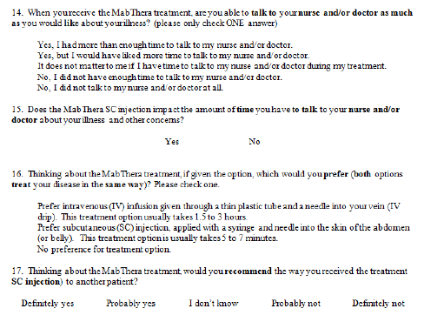

Appendix 8 - EORTC QLQ-INFO25 items
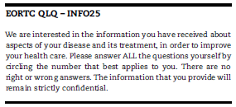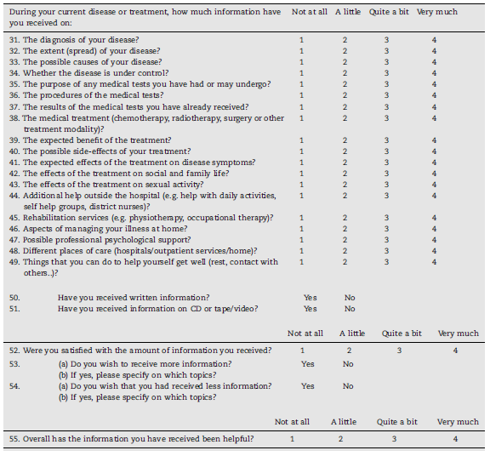

References

1. Shikiar, R. and A.M. Rentz, Satisfaction with medication: an overview of conceptual, methodologic, and regulatory issues. Value Health, 2004. 7(2): p. 204-15.
2. Amgen, Review of PRO instruments for Tolerability, Satisfaction, and Convenience of Therapy/Medication. 2017.
3. Amgen, Objectives and Endpoints for Kyprolis 20170596 study. 2017, AMGEN.
4. Abetz, L., et al., Development of the cancer therapy satisfaction questionnaire: item generation and content validity testing. Value Health, 2005. 8 Suppl 1: p. S41-53.
5. Zhao, N., et al., Gender differences in quality of life and functional disability for depression outpatients with or without residual symptoms after acute phase treatment in China. J Affect Disord, 2017. 219: p. 141-148.
6. Zan, P., et al., Reduction Osteotomy versus Extensive Release on Clinical Outcome Measures in Simultaneous Bilateral Total Knee Arthroplasty. Medical Science Monitor, 2017. 23: p. 3817-3823.
7. Young, K., et al., Early identification and longitudinal changes of patient satisfaction two-years after total knee arthroplasty. Journal of Orthopaedic Research. Conference, 2017. 35(no pagination).
8. Wilson, T.J., et al., Patient-perceived surgical indication influences patient expectations of surgery for degenerative spinal disease. Clinical Neurology and Neurosurgery, 2017. 157: p. 11-16.
9. Whitacre, E.B. and M.N. Moore, Use of real-time patient reported outcomes to improve performance in breast surgery. Cancer Research. Conference: 39th Annual CTRC AACR San Antonio Breast Cancer Symposium. United States, 2017. 77(4 Supplement 1).
10. Voznesensky, M.A., et al., Patient-Reported Social, Psychological, and Urologic Outcomes After Adult Buried Penis Repair. Urology, 2017. 103: p. 240-244.
11. Vedam, S., et al., The Mother's Autonomy in Decision Making (MADM) scale: Patient-led development and psychometric testing of a new instrument to evaluate experience of maternity care. PLoS One, 2017. 12(2): p. e0171804.
12. Vayne-Bossert, P., et al., Corticosteroids for adult patients with advanced cancer who have nausea and vomiting (not related to chemotherapy, radiotherapy, or surgery). Cochrane Database of Systematic Reviews, 2017. 2017 (7) (no pagination)(CD012002).
13. van Wulfften Palthe, O.D.R., et al., What questionnaires to use when measuring quality of life in sacral tumor patients: the updated sacral tumor survey. Spine Journal, 2017. 17(5): p. 636-644.
14. van der Ven, P.J.P., et al., Kneeling and standing up from a chair as performance-based tests to evaluate knee function in the high-flexion range: a randomized controlled trial comparing a conventional and a high-flexion TKA design. BMC Musculoskeletal Disorders, 2017. 18(1): p. 324.
15. Triebel, J., et al., Women do not fare worse than men after lumbar fusion surgery: Two-year follow-up results from 4,780 prospectively collected patients in the Swedish National Spine Register with lumbar degenerative disc disease and chronic low back pain. Spine Journal, 2017. 17(5): p. 656-662.
16. Townsend, L.A., et al., Impact of Age on Patient-Reported Outcome Measures in Total Knee Arthroplasty. Journal of Knee Surgery., 2017. 25.
17. Thiboutot, E., C. Webb, and C. Temple-Oberle, Effect of radiation therapy on the satisfaction of patients with immediate, implant-based breast reconstruction. Annals of Surgical Oncology, 2017. 24 (2 Supplement 1): p. 271-272.
18. Thaler, L., et al., An adjunctive, museum-based art therapy experience in the treatment of women with severe eating disorders. Arts in Psychotherapy, 2017. 56: p. 1-6.
19. Taher, A.T., et al., Novel iron-chelation therapies in thalassemia. Iranian Journal of Medical Sciences, 2017. 42 (3 Supplement 1): p. 2.
20. Taege, S.K., et al., Anesthetic Cream Use during Office Pessary Removal and Replacement. Obstetrics and Gynecology, 2017. 130(1): p. 190-197.
21. Svendsen, M.T., et al., Worldwide utilization of topical remedies in treatment of psoriasis: a systematic review. Journal of Dermatological Treatment, 2017. 28(5): p. 374-383.
22. Spies, B.C., et al., CAD/CAM-fabricated ceramic implant-supported single crowns made from lithium disilicate: Final results of a 5-year prospective cohort study. Clinical Implant Dentistry & Related Research, 2017. 13: p. 13.
23. Sonesson, S., et al., Psychological factors are important to return to pre-injury sport activity after anterior cruciate ligament reconstruction: expect and motivate to satisfy. Knee Surgery, Sports Traumatology, Arthroscopy, 2017. 25(5): p. 1375-1384.
24. Shin, J.H., A. Kim, and M.S. Choo, Additional low-dose antimuscarinics can improve overactive bladder symptoms in patients with suboptimal response to beta 3 agonist monotherapy. Investigative and Clinical Urology, 2017. 58(4): p. 261-266.
25. Shaw, B.E., et al., Centralized patient-reported outcome data collection in transplantation is feasible and clinically meaningful. Cancer, 2017. 17: p. 17.
26. Rosenblatt, C., Exploring the relationship between behavioural, somatic, cognitive and emotional symptoms following concussion with considerations for treatment. Brain Injury, 2017. 31 (6-7): p. 1013.
27. Romeyke, T., et al., Integration of naturopathic medicine into acute inpatient care: An approach for patient-centred medicine under diagnosis-related groups. Complementary Therapies in Clinical Practice, 2017. 28: p. 9-17.
28. Roeb, M.M., et al., Epidural Against Systemic Analgesia : An International Registry Analysis on Postoperative Pain and Related Perceptions after Abdominal Surgery. Clinical Journal of Pain, 2017. 33(3): p. 189-197.
29. Rodriguez-Correa, C., et al., Real-time assessment of patient reported outcomes in heart failure clinic. Journal of Cardiac Failure, 2017. 23 (8 Supplement 1): p. S29.
30. Roberson, T.A. and D.J. Wyland, Meniscal Allograft Transplantation With Soft Tissue in Bone Socket Fixation: Arthroscopic Technique With Technical Pearls. Arthroscopy Techniques, 2017. 6(2): p. e483-e489.
31. Reich, K., et al., A Topical Treatment Optimization Programme (TTOP) improves clinical outcome for calcipotriol/betamethasone gel in psoriasis: results of a 64-week multinational randomized phase IV study in 1790 patients (PSO-TOP). British Journal of Dermatology, 2017. 177(1): p. 197-205.
32. Pusic, A.L., et al., Patient-Reported Outcomes 1 Year After Immediate Breast Reconstruction: Results of the Mastectomy Reconstruction Outcomes Consortium Study. Journal of Clinical Oncology, 2017. 35(22): p. 2499-2506.
33. Purvis, T.E., et al., Concurrent Validity and Responsiveness of PROMIS Health Domains Among Patients Presenting for Anterior Cervical Spine Surgery. Spine., 2017. 24.
34. Prissel, M.A., et al., Plantar Plate Repair Using a Direct Plantar Approach: An Outcomes Analysis. Journal of Foot and Ankle Surgery, 2017. 56(3): p. 434-439.
35. Postler, A.E., et al., Patient-reported outcomes after revision surgery compared to primary total hip arthroplasty. HIP International, 2017. 27(2): p. 180-186.
36. Poonai, N., et al., Point-of-care Ultrasound for Nonangulated Distal Forearm Fractures in Children: Test Performance Characteristics and Patient-centered Outcomes. Academic Emergency Medicine, 2017. 24(5): p. 607-616.
37. Park, Y., et al., The effect of formulary restrictions on patient and payer outcomes: A systematic literature review. Journal of Managed Care and Specialty Pharmacy, 2017. 23(8): p. 893-901.
38. Paraskeva, N., et al., Facilitating shared decision-making with breast augmentation patients: Acceptability of the PEGASUS intervention. Journal of Plastic, Reconstructive and Aesthetic Surgery, 2017. 70(2): p. 203-208.
39. Ortiz-Declet, V.R., et al., Birmingham Hip Resurfacing vs Total Hip Arthroplasty: A Matched-Pair Comparison of Clinical Outcomes. Journal of Arthroplasty, 2017. 23: p. 23.
40. O'Deasmhunaigh, D. and J. Harty, PFC vs attune-functional outcomes. Irish Journal of Medical Science, 2017. 186 (6 Supplement 1): p. S211.
41. Oberguggenberger, A., et al., Self-reported sexual health: Breast cancer survivors compared to women from the general population - an observational study. BMC Cancer, 2017. 17(1): p. 599.
42. Nogueira, T.E., D.R. Dias, and C.R. Leles, Mandibular complete denture versus single-implant overdenture: a systematic review of patient-reported outcomes. Journal of Oral Rehabilitation, 2017. 14: p. 14.
43. Nicastro, R., et al., Subjective Distress Associated with Adult ADHD: evaluation of a new self-report. Atten Defic Hyperact Disord, 2017.
44. Murinova, N., et al., What kind of treatment do patients really want for headache? Neurology. Conference: 69th American Academy of Neurology Annual Meeting, AAN, 2017. 88(16 Supplement 1).
45. Munoz Obino, K.F., C. Aguiar Pereira, and R.S. Caron-Lienert, Coaching and barriers to weight loss: an integrative review. Diabetes Metab Syndr Obes, 2017. 10: p. 1-11.
46. Mueller, E.R., et al., Patient reported outcomes from synergy, a randomized, double-blind, multicenter study evaluating combinations of mirabegron and solifenacin compared with mirabegron and solifenacin monotherapy. Neurourology and Urodynamics, 2017. 36: p. S151-S152.
47. Momoh, A.O., et al., Tradeoffs Associated with Contralateral Prophylactic Mastectomy in Women Choosing Breast Reconstruction: Results of a Prospective Multicenter Cohort. Annals of Surgery, 2017. 266(1): p. 158-164.
48. Mommers, E.H.H., et al., Patient-reported outcomes (PROs) after total extraperitoneal hernia repair (TEP). Hernia, 2017. 21(1): p. 45-50.
49. Mommers, E.H.H., et al., Patient-reported outcomes (PROs) after total extraperitoneal hernia repair (TEP). Hernia, 2017. 21(1): p. 45-50.
50. Modi, A., et al., Impact of gastrointestinal events on patient-reported outcomes in Asia-Pacific women with osteoporosis: baseline results of the MUSIC OS-AP study. Archives of Osteoporosis, 2017. 12 (1) (no pagination)(65).
51. Menge, T.J., et al., Survivorship and Outcomes 10 Years Following Hip Arthroscopy for Femoroacetabular Impingement: Labral Debridement Compared with Labral Repair. Journal of Bone & Joint Surgery - American Volume, 2017. 99(12): p. 997-1004.
52. Matza, L.S., et al., Validation of a questionnaire to assess patient perceptions of injection devices for type 2 diabetes. Value in Health, 2017. 20 (5): p. A12.
53. Manskow, U.S., et al., Patterns of change and stability in caregiver burden and life satisfaction from 1 to 2 years after severe traumatic brain injury: A Norwegian longitudinal study. NeuroRehabilitation, 2017. 40(2): p. 211-222.
54. Madsen, L.D., et al., Native-tissue repair of isolated primary rectocele compared with nonabsorbable mesh: patient-reported outcomes. International Urogynecology Journal, 2017. 28(1): p. 49-57.
55. Lyman, S. and K.L. Yin, Patient-reported Outcome Measurement for Patients With Total Knee Arthroplasty. Journal of the American Academy of Orthopaedic Surgeons, 2017. 25 Suppl 1: p. S44-S47.
56. Lucas, S.M., et al., Establishment of a Web-based System for Collection of Patient-reported Outcomes After Radical Prostatectomy in a Statewide Quality Improvement Collaborative. Urology, 2017. 107: p. 96-102.
57. Lucas, S.M., et al., Establishment of a Web-based System for Collection of Patient-reported Outcomes After Radical Prostatectomy in a Statewide Quality Improvement Collaborative. Urology., 2017.
58. Lucas, E.T., et al., Assessment of satisfaction and Quality of Life using self -reported questionnaires after urethroplasty: a prospective analysis. International Braz J Urol, 2017. 43(2): p. 304-310.
59. Lopez, G., et al., Integrative oncology physician consultations at a comprehensive cancer center: Analysis of demographic, clinical and patient reported outcomes. Journal of Cancer, 2017. 8(3): p. 395-402.
60. Lopez, G., et al., Integrative oncology outpatient consultations: Long-term effects on patient-reported symptoms and quality of life. Journal of Cancer, 2017. 8(9): p. 1640-1646.
61. Liow, M.H.L., et al., Poorer fusion outcomes in diabetic cervical spondylotic myelopathy patients undergoing single-level anterior cervical discectomy and fusion does not compromise functional outcomes and quality of life. Spine, 2017. 29: p. 29.
62. Kuhlmann, P.K., et al., Collagenase Clostridium histolyticum in the treatment of peyronie's disease: Patient selection and perspectives. Patient Preference and Adherence, 2017. 11: p. 431-448.
63. Kozlowski, A.J., et al., Feasibility and Safety of a Powered Exoskeleton for Assisted Walking for Persons With Multiple Sclerosis: A Single-Group Preliminary Study. Archives of Physical Medicine and Rehabilitation, 2017. 98(7): p. 1300-1307.
64. Klapwijk, L.C., et al., The first 6 weeks of recovery after primary total hip arthroplasty with fast track. Acta Orthopaedica, 2017. 88(2): p. 140-144.
65. Kirchheiner, K., Differences between PRO and clinician reported morbidity and associations to clinical outcome. Radiotherapy and Oncology, 2017. 123: p. S274-S275.
66. Khalid, T., et al., Patient-reported outcome and its association with attachment type and bone volume in mandibular implant overdenture. Clinical Oral Implants Research, 2017. 28(5): p. 535-542.
67. Jessop, S., et al., Drugs for discoid lupus erythematosus. Cochrane Database Syst Rev, 2017. 5: p. Cd002954.
68. Javid, S.H., S.O. Lawrence, and D.C. Lavallee, Prioritizing Patient-Reported Outcomes in Breast Cancer Surgery Quality Improvement. Breast Journal, 2017. 23(2): p. 127-137.
69. Jain, D., et al., Higher Patient Expectations Predict Higher Patient-Reported Outcomes, But Not Satisfaction, in Total Knee Arthroplasty Patients: A Prospective Multicenter Study. 2017. 32(9 Supplement): p. S166-S170.
70. Jain, D., et al., Do Patient Expectations Influence Patient-Reported Outcomes and Satisfaction in Total Hip Arthroplasty? A Prospective, Multicenter Study. Journal of Arthroplasty., 2017.
71. Iyigun, T., et al., Patient body image, self-esteem, and cosmetic results of minimally invasive robotic cardiac surgery. International Journal Of Surgery, 2017. 39: p. 88-94.
72. Hodgkins, P., et al., Estimating minimal important differences for several scales assessing function and quality of life in patients with attention-deficit/hyperactivity disorder. Cns Spectrums, 2017. 22(1): p. 31-40.
73. Hirani, S.P., et al., Quantifying beliefs regarding telehealth: Development of the Whole Systems Demonstrator Service User Technology Acceptability Questionnaire. Journal of Telemedicine & Telecare, 2017. 23(4): p. 460-469.
74. Herren, C., et al., Incidental durotomy in decompression for lumbar spinal stenosis: incidence, risk factors and effect on outcomes in the Spine Tango registry. European Spine Journal, 2017: p. 1-13.
75. Henn, R.F., et al., The Maryland Orthopaedic Registry (MOR): Design and baseline characteristics of a prospective registry. Journal of Clinical Orthopaedics and Trauma., 2017. 27.
76. Henien, M. and C. Sproat, Interactive group therapy for the management of myofascial temporomandibular pain. British Dental Journal, 2017. 223(2): p. 90-95.
77. Heinrich, M., et al., Parents reported reduced symptoms and improved satisfaction after fundoplication and their perceptions were an important outcome measure. Acta Paediatr, 2017. 106(1): p. 168-173.
78. Hashimoto, Y., et al., The 5-year outcomes of moderately hypofractionated radiotherapy (66 Gy in 22 fractions, 3 fractions per week) for localized prostate cancer: a retrospective study. International Journal of Clinical Oncology, 2017. 31: p. 31.
79. Harvey, A.R., et al., Early postoperative patient outcomes and kinematics using a PCL-retaining TKA designed to restore anatomic motions. Journal of Orthopaedic Research. Conference, 2017. 35(no pagination).
80. Hamilton, D.K., et al., Patient Satisfaction after Adult Spinal Deformity Surgery Does Not Strongly Correlate with Health-Related Quality of Life Scores, Radiographic Parameters, or Occurrence of Complications. Spine, 2017. 42(10): p. 764-769.
81. Halpin, D.M., A.G. Kaplan, and R.K. Russell, Why choose tiotropium for my patient? A comprehensive review of actions and outcomes versus other bronchodilators. Respiratory Medicine, 2017. 128: p. 28-41.
82. Goh, G.S.H., et al., Patient-Reported Outcomes, Quality of Life, and Satisfaction Rates in Young Patients Aged 50 Years or Younger After Total Knee Arthroplasty. Journal of Arthroplasty, 2017. 32(2): p. 419-425.
83. Goh, G.S., et al., Patient-Reported Outcomes, Quality of Life, and Satisfaction Rates in Young Patients Aged 50 Years or Younger After Total Knee Arthroplasty. Journal of Arthroplasty, 2017. 32(2): p. 419-425.
84. Fung, C.H., et al., Patient-reported usability of positive airway pressure equipment is associated with adherence in older adults. Sleep, 2017. 40 (3) (no pagination)(zsw007).
85. Frick, M.A., et al., Survivorship after lower gastrointestinal cancer: Patient-reported outcomes and planning for care. Cancer, 2017. 123(10): p. 1860-1868.
86. Frick, M.A., et al., Survivorship and the chronic cancer patient: Patterns in treatment-related effects, follow-up care, and use of survivorship care plans. Cancer., 2017.
87. Frick, M., et al., Survivorship after lower gastrointestinal cancer: Patient reported outcomes and planning for care. Journal of Clinical Oncology. Conference, 2017. 35(4 Supplement 1).
88. Forcinio, H., Packaging Forum: Packaging improves medication adherence. Pharmaceutical Technology Europe, 2017. 29(7): p. 43-45.
89. Flynn, K.E., et al., Assessment of vulvar discomfort with sexual activity among women in the United States. American Journal of Obstetrics & Gynecology, 2017. 216(4): p. 391.e1-391.e8.
90. Fan, G., et al., Trajectory Planning and Guided Punctures with Isocentric Navigation in Posterolateral Endoscopic Lumbar Discectomy. World Neurosurgery, 2017. 103: p. 899-905.e4.
91. Fan, G., et al., Navigation improves the learning curve of transforamimal percutaneous endoscopic lumbar discectomy. International Orthopaedics, 2017. 41(2): p. 323-332.
92. Fakhoury, K. and M.J. Stavas, A novel integrative medicine educational program for radiation oncology patients: Feasibility and patient-reported outcomes. Journal of Clinical Oncology. Conference, 2017. 35(15 Supplement 1).
93. Evans, C., et al., Are patient's responses to five point verbal descriptor scales and visual analogue scales replicate measures? an experimental manipulation. Value in Health, 2017. 20 (5): p. A331-A332.
94. Engler, K., D. Lessard, and B. Lebouche, A Review of HIV-Specific Patient-Reported Outcome Measures. The Patient: Patient-Centered Outcomes Research, 2017. 10(2): p. 187-202.
95. Eneqvist, T., et al., Lumbar surgery prior to total hip arthroplasty is associated with worse patientreported outcomes. Bone and Joint Journal, 2017. 99B(6): p. 759-765.
96. Eneqvist, T., et al., Lumbar surgery prior to total hip arthroplasty is associated with worse patient-reported outcomes. Bone & Joint Journal, 2017. 99-B(6): p. 759-765.
97. Endler, P., et al., Outcomes of posterolateral fusion with and without instrumentation and of interbody fusion for isthmic spondylolisthesis. Journal of Bone and Joint Surgery - American Volume, 2017. 99(9): p. 743-752.
98. Elsamadicy, A.A., et al., Impact of Gender Disparities on Short-Term and Long-Term Patient Reported Outcomes and Satisfaction Measures After Elective Lumbar Spine Surgery: A Single Institutional Study of 384 Patients. World Neurosurgery, 2017. 23: p. 23.
99. Drake, G. and C.W.A.C. de, Nursing Education Interventions for Managing Acute Pain in Hospital Settings: A Systematic Review of Clinical Outcomes and Teaching Methods. Pain Manag Nurs, 2017. 18(1): p. 3-15.
100. Domb, B.G., et al., Outcomes of Hip Arthroscopic Surgery in Patients With Tonnis Grade 1 Osteoarthritis at a Minimum 5-Year Follow-up: A Matched-Pair Comparison With a Tonnis Grade 0 Control Group. American Journal of Sports Medicine, 2017. 45(10): p. 2294-2302.
101. Dizon, M.P. and M.M. Chren, Patients' reports as indicators of quality of care. British Journal of Dermatology, 2017. 176(6): p. 1431-1432.
102. Dika, E., et al., Cutaneous adverse effects during ipilimumab treatment for metastatic melanoma: A prospective study. European Journal of Dermatology, 2017. 27(3): p. 266-270.
103. De Jong, M., et al., Development and Feasibility Study of a Telemedicine Tool for All Patients with IBD: MyIBDcoach. Inflammatory Bowel Diseases, 2017. 23(4): p. 485-493.
104. Dahlback, C., et al., Aesthetic result after breast-conserving therapy is associated with quality of life several years after treatment. Swedish women evaluated with BCCT.core and BREAST-QTM. Breast Cancer Research and Treatment, 2017. 164(3): p. 679-687.
105. Crawford, C.H., 3rd, et al., Impact of preoperative diagnosis on patient satisfaction following lumbar spine surgery. Journal of Neurosurgery Spine, 2017. 26(6): p. 709-715.
106. Cole, B.J., et al., Patient Understanding, Expectations, Outcomes, and Satisfaction Regarding Anterior Cruciate Ligament Injuries and Surgical Management. Arthroscopy - Journal of Arthroscopic and Related Surgery, 2017. 33(5): p. 1092-1096.
107. Chung, K.C., et al., Seven-Year Outcomes of the Silicone Arthroplasty in Rheumatoid Arthritis Prospective Cohort Study. Arthritis Care and Research, 2017. 69(7): p. 973-981.
108. Chen, B. and H. Song, Measuring satisfaction with appearance: Validation of the FACE-Q scales for double-eyelid blepharoplasty with minor incision in young Asians- retrospective study of 200 cases. Journal of Plastic, Reconstructive & Aesthetic Surgery: JPRAS, 2017. 70(8): p. 1129-1135.
109. Chapman, J.R., Evolving the metrics of success in spine care: Focus on opioids. Global Spine Journal, 2017. 7(4): p. 301.
110. Chang, B.L., et al., Influence of Standardized Orientation on Patient Perception of Perioperative Care Following Alveolar Cleft Repair: A Survey Based Study of Patients Treated in a Large Academic Medical Center. Cleft Palate-Craniofacial Journal, 2017. 54(3): p. 287-294.
111. Chakinala, M.M., et al., Transition from parenteral to oral treprostinil in pulmonary arterial hypertension. Journal of Heart and Lung Transplantation, 2017. 36(2): p. 193-201.
112. Chahla, J., et al., Single-Bundle and Double-Bundle Posterior Cruciate Ligament Reconstructions: A Systematic Review and Meta-analysis of 441 Patients at a Minimum 2 Years' Follow-up. Arthroscopy Journal of Arthroscopic and Related Surgery., 2017.
113. Carpenter, J.S., M. Heit, and K.L. Rand, Development and psychometric properties of a measure of catheter burden with bladder drainage after pelvic reconstructive surgery. Neurourology & Urodynamics, 2017. 36(4): p. 1140-1146.
114. Carney, M.J., et al., Patient-Reported Outcomes Following Ventral Hernia Repair: Designing a Qualitative Assessment Tool. The Patient: Patient Centered Outcomes Research, 2017. 30: p. 30.
115. Carnes, D., et al., A mixed methods evaluation of a third wave cognitive behavioural therapy and osteopathic treatment programme for chronic pain in primary care (OsteoMAP). International Journal of Osteopathic Medicine, 2017. 24: p. 12-17.
116. Carlozzi, N.E., et al., Patient-Reported Outcome Measures in Huntington Disease: Quality of Life in Neurological Disorders (Neuro-QoL) Social Functioning Measures. Psychol Assess, 2017.
117. Bowling, K., et al., Laparoscopic and open inguinal hernia repair: Patient reported outcomes in the elderly from a single centre - A prospective cohort study. Annals of Medicine and Surgery, 2017. 22: p. 12-15.
118. Bogner, J., et al., Comparative effectiveness of inpatient TBI rehabilitation interventions: Impact of more time in contextualized treatment. Brain Injury, 2017. 31 (6-7): p. 889-890.
119. Berlowitz, D.R., et al., Effect of intensive blood-pressure treatment on patient-reported outcomes. New England Journal of Medicine, 2017. 377(8): p. 733-744.
120. Berliner, J.L., et al., Can Preoperative Patient-reported Outcome Measures Be Used to Predict Meaningful Improvement in Function After TKA? Clinical Orthopaedics & Related Research, 2017. 475(1): p. 149-157.
121. Berglund, M., et al., Myringoplasty Outcomes From the Swedish National Quality Registry. Laryngoscope, 2017. 20: p. 20.
122. Bensadok, M., et al., Home treatment of haemarthrosis with recombinant activated factor VII in patients with haemophilia A or B and inhibitors: Experience from developing countries. Blood Coagulation and Fibrinolysis, 2017. 28(2): p. 145-151.
123. Bekelis, K., et al., Effect of an Immersive Preoperative Virtual Reality Experience on Patient Reported Outcomes: A Randomized Controlled Trial. Annals of Surgery, 2017. 265(6): p. 1068-1073.
124. Battalio, S.L., et al., Resilience and Function in Adults With Physical Disabilities: An Observational Study. Archives of Physical Medicine and Rehabilitation, 2017. 98(6): p. 1158-1164.
125. Barone, M., et al., A Systematic Review of Patient-Reported Outcome Measures Following Transsexual Surgery. Aesthetic Plastic Surgery, 2017. 41(3): p. 700-713.
126. Barone, M., et al., A systematic review of patient-reported outcome measures after rhinoplasty. European Archives of Oto-Rhino-Laryngology, 2017. 274(4): p. 1807-1811.
127. Armstrong, K.A., et al., Effect of home monitoring via mobile app on the number of in-person visits following ambulatory surgery a randomized clinical trial. JAMA Surgery, 2017. 152(7): p. 622-627.
128. Anonymous, 2017 ARIN Annual Convention. Journal of Radiology Nursing. Conference, 2017. 36(2).
129. Alhashemi, M., et al., Impact of miniport laparoscopic cholecystectomy versus standard port laparoscopic cholecystectomy on recovery of physical activity: a randomized trial. Surgical Endoscopy and Other Interventional Techniques, 2017. 31(5): p. 2299-2309.
130. Akter, F., et al., Patient reported outcome measures in microtia surgery. J Plast Reconstr Aesthet Surg, 2017. 70(3): p. 416-424.
131. Afshar, Y., et al., Clinical characteristics & patient preferences among women planning out-of-hospital births (OOHB). Obstetrics and Gynecology, 2017. 129: p. 152S.
132. Abu-Awwad, M., et al., Treatment Outcomes and Assessment of Oral Health Related Quality of Life in Treated Hypodontia Patients. Eur J Prosthodont Restor Dent, 2017. 25(1): p. 49-56.
133. Zhang, Y., et al., LC-PROM: Validation of a patient reported outcomes measure for liver cirrhosis patients. Health Qual Life Outcomes, 2016. 14: p. 75.
134. Xie, Y., et al., Preliminary construction of conceptual framework for idiopathic pulmonary fibrosis patient-reported outcome scale based on the combination of disease and syndrome theory. Respirology, 2016. 21: p. 34.
135. Williamson, N., et al., Assessing the humanistic burden of menopausal symptoms and estrogenprogestogen therapy side effects among postmenopausal women in the US. Menopause, 2016. 23 (12): p. 1399.
136. Wells, K.J., et al., Effect of patient navigation on satisfaction with cancer-related care. Support Care Cancer, 2016. 24(4): p. 1729-53.
137. Weiss, G., et al., Evaluation of the patient reported outcomes measurement information system (PROMIS) in celiac disease. American Journal of Gastroenterology, 2016. 111: p. S464.
138. Wei, L.A., J. Diels, and M.J. Lucarelli, Treating Buccinator With Botulinum Toxin in Patients With Facial Synkinesis: A Previously Overlooked Target. Ophthal Plast Reconstr Surg, 2016. 32(2): p. 138-41.
139. Wei, C.H., et al., Psychosocial and Sexual Well-Being Following Nipple-Sparing Mastectomy and Reconstruction. Breast Journal, 2016. 22(1): p. 10-7.
140. Weeks, G., et al., Non-medical prescribing versus medical prescribing for acute and chronic disease management in primary and secondary care. Cochrane Database Syst Rev, 2016. 11: p. Cd011227.
141. Victorson, D., et al., Acupuncture-Related Quality of Life Changes Using PROMIS Computer Adaptive Tests in a Pragmatic Trial with Oncology and General Integrative Medicine Patients: The Role of Baseline Acupuncture Expectations. Journal of Alternative & Complementary Medicine, 2016. 22(10): p. 778-787.
142. Vermersch, P. and M. Trojano, Tetrahydrocannabinol: Cannabidiol oromucosal spray for multiple sclerosis-related resistant spasticity in daily practice. European Neurology, 2016. 76(5-6): p. 216-226.
143. van Verschuer, V.M., et al., Patient Satisfaction and Nipple-Areola Sensitivity After Bilateral Prophylactic Mastectomy and Immediate Implant Breast Reconstruction in a High Breast Cancer Risk Population: Nipple-Sparing Mastectomy Versus Skin-Sparing Mastectomy. Annals of Plastic Surgery, 2016. 77(2): p. 145-52.
144. Van Den Bosch, F., et al., Impact of participation in the adalimumab (humira) patient support program on patient reported outcomes among patients with rheumatoid arthritis: Passion study. Arthritis and Rheumatology, 2016. 68: p. 1762-1763.
145. Tolley, C., et al., Further validation of the haemopref in a real-world setting. Value in Health, 2016. 19 (7): p. A383-A384.
146. Thomas, D., et al., Are Patients Satisfied with their Total Joint Replacement Surgery? A Prospective Cross-sectional Survey. West Indian Medical Journal, 2016. 01: p. 01.
147. Theologis, A.A., et al., Anterior corpectomy via the mini-open, extreme lateral, transpsoas approach combined with short-segment posterior fixation for single-level traumatic lumbar burst fractures: analysis of health-related quality of life outcomes and patient satisfaction. Journal of Neurosurgery Spine, 2016. 24(1): p. 60-8.
148. Tai-Seale, M., et al., Enhancing Shared Decision Making Through Carefully Designed Interventions That Target Patient And Provider Behavior. Health Affairs, 2016. 35(4): p. 605-12.
149. Steginsky, B., et al., Patient-Reported Outcomes and Return to Activity After Peroneus Brevis Repair. Foot Ankle Int, 2016. 37(2): p. 178-85.
150. Stegemann, S., Patient reported outcomes in clinical trials and practice with older patients. AAPS Advances in the Pharmaceutical Sciences Series, 2016. 26: p. 129-138.
151. Stege, J.T., et al., Impact of a web-based decision aid for women considering breast reconstruction: Study protocol for a multicenter randomized controlled trial. Psycho-Oncology, 2016. 25: p. 102.
152. Spiegel, B., et al., Rome IV Design of Treatment Trials for FGIDs. Gastroenterology, 2016. 18: p. 18.
153. Sood, N. and Z. Wagner, Impact of health insurance for tertiary care on postoperative outcomes and seeking care for symptoms: quasi-experimental evidence from Karnataka, India. BMJ Open, 2016. 6(1): p. e010512.
154. Sohn, W., et al., Impact of Adherence to Quality Measures for Localized Prostate Cancer on Patient-reported Health-related Quality of Life Outcomes, Patient Satisfaction, and Treatment-related Complications. Med Care, 2016. 54(8): p. 738-44.
155. Skinner, D., et al., Clinical outcome following primary total hip or knee replacement in nonagenarians. Annals of the Royal College of Surgeons of England, 2016. 98(4): p. 258-64.
156. Schepers, S.A., et al., Healthcare Professionals' Preferences and Perceived Barriers for Routine Assessment of Patient-Reported Outcomes in Pediatric Oncology Practice: Moving Toward International Processes of Change. Pediatric Blood & Cancer, 2016. 63(12): p. 2181-2188.
157. Schepers, S., et al., Measuring determinants for the use of an innovative tool to monitor and discuss electronic patient-reported outcomes in paediatric oncology practice. Pediatric Blood and Cancer, 2016. 63: p. S87.
158. Sanchez, K., et al., Patient-preference disability assessment for disabling knee osteoarthritis: Validity and responsiveness of the McMaster-Toronto Arthritis Patient Preference Disability Questionnaire. Annals of Physical & Rehabilitation Medicine, 2016. 59(4): p. 255-62.
159. Ryan, C.M., et al., Is Real-Time Feedback of Burn-Specific Patient-Reported Outcome Measures in Clinical Settings Practical and Useful? A Pilot Study Implementing the Young Adult Burn Outcome Questionnaire. J Burn Care Res, 2016. 37(1): p. 64-74.
160. Russell, S. and C.R. McCloskey, Parent Perceptions of Care Received by Children With an Autism Spectrum Disorder. J Pediatr Nurs, 2016. 31(1): p. 21-31.
161. Rolfson, O., et al., Patient-reported outcome measures in arthroplasty registries. Acta Orthopaedica, 2016. 87 Suppl 1: p. 3-8.
162. Richardson, D., et al., Improvement in Patient-Specific Outcomes After Carpal Tunnel Release in Patients Older Than 80 Years. Ann Plast Surg, 2016. 76(3): p. 318-22.
163. Rezai, M., et al., Risk-reducing, conservative mastectomy-analysis of surgical outcome and quality of life in 272 implant-based reconstructions using TiLoop() Bra versus autologous corial flaps. Gland Surgery, 2016. 5(1): p. 1-8.
164. Queen, R., A. Schmitt, and S.B. Adams, Revision total ankle arthroplasty results in similar outcomes to primary total ankle arthroplasty. Journal of Orthopaedic Research. Conference, 2016. 34(no pagination).
165. Powers, J.H., 3rd, et al., Patient-Reported Outcome Assessments as Endpoints in Studies in Infectious Diseases. Clinical Infectious Diseases, 2016. 63 Suppl 2: p. S52-6.
166. Poulsen, L., Translation and linguistic validation of the body-Q in Denmark: A new patient-reported outcome measure. Value in Health, 2016. 19 (3): p. A97.
167. Pinsker, E., et al., Symptom Resolution and Patient-Perceived Recovery Following Ankle Arthroplasty and Arthrodesis. Foot & Ankle International, 2016. 37(12): p. 1269-1276.
168. Pimenta, L., et al., Lumbar total disc replacement by the lateral approach up to 10-year follow-up. Clinical Neurosurgery, 2016. 63: p. 200-201.
169. Phukan, R., et al., How Does the Level of Sacral Resection for Primary Malignant Bone Tumors Affect Physical and Mental Health, Pain, Mobility, Incontinence, and Sexual Function? Clinical Orthopaedics & Related Research, 2016. 474(3): p. 687-96.
170. Petersen, R., et al., Defining an international standard set of outcomes measures for maternity care: Consensus of the international consortium of health outcomes measurement pregnancy & childbirth working group. Australian and New Zealand Journal of Obstetrics and Gynaecology, 2016. 56: p. 51-52.
171. Payne, C., C. Jerosch-Herold, and R. Mason, Key outcomes for shoulder problems: An ICF-based study to determine how well patient reported measures capture patients' perspectives. Manual Therapy, 2016. 25: p. e52-e53.
172. Papapetropoulos, S. and G. Mitsi, A 12-month, 2-arm, 2-period, randomized, controlled trial of a digital solution for the management of Parkinson's disease (PD): Rationale and study design. Movement Disorders, 2016. 31: p. S185.
173. Omura, Y., et al., Comparison of patient-reported outcomes between immediately and conventionally loaded mandibular two-implant overdentures: A preliminary study. Journal of Prosthodontic Research, 2016. 60(3): p. 185-92.
174. Nilsson, E., L. Orwelius, and M. Kristenson, Patient-reported outcomes in the Swedish National Quality Registers. J Intern Med, 2016. 279(2): p. 141-53.
175. Mungroop, T.M., et al., Continuous wound infiltration versus epidural analgesia after pancreatic-and hepatobiliary surgery (POP-UP): A multicentre, randomised controlled, open-label, non-inferiority trial. Pancreatology, 2016. 1): p. S85.
176. Mulroy, S.J., et al., Objective and Self-Reported Physical Activity Measures and Their Association With Depression and Satisfaction With Life in Persons With Spinal Cord Injury. Arch Phys Med Rehabil, 2016. 97(10): p. 1714-20.
177. Mullerova, H., et al., Health behaviors and their correlates among participants in the Continuing to Confront COPD International Patient Survey. Int J Chron Obstruct Pulmon Dis, 2016. 11: p. 881-90.
178. Morris, A.M., et al., Perceptions of cancer treatment decision making among American Indians/Alaska Natives and their physicians. Psycho-Oncology, 2016: p. 1050-1056.
179. Mitema, D. and B.G. Jaar, How Can We Improve the Quality of Life of Dialysis Patients? Semin Dial, 2016. 29(2): p. 93-102.
180. Miravitlles, M., et al., A cross-sectional study to assess inhalation device handling and patient satisfaction in COPD. International Journal of Copd, 2016. 11: p. 407-15.
181. Middleton, R.M., et al., Clinical electronic consent for the UK MS Register. Multiple Sclerosis, 2016. 22: p. 114-115.
182. Martin, A.N., et al., Chloroquine-induced bilateral anterior shoulder dislocation: A unique aetiology for a rare clinical problem. BMJ Case Reports, 2016. 2016 (no pagination)(459).
183. Madan, A., et al., Adolescents are less satisfied with inpatient psychiatric care than their parents: Does it matter? Journal for Healthcare Quality, 2016. 38(4): p. e19-e28.
184. Maagaard, L., et al., Follow-up of patients with functional bowel symptoms treated with a low FODMAP diet. World Journal of Gastroenterology, 2016. 22(15): p. 4009-19.
185. Lyman, S. and C. Hidaka, Patient-Reported Outcome Measures-What Data Do We Really Need? Journal of Arthroplasty, 2016. 31(6): p. 1144-7.
186. Lucas, J., et al., Evolution of biologic treatment, satisfaction with control of disease, and patient-reported outcomes in european patients with psoriatic arthritis: A real-world study. Annals of the Rheumatic Diseases, 2016. 75: p. 1158.
187. Lostak, J., J. Gallo, and J. Zapletalova, Patient satisfaction after total knee arthroplasty. Analysis of pre-operative and peri-operative parameters influencing results in 826 patients. [Czech]. Acta Chirurgiae Orthopaedicae et Traumatologiae Cechoslovaca, 2016. 83(2): p. 94-101.
188. Lostak, J., J. Gallo, and J. Zapletalova, [Patient Satisfaction after Total Knee Arthroplasty. Analysis of Pre-Operative and Peri-Operative Parameters Influencing Results in 826 Patients]. Acta Chirurgiae Orthopaedicae et Traumatologiae Cechoslovaca, 2016. 83(2): p. 94-101.
189. Liu, R., et al., Aesthetic dissatisfaction in patients with hand osteoarthritis and its impact on daily life. Scand J Rheumatol, 2016. 45(3): p. 219-23.
190. Levinger, P., et al., Development and validation of a questionnaire assessing discrepancy between patients' pre-surgery expectations and abilities and post-surgical outcomes following knee replacement surgery. Knee Surgery, Sports Traumatology, Arthroscopy, 2016. 24(10): p. 3359-3368.
191. Lee, J.Y., et al., A smartphone application to help cancer survivors cope better with cancer-or treatment-related symptoms: Designing social network for cancer survivors (SONECS). Psychosomatic Medicine, 2016. 78 (3): p. A99.
192. Lee, E.H., Patient expectations and performance measures in dermatologic surgery. Clinics in Dermatology, 2016. 34(1): p. 111-3.
193. Landi, S.N., et al., Endocrine therapy and urogenital outcomes among women with a breast cancer diagnosis. Cancer Causes and Control, 2016. 27(11): p. 1325-1332.
194. Kumar, D.R., et al., A Brief Measure for Assessing Patient Perceptions of Cognitive Side Effects After Electroconvulsive Therapy: The Subjective Assessment of Memory Impairment. J ect, 2016. 32(4): p. 256-261.
195. Klassen, A.F., et al., Self-Report Scales to Measure Expectations and Appearance-Related Psychosocial Distress in Patients Seeking Cosmetic Treatments. Aesthet Surg J, 2016. 36(9): p. 1068-78.
196. Keene, D.J., et al., The ankle injury management (AIM) trial: A pragmatic, multicentre, equivalence randomised controlled trial and economic evaluation comparing close contact casting with open surgical reduction and internal fixation in the treatment of unstable ankle fractures in patients aged over 60 years. Health Technology Assessment, 2016. 20(75).
197. Kazis, L.E., et al., Recovery Curves for Pediatric Burn Survivors: Advances in Patient-Oriented Outcomes. JAMA Pediatrics, 2016. 170(6): p. 534-42.
198. Karol, L.A., K.A. Jeans, and K.A. Kaipus, The Relationship Between Gait, Gross Motor Function, and Parental Perceived Outcome in Children With Clubfeet. J Pediatr Orthop, 2016. 36(2): p. 145-51.
199. Kanavos, P., et al., The impress (international multiple sclerosis) study; results on the socio-economic burden, health related quality of life and experience of multiple sclerosis patients in France. Value in Health, 2016. 19 (7): p. A429-A430.
200. Jongen, P.J., et al., The interactive web-based program MSmonitor for self-management and multidisciplinary care in multiple sclerosis: utilization and valuation by patients. Patient preference & adherence, 2016. 10: p. 243-50.
201. Jones, D.H., et al., REFINE-1, a Multicenter, Randomized, Double-Blind, Placebo-Controlled, Phase 3 Trial With ATX-101, an Injectable Drug for Submental Fat Reduction. Dermatol Surg, 2016. 42(1): p. 38-49.
202. Jain, A., et al., Patient reported outcomes to assess quality of hemophilia care in north India-results of a global partnership. Blood. Conference: 58th Annual Meeting of the American Society of Hematology, ASH, 2016. 128(22).
203. Jaghult, S., S. Soto Villagran, and D. Andersson, Patient-reported experience measures in inflammatory bowel disease patients at the Stockholm gastro centre. Journal of Crohn's and Colitis, 2016. 10: p. S500-S501.
204. Jacobs, C.A., et al., Comparison of satisfied and dissatisfied patients 2 to 5 years after anatomic total shoulder arthroplasty. Journal of Shoulder & Elbow Surgery, 2016. 25(7): p. 1128-32.
205. Irvine, E.J., et al., Design of Treatment Trials for Functional Gastrointestinal Disorders. Gastroenterology, 2016. 150(6): p. 1469-1480.e1.
206. Hunter, A.L. and L. Swan, Quality of life in adults living with congenital heart disease: Beyond morbidity and mortality. Journal of Thoracic Disease, 2016. 8(12): p. E1632-E1636.
207. Huberty, J., et al., Online streaming yoga is a feasible non-pharmacologic management strategy in myeloproliferative neoplasm patients. Haematologica, 2016. 101: p. 809-810.
208. Hewison, D., P. Casey, and N. Mwamba, The effectiveness of couple therapy: Clinical outcomes in a naturalistic United Kingdom setting. Psychotherapy (Chic), 2016. 53(4): p. 377-387.
209. Hesse, D., et al., Atraumatic Restorative Treatment compared to the Hall Technique for occluso-proximal cavities in primary molars: study protocol for a randomized controlled trial. Trials, 2016. 17: p. 169.
210. He, W., A. Bonner, and D. Anderson, Patient reported adherence to hypertension treatment: A revalidation study. European Journal of Cardiovascular Nursing, 2016. 15(2): p. 150-6.
211. Hansen, A.H. and O.S. Lian, How do women with chronic fatigue syndrome/myalgic encephalomyelitis rate quality and coordination of healthcare services? A cross-sectional study. BMJ Open, 2016. 6(4): p. e010277.
212. Gramling, R., et al., Feeling Heard and Understood: A Patient-Reported Quality Measure for the Inpatient Palliative Care Setting. J Pain Symptom Manage, 2016. 51(2): p. 150-4.
213. Graham, B., Defining and Measuring Patient Satisfaction. Journal of Hand Surgery, 2016. 41(9): p. 929-931.
214. Gold, R., et al., Stable disability and patient-reported performance outcomes over 48 weeks of teriflunomide treatment: Results from the Phase 4 Teri-PRO Study. Multiple Sclerosis, 2016. 22: p. 307.
215. Ghosh, M., S. Muhammad, and K. Hayes, Patient satisfaction survey in a tertiary acute gynaecology unit. BJOG: An International Journal of Obstetrics and Gynaecology, 2016. 123: p. 207.
216. Galen, L.S., et al., Measurement of generic patient reported outcome measures (PROMs) in an acute admission unit: A feasibility study. Acute Med, 2016. 15(1): p. 13-9.
217. Fleming, P.S., et al., Non-pharmacological interventions for alleviating pain during orthodontic treatment. Cochrane Database Syst Rev, 2016. 12: p. Cd010263.
218. Firth, J., et al., The first national clinical audit for rheumatoid arthritis. British Journal of Nursing, 2016. 25(11): p. 613-7.
219. Finger, A., et al., Do patients prefer optional follow-up for simple upper extremity fractures: A pilot study. Injury, 2016. 47(10): p. 2276-2282.
220. Fayanju, O.M., et al., Value-Based Breast Cancer Care: A Multidisciplinary Approach for Defining Patient-Centered Outcomes. Annals of Surgical Oncology, 2016. 23(8): p. 2385-2390.
221. Falchook, A.D., et al., Use of mobile device technology to continuously collect patient-reported symptoms during radiation therapy for head and neck cancer: A prospective feasibility study. Adv Radiat Oncol, 2016. 1(2): p. 115-121.
222. Fabricant, P.D., et al., Staged bilateral total shoulder arthroplasty: improved outcomes with less than 6 months between surgeries. Journal of Shoulder & Elbow Surgery, 2016. 25(11): p. 1774-1779.
223. Eakman, A., et al., Restoring effective sleep tranquility (Rest): A pilot study. Archives of Physical Medicine and Rehabilitation, 2016. 97 (10): p. e128.
224. Du, X., et al., Influence of extended care on living quality of patients after allogeneic hematopoietic stem transplantation. Haematologica, 2016. 101: p. 603.
225. Donarelli, Z., et al., The Fertility Quality of Life Questionnaire (FertiQoL) Relational subscale: psychometric properties and discriminant validity across gender. Hum Reprod, 2016. 31(9): p. 2061-71.
226. Doll, K.M., et al., The health-related quality of life journey of gynecologic oncology surgical patients: Implications for the incorporation of patient-reported outcomes into surgical quality metrics. Gynecol Oncol, 2016. 141(2): p. 329-335.
227. De Jong, M., et al., Telemedicine for inflammatory bowel disease patients with MyIBDcoach: Description of the myIBDcoach trial. Journal of Crohn's and Colitis, 2016. 10: p. S198.
228. Dayan, S.H., et al., Overview of ATX-101 (deoxycholic acid injection): A nonsurgical approach for reduction of submental fat. Dermatologic Surgery, 2016. 42: p. S263-S270.
229. Dayan, S., et al., Improvement in aging appearance, social confidence, and psychological well-being with combined facial aesthetic treatment comprising onabotulinumtoxinA, dermal fillers, and bimatoprost: HARMONY study outcomes. Journal of the American Academy of Dermatology, 2016. 1): p. AB18.
230. Dasa, V., et al., Impact of age on patient reported outcome measures in total knee arthroplasty (TKA). Journal of Orthopaedic Research. Conference, 2016. 34(no pagination).
231. Dang, J., et al., Development and Validation of the Eyelash Satisfaction Questionnaire. Aesthetic Surgery Journal, 2016. 36(2): p. 221-8.
232. Damude, S., et al., Prospective randomized clinical trial for the evaluation of a stage adjusted reduced follow-up schedule in cutaneous melanoma patients: Results after one year. Annals of Surgical Oncology, 2016. 1): p. S30.
233. Coon, S.A., E.J. Ashjian, and M.C. Herink, Current use of statins for primary prevention of cardiovascular disease: Patient-reported outcomes and adherence. Current Cardiovascular Risk Reports, 2016. 10(7).
234. Cohen, W.A., et al., Understanding and Optimizing the Patient Experience in Breast Reconstruction. Annals of Plastic Surgery, 2016. 77(2): p. 237-41.
235. Cnudde, P., et al., Linking Swedish health data registers to establish a research database and a shared decision-making tool in hip replacement. BMC Musculoskeletal Disorders, 2016. 17(1): p. 1-10.
236. Clough, J.D., K. Patel, and W.H. Shrank, Variation in Specialty Outpatient Care Patterns in the Medicare Population. Journal of General Internal Medicine, 2016. 31(11): p. 1278-1286.
237. Cleanthous, S., et al., Patient Uncertainty Questionnaire-Rheumatology (PUQ-R): development and validation of a new patient-reported outcome instrument for systemic lupus erythematosus (SLE) and rheumatoid arthritis (RA) in a mixed methods study. Health & Quality of Life Outcomes, 2016. 14: p. 33.
238. Chotai, S., et al., Predictive model for discharge to home after elective surgery for lumbar degenerative disease: An analysis from national neurosurgery quality outcomes database registry. Spine Journal, 2016. 16 (10 Supplement 1): p. S292-S293.
239. Choo, H.M.C., et al., Patient satisfaction after breast conserving therapy. European Journal of Cancer, 2016. 57: p. S70.
240. Choi, Y.J. and H.J. Ra, Patient Satisfaction after Total Knee Arthroplasty. Knee Surgery & Related Research, 2016. 28(1): p. 1-15.
241. Chapple, C.R., et al., A Narrative Review of Patient-reported Outcomes in Overactive Bladder: What is the Way of the Future? Eur Urol, 2016. 70(5): p. 799-805.
242. Chandrasekaran, S., et al., Outcomes of Hip Arthroscopy in Patients with Tonnis Grade-2 Osteoarthritis at a Mean 2-Year Follow-up: Evaluation Using a Matched-Pair Analysis with Tonnis Grade-0 and Grade-1 Cohorts. Journal of Bone & Joint Surgery - American Volume, 2016. 98(12): p. 973-82.
243. Bukstein, D., et al., Beclomethasone Dipropionate Nasal Aerosol in Patients with Perennial Allergic Rhinitis (BALANCE) study: 6-month results. Allergy & Asthma Proceedings, 2016. 37(2): p. 121-30.
244. Bottomley, A., et al., Analysing data from patient-reported outcome and quality of life endpoints for cancer clinical trials: a start in setting international standards. The Lancet Oncology, 2016. 17(11): p. e510-e514.
245. Bloomquist, E.V., et al., A Randomized Prospective Comparison of Patient-Assessed Satisfaction and Clinical Outcomes with Radioactive Seed Localization versus Wire Localization. Breast J, 2016. 22(2): p. 151-7.
246. Bernstein, E.E., et al., Patient perceptions of physical health and bipolar symptoms: The intersection of mental and physical health. J Affect Disord, 2016. 189: p. 203-6.
247. Berliner, J.L., et al., John Charnley Award: Preoperative Patient-reported Outcome Measures Predict Clinically Meaningful Improvement in Function After THA. Clinical Orthopaedics & Related Research, 2016. 474(2): p. 321-9.
248. Berger, T., et al., Effectiveness of delayed-release dimethyl fumarate on clinical disease activity and patient-reported outcomes in patients with relapsing-remitting multiple sclerosis in the real-world setting: A multicentre, open-label study (PROTEC). Multiple Sclerosis, 2016. 22: p. 298-299.
249. Baumer, T.G., et al., Effects of rotator cuff pathology and physical therapy on shoulder motion and clinical outcomes. Journal of Orthopaedic Research. Conference, 2016. 34(no pagination).
250. Bailey, C., et al., 'The ICECAP-SCM tells you more about what I'm going through': A think-aloud study measuring quality of life among patients receiving supportive and palliative care. Palliat Med, 2016. 30(7): p. 642-52.
251. Apte, A., et al., Single-stage immediate breast reconstruction with acellular dermal matrix: Experience gained and lessons learnt from patient reported outcome measures. European Journal of Surgical Oncology, 2016. 42(1): p. 39-44.
252. Andrade-Castellanos, C.A., et al., Subcutaneous rapid-acting insulin analogues for diabetic ketoacidosis. Cochrane Database Syst Rev, 2016(1): p. Cd011281.
253. Allen, C.S., et al., Bisphosphonates for steroid-induced osteoporosis. Cochrane Database of Systematic Reviews, 2016. 10: p. CD001347.
254. Aerts, L., et al., Provoked Vestibulodynia: Does Pain Intensity Correlate With Sexual Dysfunction and Dissatisfaction? J Sex Med, 2016. 13(6): p. 955-62.
255. Williams, M.R., et al., Evaluating Patient-Centered Outcomes in Clinical Trials of Procedural Sedation, Part 1 Efficacy: Sedation Consortium on Endpoints and Procedures for Treatment, Education, and Research Recommendations. Anesthesia and Analgesia, 2017. 124(3): p. 821-830.
256. Warren, M.L., et al., Insulin Degludec 200 Units/mL Is Associated With Lower Injection Frequency and Improved Patient-Reported Outcomes Compared With Insulin Glargine 100 Units/mL in Patients With Type 2 Diabetes Requiring High-Dose Insulin. Clin Diabetes, 2017. 35(2): p. 90-95.
257. Wadhwa, K., et al., Transperineal prostate biopsies for diagnosis of prostate cancer are well tolerated: A prospective study using patient-reported outcome measures. Asian Journal of Andrology, 2017. 19(1): p. 62-66.
258. Timmermans, I., et al., The patient perspective on remote monitoring of patients with an implantable cardioverter defibrillator: Narrative review and future directions. Pacing & Clinical Electrophysiology, 2017. 40(7): p. 826-833.
259. Thong, M.S.Y., et al., A population-based approach to compare patient-reported outcomes of long-term Hodgkin's lymphosma survivors according to trial participation: a joint study from the Patient-Reported Outcomes Following Initial Treatment and Long-term Evaluation of Survivorship registry and European Organisation for Research and Treatment of Cancer. European Journal of Cancer Prevention., 2017. 01.
260. Thomas, F., et al., Comparison of treatment retention and efficacy outcomes with fingolimod, interferons and glatiramer acetate in PREFERMS. Neurology. Conference: 69th American Academy of Neurology Annual Meeting, AAN, 2017. 88(16 Supplement 1).
261. Tey, V.H.S., R. Phillips, and K. Tan, Patient-related outcome measures with implant therapy after 5 years. Clinical Oral Implants Research, 2017. 28(6): p. 683-688.
262. Taher, A.T., et al., Mediation by patient-reported outcomes on the association between film-coated versus dispersible formulations of deferasirox and serum ferritin reduction: A post hoc analysis of the eclipse trial. Haematologica, 2017. 102: p. 87.
263. Taher, A.T., et al., New film-coated tablet formulation of deferasirox is well tolerated in patients with thalassemia or lower-risk MDS: Results of the randomized, phase II ECLIPSE study. Am J Hematol, 2017. 92(5): p. 420-428.
264. Taher, A., et al., American Society of Pediatric Hematology/Oncology (ASPHO) Palais des congres de Montreal Montreal, Canada April 26-29, 2017. Pediatr Blood Cancer, 2017. 64 Suppl 1: p. S30.
265. Svolos, V., et al., Dietary treatment of Crohn's disease: perceptions of families with children treated by exclusive enteral nutrition, a questionnaire survey. BMC Gastroenterology, 2017. 17(1): p. 14.
266. Suzuki, S., et al., Evaluation of the impact of once weekly dulaglutide on patient-reported outcomes in Japanese patients with type 2 diabetes: comparisons with liraglutide, insulin glargine, and placebo in two randomized studies. Health Qual Life Outcomes, 2017. 15(1): p. 123.
267. Sun, V., et al., Wireless Monitoring Program of Patient-Centered Outcomes and Recovery Before and After Major Abdominal Cancer Surgery. JAMA Surgery, 2017. 07: p. 07.
268. Speight, J., et al., Contents. Diabetic Medicine, 2017. 34: p. 1-4.
269. Smith, O.J., et al., The CelluTome epidermal graft-harvesting system: a patient-reported outcome measure and cost evaluation study. Int Wound J, 2017. 14(3): p. 555-560.
270. Scholl, S., et al., ePoster Session. European Journal of Neurology, 2017. 24: p. 123-444.
271. Ruiz, M.A., et al., Development and validation of a new questionnaire measuring treatment satisfaction in patients with non-valvular atrial fibrillation: SAFUCA(R). Qual Life Res, 2017. 26(3): p. 767-778.
272. Odell, A., et al., Patients expectations and fulfilment of expectations before and after treatment for suspected coronary artery disease assessed with a newly developed questionnaire in combination with established health-related quality of life questionnaires. Open Heart, 2017. 4(1): p. e000529.
273. Nwachukwu, B.U., et al., Return to play and patient satisfaction after ACL reconstruction. Journal of Bone and Joint Surgery - American Volume, 2017. 99(9): p. 720-725.
274. Norrlid, H., et al., Patient-reported outcomes in topical field treatment of actinic keratosis in Swedish and Danish patients. Journal of Dermatological Treatment, 2017: p. 1-6.
275. Lofland, J.H., et al., Shared decision-making for biologic treatment of autoimmune disease: Influence on adherence, persistence, satisfaction, and health care costs. Patient Preference and Adherence, 2017. 11: p. 947-958.
276. Kurowicki, J., et al., Speed of recovery after arthroscopic rotator cuff repair. Journal of Shoulder & Elbow Surgery, 2017. 26(7): p. 1271-1277.
277. Jagsi, R., et al., Impact of radiotherapy on complications and patient-reported satisfaction with breast reconstruction: Findings from the prospective multicenter MROC study. Cancer Research. Conference: 39th Annual CTRC AACR San Antonio Breast Cancer Symposium. United States, 2017. 77(4 Supplement 1).
278. Iacovelli, N.A., et al., Abstracts of the MASCC/ISOO 2017 Annual Meeting. Support Care Cancer, 2017. 25 (2 Supplement 1): p. 21-266.
279. Iacovelli, N.A., et al., Preemptive treatment with Xonrid(R), a medical device to reduce radiation induced dermatitis in head and neck cancer patients receiving curative treatment: a pilot study. Support Care Cancer, 2017. 25(6): p. 1787-1795.
280. Hu, X., C. Zhang, and Y. Zhang, BC-PROM: validation of a patient-reported outcomes measure for patients with breast cancer. Medicine, 2017. 96(17): p. e6781.
281. Gold, R., et al., ePoster Session. European Journal of Neurology, 2017. 24: p. 123-444.
282. Gold, R., et al., Patient-reported outcomes with teriflunomide in patients with no prior disease-modifying therapy use within 2 years: Results from the phase 4 teri-pro study. Neurology. Conference: 69th American Academy of Neurology Annual Meeting, AAN, 2017. 88(16 Supplement 1).
283. Furunes, H., et al., Total disc replacement versus multidisciplinary rehabilitation in patients with chronic low back pain and degenerative discs: 8-year follow-up of a randomized controlled multicenter trial. Spine Journal., 2017.
284. Eton, D.T., et al., Development and validation of the Patient Experience with Treatment and Self-management (PETS): a patient-reported measure of treatment burden. Quality of Life Research, 2017. 26(2): p. 489-503.
285. De Marchi, F., et al., How could patient reported outcomes improve patient management in chronic myeloid leukemia? Expert Rev Hematol, 2017. 10(1): p. 9-14.
286. de Flon, P., et al., Improved treatment satisfaction after switching therapy to rituximab in relapsing-remitting MS. Mult Scler, 2017. 23(9): p. 1249-1257.
287. Coyle, P.K., et al., Patient-reported outcomes (PROS) in patients switching to teriflunomide from a prior disease-modifying therapy (DMT): Results from the phase 4 teri-pro study. Neurology. Conference: 69th American Academy of Neurology Annual Meeting, AAN, 2017. 88(16 Supplement 1).
288. Berlowitz, D.R., et al., Effect of Intensive Blood-Pressure Treatment on Patient-Reported Outcomes. New England Journal of Medicine, 2017. 377(8): p. 733-744.
289. Bagel, J., et al., Open-label study of etanercept treatment in patients with moderate-to-severe plaque psoriasis who lost a satisfactory response to adalimumab. Br J Dermatol, 2017. 177(2): p. 411-418.
290. Tran, A.M., et al., Posters. Female Pelvic Medicine & Reconstructive Surgery, 2016. 22: p. S71-S151.
291. Theodore-Oklota, C., et al., Validation of a treatment satisfaction questionnaire in non-Hodgkin lymphoma: assessing the change from intravenous to subcutaneous administration of rituximab. Patient Prefer Adherence, 2016. 10: p. 1767-1776.
292. Taylor, P.C., et al., Speed of onset of effect on patient-reported outcomes assessed through daily electronic patient diaries in the baricitinib phase 3 RA clinical program. Arthritis and Rheumatology, 2016. 68: p. 1983-1985.
293. Taher, A.T., et al., Improved patient-reported outcomes with a film-coated versus dispersible tablet formulation of deferasirox: Results from the randomized, phase II E.C.L.I.P.S.E. study. Blood. Conference: 58th Annual Meeting of the American Society of Hematology, ASH, 2016. 128(22).
294. Stover, A.M., A.C. Chiang, and E.M. Basch, ASCO PRO workgroup update: Patient-reported outcome measures as a quality indicator. Journal of Clinical Oncology. Conference: ASCO's Quality Care Symposium, 2016. 34(7 SUPPL. 1).
295. Smith, T.G., et al., The rationale for patient-reported outcomes surveillance in cancer and a reproducible method for achieving it. Cancer, 2016. 122(3): p. 344-51.
296. Rifkin, R.M., et al., Global, prospective, non-interventional, observational study of presentation, treatment patterns, and outcomes in multiple myeloma patients: The insight-MM study. Blood. Conference: 58th Annual Meeting of the American Society of Hematology, ASH, 2016. 128(22).
297. Reaney, M., C.A. Elash, and L. Litcher-Kelly, Patient Reported Outcomes (PROs) used in recent Phase 3 trials for Type 2 Diabetes: A review of concepts assessed by these PROs and factors to consider when choosing a PRO for future trials. Diabetes Res Clin Pract, 2016. 116: p. 54-67.
298. Pagkalos, E., et al., The real-life effectiveness and care patterns of diabetes management study for Greece. "recap-dm". Value in Health, 2016. 19 (7): p. A677.
299. Orbis, I.C., et al., Self-reported experience in patients treated with Hepatitis C direct acting antivirals. [Spanish]. Farmacia Hospitalaria, 2016. 40(6): p. 569-578.
300. Morawski, J., et al., ePosters. Multiple Sclerosis Journal, 2016. 22(3_suppl): p. 706-827.
301. Miravitlles, M., et al., A cross-sectional study to assess inhalation device handling and patient satisfaction in COPD. Int J Chron Obstruct Pulmon Dis, 2016. 11(1): p. 407-15.
302. Metha, S., et al., Perceived treatment effectiveness and satisfaction in fibromyalgia patients taking FDA-approved treatments: A prospective survey study. Postgraduate Medicine, 2016. 128: p. 53-54.
303. Kresa-Reahl, K., et al., ePosters. Multiple Sclerosis Journal, 2016. 22(3_suppl): p. 706-827.
304. Katusiime, B., et al., Measuring medicine-related experiences from the patient perspective: a systematic review. Patient Relat Outcome Meas, 2016. 7: p. 157-171.
305. Hudgens, S., J. Spalding, and P. Chaudhari, Validation of a Patient-reported Outcome (PRO) Measure and a Clinician-reported Outcome (CRO) Measure to Assess Satisfaction with Pharmacologic Stress Agents for Single-photon Emission Computed Tomography (SPECT) Myocardial Perfusion Imaging (MPI). Clin Ther, 2016. 38(5): p. 1141-50.
306. Hendrikx, J., et al., The influence of patient perceptions of disease on medication intensification in daily practice. Rheumatology (Oxford), 2016. 55(11): p. 1938-1945.
307. Gohil, R., et al., Treatment satisfaction of patients undergoing ranibizumab therapy for neovascular age-related macular degeneration in a real-life setting. Patient Prefer Adherence, 2016. 10: p. 949-55.
308. Coyle, P.K., et al., Teriflunomide real-world safety profile: Results of the Phase 4 Teri-PRO Study. Multiple Sclerosis, 2016. 22: p. 308-309.
309. Coyle, P.K., et al., ePosters. Multiple Sclerosis Journal, 2016. 22(3_suppl): p. 706-827.
310. Cano, S., et al., Psychometric validation of anti-clot treatment scale in Japanese patients with a trial fibrillation. Value in Health, 2016. 19 (7): p. A869-A870.
311. Bushmakin, A.G., et al., Quantifying Barriers to Improvement of Treatment Satisfaction in Men With Erectile Dysfunction: Use of Person-Item Maps. Journal of Sexual Medicine., 2016. 10.
312. Belinchon, I., et al., Adherence, satisfaction and preferences for treatment in patients with psoriasis in the European Union: a systematic review of the literature. Patient Prefer Adherence, 2016. 10: p. 2357-2367.
313. Bassel, M. and K.A. Hanson, Measuring treatment satisfaction and preference in patients with asthma and COPD: Results of a targeted literature review. Value in Health, 2016. 19 (7): p. A557-A558.
314. Sengul, N., O. Arisoy, and A. Cakir, Patient expectations and patient reported outcome of pilonidal disease treatment. Colorectal Disease, 2015. 17: p. 98.
315. Roborel de Climens, A., et al., Review of patient-reported outcome instruments measuring health-related quality of life and satisfaction in patients with type 2 diabetes treated with oral therapy. Curr Med Res Opin, 2015. 31(4): p. 643-65.
316. Rivers, J.K., et al., Patient satisfaction with onabotulinumtoxinA treatment of glabellar and lateral canthal lines evaluated using the FLSQ: A new patient-reported outcome measure. Toxicon, 2015. 93: p. S53.
317. Rivers, J.K., et al., Subject satisfaction with onabotulinumtoxinA treatment of glabellar and lateral canthal lines using a new patient-reported outcome measure. Dermatol Surg, 2015. 41(8): p. 950-9.
318. Mokiou, S. and K.A. Hanson, Measuring risk factors for non-adherence using patient-reported outcomes in studies evaluating adherence with oral antineoplastic agents: A 10-year review. Value in Health, 2015. 18 (3): p. A208.
319. Khanna, P.P., et al., Health-related quality of life and treatment satisfaction in patients with gout: results from a cross-sectional study in a managed care setting. Patient Prefer Adherence, 2015. 9: p. 971-81.
320. Chatterjee, D., et al., Subchondral Calcium Phosphate is Ineffective for Bone Marrow Edema Lesions in Adults With Advanced Osteoarthritis. Clinical Orthopaedics & Related Research, 2015. 473(7): p. 2334-42.
321. Brunetta, J., et al., Patient-Reported Outcomes After a Switch to a Single-Tablet Regimen of Rilpivirine, Emtricitabine, and Tenofovir DF in HIV-1-Positive, Virologically Suppressed Individuals: Additional Findings From a Randomized, Open-Label, 48-Week Trial. Patient, 2015. 8(3): p. 257-67.
322. Barany, P., E. Pettersson, and J. Bergstrom, Erythropoietin treatment improves quality of life in hemodialysis patients. Scand J Urol Nephrol Suppl, 1990. 131: p. 55-60.
323. Michel, M.C., et al., Which single-item measures of overactive bladder symptom treatment correlate best with patient satisfaction? Neurourol Urodyn, 2011. 30(4): p. 510-4.
324. Woodcock, A. and C. Bradley, Validation of the revised 10-item HIV Treatment Satisfaction Questionnaire status version and new change version. Value Health, 2006. 9(5): p. 320-33.
325. Vermersch, P., et al., Measuring treatment satisfaction in MS: Is the Treatment Satisfaction Questionnaire for Medication fit for purpose? Mult Scler, 2017. 23(4): p. 604-613.
326. Verhagen, A.P., Beliefs about Medicine Questionnaire. J Physiother, 2017.
327. Horne, R., M. Hankins, and R. Jenkins, The Satisfaction with Information about Medicines Scale (SIMS): a new measurement tool for audit and research. Qual Health Care, 2001. 10(3): p. 135-40.
328. Fialko, L., et al., A large-scale validation study of the Medication Adherence Rating Scale (MARS). Schizophr Res, 2008. 100(1-3): p. 53-9.
329. Broadbent, E., et al., The brief illness perception questionnaire. J Psychosom Res, 2006. 60(6): p. 631-7.
330. Hunter, M.S., The Women's Health Questionnaire (WHQ): Frequently Asked Questions (FAQ). Health Qual Life Outcomes, 2003. 1: p. 41.
331. Thayaparan, A.J. and E. Mahdi, The Patient Satisfaction Questionnaire Short Form (PSQ-18) as an adaptable, reliable, and validated tool for use in various settings. Med Educ Online, 2013. 18: p. 21747.
332. Zahrina, A.K., et al., Adherence to capecitabine treatment and contributing factors among cancer patients in Malaysia. Asian Pac J Cancer Prev, 2014. 15(21): p. 9225-32.
333. Hassan, N.B., et al., Identification of psychosocial factors of noncompliance in hypertensive patients. J Hum Hypertens, 2006. 20(1): p. 23-9.
334. Sakthong, P., et al., Development of Patient-reported Outcomes Measure of Pharmaceutical Therapy for Quality of Life (PROMPT-QoL): A novel instrument for medication management. Res Social Adm Pharm, 2015. 11(3): p. 315-38.
335. Kozma, C.M., et al., Development and validation of a patient satisfaction and preference questionnaire for inhalation devices. Treat Respir Med, 2005. 4(1): p. 41-52.
336. Hirji, I., et al., Chronic myeloid leukemia (CML): association of treatment satisfaction, negative medication experience and treatment restrictions with health outcomes, from the patient's perspective. Health Qual Life Outcomes, 2013. 11: p. 167.
337. Trask, P.C., et al., Psychometric validation of the cancer therapy satisfaction questionnaire. Value Health, 2008. 11(4): p. 669-79.
338. Sprangers, M.A., et al., The European Organization for Research and Treatment of Cancer approach to developing questionnaire modules: an update and overview. EORTC Quality of Life Study Group. Qual Life Res, 1998. 7(4): p. 291-300.
339. Bredart, A., et al., An international prospective study of the EORTC cancer in-patient satisfaction with care measure (EORTC IN-PATSAT32). Eur J Cancer, 2005. 41(14): p. 2120-31.
340. Zhang, J., et al., Validation of EORTC IN-PATSAT32 for Chinese patients with gastrointestinal cancer. Patient Prefer Adherence, 2014. 8: p. 1285-92.
341. Arraras, J.I., et al., The EORTC cancer in-patient satisfaction with care questionnaire: EORTC IN-PATSAT32 Validation study for Spanish patients. Clin Transl Oncol, 2009. 11(4): p. 237-42.
342. Obtel, M., et al., Validation of EORTC IN-PATSAT 32 in Morocco: Methods and Processes. Asian Pac J Cancer Prev, 2017. 18(5): p. 1403-1409.
343. Arraras, J.I., et al., EORTC QLQ-INFO26: a questionnaire to assess information given to cancer patients a preliminary analysis in eight countries. Psychooncology, 2007. 16(3): p. 249-54.
344. Oerlemans, S., et al., Perceived information provision and satisfaction among lymphoma and multiple myeloma survivors--results from a Dutch population-based study. Ann Hematol, 2012. 91(10): p. 1587-95.
345. Arraras, J.I., et al., An international validation study of the EORTC QLQ-INFO25 questionnaire: an instrument to assess the information given to cancer patients. Eur J Cancer, 2010. 46(15): p. 2726-38.
346. Osborne, T.R., et al., Understanding what matters most to people with multiple myeloma: a qualitative study of views on quality of life. BMC Cancer, 2014. 14(1): p. 496.
347. Conroy, T., et al., Quality-of-life findings from a randomised phase-III study of XELOX vs FOLFOX-6 in metastatic colorectal cancer. Br J Cancer, 2010. 102(1): p. 59-67.
348. Ahmad, N.S., et al., Medication adherence in patients with type 2 diabetes mellitus treated at primary health clinics in Malaysia. Patient preference and adherence, 2013. 7: p. 525.
349. Sakthong, P., et al., Psychometric Properties of the Patient-Reported Outcomes Measure of Pharmaceutical Therapy for Quality of Life (PROMPT-QOL). Value Health Reg Issues, 2017. 12: p. 41-49.
350. Atkinson, M.J., et al., Validation of a general measure of treatment satisfaction, the Treatment Satisfaction Questionnaire for Medication (TSQM), using a national panel study of chronic disease. Health Qual Life Outcomes, 2004. 2: p. 12.
351. National Quality Measures, C., "Global Satisfaction" scale of the Treatment Satisfaction Questionnaire for Medication (TSQM): the mean scale score for the "Global Satisfaction" items on the TSQM (version II). 2006.

Ovid MEDLINE(R) Epub Ahead of Print, In-Process & Other Non-Indexed Citations and Ovid MEDLINE(R) 2013 to Daily Update
Embase 1980 to 2017 Week 38

