Supplementary Information

DNA methylation stability in cardiac tissues kept at different temperatures and time intervals

Brando Poggiali¹, Mikkel Eriksen Dupont¹, Stine Bøttcher Jacobsen¹, Morten Holdgaard Smerup², Steffan Noe Niikanof Christiansen³, Jacob Tfelt-Hansen^{1,4}, Athina Vidaki^{5,6}, Niels Morling¹, Jeppe Dyrberg Andersen¹
¹ Section of Forensic Genetics, Department of Forensic Medicine, Faculty of Health and Medical Sciences, University of Copenhagen, Copenhagen, Denmark.
² Department of Cardiothoracic Surgery, Copenhagen University Hospital, Rigshospitalet, Copenhagen, Denmark
³ Department of Health Science and Technology, Aalborg University, Aalborg, Denmark
⁴ Department of Cardiology, The Heart Centre, Copenhagen University Hospital, Rigshospitalet, Copenhagen, Denmark
⁵ Department of Clinical Genetics, Maastricht University Medical Center, Maastricht, The Netherlands
⁶ Department of Genetics & Cell Biology, GROW and CARIM Institutes, Maastricht University, Maastricht, The Netherlands

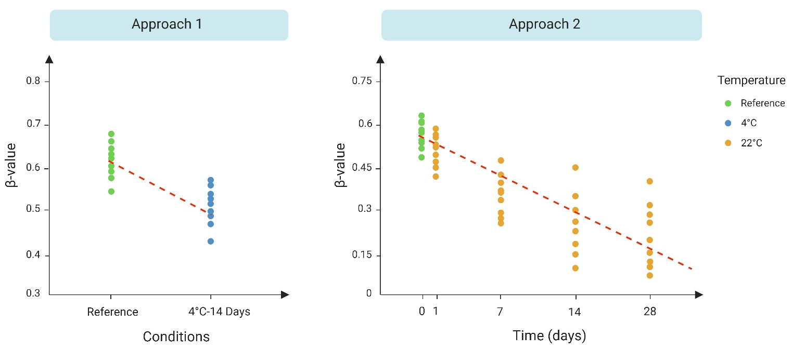
Supplementary Figure 1. Illustration of two different approaches used in the Differentially Methylated Position (DMP) analysis. In approach 1, the DMP analysis was performed using pairwise comparison between the reference and exposed samples. For illustrative purposes, the reference samples and samples incubated at 4°C for 14 days are shown. In approach 2, the DMP analysis was conducted separately for the two temperatures (4°C and 22°C), using time as a continuous variable to identify systematically deviating CpG positions.

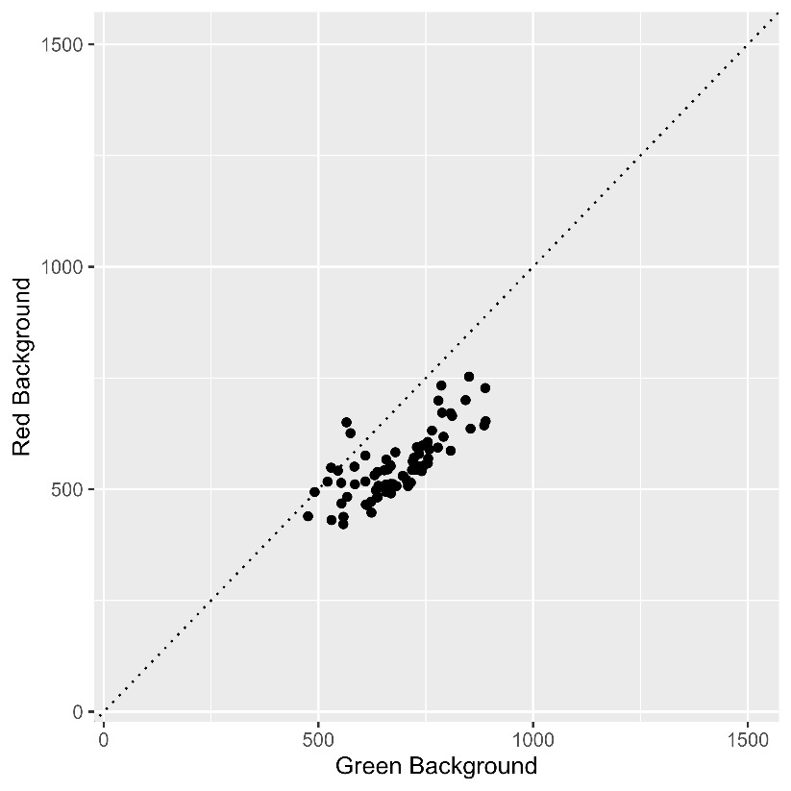
Supplementary Figure 2. Comparison of red and green mean intensity background signal intensities. Each dot represents a sample of the dataset.
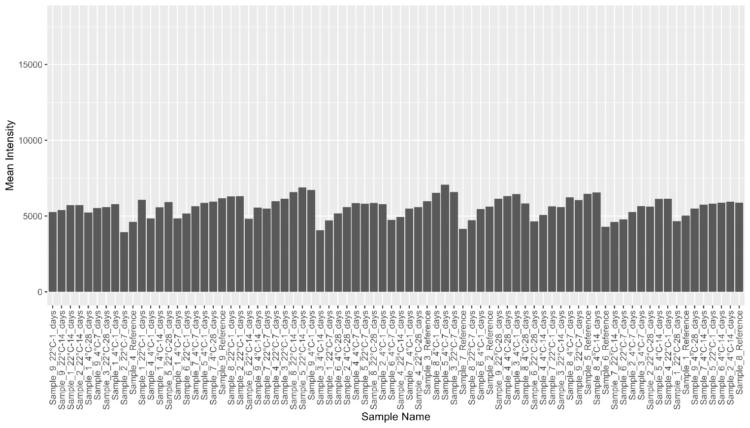
Supplementary Figure 3. Mean signal intensity values.
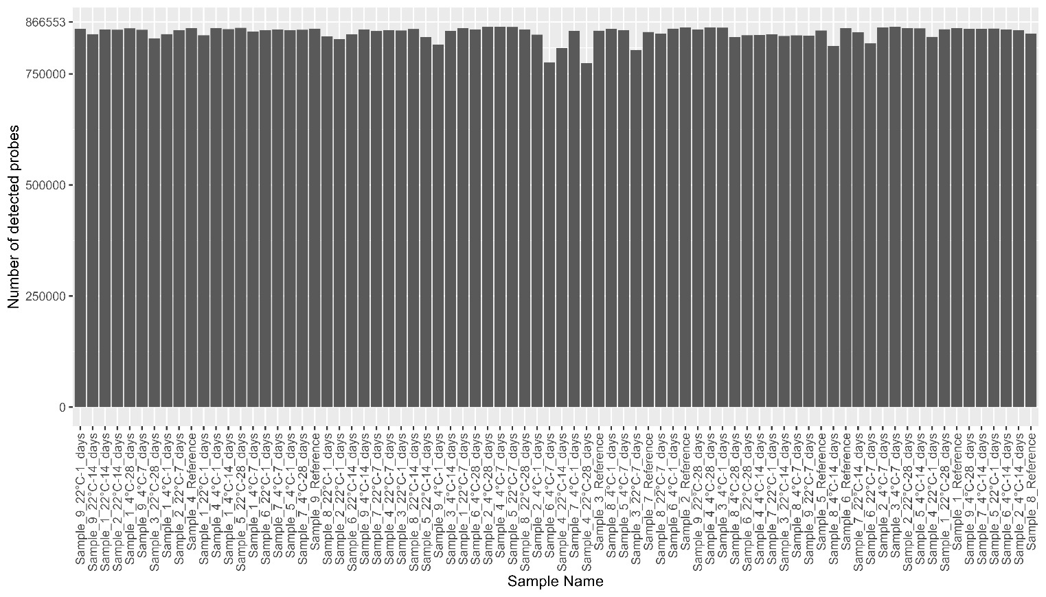
Supplementary Figure 4. Number of detected probes in all samples.
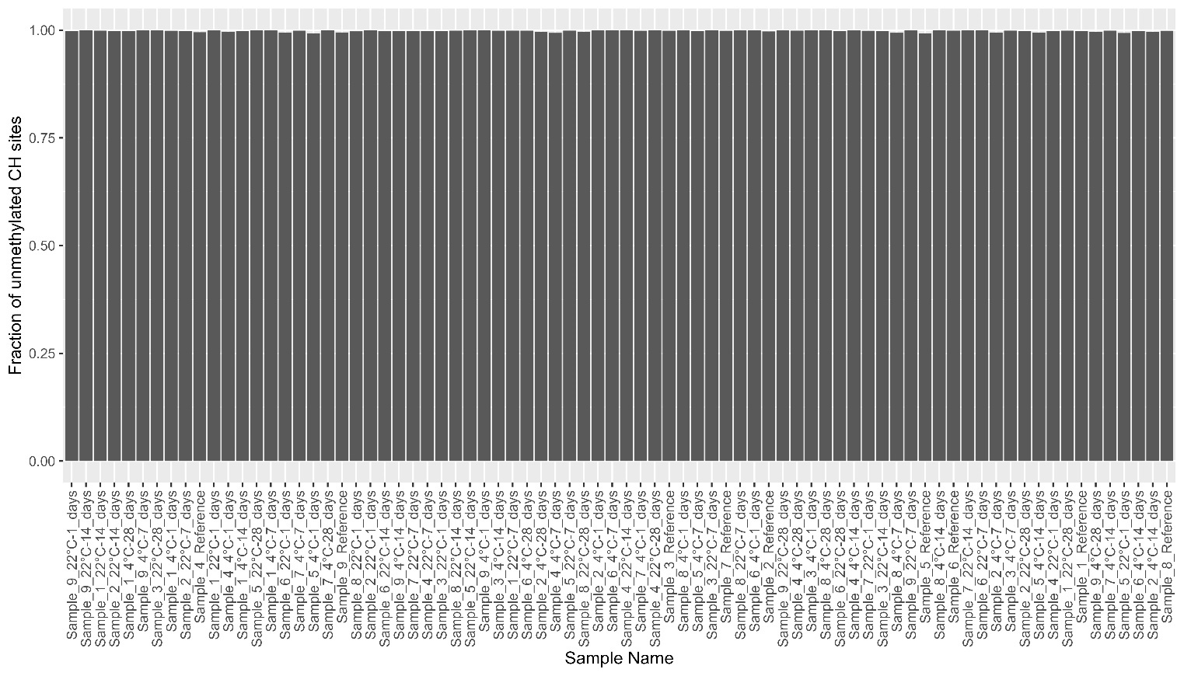
Supplementary Figure 5. Bisulfite conversion rate in all samples.

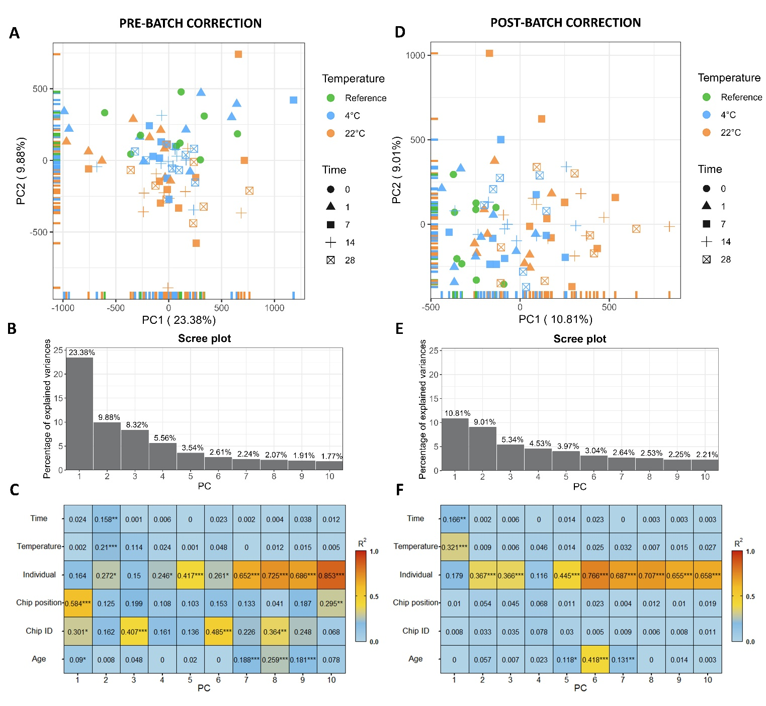
Supplementary Figure 6. Principal component analysis (PCA), Scree plot, and association analysis before and after batch correction. (A) PCA before batch correction. (B) Scree plot showing the percentage of variance explained by each PC before batch correction. (C) Association analysis result of top 10 PCs and biological/technical variables before batch correction. (D) PCA after batch correction. (E) Scree plot showing the percentage of variance explained by each PC after batch correction. (F) Association analysis result of top 10 PCs and biological/technical variables after batch correction. PC: Principal Component; R²: Squared Pearson correlation coefficient; *: p-value < 0.05; **: p-value < 0.01; ***: p-value < 0.001.
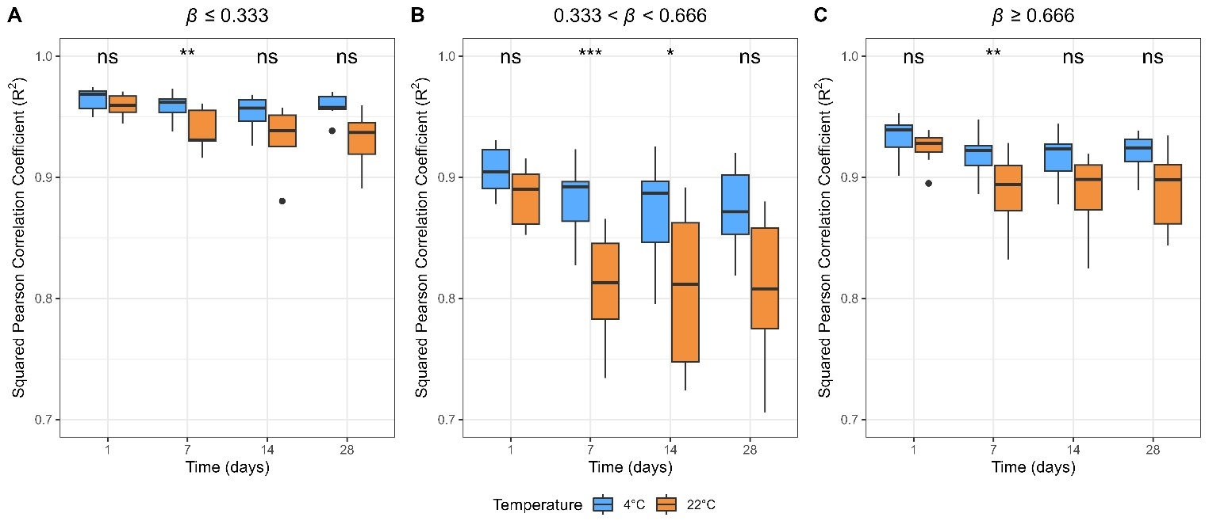
Supplementary Figure 7. Paired squared Pearson correlation coefficients (R²) between the reference and exposed samples in three DNAm intervals. *: p-value < 0.05; **: p-value < 0.01; ***: p-value < 0.001; ns: not significant.

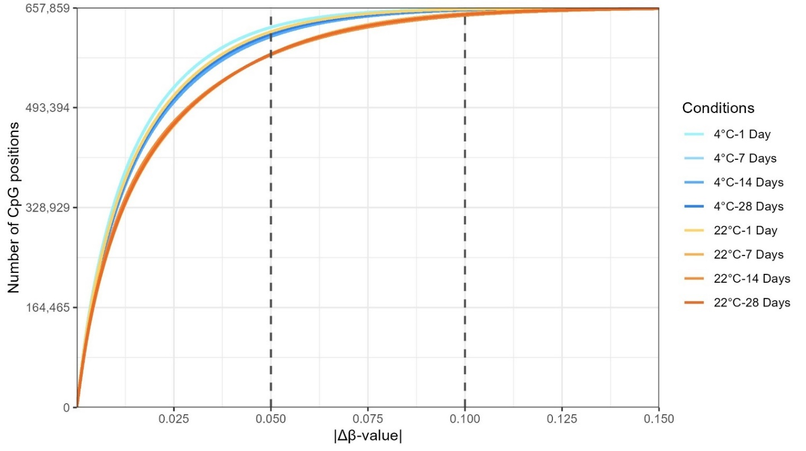Supplementary Figure 8. Cumulative distribution of CpG positions for the exposed samples. The dashed lines represent |Δβ| of 0.05 and 0.1, respectively.

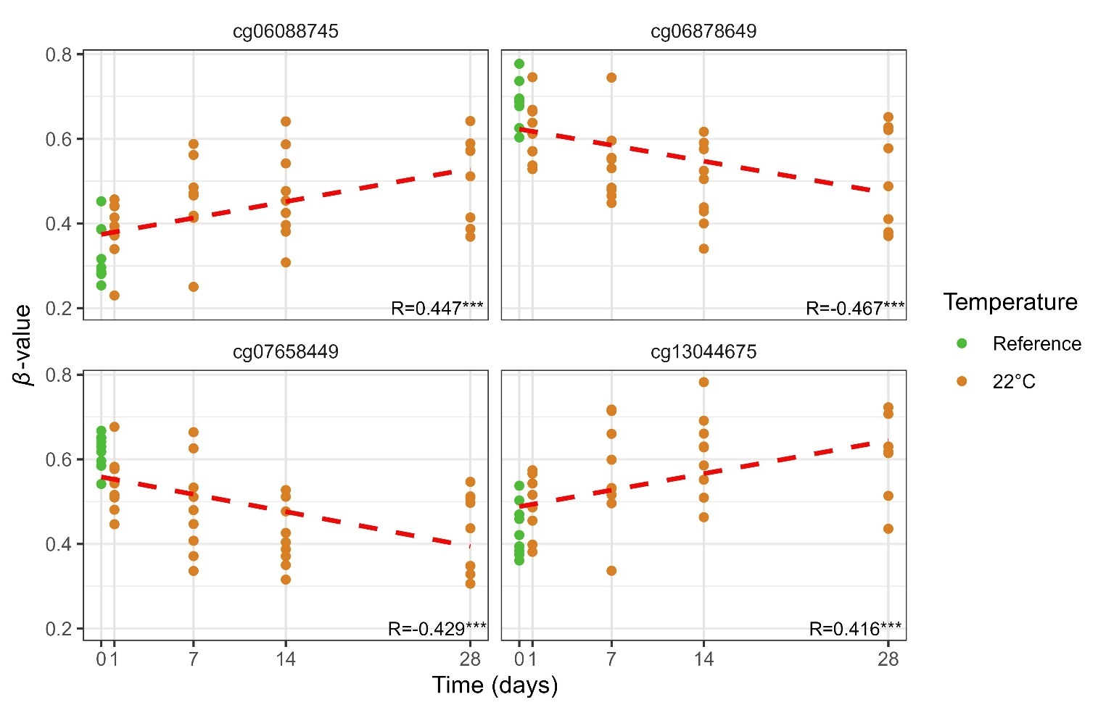
Supplementary Figure 9. Top four Differentially Methylated positions (DMPs) at 22°C with a slope coefficient higher than 0.0054. R: Pearson correlation coefficient; *: p-value < 0.05; **: p-value < 0.01; ***: p-value < 0.001.

