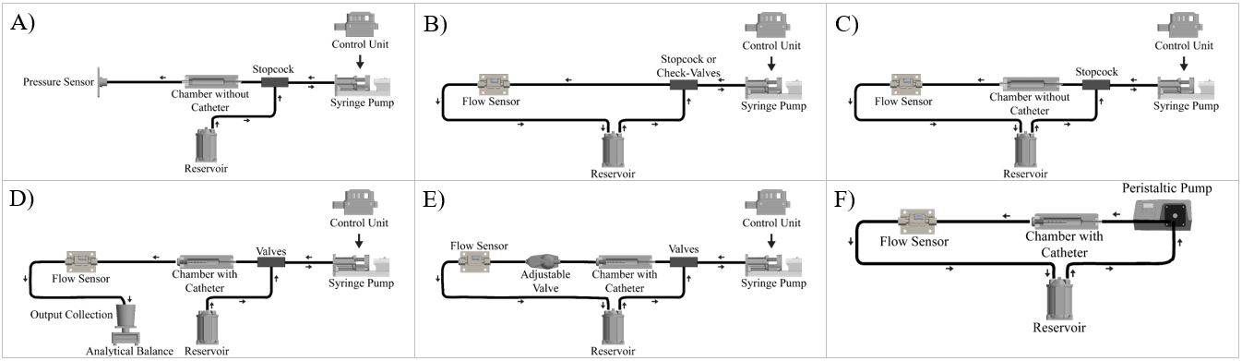
S. Fig 1. The schematic of the fluidic circuits utilized in this study. (A) The modified setup for the evaluation of the bioreactor chamber seal and peak pressure testing. (B) The setup for evaluation of Reciprocating Positive Displacement Pump peak amplitude with check valves or stopcocks (C) chamber consistency and peak amplitude evaluation setup (D) The layout of the volumetric analysis setup (E) the schematic of the setup with commercial adjustable valves (F) The setup utilized for bioreactor chamber compatibility test

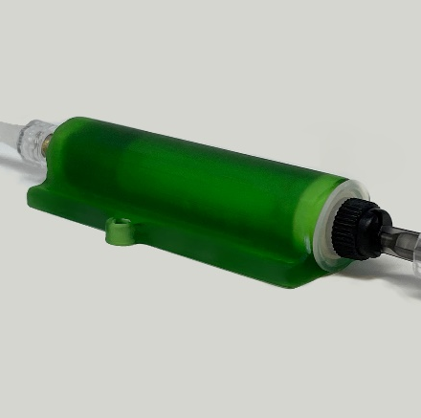  A) | 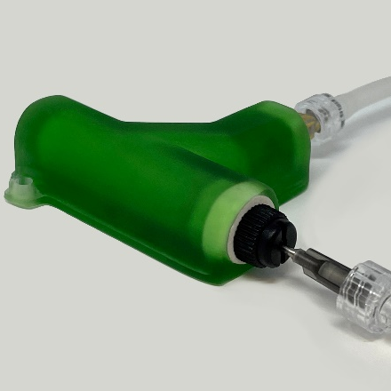  B)
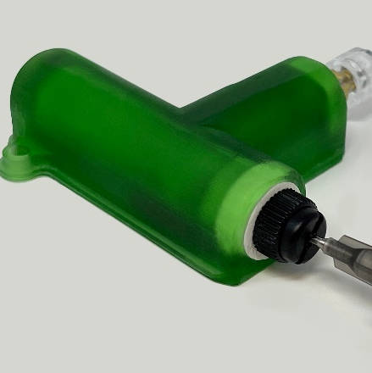  C) | 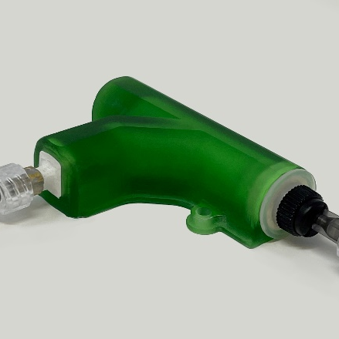  D)
S. Fig. 2. The four iterations of the single inlet Resin chamber. (A) A representative of single inlet chambers with 0° inlet angle relative to the ventricular catheter. (B) A representative of single inlet chambers with a 45° inlet angle relative to the ventricular catheter. (C) A representative of single inlet chambers with a 90° inlet angle relative to the ventricular catheter. (D) A representative of single inlet chambers with a 135° inlet angle relative to the ventricular catheter.

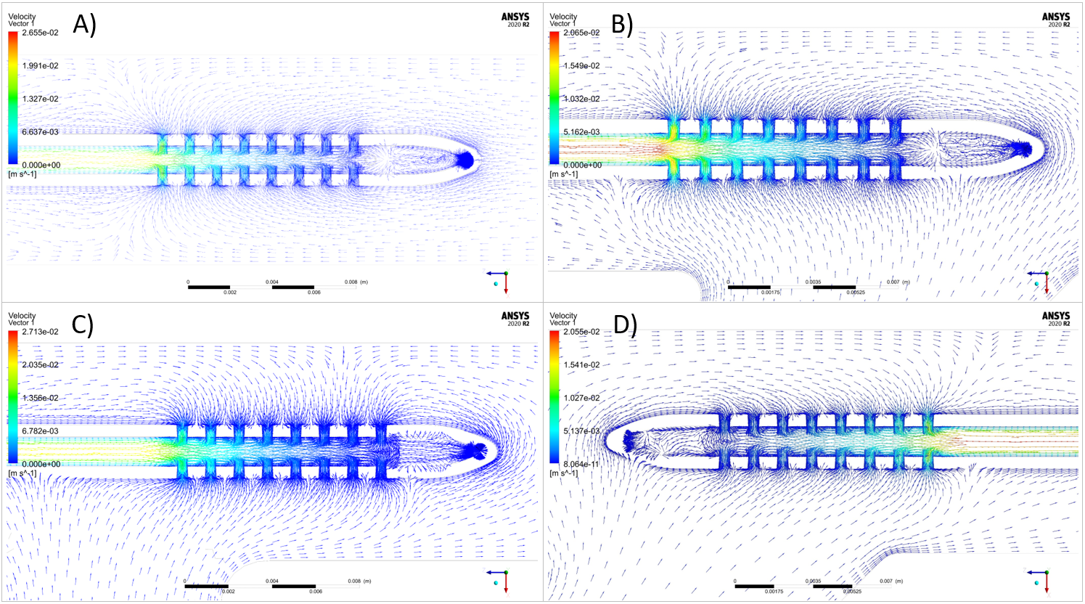
S. Fig. 3. Visual representation of flow vector directionality in the vicinity of a commercial ventricular catheter with eight lateral holes per row and the influence of inlet offset angle in the four iterations of the single inlet Resin chamber. (A) 0° inlet angle relative to the ventricular catheter. (B) 45° inlet angle relative to the ventricular catheter. (C) A representative of single inlet chambers with a 90° inlet angle relative to the ventricular catheter. (D 135° inlet angle relative to the ventricular catheter.

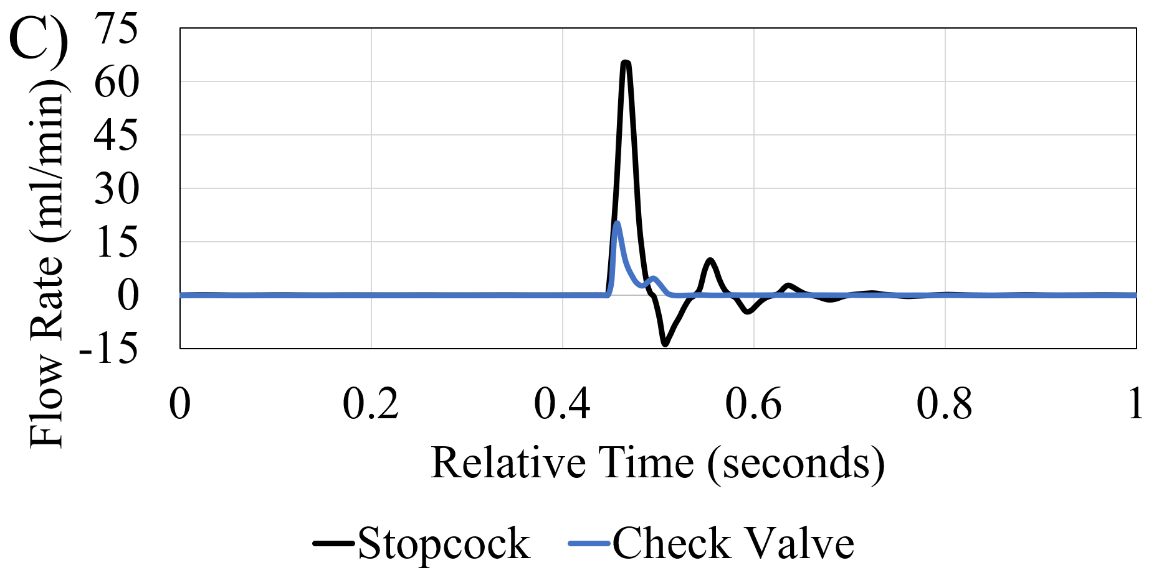

S. Fig. 4. Highest possible amplitude produced by the setup while maintaining a consistent bulk output rate of 0.3 ml/min bulk output rate. The setup includes the addition of a stopcock (black) and check valves (blue). The highest peak amplitude of the setup with the check valve was 27.26 ml/min while the peak amplitude of the setup with the stopcock reached 65 ml/min

S. Table 1. Summary of the sample number, mean, and standard deviation for the pump, single inlet resin chambers, silicone chambers, dome chambers, and PETG chambers.
Category | Sample Number | Mean ± Standard Deviation (mL/min)
Pump Output | 100 | 50.58 ± 4.06
Resin Chambers | 400 | 30.26 ± 3.32
Silicone Chambers | 400 | 50.29 ± 5.23
Dome Chambers | 50 | 12.00 ± 0.47
PETG Chambers | 500 | 3.77 ± 1.33

S. Table 2. The impact of augmented compliance on peak amplitude and flow waveform. Each category's sample size and mean of measured peak amplitude are indicated.
Category | Sample Number | Mean ± Standard Deviation (ml/min)
Pump Output- 0 µL | 10 | 5.79 ± 0.52
Pump Output- 56.25 µL | 10 | 3.34 ± 0.21
Pump Output-112.5 µL | 10 | 2.19 ± 0.17
Pump Output- 225 µL | 10 | 0.92 ± 0.07
Resin Chambers- 0 µL | 10 | 8.32 ± 0.53
Resin Chambers- 56.25 µL | 10 | 4.72 ± 0.24
Resin Chambers- 112.5 µL | 10 | 3.02 ± 0.27
Resin Chambers- 225 µL | 10 | 1.29 ± 0.06
Silicone Chambers- 0 µL | 10 | 7.27 ± 0.52
Silicone Chambers- 56.25 µL | 10 | 4.60 ± 0.23
Silicone Chambers- 112.5 µL | 10 | 1.74 ± 0.11
Silicone Chambers- 225 µL | 10 | 1.18 ± 0.16
Dome Chambers- 0 µL | 10 | 4.89 ± 0.45
Dome Chambers- 56.25 µL | 10 | 1.79 ± 0.19
Dome Chambers- 112.5 µL | 10 | 1.12 ± 0.1
Dome Chambers- 225 µL | 10 | 0.22 ± 0.03
PETG Chambers- 0 µL | 10 | 1.89 ± 0.13
PETG Chambers- 56.25 µL | 10 | 1.35 ± 0.09
PETG Chambers- 112.5 µL | 10 | 0.99 ± 0.09
PETG Chambers- 225 µL | 10 | 0.7 ± 0.14

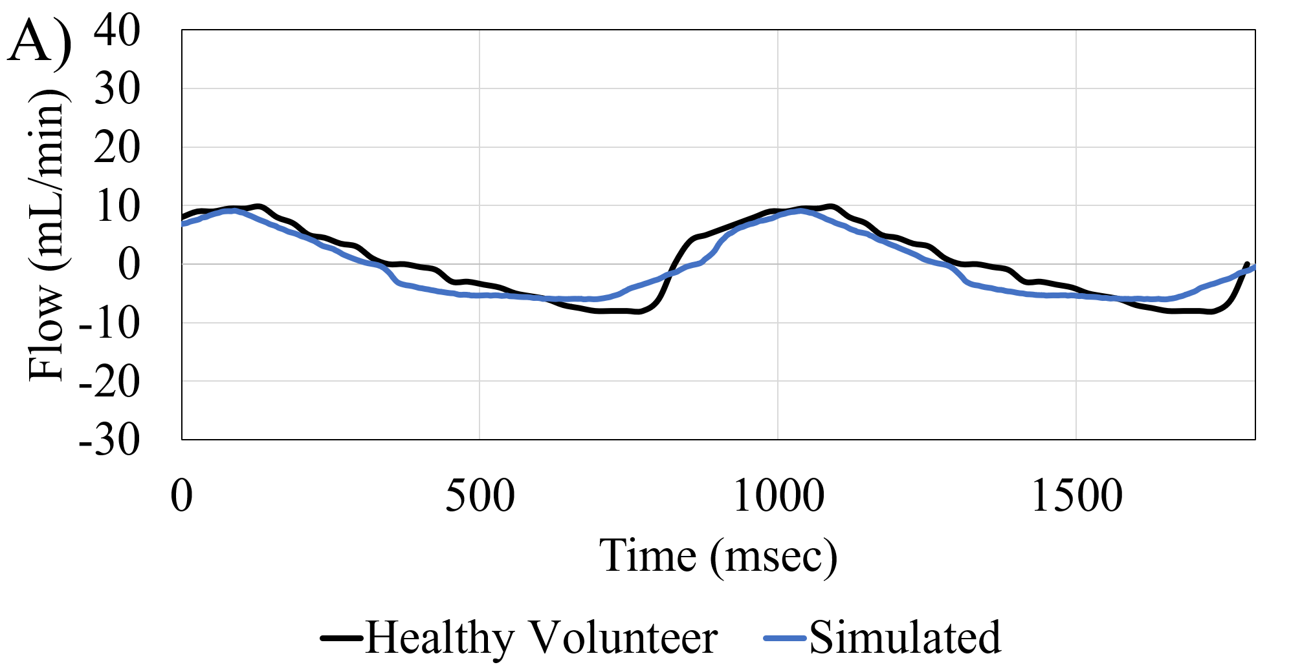 | 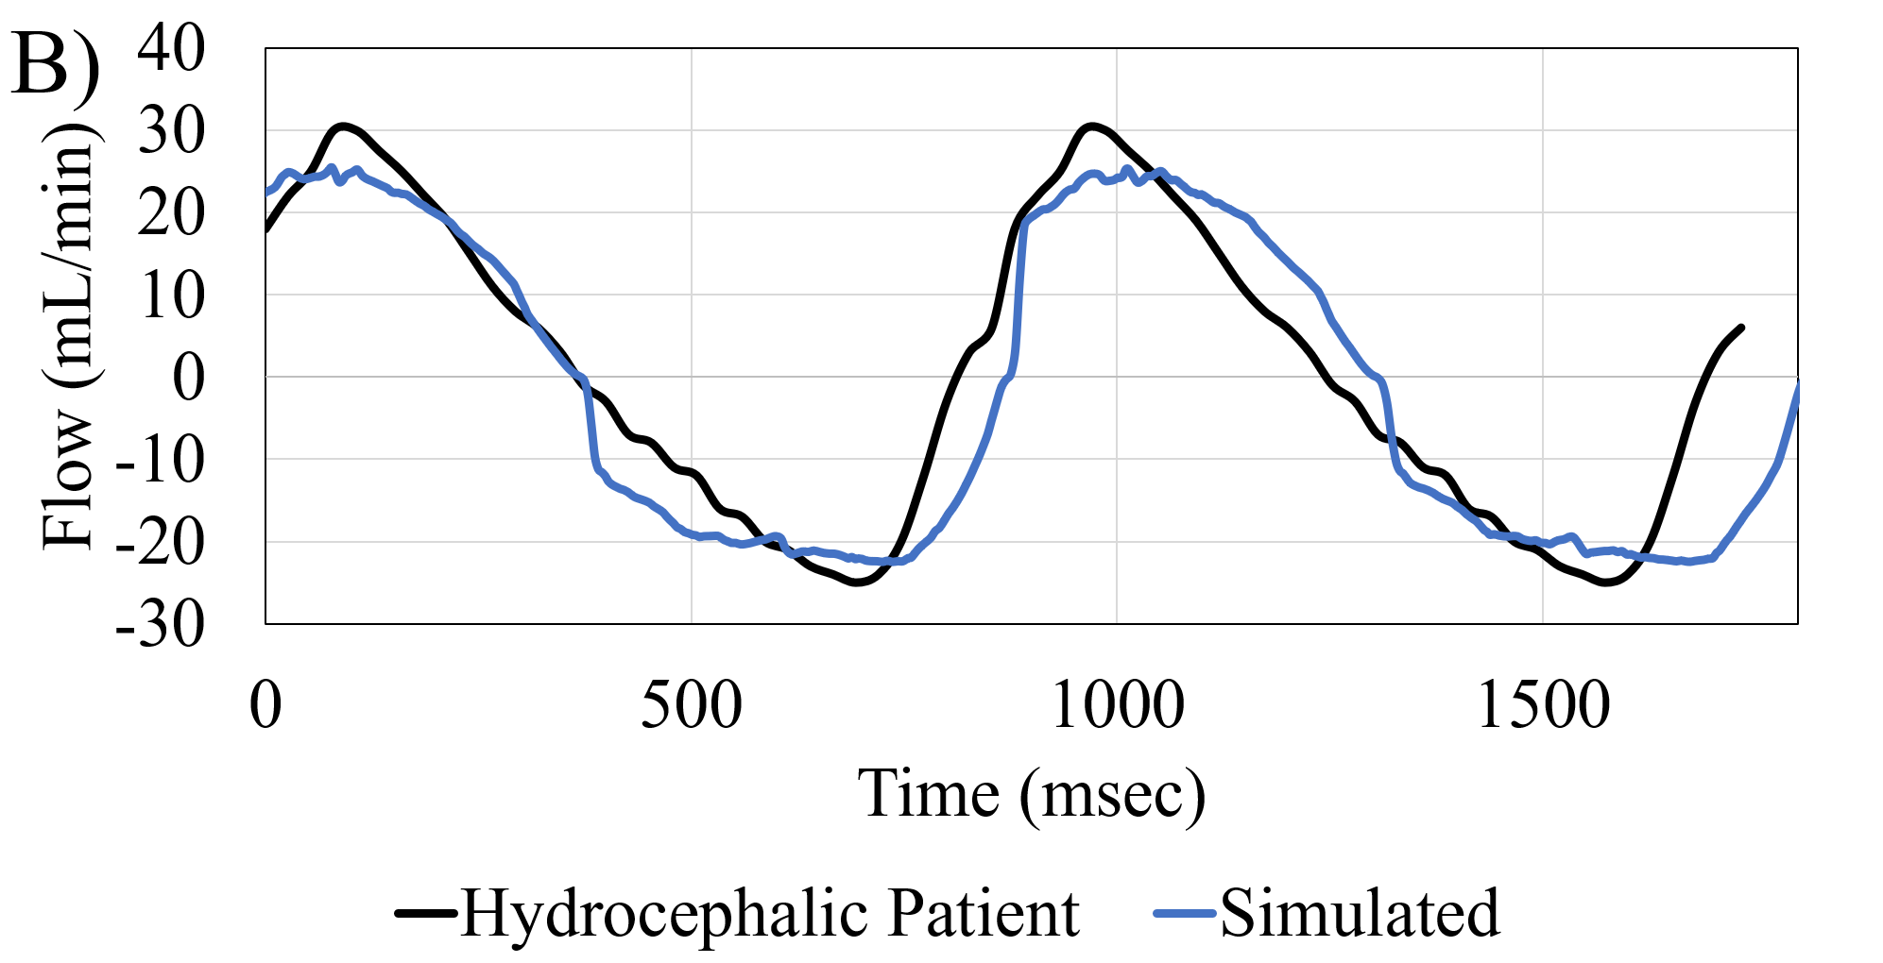
S. Fig 4 Experimental Flow Patterns Recapitulation of Aqueduct CSF flow using the custom-profile feature of the AIMS setup in A) healthy volunteer, B) Hydrocephalic patient.

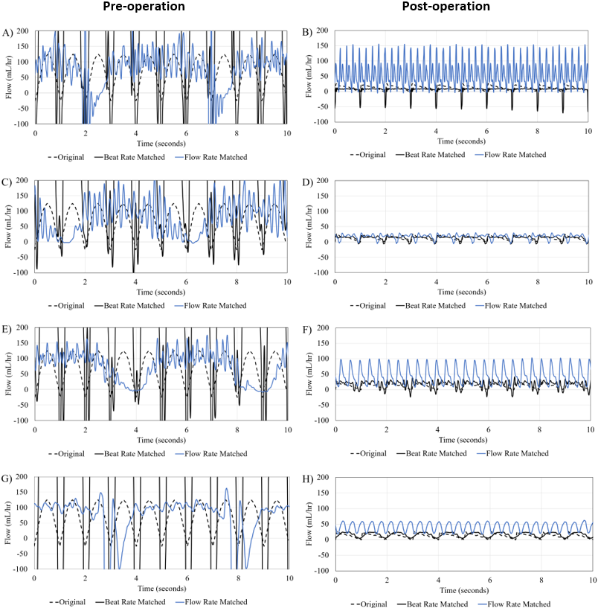
S. Fig 5. Recapitulation of clinical measurements of CSF Flow through an external ventricular drain (EVD) in a pediatric patient pre-recovery and post-recovery in four-chamber types with a peristaltic pump

