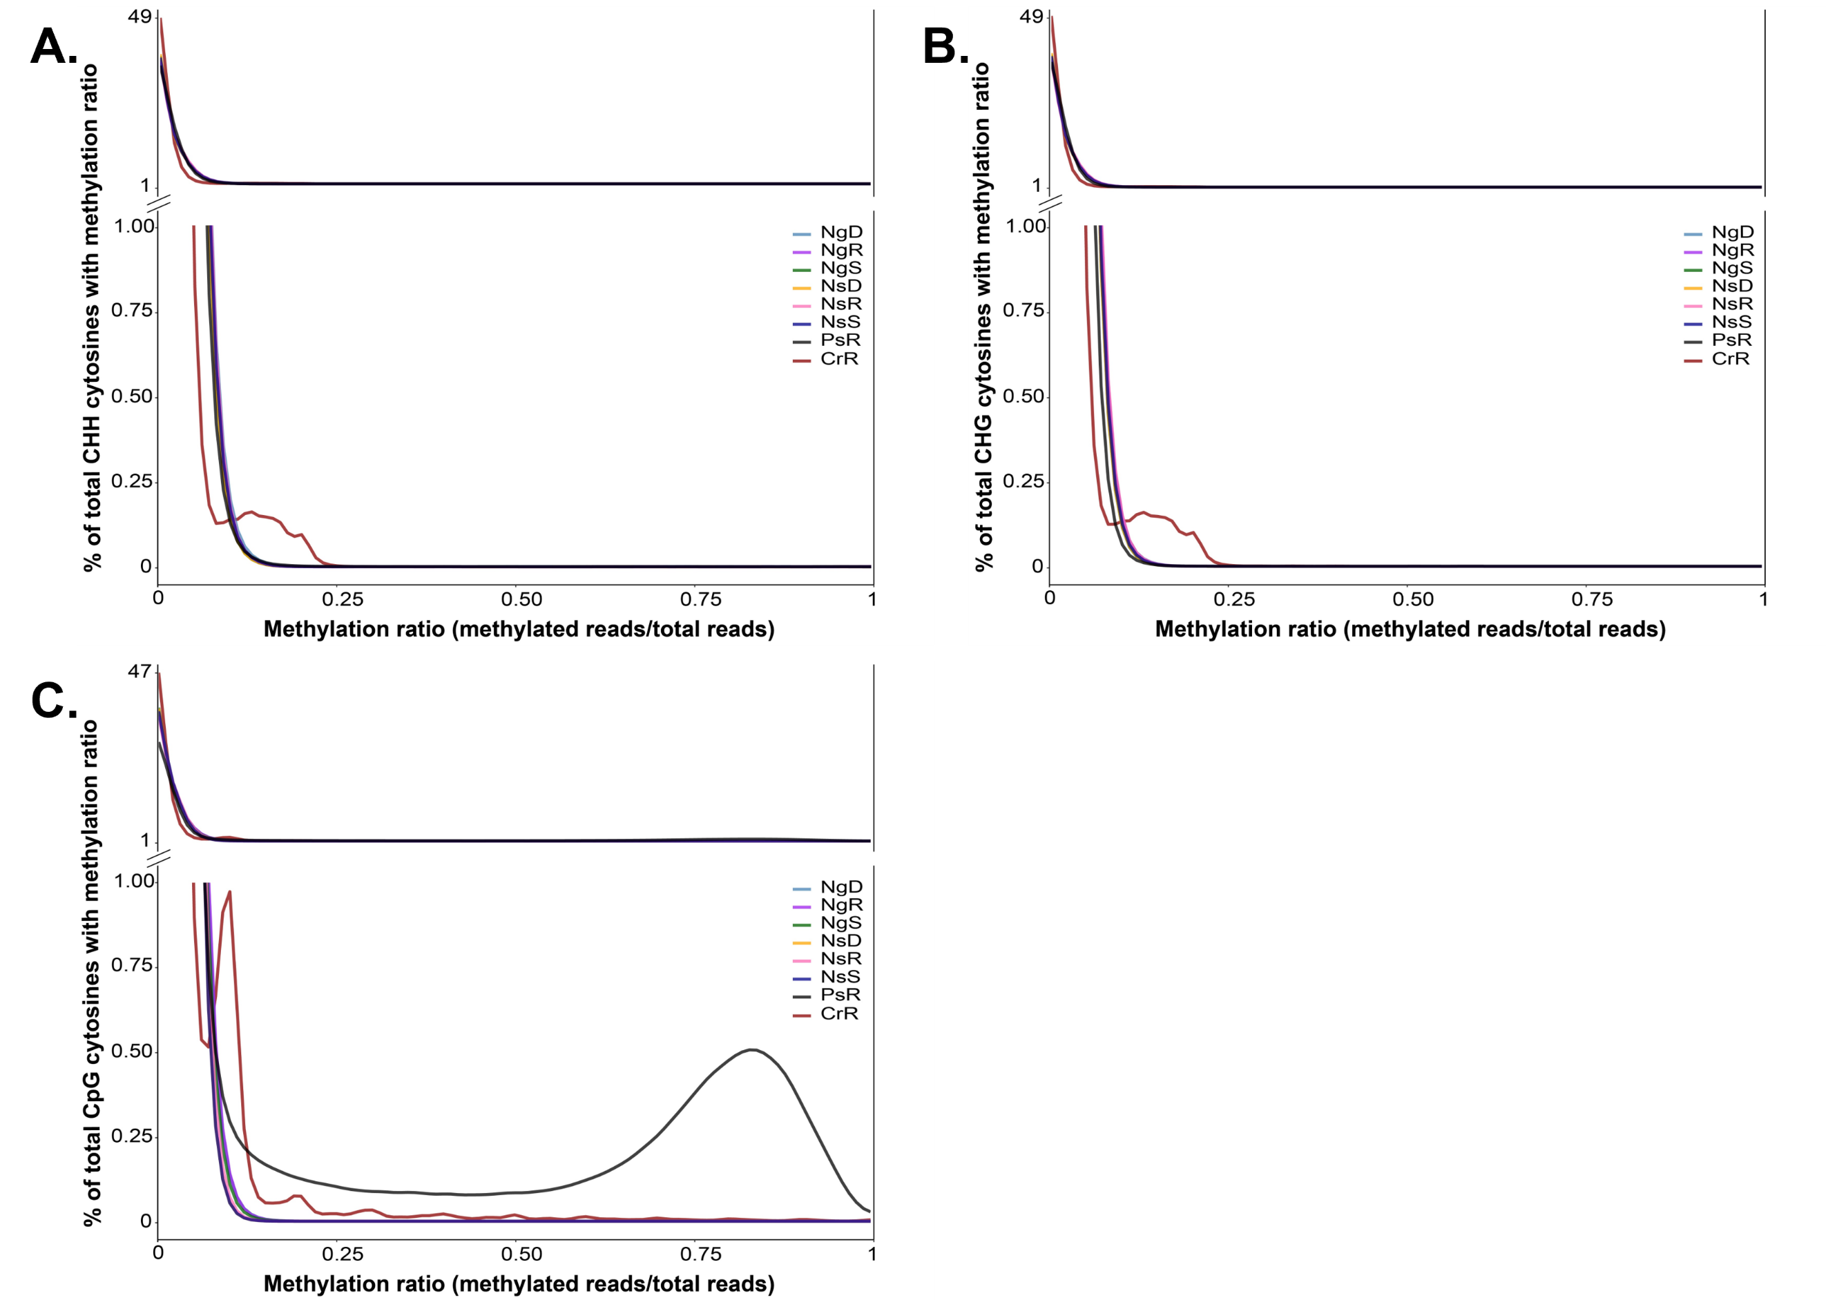

Supplemental Figure 1: WGBS: CHH, CHG, and CpG methylation ratios in select species
A) Percentage of total CHH context bases with 5X read coverage, with a given methylation ratio. NgD (N. gaditana deplete), NgR (N. gaditana replete), NgS (N. gaditana starved), NsD (N. salina deplete), NsR (N. gaditana replete), NsS (N. gaditana starved), PsR (P. soleocimus replete), CrR (C. reinhardtii replete). B) Percentage of total CHG context bases with 5X read coverage, with a given methylation ratio. C) Percentage of total CpG context bases with 10X read coverage, with a given methylation ratio.

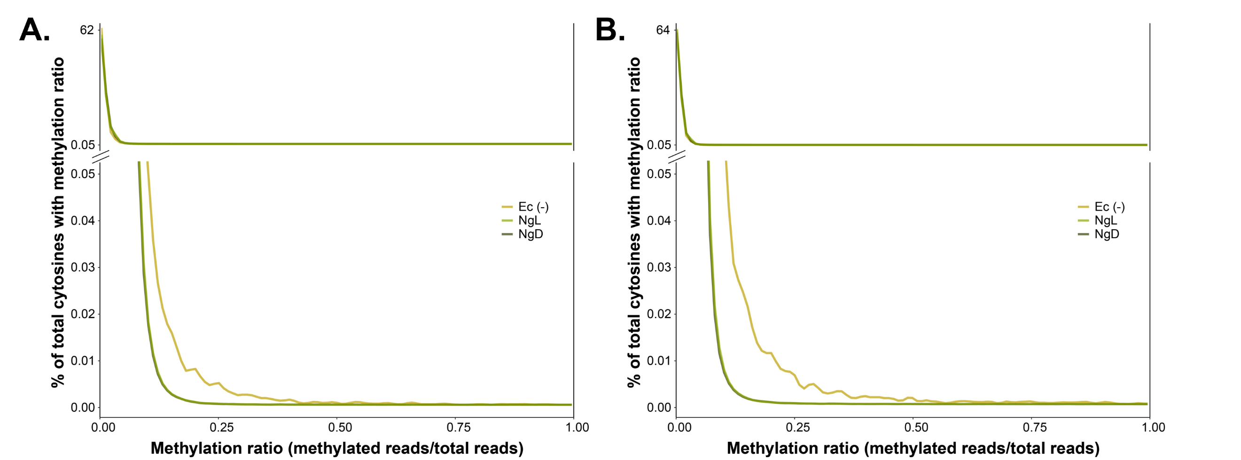
Supplemental 2: 6mA hypermethylation is distributed non-randomly across genomic features, evenly across scaffolds, and is enriched in guanine rich regions.
A) Percentage of total cytosine bases with 20X read coverage, with a given 5mC methylation ratio. B) Percentage of total cytosine bases with 20X read coverage, with a given 5hmC methylation ratio.

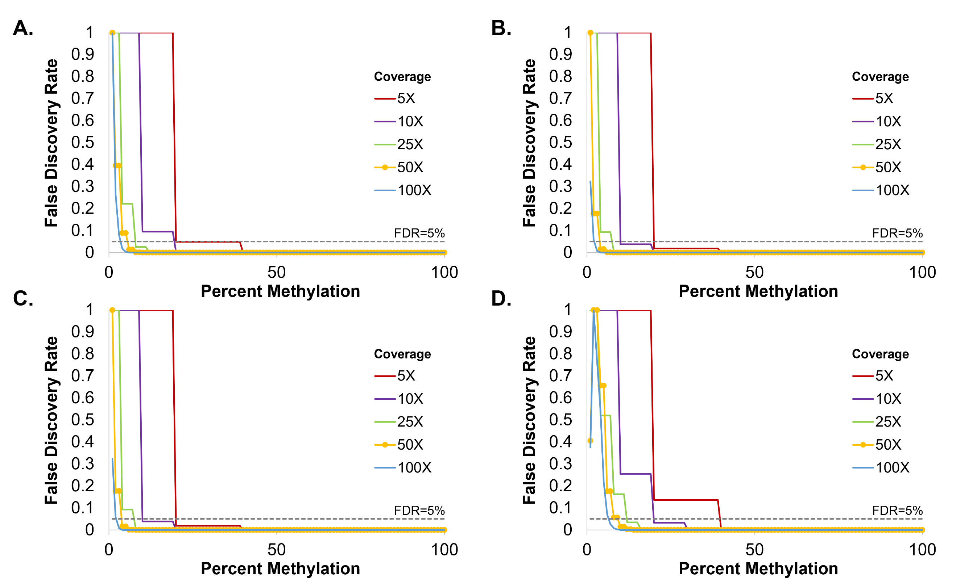
Supplemental Figure 3: False discovery rate associated with WBGS and ONT for 5mC, 5hmC and 6mA
The legend in panel A,B,C, and D denotes a hypothetic read depth or sequencing coverage A) False discovery rate (result of one-tailed binomial test) vs methylation level as a function of genome coverage for 5mC measured using WGBS, assuming 1% bisulfite conversion error. B) False discovery rate (result of one-tailed binomial test) vs methylation level as a function of genome coverage for 5mC measured by ONT, assuming a 0.4% base-calling error rate. C) False discovery rate (result of one-tailed binomial test) vs methylation level as a function of genome coverage for 5hmC measured by ONT, assuming a 0.5% base-calling error rate D) False discovery rate (result of one-tailed binomial test) vs methylation level as a function of genome coverage for 6mA measured by ONT, assuming a 2.9% base-calling error rate.

Supplemental Table 1.
Percent of cytosines in context CpG, CHG, or CHH with 5x or 10x read coverage WGBS.
Species | Sample ID | zr2802 | CpG 5X | CHG 5X | CHH 5X | CpG 10X | CHG 10X | CHH 10X
N. salina | 1776 N-1_1 | 1 | 86.57% | 82.77% | 70.17% | 61.90% | 56.59% | 41.02%
N. salina | 1776 N-1_2 | 2 | 92.71% | 89.68% | 81.15% | 80.04% | 75.84% | 62.16%
N. salina | 1776 N-1_3 | 3 | 90.23% | 87.01% | 77.36% | 72.90% | 68.40% | 54.42%
N. salina | 1776 N0_1 | 4 | 86.58% | 82.19% | 67.50% | 63.54% | 57.12% | 39.40%
N. salina | 1776 N0_2 | 5 | 88.20% | 84.08% | 70.69% | 66.55% | 60.26% | 42.91%
N. salina | 1776 N0_3 | 6 | 93.43% | 90.60% | 84.23% | 84.73% | 81.26% | 71.17%
N. salina | 1776 N+1_1 | 7 | 90.75% | 87.44% | 77.63% | 73.41% | 68.57% | 54.08%
N. salina | 1776 N+1_2 | 8 | 90.78% | 87.26% | 76.03% | 74.13% | 68.95% | 52.50%
N. salina | 1776 N+1_3 | 9 | 87.53% | 83.81% | 71.84% | 64.29% | 58.92% | 43.21%
N. gaditana | 526 N-1_1 | 18 | 83.34% | 79.98% | 69.09% | 65.99% | 61.89% | 47.88%
N. gaditana | 526 N-1_2 | 10 | 84.60% | 81.75% | 72.94% | 67.44% | 63.97% | 52.01%
N. gaditana | 526 N-1_3 | 11 | 82.39% | 79.26% | 69.47% | 61.02% | 57.09% | 44.40%
N. gaditana | 526 N0_1 | 12 | 84.49% | 81.40% | 71.50% | 66.93% | 63.01% | 49.71%
N. gaditana | 526 N0_2 | 13 | 85.66% | 82.19% | 71.74% | 68.99% | 64.01% | 49.28%
N. gaditana | 526 N0_3 | 14 | 84.39% | 80.98% | 70.65% | 66.01% | 61.22% | 47.27%
N. gaditana | 526 N+1_1 | 15 | 85.62% | 82.26% | 71.99% | 68.94% | 64.19% | 49.66%
N. gaditana | 526 N+1_2 | 16 | 79.86% | 76.00% | 62.64% | 57.42% | 52.68% | 37.26%
N. gaditana | 526 N+1_3 | 17 | 86.14% | 82.89% | 72.73% | 72.51% | 68.52% | 54.47%

Supplemental Table 2.
Percent of cytosines or adenines with 20x read coverage ONT.
Species | Sample ID | Condition | % of C's covered 20X | % of A's covered 20X
N. gaditana | NG1 | Light | 88.16% | 88.12%
N. gaditana | NG2 | Light | 85.22% | 84.05%
N. gaditana | NG3 | Light | 78.30% | 76.41%
N. gaditana | NG4 | Dark | 91.15% | 92.16%
N. gaditana | NG5 | Dark | 92.14% | 93.55%
N. gaditana | NG6 | Dark | 86.43% | 85.57%

Supplemental Table 3.
Per sample bisulfite conversion error of E. coli null DNA, and % of total cytosines identified as methylated in each sample. p-value is the result of a one-tailed welches t-test, testing the null hypothesis that %5mC of a sample is greater than the conversion error.
Species | Sample ID | zr2802 | conversion error E. coli null | % 5mC | p-value
N. salina | 1776 N-1_1 | 1 | 2.0% | 0.9% | 0.806
N. salina | 1776 N-1_2 | 2 | 1.0% | 0.9%
N. salina | 1776 N-1_3 | 3 | 1.0% | 1.1%
N. salina | 1776 N0_1 | 4 | 1.0% | 0.8% | 0.788
N. salina | 1776 N0_2 | 5 | 1.0% | 1.1%
N. salina | 1776 N0_3 | 6 | 2.0% | 0.8%
N. salina | 1776 N+1_1 | 7 | 1.0% | 0.7% | 0.92
N. salina | 1776 N+1_2 | 8 | 2.0% | 1.0%
N. salina | 1776 N+1_3 | 9 | 2.0% | 1.0%
N. gaditana | 526 N-1_1 | 10 | 1.0% | 0.9% | 0.806
N. gaditana | 526 N-1_2 | 18 | 1.0% | 0.9%
N. gaditana | 526 N-1_3 | 11 | 2.0% | 1.1%
N. gaditana | 526 N0_1 | 12 | 1.0% | 0.8% | 0.823
N. gaditana | 526 N0_2 | 13 | 1.0% | 1.0%
N. gaditana | 526 N0_3 | 14 | 2.0% | 1.0%
N. gaditana | 526 N+1_1 | 15 | 1.0% | 1.1% | 0.629
N. gaditana | 526 N+1_2 | 16 | 1.0% | 1.0%
N. gaditana | 526 N+1_3 | 17 | 1.0% | 0.8%

Supplemental Table 4.
Per sample % 5mC, 5hmC or 6ma of gDNA from N. gaditana, a 5mC/6mA competent E. coli strain (EC Positive) or a E. coli methylation incompetent strain (EC null). p-value is the result of a one-tailed students t-test, testing the null hypothesis that % methylation of a sample is greater than that of the E. coli control, or the base calling error rate.
Species | Sample ID | Condition | % 5mC | % 5hmC | % 6mA
  5mC p-value
  5hmC p-value
  6mA p-value
N. gaditana | NG1 | Light | 0.56 | 0.42 | 4.17
N. gaditana | NG2 | Light | 0.54 | 0.41 | 3.92 | 0.42 | 0.50 | 0.05
N. gaditana | NG3 | Light | 0.49 | 0.37 | 3.55
N. gaditana | NG4 | Dark | 0.57 | 0.42 | 4.07
N. gaditana | NG5 | Dark | 0.56 | 0.41 | 4.16 | 0.09 | 0.27 | 0.01
N. gaditana | NG6 | Dark | 0.54 | 0.40 | 3.90
EC Positive | K12_TSB | N/A | 1.57 | 0.65 | 8.05
EC null | null | N/A | 0.52 | 0.40 | 2.90

