Supplementary figures
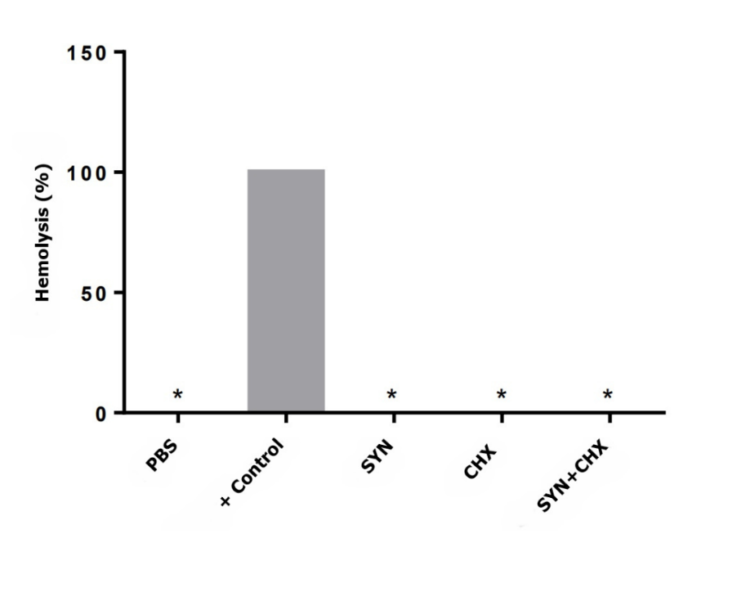

Supplementary fig 1. Biocompatibility of synoeca-MP and chlorhexidine. Assessment of hemolytic potential in the presence of the SYN peptide, CHX, and their combination. Negative control was represented by 0% hemolysis (PBS), and the positive control (0.1% triton X-100) was defined as 100% hemolysis. Experiments were performed in technical and biological triplicates, and results were expressed as mean percentage; *p < 0.0001, when compared to the positive control.

Supplementary Fig. 2. Spectrum obtained by MALDI-ToF of the synoeca-MP peptide (1595.95 Da), with purity greater than 95%.

Supplementary Fig. 3. Spectrum of monoisotopic mass profile of controls of chlorhexidine (monoisotopic mass 505.25 Da), matrix (monoisotopic mass 568.572 Da), saliva (monoisotopic mass of components i.e. LL-37 4368.62 Da) and synoeca-MP (monoisotopic mass 1596.40 Da).

Supplementary Figure 4: Representative spectrum of the stability of chlorhexidine (monoisotopic mass 505.074 Da), synoeca-MP (monoisotopic mass 1595.95 Da) and combination of synoeca-MP and chlorhexidine (monoisotopic mass 504.96 Da and 1596.075 Da, respectively) on saliva (4368.52 / 4367.67 / 4368.05 Da) from a patient diagnosed with periodontitis.

