Table.4 Overall reaction kinetics: Plasma synthesis of nitrogen fertilizer

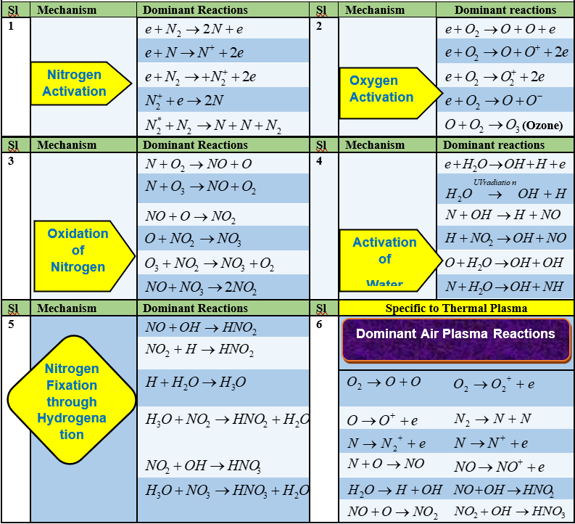

Table-4. Critical evaluation of the invented process: Comparison with synthesis rate reported in non-thermal plasma processes
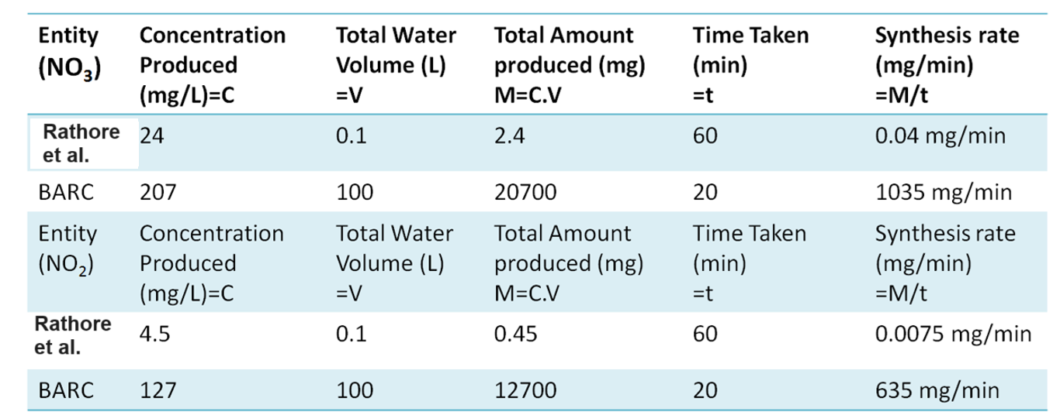

Table-5. Critical evaluation of the invented process: Comparison with globally reported maximum production rate in plasma
