Supp. Table 1. Summary and diagnostics for the black-dark brown model including: [1] intercept estimates [2] predictor coefficients (significant [alpha<=0.05] bolded) for the components of the zero-inflated beta-binomial distribution: mean (mu, blue), zero-inflated (zi, green), and precision (phi, red) [3] Rhat as a measure of convergence [4] Bulk Effective Sample Size indicating the effective sample size for estimating the bulk of the distribution [5] Tail Effective Sample Size indicating the effective sample size for estimating the tails of the distribution [6] Spatial components denoted by t2latRoundlonRound.

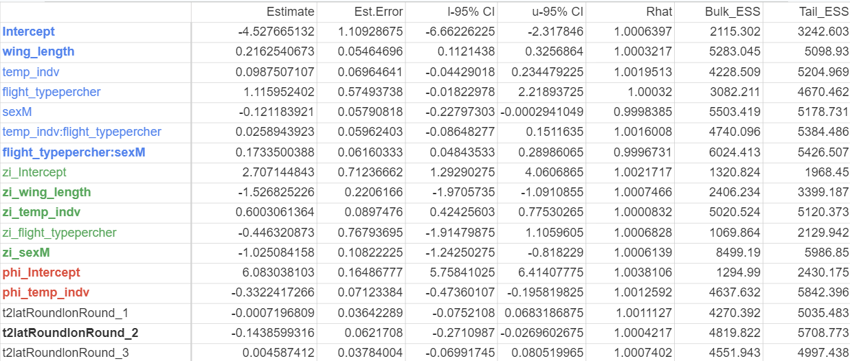

Supp. Table 2. Summary and diagnostics for the yellow light-brown model including the same information as Supp. Table 1.
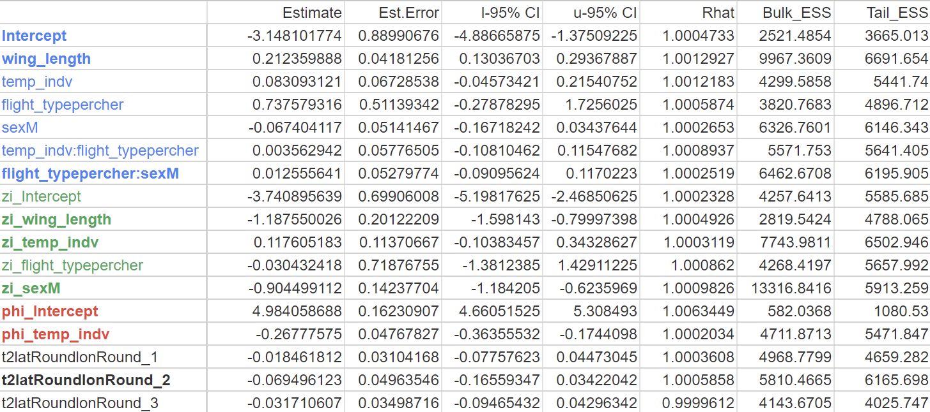

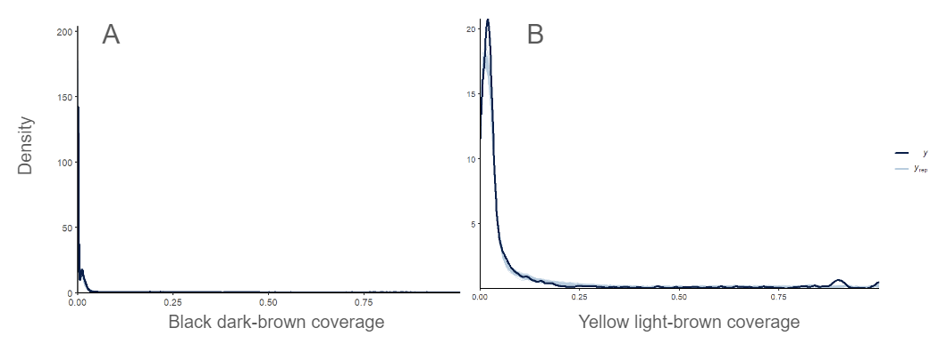
Supp. Fig. 1. Density-overlay posterior predictive checks for the black dark-brown (Panel A) and yellow light-brown (Panel B) models using the pp_check() function in brms, assessing fit between data simulated using the model (light blue, y) and the real data (black line, y_{rep}).
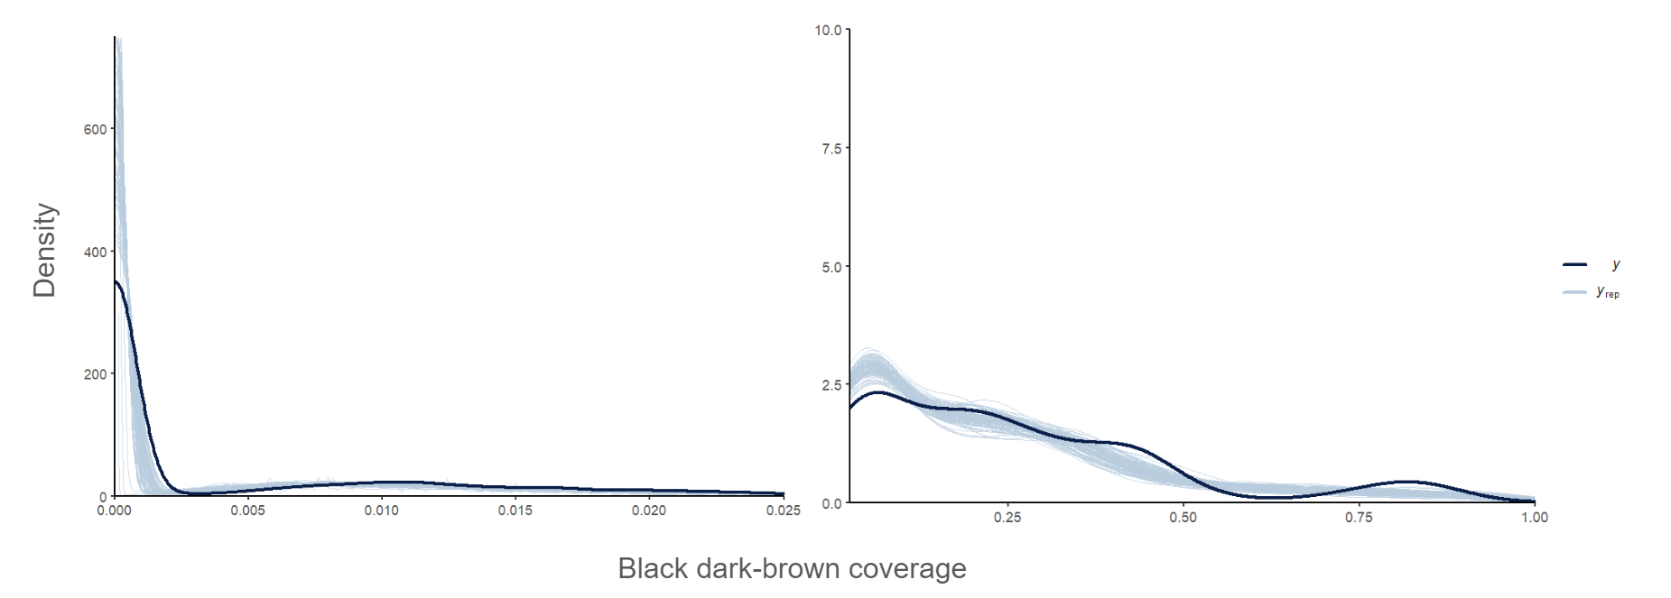
Supp. Fig. 2. Density-overlay posterior predictive check for the black dark-brown model using the pp_check() function in brms, assessing fit between data simulated using the model (light blue, y) and the real data (black line, y_{rep}). Figure is split into pieces (left: from 0% to 2.5% coverage, right: from 2.5% to 100% coverage) to better visualize fit given that the vast majority of data points have a very small amount of color coverage.

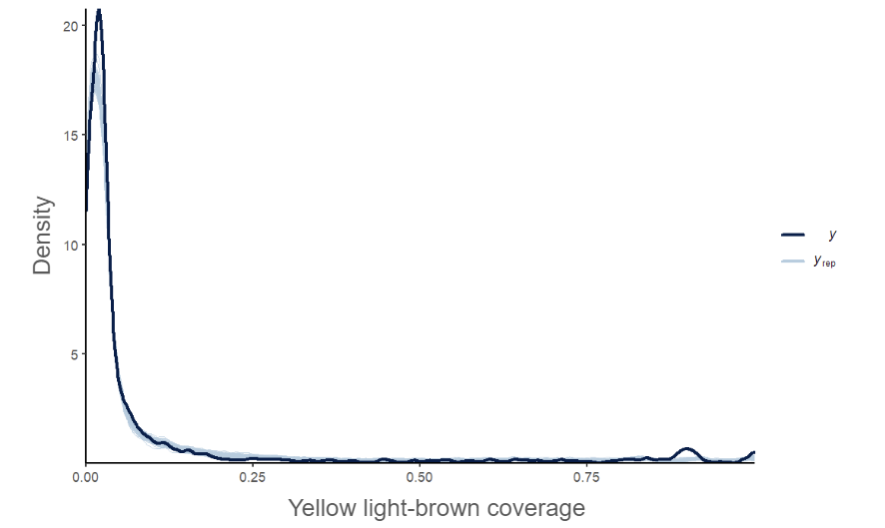
Supp. Fig. 3. Density-overlay posterior predictive check for the yellow light-brown model.

