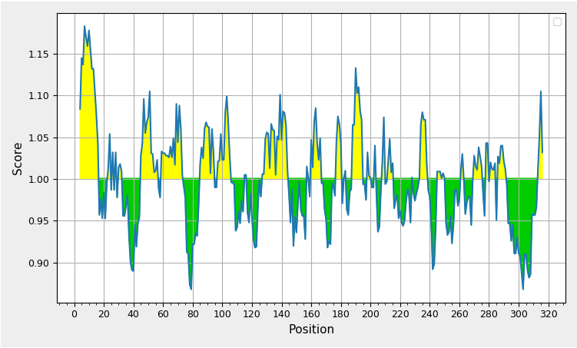
A. B cell epitopes of CadF protein. The estimated epitopes are indicated in yellow regions above the threshold line. Y and X axes depict residue scores and positions in amino acids, respectively.

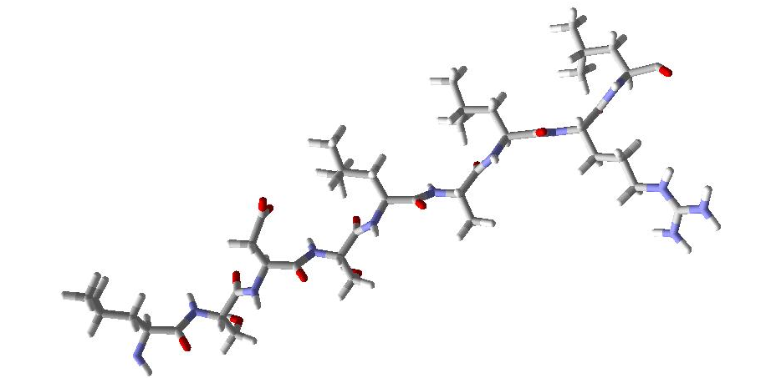
B. Three-dimensional structure of final epitope "LSDSLALRL ".

a:
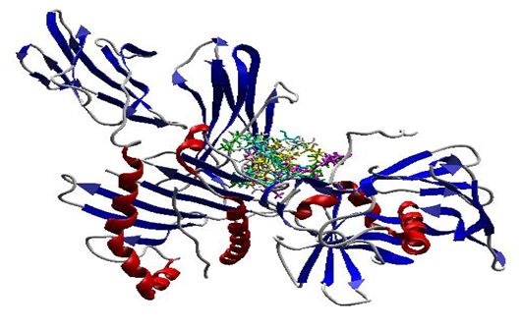
b:
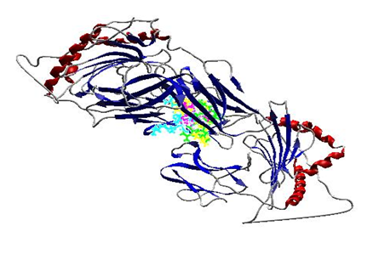
C. Molecular docking analysis. (a) HLA-A 0101 and LSDSLALRL. (b) HLA-DRB1 0101 and LSDSLALRL. The alleles are showed as secondary structures and epitopes are displayed as colorful sticks.

