Supplemental Files
Life’s Essential 8 predicts the risk of periodontitis: A nomogram
Linxu Guo, Zhixin Luo, Ke Deng, An Li, Mi Du
Table of Contents
Supplementary Figure S1: Flowchart of the participants from National Health and Nutrition Examination Survey 2009–2014 for the analysis 2
Supplementary Figure S2: AUC of the training datasets in models 2-5. 3
Supplementary Figure S3: AUC of the validation datasets in models 2-5 4
Supplementary Table S1: Definition and scoring approach for the American Heart Association’s Life’s Essential 8 score¹ 5
Supplementary Table S2: Healthy Eating Index-2015 Components & Scoring Standards^{2, 3}. 7
Supplementary Table S3: STROBE Statement–Checklist⁴ for observational study. 8
Supplementary Table S4: TRIPOD reporting checklist⁵ for prediction modelling study 9
Supplementary Table S5: Sensitivity analysis of association between LE8 score and periodontitis excluding participants without any covariates 11
Supplementary Table S6: Sensitivity analysis of association between LE8 score and periodontitis excluding participants with 2018 classification for periodontitis 12
Supplementary Table S7: Sensitivity analysis of association between LE8 score and periodontitis by ordering all participants according to LE8 and divide them into three equal parts 13

Supplementary Figure S1: Flowchart of the participants from National Health and Nutrition Examination Survey 2009–2014 for the analysis.
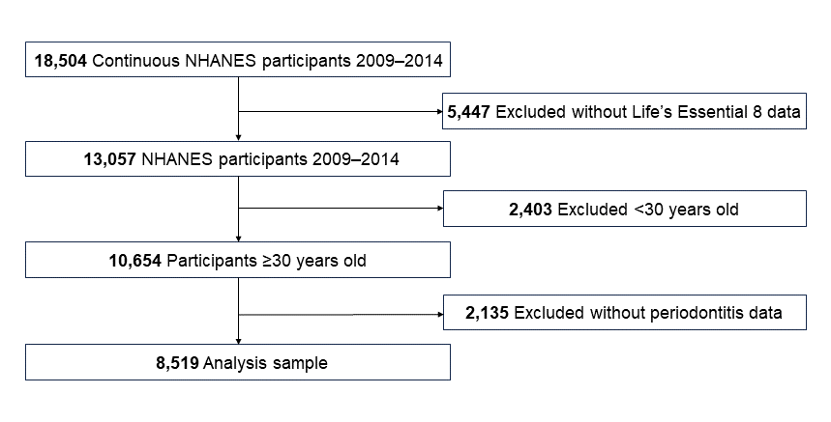
Abbreviations: NHANES, The National Health and Nutrition Examination Survey.

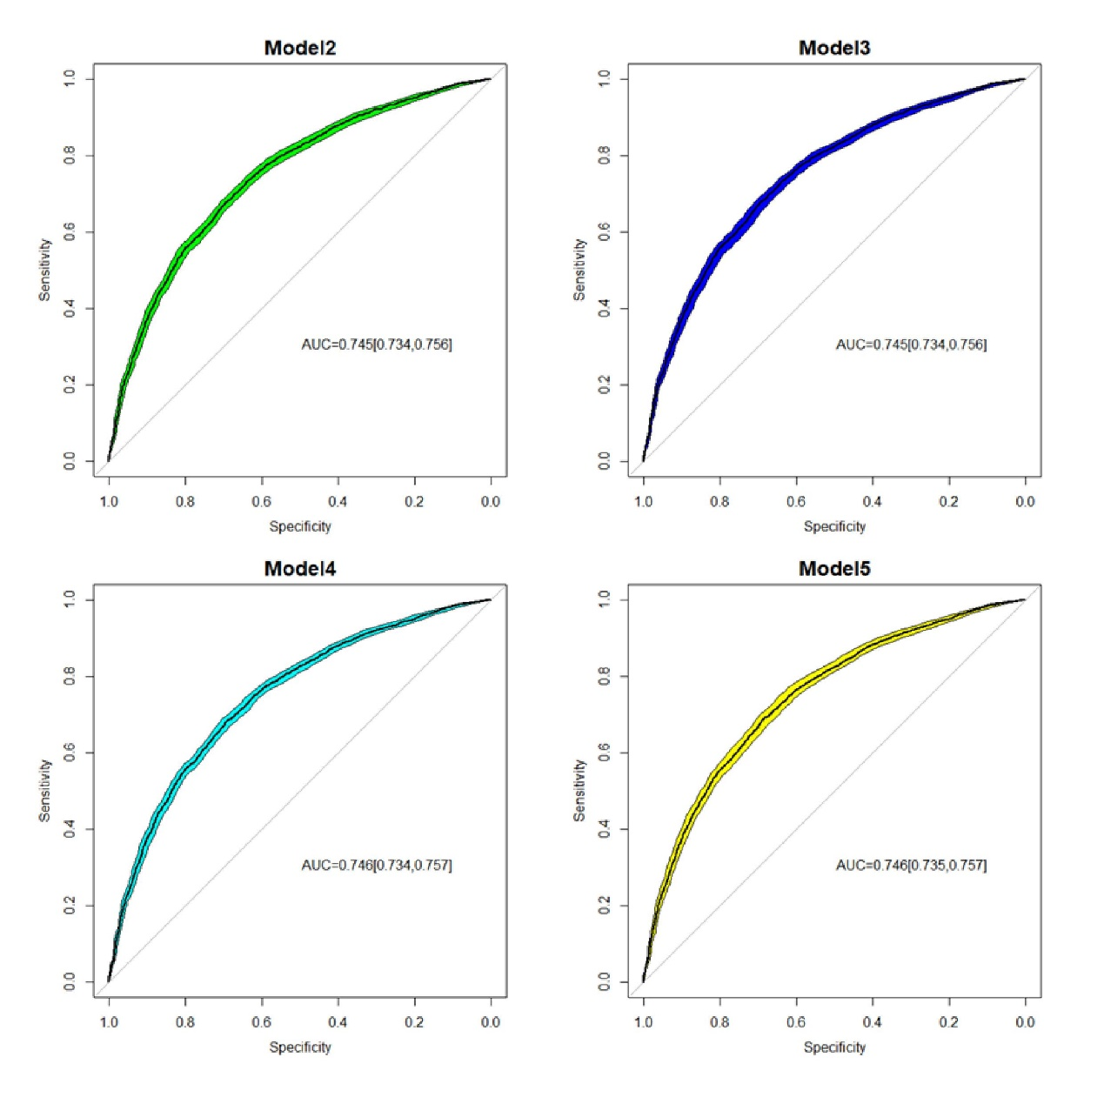
Supplementary Figure S2: AUC of the training datasets in models 2-5.
Abbreviations: AUC, area under the receiver operating characteristic curve.

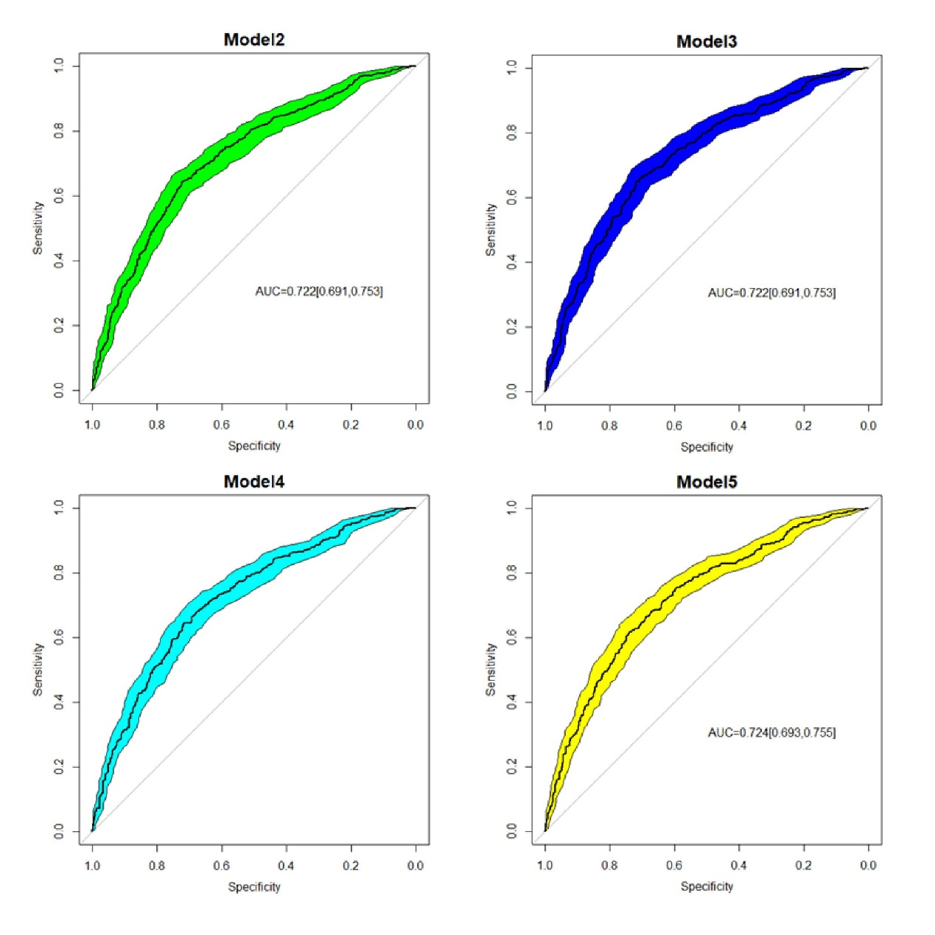
Supplementary Figure S3: AUC of the validation datasets in models 2-5.

Abbreviations: AUC, area under the receiver operating characteristic curve.
Supplementary Table S1: Definition and scoring approach for the American Heart Association’s Life’s Essential 8 score¹
Domain | CVH Metric | Measurement | Quantification and Scoring of CVH Metric
Health Behaviors | Diet | Healthy Eating Index-2015 diet score percentile | Quantiles of DASH-style diet adherence  Scoring (Population):  Points Quantile  100 ≥95th percentile (top/ideal diet)  80 75th – 94th percentile  50 50th – 74th percentile  25 25th – 49th percentile  0 1st – 24th percentile (bottom/least ideal quartile)
Health Behaviors | Physical activity | Self-reported minutes of moderate or vigorous physical activity per week | Metric: Minutes of moderate (or greater) intensity activity per week  Scoring:  Points Minutes  100 ≥150  90 120 – 149  80 90 – 119  60 60 – 89  40 30 – 59  20 1 – 29  0 0
Health Behaviors | Nicotine exposure | Self-reported use of cigarettes or inhaled nicotine- delivery system | Metric: Combustible tobacco use and/or inhaled NDS use; or secondhand smoke exposure  Scoring:  Points Status  100 Never smoker  75 Former smoker, quit ≥5 yrs  50 Former smoker, quit 1 - <5 yrs  25 Former smoker, quit <1 year, or currently using inhaled NDS  0 Current smoker  Subtract 20 points (unless score is 0) for living with active indoor smoker in home
Health Behaviors | Sleep health | Self-reported average hours of sleep per night | Metric: Average hours of sleep per night  Scoring:  Points Level  100 7 – <9  90 9 – <10  70 6 – <7  40 5 – <6 or ≥10  20 4 – <5  0 <4
Health Factors | Body mass index | Body weight (kg) divided by height squared (m²) | Metric: Body mass index (kg/m²)  Scoring: Points Level 100 <25  70 25.0 – 29.9  30 30.0 – 34.9  15 35.0 – 39.9  0 ≥40.0
Health Factors | Blood lipids | Plasma total and HDL-cholesterol with calculation of non-HDL-cholesterol | Metric: Non-HDL-cholesterol (mg/dL)  Scoring:  Points Level  100 <130  60 130 – 159  40 160 – 189  20 190 – 219  0 ≥220  If drug-treated level, subtract 20 points
Health Factors | Blood glucose | Fasting blood glucose or casual hemoglobin A1c | Metric: Fasting blood glucose (mg/dL) or Hemoglobin A1c (%)  Scoring:  Points Level  100 No history of diabetes and FBG <100 (or HbA1c < 5.7)  60 No diabetes and FBG 100 – 125 (or HbA1c 5.7-6.4) (Pre-diabetes)  40 Diabetes with HbA1c <7.0  30 Diabetes with HbA1c 7.0 – 7.9  20 Diabetes with HbA1c 8.0 – 8.9  10 Diabetes with Hb A1c 9.0 – 9.9  0 Diabetes with HbA1c ≥10.0
Health Factors | Blood pressure | Appropriately measured systolic and diastolic blood pressure | Metric: Systolic and diastolic blood pressure (mm Hg)  Scoring:  Points Level  100 <120/<80 (Optimal)  75 120-129/<80 (Elevated)  50 130-139 or 80-89 (Stage I HTN)  25 140-159 or 90-99  0 ≥160 or ≥100  Subtract 20 points if treated level

Supplementary Table S2: Healthy Eating Index-2015 Components & Scoring Standards^{2, 3}.
Component | Maximum points | Standard for maximum score | Standard for minimum score of zero
Adequacy
Total Fruits² | 5 | ≥0.8 cup equiv. per 1,000 kcal | No Fruit
Whole Fruits³ | 5 | ≥0.4 cup equiv. per 1,000 kcal | No Whole Fruit
Total Vegetables⁴ | 5 | ≥1.1 cup equiv. per 1,000 kcal | No Vegetables
Greens and Beans⁴ | 5 | ≥0.2 cup equiv. per 1,000 kcal | No Dark Green Vegetables or Legumes
Whole Grains | 10 | ≥1.5 oz equiv. per 1,000 kcal | No Whole Grains
Dairy⁵ | 10 | ≥1.3 cup equiv. per 1,000 kcal | No Dairy
Total Protein Foods⁶ | 5 | ≥2.5 oz equiv. per 1,000 kcal | No Protein Foods
Seafood and Plant Proteins^{6,7} | 5 | ≥0.8 oz equiv. per 1,000 kcal | No Seafood or Plant Proteins
Fatty Acids⁸ | 10 | (PUFAs + MUFAs)/SFAs ≥2.5 | (PUFAs + MUFAs)/SFAs ≤1.2
Moderation
Refined Grains | 10 | ≤1.8 oz equiv. per 1,000 kcal | ≥4.3 oz equiv. per 1,000 kcal
Sodium | 10 | ≤1.1 gram per 1,000 kcal | ≥2.0 grams per 1,000 kcal
Added Sugars | 10 | ≤6.5% of energy | ≥26% of energy
Saturated Fats | 10 | ≤8% of energy | ≥16% of energy

(1) Intakes between the minimum and maximum standards are scored proportionately.
(2) Includes 100% fruit juice.
(3) Includes all forms except juice.
(4) Includes legumes (beans and peas).
(5) Includes all milk products, such as fluid milk, yogurt, and cheese, and fortified soy beverages.
(6) Includes legumes (beans and peas).
(7) Includes seafood, nuts, seeds, soy products (other than beverages), and legumes (beans and peas).
(8) Ratio of poly- and monounsaturated fatty acids (PUFAs and MUFAs) to saturated fatty acids (SFAs).
Adequacy components represent the food groups, subgroups, and dietary elements that are encouraged. For these components, higher scores reflect higher intakes, because higher intakes are desirable.
Moderation components represent the food groups and dietary elements for which there are recommended limits to consumption. For moderation components, higher scores reflect lower intakes, because lower intakes are more desirable.

Supplementary Table S3: STROBE Statement–Checklist⁴ for observational study.
 | Item No | Recommendation | Y/N/NA | Page
Title and abstract | 1 | (a) Indicate the study’s design with a commonly used term in the title or the abstract | Y | 2
Title and abstract | 1 | (b) Provide in the abstract an informative and balanced summary of what was done and what was found | Y | 3, 4
Introduction
Background/rationale | 2 | Explain the scientific background and rationale for the investigation being reported | Y | 4, 5
Objectives | 3 | State specific objectives, including any prespecified hypotheses | Y | 4, 5
Methods
Study design | 4 | Present key elements of study design early in the paper | Y | 5, 6
Setting | 5 | Describe the setting, locations, and relevant dates, including periods of recruitment, exposure, follow-up, and data collection | Y | 5, 6
Participants | 6 | (a) Give the eligibility criteria, and the sources and methods of selection of participants | Y | 5, 6
Variables | 7 | Clearly define all outcomes, exposures, predictors, potential confounders, and effect modifiers. Give diagnostic criteria, if applicable | Y | 6
Data sources/ measurement | 8* | For each variable of interest, give sources of data and details of methods of assessment (measurement). Describe comparability of assessment methods if there is more than one group | Y | 6, 7, 8
Bias | 9 | Describe any efforts to address potential sources of bias | Y | 8
Study size | 10 | Explain how the study size was arrived at | Y | 6
Quantitative variables | 11 | Explain how quantitative variables were handled in the analyses. If applicable, describe which groupings were chosen and why | NA
Statistical methods | 12 | (a) Describe all statistical methods, including those used to control for confounding | Y | 7, 8
Statistical methods | 12 | (b) Describe any methods used to examine subgroups and interactions | NA
Statistical methods | 12 | (c) Explain how missing data were addressed | Y | 8
Statistical methods | 12 | (d) If applicable, describe analytical methods taking account of sampling strategy | Y | 8
Statistical methods | 12 | (e) Describe any sensitivity analyses | Y | 8
Results
Participants | 13* | (a) Report numbers of individuals at each stage of study—eg, numbers potentially eligible, examined for eligibility, confirmed eligible, included in the study, completing follow-up, and analysed | Y | 9, 10,  appendix Fig. S1
Participants | 13* | (b) Give reasons for non-participation at each stage | Y | 9, 10,  appendix Fig. S1
Participants | 13* | (c) Consider use of a flow diagram | Y | appendix Fig. S1
Descriptive data | 14* | (a) Give characteristics of study participants (eg, demographic, clinical, social) and information on exposures and potential confounders | Y | Table 1
Descriptive data | 14* | (b) Indicate number of participants with missing data for each variable of interest | NA
Outcome data | 15* | Report numbers of outcome events or summary measures | Y | 9, 10
Main results | 16 | (a) Give unadjusted estimates and, if applicable, confounder-adjusted estimates and their precision (eg, 95% confidence interval). Make clear which confounders were adjusted for and why they were included | Y | 10, 11
Main results | 16 | (b) Report category boundaries when continuous variables were categorized | Y | 9, 10
Main results | 16 | (c) If relevant, consider translating estimates of relative risk into absolute risk for a meaningful time period | NA
Other analyses | 17 | Report other analyses done—eg, analyses of subgroups and interactions, and sensitivity analyses | Y | 10
Discussion
Key results | 18 | Summarise key results with reference to study objectives | Y | 12
Limitations | 19 | Discuss limitations of the study, taking into account sources of potential bias or imprecision. Discuss both direction and magnitude of any potential bias | Y | 14
Interpretation | 20 | Give a cautious overall interpretation of results considering objectives, limitations, multiplicity of analyses, results from similar studies, and other relevant evidence | Y | 14
Generalisability | 21 | Discuss the generalisability (external validity) of the study results | Y | 13
Other information
Funding | 22 | Give the source of funding and the role of the funders for the present study and, if applicable, for the original study on which the present article is based | Y | 15
*Give information separately for exposed and unexposed groups.

Supplementary Table S4: TRIPOD reporting checklist⁵ for prediction modelling study.
Section/Topic | Item | Development or Validation? | Checklist Item
Title and abstract
Title | 1 | D; V | Identify the study as developing and/or validating a multivariable prediction model, the target population, and the outcome to be predicted.
Abstract | 2 | D; V | Provide a summary of objectives, study design, setting, participants, sample size.  predictors, outcome, statistical analysis, results, and conclusions.
Introduction
Background and objectives | 3a | D; V | Explain the medical context (including whether diagnostic or prognostic) and rationale for developing or validating the multivariable prediction model, including references to existing models.
Background and objectives | 3b | D; V | Specify the objectives, including whether the study describes the development or  validation of the model, or both.
Methods
Source of data | 4a | D; V | Describe the study design or source of data (e.g. randomized trial, cohort, or registry data), separately for the development and validation datasets, if applicable.
Source of data | 4b | D; V | Specify the key study dates, including start of accrual; end of accrual; and, if applicable end of follow-up.
Participants | 5a | D; V | Specify key elements of the study setting (e.g. primary care, secondary care, general population) including number and location of centres.
Participants | 5b | D; V | Describe eligibility criteria for participants.
Participants | 5c | D; V | Give details of treatments received, if relevant.
Outcome | 6a | D; V | Clearly define the outcome that is predicted by the prediction model, including how  and when assessed.
Outcome | 6b | D; V | Report any actions to blind assessment of the outcome to be predicted.
Predictors | 7a | D; V | Clearly define all predictors used in developing the multivariable prediction model, including how and when they were measured.
Predictors | 7b | D; V | Report any actions to blind assessment of predictors for the outcome and other predictors.
Sample size | 8 | D; V | Explain how the study size was arrived at.
Missing data | 9 | D; V | Describe how missing data were handled (e.g. complete-case analysis, single imputation, multiple imputation) with details of any imputation method.
Statistical analysis methods | 10a | D | Describe how predictors were handled in the analyses.
Statistical analysis methods | 10b | D | Specify type of model, all model-building procedures (including any predictor selection), and method for internal validation.
Statistical analysis methods | 10c | V | For validation, describe how the predictions were calculated.
Statistical analysis methods | 10d | D; V | Specify all measures used to assess model performance and, if relevant, to compare multiple models.
Statistical analysis methods | 10e | V | Describe any model updating (e.9., recalibration) arising from the validation, if done.
Risk groups | 11 | D; V | Provide details on how risk groups were created, if done.
Development vs. validation | 12 | V | For validation, identify any differences from the development data in setting, eligibility criteria, outcome, and predictors.
Results
Participants | 13a | D; V | Describe the flow of participants through the study, including the number of participants with and without the outcome and, if applicable, a summary of the follow up time. A diagram may be helpful.
Participants | 13b | D; V | Describe the characteristics of the participants (basic demographics, clinical features, available predictors), including the number of participants with missing data for predictors and outcome.
Participants | 13c | V | For validation, show a comparison with the development data of the distribution of important variables (demographics, predictors, and outcome).
Model development | 14a | D | Specify the number of participants and outcome events in each analysis.
Model development | 14b | D | If done, report the unadjusted association between each candidate predictor and outcome.
Model specification | 15a | D | Present the full prediction model to allow predictions for individuals (i.e., all regression coefficients, and model intercept or baseline survival at a given time point).
Model specification | 15b | D | Explain how to use the prediction model.
Model performance | 16 | D; V | Report performance measures (with Cls) for the prediction model.
Model updating | 17 | V | If done, report the results from any model updating (i.e., model specification, model performance).
Discussion
Limitations | 18 | D; V | Discuss any limitations of the study (such as nonrepresentative sample, few events per predictor, missing data).
Interpretation | 19a | V | For validation, discuss the results with reference to performance in the development data, and any other validation data.
Interpretation | 19b | D; V | Give an overall interpretation of the results, considering objectives, limitations, results from similar studies, and other relevant evidence.
Implications | 20 | D; V | Discuss the potential clinical use of the model and implications for future research.
Other information
Supplementary information | 21 | D; V | Provide information about the availability of supplementary resources, such as study protocol, Web calculator, and datasets.
Funding | 22 | D; V | Give the source of funding and the role of the funders for the present study.

Supplementary Table S5: Sensitivity analysis of association between LE8 score and periodontitis excluding participants without any covariates.
LE8 | Cases/N | OR (95% CI)
High (80–100) | 427/1533 | 1.00 (Reference)
Moderate (50–79) | 2491/5326 | 2.28 (2.01, 2.58)
Low (0–49) | 625/1006 | 4.25 (3.59, 5.03)

Abbreviations: LE8, Life’s Essential 8; OR, odds ratio
Supplementary Table S6: Sensitivity analysis of association between LE8 score and periodontitis excluding participants with 2018 classification for periodontitis.
LE8 | Cases/N | OR (95% CI)
High (80–100) | 651/1665 | 1.00 (Reference)
Moderate (50–79) | 3405/5773 | 2.24 (2.00, 2.50)
Low (1–49) | 777/1081 | 3.98 (3.38, 4.70)

Abbreviations: LE8, Life’s Essential 8; OR, odds ratio
Supplementary Table S7: Sensitivity analysis of association between LE8 score and periodontitis by ordering all participants according to LE8 and divide them into three equal parts.
LE8 | Cases/N | OR (95% CI)
High (5680–8519) | 931/2840 | 1.00 (Reference)
Moderate (2840–5679) | 1309/2840 | 1.75 (1.57, 1.95)
Low (1–2839) | 1634/2839 | 2.78 (2.50, 3.10)

Abbreviations: LE8, Life’s Essential 8; OR, odds ratio

REFERENCE
1. Lloyd-Jones DM, Allen NB, Anderson CAM, et al. Life's Essential 8: Updating and Enhancing the American Heart Association's Construct of Cardiovascular Health: A Presidential Advisory From the American Heart Association. Circulation 2022;146:e18-e43.
2. Krebs-Smith SM, Pannucci TE, Subar AF, et al. Update of the Healthy Eating Index: HEI-2015. Journal of the Academy of Nutrition and Dietetics 2018;118:1591-1602.
3. Johnson CL, Dohrmann SM, Burt VL, Mohadjer LK. National health and nutrition examination survey: sample design, 2011-2014. Vital and health statistics Series 2, Data evaluation and methods research 2014:1-33.
4. von Elm E, Altman DG, Egger M, Pocock SJ, Gøtzsche PC, Vandenbroucke JP. The Strengthening the Reporting of Observational Studies in Epidemiology (STROBE) statement: guidelines for reporting observational studies. Lancet (London, England) 2007;370:1453-1457.
5. Collins GS, Reitsma JB, Altman DG, Moons KG. Transparent reporting of a multivariable prediction model for individual prognosis or diagnosis (TRIPOD): the TRIPOD statement. BMJ (Clinical research ed) 2015;350:g7594.

