Supplementary Information

Temperature-dependent photoluminescence from nanostructured silicon: role of quantum confined band and interfacial defects
Shayari Basu, Ujjwal Ghanta, Saddam Khan, Manotosh Pramanik, Thangavel Rajalingam, Bipul pal, Syed Minhaz Hossain

S-I: Crystallite size distribution for S2, S3, S4 (as determined from HRTEM measurements)

Fig S1: The histograms show variation in NC core size for (a) S2, (b) S3 and (d) S4. The mean crystallite size is estimated as $8.8±0.1$nm, 5$.2±0.1$ and, $4.3±0.2 nm$ respectively.

^{S-II: FTIR Studies}
Fig S2 represents the FTIR transmittance spectra of the nanostructured silicon samples recorded in the wavenumber range from 500 cm⁻¹ to 2500 cm⁻¹. The presence of various transmission modes and the spectral changes reveal the increase in -OSiH_{X} and Si-O-Si bonds produced in the samples with increasing the current density during etching. Table S1 lists the characteristic spectral peaks for various species involved in this investigation.

Fig S2: FTIR transmittance spectra in the range 500 cm⁻¹ to 2500 cm⁻¹ for all the samples

Table S1: Characteristic frequencies of relevant transitions of species encountered during FTIR study [25,26]

Wavenumber  (cm ⁻¹) | Group | Mode
615, 622,666 | Si-H_{x} | deformation, overlapped with Si crystal modes
630-650 | SiH | rocking
800 | Si-O-Si | bending
875, 881 | O₃SiH in SiO_{x} | bending
841, 877 | O-SiH_{x} | unknown mode
915 | SiH₂ | scissoring
935 | O₂SiH₂ in SiO₂ | bending
950-1250 | Amorphous Si-O₂ absorbance | broad band
1015, 1121 | Si-O-Si | vibration
1108 | Si-O-Si | asymmetrical stretching
2090, 2125, 2141 | SiH_{X} | stretching
2330-2360 | SiH_{x} | band

S-III: Deconvolution of PL spectra
We have tried to deconvolute the PL spectra for all the samples using the three types of peak profile (Gaussian, Lorentzian, and Voigtian) as mentioned in the manuscript. In our case, we obtained best fitting of the data for Gaussian profile with lowest residual value. As a refence, we are providing Fig S3 below, showing the deconvolution and the corresponding residual plot for sample S2 at 100K. The position and intensity of the Gaussian deconvoluted peaks along with the uncertainties for sample S2 at 100K is represented in Table S2 as reference.
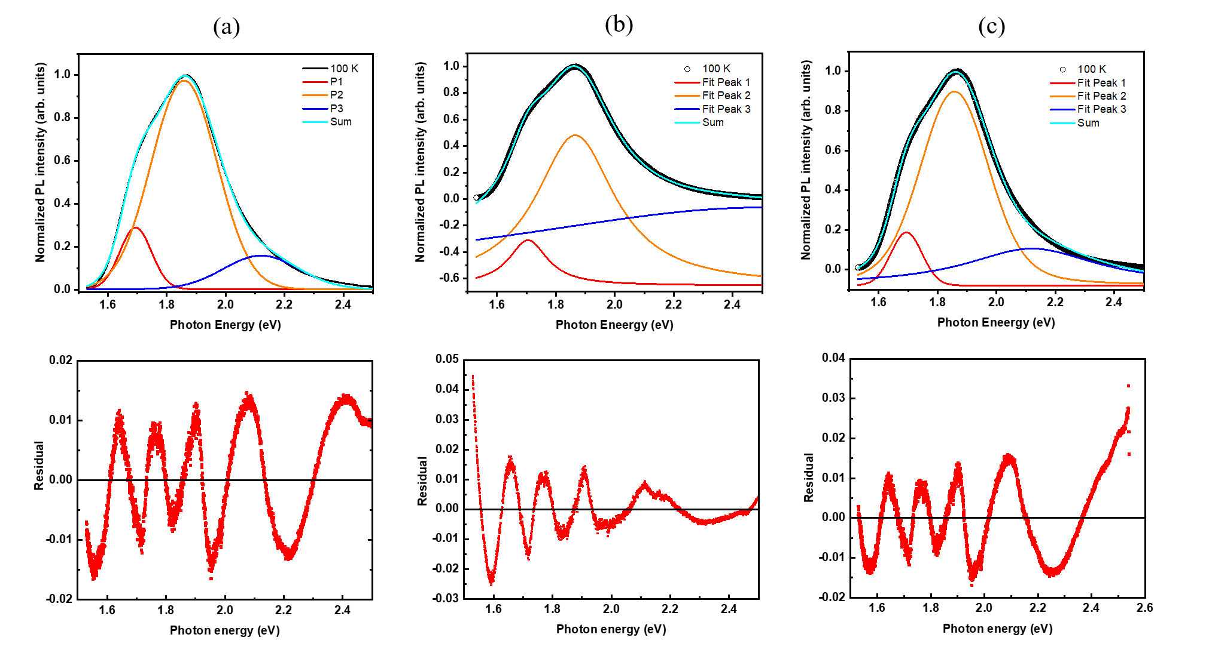

Fig S3: (a) Gaussian, (b) Lorentzian, and (c) Voigtian fit showing the deconvolution and the corresponding residual plot for sample S2 at 100K.

Table S2: The peak position and intensities of Gaussian peak profile fitting for S2 at 100K
Gaussian Peak Name | Peak Position (eV) | Peak Intensity (arb. units)
P1 | 1.69 ± 2.49×10⁻⁴ | 0.29 ± 6.0 ×10-4
P2 | 1.86 ± 3.18×10⁻⁴ | 0.98 ± 7.4 ×10-4
P3 | 2.13 ± 1.03×10⁻² | 0.16 ± 4.4 ×10-4

S-IV: Variation of peak energies with temperature for S2, S3, and S4

Fig S4: The peak energies associated to band-to- band (P3) and band-to-trap transition (P2) increase linearly at a rate strongly dependent on crystallite size up to $\sim 225 K$ and then decrease with increasing temperature whereas the peak energy assigned to trap-to-trap transition (P1) increases monotonically with a slope almost independent of crystallite size of the samples throughout the whole range of temperature variation ($5-350 K$).

