Supporting Information
Facile synthesis of ultrafine Cu, Ag, and Ni nanoparticles supported on 3D hydrogel beads for the rapid reduction of 4-nitrophenol
Shuaikang Yao^{a,1}, Jingkun Zhao^{a,1}, Guolin Shao*ª, Siyu Gaoª, Shangru Zhaiª, Zuoyi Xiao*ª, Feng Zhang*^{b}

a Faculty of Light Industry and Chemical Engineering, Dalian Polytechnic University, Dalian 116034, China.
b Hoffmann Institute of Advanced Materials, Postdoctoral Innovation Practice Base, Shenzhen Polytechnic University, Nanshan District, Shenzhen, 518055, China.
¹ These authors contributed equally to this work.

*Corresponding authors
E-mail address: zyxiao@dlpu.edu. cn (Z. Y. Xiao )
shaoguolin@dlpu.edu.cn (G.L. Shao)
zhangfeng2022@ustc.edu.cn (F Zhang)

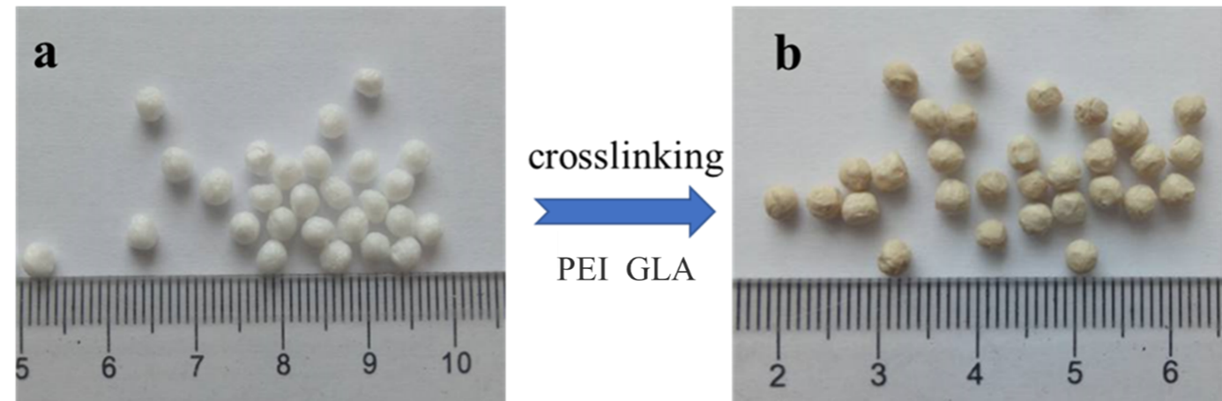
Fig. S1 Pictures of (a) Ca-SA and (b) GLA-PEI/Ca-SA hydrogel beads.

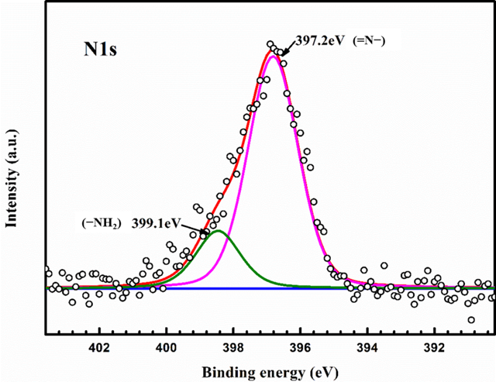
Fig. S2 High-resolution XPS spectrum of N 1s.

