Supplementary Information

Title: Warming and predation alter consumer coexistence
Journal name: Climatic Change
Peiyu Zhang^{1,2}, Huan Zhang¹, Huan Wang¹, Michelle C. Jackson³, Min Zhang⁴, Jun Xu^{1,2,*}
¹ Donghu Experimental Station of Lake Ecosystems, State Key Laboratory of Freshwater Ecology and Biotechnology of China, Institute of Hydrobiology, Chinese Academy of Sciences, Wuhan, China
² Laboratory for Marine Fisheries Science and Food Production Processes, Qingdao National Laboratory for Marine Science and Technology, Qingdao, China
³ Department of Zoology, University of Oxford, Oxford, UK
⁴ Hubei Provincial Engineering Laboratory for Pond Aquaculture, Engineering Research Center of Green development for Conventional Aquatic Biological Industry in the Yangtze River Economic Belt, Ministry of Education, College of Fisheries, Huazhong Agricultural University, Wuhan, China
* Corresponding author
Jun Xu xujun@ihb.ac.cn

The following materials are included in this supplementary information:
Figure S1 Concentrations of TN and TP in the water column changed over time.
Figure S2 Biomass and density of the two snails changed over time in each mesocosm of control and warming treatment without fish present.
Figure S3 Relative biomass and density of both snails in each treatment.
Table S1 Model comparisons, with interaction of warming and fish predation and without their interaction.
Table S2 Weibull fitted results for biomass and density of each snail in each mesocosm in the control and warming treatment without fish.
Table S3 Differences of peaks of biomass and density of R. swinhoei between control and warming treatment without fish present.

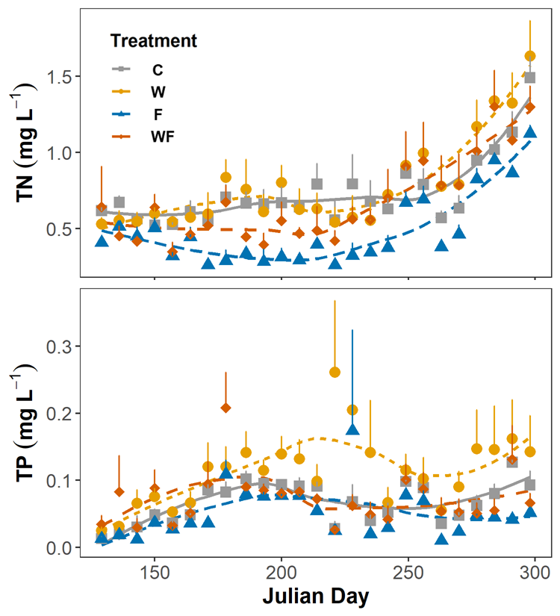

Figure S1 Concentrations of TN and TP in the water column changed over time. Vertical bars are standard errors. C for control, W for warming, F for predation and WF for warming and predation.

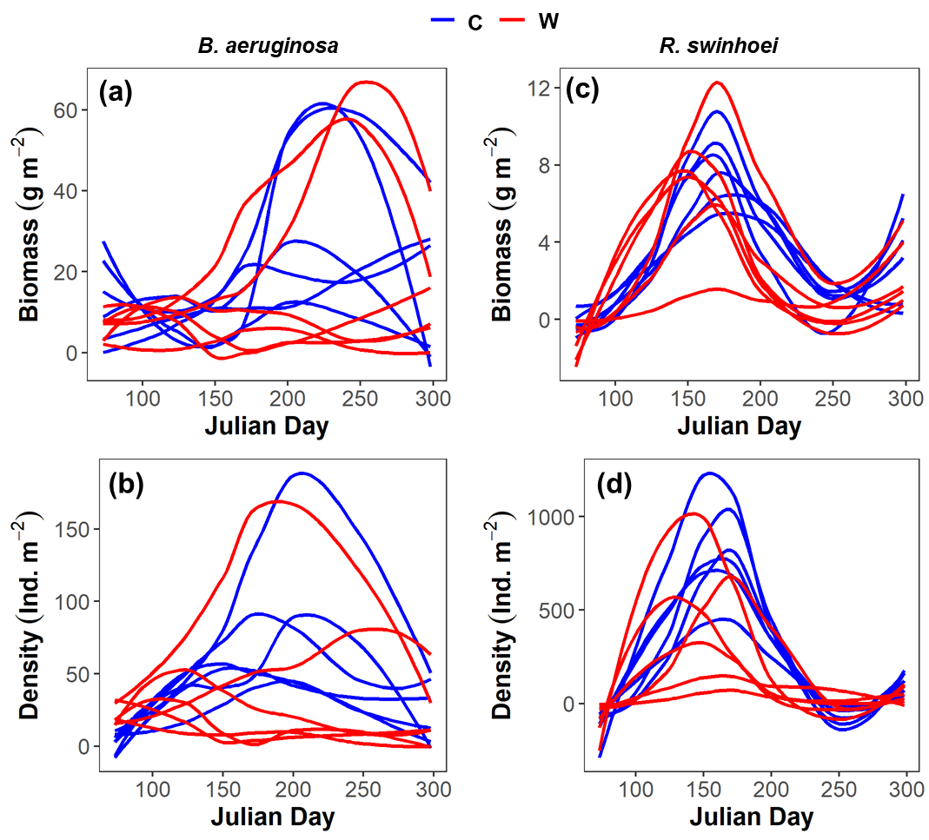

Figure S2 Biomass and density of the two snails changed over time in each mesocosm of control and warming treatment without fish present. Biomass (a) and density (b) of B. aeruginosa, and biomass (c) and density (d) of R. swinhoel. Blue indicates control and red indicates warming. The curves were fitted from the loess model in R package ggplot2. Weibull fitting results for biomass and density of each snail in each mesocosm can be found in Table S2.

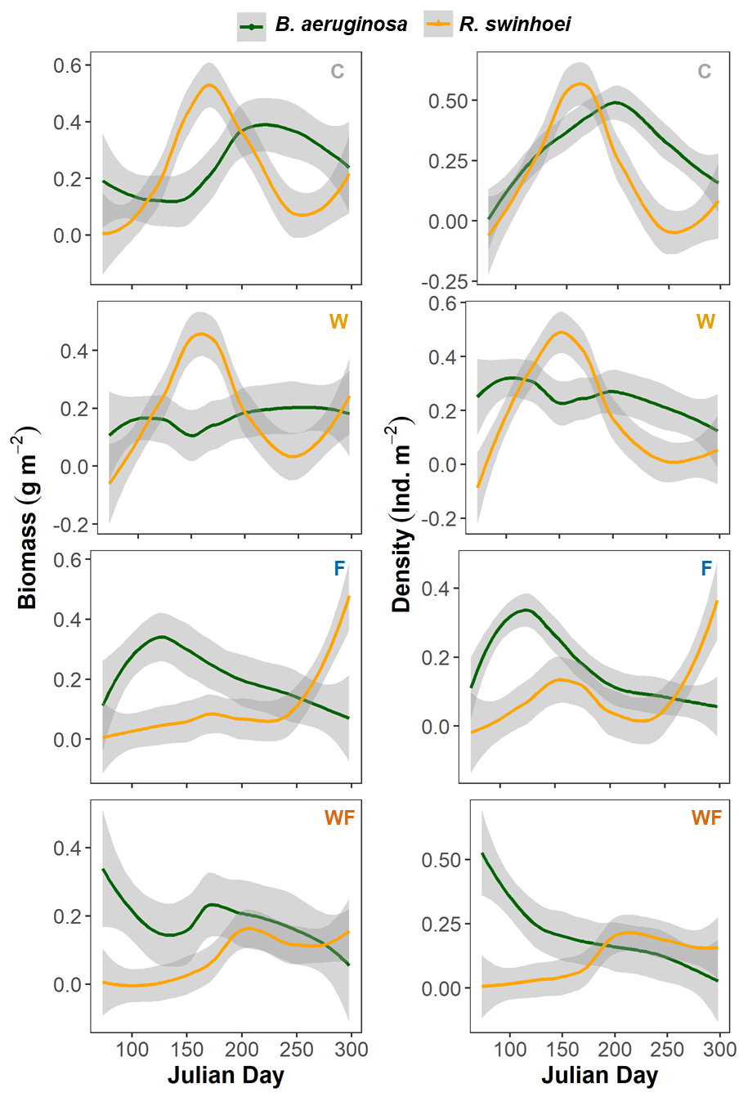
Figure S3 Relative biomass and density of both snails in each treatment. Data were normalized in each mesocosm by each snail (data were divided by the maximum value in each mesocosm) to diminish their different scales. The curves were fitted from the loess model in R package ggplot2. C for control, W for warming, F for predation and WF for warming and predation.

Table S1 Model comparisons, with interaction of warming and fish predation and without their interaction. A better model is selected if the AIC value is lower, which is highlighted in bold. * = interaction included; + = interaction excluded; df = degrees of freedom; AIC = Akaike information criterion; BIC = Bayesian information criterion; logLik = log-likelihood; F-values = sum of the main effect sizes.

 | Response | Predictors | df | AIC | BIC | logLik | F-values
B. aeruginosa | Biomass | Warming * Fish | 6 | 3758.5 | 3786.0 | -1873.3 | 78.9
B. aeruginosa | Biomass | Warming + Fish | 5 | 3756.5 | 3779.4 | -1873.3 | 79.0
B. aeruginosa | Density | Warming * Fish | 5 | 4497.2 | 4520.1 | -2243.6 | 899.5
B. aeruginosa | Density | Warming + Fish | 4 | 4499.8 | 4518.1 | -2245.9 | 919.9
R. swinhoei | Biomass | Warming * Fish | 6 | 3261.4 | 3288.8 | -1624.7 | 237.5
R. swinhoei | Biomass | Warming + Fish | 5 | 3262.6 | 3285.5 | -1626.3 | 233.5
R. swinhoei | Density | Warming * Fish | 5 | 14581.0 | 14604.0 | -7285.6 | 6052.9
R. swinhoei | Density | Warming + Fish | 4 | 14731.0 | 14749.0 | -7361.6 | 5832.5

Table S2 Weibull fitted results for biomass and density of each snail in each mesocosm in the control and warming treatment without fish. Numbers in red indicate poor fittings.
Response variable | Treatment | Mesocosm number | B. aeruginosa |  |  |  | R. swinhoei
Response variable | Treatment | Mesocosm number | Time of peak | Peak value | r² |  | Time of peak | Peak value | r²
Biomass | Control | C1 | 190.74 | 66.42 | 0.71 |  | 172.98 | 17.71 | 0.85
Biomass | Control | C2 | 59.73 | 32.64 | 0.34 |  | 178.27 | 15.81 | 0.76
Biomass | Control | C3 | 207.57 | 118.24 | 0.80 |  | 179.58 | 7.45 | 0.52
Biomass | Control | C4 | 271.18 | 52.26 | 0.49 |  | 185.19 | 5.68 | 0.51
Biomass | Control | C5 | 190.28 | 43.31 | 0.29 |  | 168.52 | 10.91 | 0.80
Biomass | Control | C6 | 293.73 | 24.38 | 0.37 |  | 162.41 | 13.35 | 0.71
Biomass | Warming | W1 | Not applicable |  |  |  | 156.39 | 8.94 | 0.63
Biomass | Warming | W2 | 102.83 | 33.23 | 0.47 |  | 180.80 | 2.68 | 0.59
Biomass | Warming | W3 | 176.86 | 17.21 | 0.65 |  | 131.95 | 10.76 | 0.66
Biomass | Warming | W4 | 100.27 | 50.59 | 0.64 |  | 156.27 | 7.94 | 0.70
Biomass | Warming | W5 | 190.18 | 58.97 | 0.57 |  | 165.83 | 12.52 | 0.82
Biomass | Warming | W6 | 220.60 | 108.24 | 0.75 |  | 178.42 | 20.83 | 0.81
Density | Control | C1 | 210.07 | 169.04 | 0.76 |  | 166.61 | 1327.17 | 0.91
Density | Control | C2 | 177.59 | 89.45 | 0.79 |  | 160.21 | 1463.66 | 0.95
Density | Control | C3 | 205.49 | 135.13 | 0.84 |  | 175.04 | 627.79 | 0.72
Density | Control | C4 | 160.72 | 132.83 | 0.60 |  | 162.49 | 762.69 | 0.79
Density | Control | C5 | 226.06 | 49.63 | 0.44 |  | 163.22 | 968.08 | 0.81
Density | Control | C6 | 175.59 | 53.65 | 0.41 |  | 165.72 | 2086.49 | 0.95
Density | Warming | W1 | 106.26 | 58.62 | 0.74 |  | 135.22 | 300.86 | 0.97
Density | Warming | W2 | 126.52 | 88.75 | 0.88 |  | 150.08 | 111.44 | 0.94
Density | Warming | W3 | Not applicable |  |  |  | 127.13 | 1417.38 | 0.76
Density | Warming | W4 | 91.55 | 62.54 | 0.87 |  | 124.16 | 671.83 | 0.86
Density | Warming | W5 | 189.65 | 205.28 | 0.67 |  | 152.24 | 498.60 | 0.84
Density | Warming | W6 | 160.61 | 115.70 | 0.76 |  | 175.37 | 1130.37 | 0.96

Table S3 Differences of peaks of biomass and density of R. swinhoei between control and warming treatment without fish present. A six parameters Weibull function was fitted for each mesocosm. Independent t-tests were used to compare the differences between control and warming treatment without fish present. n = 6.
Response variable | Peak traits | Control | Warming | t | p
Biomass | Peak biomass (g m⁻²) | 11.8 ± 4.7 | 10.6 ± 6.0 | t₁₀ = 0.39 | 0.77
Biomass | Time of peak (Julian day) | 174.5 ± 8.2 | 161.6 ± 17.9 | t₁₀ = 1.60 | 0.14
Density | Peak density (Ind. m⁻²) | 1206 ± 537 | 688 ± 499 | t₁₀ = 1.73 | 0.11
Density | Time of peak (Julian day) | 165.5 ± 5.2 | 144.0 ± 19.2 | t_{5.7} = 2.65 | 0.04

