Supplement Figure Legends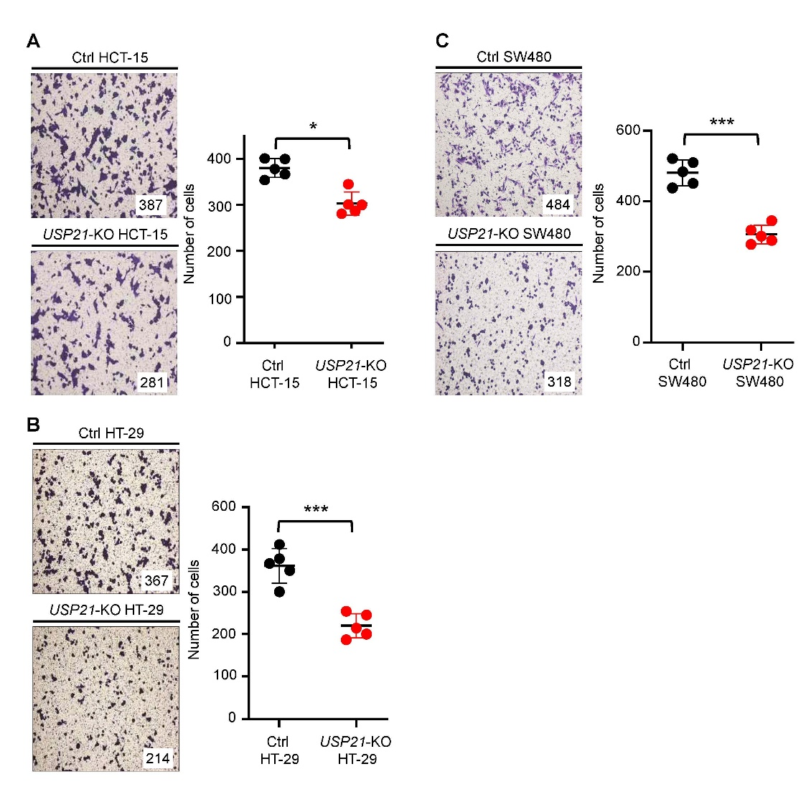
Supplementary Fig. S1. A-C Transwell migration assay was performed with Ctrl HCT-15 and USP21-KO HCT-15 cells (A), Ctrl HT-29 and USP21-KO HT-29 cells (B), or Ctrl SW480 and USP21-KO SW480 cells (C). Results are presented as mean ± SD of three independent experiments. *p<0.05, ***p < 0.001, two-tailed Student’s t-test.

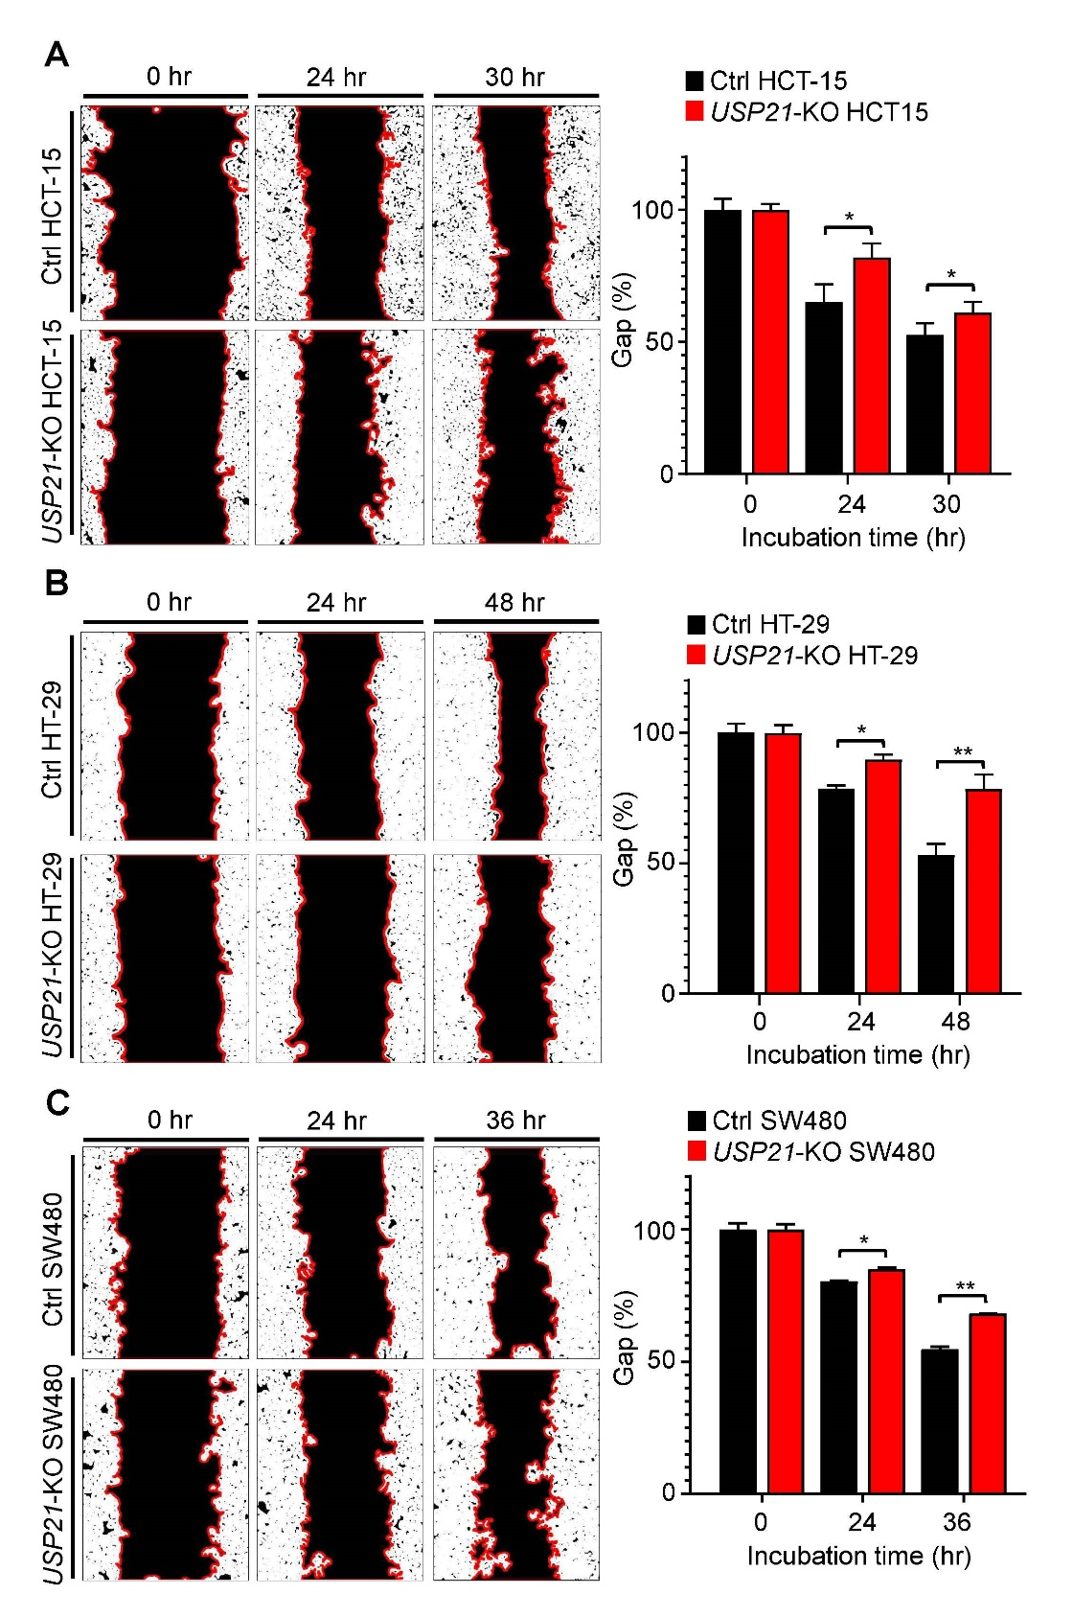
Supplementary Fig. S2. A-C Wound healing assay was performed with Ctrl HCT-15 and USP21-KO HCT-15 cells (A), Ctrl HT-29 and USP21-KO HT-29 cells (B), or Ctrl SW480 and USP21-KO SW480 cells (C). Results are presented as mean ± SD of three independent experiments. *p<0.05, **p < 0.01, two-tailed Student’s t-test.

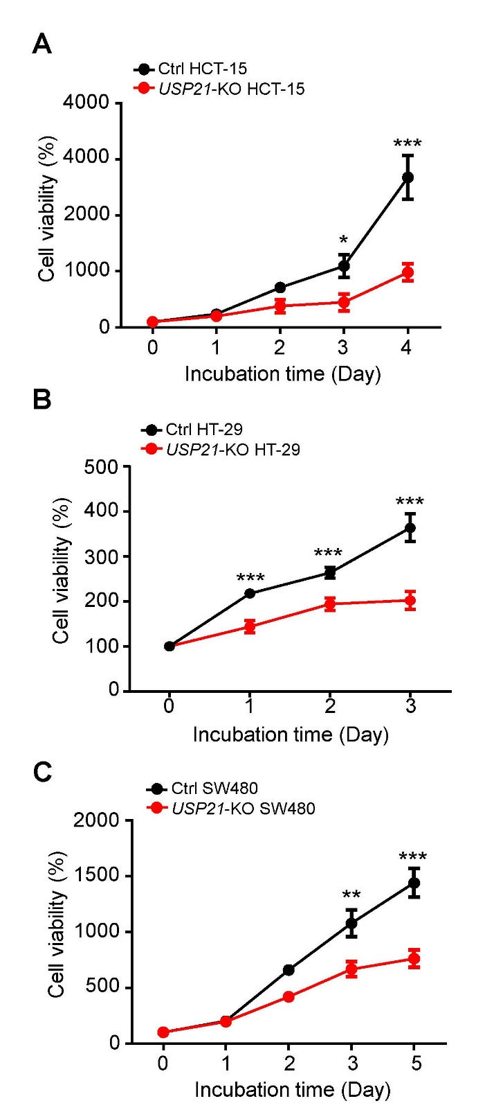
Supplementary Fig. S3. A-C Cell proliferation assay was performed with Ctrl HCT-15 and USP21-KO HCT-15 cells (A), Ctrl HT-29 and USP21-KO HT-29 cells (B), or Ctrl SW480 and USP21-KO SW480 cells (C). Results are presented as mean ± SD of three independent experiments. *p<0.05, **p < 0.01, ***p < 0.001, two-tailed Student’s t-test.

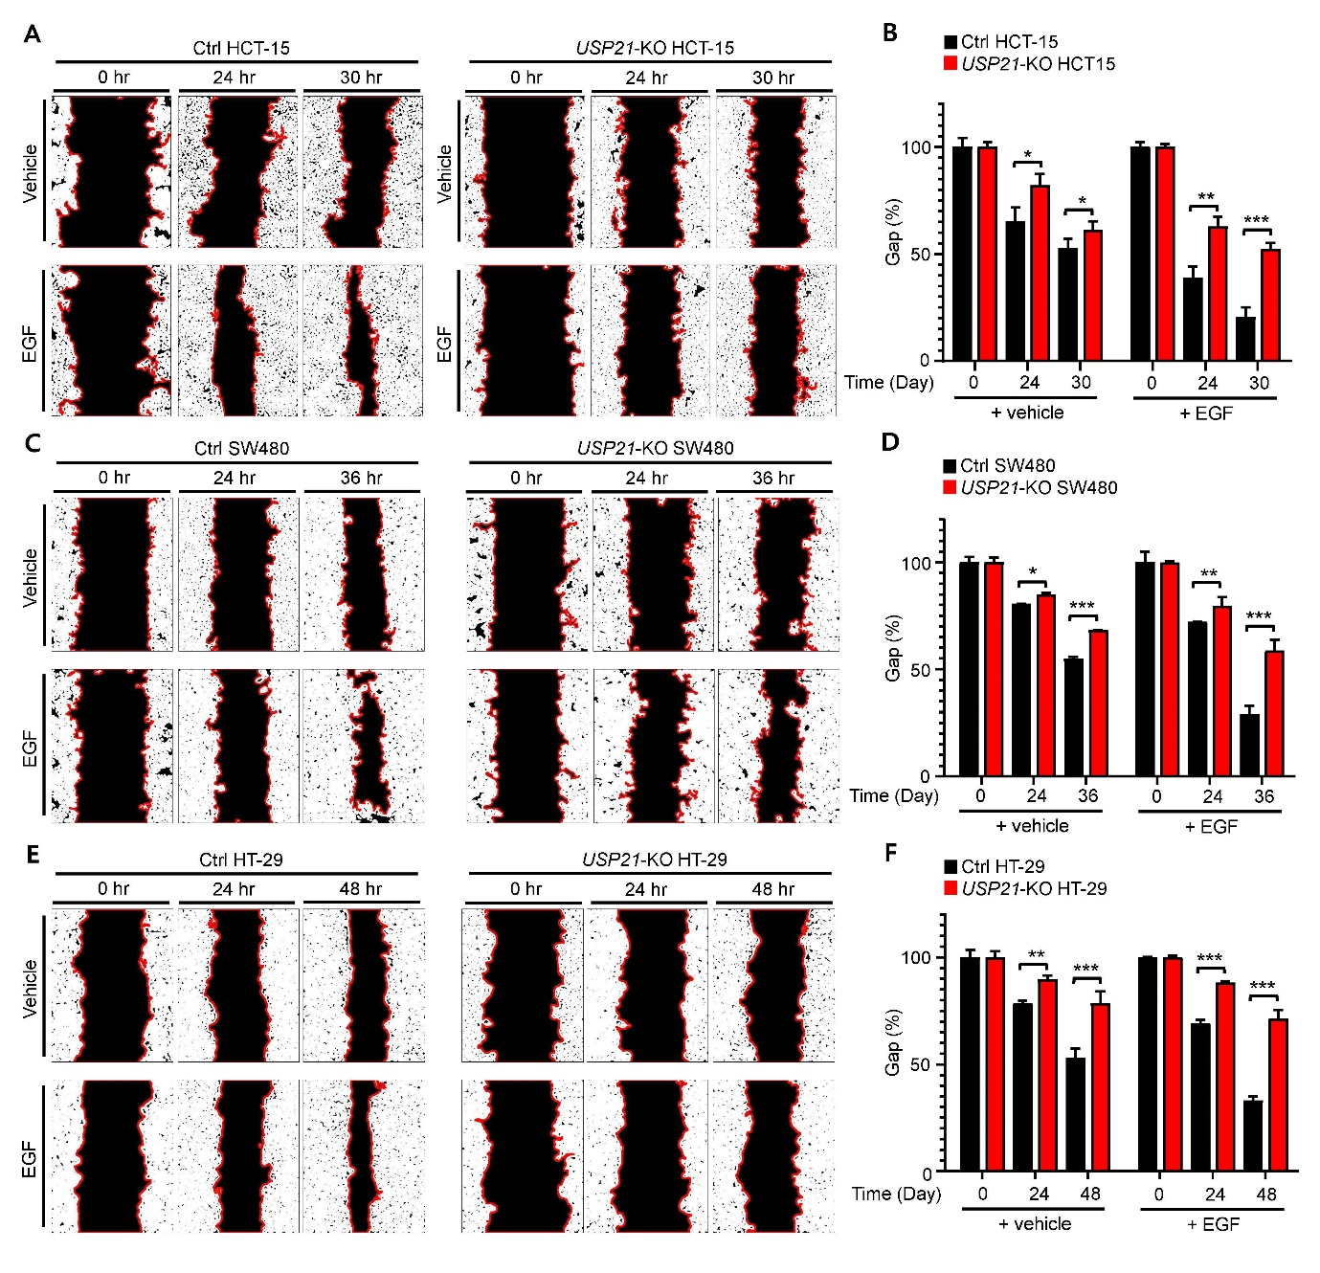
Supplementary Fig. S4. A-F Wound healing assay was performed with Ctrl HCT-15 and USP21-KO HCT-15 cells (A and B), Ctrl SW480 and USP21-KO SW480 cells (C and D), or Ctrl HT-29 and USP21-KO HT-29 cells (E and F) treated with vehicle (0.01% DMSO) or EGF (20 ng/mL). Results are presented as mean ± SD of three independent experiments. *p<0.05, **p < 0.01, ***p < 0.001, two-tailed Student’s t-test.
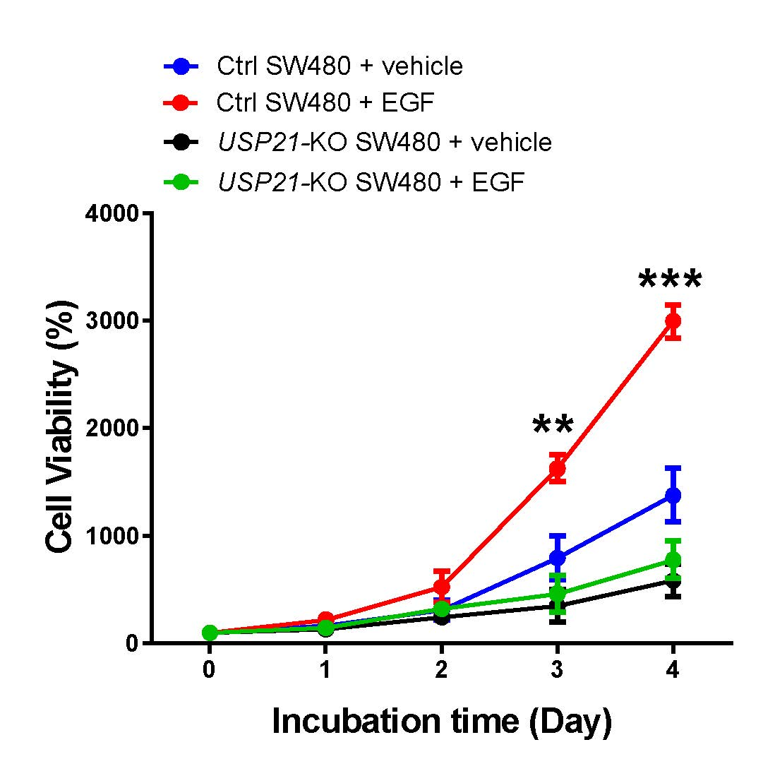

Supplementary Fig. S5. Cell proliferation assay was performed with Ctrl SW480 and USP21-KO SW480 cells treated with vehicle (0.01% DMSO) or EGF (20 ng/mL). Results are presented as mean ± SD of three independent experiments. **p < 0.01, ***p < 0.001, two-tailed Student’s t-test.

Supplement Table information
Supplementary Table S1. Clinical characteristics of CRC patients (n=27).
Supplementary Table S2. Clinical characteristics of CRC patients (n=27) and differential expression magnitude (△Mag) of USP21 and EGFR in tumor tissues (n=27) vs. matched normal tissues (n=27).

