Supplementary materials for Confident protein datasets for liquid-liquid phase separation studies

Carlos Pintado-Grima, Oriol Bárcenas, Valentín Iglesias, Eva Arribas-Ruiz, Michał Burdukiewicz and Salvador Ventura

Supplementary S1: data records’ details for the proteins collected in the study.

Dataset information is collected into two independent files:

- A tsv file (tab-separated values) which collects, for each protein, the specific UniProt Accession number, gene name, the datasets where this protein is found, the cellular localization, the fraction of derived order and curated disorder annotated by MobiDB and the full-length protein sequence. Note that if a protein is annotated in more than one dataset, they are separated by a semicolon. Cellular location is abbreviated as: cytoplasmic (C), nuclear (N), both (CN) or none (_), e.g.:

UniProt Gene Datasets GO F. order F. disorder Sequence
P35637 FUS C_D;D1;… CN 0.027 0.964 MAS...

- A json file (JavaScript object notation) which collects, for each protein, the full-length sequence, two independent lists with disordered element sequences: IDRs and PrLDs, and the annotated datasets. Proteins with negative predictions or missing sequences contain empty lists, e.g.:

{P35637:
{Full_seq: uniprot_full_length_seq},
{IDRs: [seq-IDR1, seq-IDR2, … seq-IDRn]},
{PrLDs: [seq-PrLD]},
{Dataset: dataset_name}
}

Supplementary S2: κs|s computations.

Similarly to κ in localCIDER (Holehouse et al., 2017), we compute κs|s for blobs (subsequences of amino acids belonging to the protein p) of 5- and 6-residues long. For each blob, we compute sticker/spacer asymmetry (σ) (Equation 1):

$$σ= \frac{fsticker - fspacer}{fsticker + fspacer} (1)$$

Then we compute δ, a square deviation of sticker/spacer asymmetry (Equation 2).

$$δ= \frac{\sum_{i=1}^{Nblob}{}(σi- σ̄)}{Nblob} (2)$$

Next, we relate δ to the δtotal . δtotal is computed for a theoretical protein with the same amino acid composition as protein p, where all amino acids are transposed to maximize the sticker/spacer asymmetry (Equation 3).

$κs|s=\frac{δ}{δ total} (3)$

List of symbols:
• fsticker : frequency of stickers (Y, R, F) in a given blob.
• fspacer : frequency of spacers (G, S, Q, N) in a given blob.
• σi : i-th blob charge asymmetry.
• σ̄: mean sticker/spacer asymmetry.
• Nblob : total number of residue blobs.
• δ: square deviation of sticker/spacer asymmetry.
• δtotal : a maximum sticker/spacer asymmetry for a given sequence, as computed by the modified version of localCIDER. Please check the κ function documentation in the original localCIDER package for the details.
• κs|s : relative total sticker/spacer asymmetry for the IDR.

Supplementary S3: dataset statistics for the final proteins obtained after UniProt annotation (removal of isoforms, obsolete entries and non-annotated proteins) collected in the tsv file.

Dataset | N  proteins | Average length | [Min-Max length] | Avg. N  IDRs | Avg. N PrLDs
D1 | 53 | 733 | 184-1974 | 2.3 | 0.8
D2 | 112 | 748 | 90-3338 | 2.6 | 0.7
D3 | 170 | 596 | 35-5539 | 2.6 | 0.5
D4 | 202 | 711 | 105-3144 | 2.8 | 0.5
D5 | 130 | 653 | 127-1972 | 2.6 | 0.6
C1 | 150 | 749 | 103-7390 | 2.6 | 0.3
C2 | 285 | 684 | 65-8799 | 2.7 | 0.2
NP | 1483 | 242 | 53-1370 | 1.3 | 0.0
ND | 2288 | 590 | 21-34352 | 2.3 | 0.1
CE | 363 | 695 | 65-8799 | 2.7 | 0.2
DE | 337 | 685 | 35-5539 | 2.9 | 0.4
C_D | 55 | 738 | 184-3338 | 2.5 | 0.6
C+ | 17 | 833 | 201-2759 | 2.4 | 0.1
C- | 401 | 696 | 65-8799 | 2.7 | 0.2
D+ | 77 | 660 | 174-1972 | 2.3 | 0.8
D- | 315 | 700 | 35-5539 | 3.0 | 0.4

Supplementary S4: length distribution of IDRs and PrLDs in positive (D1, D2, D3, D4, D5, C1, C2; blue) and negative datasets (NP, ND; orange).

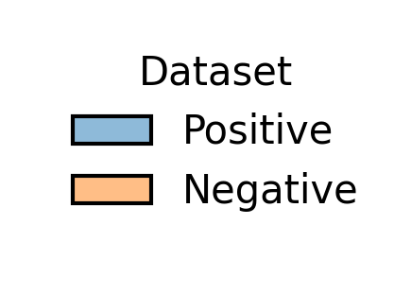

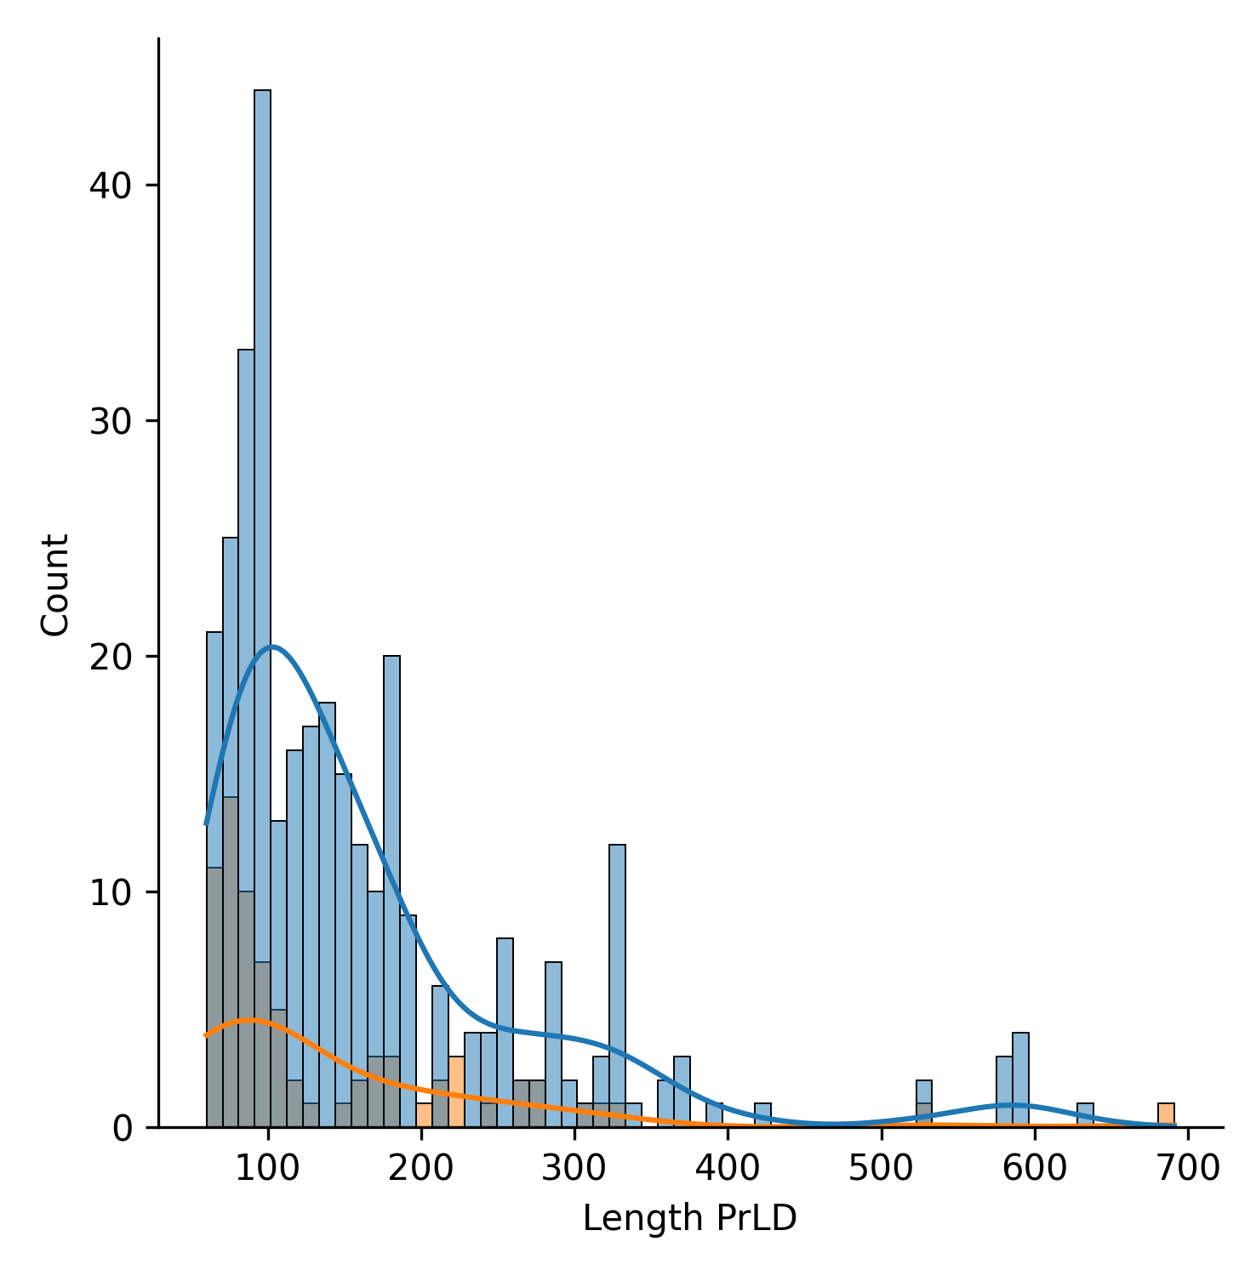
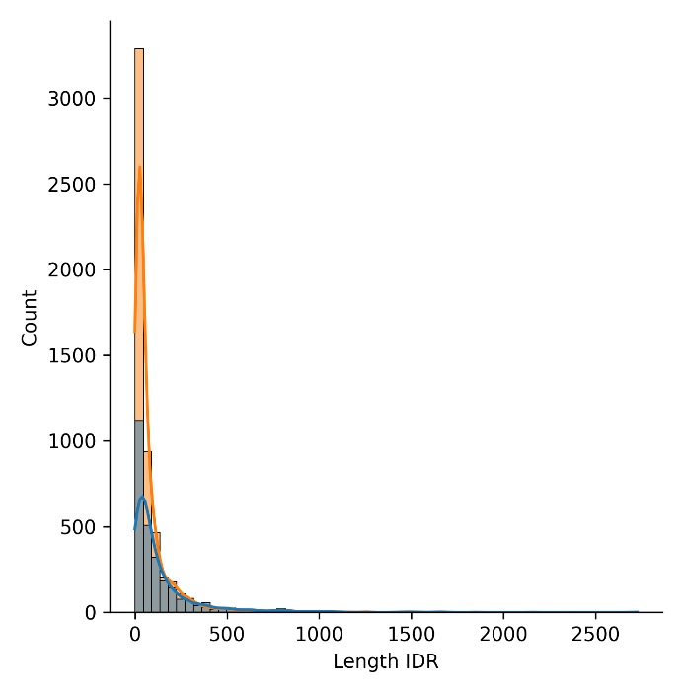

Supplementary S5: physicochemical property calculations (%Y+R, κ_{s|s}, NCPR, κ, aggregation propensity, cryptic amyloidogenicity and disorder binding) for full length sequences, IDRs and PrLDs of all proteins in datasets. The final csv file can be accessed at: https://github.com/PPMC-lab/llps-datasets/blob/main/properties/calculations_properties_datasets.csv

