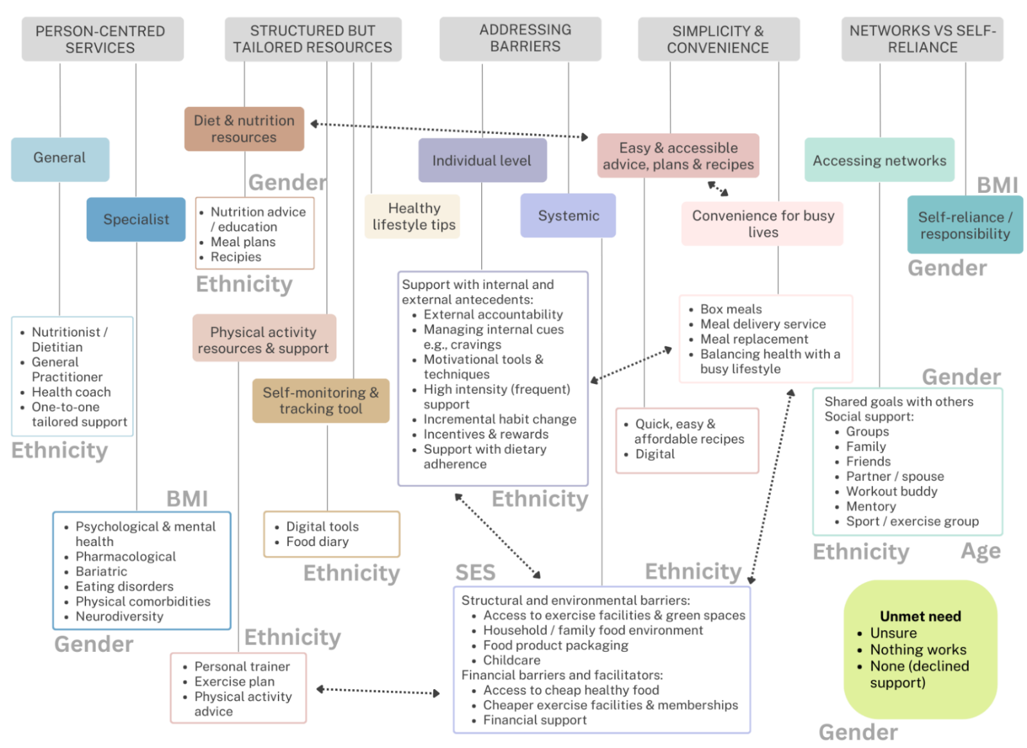
Supplementary Figure 1. Template illustrating the patterns across themes and codes and where these differ in relation to gender, ethnicity, age, and socioeconomic status

