Title:
Towards unravelling antimicrobial resistance dynamics: A longitudinal exploration of rectal swab metagenomes.

Supplementary figure 1. Co-occurrence network based on Spearman correlation between the relative abundance of each species. Only correlation with an absolute Rho ≥ 0.5 and a p-value ≤ 0.01 are displayed.

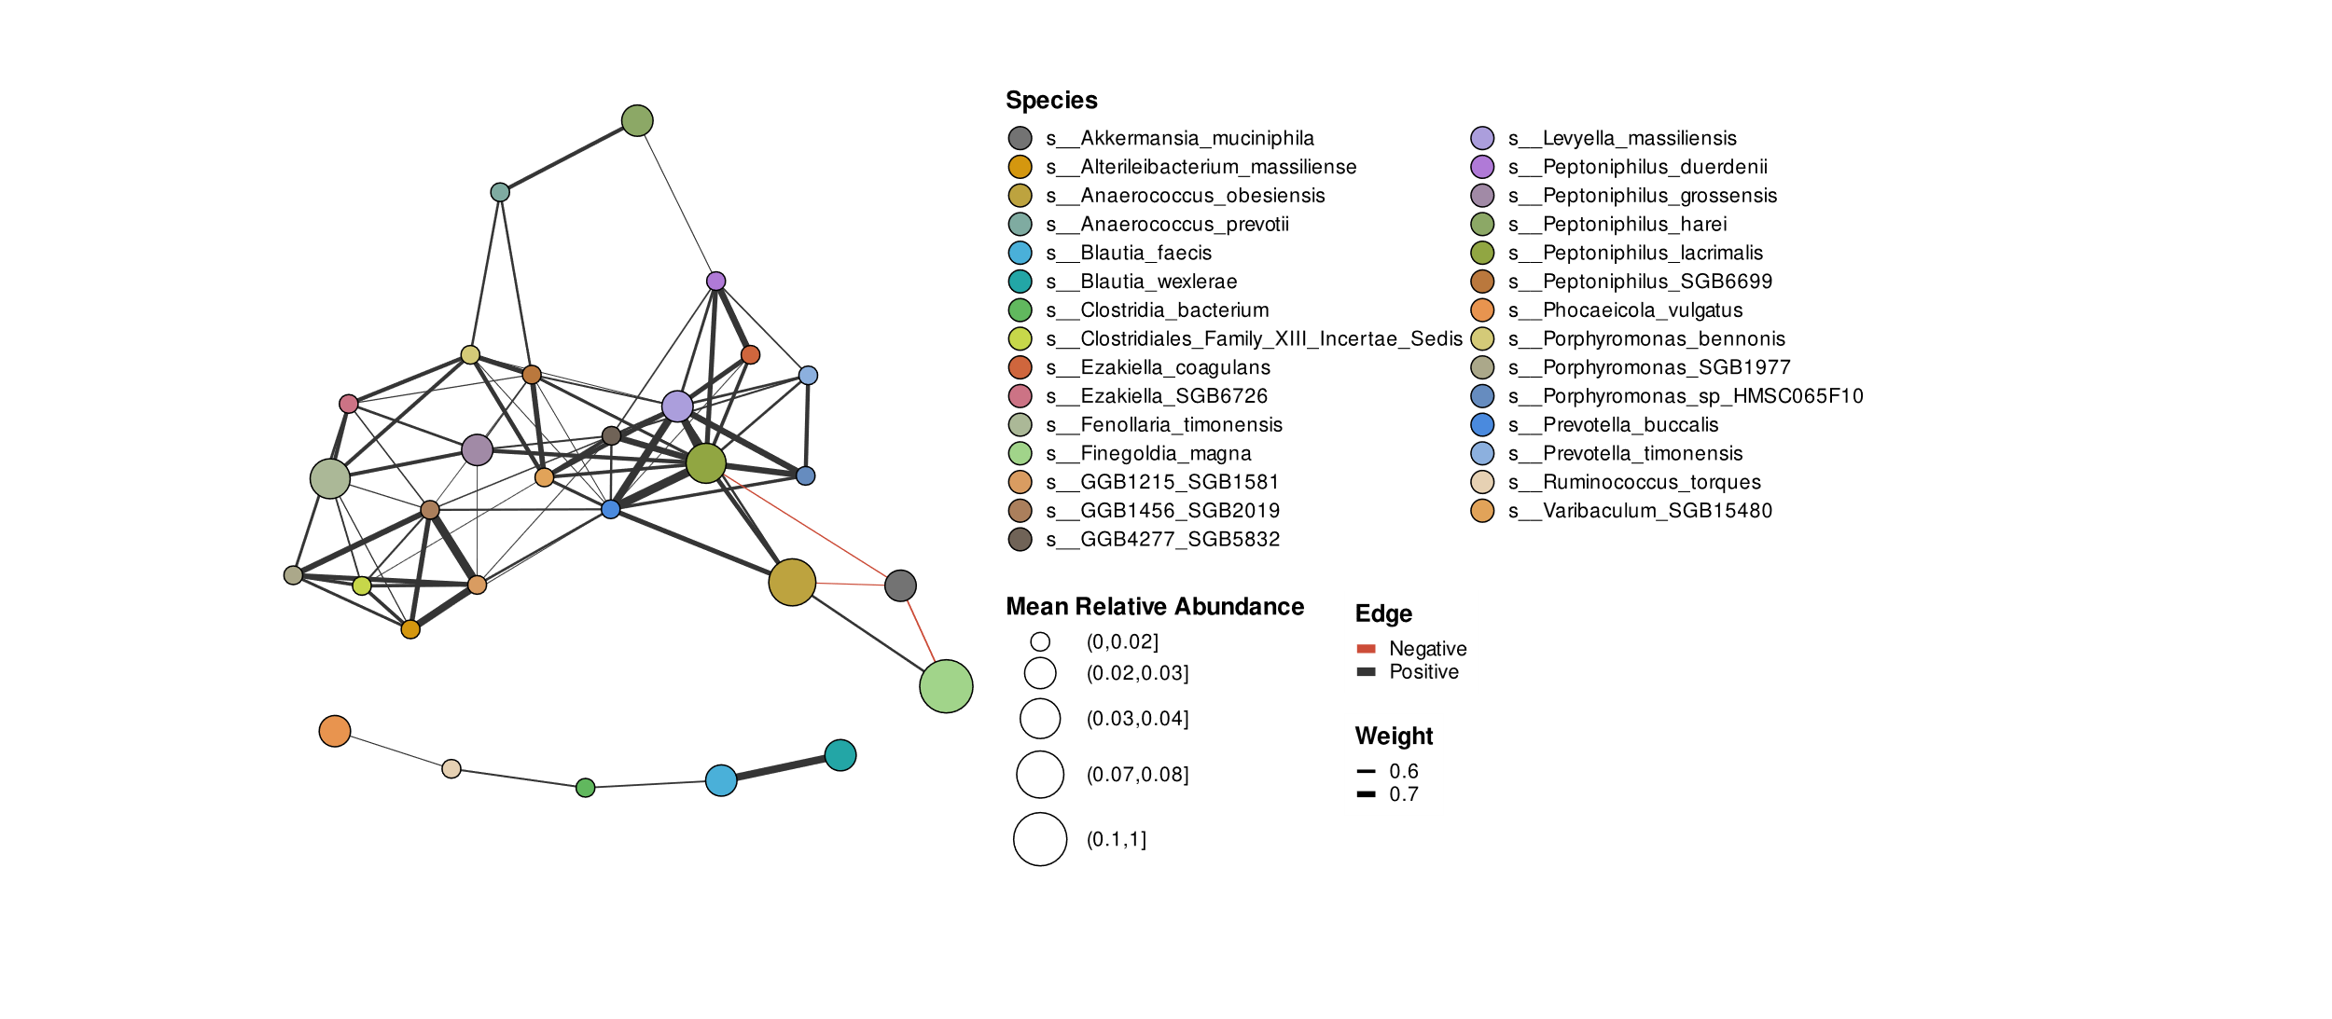
Supplementary figure 2. Impact of the timespan between the time points on the β-diversity measured by the Morisita-Horn dissimilarity index.
