Supplementary material

Figure S1. CONSORT Flow diagram from eligibility assessment to analysis

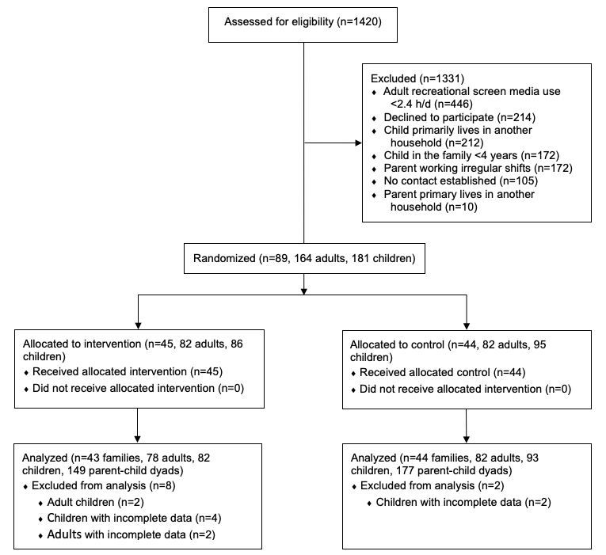

Figure S2. Line plots (24h) of crude mean proportions of leisure time with momentary (second-by-second) synchrony in active behaviors by group during weekdays (A) and weekend days (B) at baseline
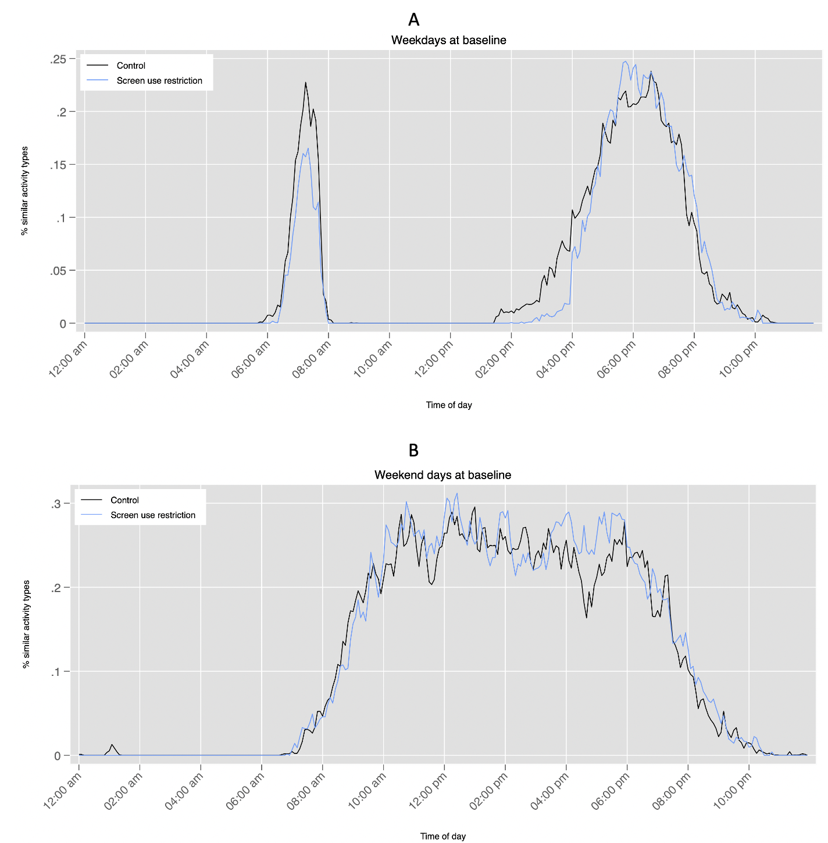

Table S1. Mean hours/day of shared awake leisure time among children and parents, weekdays and weekend days

 | Baseline | Follow-up
Weekdays | 4.97 (2.50) | 4.90 (2.47)
Weekend days | 10.96 (3.40) | 10.89 (3.41
Data are presented as mean (SD)

