Supplementary Materials

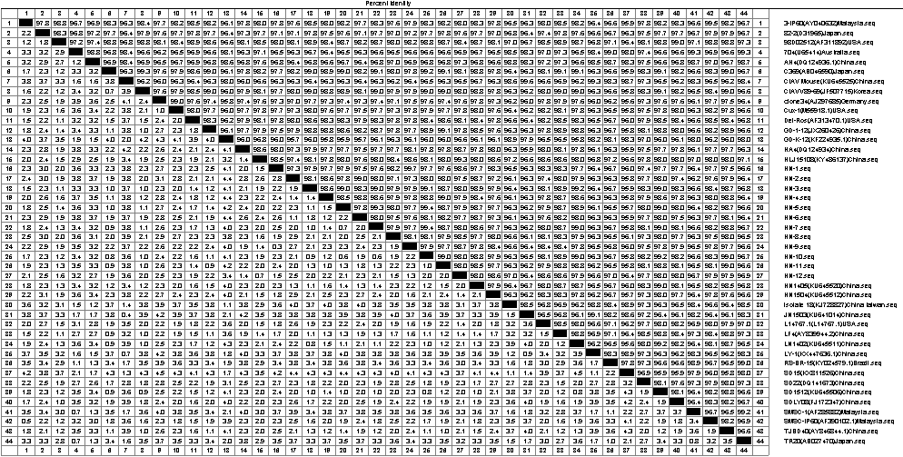
Supplementary Figures

Supplementary Figure 1. Similarity analysis of the whole genome sequences of 12 CIAV isolates.

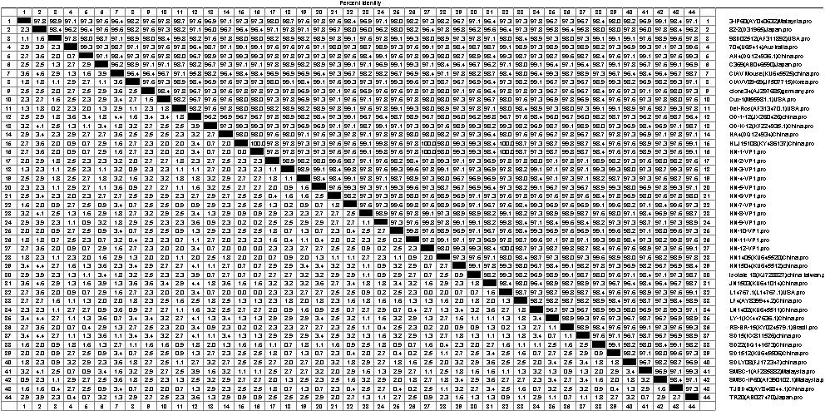

Supplementary Figure 2. The amino acid sequences similarity analysis of VP1.

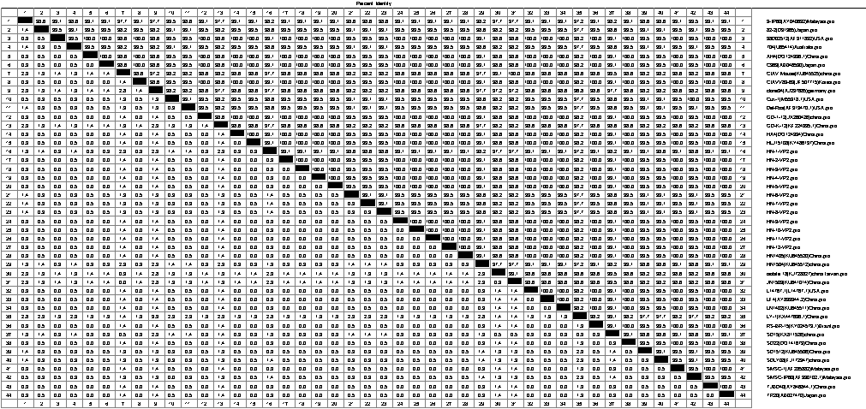

Supplementary Figure 3. The amino acid sequences similarity analysis of VP2.

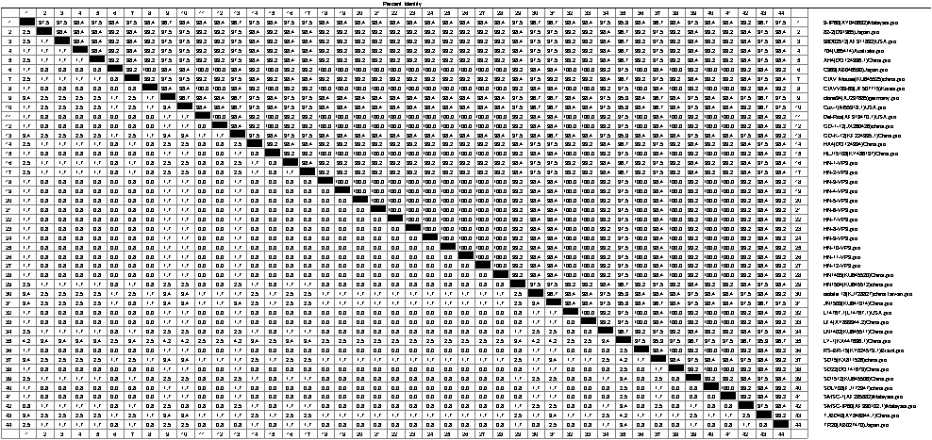

Supplementary Figure 4. The amino acid sequences similarity analysis of VP3.

