Supplementary Information
Capacity Fading Mechanisms of Ni-Rich Cathodes in All-Solid-State Batteries: Quantitative Approaches

Han-Uk Lee^{1,5}, Nam-Yung Park^{1,5}, Tae-Yeon Yu¹, In-Su Lee¹, Hun Kim¹, Sung-Min Park¹, Hun-Gi Jung², Yun-Chae Jung³ and Yang-Kook Sun^{1,4}*

¹ Department of Energy Engineering, Hanyang University, Seoul 04763, South Korea
² Energy Storage Research Center, Korea Institute of Science and Technology, Seoul 02792, South Korea
³ Advanced Battereies Research Center, Korea Electronics Technology Institute, Seongnam, Gyeonggi 13509, Republic of Korea
⁴ Department of Battery Engineering, Hanyang University, Seoul 04763, South Korea
⁵ These authors contributed equally

Corresponding author: yksun@hanyang.ac.kr(Y.-K. S)

This PDF file includes:
Supplementary References 1-18
Supplementary Figures 1-12
Supplementary Table 1-3

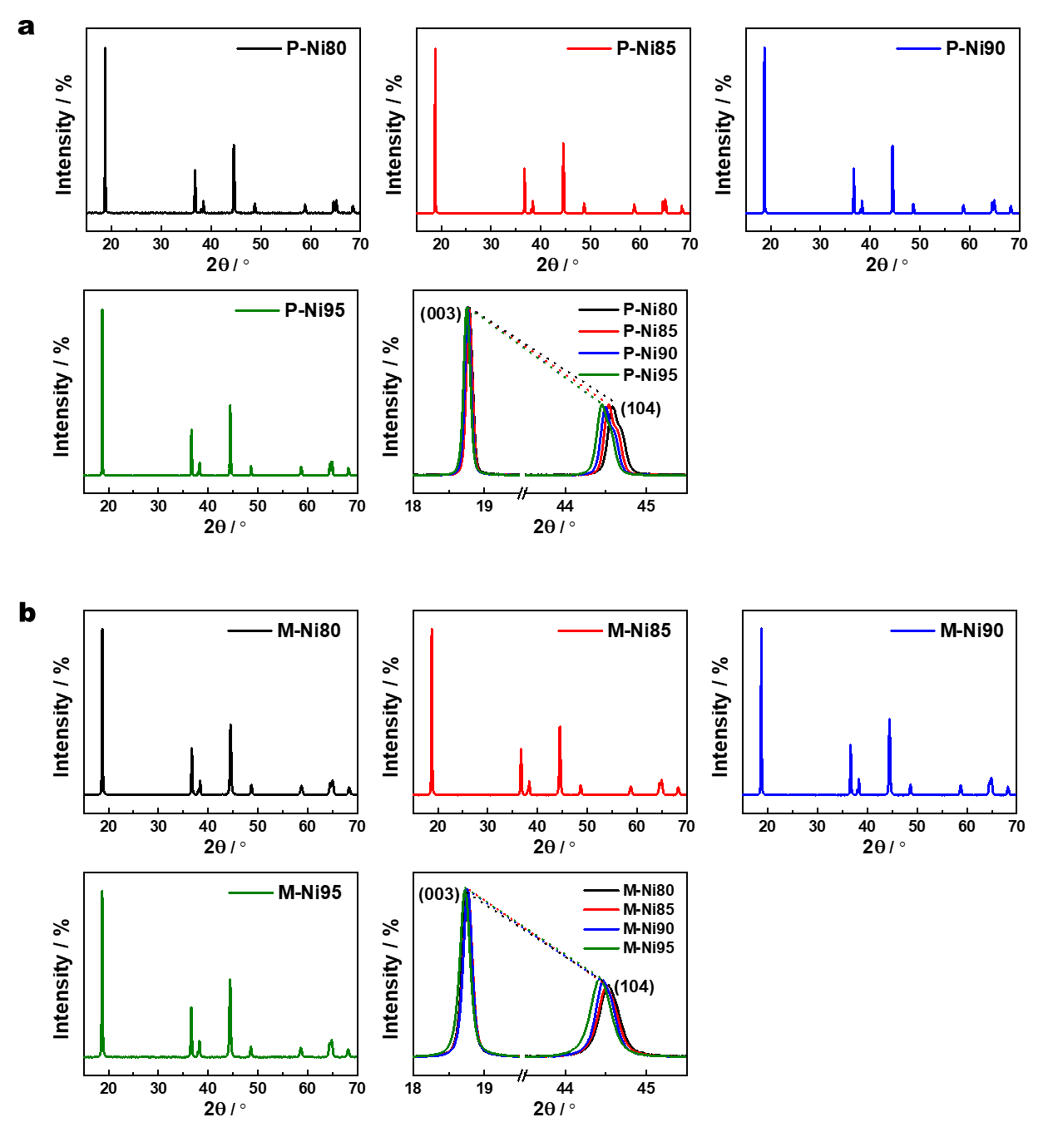
Supplementary Fig. 1 | XRD patterns of as-synthesized a. P-NCA and b. M-NCA cathodes with a wide range of Ni compositions (80% ≤ x ≤ 95%).

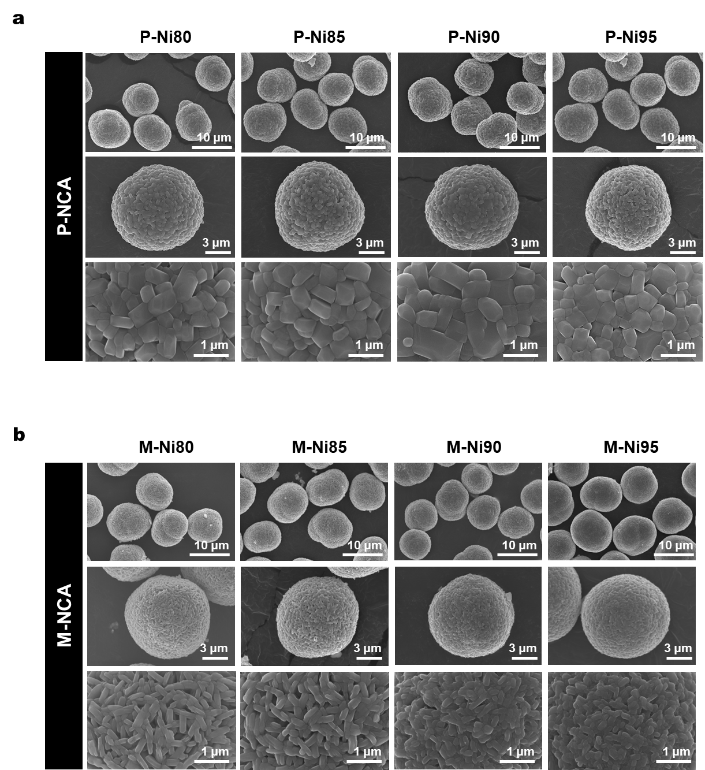
Supplementary Fig. 2 | SEM images of a. P-NCA and b. M-NCA cathodes with a wide range of Ni compositions (80% ≤ x ≤ 95%).

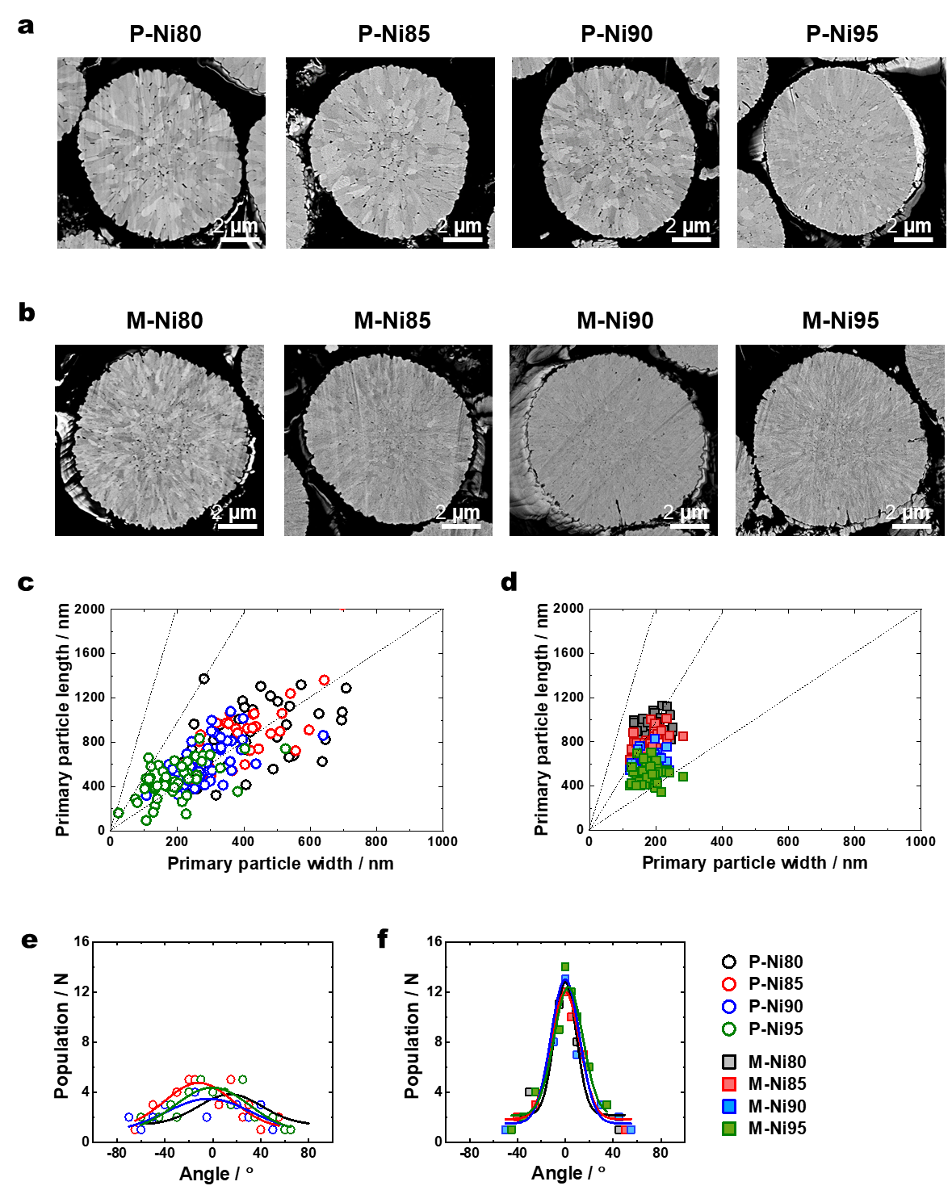
Supplementary Fig. 3 | Cross-sectional SEM images of as-synthesized a. P-NCA and b. M-NCA cathodes with a wide range of Ni compositions (80% ≤ x ≤ 95%). Widths and lengths of the primary particles of the c. P-NCA and d. M-NCA cathodes. Orientations of the primary particles of the e. P-NCA and f. M-NCA cathodes.

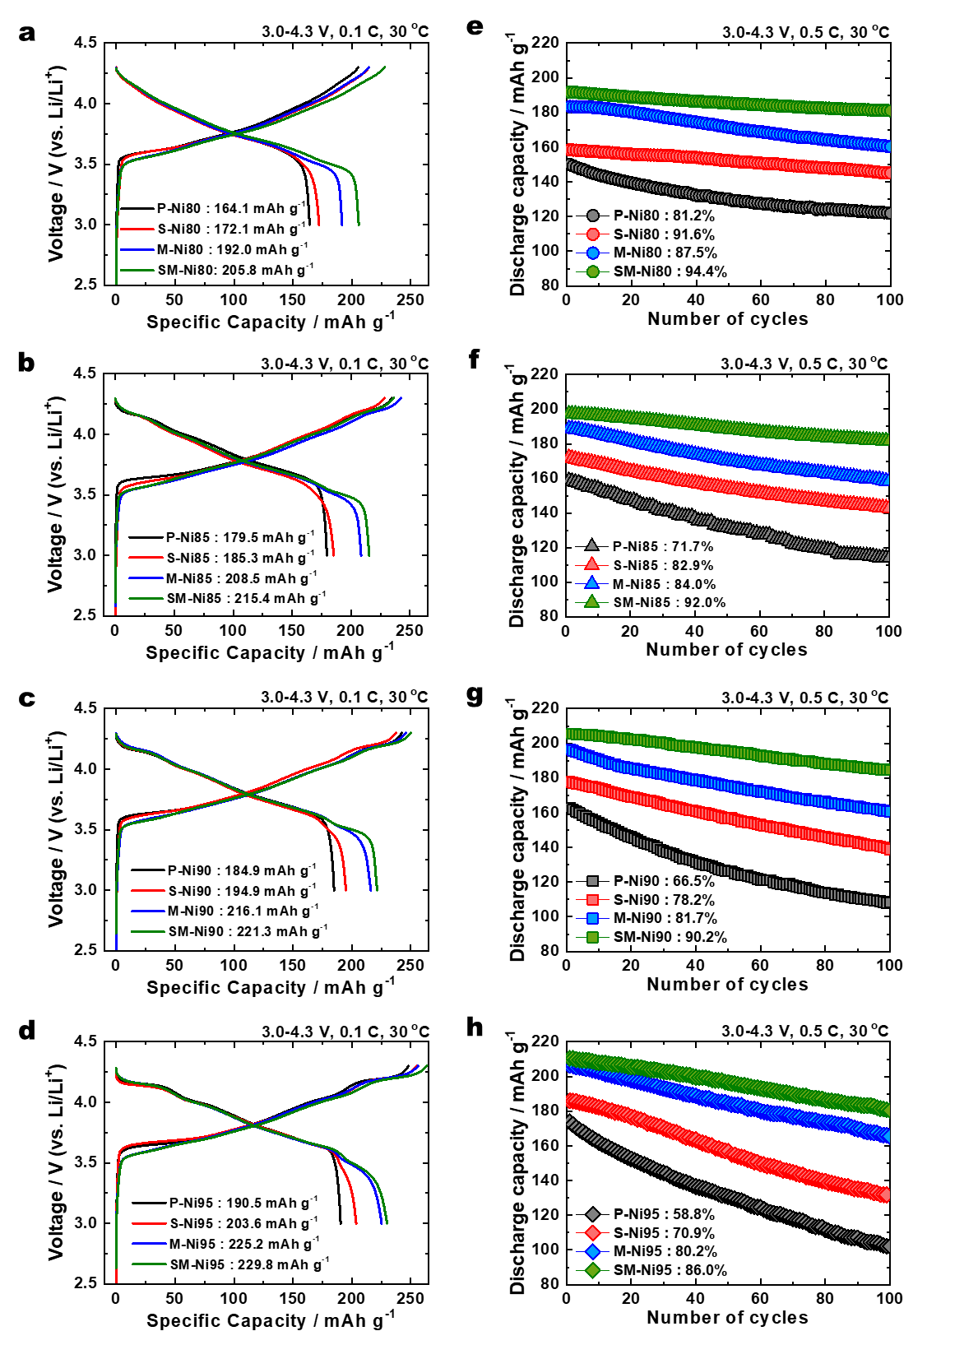
Supplementary Fig. 4 | Initial charge–discharge voltage profiles cycled at a constant current density of 0.1 C (18 mAh g⁻¹) between 3.0 and 4.3 V for P-NCA, S-NCA, M-NCA, and SM-NCA cathodes with Ni contents of a. 80%, b. 85%, c. 90%, and d. 95%. Cycling performance at a constant current density of 0.5 C (90 mAh g⁻¹) between 3.0 and 4.3 V for cathodes with Ni contents of e. 80%, f. 85%, g. 90%, and h. 95%.
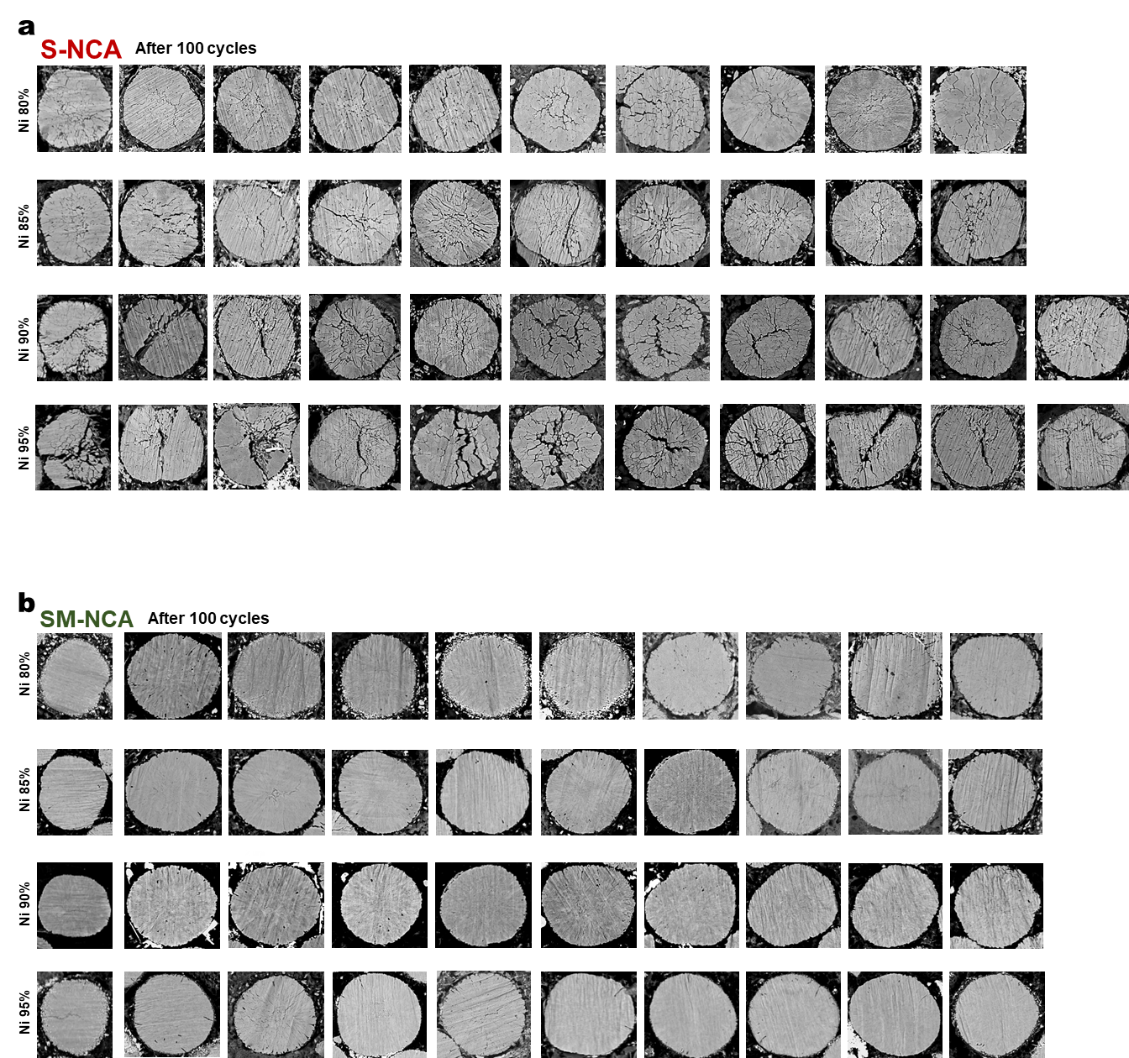
Supplementary Fig. 5 | Cross-sectional SEM images analyzed with back scatter electron mode for a. S-NCA and b. SM-NCA cathodes with a wide range of Ni compositions (80% ≤ x ≤ 95%) charged to 4.3 V after 100 cycles.
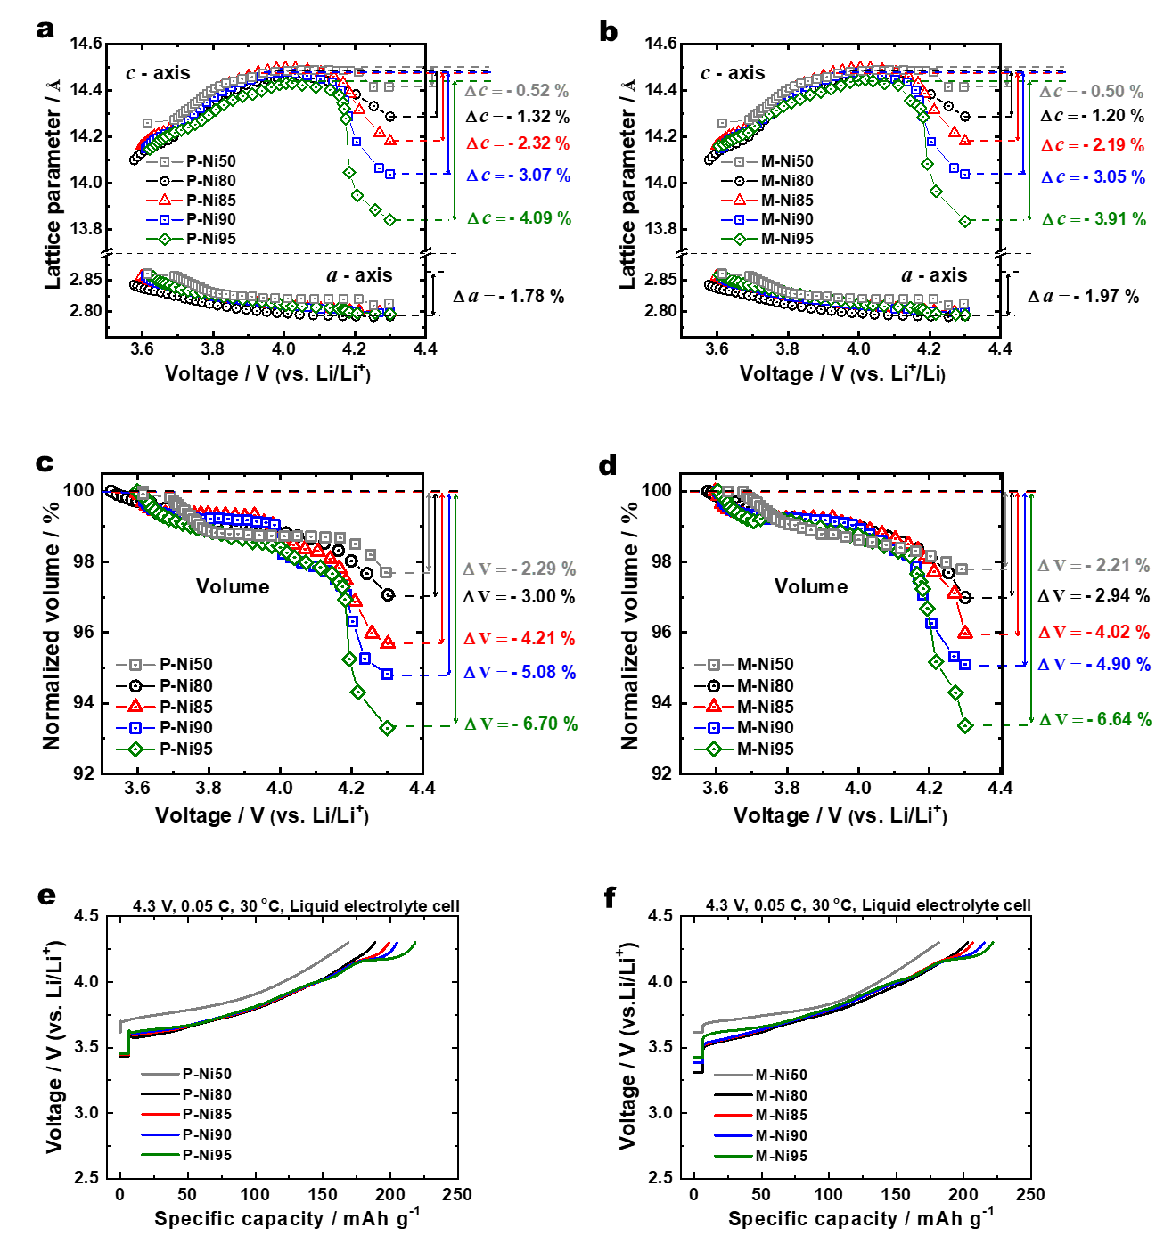
Supplementary Fig. 6 | In-situ XRD analyses of P-NCA and M-NCA cathodes with Ni contents of 50%, 80%, 85%, 90%, and 95% during first charging to 4.3 V. Variations in the a- and c-axis lattice parameters of the a. P-NCA and b. M-NCA cathodes. Normalized unit cell volumes as functions of voltage for the c. P-NCA and d. M-NCA cathodes. Charging curves at 0.05 C (9 mA g⁻¹) for e. P-NCA and f. M-NCA cathodes with Ni contents of 50%, 80%, 85%, 90%, and 95%.

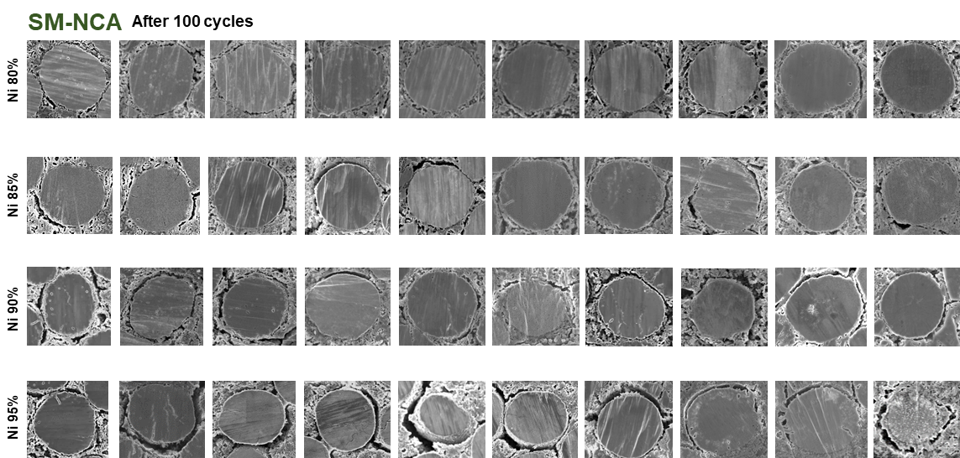
Supplementary Fig. 7 | Cross-sectional SEM images analyzed with secondary electron mode for SM-NCA cathodes with a wide range of Ni compositions (80% ≤ x ≤ 95%) charged to 4.3 V after 100 cycles.

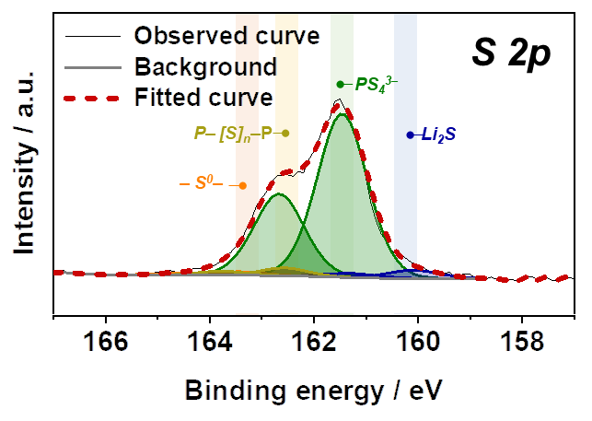
Supplementary Fig. 8 | S 2p XPS spectrum of the SM-Ni50 cathode after 100 cycles in an ASSB.

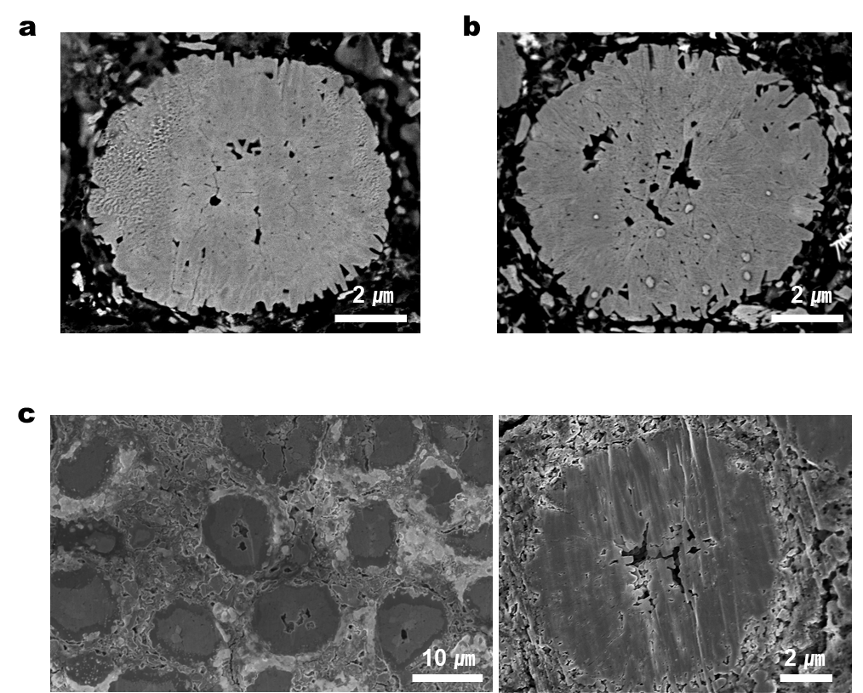
Supplementary Fig. 9 | Cross-sectional SEM images of the SM-Ni50 cathode charged to 4.3 V a. before and b. after 100 cycles, showing no isolation within the cathode particles. c. Cross-sectional SEM images of the SM-Ni50 cathode charged to 4.3 V after 100 cycles showing no detachment of cathode particles from the SE.

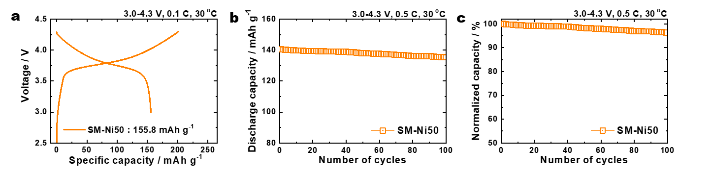
Supplementary Fig. 10 | a. Initial charge–discharge voltage profiles of the SM-Ni50 cathode at 0.1 C between 3.0 and 4.3 V vs. Li/Li⁺. b. Cycling performance at 0.5 C and c. corresponding normalized capacities.

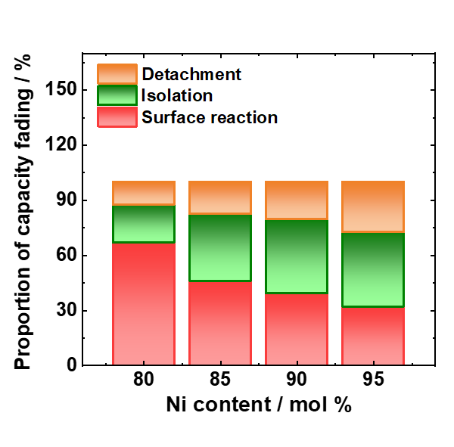
Supplementary Fig. 11 | Relative proportions of the three factors that affect the cycling life at each CAM Ni content.

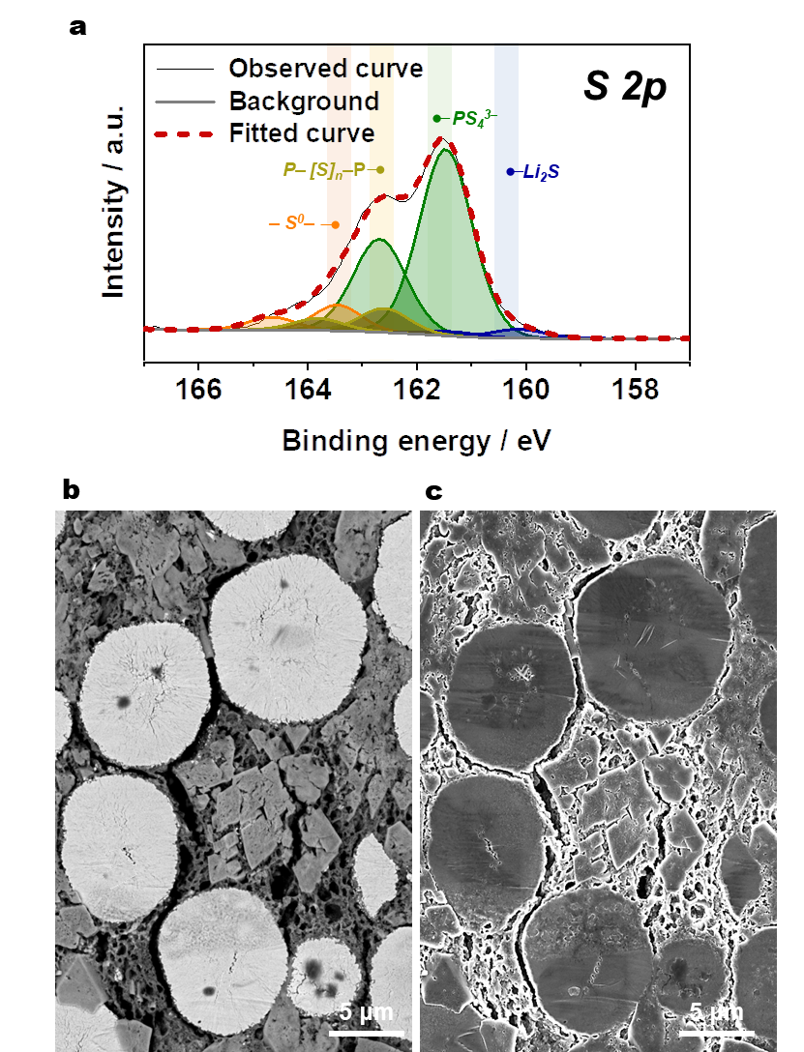
Supplementary Fig. 12 | a. S 2p XPS spectrum of a dry-processed SM-Ni90 cathode after 500 cycles. Cross-sectional SEM images analyzed with a. back scatter electron and b. secondary electron mode for a dry-processed SM-Ni90 cathode charged to 4.3 V after 500 cycles.
Supplementary Table 1. Chemical compositions of various CAMs as determined by ICP-OES
CAM | Ni  (at%) | Co  (at%) |  | Mn  (at%) |  |  | Al  (at%)
P-Ni80 | 79.0 |  | 19.0 |  | 2.0 |  | -
P-Ni85 | 85.9 |  | 12.6 |  | 1.5 |  | -
P-Ni90 | 89.7 |  | 9.5 |  | 0.8 |  | -
P-Ni95 | 95.2 |  | 3.9 |  | 0.9 | -
M-Ni80 | 78.5 |  | 19.0 |  | 1.6 | 0.9
M-Ni85 | 85.2 |  | 12.4 |  | 1.5 | 0.9
M-Ni90 | 88.8 |  | 9.5 |  | 0.8 | 0.9
M-Ni95 | 94.5 |  | 3.8 |  | 0.8 | 0.9

Supplementary Table 2. Rietveld refinement results for the CAMs prepared in this study
CAM | a-axis (Å) | c-axis (Å) |  | V (Å³) |  |  | c/3a | Cation mixing (%)
P-Ni80 | 2.8645 |  | 14.1795 |  | 100.7586 |  | 1.6503 | 0.37
P-Ni85 | 2.8682 |  | 14.1819 |  | 101.0368 |  | 1.6481 | 0.40
P-Ni90 | 2.8690 |  | 14.1834 |  | 101.1043 |  | 1.6478 | 0.43
P-Ni95 | 2.8719 |  | 14.1952 |  | 101.3919 | 1.6476 |  | 0.55
M-Ni80 | 2.8668 |  | 14.1838 |  | 100.9512 | 1.6492 |  | 1.13
M-Ni85 | 2.8694 |  | 14.1876 |  | 101.1607 | 1.6481 |  | 1.28
M-Ni90 | 2.8721 |  | 14.1891 |  | 101.3608 | 1.6468 |  | 1.40
M-Ni95 | 2.8742 |  | 14.2035 |  | 101.6139 | 1.6472 |  | 1.66

Supplementary Table 3. Comparing the electrochemical performance of NCM and NCA cathodes in ASSBs.
CAM | Solid electrolyte | Loading level  (mg cm⁻²) | Areal capacity  (mAh cm⁻²) | Discharge capacity  (mAh g⁻⁻¹) | Retention  (% @ n cycle) | Supplementary Ref.
Nb-doped LiNi_{0.89}Co_{0.10}Al_{0.01}O₂ (SM-Ni90) | Li₆PS₅Cl | 12.3 | 2.42 @ 0.5C | 197.0 @ 0.5C | 83.3% @ 500 | This work
Nb-doped LiNi_{0.89}Co_{0.10}Al_{0.01}O₂ (SM-Ni90) | Li₆PS₅Cl | 32.0 | 7.10 @ 0.5C | 221.8 @ 0.5C | 80.2% @ 300 | This work
LiNi_{0.92}Co_{0.04}Mn_{0.04}O₂ | Li₆PS₅Cl | 6.78 | 1.37 @ 0.1C  0.94 @ 2.0C | 201.6 @ 0.1C  140.0 @ 2.0C | 78.0% @ 300 | [1]
B-doped LiNi_{0.90}Co_{0.05}Mn_{0.05}O₂ | Li₆PS₅Cl | 7.68 | 1.62 @ 0.1C  1.44 @ 0.5C | 213 @ 0.1C  186 @ 0.5C | 90.7% @ 300 | [2]
LiNi_{0.90}Co_{0.05}Mn_{0.05}O₂ | Li₆PS₅Cl | 19.78 | 3.55 @ 0.1C  3.09 @ 0.2C | 175.0 @ 0.1C  152.0 @ 0.2C | 65.9% @ 300 | [3]
LiNi_{0.88}Co_{0.10}Al_{0.02}O₂ | Li₆PS₅Cl | 17.80 | 3.24 @ 0.13C  2.79 @ 0.64C | 181.9 @ 0.13C  157.2 @ 0.64C | 69.4% @ 1000 | [4]
LiNi_{0.85}Co_{0.05}Mn_{0.10}O₂ | Li₆PS₅Cl | 8.97 | 1.74 @ 0.1C  1.61 @ 0.2C | 190 @ 0.1C  180 @ 0.2C | 90.4 % @ 200 | [5]
LiNi_{0.80}Co_{0.10}Mn_{0.10}O₂ | Li₆PS₅Cl | 20.17 | - | 160 @ 0.3C | 84% @ 600 | [6]
LiNi_{0.80}Co_{0.10}Mn_{0.10}O₂ | Li₆PS₅Cl | 48.39 | 8.23 @ 0.05C | 170 @ 0.05C | 96.4% @ 100 | [7]
LiNi_{0.80}Co_{0.10}Mn_{0.10}O₂ | Li₆PS₅Cl | 24.52 | 4 @ 0.05C | 163.1 @ 0.05C | 90% @ 100 | [8]
LiNi_{0.80}Co_{0.10}Mn_{0.10}O₂ | Li₆PS₅Cl | 19.62 | 2.55 @ 1C | 130 @ 1C | 69.4% @ 100 | [9]
LiNi_{0.80}Co_{0.10}Mn_{0.10}O₂ | Li₆PS₅Cl | 32.18 | 6.5 @ 0.1C | 202 @ 0.1C  160 @ 1.0C | 93.6% @ 100 | [10]
LiNi_{0.80}Co_{0.10}Mn_{0.10}O₂ | Li₆PS₅Cl_{0.5}Br_{0.5} | 24.09 | 4 @ 0.05C | 166 @ 0.05C | 85.7% @ 145 | [11]
LiNi_{0.80}Co_{0.10}Mn_{0.10}O₂ | Li₆PS₅Cl | 24.78 | 3.05 @ 0.16C | 123.1 @ 0.16C | 79% @ 500 | [12]
LiNi_{0.80}Co_{0.15}Al_{0.05}O₂ | Li₆PS₅Cl | 15 | 2.28 @ 0.1C | 152.0 @ 0.1C | 88.5% @ 50 | [13]
LiNi_{0.80}Co_{0.10}Mn_{0.10}O₂ | Li₆PS₅Cl | 50 | 7.6 @ 0.1C | 152.0 @ 0.1C | 80.1% @ 150 | [14]
LiNi_{0.80}Co_{0.10}Mn_{0.10}O₂ | Li₆PS₅Cl | 25 | 4.7 @ 0.1C  4.1 @ 0.2C | 188.7 @ 0.1C  162.7 @ 0.2C | 98.4% @ 100 | [15]
LiNi_{0.70}Co_{0.10}Mn_{0.20}O₂ | Li₆PS₅Cl | 16.9 | 3.05 @ 0.1C | 159 @ 0.5C | 90% @ 300 | [16]
LiNi_{0.60}Co_{0.20}Mn_{0.20}O₂ | Li₆PS₅Cl | 22.7 | 3.4 @ 0.1C | 150 @ 0.2C | 87% @ 160 | [17]
LiNi_{0.60}Co_{0.20}Mn_{0.20}O₂ | Li₆PS₅Cl | 4 | 0.64 @ 0.1C  0.48 @ 1.0C | 160 @ 0.1C  120 @ 1.0C | 86.4% @ 1000 | [18]

References
- Ji, Y.J. & Park, Y.J. Improving Interfacial Stability for All-Solid-State Secondary Batteries with Precursor-Based Gradient Doping. ACS Omega 9, 8405-8416 (2024).
- Kim, U.-H., Yu, T.-Y., Lee, J.W., Lee, H.U., Belharouak, I., Yoon, C.S. & Sun, Y.-K. Microstructure- and Interface Modified Ni-Rich Cathode for High-Energy-Density All-Solid-State Lithium Batteries. ACS Energy Lett. 8, 809–817 (2023).
- Kim, J., Lee, S., Lee, H., Park, J., Lee, J., Park, J., Kim, J., Kwon, J., Jin, J., Cho, J., Paik, U. & Song, T. A facile approach to form an artificial CEI layer induced by residual Li compounds on LiNi_{0.9}Co_{0.05}Mn_{0.05}O₂ and Li₆PS₅Cl for all-solid-state batteries. eTransportation 19, 100306 (2024).
- Gao, J., Hao, J., Gao, Y., Sun, X., Zhang, Y., Song, D., Zhao, Q., Zhao, F., Si, W., Wang, K., Ohsaka, T., Matsumoto, F., Wu, J. & Xie, H. Scalable wet-slurry fabrication of sheet-type electrodes for sulfide all-solid-state batteries and performance enhancement via optimization of Ni-rich cathode coating layer. eTransportation 17, 100252 (2023).
- Huang, Y., Zhou, L., Li, C., Yu, Z. & Nazar, L.F. Waxing Bare High-Voltage Cathode Surfaces to Enable Sulfide Solid-State Batteries. ACS Energy Lett. 8, 4946-4956 (2023).
- Li, Y., Wu, Y., Ma, T., Wang, Z., Gao, Q., Xu, J., Chen, L., Li, H. & Wu, F. Long-Life Sulfide All-Solid-State Battery Enabled by Substrate-Modulated Dry-Process Binder. Adv. Energy Mater. 12, 2201732 (2022).
- Kim, H.-S., Jung, J.Y., Kim, K., Hwang, C., Yu, J., Park, M.-S. & Cho, W. Functionalized Electrode Additive for Simultaneously Reinforcing Chemo-Mechanical Properties of Millimeter-Thick Dry-Electrode for High-Energy All-Solid-State Batteries. Adv. Energy Mater. 14, 2303965 (2023).
- Kim, J., Kim, M.J., Kim, J., Lee, J.W., Park, J., Wang, S.E., Lee, S., Kang, Y.C., Paik, U. & Song, T. High-Performance All-Solid-State Batteries Enabled by Intimate Interfacial Contact Between the Cathode and Sulfide-Based Solid Electrolytes. Adv. Funct. Mater. 33, 2211355 (2023).
- Wan, H., Zhang, J., Xia, J., Ji, X., He, X., Liu, S. & Wang, C. F and N Rich Solid Electrolyte for Stable All-Solid-State Battery. Adv. Funct. Mater. 32, 2110876 (2022).
- Hippauf, F., Schumm, B., Doerfler, S., Althues, H., Fujiki, S., Shiratsuchi, T., Tsujimura, T., Aihara, Y. & Kaskel, S. Overcoming binder limitations of sheet-type solid-state cathodes using a solvent-free dry-film approach. Energy Storage Mater. 21, 390-398 (2019).
- Oh, D.Y., Kim, K.T., Jung, S.H., Kim, D.H., Jun, S., Jeoung, S., Moon, H.R. & Jung, Y.S. Tactical hybrids of Li⁺-conductive dry polymer electrolytes with sulfide solid electrolytes: Toward practical all-solid-state batteries with wider temperature operability. Mater. Today 53, 7-15 (2022).
- Liu, S., Zhou, L., Han, J., Wen, K., Guan, S., Xue, C., Zhang, Z., Xu, B., Lin, Y., Shen, Y., Li, L. & Nan, C.-W. Super Long-Cycling All-Solid-State Battery with Thin Li₆PS₅Cl-Based Electrolyte. Adv. Energy Mater. 12, 2200660 (2022).
- Shin, D., Nam, J.S., Nguyen, C.T.L., Jo, Y., Lee, K., Hwang, S.M. & Kim, Y.-J. Design of densified nickel-rich layered composite cathode via the dry-film process for sulfide-based solid-state batteries. J. Mater. Chem. A 10, 23222-23231 (2022).
- Lee, D. & Manthiram, A. Boosting the electrochemical performance with functionalized dry electrodes for practical all-solid-state batteries. J. Mater. Chem. A 12, 3323-3330 (2024).
- Jung, J.Y., Han, S.A., Kim, H.-S., Suh, J.H., Yu, J.-S., Cho, W., Park, M.-S. & Kim, J.H. Dry-Electrode All-Solid-State Batteries Fortified with a Moisture Absorbent. ACS Nano 17, 15931-15941 (2023).
- Hong, S.-B., Lee, Y.-J., Kim, U.-H., Bak, C., Lee, Y.M., Cho, W., Hah, H.-J., Sun, Y.-K. & Kim, D.-W. All-Solid-State Lithium Batteries: Li⁺-Conducting Ionomer Binder for Dry-Processed Composite Cathodes. ACS Energy Lett. 7, 1092-1100 (2022).
- Park, S.W., Choi, H.J., Yoo, Y., Lim, H.-D., Park, J.-W., Lee, Y.-J., Ha, Y.-C., Lee, S.-M. & Kim, B.G. Stable Cycling of All-Solid-State Batteries with Sacrificial Cathode and Lithium-Free Indium Layer. Adv. Funct. Mater. 32, 2108203 (2022).
- Li, J., Li, Y., Zhang, S., Liu, T., Li, D. & Ci, L. Long cycle life all-solid-state batteries enabled by solvent-free approach for sulfide solid electrolyte and cathode films. J. Chem. Eng. 455, 140605 (2023).

