Supplementary information
A Microgripper Based on Electrothermal Al-SiO₂ Bimorphs
Hengzhang Yang^{1,2}, Yao Lu^{1,2,3}, Yingtao Ding^{1,2}, Ziyue Zhang^{1,2} Anrun Ren^{1,2}, Haopu Wang^{1,2}, Xiaoyi Wang^{1,2,3}, Jiafang Li⁴, Shuailong Zhang^{1,2,3*} and Huikai Xie^{1,2,3*}
¹School of Integrated Circuits and Electronics, Beijing Institute of Technology, Beijing, CHINA
²Engineering Research Center of Integrated Acousto-opto-electronic Microsystems, Ministry of Education of China, Beijing, CHINA
³Chongqing Institute of Microelectronics and Microsystems, Beijing Institute of Technology, Chongqing, CHINA
⁴School of Physics, Beijing Institute of Technology, Beijing, CHINA
shuailong.zhang@bit.edu.cn
hk.xie@bit.edu.cn

Supplementary Materials:
Figures S1-S8.
Table S1.
Movie S1-S2
References S1, S2.

Supplementary Figures

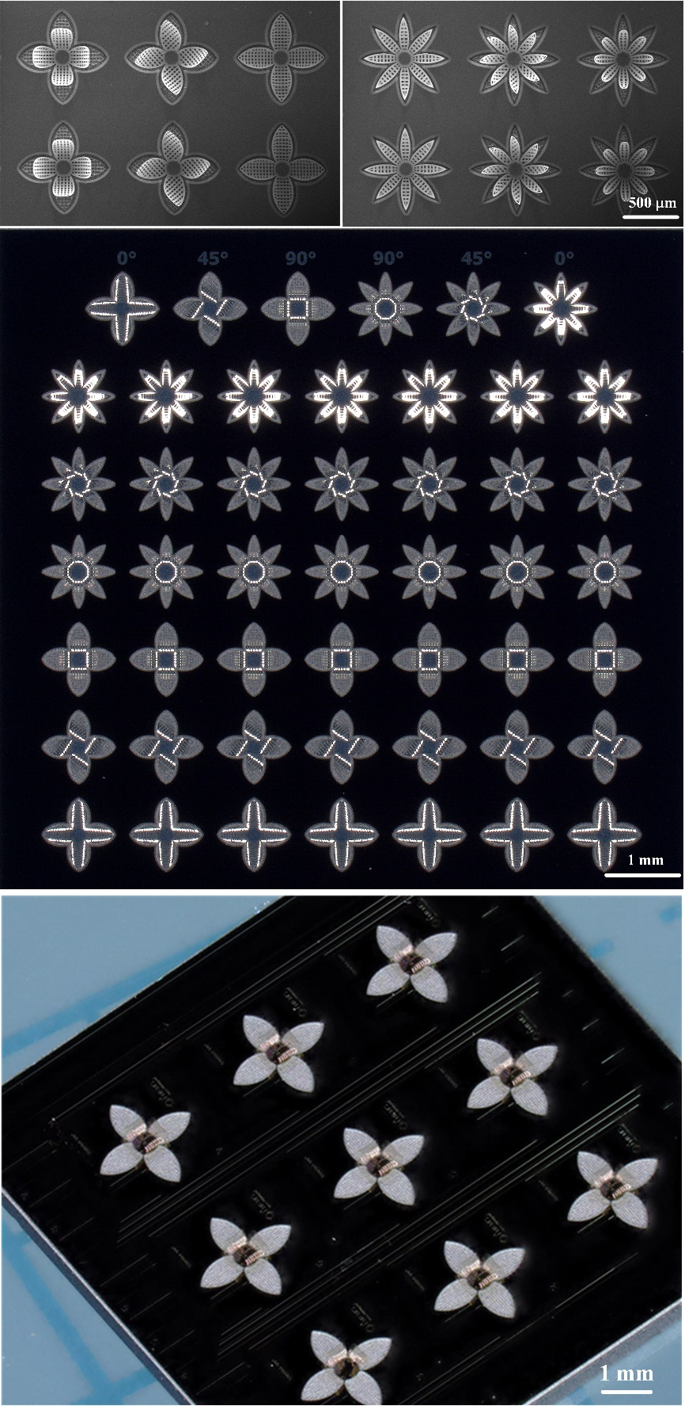
Figure S1. Images of an array of actuators with different designs (all on a single silicon wafer).

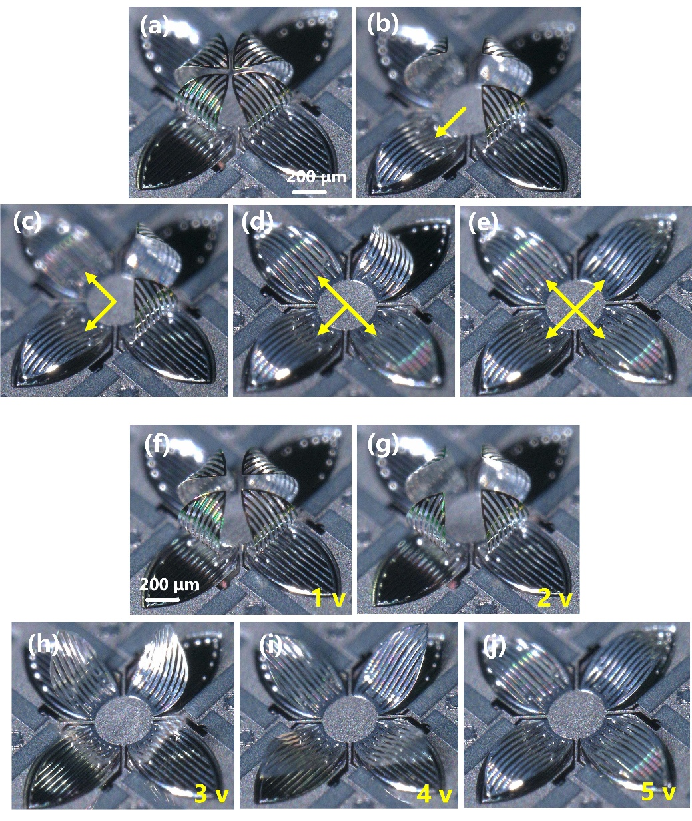
Figure S2. Optical images of the different working modes of a microgripper. (a~e). The four actuators are driven in sequence at 5 V. (f~j). The four actuators are driven simultaneously at a driving voltage from 1 V to 5 V.

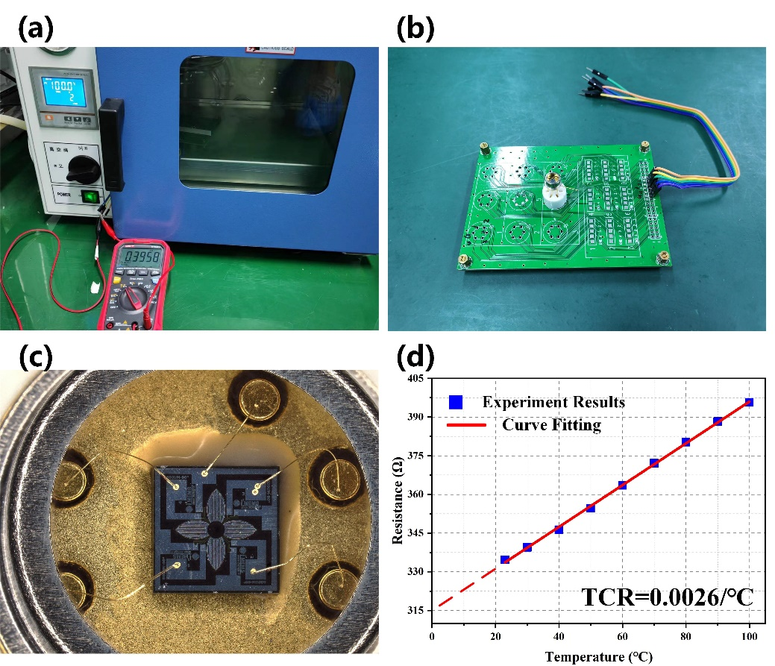
Figure S3. The experimental method for TCR. (a) Experimental setup. A temperature-controlled oven is used to set the temperature, and a multimeter is used to measure the resistance at different temperatures. (b) Close view of the PCB board of the microgripper. (c) Close view of the device with TO package. (d) Relationship between the resistance and temperature. The measurement error of the resistance is ±1 Ω. The TCR of the resistance can be calculated as the ratio of the slope to the R-axis intercept of its R-T curve [S1], and the value is calculated to be 0.0026/K.

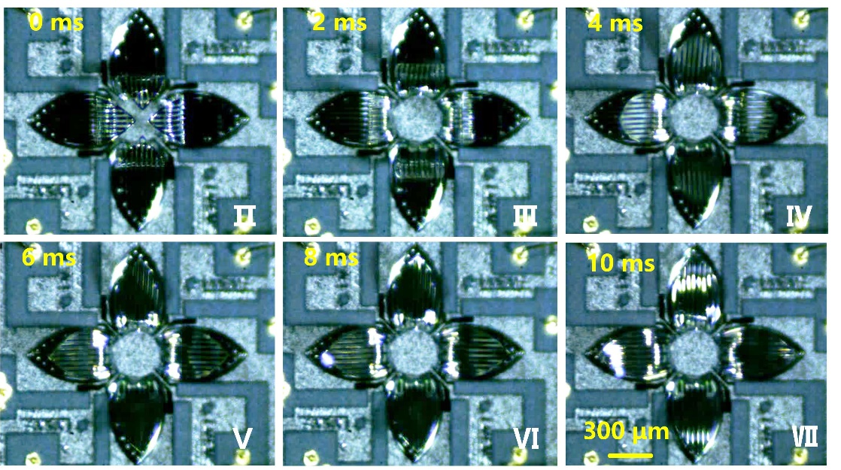
Figure S4. Six states of the microgripper during the opening process.

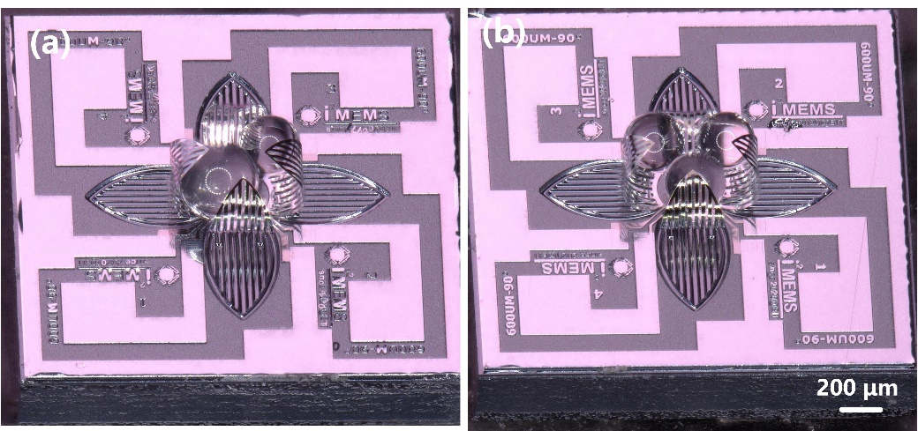
Figure S5. Optical images of multiple PMMA microbeads captured by the microgripper. (a) Two microbeads with different diameters are captured by the microgripper. (b) Three microbeads with the same diameters are captured by the microgripper.

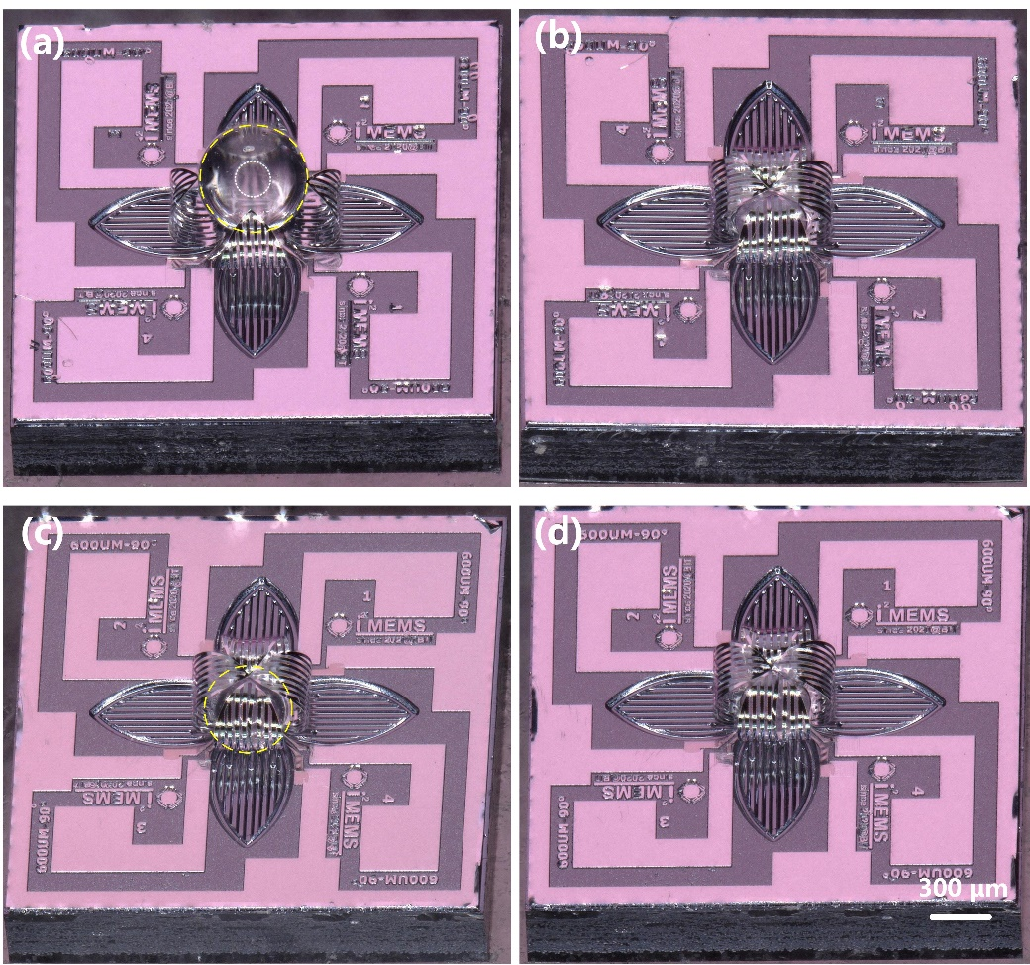
Figure S6. Optical images of the two wrapping modes before and after the vibration tests. (a~b) Type-A. (c~d) Type-B.

Figure S6(a) shows the shape of the Type-A before the vibration test. Figure S6(b) shows the shape of the Type-A after the vibration test, the microgripper recover to its original structure under the residual stress. Figures S6(c~d) show the structure of the Type-B before and after the vibration test, respectively. Although the microbead falls from the microgripper, the vibration has little effect on the actuator's mechanical structure and functionality.

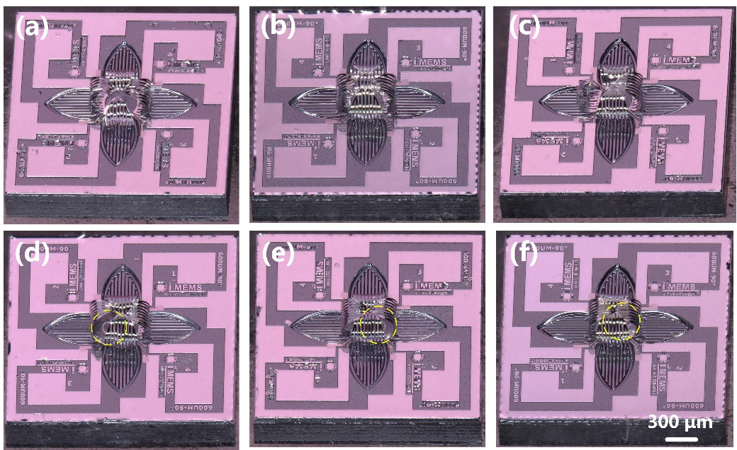
Figure S7. Optical images of the two wrapping modes after impact tests. (a~c) Type-A. (d~f) Type-B.

Figures S8(a~c) show the structures of the Type-A after impact tests. The actuator is irreversibly deformed under the impact of the microbead. Despite suffering from an acceleration load of 1600g, the microbead is still firmly held by the microgripper (Type-B) with the microbead’s position slightly shifted from its original place.

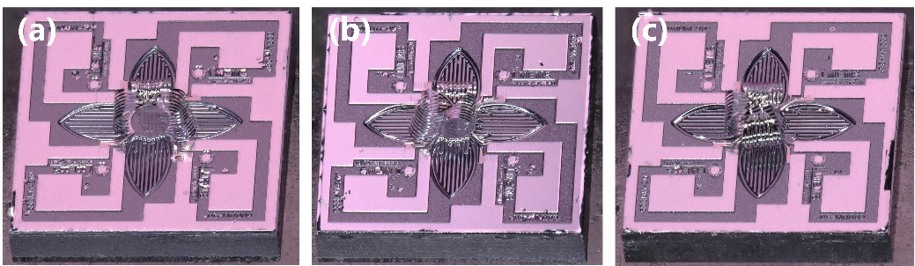
Figure S8. Optical images of the damaged microgripper.

Supplementary Table

Table S1. Comparison of properties of the used materials
Material | Young’s modulus (GPa) | CTE (ppm·K⁻¹) | Thermal conductivity (W·m⁻¹·K⁻¹) | Electrical conductivity (S·m⁻¹)
Al [S2] | 70 | 23.1 | 237 | 35.5 × 10⁶
SiO₂ [S2] | 70 | 0.5 | 1.4 | Insulator
Pt [S2] | 168 | 8.8 | 71.6 | 8.9 × 10⁶

Supplementary Movies

Movie S1: The detailed deformation process of the microgripper. The shooting speed of the high-speed camera is 2000 frames per second, and the play speed of the video is 1/30 of the actual speed.

Movie S2: The detailed failure process of Type A during a vibration test. The acceleration of the plate is 5g.

Reference
[S1] L. Xiao, Y. Ding, P. Wang & H. Xie. Analog-controlled light microshutters based on electrothermal actuation for smart windows. Opt Express 28, 33106-33122 (2020).
[S2] S. Pal & H. Xie. Fabrication of robust electrothermal MEMS devices using aluminum–tungsten bimorphs and polyimide thermal isolation. J. Micromech. Microeng. 22, (2012).

