Online Resource 1

Fig S1. Map of the summit of Mauna Loa showing the total GNSS displacements after 48 hours using 15-minute samples (black vectors with 95% confidence ellipses). Blue vectors are the overall fit of the co-eruptive model (Fig. 11, Fig. S2 in Online Resource 1, and animation in Online Resource 2). Yellow lines are the surface trace of the modeled tabular body, which has three segments with different strikes. Red lines are mapped fissures and faults.

Fig. S2. Snapshots of instantaneous rates of opening from the output of the co-eruptive Extended Network Inversion Filter (ENIF) model. The time of each frame is the number of hours after the onset of the eruption at 23:23 Hawaii Standard Time. Red colors correspond with positive rates and show increasing opening and decreasing closing. Grey shades show negative rates, which correspond with decreasing opening and increasing closing. The map trace of the three panels that comprise the model surface is shown in Fig. S1 in Online Resource 1. Vertical dashed lines show the boundaries of four “zones” that were used in the volume calculations shown in Fig. S3 in Online Resource 1. The numbers 1–4 above the topmost panel indicate the zone numbers. Note that the model contains three segments with different strikes (Fig. S1 in Online Resource 1). The x-axis is the cumulative distance along strike of each segment with zero defined as the southwest end of the model. Black circles are cataloged earthquakes that occurred during the 2 hours before the given timestep.

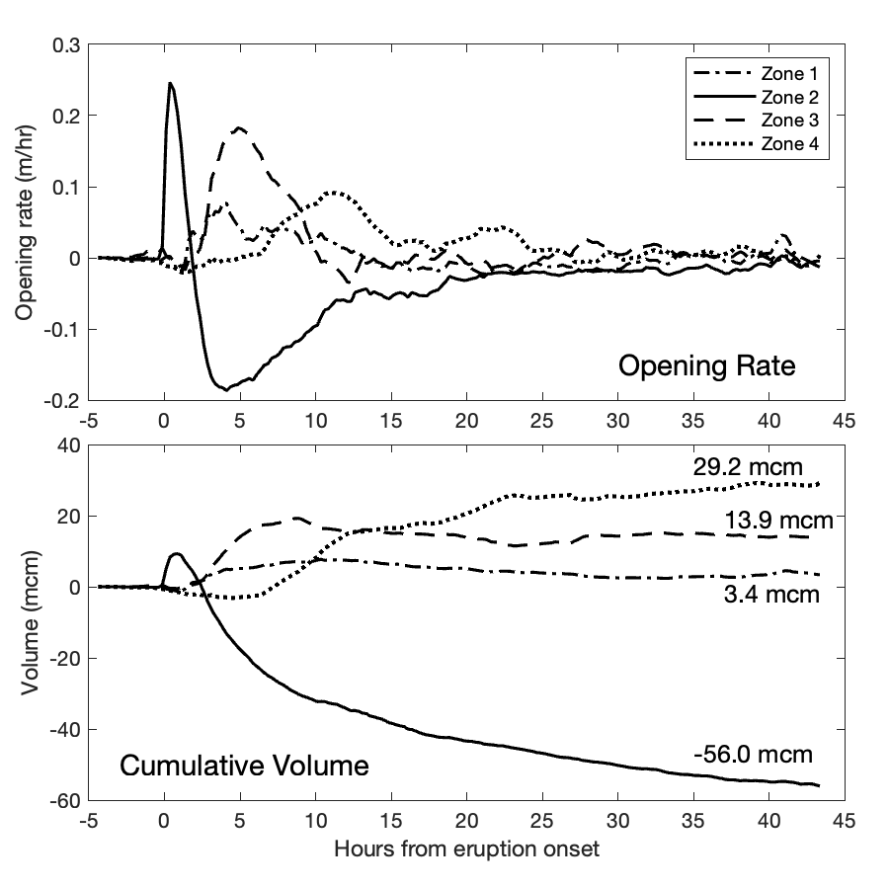
Fig S3. Top panel shows the average opening rate for the four model zones through time. Zones proceed from southwest to northeast and are shown in Fig. S2 in Online Resource 1. Zone 2 includes the initial vent opening, as well as the primary locus of deflation. The bottom panel plots cumulative volume for each of the four zones, with the total volume change indicated by the labels on the right (mcm stands for “million cubic meters”). Zone 1, 3, and 4 experienced net opening, while Zone 2 experienced high opening rates initially, and quickly changed to closing.

