Expanding housekeeping gene concepts: The role of retroelements in gene expression stability across tissues

Additional information 2.

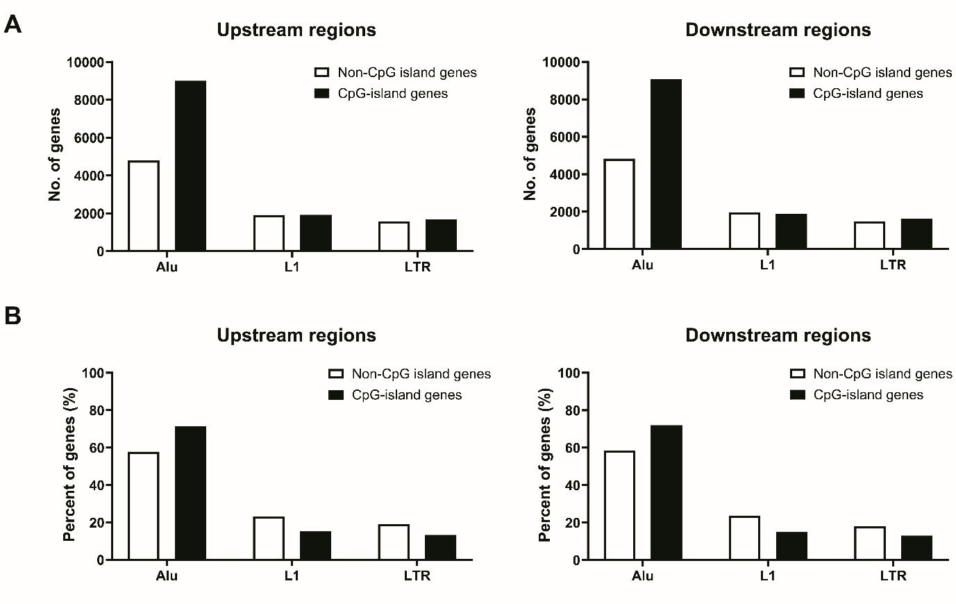
Figure S1. Comparison of genes classified based on the closest retroelements to the TSSs. Genes are distinguished by the type of retroelement (Alu, L1, LTR) located proximal to their TSSs in upstream and downstream regions, analysed separately for CpG-island genes and non-CpG island genes. The number of genes in each category (A) and the proportion of genes in each category (B) are shown.

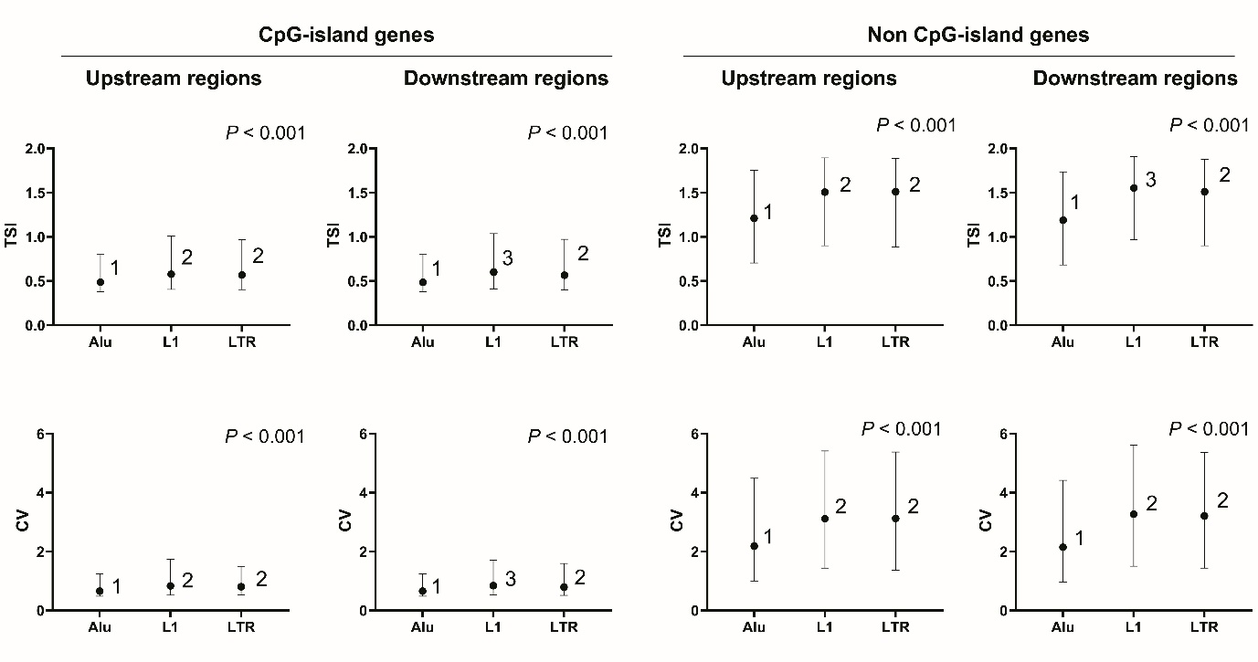
Figure S2. Comparison of TSI and CV values among genes adjacent to Alu, L1 and LTR elements in upstream and downstream regions. Analysis is performed separately for CpG-island genes and non-CpG island genes. The Kruskal-Wallis test was used to identify significant differences in TSI and CV values among gene groups. Post-hoc analysis results are indicated by numbers to distinguish subgroups within the same gene category.

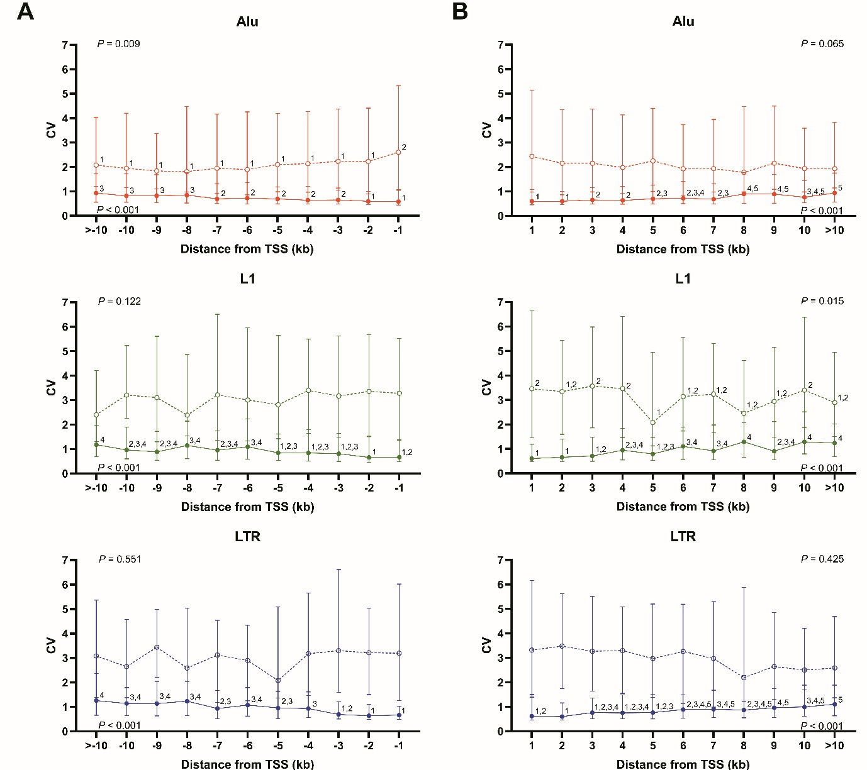
Figure S3. Comparison of CV values among genes adjacent to Alu, L1, and LTR elements across 1-kb intervals within 10 kb upstream (A) and downstream (B) regions. Each dot represents the median CV value for each gene group in CpG-island (closed dots) and non-CpG island genes (open dots), with the upper and lower bars indicating the quartile values. The Kruskal-Wallis test was used to identify significant differences in CV values among gene groups. Post-hoc analysis results are denoted by numbers to distinguish significant differences.

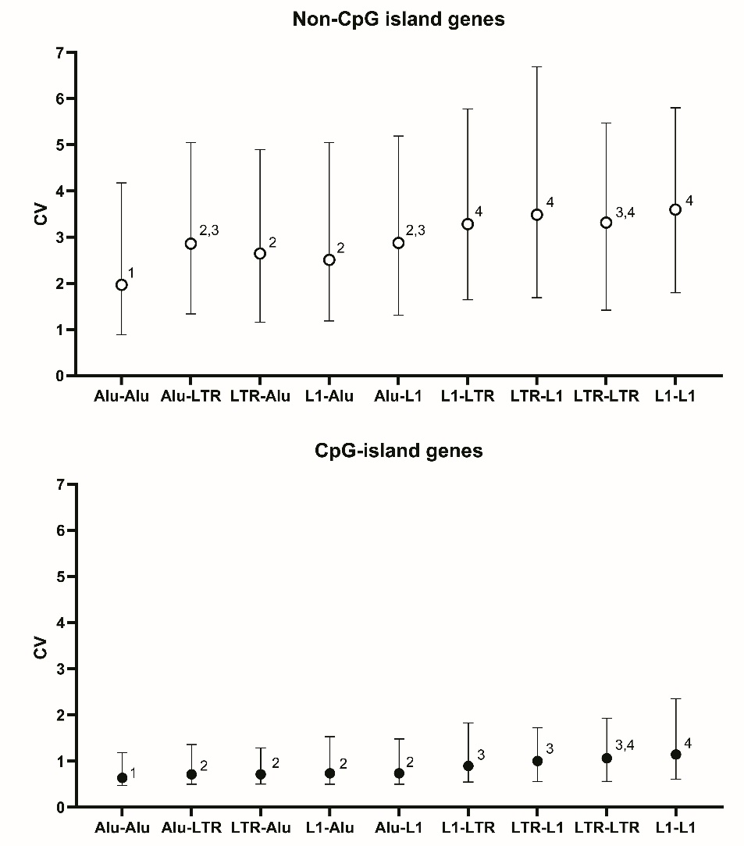
Figure S4. Comparative analysis of CV values based on combinations of retroelements near genes in upstream and downstream regions. Genes are categorised by nine combinations of Alu, L1 and LTR retroelements, labelled according to their position relative to the gene (upstream-downstream order). Each dot represents the median CV value for each retroelement combination in CpG-island (closed dots) and non-CpG island genes (open dots), with bars showing interquartile ranges. Statistical differences were evaluated using the Kruskal-Wallis test and post-hoc tests, with significant subgroups denoted by numbers. The retroelement combinations are ordered by ascending median TSI values for CpG-island genes.

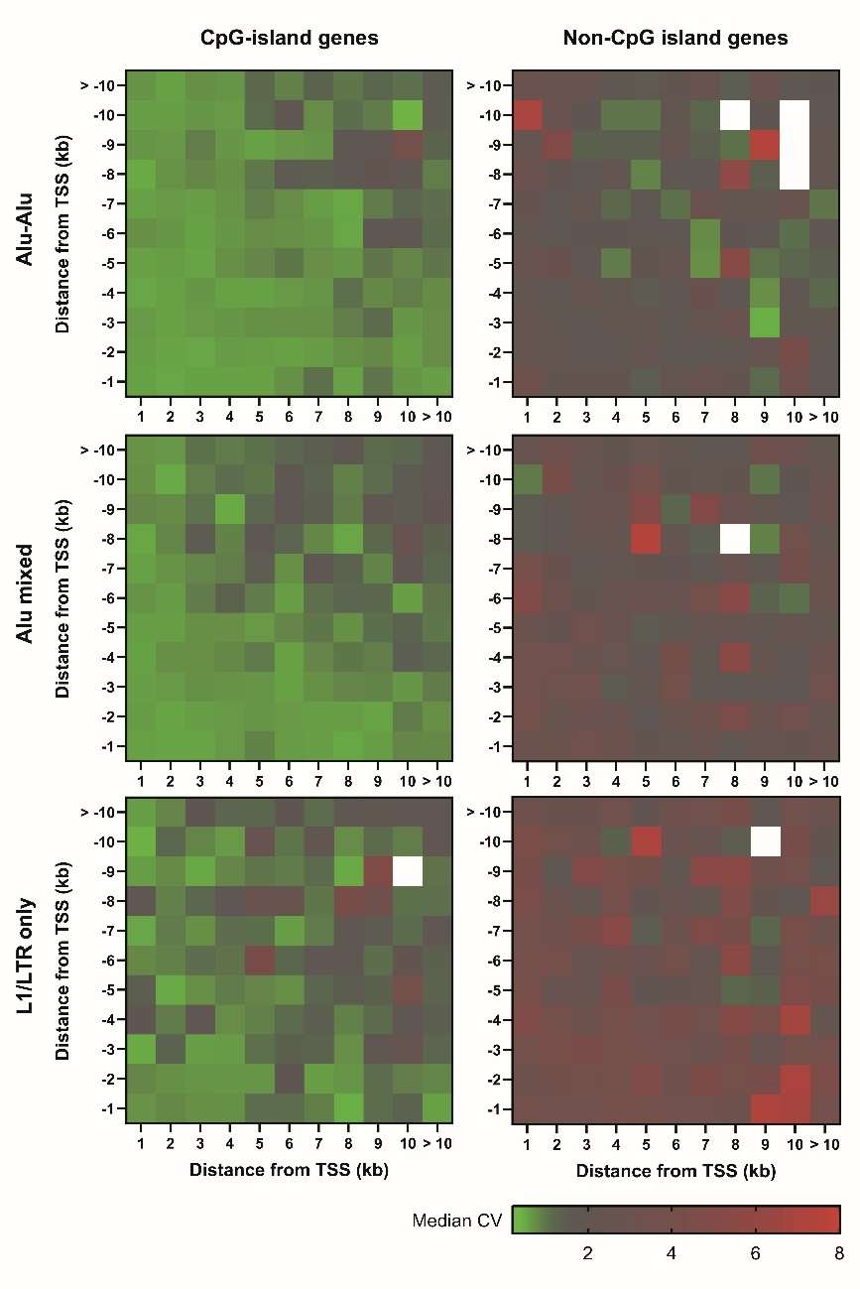
Figure S5. Heat map distribution of CV values based on combinations of retroelements near genes. Genes are analysed separately for CpG-island and non-CpG island genes and are categorised into groups based on the combination of retroelements (Alu, L1, LTR) arranged in upstream-downstream order: Alu-Alu, Alu mixed (Alu-L1, Alu-LTR, L1-Alu, LTR-Alu) and L1/LTR only (L1-L1, L1-LTR, LTR-L1, LTR-LTR).

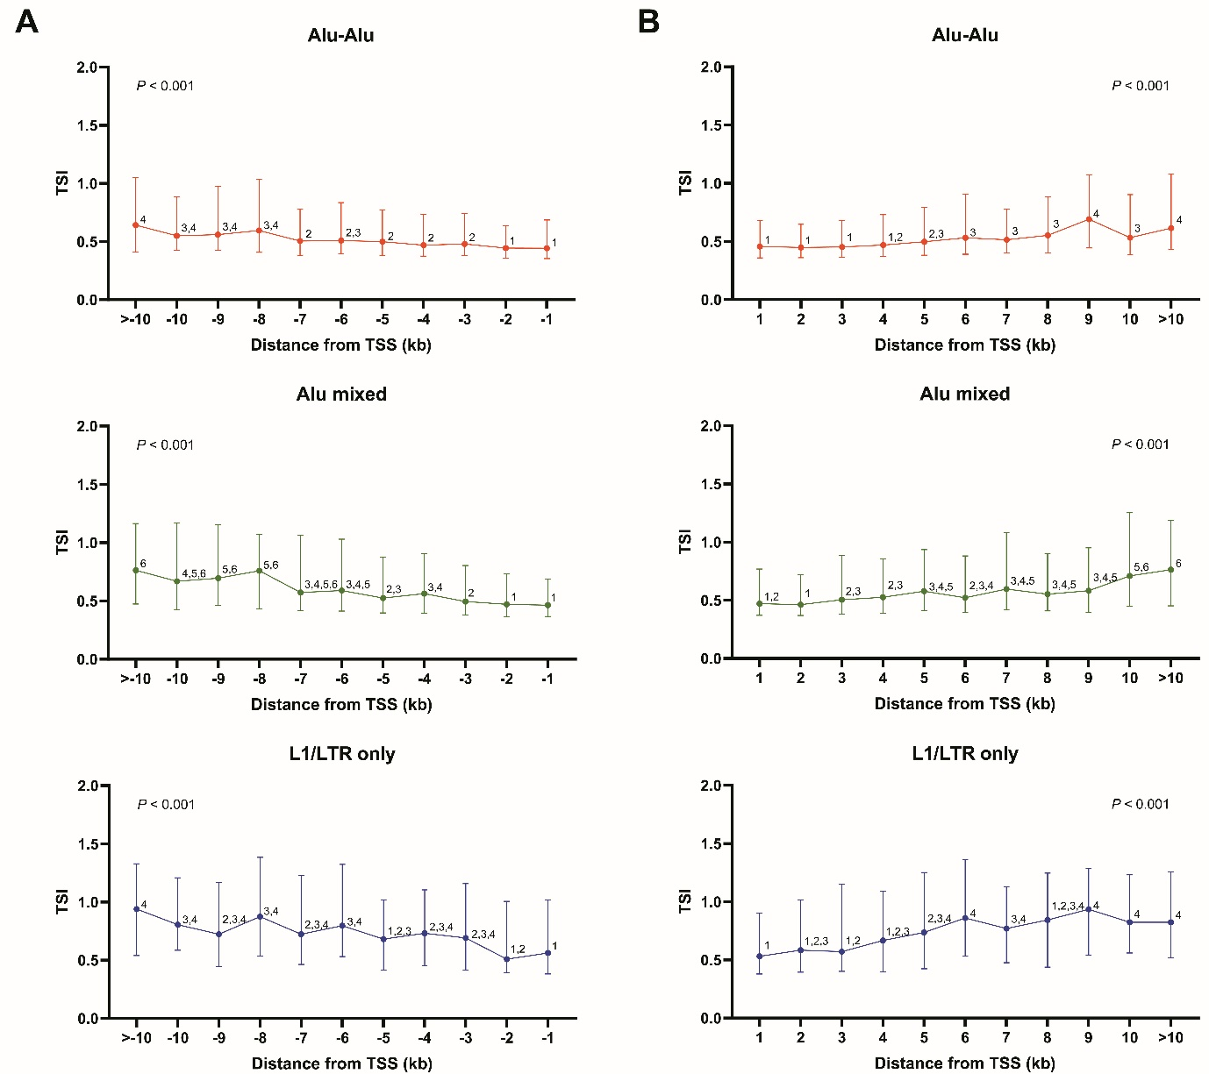
Figure S6. Comparison of TSI values among CpG-island genes grouped by proximity to gene-adjacent retroelements across 1-kb intervals within 10 kb upstream (A) and downstream (B) regions. The genes are classified into three distinct groups based on the type of retroelement combinations, as outlined in the manuscript: Alu-Alu, Alu mixed and L1/LTR only. Each dot represents the median TSI value for each gene group, with the upper and lower bars indicating the quartile values. Significant differences in TSI values among the gene groups were identified using the Kruskal-Wallis test. Post-hoc analysis results are indicated by numbers to distinguish subgroups within the same gene category based on their proximity to the TSSs.

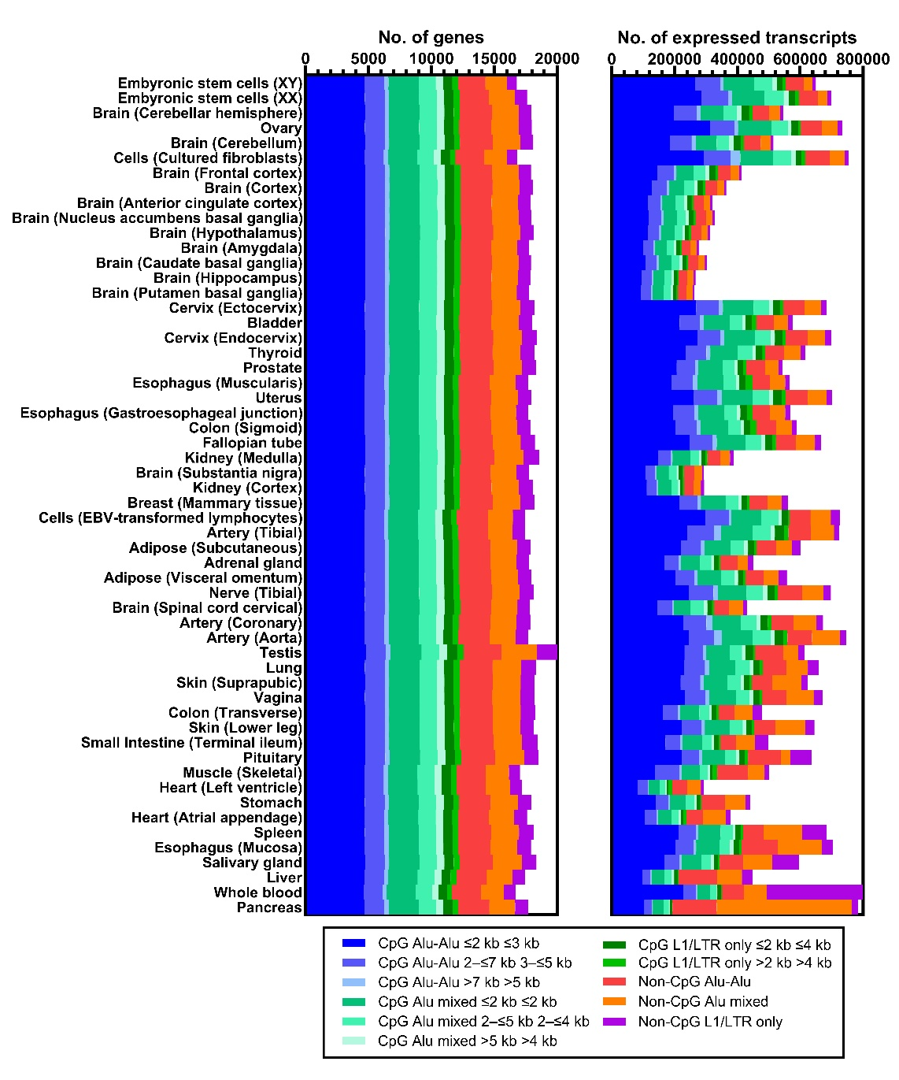
Figure S7. Distribution of gene expression across 56 tissues within gene groups defined by CpG islands and proximity to gene-adjacent retroelements. This figure shows the number of expressed genes and the cumulative gene transcripts across 56 tissues, as per the gene groups outlined in the manuscript. The left panel displays the number of expressed genes, while the right panel details the cumulative gene transcripts. Tissues are ordered from top to bottom by the descending proportion of CpG-island gene expression. Each bar represents a specific tissue and is subdivided into coloured segments corresponding to different gene groups.

