Supplementary Information

Kazumasa Okamoto,^{1,2*} Yusa Muroya,¹ Takahiro Kozawa¹
Dynamics of ionized poly(4-hydroxystyrene)-type resist polymers with tert-butoxycarbonyl-protecting groups
1. SANKEN (The Institute of Scientific and Industrial Research), Osaka University, Ibaraki, Osaka 567-0047, Japan
2. Artificial Intelligence Research Center, SANKEN (AIRC-SANKEN), Osaka University, Ibaraki, Osaka 567-0047, Japan
E-mail: kazu@sanken.osaka-u.ac.jp

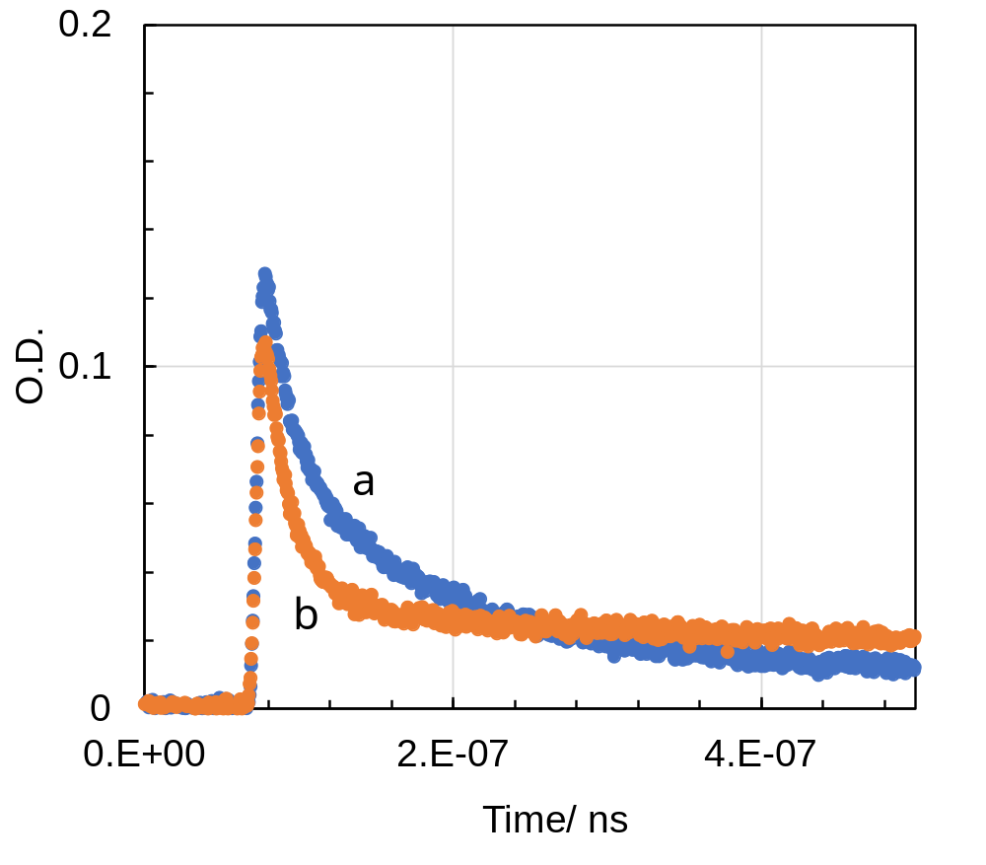

Fig. S1. Kinetic traces obtained by nanosecond pulse radiolysis at 600 nm: (a) PTBOS (100 mM (unit conc.)) in Ar-saturated CHN, (b) PTBOS (100 mM (unit conc.)) with 5 mM TPS-nf in Ar-saturated CHN.
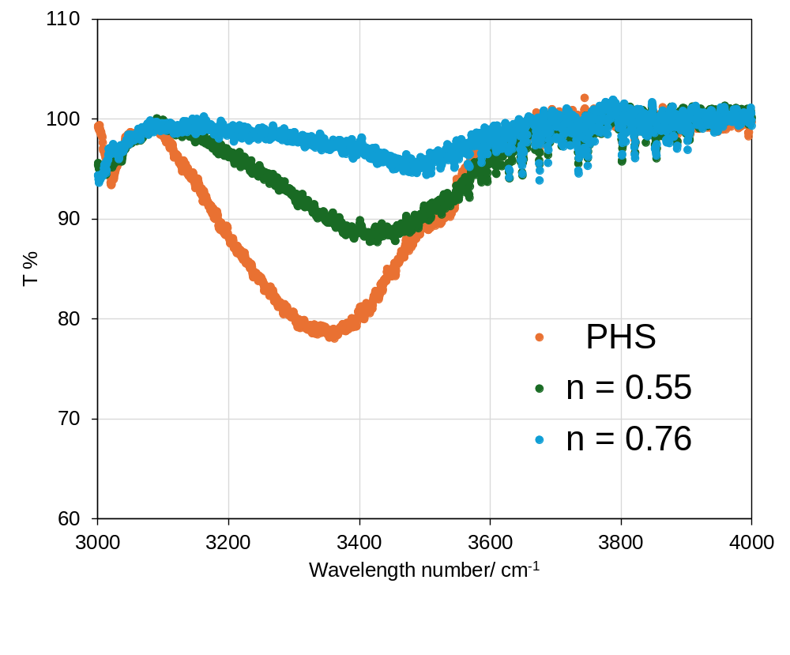Fig. S2. FT-IR spectra of OH vibrations of PHS and P(TBOS-co-HS) films on an undoped Si wafer with t-BOC protection ratios n of 0.55 and 0.76.
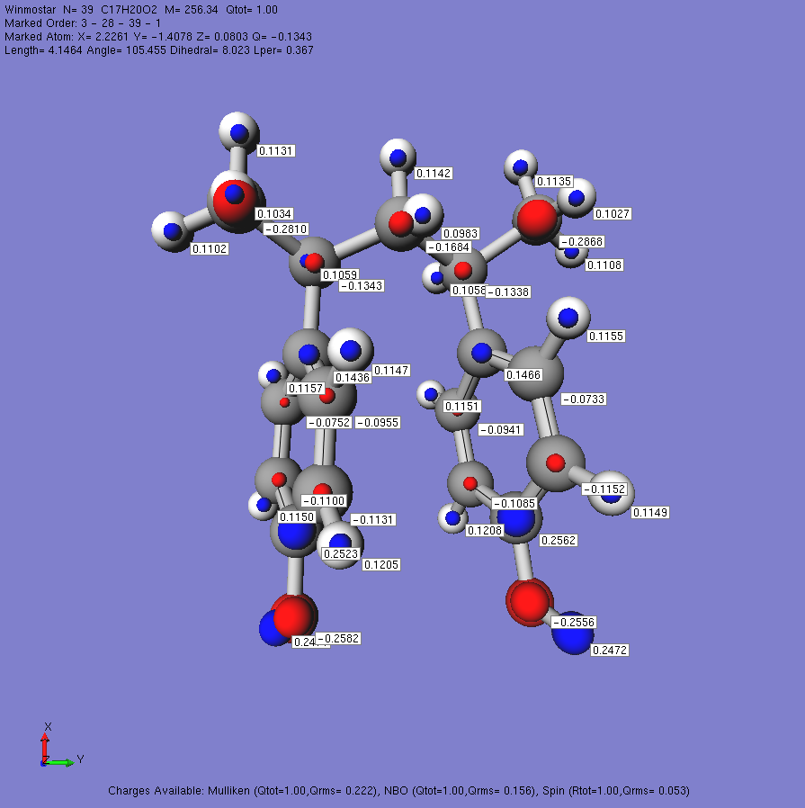
PHS (anti) NBO

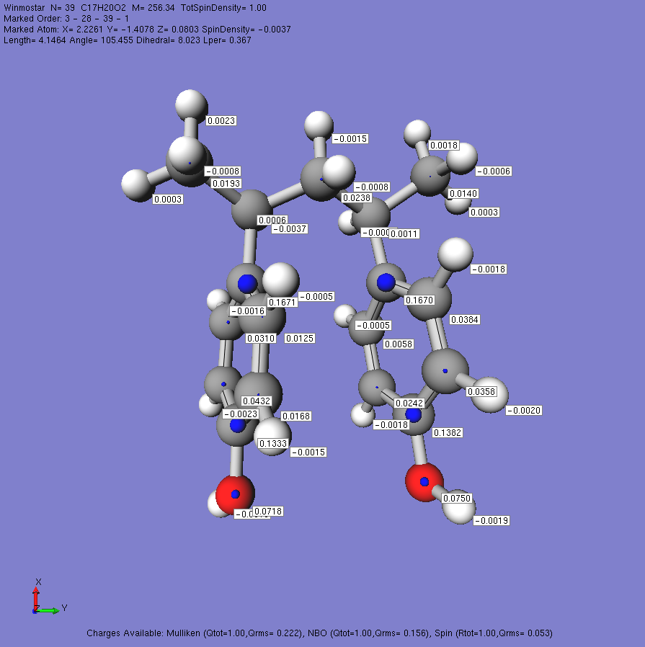
PHS (anti) spin

Fig. S3. Optimized structure of m-2,4-diphenyl pentane derivatives as the PHS dimer radical cation model (OH, OH) with NBO charge and spin density on atoms. The hydroxyl groups are in the opposite direction (anti). DFT calculations are carried out using the wB97X-D/def2-TZVP level.

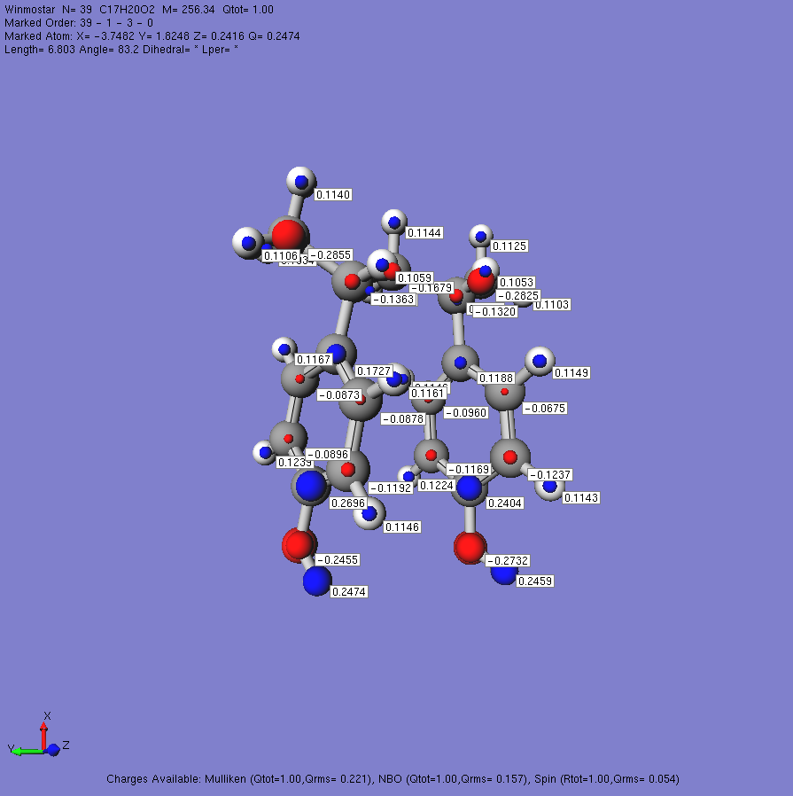
PHS (syn) NBO

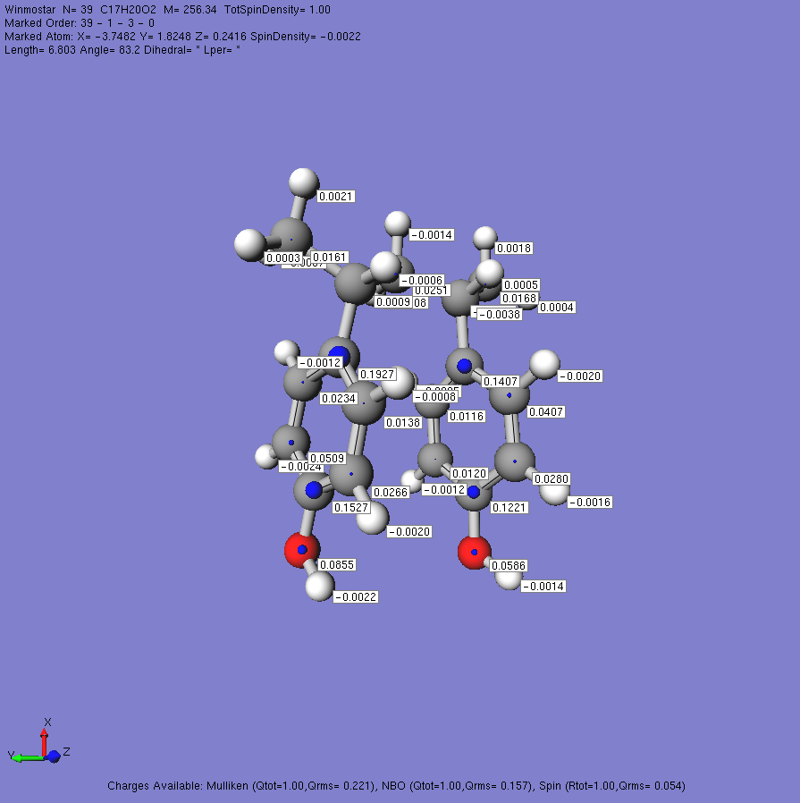
PHS (syn) spin

Fig. S4. Optimized structure of m-2,4-diphenyl pentane derivatives as the PHS dimer radical cation model (OH, OH) with NBO charge and spin density on atoms. The hydroxyl groups are in the same direction (syn). DFT calculations are carried out using the wB97X-D/def2-TZVP level.

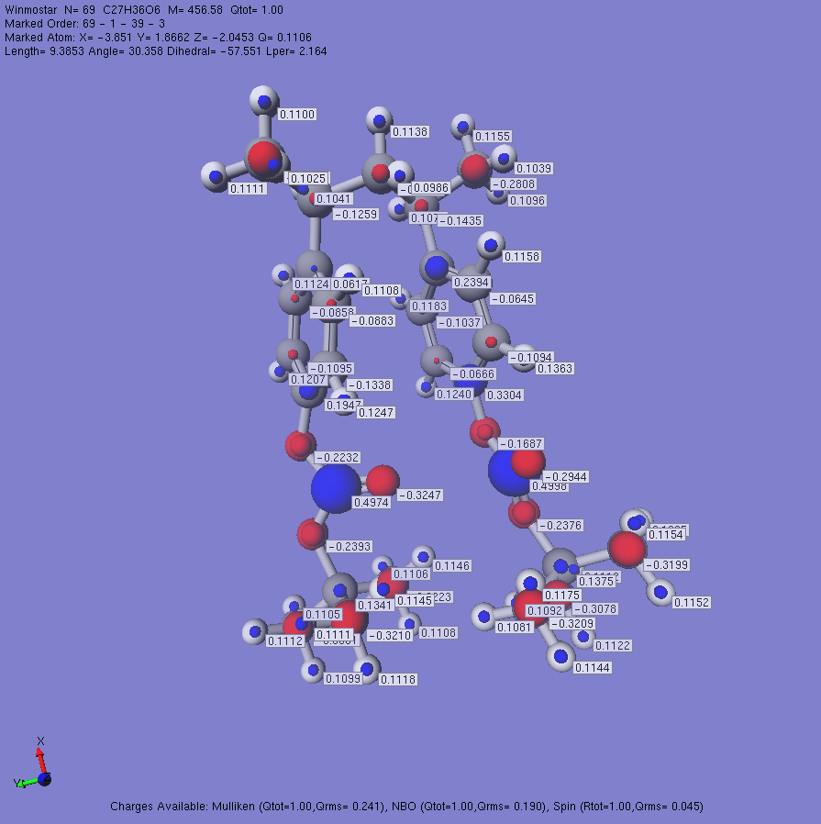
PTBOCS (syn) NBO

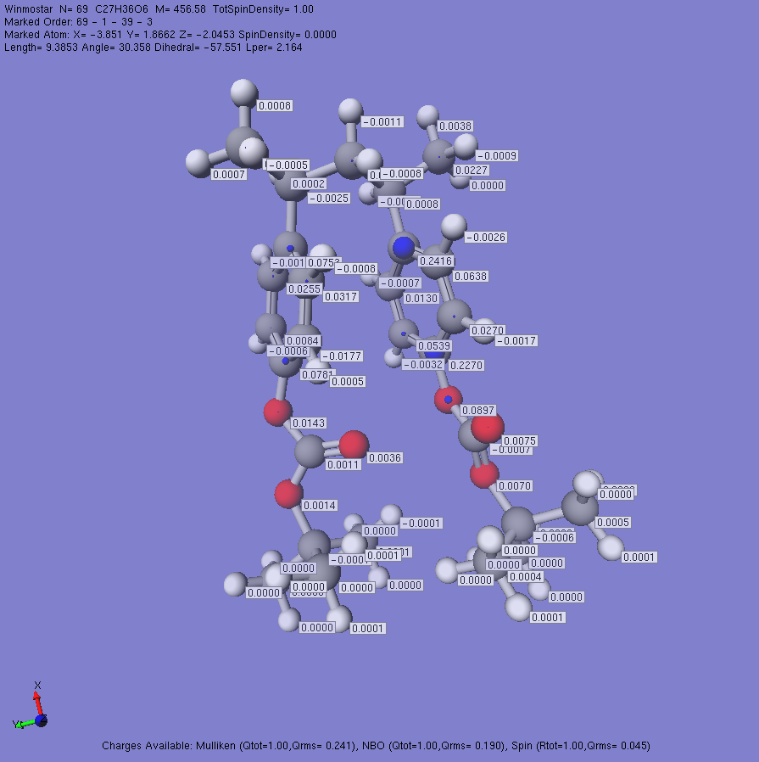
PTBOCS (syn) spin

Fig. S5. Optimized structure of m-2,4-diphenyl pentane derivatives as the PTBOCS dimer radical cation model (t-BOC, t-BOC) with NBO charge and spin density on atoms. The carbonyl O atom of t-BOC groups are in the same direction (syn). DFT calculations are carried out using the wB97X-D/def2-TZVP level.

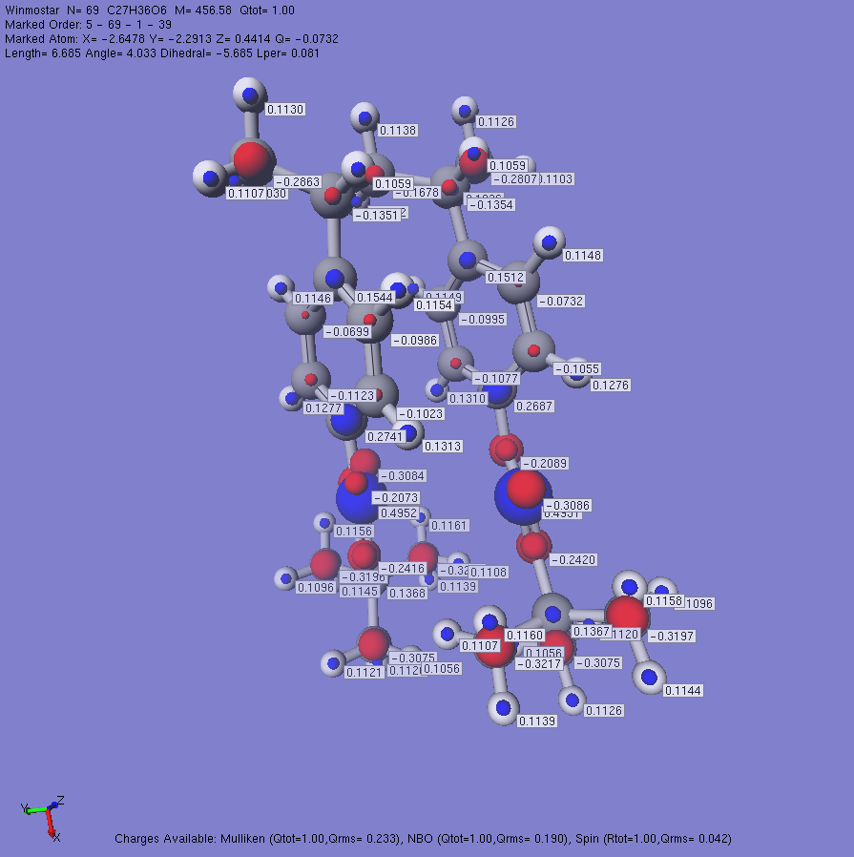
PTBOCS (anti) NBO

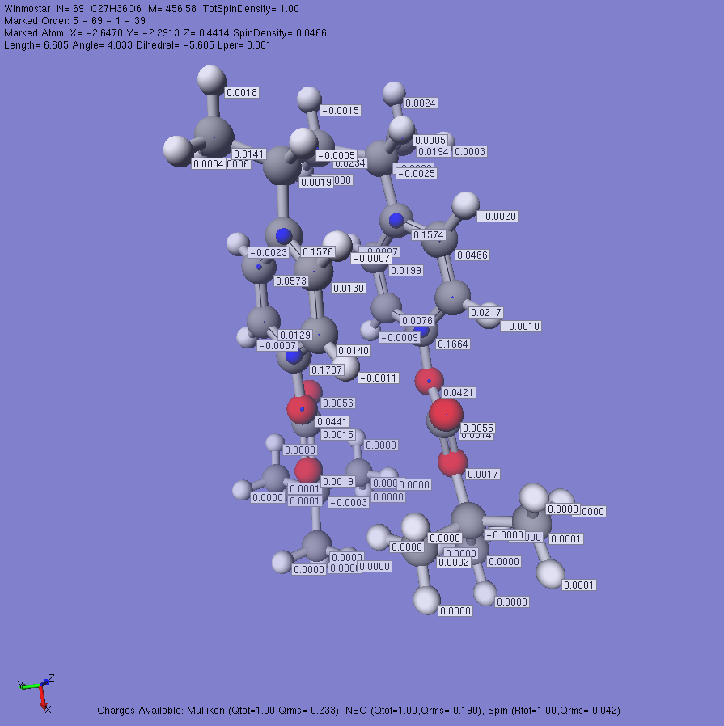
PTBOCS (anti) spin

Fig. S6. Optimized structure of m-2,4-diphenyl pentane derivatives as the PTBOCS dimer radical cation model (t-BOC, t-BOC) with NBO charge and spin density on atoms. The carbonyl O atom of t-BOC groups are in the same direction (anti). DFT calculations are carried out using the wB97X-D/def2-TZVP level.

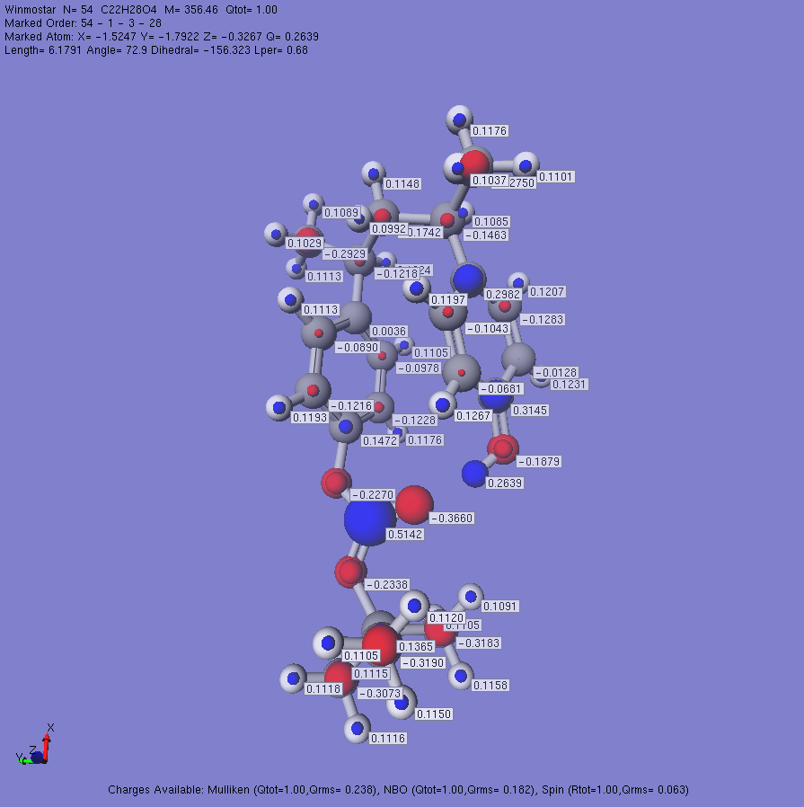
P(HS-co-TBOC) NBO

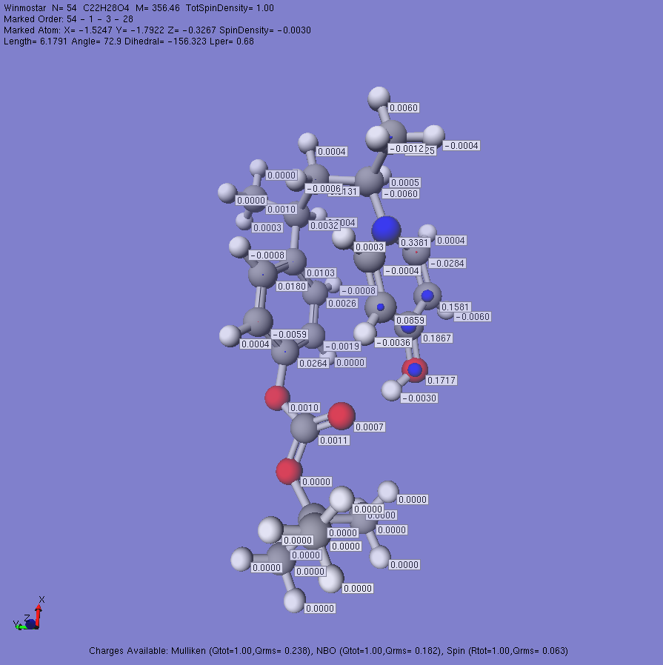
P(HS-co-TBOC) spin
Fig. S7. Optimized structure of m-2,4-diphenyl pentane derivatives as the P(HS-co-TBOC) dimer radical cation model (t-BOC, OH) with NBO charge and spin density on atoms. DFT calculations are carried out using the wB97X-D/def2-TZVP level.

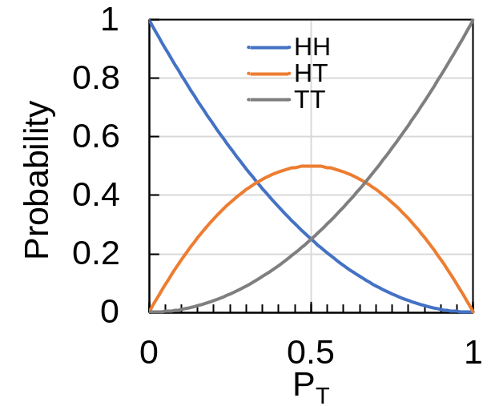
Fig. S8. Relationship between the probability of presence of hydroxystyrene units and t-BOC-protected hydroxystyrene units in the diad and the protection ratio based on the Bernoulli model [1]. Here, the combinations of substituents on the benzene ring are HH: (OH, OH), HT: (t-BOC(oxy), OH), and TT: (t-BOC(oxy, t-BOC(oxy)).

Reference
[1] L. M. Smith and M. L. Coote, Polym. J. 51 (2013) 3351.

